Date: 15/11/18

Country report: Spain

Case Study: ES1 Extensive crops trials visit

WP5: Case studies of demonstration activities in commercial farms

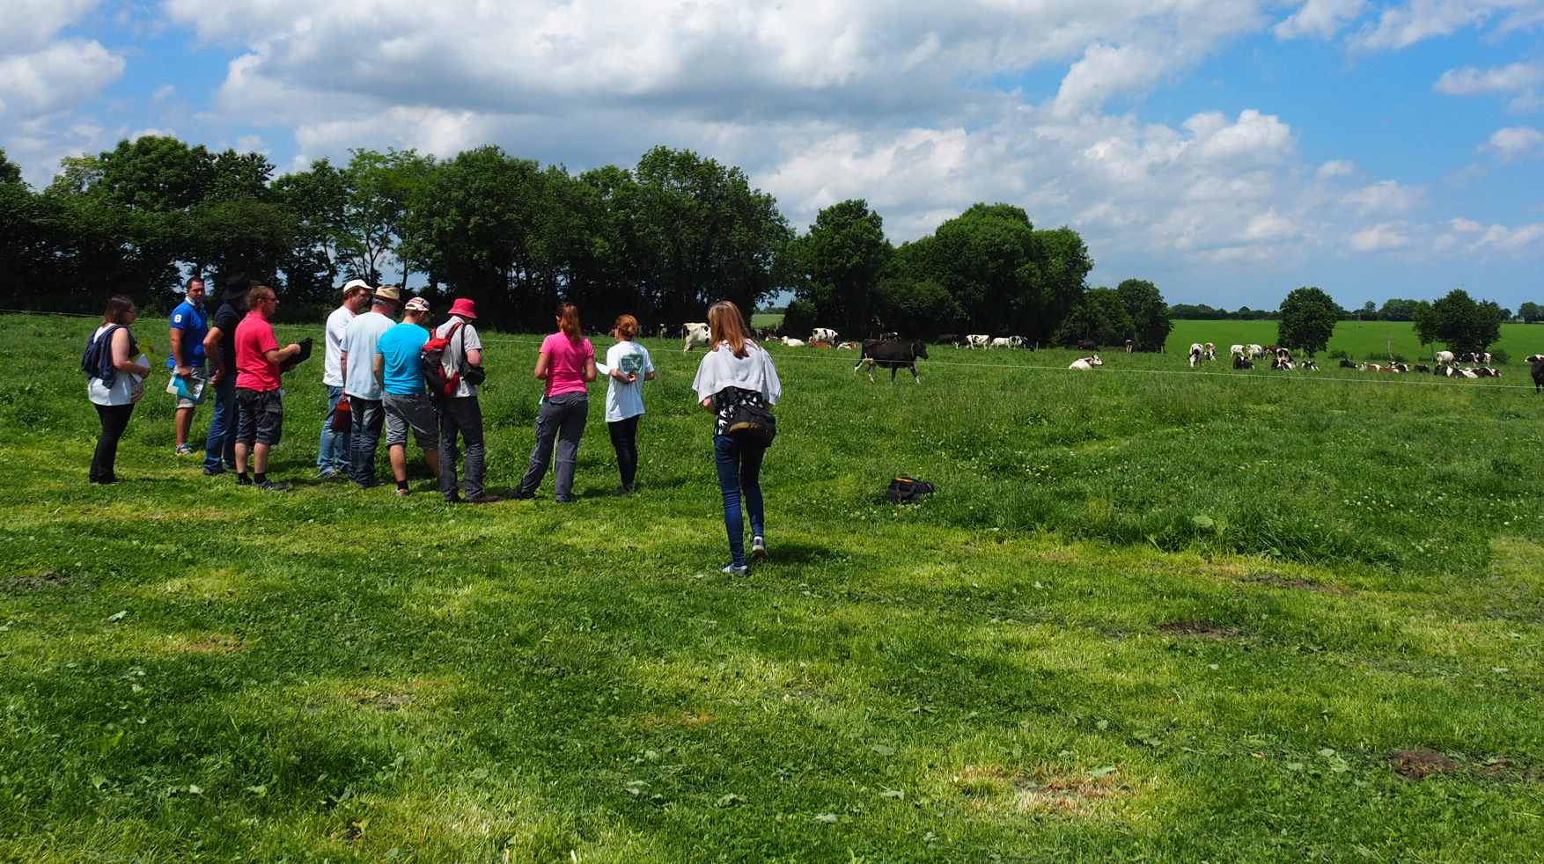
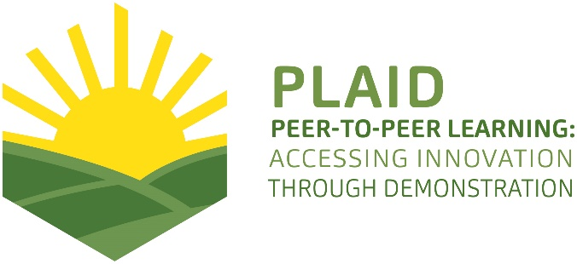
This project has received funding from the European Union’s Horizon 2020 research and innovation programme under Grant Agreement No 727388.
This project has received funding from the European Union’s Horizon 2020 research and innovation program under Grant Agreement No 727388

PLAID PARTNERS

Advisory Service Croatia ASC | 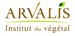  ARVALIS Institut du Végétal | Association de Coordination Technique Agricole ACTA
Institute for Rural and Regional Research | 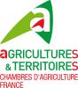  Chambers of Agriculture | Delphy
European Forum for Agricultural and Rural Advisory Services EUFRAS | Innovatiesteunpunt ISP | Institut de l’Elevage – Idele
Instituto Navarro de Tecnologías e Infraestructuras Agroalimentarias | 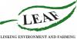  Linking Environment and Farming LEAF | 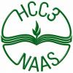  National Agricultural Advisory Service
Nodibinajums Baltic Studies Centre (BSC) | Research Institute of Organic Agriculture (FIBL) | Stichting Wageningen Research
The James Hutton Institute | VINIDEA

DOCUMENT SUMMARY

__________________________________________________________________________________
Milestone Title: 24 Case Studies
__________________________________________________________________________________
Case Study Title: Extensive crops trials visit (Spain)
__________________________________________________________________________________
Version: 2
__________________________________________________________________________________
Task Lead: WUR
__________________________________________________________________________________
Related Work package: WP5
__________________________________________________________________________________
Authors: Alberto Lafarga, Isabel Gárriz (INTIA)
__________________________________________________________________________________
Grant Agreement Number: 727388
__________________________________________________________________________________
Project name: PLAID
__________________________________________________________________________________
Start date of Project: January 2017
__________________________________________________________________________________
Duration: 30 Months
__________________________________________________________________________________
Project coordinator: The James Hutton Institute

ABSTRACT New varieties and cultivation techniques adapted to Valdorba (21-May-2018)
The Valdorba demonstration is an initiative born from the Valdorba agrarian cooperative itself and the support of INTIA. There are two main topics of the visit: Knowing the new varieties of cereals and the new solutions in treatments of fungicides. The topics was selected by the cooperative and the advisor of INTIA (Public Advisory Service) and validated by farmers and advisors of the agrarian cooperative. The visitors were 22 professional farmers. Only one woman attended. All of them are active members of the coop and very interested in sharing their practical experiences. During the demonstration there was a tour guide by the farmer demonstrative parcels and INTIA trial plots. The demonstration was in general positive: It was well organized, and it was very interesting. The main practical recommendations to deal with this kind of event are:
- The demonstration has to offer something new that attendees can see beneficial to their interests: New techniques (varieties mostly in this event), be up to date, meet other professionals, etc.
- The demonstration has to be organized by someone that farmer considers prepared, expert, and also close to the farmers, as it is the case of technicians of INTIA and the coop.
- It is necessary to program the demonstration from the moment in which the applied field trials are designed to be shown on the day of the event. Do not improvise the day of the event.
- Integrating the contribution of technicians with the contributions of farmers is highly valued by the entire group.
- We need to find instruments that facilitate communication so that all farmers can express themselves.
-.

TABLE OF CONTENTS

1 Demo context 7
1.1 The value chain 7
1.2 Typical farm characteristics 9
1.3 AKIS 9
1.4 Sustainability challenges 10
2 Demonstration summary 10
3 Governance: set up and organisation 11
3.1 Organiser(s) and history 11
3.2 Funding 12
3.3 Gender 12
3.4 Objective(s) 13
3.5 Topic(s) 13
4 Demonstration event 14
4.1 Visitors 14
4.2 Communication & Mediation 14
4.3 Active participation 14
And the end of the day he whole group went to the cooperative to carried out the evaluation of the day with the Focus Group methodology within the framework of PLAID. 16
4.4 Doing business 16
4.5 Role of sustainability 16
4.6 Unforeseen circumstances 16
4.7 Plans vs. practice 16
4.8 Participants feedback 17
5 Motives, learning and networking 17
5.1 Reasons to attend demos 17
5.2 Forms of learning 18
5.3 Content of learning 18
5.4 Outcomes of learning 18
5.5 Networking 19
6 Anchoring: Application of demo lessons by participants 19
6.1 Anchoring related to the present demo 19
6.2 Stimulating anchoring 20
6.3 Anchoring related to earlier demos 21
7 Scaling: Application of demo lessons by the wider farming community 22
7.1 Retrospective examples of scaling 22
7.2 Prospective assessment of scaling: Impact pathways 23
8 Case study reflection 24
8.1 Demonstrations-innovation narrative 24
8.2 Facilitating and impeding factors for successful demonstrations 25
8.3 Impact of demonstrations 25
8.4 Key lessons from this case study 26
9 Annexes 28
9.1 Data sources 28
9.2 Data collection methods 28

Demo context

The value chain

The agri-food sector represents the 7.9% (in 2015 is 526,159.7 thousand euros) of the total GVA of Navarre. Related to Vegetal Production, 37.6% corresponds to Vegetables, a 28.8% to Cereals, 12.7% to Forage plants, and 11.4% to Fruits.

Innovations in cereals are the focus of this Program of Demonstrations. As 80% of the cereal production is under control of the cooperative sector, cooperatives are one of the most active institutions in this area of economical activity. Valdorba is one the representative coops in Navarra, devoted to the cereal production as well as other arable crops in rotation with cereals.

A group of farmers in the coop are playing the role of innovators, being a reference for the rest. Three areas of interest are identifies for this group to be presented in this demonstration, pest control, access to new varieties of cereals and crop diversification.

The varietal renewal in the cereal sector

Value chain. The commercial interests in relation to the innovation in varieties are structured in several stakeholders that make up the value chain of this sector:
- Genetic improvement companies.
- Seed producing companies.
- The cooperatives providing seeds to farmers, COSENA, URLUSA, ...
- Farmers who use the seeds.
- Cooperatives that store and market the production.
- The agro industry that buy the production and demand specific qualities.
It is a sector with a high turnover, not so much because of the unit value of the seeds but because of its high demand in the market. Some figures:
- 80,000 hectares of soft wheat in Navarra x 200 kg / ha of seed x 0.25 € / kg of seed, represents a total turnover of approximately 4 million Euros.
- It is important to note here the fact that there are two clearly differentiated seed markets, the seed grain market (farmer's right) and the certified seed market, the latter being the one that enables varietal renewal and innovation. In Navarra it represents approximately 50%, with which the actual business figure would be approximately 2 million Euros.
- In any case, the number of commercial agents is very high among breeders and seed multipliers (companies and cooperatives)

On the other hand, it is important to observe the fact that for the farmer innovation in varieties must offer solutions for improvement in several aspects:
- Improve productivity and in this way the income of the farmer
- Improve the adaptation to the environment, more resilient varieties against climatic conditions or biotic agents such as pests, diseases or weeds.
- Adapt to the technological quality demanded by agro-industry.
On the part of agro-industry, the demands on innovation refer to the technological quality of the new varieties. There are often very specific requirements for their industrial production processes.

Integrated Pest Management (IPM)
The commercial interests are focused on the pesticides industry, which is structured in several interest groups that make up the value chain of this sector:

- Plant protection companies.
- The distribution companies.
- Cooperatives that provide pesticides products to farmers.
- Farmers who use pesticides products.
- The administration that controls the safety and environmental impact of the use of pesticides products.
It is a sector with a high turnover. Some figures:
- 200,000 hectares of cereals in Navarra x € 20 / ha of average treatment cost in herbicides, represents a total business figure of approximately 4 million euros. If we talk about fungicides we can estimate a similar cost per hectare but only 25% of the treated area, which means adding another million euros to the total spending of pesticides products in a cereal campaign, that is to say approximately 5 million euros.
- In any case, the number of commercial agents is quite small (companies and cooperatives)

On the other hand it is important to observe the fact that for the farmer the innovation in pesticides is very relevant for his economy and must offer solutions of improvement in several aspects:

- Improve the control of weeds and diseases, since the loss of yield and income can be very important in this way.
- Reduce the damages caused in the crop by the use of pesticides products.
On the part of the control organisms there is a special interest in reducing the use of pesticides products in crops or at least minimizing their risk both for the applicator and for the environment and the health of the harvested products.

Crop diversification
Health problems of crops such as the proliferation of weeds and the development of root diseases of cereals are encouraging farmers to make longer and more diverse rotations of crops.

In this sense legumes are the preferred plants for their agronomic value in the rotation, but also other species such as rapeseed and sunflower.

There is a long tradition in the cooperative in the production of legumes for seed, maintained with the support of the cooperative managers who look after this market as an opportunity for diversification.

The agents in the legume seed production market are few and the market volume reduced. This market is managed through contracts between the companies and the cooperative.

The rape and sunflower markets are wider and more dynamic.

As a summary:
Innovation in the area of cereal production focuses on three fundamental elements: new varieties, pesticides products and alternative crops. The first two have different and important value chains for their business figures. Not so the third of the three, where the agents in the market are small and less significant.

Typical farm characteristics
Characteristics of the productive sector.
Cereal farms are evolving in recent years both in this cooperative and in the rest of the cereal cooperatives in Navarra. Twenty years ago they were small family farms between 20-50 hectares but now it has increased in size, with averages between 100-200 ha and more professional farmers, specialized in the production of cereals and well equipped with appropriate machinery for these farm dimensions.

It is convenient to know at what point of innovation the sector is. Cooperatives have a structure that supports innovation in new varieties very well due to the fact that they produce directly the commercial seeds themselves. In addition, there are also the cooperative seed multiplication organizations, COSENA, URLUSA, as an efficient instrument to organize the cooperative sector, really active protagonists of this innovation process, as mediators of farmers.
It is also relevant to bear in mind the interest of the cereal sector to whom this demonstration is directed. A sector that has more than 200,000 has. among which there are large professional farmers, cooperatives and production associations and also a large number of small family farms. The total number of farmers is higher than 2000. Although there are a few in organic, the production system clearly predominant is the conventional one.

The farmers are professionals specialized in extensive crops. Their farms are very well mechanized and with adequate size. These are medium and large farms, between 50 and 200 hectares, with extensive crops mainly cereals, legumes and oilseeds.

AKIS
General Key actors of Agricultural knowledge Information System AKIS in the region of Navarra:
- Universities of Navarra (public, private). Very active collaborations in Soils and Agro ecosystems.
- Higher Council for Scientific Research (CSIC). New breeding materials.
- Instituto Navarro de Tecnologías e Infraestructuras Agroalimentarias (INTIA)
- Farmer’s associations (2)
- Cooperative association (UCAN, COOVA)
Specifically of the cereal sector:
- The available knowledge comes in from the seed companies (brochures, trials, etc.) and official Spanish Registration Networks (OEVV, other European countries, ...). It is information of some Spanish trials or European networks. Information that is not very accessible, rather remote and of medium or low credibility.
- At the Spanish level, networks such as GENVCE (National Spanish Group for the Evaluation of New Varieties of Cereals) and the regional network of INTIA are available in the specific case of Navarra. Agents such as Cosena and Urlusa (seed producer cooperatives) also play a role in the choice of new varieties to multiply and disseminate their results. These are more accessible information, rather close to farmers and of medium or high credibility for them.
- On the other hand, there is the experience of innovative farmers who begin to multiply a variety on their own farm. This information is moderately accessible but closer and of high credibility for farmers.
- Finally, the experience in their own farms, growing new varieties, is obviously, the more accessible, close and with high credibility information.

Sustainability challenges

Challenges of sustainability related to cereal conventional production system are the tolerance or resistance to diseases fundamentally, since it allows a reduction of the environmental impacts derived from the use of pesticides.
This is an opportunity for competition, although with clear barriers currently in the dynamics of resistance creation by fungi. It is necessary to apply a lot of agronomic knowledge and strategy in this field in order to manage properly fungi populations in the crops.
Other challenges may be related to improving the efficiency of the use of fundamental raw materials such as water and nitrogen, thus reducing the impact of energy and emissions from productive activity. This improvement in efficiency can be achieved, in a complementary way, more easily via techniques of production.

From the point of view of farmers, the main challenge is to maintain or improve the economic sustainability of their farms, this being the main focus of the demonstration.
Regarding social challenges, not yet being a subject explicitly present in the demonstrations, we can identify some relevant aspects, such as the concern for the quality of life of the farmers themselves and the food security that they can offer to society as a public good.

Demonstration summary

This demonstration is is initiated by the cooperative and a group of farmers. In the organization INTIA play an specific role, always in collaboration with the Valdorba agrarian cooperative. It is a mostly farmer-led inciative, with innovative demonstrations in plots of their real farms, and in addiction, in trials of INTIA. The demo objectives: Variety renewal and new pesticides products, herbicides and fungicides in cereals as well as crop diversification. The main context, a group of innovative farmers, partners of a cooperative, sharing the interest for innovation as an properly way to look for the best solutions to their common problems.
The main problem is the need for innovation to increase profitability of the farms and to face new sanitary problems. Genetic improvement is a source of increased productivity and environmental adaptation (sowing dates) and resistance to diseases (yellow rust).
Comparison trials of new varieties, herbicides and fungicides. Trials of wheat, barley, oats, peas, beans, and rapeseed were presented to the group.
In the Programme the Demonstration offers visits to demo parcels and experimental trials, with an additional final meeting to discuss in group the conclusion of the event (focus group).

https://farmdemo.eu/hub/app/inv/org.php?id=850

To analyse the demo results and conclusions, a online survey and mainly a focus group are organized. The outcomes of the demo are mainly a clear identification of best practices to promote (new varieties, pesticides and techniques) and also some problems and strategies to face together for the new year.

Governance: set up and organisation

Organiser(s) and history
Cereal demonstrations in Navarra
INTIA is a public company with more than 40 years of history, with a double mission, innovation and transfer. The innovation is carried out mainly through field trials and research projects in collaboration with other researchers and AKIS actors. The transfer is carried out mainly through a team of technical advisors who work directly with the sector and very especially with the cooperatives and the farmers associated with them.
Since it is a type of demonstration with a long tradition in Navarra and INTIA, which has been carried out every year for more than 25 years, we can say that there is a lot of experience in the organization and development, with the involvement of a large number of people.
The main topic on which the demonstration is organized is sustainable innovation in new varieties and new cultivation techniques in extensive crops, with a main focus on cereals, as the predominant crops.
INTIA carries out a large number of trials of new varieties and cultivation techniques and organizes a few days of open doors to show the results obtained on the ground. These demonstrations have always aroused much interest among farmers who want to see the practical results of innovation directly on the spot.
Other aspects presented are crop protection against weeds, diseases and pests, as well as fertilization and planting techniques (sowing dates, seed dose, etc.). In this sense, the presentation of innovation in the field of available herbicides and fungicides is particularly relevant.
The greatest interest of the farmers is focused on knowing the most practical aspects of the new varieties, new herbicides and new fungicides in relation to their main agronomic problems (weed resistances, diseases and environmental adaptation).
A circuit of visits with buses is usually organized to facilitate the mobility of the participants. The event lasts a whole morning, normally taking 4-5 scheduled visits.
In each of the visits there is an INTIA technician who is in charge of presenting the news and answering the questions of the attendees.
Another INTIA technician is responsible for the organizational aspects of the event, buses, catering, speakers, signage, posters…

Demonstration in Valdorba Agrarian Cooperative

The Valdorba demonstration, which we are studying, is of special interest because it is an initiative born from the Valdorba cooperative itself and seeks the support and support of INTIA to develop.

The Valdorba cooperative has 115 members, is mainly dedicated to the cultivation of cereals, 6000 hectares. In total, they represent a total harvest of 28,500 t.

The Valdorba cooperative is very dynamic in relation to the changes in cereal varieties and pesticides products used. It is open to innovation in this type of products and to share the results obtained in the field through these demonstrations and a group work promoted by the coop itself. In view of the need for new alternative crops, farmers are also interested in trying out new options and proposing that INTIA carry out tests in this regard.

The demonstration is organized in the context of a group of innovative farmers who want to be direct actors of progress and finding solutions to their own problems. For this, they look for the necessary external supports and develop their own trials and demonstration fields in their plots.

The experience in this demonstration model is relatively recent. Although the group of farmers has been collaborating for the last 15 years, it is in the last three that they have designed a precise collaborative work model throughout the year. Finishing with one or several demonstrations on the ground to make known the progress made.

The cooperative organizes the days of demonstration throughout the year, depending on the needs that are detected. Normally 2-3 small visits to the field are made prior to the main demonstration day that takes place at the end of the cultivation cycle, in the month of May. It is important to highlight that farmers are responsible for these small innovative trials in their own plots and they are responsible for their follow-up throughout the year. The INTIA technical advisor provides these farmers with all the technical support necessary to carry out these tasks.

It is important to highlight the group's satisfaction in its work model and the results it is producing not only in the field of innovation but also in the social capital developed in the cohesion of the group.

Funding

The demonstrations are funded by INTIA and also Valdorba cooperative who is taking in charge the cost of some trials and in the field’s demos, representing around a 25% of the total cost.

Gender
In general, the cereal sector of Navarra is run by men and women have very little representation. The role of women in cereal farms is very small since they are much mechanized farms. It is common for farmers' wives to have other professions outside agriculture. The traditional idea of family farms with all its members involved in the production system has been left behind in this productive area in Navarra.

On the other hand, INTIA's advisers were traditionally men in a first stage, replicating in some way the model described. However, in recent years, 20% of the advisors are women and the experience is proving very positive, with a clear acceptance of this change by farmers.

In this context, the Valdorba demonstration is organised by men, and only one woman take part in the demonstration. It is the result of a production sector where farmers are mostly men and the role of the women is anecdotic.
Men farmers are open and inclusive to accept women in their group. The only woman that is in the group takes an active role and her point of view are taking into account and openly discussed.

Objective(s)
The general objective is bring farmers closer, inform and show on the spot the existing innovations in the management of the arable crops, with a special focus in pesticides and varieties.
Related to the graph, this demonstration should be closer to the farmers-led axis due to the important role that farmers play in the installation of small innovative trials in their own plots. It is also important that your own cooperative is the promoter of this activity.
However, it is also important to highlight the fact that INTIA has an important role in the realization of tests and their dissemination, which is why this institutionally-led should also be represented in the graph.
Regarding vertical orientation in the graph, there is no doubt that the graph must show a clearly focused position towards commercial orientation, without this implying that there is no interest in other aspects of sustainability, mainly environmental aspects.

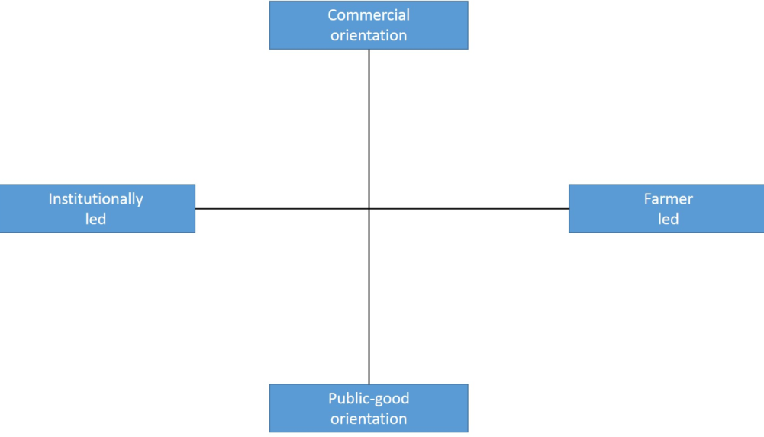
ES1

Topic(s)
- There are two main topics of the visit: Knowing the new varieties of cereals and the treatments of fungicides. The topics was selected by the cooperative and the advisor of INTIA and validated by farmers and advisors of the agrarian cooperative.How new varieties of barley can tolerate rynchosporium disease.
- How new varieties of wheat can allows us to reduce the use of rust pesticides.
- Witch new alternative crops well adapted to our environmental conditions can be profitable to increase diversification: Peas, vetch, phaba beans, etc.

Demonstration event

Visitors
The visitors were 22 professional farmers. Only one woman attended. With ages between 22 and 59 years. All of them active members of the coop and very interested in sharing their practical experiences.
This group of farmers is very representative of the cooperative. The coop of Valdorba has more than 100 current members, but between them, the 30 most professionals carry out 90% of the productive activity, being those that have constituted the action group and are in charge of organizing the trials and demonstrations.

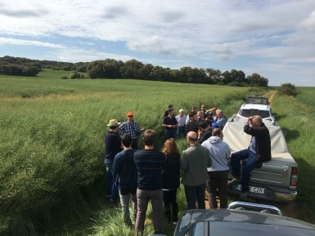

Communication & Mediation
During the demonstration there is a tour guide by the farmer demonstrative parcels and INTIA trial plots.
- Demonstrative parcels means plots where farmers apply some innovative practice, as a new variety, treatment or technique previously selected by the interest of the group. They are carried out on a real scale, in his own plots and allow to see the results of a variety or a technique in its true dimensions.
- Trials is a classical experimental instrument offered by INTIA in small plots to compare different options, as new varieties or techniques in the same environmental conditions. INTIA trials are designed in microplots, with 4 randomized repetitions to compare different theses, whether they are varieties or techniques, they are very good to compare but their scale is very small. This is a good method to start looking for solutions to a problem. Once the trial has allowed to select the 2-3 best theses, these can be passed to real-scale demonstrations with the farmers themselves.
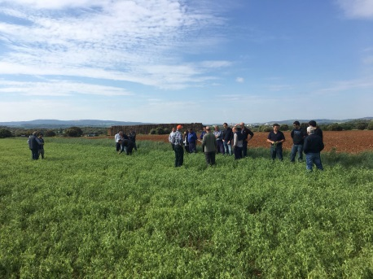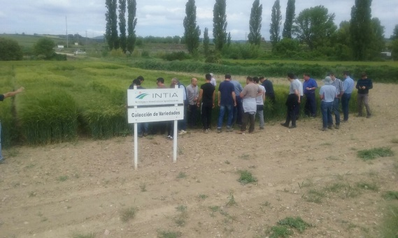
Photo 3: Farmer trial plot Photo 4: INTIA trial plot

Active participation

As they arrive, the visitors to the cooperative were asked to fill in an attendance form incorporating their signature. This form collects the email to facilitate later contact with the group. Before going to the field the facilitator (the technitians of the coop) made a presentation of the planned program and explained the context in which the PLAID PROJECT will be incorporated, with its methodology and interest to share at European level the peer learning experiences that are taking place in the demonstrations of the different participating countries. Then the group was organized to share cars and goes out to the field to start the visit. Keep in mind that farmers come to the demonstration in their own cars from villages that are between 5-20 km from the coop. For this reason, to carry out the demonstration they are asked to share cars and thus reducing greenhouse emissions.

The first visit started in to the farmer’s plots: Rapeseed (Arsenal), pea (avenger) and wheat (Nudel).
Visit pea plots: The farmer presents some data of the visited plot, especially the possibility of comparing the development of two different varieties that are being planted in the coop. The participants are interested in several aspects of the crop: the applications made for the control of herbs, the sowing dates, creating a certain debate in this sense. Late sowings are more interesting due to sanitary issues and reduction of the use of pesticides, but they have risks of being able to enter in good conditions of soil moisture in the plot, varietal sensitivity to diseases such as ascochita, influence on the health of the repetition of cultivation in the same plot. This poses a problem of need for more alternative crops if we do not want to repeat pea every 3-4 years, which is not recommended sanitarily.
Visit rapeseed plot: The whole group travels to visit a spectacular rapeseed crop plot, whose success seems to lie in the fact of its early planting in the middle of September and its fast and homogeneous growth thanks to a subsequent rain. In the debate the following aspects of interest arise: the crop is very profitable nowadays but it has problems of implantation, control of the herbs in the oilseed rape is also a problem, on the other hand, alternative cultivation such as rapeseed is necessary in the face of the problem of vallico, which is spreading in a worrying way in cereal crops, It does not seem that the variety is too critical, given the importance of good sowing.
The next visit was made to several plots of soft wheat. In relation to this crop, the cooperative seemed to be very interested in choosing varieties that tolerate diseases well, especially yellow rust. The topic of grass, especially the vallico, is very worrisome. They are having to make several applications of herbicides with high cost and not always good results. There is even concern about the emergence of resistant herbs, such as scandix or vallico, ...The variety interests that it is resistant to diseases to avoid especially the rust, although it is already incorporated the habit of treating and does not create major problems since the costs are not high. Camargo (high potential, but sensitive to rust), Marcopolo, Arkeos, Noodle (tolerant to rust), Philo, are the varieties of the coop. An interesting diversification is found for the fight against foliar diseases.

The second part to the visit was to the trials of fungicides and barley varieties. The group moved to the INTIA testing platform very close to the facilities of the cooperative, a space in which the technicians presented two barley trials, the first addressing the varietal renewal and the second the concern for the control of foliar diseases, both they were tests proposed by the cooperative.
Varieties of barley: It is proposed to farmers that before the technician presents the varieties, they themselves make a tour of the trial and try to identify which are the best from their point of view. In any case, no clear conclusion is reached as a group, with diverse opinions and little interest in defining oneself (perhaps the pressure of the group and the presence of the technicians, considered more experts, limits the positioning of the farmers). Later the technician will explain the most remarkable characteristics of each variety. Aspects of cycle, tolerance to diseases, malting aptitude, date of appropriate sowing, are those that greater interest arouse in the visitors.
Control of foliar diseases in barley. The technician began by reporting the incidence on the yield of foliar diseases in barley, usually less than in wheat. Also the control is more uncertain with the available fungicides. As the attack of diseases is under the test cannot show differences between the treatments performed.
Treatments of seed in barley for disease control. The technician presented this option as possible but with a high economic cost. Some farmers refered to the problem with wildlife (partridge) that becomes contaminated by consuming the treated grain and is causing controversy with hunters.
The last visit takes place in a Noodle wheat production field, interesting for its tolerance to rust. The farmer was very interested in showing his effort to reduce the use of pesticides, both herbicides and fungicides, looking for a more agroecological production. A certain resistance among the other farmers can be observed, because they are very used to use pesticides.

And the end of the day he whole group went to the cooperative to carried out the evaluation of the day with the Focus Group methodology within the framework of PLAID.

Doing business
The attendees could not do business between them, because all of them are farmers, no commercial participants take part in the group. But, in an indirect sense, business is the specific role of the coop representative, because they are collecting farmers needs in order to be prepared to buy new varieties or pesticides with the best relation quality price.

We must not forget that the INTIA and the cooperative technicians are also in the group and they can take note of the demands of farmers to acquire new varieties or pesticides that they can then supply to farmers (these cooperatives supply raw materials to partner farmers)

Role of sustainability
Regarding sustainability, it is interesting to highlight the debate created in the group regarding the use of fungicides in wheat to control rusts. The debate begins when one of the presentations in the field, a farmer prioritizes the choice of a variety of unproductive wheat to ensure that you do not have to use fungicides to control rust.
The most common opinion and the most common practice is to choose the most productive variety and apply fungicide treatments if you have rust problems.
This type of debate is very rich because it confronts the farmer to take a position on environmental issues and commit himself to finding alternatives that reduce the use of pesticides.

Another interesting debate takes place in relation to the problem identified with the evolution of resistant weeds (lolium spp). In this case farmers demand herbicide solutions to the industry, but this is not successful and there are no interesting new products to control this weed in cereals.
The solution comes from the diversification of crops, this being a good environmental alternative that will reduce the use of herbicides.

Finally, in the focus group at the end of the visit, there is an interest to defend the good image of the sector (social sustainability) as a group concerned with food safety that tries to reduce to the maximum the use of pesticides that could damage the health of the consumers.

Unforeseen circumstances

The demonstration was perfect and the weather wonderful. Anyway, when the coop organized the demonstration they had foreseen the possibility of bad conditions due to the rain. In that case, the first part of the demonstration was planned in the coop, analyzing the proposal of demonstrations to be visited and arranging a new date to visit the fields with the farmers (several alternative dates were possible in the following week).
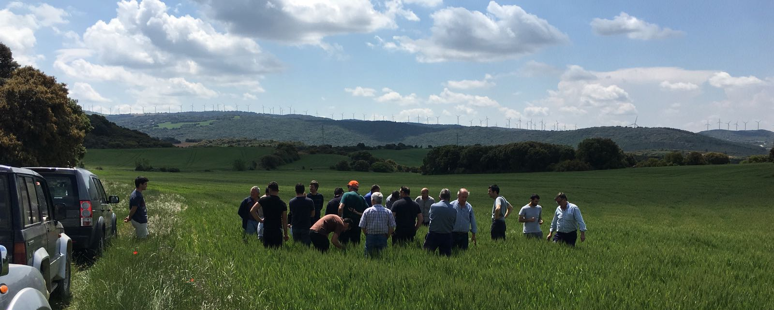

Plans vs. practice
With an experienced group like this it was difficult to maintain a scheduled programme as planned by the organisers. The experience is that the line between sharing ideas, identifying what has been learned and deciding to put it into practice is very slight.

Being a small group, the facilitator is open to any changes that may be suggested. In any case, the order of the planned visits could be managed as planned. The discussions at the field level were perhaps more disorganized and they found problems with open communication, either they did not hear well or they formed small groups and the speaker was not listened to attentively.

Perhaps in the focus group it is where the planned program was more clearly altered, it being very difficult to maintain the order planned to analyze what was learned, the anchoring and the scaling. The colloquium lacked rules and the three aspects were appearing mixed. The whole group is very open to change in relation to the new varieties, fungicides and crops, from the beginning and there is great confidence in the technicians who support this innovation, both the coop and INTIA.

.

Participants feedback
Related to the survey carried out at the end of the demonstration, the answers are in general positive:
It was well organized, and it was very interesting.
Our general impressions are good and favourable to the dynamics used. There is a need to improve the performance of disease trials. Succeeding prioritizing the choice of more sensitive varieties? The visit to real parcels of farmers of the group is very positively valued. The contribution of the INTIA technicians with the trials is very positively valued because they are the ones who contribute knowledge to carry out the practice.

Also, at the end of the demonstration day, a focus group with a small number of farmers (12) is used to evaluate the process of what has been learned, what will be able to be anchored in their farms and what they think will be able to be proposed openly to all the other farmers of the cooperative (scaling).
The problem of this focus group has been that the order of learning, anchoring and scaling, has not been possible since the beginning of the meeting. However, the conclusions that derive from the opinions of the farmers indicate that the messages have been incorporated and the willingness to change is very high on the part of the farmers attending the meeting. It may be necessary to define precisely in which way the scaling will be carried out to the rest of the farmers of the coop.

Motives, learning and networking

Reasons to attend demos
Attitudes and perceptions
In this case of study the attendees were experienced farmers.
We did a survey to answer this question: What expectations did you have before visiting this demonstration (can it be more than one)? (13 responses)
See something different Learning. Know new varieties. Learn new knowledge.
Know and learn the new varieties. The performance of the different farmers in their plots. Learn more about certain diseases and techniques for their treatment (if they are diseases that you have to observe more an evolution or it is better to treat them as soon as you see the first symptoms).Know the new varieties, share experiences and information with the other attendees. Know new effective fungicide products. Get to know the young people a little. Know some varieties of barley and clear any doubt about fungi.

In the same survey we asked them what information sources do they use to inform themselves about the issues that affect their farm? And the most common answer is internet (4 answers), and also experiences of other farmers or exchanges with farmers is fundamental, as “they can do different things, and tell you how they do them”, and in this way you value and learn from it.
The other options that exist to learn about the themes of the demonstration are the INTIA advisers, INTIA training courses, agricultural unions, the public administration, specialized magazines. To interact with other farmers there are INTIA training days, workshops of the agrarian unions, associations of producers ...
Norms
The Valdorba cooperative is very dynamic in relation to the changes in cereal varieties and pesticides used. It is open to innovation in this type of products and to share the results obtained in the field through these demonstrations and a group work promoted by the coop itself.

It is important to note that more experienced farmers play a more innovative and open role to change than small farmers who are drawn by the experience of the former.
Practicalities
Attendance at the event was planned from the begging of May (it is held the 21th of May) to facilitate the attendance of all the participants. The date did not coincide with other events.

The good dates to organize the event are rather few, since it is about getting the crops to be at the best moment of their vegetative cycle and at the same time the availability of technicians and farmers is appropriate. In practice, two weeks are available in May and therefore the date must be chosen as soon as possible.

Forms of learning
The demonstration consisted of a guided tour of the different trials plots in which the farmer or advisor used his verbal expression, accompanying the exact location so that attendees could see for themselves what he was explaining.
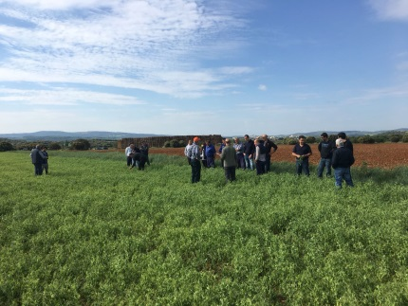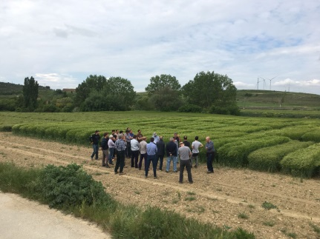

Relavant aspects can be learned by analyzing the different way in which farmers and technicians communicate, each of them contributing different values ​​and assuming different limitations.
In the case of farmers, the language is direct and simple, which allows a very fast and fluid communication with other farmers. Perhaps the greatest limitation is the lack of analysis and the consequences of the observed. Perhaps the technician could help complete the communication by providing very specific questions with this analysis of the situations presented.
On the part of technicians, communication is long and complex. Usually the technician tries to provide a lot of information and maybe the farmer cannot take advantage of everything that is being offered at that moment. In this case the farmer has to help the technician to specify and simplify the message in its fundamental aspects, demanding a summary or with precise questions.

Content of learning
The visit was structured in 2 parts, each with a different setting: The first visit started in to the farmers plots: Colza (Arsenal), peas (avenger) and wheat. And the second part to the visit was in the trials of fungicides and barley varieties of the INTIA testing platform.

The answer to the survey show that farmers learn many things during the event,
as barley varieties response to the use of fungicides, for instance, or the most significant characteristics of the new varieties of wheat and barley

Outcomes of learning
In the survey we did the attendees found the visit very interesting, and in general they see the possibility to apply other varieties.
When farmers are asked in the survey what have they learnt for their own farms, the answers show a willingness to apply what they have learned in general, especially in relation to the use of new varieties, the management of rapeseed , treatments for disease control in barley, etc.
In this type of demonstrations the product innovations are very well valuated by the farmers. The demonstration facilitates the practical knowledge and eliminates or reduces the uncertainties that are normally linked to the introduction of the new, the different, in the usual agricultural activity.

Networking
In the general survey they answered that the most interesting people they had met were experienced farmers and well informed technicians.

When farmers are questioned about networking, if they have met any interesting people in the demonstration, the answers were also positive. The dominant idea is that people have something to transmit to others and I try to learn from them, also underlining certain kind of people, interesting people with great experience, sensitive and observant, open sharing experiences.

In another line they also highlight the relationship with the technicians who bring a lot of knowledge and during the demonstration it is possible to have a very close and direct contact, without barriers to be able to ask and clarify the doubts that arise.

In relation to networking is true that being a small and stable group, does not have the wealth of novelty that can bring the arrival of new people who can bring new experiences and thereby enrich the knowledge of the group itself. In this sense, the organizers of the cooperative have seen this limitation and are considering exchanges with other cooperatives and farmers in nearby areas.

Anchoring: Application of demo lessons by participants

Anchoring related to the present demo
In general, the answers are very favourable to apply what was learned in the demo and do not have important barriers to do it.

When we ask the farmers if they are willing to apply what they have learned in their own farms, the answers are positive, they are all willing to change their varieties or the pesticides they are using because they are showing themselves to be better in the demonstrations.

Anyway, it is true that the conclusions drawn in this demonstration will later have a personalized advice service that will reinforce the conclusions drawn, confirm to each farmer that he is taking the best decision in his plots and help each one of them. they innovate in their exploitation overcoming the usual uncertainties and concerns when something new has to be done in your crops.

.

Stimulating anchoring
Every year and during the last 25 years, visits to the INTIA cereals trials are organized by zones. In addition, trips are organized to visit the trials of the GENVCE network. A special day is also held every year for the managers of the agricultural cooperatives with the balance of the cereal campaign of each year. The results obtained in the trials are available to the farmer partners of INTIA. The results of the different varieties are published every year in the journal Navarra Agraria. Annual talks are also organized in the Cooperatives with INTIA technicians to explain the results of the campaign.

Some elements are efficient to get a good anchoring of the new techniques:
- Demonstrations (Valdorba) as the opportunity to see in the parcels of other farmers the expected results of the innovation (variety or technique).
- Working and exchanging in a consolidated group, a network of farmers as in this CS.
- The support of a recognized advisory service as INTIA
- Publication of trial results
- Technical seminars and meetings in the cooperatives
- Access to the advisor

Peer to peer learning is in this case the most profitable way to guaranty a progressive anchoring of innovation, step by step, from influencers to the rest of the farmers in the coop.

Anchoring related to earlier demos
Farmers can have a global view of the effect of Demos as an strategy being largely used in the coop, so not only the specific event of this year. As it was explained before demos are part of a global innovation strategy managed by a consolidated group of farmers, planning and working together in the last years and under the umbrellas of the coop of Valdorba.

In this case of study, the transfer of knowledge made by the cooperative to its members is very important and it is carried out. We carry out this question in the online survey. Two main actors are identifies, INTIA and the coop, and more precisely the technicians in charge of these two institutions, also the farmers in peer to peer relation. Relate to instruments direct communication, the weekly visits of the technician, is the most valuable tool, but also WhatsApp (called Valdorba formation in which all the experiences are shared).

According to the interview with INTIA expert on varieties of extensive crops (interview using a ‘snowball’ technique)
,
in general in the cooperatives farmers are very interested in innovating in varieties and there is always a small group of innovative farmers who want to try out new varieties in their plots. Then the other farmers follow the innovators. The varietal renewal is very dynamic in the cereals sector (graph of the bell balance day with the evolution of cereals). The same goes for innovation in fungicides and herbicides. The role of the technical advisor is fundamental in all cases, offering a framework of security in the decisions that are taken jointly.

Related to the way farmers learnt with demos en the past years, he confirm that farmer learns more by seeing innovations in the field and recalls the images of the aspects that have most interested him, such as tolerance to diseases, good productivity, etc. It is the greatest stimulus to change in their exploitation. The support of the technicians is fundamental because they are reliable people who have been working together on the farm for many years.

Finally, focusing in the assessment of the potential role of demos in the uptake of innovation, there is a very positive answer, underlining that the demonstration has a fundamental role since it offers practical and visible solutions clearly on the ground, either in its own plots or in tests carried out in the same area of ​​cultivation. It is a very valuable instrument for farmers and technicians. The attendance at the demonstrations is high and highly valued by farmers and technicians. Innovation in varieties and pesticides products is very dynamic in cooperatives and applied experimentation has a fundamental role in this regard. Together with the advice system, they are the two pillars of innovation in this area of ​​knowledge

Scaling: Application of demo lessons by the wider farming community

Retrospective examples of scaling
The cooperatives are an engine of innovation in the cereal sector of Navarra, for its ability to promote varietal renewal and access to new plant protection products, with the support of INTIA's technical service. It is a consolidated work system in the last 40 years, with two fundamental pillars, the applied experimentation system (demonstrations are part of this experimentation system in farmers' own plots) and weekly advice to farmers ( the proximity of technicians is key to drive continuous innovation in this area of knowledge)

INTIA publishes a report every year describing the results of the cereal in Navarra . This publication is based on the results of all the tests carried out during a production cycle in the different species cultivated by farmers in Navarre. These results come to complete the information that the farmer needs to make his decisions. They are presented in technical conferences and published as indicated here.

Given that in the demonstration of our case study one of the fundamental topics has been the innovation in cereal varieties, we can present below some graphs that show the dynamism of this sector and therefore its capacity for continuous innovation. It should be noted that the varieties that appear in the graphs are in general the most recommended varieties and that the best results have been shown in the demonstrations and tests carried out, as those described in Valdorba.

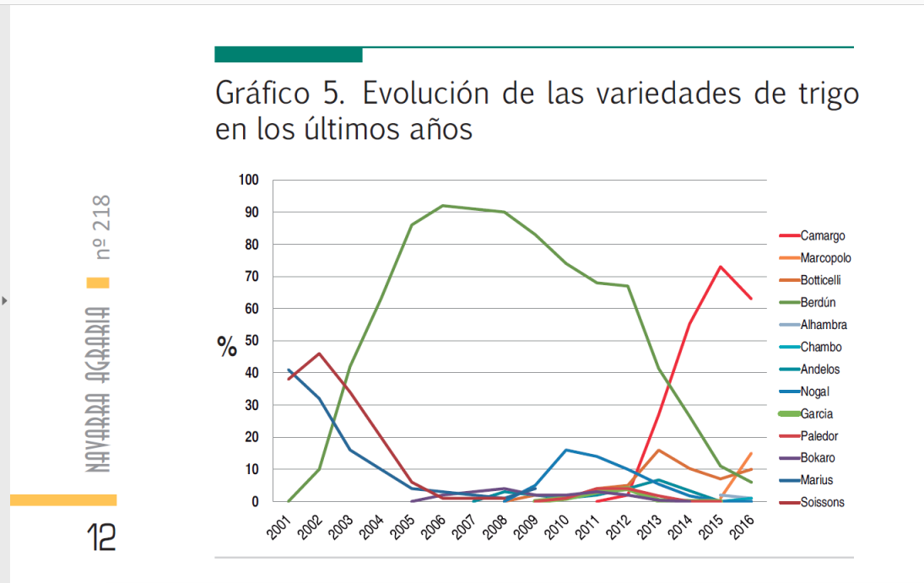
Grapf 5.- Evolution of the varieties of wheat in Navarra in the last years.

Graph 6.- Evolution of varieties of barley in Navarra en the last years.

It can also be seen that 63% of the varieties of wheat used by farmers in the year is Camargo and 77% in the case of varieties of barley is Meseta. These two varieties are the first recommended varieties for both crops. It can be taken as an example of the success of the innovation in this area of new varieties in Navarra, and the way that farmers follow the conclusions of the trials and demonstrations done, as it was explained in the case study of Valdorba.
Graph 3 Share of varieties of wheat. 2015-2016
Graph 4 Share of varieties of barley. 2015-2016

Prospective assessment of scaling: Impact pathways

The main impact pathways identified which lessons from a demo become widely shared and may influence the farming community at large are:
- Via advisory services: INTIA has a team of technicians advisers in cereals that attend other demonstrations and events and inform farmers. The most interesting tools used by INTIA are demonstrations, conventional meeting, small working groups, and direct advise.

- Via European projects: INTIA participates as a leader in several European projects, as IWMPRAISE, RustWatch, organizes meetings and visits to other European regions, in some cases with farmers.

- Via p2p contacts: Peer learning plays a key role in scaling up innovation in the region. Innovative farmers, influencers, together with their technicians, initiate the change and are then followed by the rest of the farmers in the region.

- Agricultural press and other media tools: Magazine specialized, as Navarra Agraria, that discloses the demonstrations that are made in INTIA. Also other brochures, newsletter, etc.

- Internet: The supply of information through online media is increasing, not only through the classic dissemination instruments of INTIA and companies, but also through the role played by social networks in the dissemination of good practices and the good results of innovation from one farm to another.

- Agrarian organizations: unions, networks. These are not relevant actors in Navarra, although it is important to take them into account since there are always messages that can reach farmers through their organizations. Normally, these organizations consider INTIA as the technical instrument of reference and guide their farmers in this regard. The direct advice they can normally do is based in an access to the information produced by INTIA.

Case study reflection

Demonstrations-innovation narrative
If we want to present a TIMELINE of this demonstration we have to place it in its context:
- It is a group of farmers of the Valdorba cooperative with a dynamic of collaborative work in relation to sustainable innovation in recent years, with the support of technicians from the cooperative and INTIA.
- In the last 5 years the group decides to organize and prepare demonstrations on their own plots. It also requests the participation of the coop and INTIA technicians. Intia offers the installation of trials of your interest in your own plots.- In these previous years the group has been consolidating its way of doing, through a programming of its actions throughout the agricultural cereal campaign.

The realization of the demonstration is the end point of a program of actions throughout the agricultural campaign.
- First, before the start of the campaign, in September, farmers, together with the coop, decide which new varieties they are interested in evaluating in their plots.
- The cooperative is responsible for obtaining the necessary seeds and makes them available to farmers.
- In this way a variable number of farmers install in their plots the new varieties that can be visited at the end of the demonstration.
- The group holds several work meetings throughout the year, analyzing the innovations available to solve their problems. For example, in this campaign, the most significant problems were the control of weeds (lolium) and diseases in barley and wheat.

In these meetings the practical evaluation in field in real scale in some of its plots of the innovative solutions raised by the technicians is decided.
The demonstration event in the field can be one only at the end of the campaign or several throughout the campaign. To decide this, the group identifies relevant aspects to be visited by the group and the most appropriate moment. Being a small group well communicated, visits to the field are organized with great agility.

At the end of the agricultural year (August), an evaluation and compilation of conclusions will be made, which will serve to propose the new agricultural campaign.

Facilitating and impeding factors for successful demonstrations

- We can highlight the most critical factors in the success of the Valdorba case study that concerns us:
- The theme of the demonstration is attractive to farmers. It is the key piece of the success of the demonstration, the first thing is to have something new to offer, it is not enough more of the same, because the time of the farmer is limited and has to select well what uses it.
- The demonstration atmosphere is serious and friendly. We note that this aspect is fundamental for the operation of small groups of farmers as is the case of this case study in Valdorba. Maybe it's different for big events, but working with small groups can be more effective and you need to generate that serious and at the same time friendly environment.
- The interaction between the visitors exists and is fluid. Without a doubt this is a learning since the current demonstrations put the accent on the transfer of information from the technicians to the visitors. This group of Valdorba is trying to break those barriers but still has a long way to go.
- The interaction between the attendees and the speaker is planned. This is also an aspect that needs improvement in this case study. And it is in this aspect that it is necessary to find instruments and methodologies that help the technician to connect with farmers.
- The visitors are satisfied with what they have learned. The aspects related to the evaluation of visitor satisfaction are very important, since it is the only way to learn and improve.
- Verify what they have learned and they think is applicable for them. We see the importance of seeing the demonstration in a more global context of the innovation process in which more actors and other instruments intervene. Especially the back support of the advisor is a fundamental element to guarantee the anchoring of what has been learned.

- Factors that have impeded successful organization and implementation of the demonstration activities. These are the following three groups of factors, as proposed by the PLAID conceptual framework:
The biggest limitation comes from the lack of time to devote to the preparation of the event. In the same way, the lack of methodology is another important limitation and in this sense Plaid can be very useful. Also, the lack of instruments to evaluate the impact achieved in learning, the anchoring of what was learned and scaling.

- Access (geographic, social, economic) (including gender, age, income, stakeholder groups)
Regarding access to the event, the success is that it is a small group of farmers that is already well-established and therefore very efficient in learning. Maybe the group needs to analyze how to open up to other experiences and thereby improve their access to information and learning.

- Demonstration process (methods, content, interaction form)
It is important to improve communication tools both among farmers and between farmers and technicians. In this sense Plaid will be able to offer good practices, instruments and methodologies that help improve these interactions. Also a key to success lies in the ambition with which it is raised at the topic and call level, being perhaps the best option to organize demonstration events with very specific topics and aimed at well identified groups of farmers, who have a common problem what to address

Impact of demonstrations
The impact of this demonstration is important, especially since it is an instrument added to the whole dynamic of a group of farmers for sustainable innovation in the cooperative. The group has its own dynamic throughout the year and supports its work in applied experimentation in its own plots, with which the demonstration is the most important moment of that practical learning process in the field. The technical advisors support this dynamic and contribute with trials established in the same environment close to the farmers, thus supplementing the sources of information.

· Productivity and profitability. Varietal renewal is very dynamic in this cooperative and through it is possible to clearly improve productivity and profitability, especially with the species in which there is more research on plant material such as wheat. Barley has a slower evolution and the lack of a wide range of new varieties makes progress not so evident.

· Resilience. One of the most important conclusions of the working group and the demonstration is the need to have alternative crops, especially legumes that can rotate with cereals and reduce production costs, increasing the resilience of these crops to climatic accidents It is a demand that becomes an objective of the next campaigns. The resilience of the farms is increased thanks to the application of the diversification of which we are talking about, by reducing the risks linked to the health of the crop, by increasing the productivity of crops and by reducing production costs. Of course, this can only be assessed in the mid-term of a rotation of 4-5 years, hence the difficulties for the farmer to make immediate decisions from one year to the next, often without considering the beneficial long-term effects. of good crop rotations.

· Environmental sustainability. It has become clear that the reduction of the use of fungicides is a reason for debate and concern in the working group. In this sense the choice of the variety is the best opportunity to reduce the pressure of diseases and thus the use of fungicides. On the other hand there is a great concern with herbicides and the progression of the "vallico" (grass that is generating resistance and very difficult to control). The best possible approach is crop rotation and so that is the strategy proposed by farmers to reduce the use of herbicides.

· Quality of life. The diversification of crops is the best way to improve the distribution of work and thus improve the quality of life of farmers. One of the usual problem that the farmer faces is the periods with an excess of work due to the accumulation of tasks. This occurs whenever we have a reduced number of crops. The diversification allows distributing the work better throughout the year and improving the quality of life of the farmer. Teamwork, as a group, is highly satisfactory for all of them and involves a clear increase in security and tranquility with which decisions are made when they are discussed and shared.

· Empowerment. The importance that farmers give to their own experience is very clear, as a complement to the tests that technicians do. This working group is assuming a clear increase in the personal and group self-esteem of this group.

Key lessons from this case study
- The demonstration has to offer something new that attendees can see beneficial to their interests: New techniques, be up to date, meet with other professionals, etc. We often complain that the farmers do not attend the demonstrations and we are saying that the reason may be that we are not offering really interesting and innovative things, the farmer is too busy to offer more of the same.
- The demonstration has to be organized by someone the farmer considers prepared, expert, close to their busness. The consideration that the guests have of the organizer is very important. When a farmer decides to attend a demonstration event, he hopes to find something valuable in the place or in the people who have invited him.
- The planning of the demonstration is very important and you have to dedicate time.. Perhaps the biggest problem that is usually found in the organization of demonstrations is the lack of time to do it with care and the necessary attention to detail. It is not good to leave much to improvisation. It is very important to take care of the details. A good guide will help us a lot in this sense not to forget what is important.
- It is necessary to program the demonstration from the moment in which the applied experimentation is designed to be shown on the day of the event. Count on the participation of all the actors from the beginning. Do not improvise the day of the event.
- It is very important that the trials and demonstrations in farmers' plots are well chosen in relation to the solution of problems that are intended to be addressed and then presented in the demonstration. It is not advisable to prepare the demonstration with any type of trials that we have at hand, but it will only make sense if it is responding to a real concern of the farmers who are going to attend the demonstration. Integrating the contribution of technicians with the contributions of farmers is highly valued by the entire group.
- We need to find instruments that facilitate communication so that all farmers can express themselves. In the demonstration that we have analyzed in this case of study, no instrument has been used to facilitate the work of communication. This can be an interesting contribution of the Plaid methodology to the organizers of demonstration events.

Acknowledgements

We want to thank Cooperative Valdorva, especially Rafa Leon, for the hosts of the demonstration which always lend themselves to collaborating with INTIA, in all the novelties that we propose. To our colleagues of INTIA, Javier Torrecilla, the advisor of the agrarian cooperative of Valdorba in Navarra. I also want to thank Boelie Elzen and Frank Wijnands as direct responsible for the work methodology that we have applied in this task, together with the entire Plaid team. And, finally Anda Adamsone, for her valuable contribution in the revision of this report.

Annexes

Data sources
- https://www.intiasa.es/es/
- https://www.navarraagraria.com/item/1234-campana-de-cereales-2015-2016
- Article Navarra Agraria magazine nº 218.

Data collection methods
- Notes write down by the observer in the de demonstration
- Questionnaire on-line sent after the demo. It was offer to 20 people and 13 responses were collected.

1. Gender: Man, Woman?
2. Age?
3. Location and province in which you reside
4. What expectations did you have before visiting this demonstration (can it be more than one)?
5. In which part of the visit have you learned more? What have you learned?
6. What have you learned more interesting for your own exploitation?
7. Do you have possibilities to apply it? What barriers or difficulties do you have to apply it?
8. What changes have you made to your farm in the last 4 years: integrated pest management, Varieties, Alternative crops?
9. What are your plans on how to use the information received during the visit?
10. How is the knowledge dissemination carried out in the cooperative?
11. What other sources of knowledge do you use to inform you about the issues that affect your farm?
12. What part of the visit did you like the most?
13. Do you think the view is well organized? How would you improve the next visit?
14. Have you met any interesting people in the demonstration? Because it's interesting?

- Interview with the expert in cereals varities of INTIA.
- Focus group activity

What aspects have you found most interesting in the demonstration?
What have you learned concretely in this demonstration day?
From what you have learned, what things do you think you can apply already in your farm? What barriers prevent you to do that?
Of all these things learned, what do you think that can be proposed to other farmers in your area or extend to the whole cooperative?

