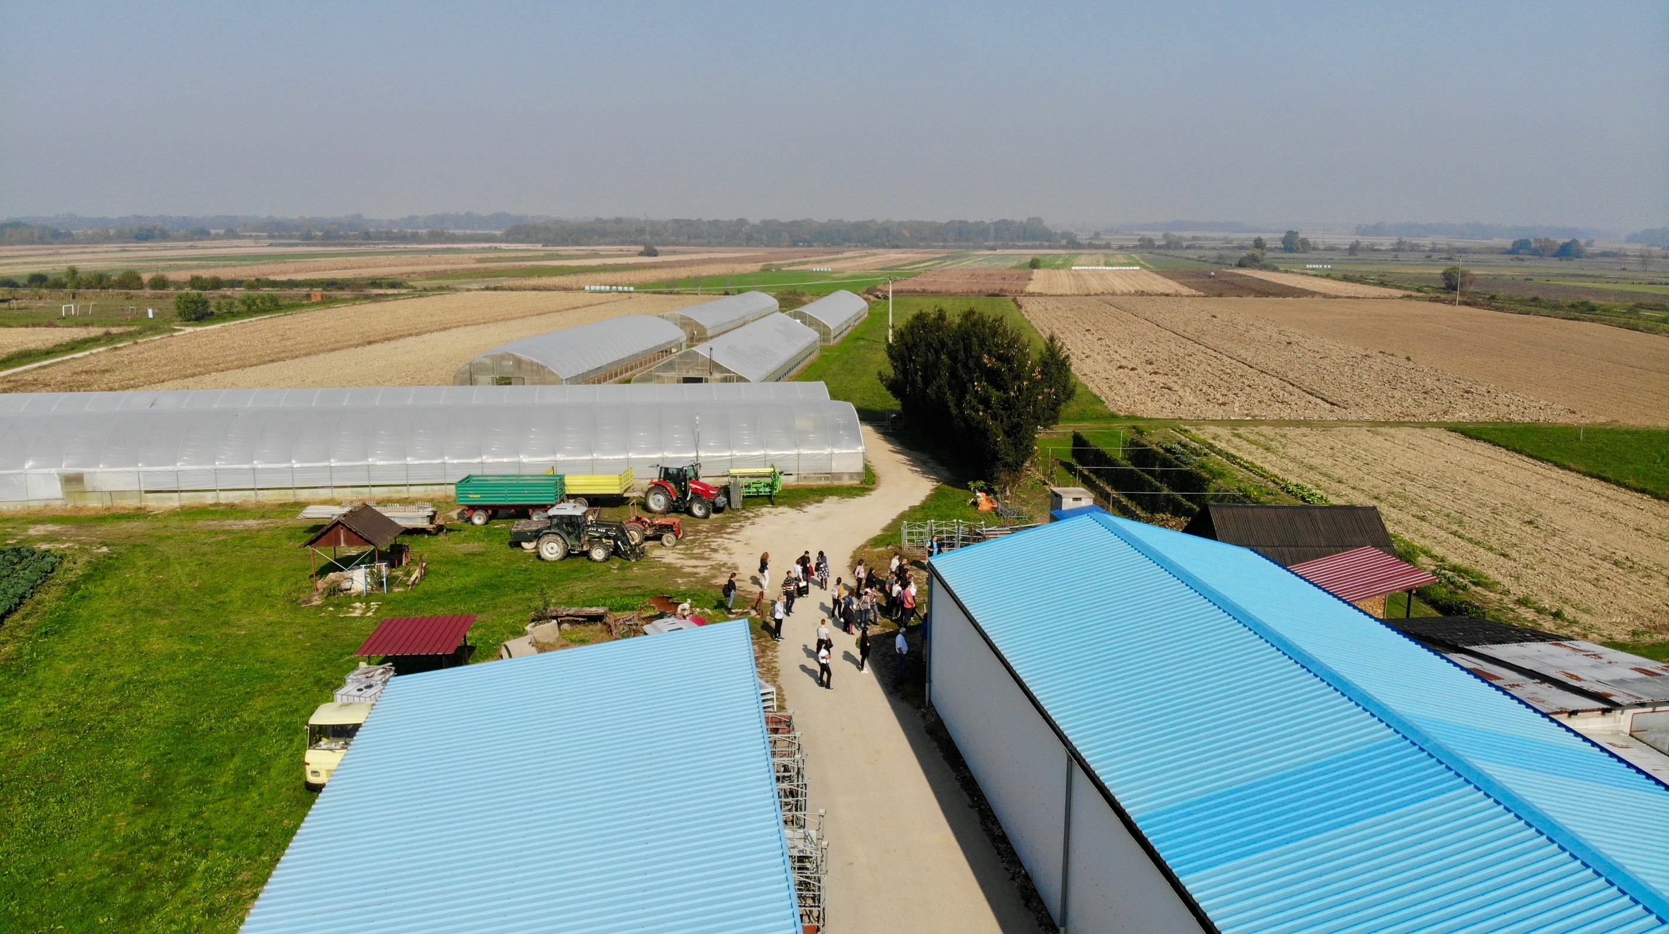

Date: December 2018

Country report: Croatia

Case Study: CRO 3 – Young farmer in glasshouse vegetable and seedlings production

WP5: Case studies of demonstration activities in commercial farms

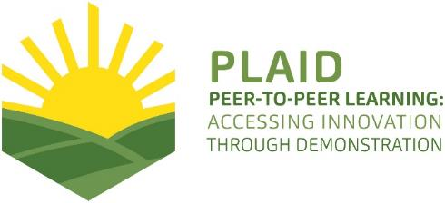
This project has received funding from the European Union’s Horizon 2020 research and innovation program under Grant Agreement No 727388

PLAID PARTNERS

Croatian Agricultural Forestry Advisory Service CAFAS | 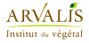  ARVALIS Institut du Végétal | Association de Coordination Technique Agricole ACTA
Institute for Rural and Regional Research | Chambers of Agriculture | Delphy
European Forum for Agricultural and Rural Advisory Services EUFRAS | Innovatiesteunpunt ISP | Institut de l’Elevage – Idele
Instituto Navarro De Tecnologías E Infraestructuras Agrolimentarias | Linking Environment and Farming LEAF | 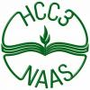  National Agricultural Advisory Service
Nodibinajums Baltic Studies Centre (BSC) | Research Institute of Organic Agriculture (FIBL) | Stichting Wageningen Research
The James Hutton Institute | VINIDEA

DOCUMENT SUMMARY

__________________________________________________________________________________
Milestone Title: 24 Case Studies
__________________________________________________________________________________
Case Study Title: CRO 3 - Young farmer in glasshouse vegetable and
seedlings production Croatia
__________________________________________________________________________________
Version: 1.3
__________________________________________________________________________________
Task Lead: WUR
__________________________________________________________________________________
Related Work package: WP5
__________________________________________________________________________________
Authors: Kristijan Jelakovic, Milan Husnjak, Aleksandar Horvatic,
Matija Cabrajec
__________________________________________________________________________________
Grant Agreement Number: 727388
__________________________________________________________________________________
Project name: PLAID
__________________________________________________________________________________
Start date of Project: January 2017
__________________________________________________________________________________
Duration: 30 Months
__________________________________________________________________________________
Project coordinator: The James Hutton Institute
__________________________________________________________________________________

ABSTRACT

The demo on family farm Grunt specialised in vegetable seedlings and fresh vegetable production was organised and led by the farmer in close collaboration with the faculties and collage. Mutual experience exchange and knowledge dissemination in integrated and glasshouse production including best integrated and glasshouse production practises and problems were demonstrated in very educative and practical way. The targeted visitors were students of agriculture, with emphasis on student young farmers.
The case study shows that a good demonstrator with pedagogical skills can play a significant role in successful demonstration. Interested audience in good atmosphere enables demo to play a role in decision making and learning. Small group work is better for specific topics such this was. Weather conditions can play a significant role in demonstration planning and realizing. Video recording is a good practice for analysing materials and in depth analysis. Methods used in demonstration play a major role in demo success.

TABLE OF CONTENTS
1 Demo context 6
1.1 The value chain 6
1.2 Typical farm characteristics 6
1.3 AKIS 6
1.4 Sustainability challenges 7
2 Demonstration summary 7
3 Governance: set up and organisation 7
3.1 Organisers and history 7
3.2 Funding 9
3.3 Host 9
3.4 Gender 9
3.5 Objectives 9
3.6 Topics 10
3.7 Access 11
4 Demonstration event 11
4.1 Visitors 11
4.2 Communication & Mediation 12
4.3 Active participation 13
4.4 Doing business 13
4.5 Role of sustainability 14
4.6 Unforeseen circumstances 14
4.7 Plans vs. practice 14
4.8 Participants feedback 15
5 Motives, learning and networking 15
5.1 Reasons to attend demos 15
5.2 Forms of learning 16
5.3 Content of learning 17
5.4 Outcomes of learning 18
5.5 Networking 18
6 Anchoring: Application of demo lessons by participants 19
6.1 Anchoring related to the present demo 19
6.2 Stimulating anchoring 19
6.3 Anchoring related to earlier demos 19
7 Scaling: Application of demo lessons by the wider farming community 20
7.1 Retrospective examples of scaling 20
7.2 Prospective assessment of scaling: Impact pathways 20
8 Case study reflection 20
8.1 Facilitating and impeding factors for successful demonstrations 20
8.2 Impact of demonstrations 21
8.3 Key lessons from this case study 21
9 Annexes 22
9.1 Data sources 22
9.2 Data collection methods 22

Demo context

The value chain
Croatia is a geographically diverse country, divided in two regions (NUTS2): Continental and Adriatic Croatia. This determines completely agricultural production. In Continental region there is intense production of grains, vegetables, fruits, grapes, dairy and meat cattle, and pigs (except for the mountain areas; grazing livestock). In Adriatic region are Mediterranean cultures (olives, fruits, grape), vegetables, sheep and goats, categorizing small farm size.
Vegetables production is represent in both regions by the numerous of small producers, family farmers who produce vegetables on open fields or in greenhouses. The variety of cultivars are spread from the commercial standards to the more traditional and local cultivars. The less developed vegetable producers are producing vegetables on open fields mainly for own consumption, and they represents more than half of vegetable producers. The commercial orientation of thus farms is limited, so they are selling only the surpluses. Commercial orientated farmers are producing vegetables mostly in greenhouses by using the quality seed and seedlings, are on the higher level of specialization and on the higher level of revenues (DMLA).
In general, tradition of selling fresh vegetables on the local markets in the village or the city centre characterize the small family farms. To change a trend, and to increase the farm size, one of the most important factor is education of young generation of farmers and/or students in agriculture.

Typical farm characteristics
In Croatian farm structure half of all farms are small family farms with less than 2 hectares of utilized area, and the same situation is in horticulture type of farming, where more than half of the farms are small farms. Vegetable production represents only 1% of utilized area and 2% of total output in Croatian agriculture. Vegetables production in glasshouse covers 48% of the farms in horticulture type of farming, usually led by family farms which are characterised by a high level of professionalization. The biggest challenges in vegetables production is connected to the selection of quality seed and seedlings, cultivation technologies (especially in controlled conditions such as greenhouses), harvesting, storage capacity and management, as well as vegetables packaging.
Moreover, the market orientation and the quantity of vegetables produced highly depends on the possession of knowledge and the level of technology used. On the other side, the level of basic education in Croatian agriculture is rather low. The population of small farms is characterized by low level of education in agriculture, where most of them have no agricultural education at all (DMLA). The number of students who have completed education and who continue to deal with agriculture after graduation is unknown.

AKIS
Generally, AKIS in Croatia is very fragmented and disconnected so it is still not really possible to talk about the system. Vertical and horizontal cooperation between stakeholders in generating and transferring agricultural knowledge has not yet been perceived as a single system. Cooperation is largely not institutionalized. Most often, it happens at the initiative of more engaged individuals from various scientific and higher education institutions, professional organizations and rarely by the farmer organizations.
The PRO-AKIS project was not implemented in Croatia because at the time of the implementation of projects Croatia was not yet a member of the EU. EIP-AGRI in Croatia is not yet in implementation. In February 2018, a procurement for Measure 16.1.1 „Support to establishing Operational groups“ was announced for applied research and development measures for mitigation and adaptation to climate change in order to improve agricultural production, breeding, quality and soil fertility or to strengthen the resilience to changes of agricultural systems with the advanced use of new technologies or alternative production systems, and the increase of biomass production in agriculture and its use as well as use of other biomass produced on farm. Measure 16.4. Short supply chains and local markets is in preparation phase.

Sustainability challenges
The importance of family farms in Croatia is significant. From 180.000 farms in the farm register, 97% are family farms and they are using family members’ resources to produce and offer agricultural products on common market. Most of the national strategic plans for agriculture in recent 20 years describes family farm as the nucleus of agricultural production in Croatia, strategic organizational form important for achieving sustainable development, achieving the principle of food safety, preserving natural resources and enhancing and increasing the competitiveness of agricultural sector as whole. Also, this organisational form encourage young people to stay on land and find agriculture as business opportunity.
More than half of all family farms are small farms characterized by fragmented production units (plots) with the average size of utilized area below 6 hectares and low level of agricultural education (DMLA).
The challenges in agricultural production on family farms are close connected with the level of education, type of production, cultivation technologies, market orientation, experience and access to new knowledge. Provision of accessible extension services, trainings and education, among others, increases comparability and competitiveness.

Demonstration summary

Family farm Grunt is led by Vladimir Bais, a young farmer who has production on 6 hectares in open fields and 4.000 m² of glasshouse production, produces four million of the most varied vegetable seedlings and one thousand tons of vegetables annually following the principles of integrated production. Production of quality seedlings in shortest time with required mechanization, glasshouse specific production, sustainability in glasshouse production, principles of integrated production and market were the main objectives of this demonstration.
Main topics were to demonstrate seedling planting robotic system, germination of seedlings in germination chamber, seedlings “over nosediving” and glasshouses specific production. Mutual experience exchange and knowledge dissemination in integrated and glasshouse production including best integrated and glasshouse production practises and problems were demonstrated in very educative and practical way (EAIO).

Governance: set up and organisation

Organisers and history
Family farm Grunt is located in North-western part of Croatia in small village Imbriovec Jalzabetski near Varazdin.
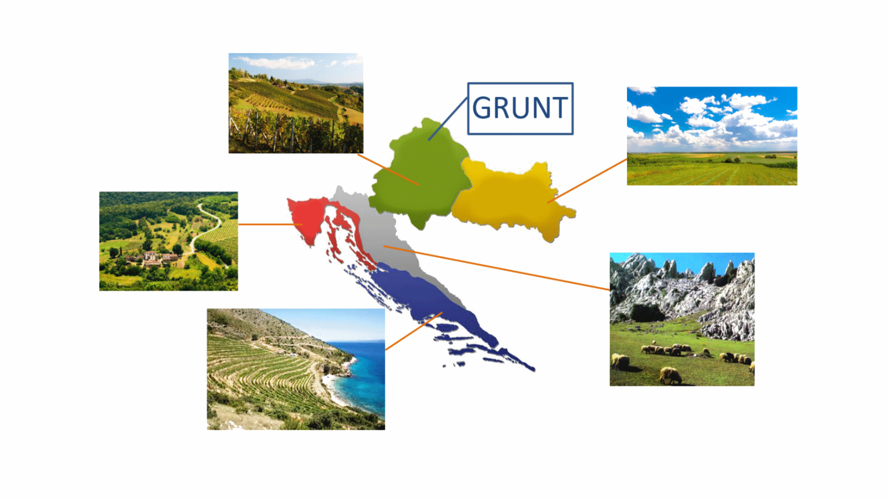
Figure 1: Croatia production regions and family farm Grunt location

Family farm Grunt has decades of tradition in agricultural production, but first significant modernisation dates back to the sixties when the first generation of Bais family and as first in local community bought tractor and started with significant land cultivation. During the seventies they started primarily with livestock production and peas and hot pepper production as a cooperative for local processing company.
The second generation of Bais family started to modernise and enlarge the family farm. As the number of cattle has grown, they increased the utilized area and realized they could grow various vegetables that were not represented in the area at the time. In the 1990 they started with cucumber and paprika production, and later focused their production entirely on vegetable. The third generation of Bais family with agricultural university level education and capacity for innovations, due to the problems with seedlings procurement (price and quality were not satisfying), they invested in glasshouse seedlings production in 1998 with one glasshouse. In the next year’s production has rapidly grown and they built five new glasshouses and large cooler space for storage. In addition, they bought new mechanization including seedling-planting robot. Nowadays, they are pioneers in seedling production with high innovation systems and integrated vegetable production.
The third generation of Bais family in close collaboration with the advisory service initiated demonstration 20 years ago. First demo activity were just simple presentation for farmers who had a similar production or showed interest for glasshouse production. As the first demonstration were successful, faculties and colleges showed an interest for practical demonstration for students. Further on, as the glasshouse production has grown, so has the interest for demonstration, because they are one of a few successful seedlings producers in whole country.
Even though there is no written data available, according to verbal information from the manager and his father, family farm Grunt hosts up to 10 demonstrations annually. With years of experience in organizing demonstrations and good cooperation with advisory service and faculties, this demonstration is in annual work plan and students curriculum (EAIO).

Funding
The event is organized for participants with no participant fee or paying. In addition, the farmer provides food and beverages for participants on his own cost. For participants everything was free of charge. When asked how is this profitable for him, he answers that demonstration has no price regarding knowledge exchange and he hopes that he will encourage demonstration participants with his good example to be successful in agricultural production (EAIO). Co-organisers from faculties and college organised bus transport for students.

Host
The demo was held on family farm Grunt led by the manager, Vladimir Bais. Demonstration farm type is commercial, but one could say that this family farm works also for public good. The part and full time workers comes from the neighbourhood. Vladimir is recognised as a “good farmer” by the co-organisers because he has practical and vocational education in agriculture, manages to increase production over the years and also is open-minded to innovations. In addition, he is a young farmer speaking foreign languages (English and German) and participated in dozens of demonstration activities all over the Europe. Demonstration is organised by Vladimir and co-organisers faculties and college from Zagreb and Krizevci. Vladimir showed a keen sense in methodological part during demonstration activity knowing how to present his seedlings and vegetable production in best possible way by including participants in each demonstration stage. Participants were able to experience how to handle a planting machine, planting seedlings, glasshouse maintenance and vegetable handling.

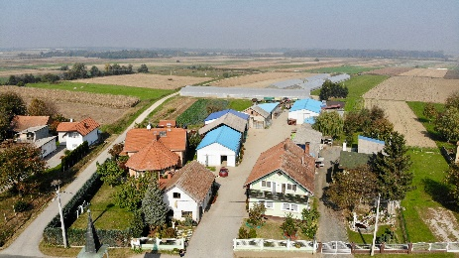

Figure 1: Family farm Grunt in Imbriovec Jalzabetski

Gender
The demonstration was fully commissioned and organised by men. Also the speaker was men. Women was responsible for organising the transportation for students.

Objectives
The main objective was to demonstrate production of quality seedlings in shortest time with required mechanization, glasshouse specific production, sustainability in glasshouse production, principles of integrated production and market.

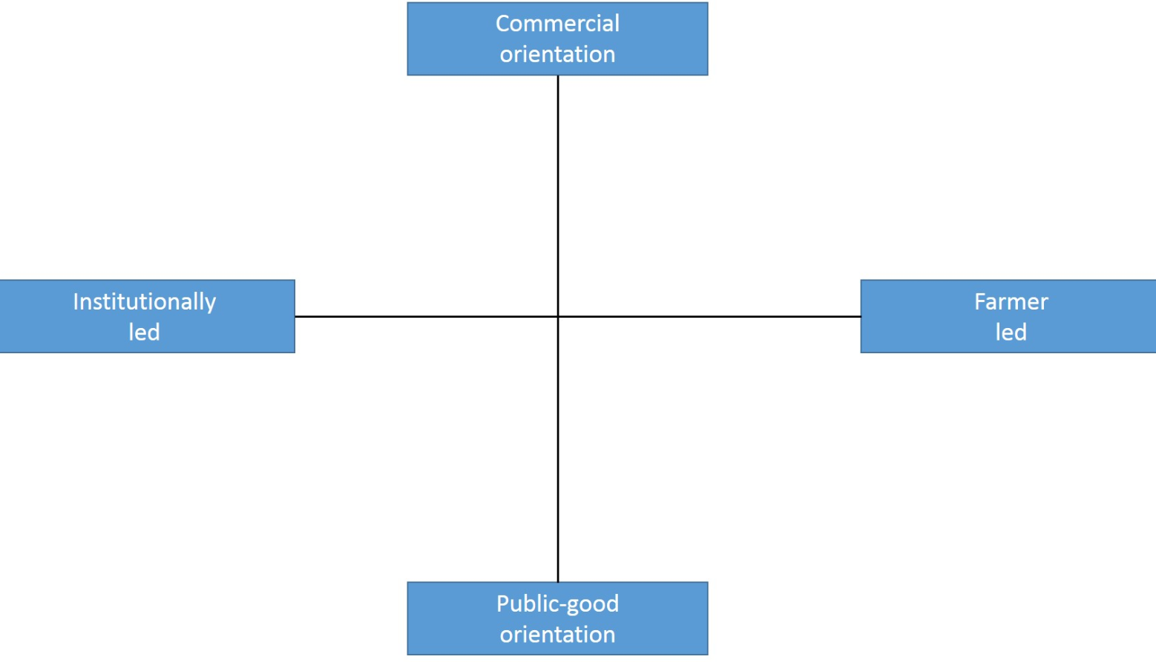
CRO 3

Figure 2: Positioning of the family farm Grunt in the PLAID typology for demo focus

This demonstration was farmer led and had commercial orientation, but also public-good because farmer is willing to exchange experience and knowledge with all parties interested in specific production. The population of farmers in Croatia generally are not used to initiate and organize demonstration activities on their own. Nevertheless, in close collaboration with the advisors, other institutions and commercial companies, farmers are willing to provide their production resources, time and experience in organizing demonstration activities. So, demonstration activities in Croatia are less farmer led, but more led by the farmers in close cooperation with others (DMLA).

Topics
This topics were very concrete with the demonstration of seedling planting robotic process, consisted from styrofoam container, substrate filling, hedgehogs for seedlings impression, pneumatic seedlings machine, Vermiculite top dressing roller on styrofoam containers, watering the container, and palletizing of seeded containers. Second stage was to show germination of seedlings in germination chamber. Seedling production before seedling “nosediving” requires specific conditions and high control of microclimate in glasshouse including exact amount of light, temperature, air humidity and substrate for seedling production. Seedlings “over nosediving” is processed in electro-pneumatic machine depending on type of container and seedling variety. Afterwards, seedling production moves to glasshouse in plastic jars raised above land in accordance with required phytosanitary conditions (EAIO). Apart from seedling production, the participants saw how to plant a seedling in the glasshouse and all other aspects of integrated vegetables production, from planting, cultivation, use of machinery and equipment, cleaning, packaging and storing the fresh vegetables.

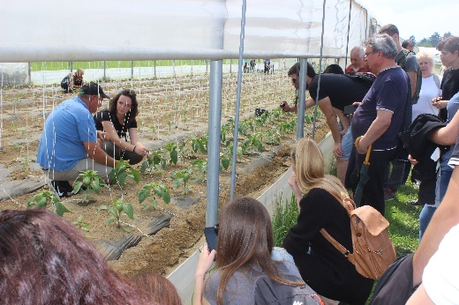
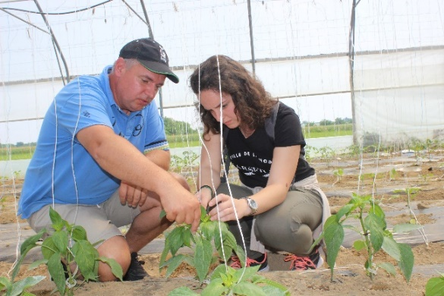

Figure 3 and 4: Young plants in greenhouse, young farmer and student

Access
The target group included students from faculties and collage, their professors and advisors from the region who got insight into the practical side, experience exchange and knowledge transfer in integrated and glasshouse production. Moreover, the sub group of the students were the students who are family farm members, young farmers or the students who are willing to take over the farm after graduation.

Demonstration event

Visitors
Originally, demo was supposed to be held in one day for students of agriculture from Zagreb and Krizevci, but co-organizer professors couldn`t arrange dates, so first demo was organised for students from Zagreb on May 23, 2018. This was smaller group contained only 17 third-year students who shared their interest to attend this demo. Second group of 46 students from Krizevci College attended demonstration on May 29, 2018 containing all third-year college students. From this group, eleven students were also young farmers involved in agricultural production at their family farms and they were in focus of our observation. All students were younger than 25 years of age. 38 were female students and 25 male students. We asked professors Nina Toth and Tomislava Peremin-Volf about gender balance among students at the College and Faculty, and they answered that in last few years there has been increasing number of female students, so now traditionally “male” College and Faculty of agriculture are dominated by over 60% of female students.

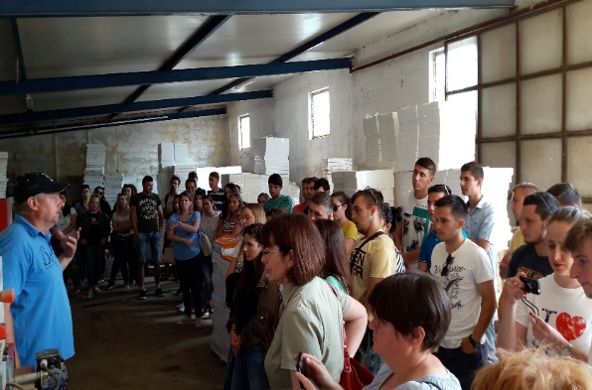
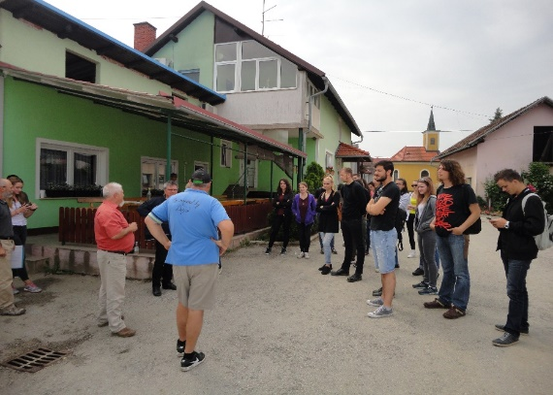

Figure 5 and 6: Faculty of Zagreb group and Krizevci College group

Communication & Mediation
Communication at the demo was very good at both demo invents. At the beginning Vladimir as host, demonstrator and speaker welcomed groups from Zagreb and Krizevci offering them with welcoming drink. He shook hands not only with professors, but also with every student. He introduced himself, announced topics and expected duration of demonstration for about two hours. Also, he mentioned that PLAID team will observe this demo, and gave us opportunity to represent PLAID and our role in this demo. We asked all of participants to sign photograph, video and audio recording consent form. In demo preparation phase, PLAID team informed speaker and professors that we would ask them to sign this consent, so there were no problems with signing. PLAID team members were following demo participants and collecting their impressions, observations and interaction (PO). We tried not to be intrusive, just to encourage participants to discussion and interaction with asking them about their impression.

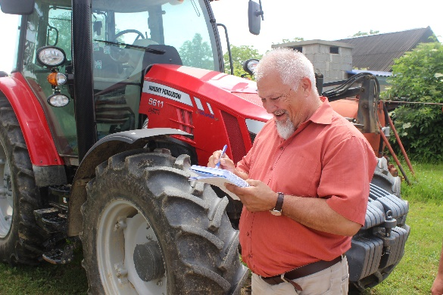
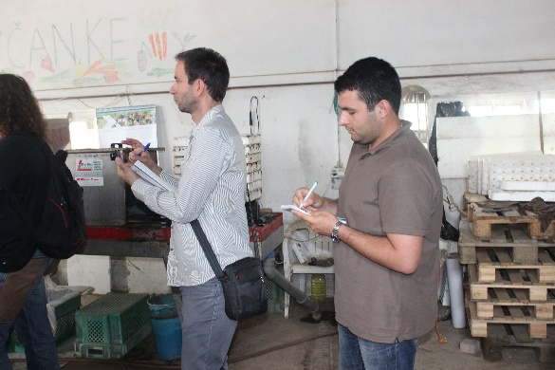

Figure 7 and 8: Collection of impressions and participants observations

Most of the demo was speaker frontal presentation, but with numerous of examples and experiences from seedling and vegetable production. Speaker demonstrated not only good experiences, but also some mistakes from the past and learned “how not to” do some things. Speaker also encouraged students to ask questions, so communication was not only one way direction but in reciprocity. Students were able to try handling with a planting machine, planting seedlings, glasshouse maintenance and vegetable handling. More interesting for male participants was machinery demonstration and more interesting for female participants “soft skills” in glasshouse production.

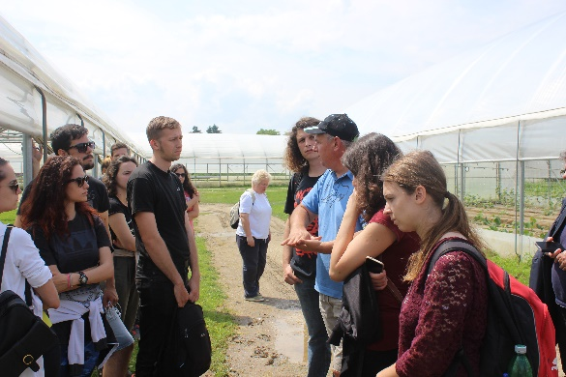
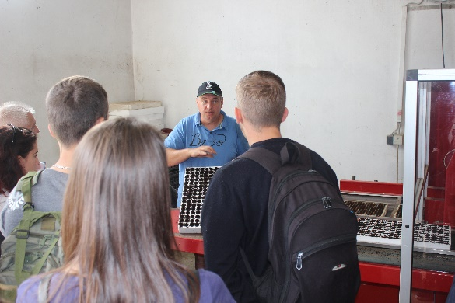

Figure 9 and 10: Different stages of demo activity (“speaker in action”)

Active participation
As there were two groups of students, there is a good background to compare the same demonstration with similar but also different group type of participants. Smaller group from Zagreb showed much more interest for demonstration than larger group from Krizevci. That is quite understanding regarding situation that Krizevci student group “had to” attend the demo due to their curriculum. Professor from Faculty of Agronomy from Zagreb Nina Toth said that in last few years they prefer to have a group of students who express their interest for this demo, rather than all of third-year students. She said that this practise showed good results because students were more active at the demo, participated with large interest and had better knowledge in this topic at final exams. Also the “discipline” at the demo is much better and students are more focused on the demo topic. When asked to experience demonstrated for their own, students accepted Vladimir’s proposal and were excited doing that, but in group from Krizevci, no one of 46 students was willing to try this.
In larger group at the beginning of the demo, the “discipline” was good, but as the demo day developed, several smaller group of students formed, they started to walk around and chat about topics not related to the demo. When asked if this topic is not interested for them, they answered that everything is interesting and Vladimir is a good demonstrator, but they decided that they heard enough for their own opinion (PO). Of course, there were a few students in larger group that were near the speaker all the time and actively participated in demo by asking questions and discussing with other students, but not so much as smaller group from Zagreb. Nevertheless, atmosphere in Krizevci group was better, there were more laugh, and everybody was more relaxed. This could be explained that Zagreb group were more focused and didn`t want to miss some relevant information.

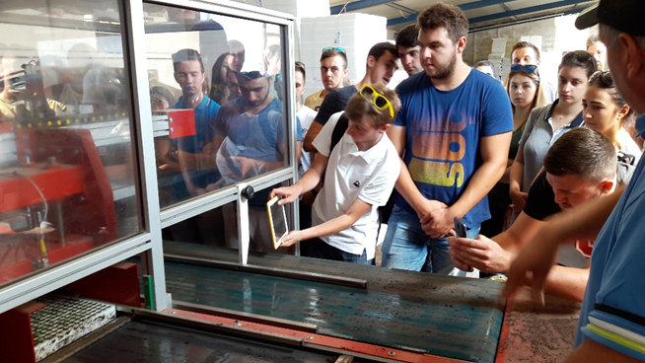

Figure 11: Students taking photos and notes during demo

Doing business
There was no direct possibility to “do business” but two students arranged their student practice at this demos in family farm Grunt, so one could say that some business has been done. Also, there were no stands of agricultural machinery companies or other companies at the event.

Role of sustainability
The event addressed various issues related to sustainability. Students were explicitly and actively confronted with sustainability aspects of seedling and vegetable production. Most of the questions from students were connected with economic benefits of his production. Also, they wanted to know how he manages to obtain sustainability in production. Vladimir secret is in “small steps”, he`s not aiming to ambitions he cannot realize in production, but is evolving in close connection with market demands and his own production possibilities with emphasis on environmental preservation. The location of the farm is in a small village were the people are hardworking, so at the farm works four long-term and up to 20 seasonal employees from the neighbourhood enabling economic and social stability for the residence. Environmental aspect is in implementation of the principles and measures of integrated production, even if the profit is lower than in conventional production.

Unforeseen circumstances
The weather can play a significant role in demonstrations and this was obvious at this demo events. First demo was held day after raining, temperature was optimal and sun rays were not too strong, so even when we were at open field, there were no problems for all of the participants. Second group had a different weather conditions, temperature was about 29° C and air humidity was high, so students were looking for shade.

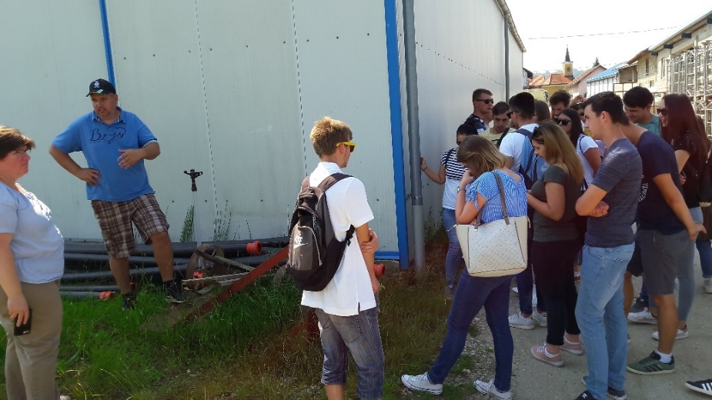

Figure 12: Students hiding in the shadow behind cooling chamber

Plans vs. practice
Generally, this demo event was well organized and clearly structured. It was obvious that this was not the farmer’s first demonstration event and he gain a lot of experience from previous years. Demo set-up and demo event were realised up to everything arranged except for two details. As mentioned before, demonstration was supposed to be held in one day but co-organizer professors couldn`t arrange dates. Also, with expected duration of demo for two hours, second demonstration was a bit shorter because demonstration on open field was interrupted due to higher temperature. Expectations and objectives of the organisers and participants were fulfilled (EIP).

Participants feedback
In short exit interview with participants after demo, we asked students about importance of this demo for them and did they think this demo could have benefits to them. Most of them answered that demo was good organised and they could have benefits, even just in exams preparation. Some of them who are young farmers found some ideas that they could potentially try to implement on their own farms (EIP). Two students expressed interest to obtain their student practise at this family farm, and the manager really liked this idea and arranged details with them so they had mutual benefits from this demo.

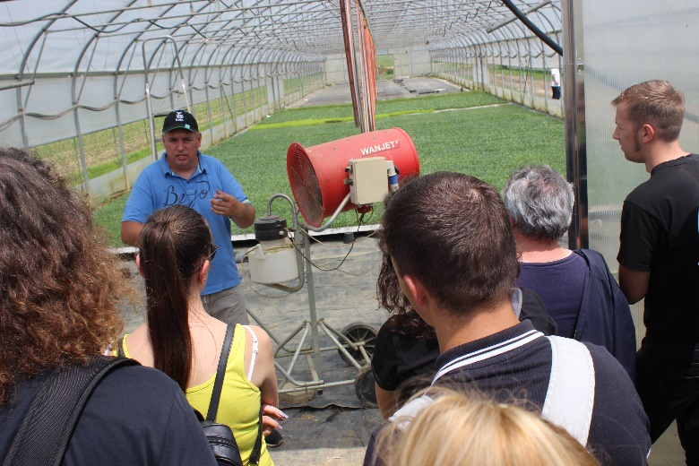

Figure 13: Participants listening to a session

Motives, learning and networking

Reasons to attend demos
Attitudes and perceptions
In prepared questionnaire, students were asked to answer weather they have participated to other demonstrations other than this demo. This demo was specific because it was obligatory for students from Krizevci. We have focused on students young farmers who answered that they have been attending more demo events in the past. Answers were similar and included importance to attend demos for knowledge exchange, meeting other farmers with similar production and exchange of ideas for innovation. Other members of their farms have attended some demos in the past depending on topic of the demo and amount of work on their farms. All of them answered that they have “googled” most of things before attending demos, but also gathered new information on demos. We also asked the interviewees how important is the knowledge exchange with other farmers is to them. Most of the respondents said that it is very important. They also added the importance to participate on manifestations, fairs, and vocational lectures organised by farmer associations and stakeholders (EIP).

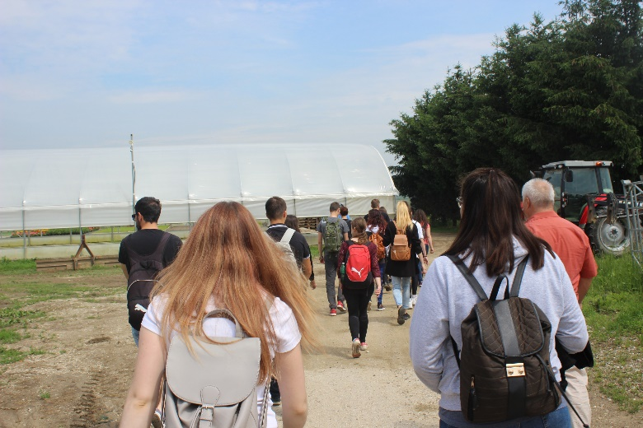

Figure 14: Participants walking from to the next session
Norms
When we asked the participants about the level of information they would appreciate at such an event, respondents stated that this family farm is a good and representative farm and demo showed prosperity, good governance and sustainability of his farm. When we asked if they would recommend other farmers to attend demo at this farm, all answers were affirmative. For several students who showed their interest to attend demo, other students who were at this demo before, played a role in their decision to attend this demo because their recommendation was to attend this demo if they can (EIP).

Practicalities
We asked the students about the most practical or important reasons why they can or cannot attend events such as this. Most of the respondents said that everything was free of charge for participants, organised transport, and no participant fee. When asked if attending the demo would make a difference on their farms, students answered that they cannot answer this yet (EIP).

Forms of learning
Most of the participants were students from the faculty and college, and the sessions were mostly dominated by a one-way communication from speaker to participants. The speaker led demonstration as a good lecturer using frontal presentation and information provision in glasshouse and on open fields. Participants were actively engaged in some parts they found appropriate and speaker encouraged them at several stage to try for their own what he demonstrated. At some smaller part of the demo “learning process” took place in one-way communication, but at most of demo it was interactive (PO).
At first demo level of interactivity was higher than at second demo. Speaker’s diction and vocabulary were very appropriate with a lot of practical examples. Information was presented to the participants in a very simple but understandable way with practical presentation. Peer to peer learning was represented at this demo because students learned from the speaker, but speaker was also asking questions for possible problem solutions and ideas for business improvement (PO). Gender difference was noticeable for some topics. When heavy machinery was presented, male participants were the first in the row, walking around machines and asking question. When asked to try planting, the first that applied for the task was female participant, while other male students stood back. Female students showed more interest for plant handling.
Learning styles:
- Auditory: Speaker showed machinery operations that was quite noisy
- Verbal: Most of the demo was verbal exposure in speech, some students were taking notes
- Physical: Students were able to try handling seedlings and plants by hands, and were asked to smell some specific seedlings for recognition. Also they had opportunity to handle with machinery.
- Logical: Host occasionally asked students questions what do they think about some possible solutions or to connect information for different production stages.

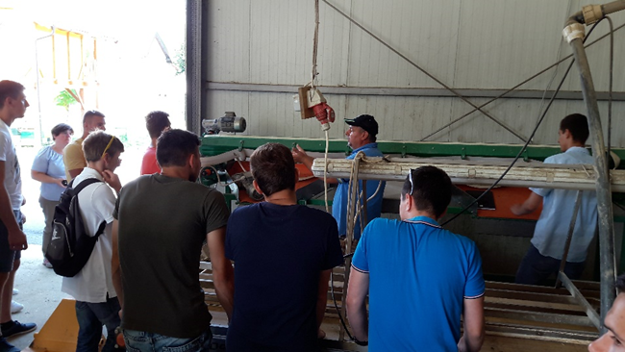

Photo 15: Machinery demonstration – more interesting for male students

Content of learning
The information and knowledge offered at the family farm Grunt was quite specific and partially ready to use at the farm level (EAIO). Information provided by the speaker were concrete with no redundant materials. As the topics were specific, information were also concrete but demonstrated in comprehensive way. Whole seedling production process and the importance of seedlings for vegetables production in glasshouse and on open fields was considered applicable on their own farms (PO).
The demonstration of the technology used (machinery, irrigation system) played an important role in the demo (PO). The speaker also addressed the question for which type of farms such a machinery is worth investing in (medium or bigger horticulture type of farms) or for which it would make more sense to hire a contractor (small farms). This session, included a real life demonstration of an agricultural practice as well (EPIO).
It can be stated that the presentation of the process of seedling production were focusing more on presentation and the importance of quality seedlings for vegetable production. It was very theoretical including a lot of background information and little demonstrative elements, and the practical relevance was rather low (EIP).
The demonstration included not only the practice and principles in seedling and vegetable production but also information on the broader context and current market developments. How to wash and clean fresh vegetables and prepare for the market helped the participants to identify the relevance of the demonstrated approaches (EPIO).
In terms of novelties, the speaker stated that only a small number of the participants are real farmers, so the demonstrated innovative solutions were not recognized or discussed more detailed (EPIO).

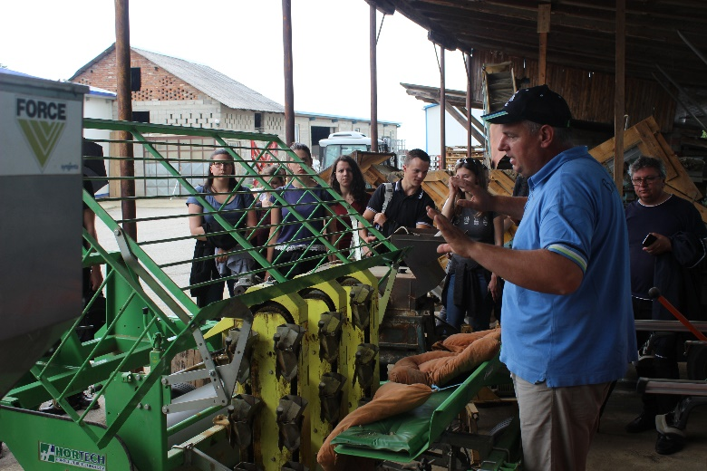

Figure 16: Demonstration of machinery in horticulture

Outcomes of learning
Learning outcomes were a bit hard to access, since the topic was related to the collection of experience and knowledge transfer in integrated and glasshouse production. We asked the students, which part of demo were most interesting to them, and all of them answered that the all topics demonstrated were interesting. When asked if demonstrated could be applicable on their own farm, they answered affirmative, but could not say when they will decide to apply it (EIP).

Networking
At the end of the demo, two students arranged student practice at family farm Grunt. Also, all of them had a good impression of the farm host and know that they can make contacts in case of some additional question. With recommendation from students that attended this demo in previous years, students also said that it was very pleasant for them at the demo, they have learned more about vegetable production and would recommend to other students to attend this demo (EIP).

Anchoring: Application of demo lessons by participants

Anchoring related to the present demo
By the information from the host, in previous demonstration events there were some interested participants who make contacts afterwards but just to gather some additional information. Only a few of them applied some practicalities at their farms, but is rather hard to describe as the learnings from the demonstration alone. It is also considered that this was learned not only at this demonstration, because they were attending also other demonstrations and study visits abroad, so they were collecting knowledge broadly (EPIO).
Generally, when asked participants if they will apply something of the demonstrated, all answers were negative. When asked do demonstrated novelties have good potential for their future professional activities, some students answered affirmative, but without incentives and a lot of time and money is uncertain (EIP).
Having in mind that the students from the faculty and collage were the participants of this demo, the effect of the demonstration can be reflected in the success of the final exams from integrated and glasshouse production (EIP).
In September 2018 a short ex-post interview with eight students were planned. They agreed during the demo to additional survey, but all of them had a lack of time due to exams preparation, and they refuse to provide answers (EPP).

Stimulating anchoring
The host stated that sometimes the participants get back to them by e-mail with some questions after the event. But, no systematically feedback information or any evaluation forms from past demos was collected (EAIO). For this demo event, he did not receive any follow-up e-mails by participants. Also, when asking if it would be useful to do some evaluation or to have some press release after the demo, he answered positive, but he also mentioned that there is no need for him to apply that (EPIO). The format of this demo were the participants are the students can emphasize the role of faculty and college professors who should use this demonstration events as valuable learning tool and a link between theory and practice (EIP).

Anchoring related to earlier demos
Lack of information from the previous demonstration disables answers to this part of this report (EAIO).

Scaling: Application of demo lessons by the wider farming community

Retrospective examples of scaling
In ex-post interview with the host together with local advisors, information about widely applied innovations in vegetable production was hard to recognize as a result of demo presented at family farm Grunt. Their opinion is that perhaps this demo took place in innovation making decision, but also emphasized the importance of other demonstration events, study visits or experience exchange between farmers in learning about how to apply innovations (EPIO).

Prospective assessment of scaling: Impact pathways
The advisors have been a part of this demo for years and have a wider overview of the local situation in vegetable production, but are not willing to testify that this demo is relevant for spreading novelties and innovations on local level (EPIO). There is a lack of information about wider peer to peer learning between farmers and advisors have no information about this topic. Although a lot information is available on the internet, demos are not so represented in Croatian web pages (DMLA).
The students will finished their agricultural studies depends on whether they have learned from the literature and whether they seen it working in practice. As farmers, or future young farmers, they will apply new approaches and techniques depends on whether they have seen it working in practice and whether they have the required financial means. This is why the demonstration events together with financial incentives are of high importance (EPIO).

Case study reflection

Facilitating and impeding factors for successful demonstrations
In general, successful demonstration can be addressed to a demo where all parties have a positive feedback. This implies that all parties will have benefits from demo. For a successful demo knowledge exchange is the most important part, even if visitors do not apply learned at their farms. The best efficiency for the demo would be to have minimum inputs with best results including human resources, time and finances. Also an interest for demo is important, so the visitors are really into demo topics and are ready to cooperate during the demo. When it’s free of charge, demo is more approachable to interested parties. When demo have a good demonstrator, as this specific demo at family farm Grunt has, with developed methodological skills, success is granted. Possibility for visitors to try and experience demonstrated at the demo has perhaps the best influence on how this knowledge “anchor” will (EPIO).
There are no scientifically and expertly processed databases in Croatia on 6 demo aspects that define the PLAID methodology (context, set-up, event, learning, anchoring, scaling).

Impact of demonstrations
The topics addressed at the demo on family farm Grunt included some elements of impact domains from the PLAID conceptual framework (productivity & profitability; resilience; sustainability; quality of life; empowerment). The possibilities of learning and networking in demo depends on several aspects but mostly about creating a good atmosphere with concrete presentation. Profitability of this demo is not measurable in some finance aspects, but is important in knowledge exchange. Amount of resilience is always necessary to perform a good demo, because you cannot expect that everything will be as planned. Sustainability plays perhaps the most important role with impact on quality of life and empowerment of local community. Family farm Grunt has supported a local community employing some of their neighbours and contributing to the empowerment and development of the village. Demonstration activities at this farm are a part of this process. Otherwise, would all partners from PLAID team ever had a possibility or need to visit this small family farm somewhere in North-western part of Croatia.

Key lessons from this case study
- Good demonstrator with pedagogical skills can play a significant role in successful demonstration
- Interested audience with good atmosphere enables demo play a role in decision making and learning
- Ensure active involvement of the participants
- Small group work is better for specific topics
- Weather conditions can play a significant role in demonstration planning and realizing
- Video recording is a good practice for analysing materials and in depth analysis

Acknowledgements

Croatian PLAID team would like to thank Vladimir Bais and his family, Professors Nina Toth and Tomislava Peremin-Volf as well as all students participating this demo. Many thanks to Elzen Boelie and Frank Wijnands for preparing excellent background for this report and special thanks to Claire Hardy and Lee-Ann Sutherland for all the care for PLAID.

Annexes

Data sources
DMLA Document, Media and Literature Analysis
EAIO Ex-Ante Interview with Organisers
EIP Exit Interviews with Participants
EPIO Ex-Post Interview with Organisers
EPP Ex-Post Interview with Students (not realized)
PO Participant Observation

Data sources used were consisted from oral interviews, video and photograph recording and questionnaire survey. For this purpose, PLAID team prepared informed consent, were the participants consent to the use of image or voice captured by video recording or photography by the members of the PLAID consortium project.

Data collection methods
DMLA Document, Media and Literature Analysis:
Analysis of various documents, e.g. newspaper articles and webpages
EAIO Ex-Ante Interview with Organisers:
One conversation carried out with the host prior to the event. An interview guideline was used. No recording. Documentation: Personal notes by the interviewer.
EIP Exit Interviews with Participants:
11 surveys (interviews) carried out during the event with students. Every interviewer used the same questionnaire. No recording. Documentation: Filled questionnaires.
EPIO Ex-Post Interview with Organisers:
One follow up interview carried out with the host, speaker and the manager of family farm Grunt, mr. Vladimir Bais. Open interview guideline. No recording. Documentation: Personal notes by the interviewer.
EPP Ex-Post Interviews with Participants:
8 follow-up interviews were planned, but students cancelled due to other obligations.
PO Participant Observation:
Observations by PLAID team members during the demo event. Observation guideline. Notes taken during the observation, which were complemented after the event.

