Date: December 2018

Country report: Croatia

Case Study: CRO 1 – Crop production (Wheat and Barley Field day by AIO)

WP5: Case studies of demonstration activities in commercial farms

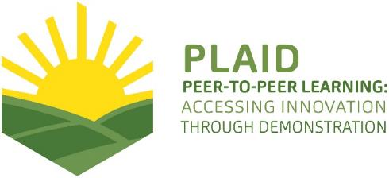
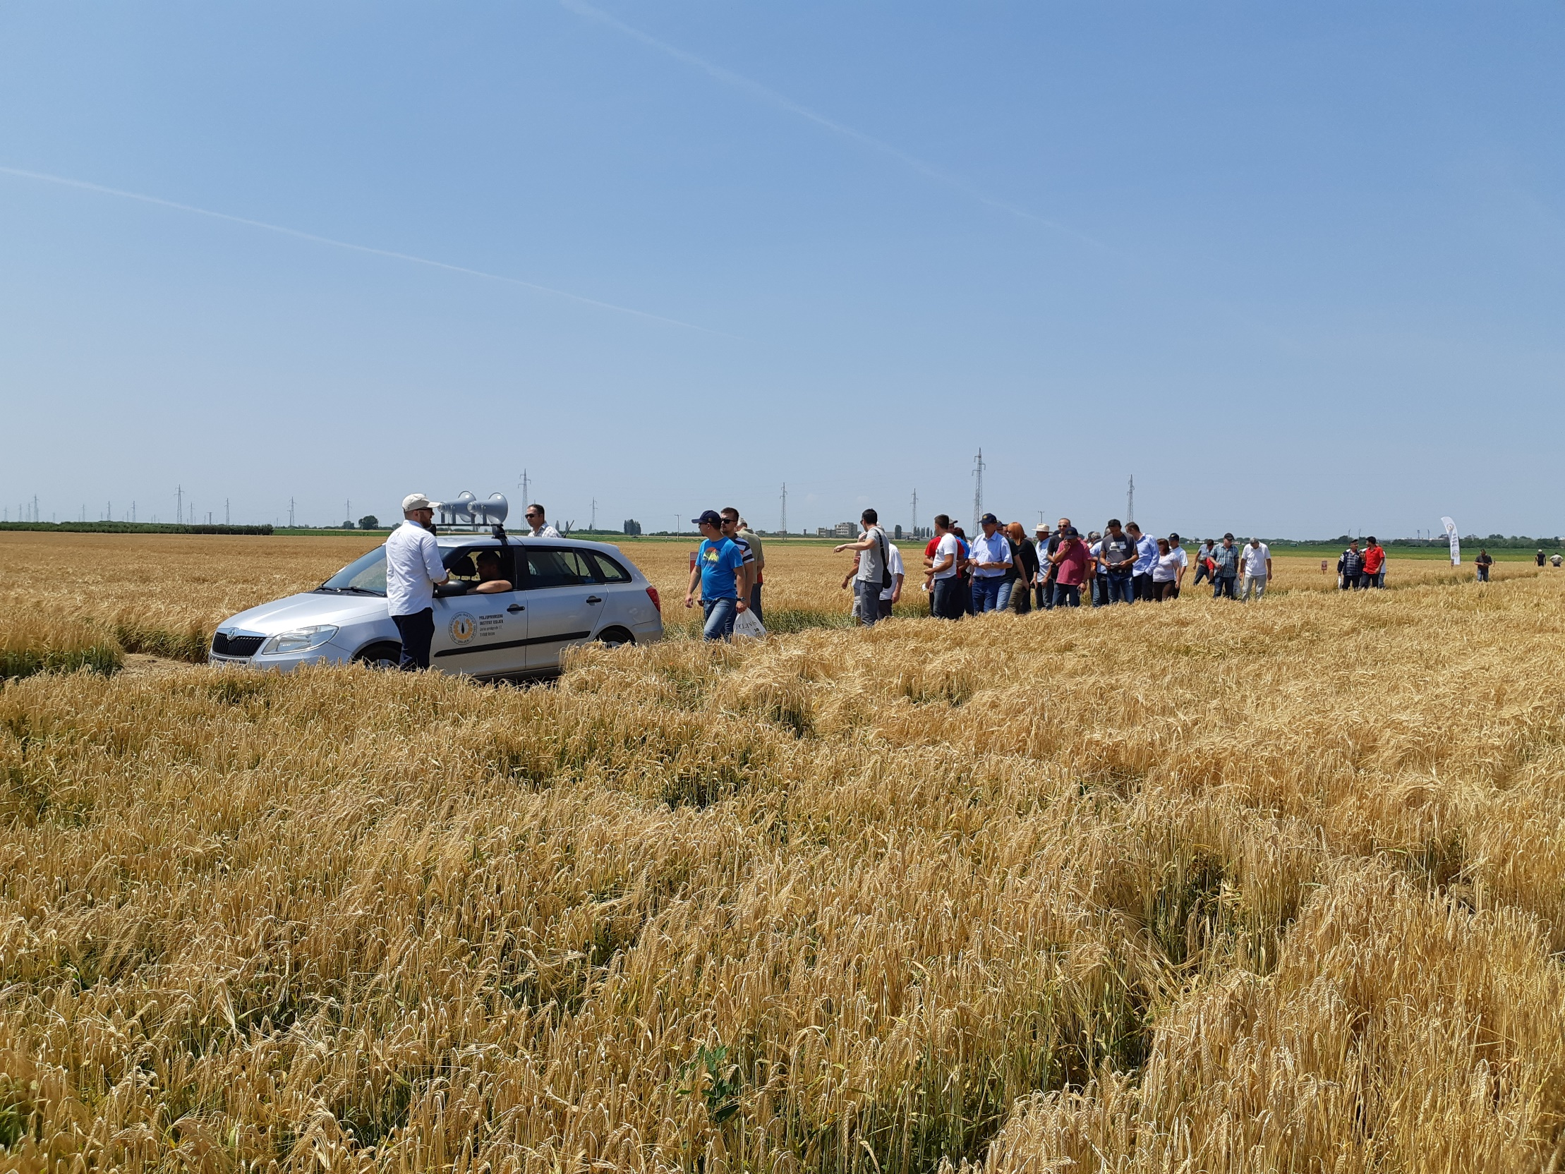
This project has received funding from the European Union’s Horizon 2020 research and innovation program under Grant Agreement No 727388

PLAID PARTNERS

Croatian Agricultural Forestry Advisory Service CAFAS | 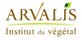  ARVALIS Institut du Végétal | Association de Coordination Technique Agricole ACTA
Institute for Rural and Regional Research | 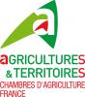  Chambers of Agriculture | Delphy
European Forum for Agricultural and Rural Advisory Services EUFRAS | Innovatiesteunpunt ISP | Institut de l’Elevage – Idele
Instituto Navarro De Tecnologías E Infraestructuras Agrolimentarias | Linking Environment and Farming LEAF | 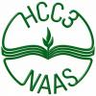  National Agricultural Advisory Service
Nodibinajums Baltic Studies Centre (BSC) | Research Institute of Organic Agriculture (FIBL) | Stichting Wageningen Research
The James Hutton Institute | VINIDEA

DOCUMENT SUMMARY

__________________________________________________________________________________
Milestone Title: 24 Case Studies
__________________________________________________________________________________
Case Study Title: CRO 1 - Crop production
Wheat and barley Field day by Agricultural Institute Osijek (AIO)
__________________________________________________________________________________
Version: 1.1
__________________________________________________________________________________
Task Lead: WUR
__________________________________________________________________________________
Related Work package: WP5
__________________________________________________________________________________
Authors: Kristijan Jelakovic, Milan Husnjak, Aleksandar Horvatic,
Matija Cabrajec
__________________________________________________________________________________
Grant Agreement Number: 727388
__________________________________________________________________________________
Project name: PLAID
__________________________________________________________________________________
Start date of Project: January 2017
__________________________________________________________________________________
Duration: 30 Months
__________________________________________________________________________________
Project coordinator: The James Hutton Institute
__________________________________________________________________________________

ABSTRACT

Demonstration activity was organised by Agricultural Institute Osijek (AIO), a public research institute in the scientific field of biotechnology which through scientific research and through finding innovative solutions contributes to the development and advancement of plant science and agricultural production.
The demo is held on the Basic Seed Production farm with commercial and public-good orientation, established in 1931, and has about 700 ha of cultivated land.
The main objective of the demo was to present best practices and new varieties in wheat and barley production, experience exchange and knowledge transfer between farmers, advisors and other interested parties.
Crop production demonstration named „Wheat and Barley Field day by AIO”, gathered the most significant participants in the chain of wheat and barley seed production, mercantile wheat and barley producers, advisors, fertilizers and protection distributors, merchants or end users of wheat and barley such as representatives from bakery industry, beer producers, animal feed producers, and other farmers. The total number of participants were 660 from Italy, Hungary, Albania, Romania, Turkey, Slovenia, Serbia, Bosnia and Herzegovina, Macedonia, Kosovo, and Croatia.

TABLE OF CONTENTS
1 Demo context 6
1.1 The value chain 6
1.2 Typical farm characteristics 6
1.3 AKIS 7
1.4 Sustainability challenges 7
2 Demonstration summary 8
3 Governance: set up and organisation 9
3.1 Organisers and history 9
3.2 Funding 9
3.3 Host 9
3.4 Gender 10
3.5 Objectives 10
3.6 Topics 10
3.7 Access 10
4 Demonstration event 11
4.1 Visitors 11
4.2 Communication & Mediation 12
4.3 Active participation 12
4.4 Doing business 13
4.5 Role of sustainability 13
4.6 Unforeseen circumstances 14
4.7 Plans vs. practice 14
4.8 Participants feedback 15
5 Motives, learning and networking 15
5.1 Reasons to attend demos 15
5.2 Forms of learning 16
5.3 Content of learning 17
5.4 Outcomes of learning 17
5.5 Networking 18
6 Anchoring: Application of demo lessons by participants 18
6.1 Anchoring related to the present demo 18
6.2 Stimulating anchoring 18
6.3 Anchoring related to earlier demos 19
7 Scaling: Application of demo lessons by the wider farming community 19
7.1 Retrospective examples of scaling 19
7.2 Prospective assessment of scaling: Impact pathways 19
8 Case study reflection 19
8.1 Facilitating and impeding factors for successful demonstrations 19
8.2 Impact of demonstrations 20
8.3 Key lessons from this case study 20
9 Annexes 21
9.1 Data sources 21
9.2 Data collection methods 21
9.3 Form of questionnaire for data collection 22

Demo context

The value chain
The Wheat and Barley Field day by AIO focused on the most significant participants in the chain of wheat and barley seed production, mercantile wheat and barley producers, advisors, fertilizers and protection distributors, merchants or end users of wheat and barley such as representatives from bakery industry, beer producers, animal feed producers, and other farmers.

The situation in wheat and barley production in Croatia, 2017 (DMLA):
- Croatia produced 682.300 tons of wheat and 260.400 tons of barley.
- In comparison to 2016
- Domestic needs are between 530.000 and 550.000 tons of wheat
- Wheat seed production is from 40.000 till 60.000 tons which is enough for domestic needs
- Capacity of 55 mills for wheat flour exceeds 1.300.000 tons
- Total consumption of flour in Croatia is about 460.000 tons
- Fluctuation in production are mostly due to favourable or adverse impacts of the climate (floods, droughts, storms etc.), but also to the inadequate production techniques
- According to the Croatian Chamber of Economy, in the last three years the interest in wheat production has been reduced (2017/2016, 30% decrease)
- In the last 15 years, agricultural land sown with wheat was between 115.000 and 240.000 hectares
- In 2017, wheat was sown on 116.000 ha and barley on 54.000 ha.
- The average yield in 2017 was 5.9 t/ha for wheat and 4.8 t/ha for barley.
- With the application of the Grain harvest Code showed that over 60% of third-grade wheat was produced
- About 7% is classified as forage
- Based on the estimates from the advisors, small family farms suffers from lack of the circulating capital (high cost of inputs), so they using own produced seed (so called "attic seed")
- It is important to mention a considerable difference between yields in family farms and yields in large corporative farms, where the corporative farms make about 25% higher yields
In wheat production, as much as in the other cereal production, it is important to think about irrigation and drainage, which must be set as a strategic commitment. About this issue, Croatia is not using its capabilities as it should.

Typical farm characteristics
Wheat and Barley breeding in Croatia and SEE Region is significant for the AIO. For eighty years of continuous work the AIO winter wheat breeders created a total of 121 winter wheat cultivars which are recognized on national level and 50 of total winter wheat cultivars are recognized internationally. Winter wheat varieties are characterized by high grain potential, stability, and adaptability in different environmental conditions, and they meet the requirements of wheat producers, seed processors professionals, milling and baking industries, and have good economic characteristics. Over the past 25 years, the share of OS winter wheat cultivars in Croatia’s total wheat production per annum has been in the range of 45 - 65%.
For past eight decades AIO has made a major significance in breeding and seed production programmes for winter and spring barley for beer and malt industry, animal husbandry and human nutrition. So far, the work of barley breeders has resulted in the recognition of 99 barley cultivars. The characteristics of this cultivars are excellent lodging resistance, tolerance to typical barley diseases with a high spikes per square meter potential and heading time (length of vegetation) adapted to barley production conditions in South East Europe. Over the past three decades, this cultivars have participated in Croatia’s total annual barley production with approximately 70%.
The domestic market is saturated, and exports are hampered by the fact that Croatian wheat has poor quality and is mostly treated as a forage crop and thus does not achieve a satisfactory price. The poor harvest of crops, in the first place of wheat, is enough reason for the alert, and the main causes of mentioned problems are bad weather conditions and appearance of diseases. (EAIO)

AKIS
Generally, AKIS in in the region where demos were held, eastern part of Croatia is very fragmented and disconnected so it is still not really possible to talk about the system. Vertical and horizontal cooperation between stakeholders in generating and transferring agricultural knowledge has not yet been perceived as a single system. Cooperation is largely not institutionalized. Most often, it happens at the initiative of more engaged individuals from various scientific and higher education institutions, professional organizations and rarely by the farmer organizations.
The PRO-AKIS project was not implemented in Croatia because at the time of the implementation of projects Croatia was not yet a member of the EU. EIP-AGRI in Croatia is not yet in implementation. In February 2018, a procurement for Measure 16.1.1 „Support to establishing Operational groups“ was announced for applied research and development measures for mitigation and adaptation to climate change in order to improve agricultural production, breeding, quality and soil fertility or to strengthen the resilience to changes of agricultural systems with the advanced use of new technologies or alternative production systems, and the increase of biomass production in agriculture and its use as well as use of other biomass produced on farm. Measure 16.4. Short supply chains and local markets is in preparation phase.

Sustainability challenges
In period from 1961 onwards, Croatia recorded the increase of rainfall by approximately 20 mm. Also, from 1994, an average increase in air temperature of 1 Celsius degree was recorded. The impact of drought on Croatia agriculture:
- Decreased yield in harvest from 20 to 90%
- Total damage in net worth more than billion HRK
- Only 0.46% of utilized area in Croatia is irrigated
Croatia's fields are mostly hungry, thirsty and sour, and most of them lack phosphorus. Big amount of nitrogen in soils is ensured by introducing legumes into the production. But, these subjects are not in focus of the CS. (DMLA)

Demonstration summary

The Wheat and barley Field day by AIO is international demonstration event on arable farming in Osijek, Croatia. It has been organised on a yearly basis, and has tradition for more than thirty years. This year’s event took place on June 6th 2018, 9.30 – 15.00 a.m. The main organiser of the event is the Agricultural Institute Osijek. The event attracts around 600 visitors every summer. (DMLA)
On demonstration 22 varieties of wheat were shown on experimental fields (field trails), as well as 22 varieties of winter barley and 7 varieties of spring barley, that are in wide range production. The main objective of this demonstration was to ensure and to develop excellence in applied research and development in the field of plant science and to improve production of wheat and barley. The demo was institutionally led – commercial orientation and public-good orientation. The main demo methods were lectures indoors and field trail on experimental fields with guides (speakers). The targeted group were farmers in crop production, advisors and all interested facilitators from the region and abroad. (EAIO)
The event addressed various issues related to sustainability. In terms of seed selection, the importance of dry-resistant varieties were presented.
Programme of the Wheat and barley Field day by AIO, 2018
9.30 a.m. Welcome and group assignments
10.00 -10.30 a.m. A salute of the director and the guests
10.30 -13.00 a.m. Presentation of the results of scientific research and expert work
in the fields of breeding and seedling of wheat and barley
Oral presentations
Poster exhibition
A joint tour of field trials
13.00 a.m. Lunch

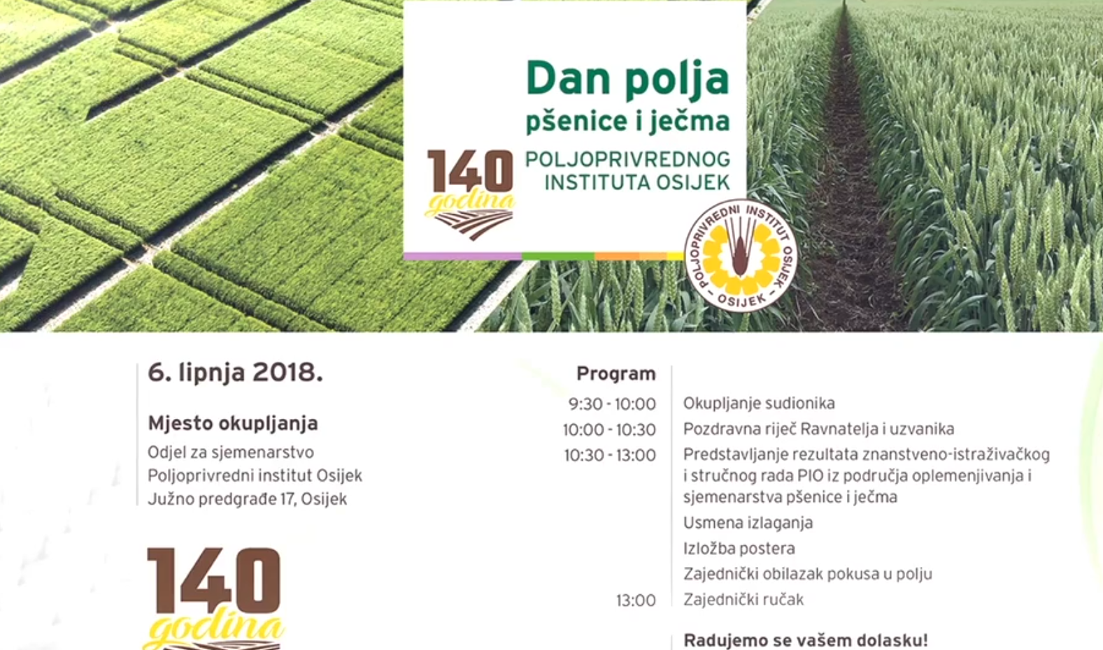
Figure 1: Invitation card with the program of AIO Field days (www.poljinos.hr)

Governance: set up and organisation

Organisers and history
The Agricultural Institute in Osijek (AIO) is a public research institute in scientific field of biotechnology which through scientific research and innovative solutions contributes to the development and advancement of plant science and agricultural production. The institute establishes scientific programs of strategic importance for Croatia. In collaboration with institutions of higher education it establishes the scientific infrastructure of the whole system of science and higher education and participates in the process of higher education.
For over 80 years of continuous work, breeders of the institute have created a numeriuos variaties of winter and spring wheat and barley cultivars which are recognized in the Republic of Croatia and internationally. All this nouvalities are spred among family farmers, cooperatives, corporatives, advisors and all other stakeholders in area of crop production by organising an annual Wheat and barley Field day by AIO. This days have tradition for over thirty years. (EAIO)

Funding
All costs of the demo organization were covered by the organizer, AIO and their employees. After indoor lectures and field trails, lunch and beverages was organised for all participants and their guests. Participants only payed for their transportation and accommodation.

Host
Demonstration activity was organised by AIO on experimental fields next to the office buildings and warehouses where all the basic machinery (tractors, seed drills, sprinklers, combine harvesters) are housed, as well as the repair shop for the machinery and other equipment.
Basic Seed Production of AIO has in total 700 ha of cultivated land (about 580 ha for the multiplication of pre-basic and basic seed, and about 120 ha for experiments and the selection material of the plant breeding departments).

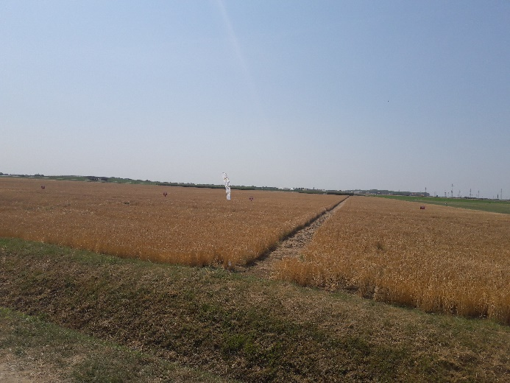
Figure 2: AIO’s experimental fields near Osijek

Gender
The demonstration was mostly commissioned by men. Also, all the speakers were men. However, apart from the speakers and demonstrators, the gender balance within the AIO as the institution that organized the event is in favor of females, so it can be considered that women played important role in organizing this event, working out of the shadow.

Objectives
The main objective of the Wheat and barley Field day by AIO was to demonstrate best practises in crop production, especially wheat and barley cultivars, mutual experience exchange and knowledge dissemination, and problems. (EAIO)

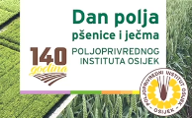
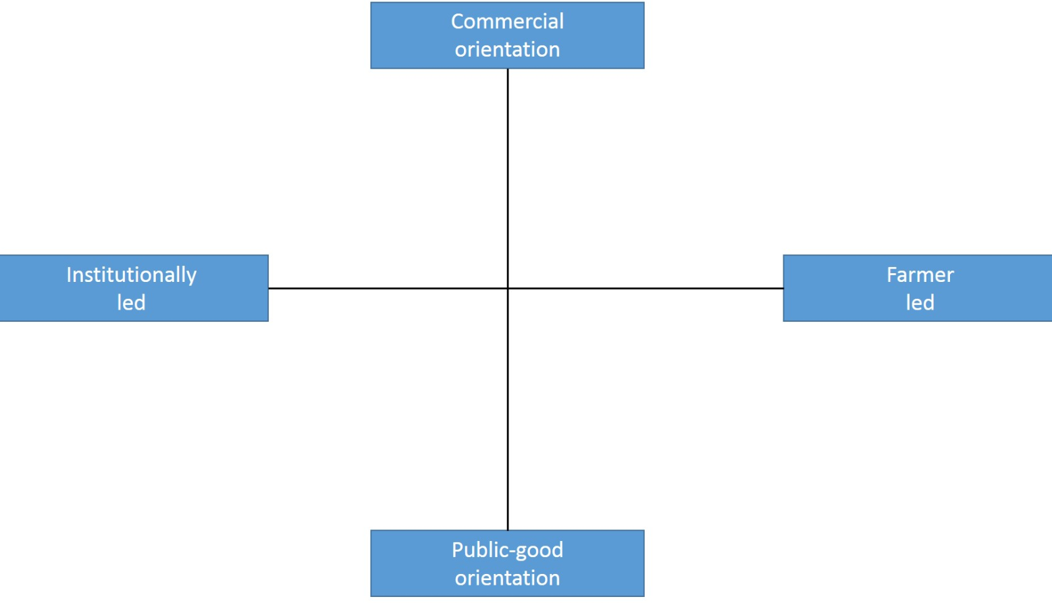

Figure 3: Positioning of the AIO’s Field day in the PLAID typology for demo focus

This demonstration was commercial led and had commercial orientation, but also public-good because the institute is willing to exchange experience and knowledge with all parties interested in arable production, especially wheat and barley production. In close collaboration with other institutions of higher education and commercial companies, institute is willing to share production resources, time and experience in organizing demonstration activities. (DMLA)

Topics
This year’s topics of the Wheat and barley Field day by AIO were very concrete with the demonstration of primarily basic and pre-planting processing, as well as in other technological processes in the production of dry-resistant varieties of wheat, winter and spring barley. Generally, the event’s topics were related to show the latest results of scientific research and expert work in the fields of breeding and seedling of wheat and barley. Besides that, the sustainable aspects in wheat and barley production in Croatia and neighbouring countries were examined (EAIO)

Access
The invitation for this demo was published on the website of the AIO (www.poljinos.hr) or sent through e-mails, newspapers, media or personal. Attractiveness was insured with free food and beverages, traditional music for all participants and great visibility with tradition for over thirty years. Free bus transportation was organized from the city centre for interested parties that came from a far. (EAIO)

Demonstration event

Visitors
In total, there were about 660 participants at the Wheat and barley Field day by AIO from the chain of wheat and barley seed producers, mercantile wheat and barley producers, advisors, fertilizers and plant protection distributors, merchants or end users of wheat and barley such as representatives from bakery industry, beer producers, animal feed producers, and farmers. The assumption was that the vast majority of participants were farmers. (PO) There were a disproportionate number of visitors that could be described as technical experts, some of which have their own arable production and has special interest to participate on this demo activity. (EPIO) At the end of the event, all visitors were invited to a lunch. Most of the visitors stayed for lunch and we had the opportunity carry out interviews.
Even though there were more than 600 visitors and only four PLAID team members, we managed to interview twenty farmers. A sample of farmer’s population in relation to the demonstration theme is not representative. In terms of composition of the interviewees were from the region of East Croatia, and they travelled up to 30 km to the event. (EIP) Moreover, the representatives of local media were interviewed visitors and organizers. (EPIO)
The interviewed farmers farm under the conventional or the integrated production system. Most of the interviewed farmers were specialized in arable farming, and five of them have mixed farms with both arable farming and animal husbandry. Moreover, in terms of land use, most of them cultivate between 50 and 100 hectares. Furthermore, we asked the interviewees how many times they attended this demo event (including this year’s event). Almost two thirds of the interviewees have already attended three or four times. They have learned about the event because they are customers and they were invited by organizers. (EIP)
Women and young people were less represented, which can be explained by the general state of affinity of these groups in agricultural production in Croatia. The reason for this is not the way of setting up and organizing the demonstration. (DMLA)

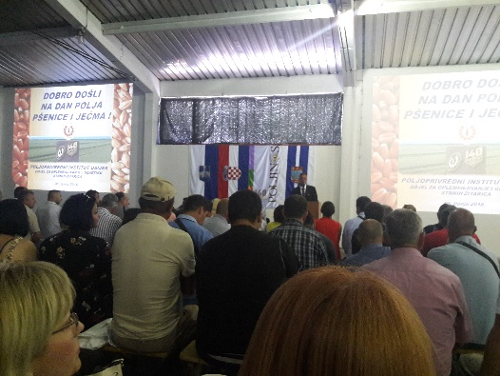
Figure 4: Welcome speech and lectures in indoor space
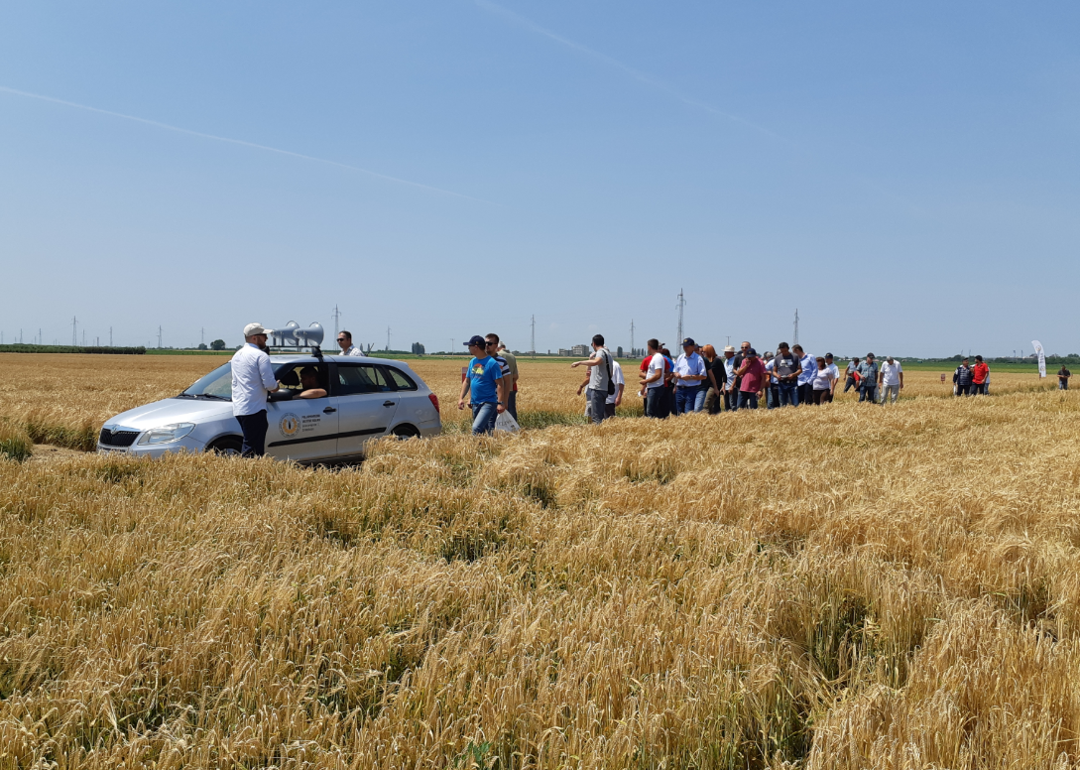
Figure 5: Field trails with demonstrator

Communication & Mediation
The wheat and barley field day by AIO was structured into two main parts. First part of demonstration event was organised as lectures in indoor space, and second part in the experimental fields. Indoor space were equipped with a speaker and projector system, while in the open was used a loudspeaker system that was located on the car roof. (EAIO)
In the open ceremony, director of AIO held a greeting speech, presented the program of this demonstration and informed all participants about PLAID project. He also invited the participants to contribute to the implementation of the project and to complete a questionnaire in cooperation with PLAID team after the field trails.

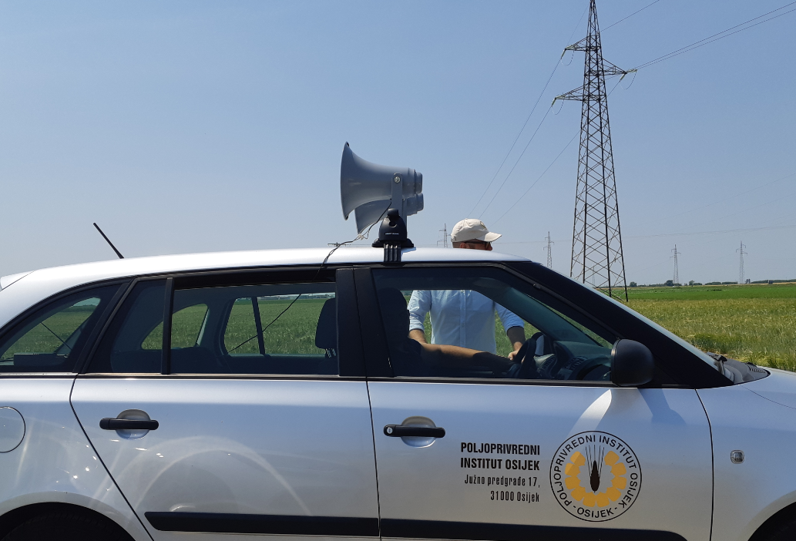
Figure 6: Loudspeakers on the car roof

Active participation
Given the large number of participants, active participation was only in the form of interlocutors' conversations. Due to the size of the event, there was a lack of interaction between participants and demonstrators. The interaction consisted of a small number of questions posed after each PP presentation in the indoor space and a few questions and answers during the field trails on the demonstration parcels. (PO) In both cases, demonstrators used loudspeakers because of the number and dispersion of the participants, which made the interaction between the demonstrators and the participants complicated. (EPIO) Interaction among participants was mostly limited to contacts within a group of participants who had previously been associated with formal or informal relationships (EIP).

Doing business
The participants were mostly passive listeners and observers. (EIP) They opportunity was not expressed except that attendees were invited to participate in some new similar events planned by the same organizer. (PO) As the organizer is also a seed material manufacturer / supplier, the demonstrator has argued that it is desirable to use / buy this seed material. (EPIO)

Role of sustainability
The event addressed various issues related to sustainability. The overall topic of the event were to show the results of scientific research and expert work in the fields of breeding and seedling of wheat and barley. Demonstrated and presented approved and advanced varieties of wheat and barley have a significant impact on the resilience to climate changes (droughts, floods), the production risk in arable cropping and on maintaining an adequate income level for farmers. In addition, economic aspects were included. In the first part of this demonstration, the profitability of wheat and barley was evaluated and emphasized. This part also included the presentation and discussion of the current market situation and subsidies related to specific production systems and agricultural practices. The presentation of dry-resistant varieties of wheat and barley raised the greatest interest among farmers. (PO)
Environmental and social aspects have not been elaborated separately, and economic impacts are implicated through the yield and quality of the varieties showed. However, the presented yield were achieved in optimal agrotechnical conditions in experimental fields. (PO)
During the demonstration activity, a representatives of local media was present, and they interviewed some participants and also the organizers. The field trails were recorded also from the air by using drones. (EPIO)

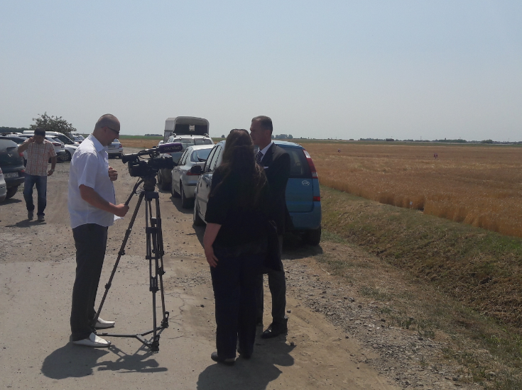
Figure 7: AIO’s director gives an interview to local media

Unforeseen circumstances
The weather can play a significant role in demonstrations and this was obvious at this demo event. In second part in the field trails people were just scattered around. Temperature was over 30˚C. (EIP)
The weather was commented - the big heat certainly had a negative impact, reducing the mobility of the participants and pushing them to sunbathing and shortening the time spent on demonstration fields. (EPIO)

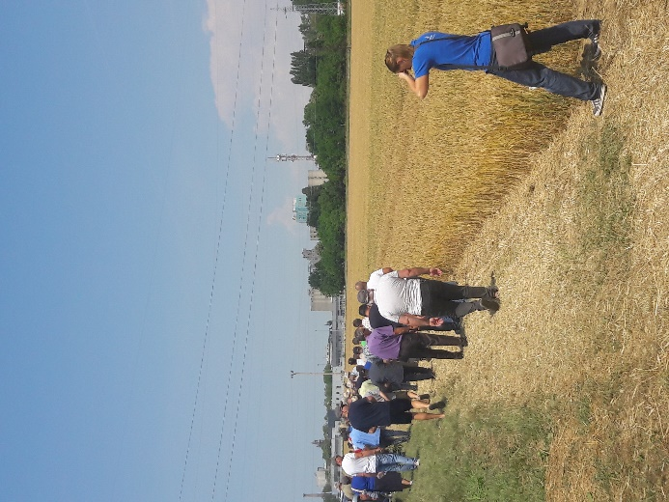
Figure 8: Participants exposed to strong sunlight

Plans vs. practice
The Wheat and barley Field day by AIO was well organized and clearly structured. It was obvious that this was not the organizers’ first demonstration event and they built upon the experience from previous years. There was a lot of staff at the event. Many of these people were the employees of the AIO. The time frame were pursuit and in the first part were no delays. In second part, the weather conditions were not ideal for field trials. It was just too hot to walk around the fields and the duration of field trails were reduced. (EIP)
Finally, the lunch was organized with music band just after the field trails so there was only a short time to do the interviews because afterwards visitors were gone home or were singing and dancing (!).
The main objectives have been achieved. The final number of participants were within the expected limits, as well as the advertising of the event. All planned presentations were held and accompanied by attentions of the participants, albeit with a small interaction. The field trails were probably shorter than expected and with fewer people, due to the heat. The acoustics were not ideal, indoor and outdoor, and that the level of attentiveness dropped because of that. There was enough refreshments during the entire duration of the demo event. (EPIO)

Participants feedback
We asked the interviewed farmers whether there is anything that they would change about the event in the future. All of the interviewees appreciates the format of this demonstration events and would not change anything. This event has a long history and strong tradition, and all visitors knows in advance what to expect. Additionally, some of the interviewers suggested some improvements, e.g. demonstration of innovative technologies, and focusing more on different production systems. All interviewees stated that this was a great place to meet other farmers and experts, to share and exchange the experience and to discuss in informal way on all topics relevant for their production. (EIP) One advisor stated that this is the only event of this kind in this part of Croatia that attracts all stakeholders - farmers, experts, traders in one place on annual base.
In general, everyone stated that was useful, almost no one criticizes, and criticism was much more focused on the current situation in the agricultural sector, especially in market situation in Croatia. (EIP)

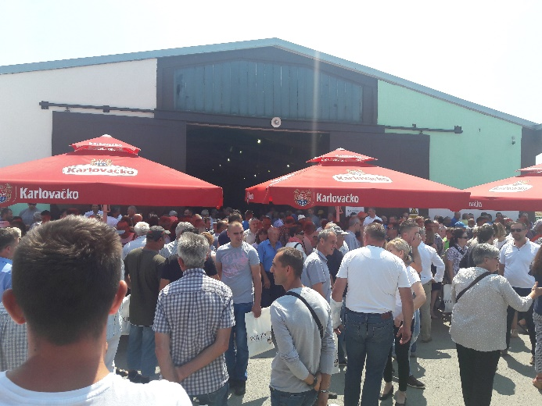
Figure 9: Participants after the field trails

Motives, learning and networking

Reasons to attend demos
Attitudes and perceptions
In prepared questionnaire, interviewees were asked to answer weather they have participated to other demonstrations than this one. Answers were similar and all included importance to attend demos for knowledge exchange, meeting other farmers with similar production and exchange of ideas for innovation. All of the interviewees stated that they have attended at least ten demonstrations in the past. Additionally, they mentioned the importance to participate on manifestations, fairs, and vocational trainings organised by farmer associations, education centres or extension services. We also asked the interviewees on the motivation factor. The responses could be the challenge, problem or both. Most of the responds were something else – knowledge exchange, presentation of novelties and informal gatherings with other farmers and experts. When asking about the exchange of the information and knowledge during the demo depending on the source of information, the interviewees grated the relevance. In average, the most important source of data comes from their own experiences and knowledges, than from the experiences of others farmers and experts. Education courses, trainings and workshops are also graded by the majority as important. Less important was the use of internet, social media, and literature. Two thirds of the interviewees stated that the role of advisors and other consultants in rural area is very important in exchange of the experience and knowledge as well. (EIP)
Norms
When we asked the participants about the level of information they would appreciate at such an event, respondents stated that a good average should be aimed to innovations presented and the experience form other farmers in using this innovative technologies. This was very close connected with the varieties of wheat and barley seed presented and used by others, especially dry-resistant varieties of wheat and barley. When we asked if they would recommend other farmers to attend this demo, all answers were affirmative. (EIP).
Practicalities
We asked the participants about the most practical or important reasons why they can or cannot attend events such as this. Most of the respondents said that the history and tradition of attending this event played a significant role among the farmers specialized in arable production in making decision to attend this event. Also, organizer provided free food and beverages for all visitors (music was also included), the transportation was organized for free, as well as the participant fee. When asked if attending the demo would make a difference on their farms, participants answered affirmative. (EIP)

Forms of learning
The main forms of learning were listening to lectures in indoor space, visiting experimental fields, and exchange of experiences among farmers and experts. Most of the speakers were employees of the AIO and guests lecturers from faculties and other institutions. The field trails were organized by the AIO’s employees as well. The visual style was used, which mostly consisted of looking at something, i.e. fields with different trials. The way of presenting field trails by using a loudspeaker attached to the car roof was excellent and innovative idea. (PO) Even though, demonstrations were mostly dominated by a one-way communication from the speakers to participants. All the speakers who led demonstration in both parts was good lecturers and they used frontal presentation. Participants were rarely engaged, and had no opportunities to ask questions and to discuss. At some smaller part of the demo “learning process” took place in one-way communication, when the farmers and experts exchange some information among themselves during demonstration, for which they had more than enough time. There were no physical elements that would allow the participants to try or test something themselves. (PO)
At first part of this demo event in indoors, during the presentations the level of interactivity was higher than on field trails, due to the fact that the discussion was moderated, and some participants were involved in the discussion (verbal learning). The handouts were distributed to all participants, as well as brochure and T-shirts.
Peer to peer learning was represented at this demo but only among the participants, were the exchange of experience was important in ensuring practical relevance. During lunchtime, discussing and exchanging continued and played an important role. (EIP)
Concerning gender balance, there were mostly men present at the event. In addition, most of the speakers were men. This picture represents the general situation among the farm managers specialized in arable production. (PO)

Content of learning
The information and knowledge offered at the Wheat and Barley Field days by AIO was quite specific and partially ready to use at the farm level. Information provided by the speakers were concrete with no redundant materials. As the topics were specific, it was very theoretical including a lot of background information and little demonstrative elements, and the practical relevance was rather low. (EIP) The farmers preferred, based on the previous experience, getting only an overview of the novelties instead of receiving in-depth information, for what the time was not sufficient. More important was the experience exchange among farmers and experts. (PO)
The demonstration of new and advanced varieties of wheat and barley was one of the most important objectives of this demo. During demonstration event, some additional inputs concerning the right selection of different seeds were explained, so the final benefit for the farmers’ could be recognized and reached. Importance of dry-resistant cultivars of wheat and barley were emphasized (EPIO; PO)

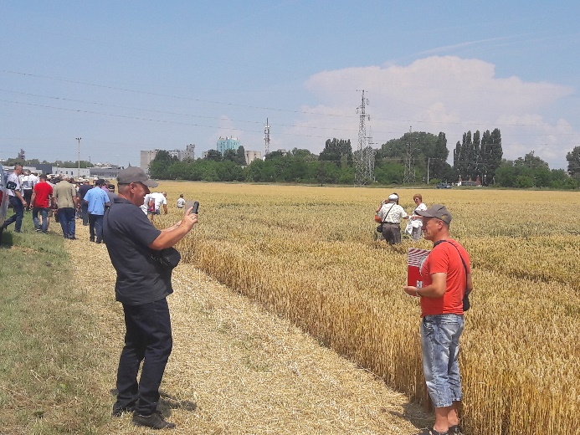
Figure 10: Participants are taking photos in field trails

Outcomes of learning
One indicator is that the wheat and barley cultivars of the AIO have made stable share of 60 percent in arable crop production in Croatia for many years. Learning outcomes were a bit hard to access, since the topic was related to the best practices and new varieties in wheat and barley production, experience exchange and knowledge transfer between farmers, advisors and other interested parties. (EIP)
The best practices in wheat and barley production were presented only theoretically by explaining the pros and cons in selection of more quality varieties depending on the area, type of soil and cultivation technology. The in-deep learning were not in the focus of this event. We asked the interviewees, which part of demo were most interesting to them, and all of them answered that the experience exchange and knowledge transfer between farmers were interesting. When asked if demonstrated results can be applicable on their own farm, they answered affirmative, but could not say for certain when they will decide to apply more quality varieties of wheat and barley in their crop rotation. The effect of drought on yields, and consequently on revenues in recent years will speed up the decision on the application of new dry-resistant varieties of wheat and barley that was presented on this demo event. (EIP)

Networking
The demo was important for all participants, especially farmers to interact with each other and the experts to 'refresh' existing contacts and to establish new contacts across the region and neighbouring countries.

Anchoring: Application of demo lessons by participants

Anchoring related to the present demo
According to the information provided by the organizers (Ms. Aleksandra Sudarić), evaluation of the applied and learned is not carried out. But the organizers conclude that traditional field days indirectly have the impact in application of learned by saying that the market share increased and it can be confirmed the sowing of their quality and dry-resistant varieties of wheat and barley. (EPIO)
The involvement of the participants in the demo is important in order to give them the chance to clarify questions and to relate what they hear to implement on their own farm. Generally, there were not many opportunities for interaction during this demo event. In some cases, the moderators asked the participants’ for their experiences but it was rather poor contribution.
Elements which help the visitors decide whether the information is relevant for their farm are important. On this demo, this kind of information was very difficult to track. The exchange of experience among farmers and experts are important to encourage anchoring. Giving clear conclusions and take-home messages at the end of the demonstration activity is crucial when it comes to the anchoring of the conveyed information. The organizer provides handouts for all participants with the information on everything that was showed during the demonstration. This may help the visitors to repeat at home what they learned or experienced during the event. (EPIO)

Stimulating anchoring
The organizer’s market share indicates that the outcome of the demonstration will reach their objectives. Also, the results of the presented new varieties of wheat and barley helps the farmers to make a good decision in sowing the quality and dry-resistant varieties of seeds tested end cultivated by other farmers who were at demo event. Very important is the fact that the new varieties of wheat and barley has been tested in the same production area. The exchange of experience among farmers and experts in using quality seed during this demo event have significant impact in stimulating anchoring. (EPIO)
The organizers stated that sometimes the participants of the demonstration get back to them by e-mail with some additional questions after the event. However, for this year’s event, the organizers stated that they did not receive any follow-up e-mails by participants. The visitors have the possibility to visit the field trials throughout the year in order to observe the different stage of development of plants throughout the vegetation period. (EPIO)
Apart from the farmers being the costumers at the end, the organizer stated that the final beneficiaries are the advisors and all other experts who attended this demo event, due to their role to expand the learnings and experience to much higher level. How to measure the impact of this demo event to this learning process it’s impossible to indicate or evaluate. In terms of stimulating anchoring, the advisors and the experts will pass the learnings to their beneficiaries and consumers, so the learnings will continue to be successfully applied. (EPIO)

Anchoring related to earlier demos
The AIO as organizer so far has no practice in organizing and systematically collecting feedback from participants at or after the demo event. All members in the chain of wheat and barley seed production, mercantile wheat and barley producers, advisors, fertilizers and protection distributors, merchants or end users of wheat and barley such as representatives from bakery industry, beer producers, and animal feed producers, together with the AIO, contributed actively for more than thirty years in creating a successful and permanent demo event. (EPIO; EIP)

Scaling: Application of demo lessons by the wider farming community

Retrospective examples of scaling
Many other farmers learned about the demonstrated new quality and dry-resistant varieties of wheat and barley via a variety of indirect ways, via advisors or other farmers who visited this demo event. Also, a large group of farmers are struggling with the consequences of droughts and other natural disasters.

Prospective assessment of scaling: Impact pathways
Having the tradition of organising this demo event for more than thirty years and stabile market share over the same period of time in wheat and barley seed production, leads to the conclusion that the transfer of knowledge and experience was successful. All members in the chain of wheat and barley seed production, mercantile wheat and barley producers, advisors, fertilizers and protection distributors, merchants or end users of wheat and barley, together with the AIO, shows the importance of this demo event to the general peer-to-peer exchange by their active contribution in creating a successful and permanent demo event. (EPIO)
Main impact pathways of the Wheat and Barley field days by AIO are:
- Farmers have a variety of contacts with other farmers, some of whom may have adopted a new quality and dry-resistant wheat and barley seeds
- Agricultural journalists reports upon what they have witnessed at a demo in journals, on local TV and radio stations and other social media
- Agricultural advisors and other experts in rural area visited a demo and subsequently inform a range of other farmers of what they have witnessed

Case study reflection

Facilitating and impeding factors for successful demonstrations
The organizers stated that the tradition of organizing such a demo event, and the experience collected over the years are used in organizing this demo event. The success of this, as well as all the previous demonstrations, are close connected with the general situation in agricultural sector in Croatia. The demonstration of this scale, where the most important stakeholders are present, in some way reflects the achievements in scientific research and innovative solutions of new varieties but also creates a trends for the development and advancement of plant science and agricultural production. Most of this depends on the current situation in the surroundings and the strategies prepared in some ministry office. The impact of these trends also affects the success of the demo. (EPIO) All interviewees who participated on this event in previous years are unique in the standpoint that the quality of this demo event has been changed, how the conditions in agricultural production changed. The extent of these changes can be easily experienced on this demonstration, where the science meet the farmer. (EIP)

Impact of demonstrations
An organized demo on this scale with a lot of people, food, drinks and music is suitable for spreading information about the importance of new quality and dry-resistance varieties of wheat and barley to large number of participants. After the interviews with the farmers and analysis of the information collected, all has a singular attitude that the objective of this demo has been achieved. All interviewees stated that they collected new information, they increased the awareness of the importance of sowing quality and dry-resistance varieties of cereals, and they exchange experiences in informal way with other farmers and experts. (EIP) This demo event is the fine example, and represent a small piece of the agriculture knowledge and innovation system, less developed in Croatia and this part of the Europe, where the results of the applied research are spread among the farm community, and where all members of the chain were included. (EPIO)

Key lessons from this case study
- In the preparation phase it’s crucial to have a good communication with the organisers for getting specific information prior to the event
- Use of pre-prepared survey questionnaire proved to be very practical for collecting basic information from organizers and participants
- Experience exchange and knowledge transfer between the participants during the event is very important
- Demo with a large number of participants is suitable for spreading information
- Weather conditions have a huge impact on mobility of the participants and the duration of the demonstration

Acknowledgements

Croatian PLAID team would like to thank to the people who provided information, and who discussed results: Prof. dr. sc. Zvonimir Zdunić dr. sc. Aleksandra Sudarić, dr. sc Krešimir Dvojković, from Agricultural institute Osijek, and Slavica Kuzmić, student from Agriculture faculty in Zagreb, for technical assistant. Many thanks to Elzen Boelie and Frank Wijnands for preparing excellent background for this report and special thanks to Claire Hardy and Lee-Ann Sutherland for all the care for PLAID.

Annexes

Data sources
DMLA Document, Media and Literature Analysis
EAIO Ex-Ante Interview with Organisers
EIP Exit Interviews with Participants
EPIO Ex-Post Interview with Organisers
EPP Ex-Post Interview with Students (not realized)
PO Participant Observation

Data sources used were consisted from oral interviews, video and photograph recording and questionnaire survey. For this purpose, PLAID team prepared informed consent, were the participants consent to the use of image or voice captured by video recording or photography by the members of the PLAID consortium project.

Data collection methods
DMLA Document, Media and Literature Analysis:
Analysis of various documents, e.g. newspaper articles and webpages
EAIO Ex-Ante Interview with Organisers:
One conversation carried out with the host prior to the event. An interview guideline was used. No recording. Documentation: Personal notes by the interviewer.
EIP Exit Interviews with Participants:
Twenty surveys (interviews) carried out during and after the demo event with the farmers. Every interviewer used the same questionnaire. No recording. Documentation: Filled questionnaires.
EPIO Ex-Post Interview with Organisers:
One follow up interview carried out with the organiser. Open interview guideline. No recording. Documentation: Personal notes by the interviewer.
EPP Ex-Post Interviews with Participants:
All twenty follow-up interviews were planned, but the farmers refused due to other obligations.
PO Participant Observation:
Observations by PLAID team members during the demo event. Observation guideline. Notes taken during the observation, which were complemented after the demo event.

Form of questionnaire for data collection

Data collection methods used for the purpose to collect information from the participants where questionnaire, prepared in advance.
Questionnaire contains a list of question, aggregated in two parts, as follows:

- GENERAL INFORMATION ABOUT PARTICIPANTS
- Name and surname
- Address
- Gender
- Age
- Agricultural and/or other education
- Type of production
- Quantity of production
- Duration of production
- Motive for attending demo (challenge, problem, both, something else-what?)
- Previous participation in demo activities (0, 1-5, 6-10, more than 10)
- I agree to an additional survey (yes, no, maybe)

- DEMONSTRATION SCORE
- Invitation (telephone, e-mail, web)
- Time of invitation
- Importance of the topic (really relevant, relevant, irrelevant)
- Communication at demo (good, bad, both)
- Applicability on my own farm (high, maybe, low)
- Enough time to exchange experiences and knowledge (yes, no)
- Atmosphere in demo was good and pleasant (yes, in between, no)

- EXCHANGE OF INFORMATION BASED ON THE SOURCE OF INFORMATION
(scale: not relevant, less important, important, very important)
- Own knowledge and experiences
- Knowledge end experiences from others
- Trainings, workshops, and courses
- Internet, social media
- Scientific journals, literature
- Advisors, consultants in rural area

