Date: November 2018

Country report: Switzerland

Case Study: CH2 PROVIEH (Organic cattle day, Bioviehtag)

WP5: Case studies of demonstration activities in commercial farms

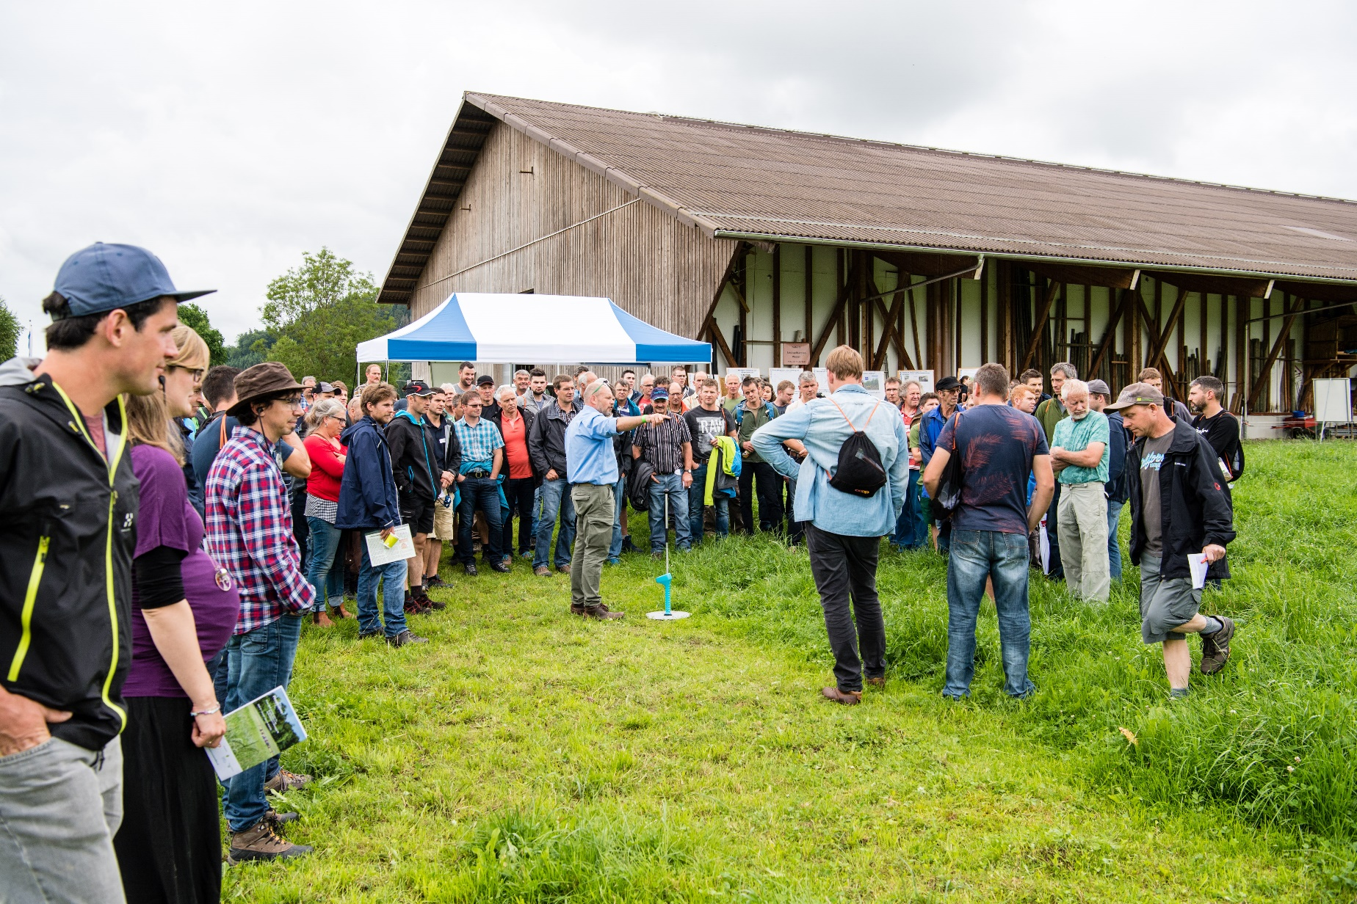
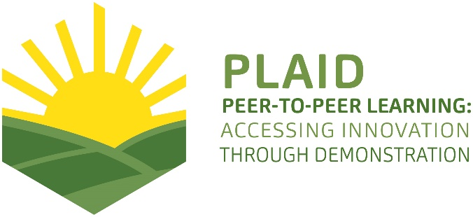
This project has received funding from the European Union’s Horizon 2020 research and innovation program under Grant Agreement No 727388

PLAID PARTNERS

Advisory Service Croatia ASC | 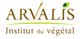  ARVALIS Institut du Végétal | Association de Coordination Technique Agricole ACTA
Institute for Rural and Regional Research | 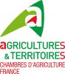  Chambers of Agriculture | Delphy
European Forum for Agricultural and Rural Advisory Services EUFRAS | Innovatiesteunpunt ISP | 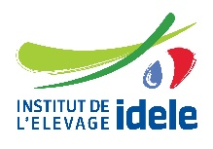  Institut de l’Elevage – Idele
Instituto Navarro De Tecnologías E Infraestructuras Agrolimentarias | Linking Environment and Farming LEAF | 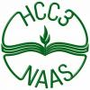  National Agricultural Advisory Service
Nodibinajums Baltic Studies Centre (BSC) | Research Institute of Organic Agriculture (FIBL) | Stichting Wageningen Research
The James Hutton Institute | VINIDEA

DOCUMENT SUMMARY

__________________________________________________________________________________
Milestone Title: 24 Case Studies
__________________________________________________________________________________
Case Study Title: PROVIEH (CH2, Switzerland)
__________________________________________________________________________________
Version: 2
__________________________________________________________________________________
Task Lead: WUR
__________________________________________________________________________________
Related Work package: WP5
__________________________________________________________________________________
Authors: Frick Rebekka with support from Alföldi Thomas, Huber Kathrin, Moschitz Heidrun (all FiBL)
__________________________________________________________________________________
Grant Agreement Number: 727388
__________________________________________________________________________________
Project name: PLAID
__________________________________________________________________________________
Start date of Project: January 2017
__________________________________________________________________________________
Duration: 30 Months
__________________________________________________________________________________
Project coordinator: The James Hutton Institute
__________________________________________________________________________________
Pictures: © Bio Suisse/Marion Nitsch

ABSTRACT
The Organic Cattle Day 2018 was organised by Bio Suisse (association of organic farmers in Switzerland), and FiBL Research Institute for Organic Agriculture in collaboration with the agricultural centre of Lucerne and its advisors for organic agriculture, the regional organic farmers’ association as well as the host farm. It was the first event of its kind and was held in Central Switzerland. The event is embedded in the PROVIEH programme by Bio Suisse aiming at fostering farmer-to-farmer learning in the realm of cattle and animal husbandry.
The Organic Cattle Day 2018 took place on June 12th and its focus was on exchange of agricultural practice, extension and research on organic cattle husbandry. The event included sessions on grazing strategies, cow breeds, fodder, biodiversity, husbandry conditions and milking process, parasites and veterinary medicine, cost accounting, etc. Various sustainability aspects played an important role, in particular grassland based feeding.
The core of the event were fourteen thematic sessions on the above described contents and one session with short testimonies by seven innovative farmers. Each thematic session usually had several speakers including both farmers and advisors or scientists. The visitors could flexibly choose the sessions according to their interests and time. The sessions’ contents were of high practical relevance and were complemented by the participants’ involvement and exchange of experience.
TABLE OF CONTENTS
1 Demo context 6
1.1 The value chain 6
1.2 Typical farm characteristics 6
1.3 AKIS 6
1.4 Sustainability challenges 7
2 Demonstration summary 7
3 Governance: set up and organisation 8
3.1 Organisers and history 8
3.2 Funding 9
3.3 Host 9
3.4 Gender 10
3.5 Objectives 10
3.6 Topics 11
3.7 Access 12
4 Demonstration event 13
4.1 Visitors 13
4.2 Communication & Mediation 14
4.3 Active participation 16
4.4 Doing business 18
4.5 Role of sustainability 18
4.6 Unforeseen circumstances 19
4.7 Plans vs. practice 19
4.8 Participants feedback 20
5 Motives, learning and networking 21
5.1 Reasons to attend demos 21
5.2 Forms of learning 22
5.3 Content of learning 24
5.4 Outcomes of learning 25
5.5 Networking 26
6 Anchoring: Application of demo lessons by participants 27
6.1 Anchoring related to the present demo 27
6.2 Stimulating anchoring 28
6.3 Anchoring related to earlier demos 30
7 Scaling: Application of demo lessons by the wider farming community 31
7.1 Retrospective examples of scaling 31
7.2 Prospective assessment of scaling: Impact pathways 32
8 Case study reflection 33
8.1 Facilitating and impeding factors for successful demonstrations 33
8.2 Impact of demonstrations 34
8.3 Key lessons from this case study 34
9 Annexes 37
9.1 Data sources 37
9.2 Data collection methods 37

Demo context

The value chain
The focus of the Organic Cattle Day is on organic beef and milk production. The value chain of these products is characterized by agricultural production (cattle farms), processing (dairies and slaughterhouses/butcheries) as well as retail companies. Furthermore, the organic beef and milk production also includes companies providing equipment and machinery (e.g. milking parlour, management of grasslands), as well as fodder and medical treatment (DMLA). The Organic Cattle Day targets mainly producers and agricultural advisors. (EAIO)

Typical farm characteristics
The organic beef and milk production in Switzerland is characterized by small to midsize family farms with a high level of professionalization. It is a very common agricultural branch as a majority of farms are livestock farms or mixed farms with both animal and plant production. This is particularly the case for organic farms as they put a strong focus on the closure of nutrient cycles (fodder, fertiliser). In organic farming, only limited use of concentrate fodder is allowed. The regulations for the Bio Knospe – the most important label for organic products in Switzerland – prescribe that the fodder for cattle consists of 10 per cent concentrate fodder at most. Organic agriculture not only differs from conventional agriculture in terms of fodder but also in terms of husbandry conditions, free-range and medical treatments. Herbal medicine and low inputs of antibiotics play an important role. (DMLA)

AKIS
Generally, the Agricultural Knowledge and Innovation System (AKIS) of organic cattle husbandry does not fundamentally differ between the different regions in Switzerland. In terms of education, agricultural schools play the most important role. They offer specialized courses on agriculture. Apprentices can get a specific diploma for organic agriculture if they spend at least half of their vocational training on an organic farm and if they attend at least 240 lessons in organic agriculture. Mostly, apprentices in organic agriculture study at the common cantonal agricultural schools together with apprentices in conventional agriculture. However, there are also two specialized schools for organic in Switzerland. (DMLA)
Organic farmers are supported by specialized advisors at the cantonal level as well as by the national organic farmers’ association Bio Suisse, the regional organic farmers’ associations and research institutes. In terms of research on organic agriculture, FiBL Research Institute of Organic Agriculture plays the most important role in Switzerland. Looking at the cattle branch, the programme PROVIEH by Bio Suisse and FiBL focuses on the exchange of experience among farmers. Moreover, courses on organic cattle husbandry are organised by FiBL, Agridea (national agricultural extension organisation), Agroscope (national agricultural research organisation), agricultural schools as well as farmers associations. (DMLA)
Apart from institutions focusing on education and training on organic cattle husbandry, also media such as journals and the internet and the direct exchange among farmers play an important role when it comes to knowledge and innovations. (DMLA)

Sustainability challenges
The beef and milk production has considerable negative impacts on the environment. There is a considerable nitrogen surplus (i.e. ammonium, nitrate, nitrite; nitrous oxide) leading to negative impacts on water quality, to eutrophication and losses in biodiversity and to climate change. The emissions occur both in conventional and organic agriculture. They are however less important in organic cattle husbandry due to lower inputs of concentrate fodder (which is often imported from abroad or from other farms), to renunciation to mineral fertilizers and to reduced tillage in arable farming. Moreover, cattle is an important source of greenhouse gas emissions, i.e. methane, due to their ruminant digestions system. Moreover, health issues are an important topic when it comes to cattle husbandry. An important and very recent topic is the resistance to antibiotics. In organic agriculture, only very limited use of conventional medicine is allowed. The use of antibiotics is much lower as compared to conventional agriculture. Finally, animal husbandry always involves questions on whether the animals are held in species-appropriate conditions. This includes the design of barns, opportunities to move freely, also outside on pastures, transportation, rearing, etc. The husbandry conditions are much stricter in organic agriculture as compared to conventional agriculture. (DMLA)
In economic and social terms, the organic beef production partly faces similar challenges as the entire agricultural sector such as low milk prices, pressure from deregulated markets as well as low income. An important issue in terms of cost-efficiency are the high costs for concentrate fodder. In organic agriculture, the use of concentrate fodder is very limited. This results however in lower yields. Moreover, in Swiss organic cattle husbandry there is the problem that two third of the 50’000 calves that are born every year is lost to the conventional sector because there are not enough farms rearing organic calves. One approach to address this issue is to foster production systems with mother- as well as nurse-bound calf rearing. Moreover, converting to organic agriculture often includes high investment costs for adapting the infrastructure, e.g. barns, to the requirements of organic agriculture. (DMLA)
However, there is a strong increase in the demand for organic products in Switzerland. This includes also an increase in demand for ethically produced meat. This is an opportunity for all organic farmers and for farmers who are considering converting to organic agriculture. Furthermore, also the development of the agricultural policy can be an opportunity in the future, as the government aims at focusing its support measuring more on the delivery of public goods. (DMLA)

Demonstration summary
The Organic Cattle Day (German: Bioviehtag) 2018 was organised by Bio Suisse (association of organic farmers in Switzerland), and FiBL Research Institute for Organic Agriculture in collaboration with the agricultural centre of Lucerne and its advisors for organic agriculture, the regional organic farmers’ association as well as the host farm. It was the first event of its kind and was held in Central Switzerland. It is embedded in the PROVIEH programme by Bio Suisse aiming at fostering farmer-to-farmer learning in the realm of cattle and animal husbandry. (EAIO)
The Organic Cattle Day 2018 took place on June 12th and its focus was on exchange of agricultural practice, extension and research on organic cattle husbandry. The event included sessions on cow breeds, fodder, husbandry conditions and milking process, parasites and veterinary medicine, cost accounting, as well as testimonies by farmers. The day was organised into 14 thematic posts and farm testimonies which were hosted by more than 30 speakers. The sessions were held in seven defined time slots in the course of the day. In each time slot, seven posts ran in parallel and each post was repeated three to four times during the day. A buffer of ten minutes each was planned in for changing between posts. As a result, farmers could put their individual program together according to their interests and time; there were no guides to guide groups of visitors from one post to another. (EAIO, PO)
The Organic Cattle Day is part of the PROVIEH programme. PROVIEH is a concept and approach based on farmer-to-farmer-learning on topics related to organic cattle husbandry. The concept consists of decentral farmers’ working groups of limited size (about 10 members) and similarly decentral stable visits of slightly larger groups of farmers who meet at one farm, accompanied by some input from advisers and/or researchers. The programme has been running since 2014 and was developed by Bio Suisse in close cooperation with FiBL, the cantonal agricultural centres and regional organic farmers associations. (EAIO; EPIO) PROVIEH participants are farmers with livestock farms or mixed farms. So far, more than 2100 farmers have participated in 83 information events and stable visits throughout Switzerland. PROVIEH stable visits offer an insight into interesting farms and an exchange of experience in organic livestock husbandry among colleagues as well as with veterinarians and consultants. (EAIO; DMLA)
Homepage of the Organic Cattle Day 2018: https://www.bioviehtag.org
Homepage of the PROVIEH programme: https://www.bio-suisse.ch/de/provieh.php

Governance: set up and organisation

Organisers and history
The main organisers of the Organic Cattle Day 2018 are Bio Suisse and FiBL. They organised the event in collaboration with the agricultural centre of Lucerne and its advisors for organic agriculture, the regional organic farmers’ association as well as the host farm. It was the first event of its kind and was held in Central Switzerland. (EAIO; EPIO) In terms of labour division for the organisation of the Organic Cattle Day, Bio Suisse and FiBL mostly focused on the general organisation and administration of the event. The agricultural centre brought in technical competence and contribution to the focus and conception of the event. The regional organic farmers’ association helped setting up the event, e.g. setting up a pole tent, etc. The host farm provided the infrastructure and catering services. The group of organisers was composed by people who all have known each other for a long time and who have collaborated on other projects/events. The main organisers state that there is a high level of trust within this group of organisers. (EPIO)

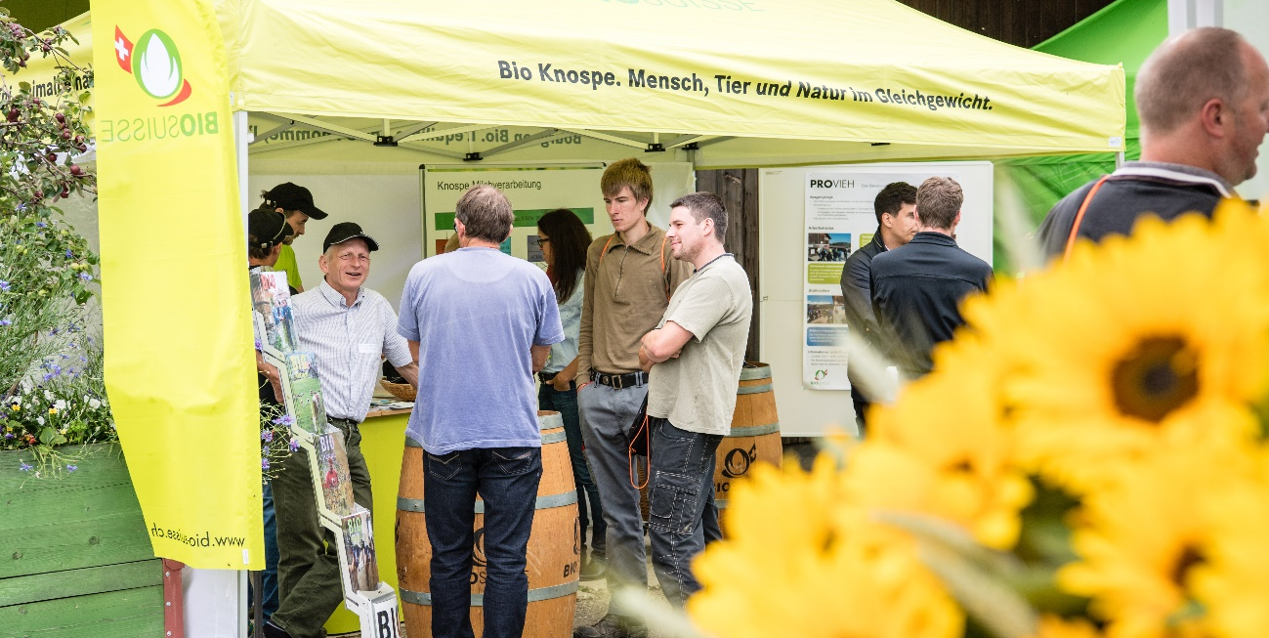
Figure 1: Exhibition stand of Bio Suisse at the Organic Cattle Day 2018.

Funding
The participation was free of charge. (EAIO)The Organic Cattle Day was funded through sponsoring by a retailer and a foundation as well as through the budget of the PROVIEH programme. The organisers aimed at being independent from funding and sponsoring from companies such as the fodder industry. There was an exhibition area at the event including breeders, cattle traders, certification bodies, label organisations, among other. The event was however not funded by sponsoring through these exhibitors. The focus should lie on information and knowledge exchange. (EPIO)
The organisers state that the aim of being independent was reached and that they were in a lucky position not having to spend a lot of effort on fundraising. (EPIO)

Host
The main selection criteria for the hosting farm were that it should be easily reachable, it should be in an area where there are local organisations with committed people and it should have the infrastructure and space to host an event of such a format. (EPIO)
The host farm is located in Central Switzerland in an area that is easily reachable from most parts in Switzerland. Moreover, in this region there are local institutions (agricultural centre and regional organic farmers’ association) with very engaged staff members. (EPIO)
The host farm is very diverse farm including agricultural production as well as food processing (cheese, meat, honey, bread). It is ideal to host events because they have the experience and the catering infrastructure for a large number of people. At the same time, it has a visitor centre including museum and restaurant. Moreover, the farm is one of the producers of RegioFair products. RegioFair is a marketing platform for organic and fair products from Central Switzerland. (DMLA)

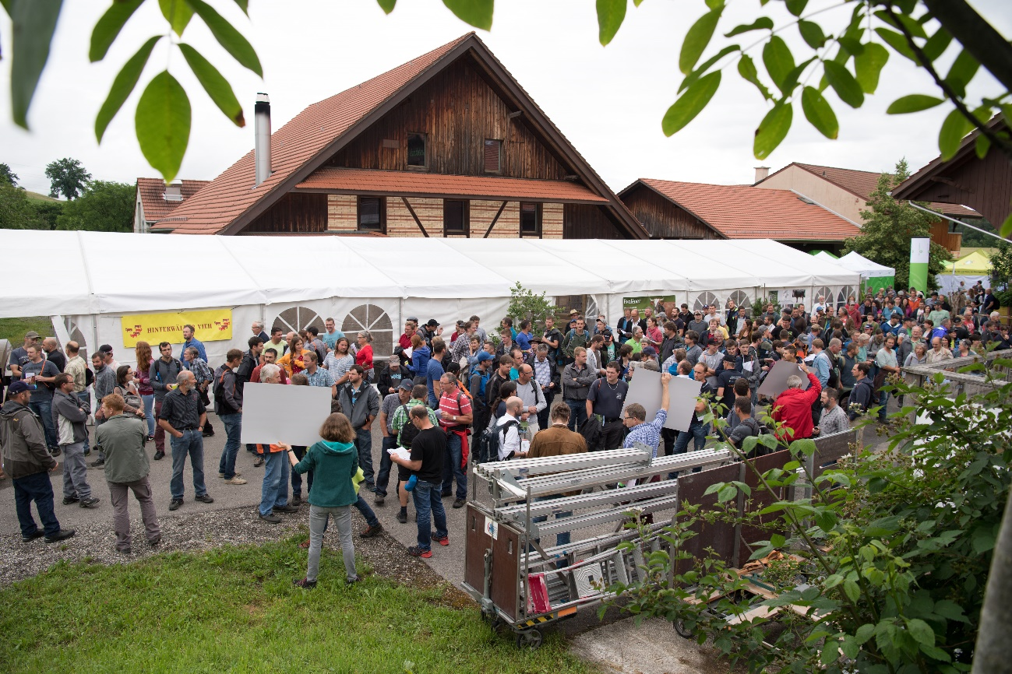
Figure 2: Host Farm of the Organic Cattle Day 2018.
The focus of the agricultural production is on organic milk production with about 70 cows in a spacious loose housing barn. It is a grassland-based milk production system with the cattle being on the pastures most of the time. Apart from cattle, the farm hosts about 1000 chickens as well as an orchard with old fruit varieties. The farm is labelled with the organic Bio Knospe label. It is jointly managed by two families. (DMLA; PO)

Gender
The group of organisers is composed to the largest extent by men. The women involved were in charge of organisational issues and coordination of the entire event. The picture looks different when focusing on the speakers of the thematic sessions: More than one third of the speakers were women (13 out of 37). This represents the general composition of event’s visitors (see 4.1).

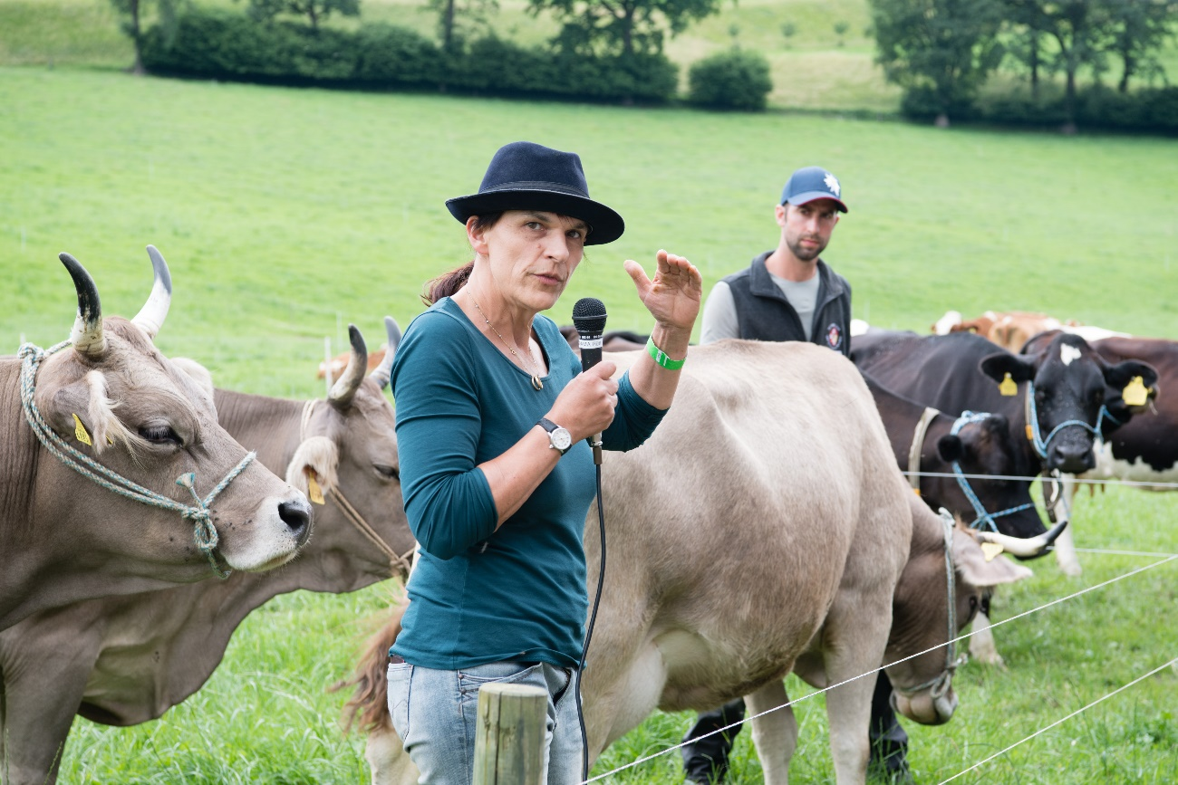
Figure 3: Speaker of one of the thematic sessions at the Organic Cattle Day 2018.

Objectives
The main organisers’ aim was to provide a platform for knowledge exchange with a strong focus on farmer-to-farmer learning. The other organisers may of course have differing objectives which could however not be assessed in the framework of this project. The event should awaken interest for certain production systems and techniques and to provide a platform for socialising among the farmers. Moreover, it should advertise the PROVIEH programme (see 3.1) in which the Organic Cattle Day is embedded. There is a strong focus on farmer-to-farmer learning in the PROVIEH programme which was also important during the Organic Cattle Day while also focusing on bringing in other actors such as advisors and researchers. (EAIO)
Figure 4 shows how the Organic Cattle Day is positioned in the PLAID typology to describe the demo’s focus. In terms of leadership, both the PROVIEH program and the Organic Cattle Day were launched by institutions, i.e. Bio Suisse and FiBL. The PROVIEH program is however based on the principle of farmer-to-farmer learning. The institutions provide the format and help organizing the event, but the contents are determined by the participating farmers themselves. Also the moderators are farmers. The Organic Cattle Day is embedded in the PROVIEH program and the organizers aimed at keeping the farmer-to-farmer learning approach. The program of the demo event was designed by the organizers though. The team of organizers is however very close to farmers and includes farmers as well (regional organic farmers association, host). The speakers of the farmer testimonials session were all farmers and about half of the thematic sessions were co-led by farmers. (EAIO, EPIO, DMLA)
Moreover, the event put a strong focus on public-good orientation by focusing on organic agriculture including topics such as stress-reduction and good treatment of animals, reduction of concentrate fodder and antibiotics, improving biodiversity, etc. At the same time, it included commercial components by looking at the market situation and at farm specific cost accounting. At the same time, the organizers decided not to have representatives of the agricultural industry selling their products at the event (see 3.2). (EAIO, EPIO, DMLA)

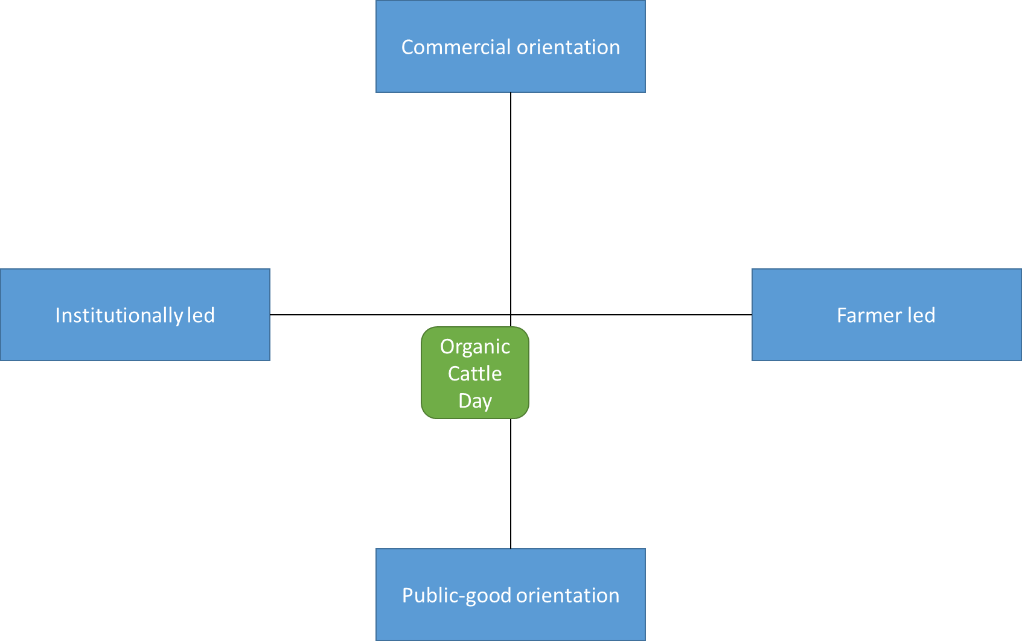
Figure 4: Positioning of the Organic Cattle Day in the PLAID typology for demo focus.

Topics
The fourteen sessions covered a broad range of topics in relation to organic cattle husbandry. Generally, the topics of the single thematic sessions were quite specific and there was a lot of overlapping and connections between the single sessions. There were several sessions on grassland-based fodder, the reduction of concentrate fodder, on pasture management and grazing strategies. This also included a session on the interrelationship of species diversity on pastures and fodder quality. Other sessions focused on site- and farm-specific breeds including breeds specialized on grassland-based fodder. One session put a special focus on the quality of grassland-based meat. Moreover, health issues were important topics ranging from how to regulate parasites on pastures, to, to the use of medical plants and the reduction of antibiotics. In relation to that, also questions like how to reduce stress for the animals and how to improve the milking process were addressed. Furthermore, there were two session addressing farm-economic issues and the cost-efficiency of grass-land based production systems. Finally, one session presented the approach of the PROVIEH working circles on cattle husbandry. Apart from the thematic sessions, there were the farmer testimonials which were short presentations by innovative farmers. This session was less specific but rather focused on giving a short impression of these individual farms. (DMLA; PO)
Organic cattle husbandry was chosen overall topic because it is the general focus of the PROVIEH program out of which the event arouse. We could not assess to what extent the organisers knew the visitors’ needs beforehand and to what extent they chose the topics based on these needs. The fact that the organization group is very close to the farmers’ community however suggests that this was given thorough consideration. Generally, the topics offered at the Organic Cattle Day can be described as supply-driven rather than demand-driven. The topics were mostly about concrete challenges which farmers face when implementing a certain approach (supply) and less so about pull factors and market developments (demand). At the same time, the focus on grassland-based milk and beef production was probably also determined by the increasing demand for such products but more importantly by the organic farmers association’s decision to foster grassland-based systems. For future events, the organizers are considering including other animals (e.g. small ruminants, pigs) as well. (EAIO; EPIO; DMLA)

Access
The target audience of the event were farmers – especially organic farmers – interested in organic cattle husbandry from Switzerland. The organizers hoped to attract not only those farmers who are generally very engaged in the organic movement but to have representatives of the entire organic farming sector. The geographical accessibility was a core criterion for the selection of the hosting farm. It should be in a region, which is reachable from most parts of Switzerland, also by public transport. Moreover, the organisers aimed at providing a programme, which invited the visitors to stay the entire day while at the same time also being useful for those visitors who could only attend the event either in the morning or in the afternoon. (EAIO; EPIO) In addition, they aimed at choosing a date that allows as many farmers as possible to attend the event. (EAIO; EPIO) In terms of language, the organisers provided translation services for French speaking people. (PO) The organisers did not mention that they specifically focused on gender issues when choosing the host farm and when designing the format of the event. (EPIO)

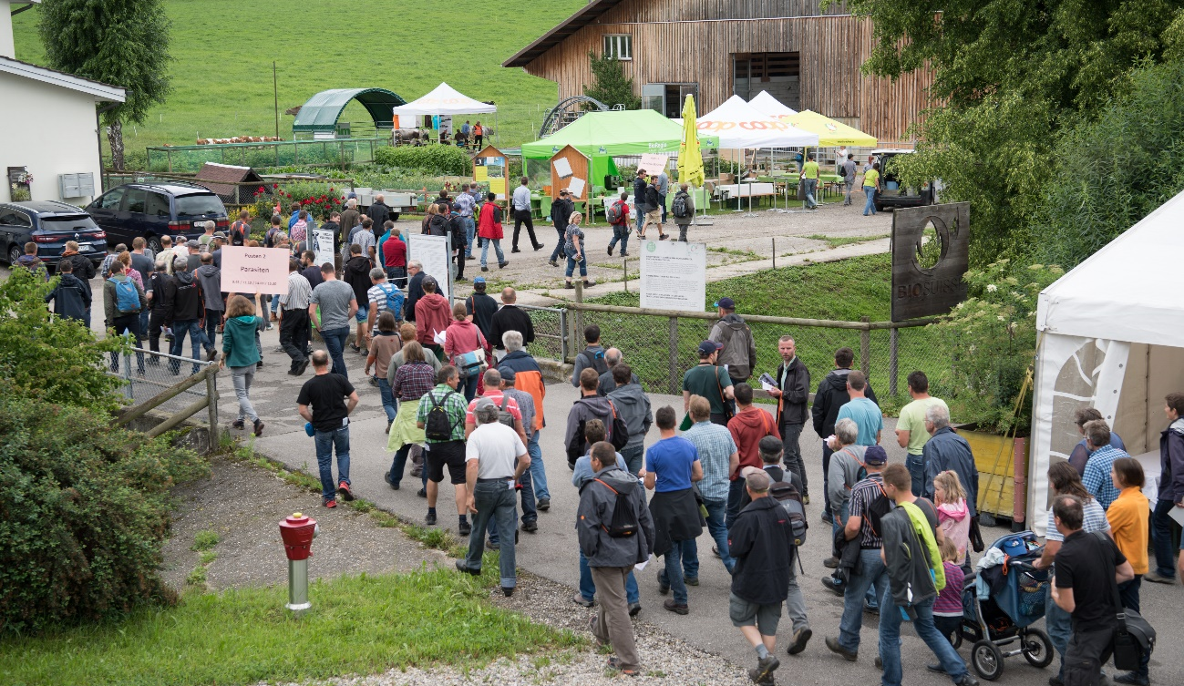
Figure 5: Visitors of the Organic Cattle Day 2018 on their way to the thematic sessions.

Demonstration event

Visitors
In total, about 500-600 people visited the Organic Cattle Day 2018. In addition to that, about 150 helped organising the event, held presentations, worked in the exhibitor’s area, organised the catering, etc. Generally, the organisers were happy with the number of people who showed up. (EPIO)
In terms of composition of the visitors, it is difficult to say what percentage of the participants was farmers, advisors, etc. (EPIO, PO) Out of the 62 people whom we interviewed on the day, 58 were farmers. (EIP) This leads to the assumption that the vast majority of participants were farmers themselves. We cannot say however, to what extent these farmers have additional functions such as being advisors, etc. Two thirds of the interviewed farmers farm under the organic production system and one third would be either under conversion to organic agriculture or conventional farms (see Figure 6). All the conventional farmers are farming according to the requirements for integrated production from the IP Suisse association. (EIP)
Figure 6: Production system of the interviewed farmers. (Source: EIP, N=55)
In terms of age, people of all ages were present at the event. The interviewees ages range from 18 to 81, 44 being the mean age. (EIP, PO)
About two thirds of the interviewed visitors were male and one third female (see Figure 7). (EIP) The participant observers estimated that around 20-30% of women were present in the thematic sessions. (PO)
Figure 7: Gender of the interviewed visitors. (Source: EIP, N=60)
About half of the interviewed visitors came from the regions Central Switzerland and Espace Mittelland, being the closest regions to the place where the demonstration took place (see Figure 8). (EIP) During the sessions, it could be observed that there were also some visitors from the French speaking parts of Switzerland. (PO; EPSME)
The possibility to access the event by public transport was used by some visitors. It is however not possible to say how many people came by public transport and how many by car. (PO)

Figure 8: Origin of the interviewed visitors. (Source: EIP, N=62)

Communication & Mediation
In total there were 14 thematic sessions and one “farmers’ sessions” with insights from seven farms. The thematic sessions were each led by one or several speakers who were supported by a moderator. The moderator’s task was to support the speaker in terms of time keeping, taking notes, moderating discussions, etc. The average number of participants of the thematic sessions was around 40, but generally being quite heterogeneous ranging from 15-70 visitors per session. In the farm testimonies sessions, there were around 50-70 visitors. (PO; EPSME)

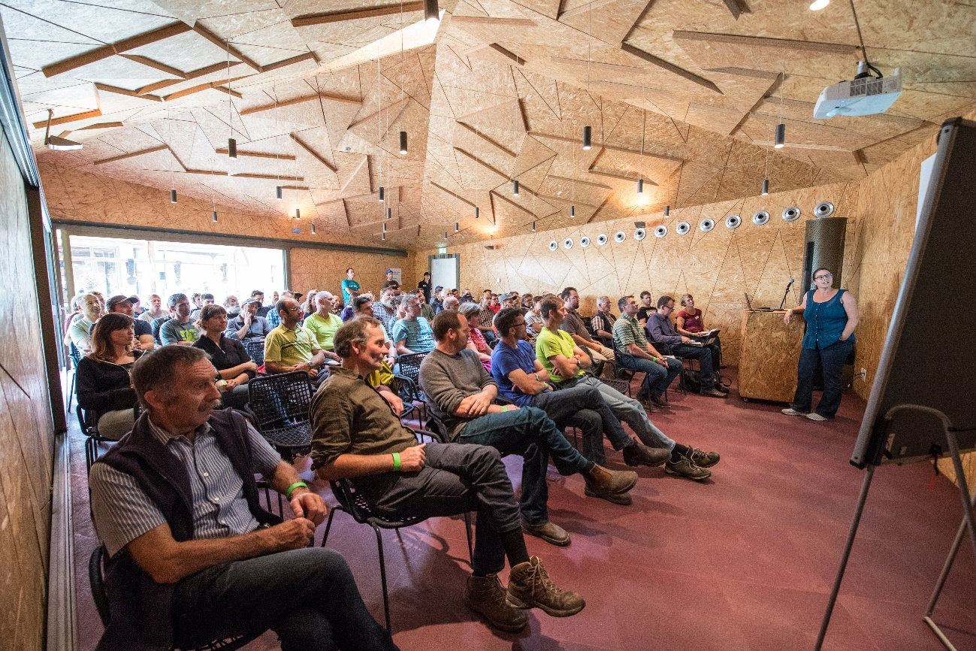
Figure 9: Visitors listening to the farmer testimonials at the Organic Cattle Day 2018.
Quite a lot of the speakers of the thematic sessions were farmers themselves. In some cases, they were however presenting in their role as advisors and/or scientists. In five out of the 14 thematic sessions, farmers were presenting and speaking in their role as farmers. Usually, the sessions were a collaboration between farmers and advisors/scientists, including a theoretical and a practical part. Figure 10 shows the main roles of the speakers of the thematic sessions. As one example, 22% of the sessions were led by one or several persons who spoke in the role of a farmers together with one or several persons who spoke in the role of advisors.
The session on the working circle and the farmers’ testimonies were fully led by farmers. About one third of the speakers were women. (PO)
Figure 10: Main roles of the speakers of the 14 thematic sessions at the Organic Cattle Day. (Source: DMLA)

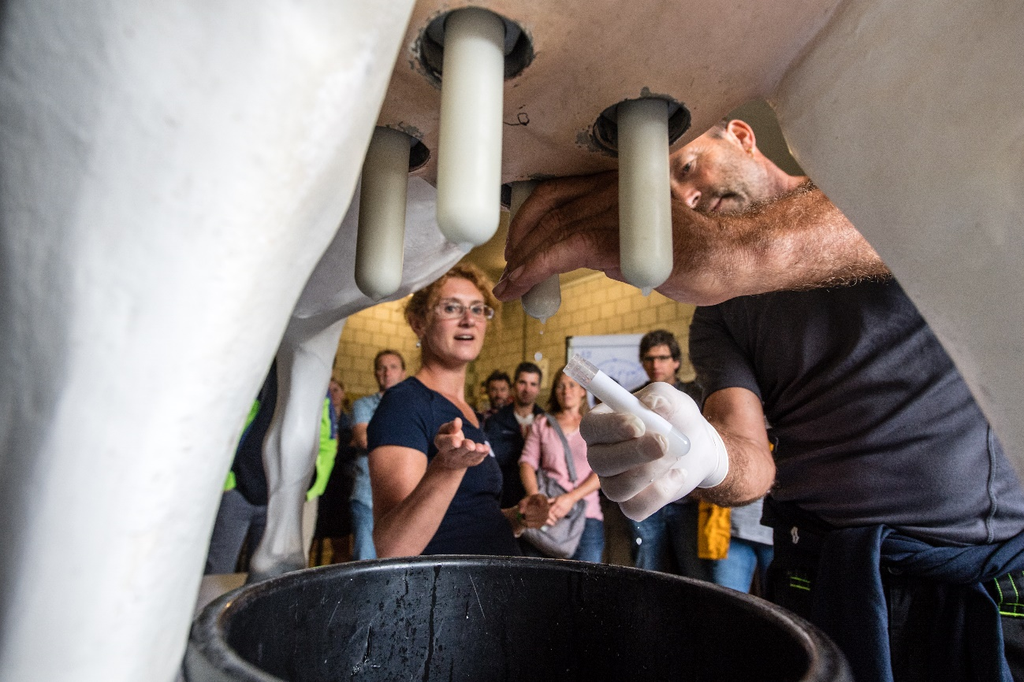
Figure 11: Milking demonstration with artificial cow at the Organic Cattle Day 2018.
The organisers’ aim was to have sessions with a lot of interaction between the different actors involved and not just speakers presenting. The organisers provided a guideline to the speakers on how to structure and organize their sessions and asked them to send a copy back prior to the event. This was to ensure that the speakers would take care of the content of their session early in advance. Generally, this worked out well and there were just a few speakers who would not use this guideline. (EPIO)
There were sessions were an approach and/or tool was demonstrated in practice, sessions where presentations were predominant and sessions which were very interactive. Most of the sessions were divided into a theoretical part on the background and state of research and a practical part involving the actual demonstration activities. The communication and information channels used were very diverse, including power point presentations, posters, pictures, demonstration of tools, animals, pastures, etc., and discussion rounds. (PO)
The session on the working circles was a special format because the focus was on demonstrating the learning approach of the working circles. The visitors and their contributions mainly determined the content of the session. The working circles live from the active participation of the participants. (PO)

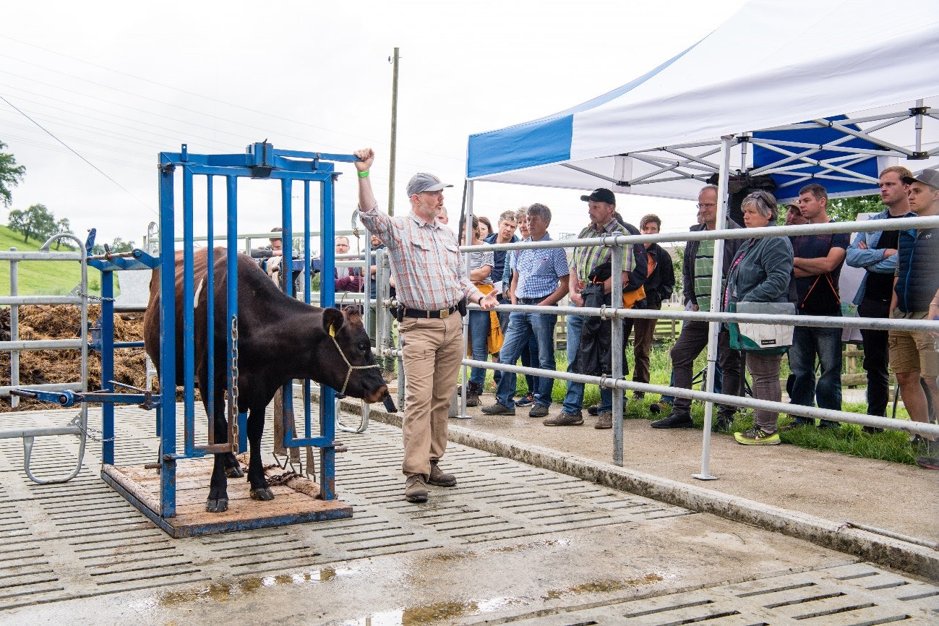
Figure 12: Learning about stress reduction in the hoof stand at the Organic Cattle Day 2018.

Active participation
It was stated by different actors, including the organisers, participants as well as the participant observers that there was a very good ambiance at the event. The participants were very active and engaged. The organisers observed that even after lunch, the participants would go right back to the sessions without taking a longer break. This is different from how it can often be observed at events of this kind. The organisers lead this back to the fact that the programme was attractive and that there was a broad variety of topics presented. There was also an exhibitors area, which was, however, rather a side-stage as compared to how this usually is the case for demonstration events. The organisers state that the participants did not spend much time in the exhibitors area and would rather go right back to the sessions (EPIO).
The program of the Organic Cattle Day was allowing for active participation by providing the opportunity to ask questions and engage in discussions. Generally, the level of participation and attentiveness was quite good. (PO) The survey among the speakers and moderators confirms that the visitors were very engaged and happy to share their experiences and that the visitors could really benefit from this type of peer-to-peer exchange. (EPSME) To what extent people were participating and asking questions differed however strongly between the single sessions. Usually a remark in the beginning, that questions could be asked was not sufficient to engage the visitors. We observed that in the case where the speakers repeatedly gave the opportunity to ask questions throughout the session, the level of participation was much higher. This is especially important before a change of topic within one session. Most successful in terms of the level of participation were those sessions where the visitors were asked to share their personal experiences. Asking the visitors concrete questions about their farms (e.g. What tool do you use? Why do you use that tool?) gave the visitors the chance to learn more about the other participants and their concrete situations and motives. In addition, it shows the visitors that their knowledge and experiences are valuable for other farmers. In one session, the speaker asked a question on the participants’ farm situation in the very beginning and he had the visitors’ full attention right away. In sessions with both theoretical and practical parts, we observed that visitors asked more question in the practical parts though. There was no noticeable difference between the participation level of women and men. (PO)
There was also quite a difference to what extent the visitors expressed different opinions and engaged in discussions with the speakers and other visitors. One example of a topic which did not have the uniform consent by all visitors was the use of iodine for udder inflammations. In some sessions, discussions were encouraged. At the same time, there were speakers who in fact encouraged discussions but still expressed their clear opinion on a topic. (PO)
Different examples showed that with disturbances and acoustical problems, the attention would drop quickly. This happened in different cases, where the speakers would not repeat the questions asked to ensure everyone understood. The level of participation also depended on the volume of the speakers’ voice and on the visibility of what was demonstrated. Microphones were distributed to several session. In those sessions were the microphone was not used and where there was a lot of background noise the level of attention dropped quite quickly and the participants would start chatting and discussing among small groups while the speaker would still present. (PO)

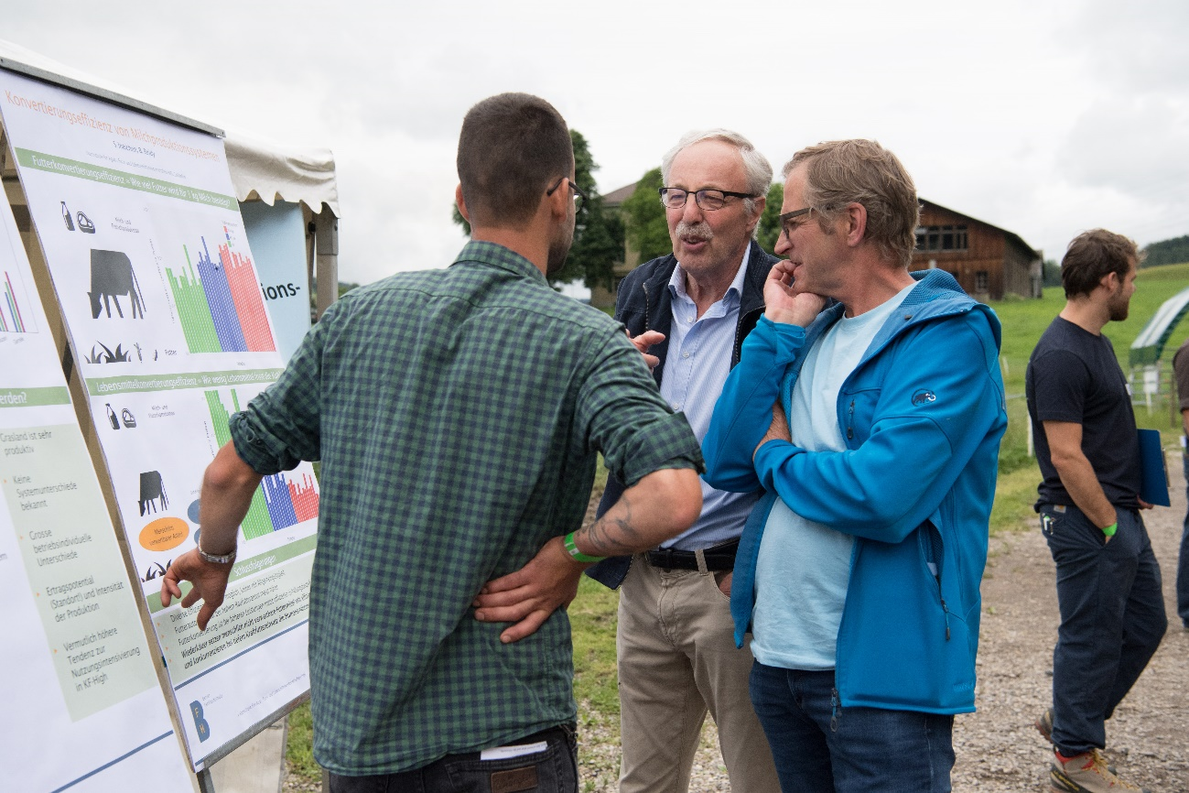
Figure 13: Visitors of the Organic Cattle Day 2018 discussing the contents of a thematic session.

Doing business
The organisers’ aim with regards to the Organic Cattle Day was to focus on knowledge and experience exchange rather than providing a business platform. The goal was to give participants the incentive to visit the sessions rather than spending much time at the exhibitors area. Also, providing the opportunity to sell products could be in conflict with the addressed contents in the sessions. As an example, having a representative of the fodder industry selling their produce would be in conflict with the general efforts to reduce concentrate feed in organic agriculture. (EPIO) During the thematic session, some speakers took the opportunity of advertising their products and services, e.g. advertising breeds, PROVIEH working circles, advisory services etc. (PO) Generally, visitors however appreciated that the Organic Cattle Day was not a business platform. (EIP; EPSME)

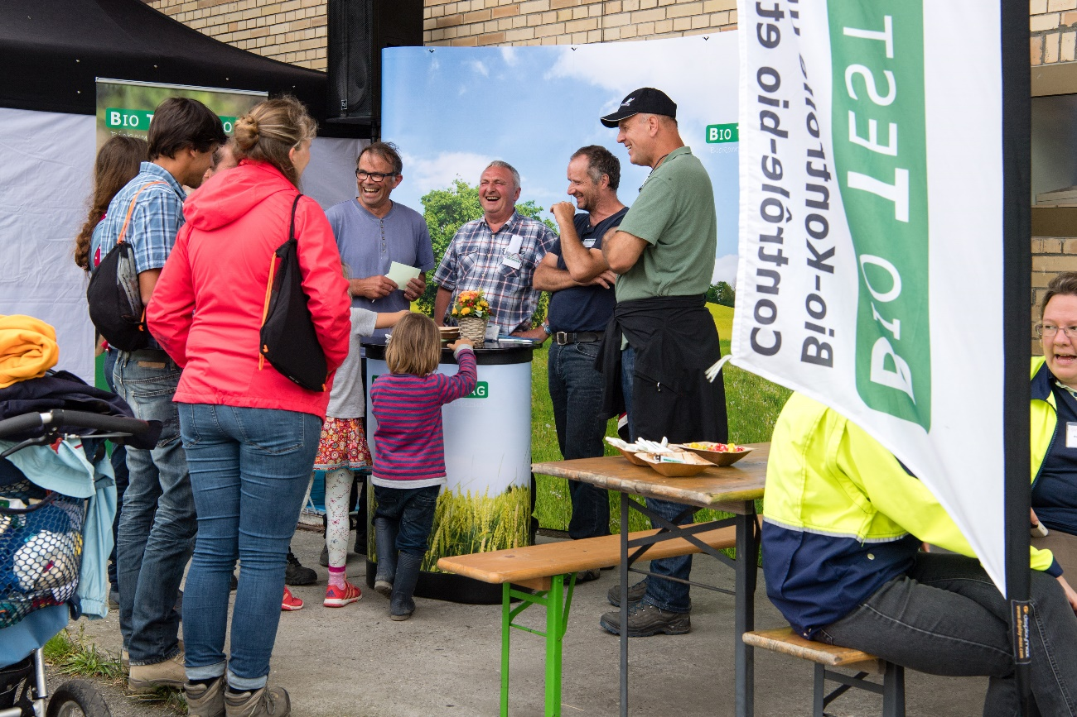
Figure 14: Exhibitor’s stand at the Organic Cattle Day 2018.

Role of sustainability
Sustainability played an important role at the Organic Cattle Day 2018. Most of the thematic sessions as well as the farmers’ testimonials addressed issues related to the different dimensions of sustainability. This included sessions on how and why to reduce concentrate fodder and its implications on breeds and yields. Questions related to biodiversity were addressed, i.e. how to promote biodiversity on grasslands and how fodder quality interrelates with the biodiversity level. In terms of medical treatment, herbal medicine and the reduction of antibiotics was targeted. The latter is relevant both for the health of animals and of humans. Animal ethics and the question on how to reduce stress for animals were discussed. Moreover, the event included sessions on how to do proper farm-level cost-accounting with a special focus on grassland-based farm systems. This includes the focus on the fitness of animals instead on the yearly milk yield as performance indicator. Finally, social issues were addressed in a very interactive session on life quality of cattle farmers. The farmers’ testimonies included the presentation of technologies, which improve the farmers’ working conditions. (DMLA, PO)
Most of the visitors were organic farmers (see Chapter 4.1). This implies that most of the visitors have already considered environmental impacts of agriculture before and are generally interested in learning how to improve sustainability on their farms. This is supported by the fact that so many visitors came to the Organic Cattle Day which mainly was on sustainability-related topics.

Unforeseen circumstances
The weather forecast announced rainy and even stormy weather. The storm didn’t come but the organisers took quite some effort some days prior to the event to be prepared (e.g. taking down the tent, etc.). In the end, the weather was ideal for such a type of event. It had rained for some days prior to the event and the weather was grey but dry during the event. The circumstances were therefore not ideal to work on the farm and the organisers assume that this invited many people to come to the event. At the same time, also a regional “Alpaufzug” (German for: procession of the cows to the Alpine pastures) took place which may negatively influenced the number of visitors at the Organic Cattle Day. (EPIO)
At some sessions, the acoustics were not ideal because of surrounding noises (other sessions, cows, etc.). (PO) The organisers distributed microphones to some of the speakers but not every speaker had a microphone or some preferred not using it. (EPIO) The participants’ attention in these sessions dropped quite quickly. In one session, it could be observed that the speaker would take up the microphone provided towards the end of the session and that led to a sudden increase in participation and attention among the participants. (PO)

Plans vs. practice
The organisers put a lot of thought into the process of the event, i.e. the session sequences and their timing. In total there were 14 thematic sessions and one session with farm testimonies. The organisers were happy with how the participants understood the timing and rotation of the single sessions. The participants were free to choose which session they would go to. All the sessions were well visited, each session having between 15-70 visitors. The difficulty was to organise the sessions in a way that the participants could visit as many presentations as possible. The organisers think that it was really worth the effort of doing a thorough planning and that it worked out very well. In many sessions, we observed that there were people joining the sessions later on or leaving them after some time. Also, the organisers considered to give incentives for participants to stay until the end of the event. This was however not needed as there were still quite a lot of people in the last sessions. (PO; EPIO)
The exhibitor’s area was not much visited. As already stated in 4.3, it was the organisers aim to focus on knowledge sharing rather than selling agricultural products at the event. For the organisers, the low number of visitors in the exhibitor’s area was thus not a surprise. Some exhibitors gave the feedback that the exhibitor’s area could have been better visited. At the same time, they claimed that they were generally happy with the event and that they would come again. The organisers state that they would consider expanding the exhibitor’s area but that given the size and the focus of this year’s event the format was ideal. (EPIO; EPSME)
In terms of visitors, the organisers were happy with the number of people who showed up. There were, however, different numbers circulating (500 vs. 1500) which caused some misunderstandings. Moreover, the organisers hoped to see not only those farmers who are generally very engaged in the organic movement but also others, more from the “middle”, as they called it. They state having seen a lot of familiar faces, also related to the PROVIEH programme, but that actually, there were also quite a lot of unknown people. (EAIO, EPIO)
In terms of general organisation, the organisers state that there could however have been a better labour division among them especially to release pressure from the main organisers. (EPIO) Also some of the speakers and moderators said that there should have been a better and/or earlier coordination among them to better prepare the sessions. (EPSME) Finally, one of the organisers’ objectives was to advertise the PROVIEH program. In retrospect, the organisers say that this was not very successful and that they should have done more activities to advertise the program. (EPIO)

Participants feedback
Generally, the participants were very happy with the programme and the organisation of the event. 57 out of the 62 interviewed visitors stated that the event met with their expectations (see Chapter 5.1). To have the opportunity to exchange with peers and to learn about novelties was very much appreciated. (EIP; EPP) Different interviewees emphasized the importance of such demonstration events because they give the opportunity to get training for free. (EPP) One visitor explicitly stated that he appreciated that the event did not have a commercial focus. (EIP)
We also asked the visitors what they would change in the organisation of a future Organic Cattle Day. Figure 15 shows the categories in which the different suggestions for change fall. In terms of content, 15 respondents gave feedback. Some interviewees would have preferred specific topics being less focused on (e.g. milk production and cattle) and others more focused on (e.g. other animals; fodder quality; nutrient-cycle at farm level; reasons and prevention related to illnesses/diseases; animal expressions). Two interviewees found some sessions to be too scientific and theoretic with a missing link to practice. Five respondents stated that the information conveyed should have been deeper, that less contents should have been offered and/or that the farmer testimonials should have been less but with more details. Quite a number of respondents stated that they appreciated the diversity of the thematic sessions’ topics. (EIP; EPP; EPSME)
About 10 interviewees referred to the organization of the sessions and the general process of the event. Points of critique were that the process was too complicated; that it was not clear enough where to find which session; that there were too many sessions which made it difficult to decide where to go; that the program did not allow to attend all the sessions; that there should have been more chairs/benches at the sessions. (EIP)
There were some other points of critique, including that there was not enough information provided on the organization and structure of the event (e.g. location of the sessions; schedule; announcement of the detailed program prior to the event) and the presentation techniques used (e.g. do shorter presentations; improve acoustics by using microphones in all sessions; make graphs and posters less complex). (EIP) These points of critique were confirmed by the feedback given by the speakers and moderators. (EPSME) When comparing the answers of female and male respondents, no striking differences could be found. (EIP)
The respondents of the ex-post interviews were generally happy with the chosen date of the Organic Cattle Day. For some the date in June may however fall directly into the haying season. (EPP) Most of the respondents of the moderators and speakers survey were happy with the date chosen. The picture is however not very clear as other respondents suggested diverse months between March and November to be ideal depending on a variety of needs (hay season, mountain pasture season, etc.). (EPSME)
As mentioned above, the visitors were generally very happy with the organisation of the event. This is supported by the fact that 24 of the interviewees did not have any critique on the event at all. (EPI) Different respondents mentioned the very good atmosphere and the lively exchanges at the event. (EPI, EPSME)

Figure 15: Answer of the interviewed visitors to the question what they would change in the organisation of a future Organic Cattle Day. (N=62)

Motives, learning and networking

Reasons to attend demos
Attitudes and perceptions
We asked the interviewed visitors about their expectations in regard to the Organic Cattle Day (see Figure 16). The most important expectation was to learn and gain knowledge about organic cattle husbandry (mentioned by 41% of the interviewees). In relation to that, many stated that they expected to discover novelties and innovations about organic cattle husbandry (mentioned by 30% of the interviewees). The third important expectation was to exchange and network with other farmers and with experts (mentioned by 28% of the interviewees). (EIP) For one respondent of the ex-post interviews the presentation of results from research, namely from FiBL, was a crucial content and considered as obvious to be part of such an event. (EPP)
Another interviewee stated that apart from discovering novelties, it was also important to him to get confirmation on approaches and techniques that he is already implementing on his farm. Another interviewee said that he would more likely attend such an event if he is actually planning to do some changes on his farm. (EPP)

Figure 16: Expectations with regards to the Organic Cattle Day among the interviewed visitors. (Source: EIP, N=61)
Norms
Different interviewees stated that they appreciate demonstration events on organic agriculture not only because of the specific issues and topics addressed but also because they can exchange with other organic farmers. The fact that the interviewees expressed such a high expectation in meeting and exchanging with other farmers shows that the visitors really want to hear the opinion and experiences of other farmers. As organic farmers are still a minority, they usually do not have any neighbouring farmers who farm organically and therefore deal with similar issues. Moreover, several interviewees stated that there is a different attitude among organic farmers in comparison to the general farmers’ community and that it is more common to discuss even if there are opposing opinions. (EIP; EPP)
The shift to grassland-based beef and milk production systems is considered a responsibility of the organic movement in Switzerland. (DMLA, PO) A lot of sessions were on this topic and were well visited which leads to the conclusion that the visitors care about the general concerns of the organic movement. (PO)
One interviewee stated that he has already been implementing much of what was taught at the Organic Cattle Day beforehand. At the same time, he still favoured the topics chosen because not all farmers are as advanced as him and should get the chance to learn about them. (EPP) The fact that this visitor not only thinks about his own benefit but also the potential benefit for other visitors suggests that there is quite a strong cohesion among the organic farmers. Another interviewee who is an advisor for organic agriculture and prior farmer however observes that since the organic movement is growing rapidly there is a tendency away from this cohesion and that the farmers are rather concerned about themselves and their farms. (EPP)
In terms of gender, we could not observe that women tended to visit sessions led by women or men tended to visit sessions led by men. The overall share of female visitors was about one third. In the thematic sessions, the share of women ranged from 10 to 36% (estimations) and was not related to whether a session was led by men or by women. Neither could we observe a correlation between female visitors’ attendance and specific topics of the sessions. (PO)
Practicalities
We asked the participants of the ex-post interviews what factors determine whether they actually can participate at such events. The location was mentioned several times. The interviewees stated that they are willing to travel up to 1.5-2 hours to such an event. (EPP) Moreover, the time of the year is crucial. If the event falls into a time with workload peaks, the participation will be very difficult. In this regard, also the weather plays an important role. (EPP)

Forms of learning
The different sessions included a large variety of mediation techniques and forms of learning. Overall, the aural and verbal learning style were predominant with presentations, question and answer sessions and discussions. But also the visual approach was important, including the observation of animal behaviour, the observation of a tool demonstration, the examination of a liver and of milk to assess the animal’s health status, and the evaluation of meat quality. In the farmers’ testimonials session, a lot of pictures of the different farms were displayed, which played an important role for giving the audience an idea of how the farms operate. In some sessions, the visitors were invited to assist or to test a tool or an approach or to taste and smell some products themselves (physical learning style). To a smaller extent, logical elements such as the demonstration of numbers and statistics were applied. Not all sessions included demonstrative elements. Those that did clearly had visitors with higher level of attentiveness and interest. (PO)
In the sessions where the participants were invited to do something themselves, there was often some hesitation. In two sessions, it even happened that none of the visitors volunteered or dared trying. The session on the working circles was a special format because it was almost entirely shaped by the contributions of the participants. This type of format lives from the active participation of the participants and it only works if people actually contribute. The session was organized in such a way that every participant had to contribute. (PO)
Generally, the mediation techniques used were suitable for the contents conveyed. Given the rather big group sizes, it was sometimes difficult for the people in the back to see the demonstration or the slides. The same was true in terms of hearing in the sessions where the speakers didn’t use a microphone. The clear advantage of having posters was that the participants could go read in more detail after the session if they missed something or were interested in getting more information on a topic. Also the posters often turned out to be small meeting points where people met and where discussions on the session’s topic started afterwards. (PO) These observations are confirmed by feedback given by the moderators. (EPSME)
Discussions with the entire group of visitors happened only in very few sessions. This is most probably due to the fact that the group size was usually too big to allow for discussions. Discussions took place either after the sessions or with a small group of people during the sessions while the session was ongoing. The possibility to have discussions following the sessions was actively made use of. As mentioned in section 4.2, some sessions did not have a clear conclusion and take-home message, but passed right to bilateral discussions. What can be seen as a disadvantage in terms of anchoring (see Chapter 6), could also be seen as an advantage because it allows for follow-up discussions on the concrete issues and needs of the visitors. (PO) Moreover, the fact that the event took place throughout the entire day, allowed the visitors to go back to the speakers and ask questions. The survey conducted with the speakers shows that this possibility was made use of. (EPSME)
Generally, the sessions differed in how the speakers and moderators concluded: In some sessions, the speakers would give a short summary and take home message. A few presenters used elements to structure their contents, which help memorizing the most important information. In other sessions, the ending was however not so clear and the presentation shifted over to small group discussions. (PO)
The sessions were organised in a way that speakers would have breaks in between their presentations. This gave participants the opportunity to ask the speakers further questions and to engage into discussions after the session. An opportunity which in many cases was made use of and which was also appreciated by the speakers. (EPIO; PO)

Content of learning
Half of the interviewed visitors responded that the thematic sessions with the various contents were the most interesting about the Organic Cattle Day. The contents and topics which they referred to differentiated among the respondents. This shows that the broad range of topics addressed was ideal for the audience. (EPI) This is supported by the fact, that all sessions were well attended. (EPI; PO) Moreover, we explicitly asked the visitors on whether they were happy with the contents of the thematic sessions (see Figure 17). 93% of the interviewees stated to be either very satisfied or rather satisfied. 7% of the interviewees were not sure and no one was dissatisfied. (EPI) Different interviewees appreciated the topicality and current relevance of the contents chosen. (EPI; EPP)
Figure 17: Answer of the interviewed visitors to the question whether they were satisfied with the topic selection of the thematic sessions. (Source: EIP, N=61)
Generally, it is difficult to relate the number of visitors of the single sessions to specific topics. We could however observe that sessions on efficiency and administration tended to have lower numbers of visitors and sessions on issues related to grazing tended to have most visitors. (PO)
Overall, the sessions mostly included a mixture of research results, farmers’ practical experiences and the advisors’ point of view. Many interviewees state that they appreciated the high level of practice orientation of the sessions. (EPI) This was supported by many sessions’ direct linkages to current political discussions, to legal requirements and the organic regulations as well as to current market situations and developments. (PO) In section 5.4, several examples are given of where the visitors considered the conveyed information as “ready to use” on their farm.
At the same time, one interviewee emphasized that research results are relevant if they are combined with suggestions for practical implementation and that this was well done at the Organic Cattle Day. (EPP)
The depth of the information conveyed differentiated among the different sessions but generally the topics were rather specific and including the demonstration of the practical application and implementation. From the questions asked by the visitors and the discussions we can conclude that the depth of the contents was ideal for most of the visitors. (PO) This is confirmed by the result of the survey conducted with the visitors (Figure 18). (EIP) One interviewee stated that he didn’t consider the event to be a course where he would learn an approach in very detail but that it provides basic information and inspiration which is needed to decide whether to continue on the topic or not. Another interviewee however would have appreiciated more depth and focus and less topics offered. (EPP)
Figure 18: Answers of the interviewed visitors to the question whether they were satisfied with the depth of the contents conveyed. (Source: EIP, N=59)
The farmers’ testimonials session differed from the thematic sessions in the sense that the focus was on the presentation of the business models of forerunner farms. The single farmers’ testimonials were quite short and would rather stay at a general level giving an overview rather than specific information. Unfortunately, this short format did not allow to get much background information about the farmers’ motives on why they decided to change their production system and what their experiences are. (PO)

Outcomes of learning
We asked the visitors what they found the most interesting at the Organic Cattle Day. Many interviewees responded that the actual demonstration of a technique or a tool was most interesting to them (e.g. production of herbal medicine, demonstration and evaluation of different types of cows for grazing, demonstration of the barn, pasture management, stress reduction for animals, etc.). One farmer stated that this gives the opportunity to directly compare to the own farm and practices. Another farmer directly referred to the problems on his farm related to parasites and stated that he learned why this is an issue on his farm. A third farmer appreciated that the approach (Low Stress Stockmanship) is easy to implement. This shows that she thought about the situation on her farm and considered how to implement it there. Another interviewee referred to the reduction of antibiotics. He learned that there is already a long-time positive experience with reduction of antibiotics and stated that this encourages him to make changes on his farm. Visitors from abroad stated different times, that they directly compared the presented contents to how it is generally done on farms in their countries. (EIP)
Various sessions directly involved the needs and topics of individual farmers. One speaker clarified in the beginning that his session would be on parasites of cattle and not of small ruminants. This gave the visitors an idea on how relevant the session would be for their farm. The visitors could flexibly change between the different sessions. In many sessions, we observed that there were people joining the sessions later on or leaving them after some time. Generally, sessions which were relevant for all farmers such as the session on stress reduction in animal handling were very well visited. (PO)
The level of participation (see chapter 4.3) can be considered as an indicator to what extent the visitors processed the information and related it to their individual farm situation. As described above, the level of participation was generally quite high but differed between the single session. Some speakers actively asked the visitors about their experiences with regards to specific techniques and tools. These sessions tended to have more contributions by farmers. On the other hand, there were also sessions with only little interaction where it is difficult to say whether the contents were relevant for the visitors. There were also differences in whether the participants had critical remarks or were sceptical about what they just learned. In the cases where there were critical remarks, we observed that these participants actively considered what could be the problems to apply what they heard to their farm. (PO)
Often, what the interviewees stated to be most important is not what they said to be their main expectation for coming to the Organic Cattle Day. This shows that the visitors learned something new which they have not considered to be so important to them beforehand. (EIP)

Figure 19: Visitors at the Organic Cattle Day 2018.

Networking
The event was an ideal place for networking which was highly made use of. The interviewees appreciated that the event gave them the chance to meet and exchange with colleagues. There was a lot of interaction between the participants. This was the case mostly during lunch break, between the sessions or also during sessions in the case were participants of one session would stand together and continue discussing a topic. The event provided a lot of space for interaction and networking and it was designed in a way, to allow participants complete flexibility on whether to continue from one session to a next session or to continue discussing a topic even after one session was finished. (EIP; PO; EPP; EPIO) Different interviewees stated that it was important to them to get to meet the people who offer courses on specific topics and to know whom to get back to when questions arise. (EPP) Some exhibitors stated that they invited customers to attend the event and took the event as a chance to network and exchange with them. (EPSME) Different interviewees explicitly referred to the importance of the social dimension of networking and that they appreciated meeting and socialising with farmers from all over Switzerland. (EPP)
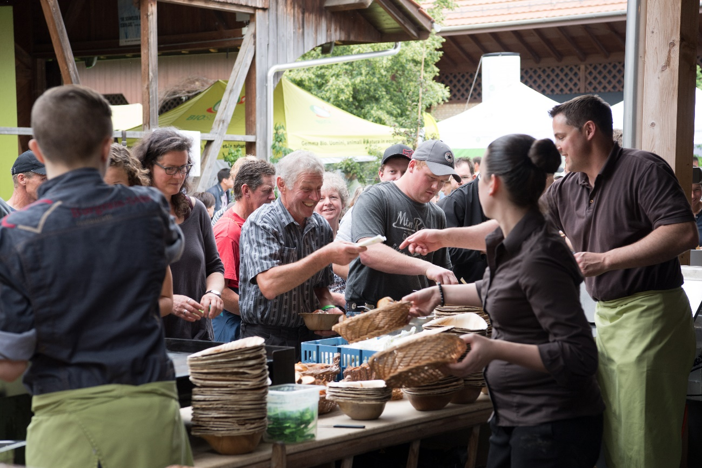
Figure 20: Lunch break at the Organic Cattle Day 2018.

Anchoring: Application of demo lessons by participants

Anchoring related to the present demo
The organisers’ main focus was on knowledge sharing, to awaken interest for certain production systems and techniques and to provide a platform for socialising among the farmers. Whether or not farmers actually do implement what they learned during the demo event is difficult to evaluate for the organisers. (EPIO) From the interviews with the visitors, we learned that they appreciated the high level of practicability of what they learned at the event. In 5.4, we already described different cases where the visitors compared to their own farm thinking about whether and how to implement what they learned in their farm. (EIP)
We asked the visitors on the day of the event whether they are planning to implement some of what they learned on their farm (Figure 21). Two thirds of the interviewed visitors responded that yes, they are planning to implement some of what they learned and one third was not sure yet. No interviewee stated that he or she was not planning to implement something. We didn’t ask them what they were planning to implement but three interviewees gave us this information anyway. One of them said that he was planning to implement what he learned in the session on stress reduction, namely how to reduce stress for animals when being transported. Another interviewee stated that he was planning to bring the cattle to the pastures earlier in the year. Finally, a third interviewee stated that he was planning to give less concentrate fodder. (EIP) The fact that these interviewees specified what they were planning to implement leads to the assumption that they are really planning to implement something and are not just saying so. As we did not ask this question to all the interviewees and can therefore not make conclusions on how the general picture over all interviewees looks like.
Figure 21: Answer by the interviewed visitors to the question whether they are planning to implement something of what they learned at the Organic Cattle Day. (Source: EIP, N=62)
About half a year after the event, we carried out ex-post interviews with eight visitors. Most respondents stated that they followed up on the event’s topics in the meantime. One respondent has been busy with the arable farming but he is planning to follow up on these topics in winter. One referred to a strategy day on breeding that he attended in the meantime. Also, he stated that he didn’t exchange with peers much on the topic in the meantime. Another respondent stated that he called the speaker of one of the sessions in order to ask him something. Several respondents referred to the documentation provided at the event and that they had a look at that again. (EPP)
In terms of implementation, all the respondents stated that they are still planning to implement something of what they learned at the event. One respondent said that he already started implementing one approach he learned at the event (grazing strategy). He emphasized that the speaker was really convincing and that he taught differently from what is commonly told in agricultural education. The same respondent also emphasized the fact that it was important to him to get confirmation on approaches he already implements on his farm. Another respondent got interested in applying homeopathy on the animals and is planning to attend a course on this topic in the future. (EPP)

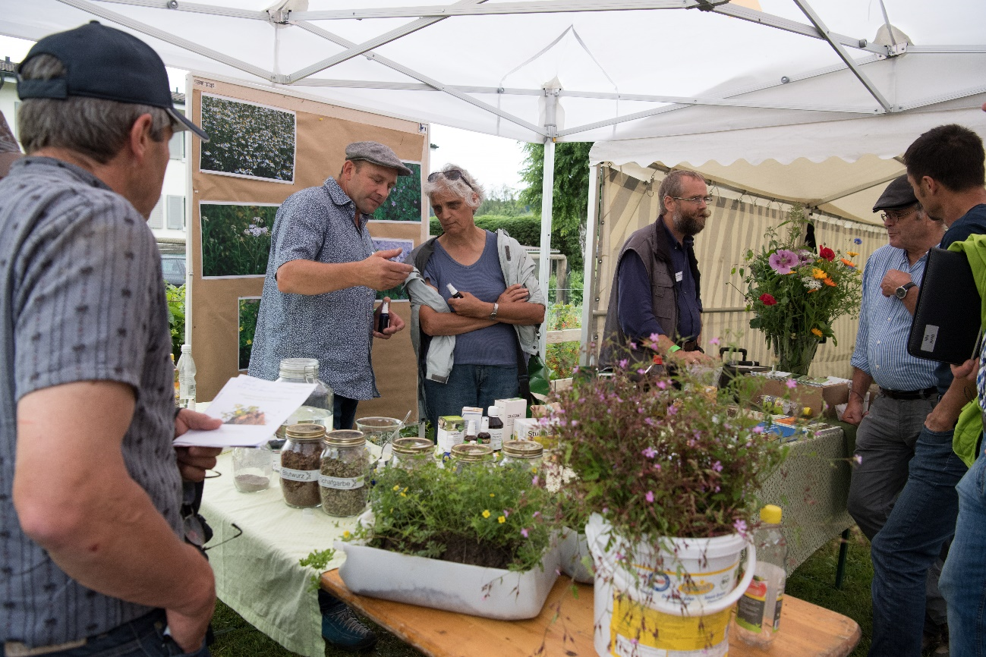
Figure 22: Stand on Complementary Medicine in Cattle Husbandry at the Organic Cattle Day 2018.

Stimulating anchoring
The sessions included different elements that stimulate the anchoring of the conveyed information. Firstly, there were a lot of cross-references and connections between the single sessions which helps memorizing. Secondly, most speakers provided hand-outs to the participants. They were also published on the event’s webpage for downloading after the event. At the event, there were however several sessions where a hand-out was available but not actively advertised so that the participants would often not even realize that there is something to take home. (PO)
Another element that is important to ensure anchoring is to end the sessions with a clear conclusion and take-home-message. In most sessions, this was well done. In others, the ending was however not so clear. One example is a session where the visitors were asked at the end to describe their experiences by putting a sticker on a flipchart. This happened while some of the visitors were already leaving and the results were not summarised to the entire group. (PO) Another approach could have been to do this exercise in the very beginning rather than in the end, and get back to this initial picture at the end of the session.
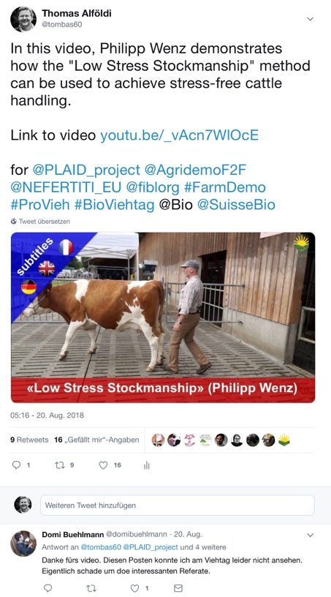
In the interviews we carried out half a year after the event, different respondents said that whether or not they would remember something from such event depends a lot on the speakers. One respondent referred to a specific session that he could clearly remember because of the speaker’s good presentation techniques and convincing arguments. A clear argumentation is crucial especially in the case of topics, which in the past (or even in the present) have been taught differently (e.g. at agricultural schools). One interviewee stated that one session on biodiversity was not convincing because the focus was on optimization of subsidies and not on optimization of the fodder quality. (EPP)
Moreover, the exchange with peers after the sessions was important. One interviewee stated that during such an exchange he realized that quite a lot of his peers already implemented the approach. This showed him that this approach is the right way forward and encouraged him to consider it for his farm. (EPP)
Outside of the event itself, there were/are other activities happening which stimulate anchoring. As explained above, the Organic Cattle Day is part of the PROVIEH programme which organizes working circles and stable visits on a regular basis. Those farmers who participate in these activities will very probably hear again about the topics that were addressed at the Organic Cattle Day. Moreover, the organisers aimed at advertising the PROVIEH programme in order to attract new participants. It is difficult to say whether this was successful. The organisers state that advertising the PROVIEH programme did in the end not play much of a role during the event but that it should be reconsidered when organising such an event in the future. (EPIO)
Figure 23: Twitter post with a video produced at the Organic Cattle Day.
Moreover, the organisers used the event’s webpage to publish the hand-outs and further documentation of the different sessions. In addition, a promo-video of the event, a number of pictures, the press release and various media coverages were published on the website. Different farmers’ media reported on the event. (DMLA) For the PLAID project, learning videos were produced from four of the event’s sessions (Low Stress Stockmanship; Milking Strategies; Ideal Gazing Breeds; Presentation of Swiss Fleckvieh Bull). A twitter post on one of the videos was commented by a participant of the Organic Cattle Day (Figure 23). He appreciates the video because it gave him the opportunity to look into one of the sessions he would have like to attend but couldn’t because of a lack in time. (DMLA)

Anchoring related to earlier demos
The Organic Cattle Day 2018 was the first of its kind. It is therefore not possible to draw conclusions from earlier events. We however asked the interviewed visitors about their three main information sources (see Figure 24). The most mentioned information source are other farmers and farmers’ press. Demonstration events are the third important information source. Among “Other” the interviewees also mentioned the Internet and the PROVIEH working circles (see 3.1) of being one of their three main information sources. (EPI)
One respondent of the ex-post interviews stated that journals and the exchange with other farmers are important. At the same time, he emphasized the importance of demonstration events because from journals he wouldn’t get all the information needed and he wouldn’t get answers to his questions and the exchange with neighbouring farmers is usually not so beneficial to him because they are conventional farmers and don’t deal with the same issues. (EPP)
In some sessions, reference was made to other information sources and also other demonstration events explaining how the approaches conveyed have changed over time. (PO; EPP) In terms of anchoring, it should therefore be considered by organizers and speakers to what extent their approaches differ from what was taught in the past and make sure that they reason well why the new approaches are more suitable, etc.
Most respondents of the ex-post interviews stated that the topics of the Organic Cattle Day were not completely new to them and that they had been dealing with them even beforehand. In some cases, the event provided them with the crucial information that was missing to them or that has finally convinced them to start implementing. (EPP)

Figure 24: Answer to the question which are the three main information sources for the interviewed visitors. (Source: EIP, N=60)

Scaling: Application of demo lessons by the wider farming community

Retrospective examples of scaling
The Organic Cattle Day put a special focus on issues related to grassland-based feeding. The event was the first of its kind but there have been different events in the past ten years, which have promoted the introduction of such feeding strategies. Actually, it is a reintroduction (or so-called retro-innovation) rather than an introduction of fully grassland-based feeding because traditionally, cattle fodder consisted only of grassland and was only complemented with concentrate fodder later. Figure 25 shows some examples of events, which are likely to have influenced the scaling of this feeding strategy. There have been different research projects providing the scientific knowledge on the topic. As part of the agricultural policy 2014-2017 (AP 14-17), special payments for farms with grassland-based feeding (GMF) were introduced. Since 2014, farms who feed at least 75% grassland-based fodder (85% in mountain areas) to their cattle are eligible for the payments. Also in 2014, Bio Suisse and FiBL launched the PROVIEH programme. The programme focuses on organic cattle husbandry including various issues related to fodder and feeding strategies. The programme consists of various demonstration activities such as stable visits and working circles. The current regulations for the Swiss Knospe (bud) label prescribe that 90% of the fodder has to consist of roughages and not more than 10% of concentrate fodder is allowed. In 2018, the general assembly of Bio Suisse decided that from 2022 onwards, the fodder has to consist of at least 95% roughages and only 5% concentrate fodder is allowed. Moreover, in 2016, the general assembly decided that starting from 2018, all farms also have to comply with the GMF requirements (see above), which not only influences the allowed shares of concentrate fodder but also of silage maize (counting as a roughage). (DMLA)
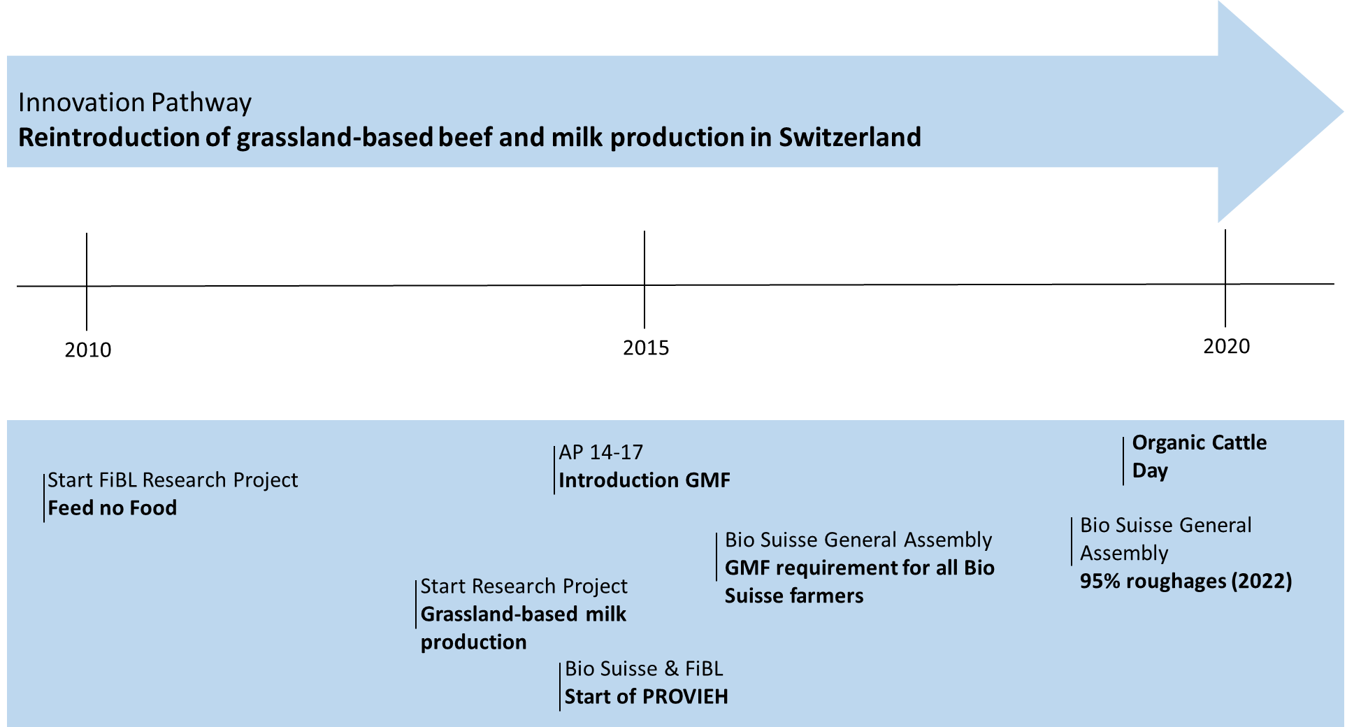
Figure 25: Examples of milestone events for the introduction of grassland-based beef and milk production in Switzerland over the past 10 years. Source: Own presentation.

Prospective assessment of scaling: Impact pathways
It is not possible to assess the impact pathways of previous events because the Organic Cattle Day was the first event of its kind. As stated in chapter 6.3Anchoring related to earlier demos, the visitors of the event generally estimate demonstration events to be an important information source. In 2017, there were about 5’100 organic farms with cattle in Switzerland. The Organic Cattle Day attracted about 500-600 visitors. Even though this number includes both organic and conventional farmers as well as other agricultural actors such as advisors, it is still a considerable number of farmers who got in touch with the different contents conveyed at the Organic Cattle Day. So far, the Organic Cattle Day was the biggest learning event on organic cattle husbandry carried out and is to be expected to have a considerable impact in introducing innovations such as the reintroduction of grassland-based feeding strategies both in organic and in conventional agriculture in Switzerland. (DMLA; PO) Different interviewees suggested that the event should be organised again in the near future. (EIP; EPP)
The most common impact pathway is to be expected via farmers and advisors who visited the event and who will share their knowledge with peers (in the case of farmers) and with customers (in the case of advisors). Agricultural press is the second important information source mentioned by the interviewees (Chapter 6.3). It is therefore expectable that the media coverage on the Organic Cattle Day (Chapter 6.2) will be another important impact pathway. On the other hand, it is difficult to summarize all the contents conveyed at such a big event like the Organic Cattle Day in a newspaper article. They would usually rather inform about the event and its highlights but not give the reader information on specific topics, which he or she could apply on the farm.
We asked the participants of the ex-post interviews what the factors are that hinder farmers to implement a new approach even if they consider it a good approach. The common response to that was the time factor especially when it comes to techniques or approaches which require radical changes and/or investments on the farm. Moreover, different interviewees said that it is often about habits and the comfort with common practices that hinder to try out something new. (EPP)

Case study reflection

Facilitating and impeding factors for successful demonstrations
The organisers stated that it is important to consider the division of labour among the different organisers involved. Many of the organisers were engaged as speakers in the various sessions and could not help out with organisational issues during the event. Also there should have been people close to the hosting farm in the run-up of the event taking care of administrational and organisational issues as the main organiser Bio Suisse did a lot of travelling back and forth. The group of organisers acted primarily as a body for exchanging and discussing the concept and focus of the event. (EPIO)
During the event, the visitors could flexibly switch between the different sessions. In many sessions, we observed that there were people joining the sessions later on or leaving them after some time. (PO) The disadvantage of such an approach is that it makes the sessions more agitated and may disturb other visitors. However, none of the interviewed visitors gave the feedback having been disturbed and the participant observers did not observe this either. (EIP; PO) Instead, different interviewees appreciated the fact that they could try out different sessions in order to decide whether they are relevant to them or not. (EIP; EPP) Giving the visitors the flexibility to change between can therefore be a good way of stimulating learning and anchoring because it helps making sure the sessions are relevant to the visitors. This may be less the case for demonstration activities with smaller groups where the movement and agitation would be more disturbing.
The exchange with practitioners who already implement a certain technique or innovative approach was very important to the visitors of the Organic Cattle Day. This was ensured by having a number of peer-to-peer-sessions with farmers speaking about their own situation. Moreover, we observed that group discussions often started by visitors who are already familiar with the discussed technique/approach. This was the case both during as well as after the sessions. We did not observe that the unexperienced visitors were intimidated by this but rather encouraged to get to know more about why their peers were already implementing a certain approach and what their experiences were. (PO) Moreover, the event also gave the visitors the possibility to get an overall picture on how many farmers have already applied a certain technique or introduced an innovative approach. One interviewee stated that it is not discouraging or even intimidating for the less experienced to exchange with the experienced farmers because everyone knows that also the others are coming to such events to learn, but maybe in a different area. On the other hand, one interviewee from the Italian speaking part of Switzerland stated that she finds it difficult to get farmers coming to demonstration events, i.e. working circles, namely because they are not so open for sharing their concerns and problems. (EPP)
Generally, organic farmers are said to be people who are used to do things differently as compared to their conventional peers. They want to build their own opinion about what is best for their farm. (EPP) The inputs from expert (incl. expert farmers) play an important role but at the same time, it is crucial to provide formats for discussion and exchange within the demonstration event. Probably, this cannot be generalized for the entire organic farming sector but it should be taken into consideration when organizing such demonstration events.
Interaction is not just important for developing an opinion but also generally for promoting the anchoring of the contents conveyed. Generally, there was a lot of interaction during and also in between the different sessions of the Organic Cattle Day. The level of interaction varied however considerably between the single sessions. The most successful sessions in terms of interaction were those, which included interaction elements other than question-answer sessions such as voting boxes to gather the participants’ opinions or experience, subgroups for discussing some contents in more detail and provide a format for exchange of experience or more hands-on experience by asking the visitors to test a tool themselves.
In addition, having clear conclusions and take-home messages appear to be a crucial factor determining successful learning and anchoring. There was a mixed picture at the Organic Cattle Day, and in some cases, the sessions did not have a clear ending and a clear take-home message. Sometimes, the sessions passed right over to small group discussions emerging out of the session. Having clear endings can be an advantage but on the other hand, it can also inhibit further discussions by putting a clear end to the session.
In summary, the organisers were happy with how the event went and are planning to organise it again in the near future. (EPIO) For future events, the question will be whether similar topics should be focused on or whether new topics should be chosen. From the interviews we carried out with visitors on the day and also after, we learned that they usually have concrete ideas and suggestions for the topic selection of future events. (EPP) It was suggested by some moderators and speakers to make use of existing networks and groups such as the PROVIEH working circles in order to determine the topics. (EPSME)

Impact of demonstrations
The topics addressed at the Organic Cattle Day included elements of all five impact domains from the PLAID conceptual framework (Productivity & profitability; Resilience; Sustainability; Quality of life; Empowerment). The focus was however clearly on issues related to sustainability and profitability. Generally, the visitors were engaged and interested in hearing different opinions. It is crucial to consider how to engage the visitors in discussions and make them think about their own farm situation.
The level of information offered is crucial when it comes to the impact of a demonstration. The general picture shows a high level of satisfaction when it comes to the choice of topics and contents offered at the Organic Cattle Day (see Chapter 4.8). Different interviewees suggested that the level of information of such events should be ideal for people who are not very advanced yet and want to get a first impression and inspiration. Other interviewees however suggested to go more into depth and to offer events on concrete topics such as milk production, suckling cows, fodder, etc. (EPP) This shows how important it is to clearly know the target group and to shape the contents accordingly.
Whether or not participants will implement something of what they learned depends highly on the feasibility of the approaches. At least in the short term, the farmers will only implement approaches which do not require big changes on their farm or big investments. One respondent referred to a grazing strategy he learnt about at the event and which he could implement right away. He only had to relocate the fence of the pasture. (EPP) Still it is important to also teach approaches which may require bigger changes but organizers of demonstration events should consider including easy-to-implement approaches as well.

Key lessons from this case study
- Ensure active involvement of the visitors by providing them opportunities to discuss, to share their experiences and to identify the relevance of certain topics to their farm;
- Give participants flexibility in choosing themselves, which sessions are relevant to them and they want to attend;
- Provide formats for peer-to-peer exchange (incl. both unexperienced and experienced peers);
- Make sure the topics chosen are relevant for the target group but also try to surprise the visitors and present them innovations/techniques, that they haven’t considered or heard of.

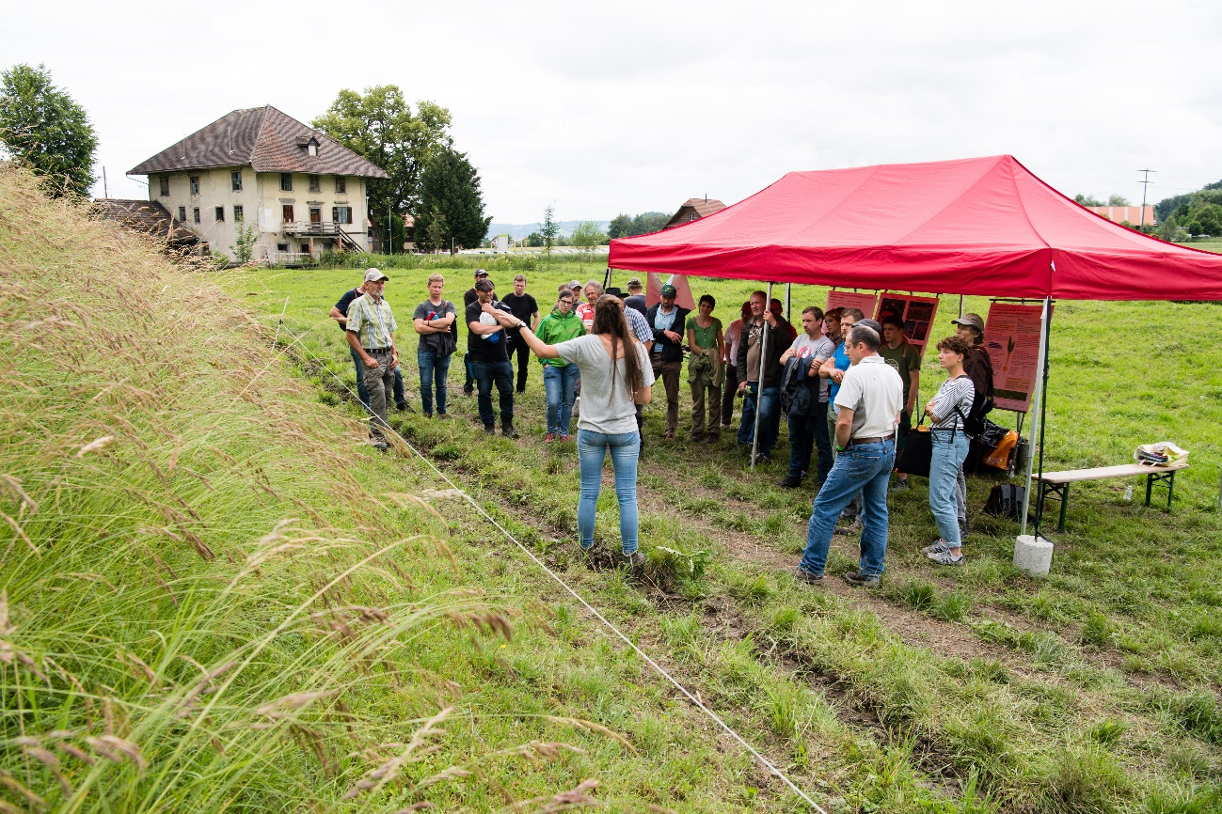
Figure 26: Stand on biodiversity and fodder quality at the Organic Cattle Day 2018.

Acknowledgements

We would like to thank the organisers of the Organic Cattle Day for giving us the opportunity to gain knowledge on demonstration activities by looking into this specific case study. This not only includes the possibility to attend the event, to observe and to carry out interviews but also different interviews and conversation we had with the organisers themselves. Moreover, we would like to thank different staff members at FiBL who supported us in the data collection, namely in carrying out the exit-interviews with the visitors on the event.

Annexes

Data sources
DMLA Document, Media and Literature Analysis
EAIO Ex-Ante Interview with Organisers
EIP Exit Interviews with Participants
EPIO Ex-Post Interview with Organisers
EPP Ex-Post Interviews with Participants
EPSME Ex-Post Interviews with Speakers, Moderators and Exhibitors (carried out by Bio Suisse)
PO Participant Observation

Data collection methods
DMLA Document, Media and Literature Analysis:
Analysis of various documents on the Organic Cattle Day, including newspaper articles, webpages and videos
EAIO Ex-Ante Interview with Organisers:
One conversation carried out with the organisers prior to the event. No interview guideline was used. No recording. Documentation: Personal notes by the interviewer.
EIP Exit Interviews with Participants:
62 suverys (interviews) carried out during the event with visitors. Every interviewer used the same questionnaire. No recording. Documentation: Filled questionnaires.
EPIO Ex-Post Interview with Organisers:
One follow up interview carried out with the main organisers (Bio Suisse and FiBL). Open interview guideline. With recording. Documentation: Compilation of notes complemented with additional information from the recording. No transcripts.
EPP Ex-Post Interviews with Participants:
8 foolow-up interviews carried out with visitors who accepted during the EIP to be contacted again. Semi-structured interview with guideline. With recording. Documentation: Compilation of notes complemented with additional information from the recording. Almost-transcripts.
EPSME Ex-Post Interviews with Speakers, Moderators and Exhibitors (carried out by Bio Suisse):
Surveys carried out by the organisers made available for this report.
PO Participant Observation:
Observations from 14 thematic sessions and from the farmers’ testimonials session, following a guideline. Notes taken during the observation, which were complemented right after each session.

Letters in brackets at the end of paragraphs indicate the data source of the information. Explanations can be found in the annex to the report.
Webpage of the Organic Cattle Day: https://www.bioviehtag.org/de/
Article in the “Schweizer Bauer“: https://www.bioviehtag.org/wp-content/uploads/2018/06/180616_SchweizerBauer_sum-viehtag.pdf; Article in the „Bauernzeitung“: https://www.bioviehtag.org/wp-content/uploads/2018/06/180615_BauernZeitung_Bio_Viehtag.pdf; Article in the „Zürcher Bauer“: https://www.bioaktuell.ch/fileadmin/documents/ba/medienspiegel/Medienspiegel-2018/6-juni-2018/ZB_Bioviehtag_2018-07-22.pdf; Article on „BioAktuell.ch“: https://www.bioaktuell.ch/aktuell/meldung/bioviehtag-12-06-2018.html
The Knospe label is the organic label of Bio Suisse (Swiss Organic farmers’ association) and is the most common organic label in Switzerland.
Roughages include grassland-based fodder but also silage maize, which is a common fodder in Swiss organic agriculture.

