Date: 30.11.2018

Country report: Bulgaria

Case Study: BG2 & New plant protection technologies in grain crop production

WP5: Case studies of demonstration activities in commercial farms

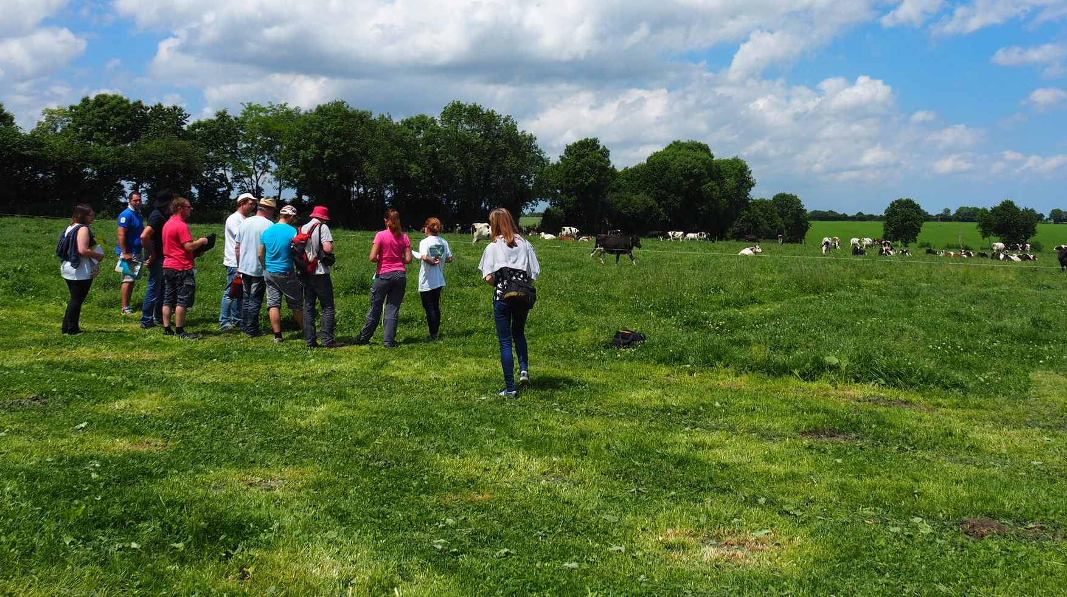
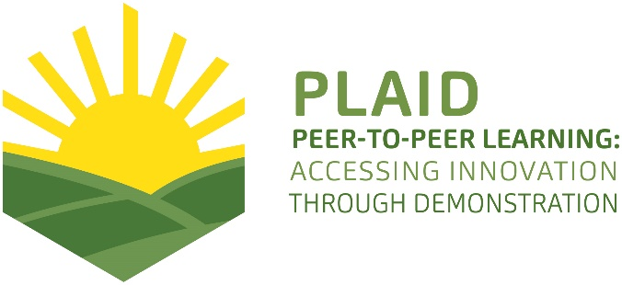
This project has received funding from the European Union’s Horizon 2020 research and innovation programme under Grant Agreement No 727388.
This project has received funding from the European Union’s Horizon 2020 research and innovation program under Grant Agreement No 727388

PLAID PARTNERS
Advisory Service Croatia ASC | ARVALIS Institut du Végétal | Association de Coordination Technique Agricole ACTA
Institute for Rural and Regional Research | Chambers of Agriculture | Delphy
European Forum for Agricultural and Rural Advisory Services EUFRAS | Innovatiesteunpunt ISP | Institut de l’Elevage – Idele
Instituto Navarro De Tecnologías E Infraestructuras Agrolimentarias | Linking Environment and Farming LEAF | National Agricultural Advisory Service
Nodibinajums Baltic Studies Centre (BSC) | Research Institute of Organic Agriculture (FIBL) | Stichting Wageningen Research
The James Hutton Institute | VINIDEA

DOCUMENT SUMMARY

__________________________________________________________________________________
Milestone Title: 24 Case Studies
__________________________________________________________________________________
Case Study Title: New plant protection technologies in grain crop production (Bulgaria)
__________________________________________________________________________________
Version: 1
__________________________________________________________________________________
Task Lead: WUR
__________________________________________________________________________________
Related Work package: WP5
__________________________________________________________________________________
Authors: Dimitar Vanev, Galina Metodieva, Emanuela Dimitrova and Petya Kumanova
__________________________________________________________________________________
Grant Agreement Number: 727388
__________________________________________________________________________________
Project name: PLAID
__________________________________________________________________________________
Start date of Project: January 2017
__________________________________________________________________________________
Duration: 30 Months
__________________________________________________________________________________
Project coordinator: The James Hutton Institute

ABSTRACT

The history of agricultural demonstration activities in Bulgaria is divided into two periods. The 1st is until year 1989 (state property of the land). The 2nd is after 1990, when private commercial companies start to enter the agricultural sector and make demonstrations. The main providers of demonstration are individual farmers, NAAS, Agricultural Academy, Agrarian Universities, Foundation for Organic Agriculture BIOSELENA and supply chain companies. Especially for the current case, the demonstrations are organized by suppliers and Bulgarian Crop Protection Association. The demonstrations address a whole range of problems that the farmers have with safety for humans and the environment use of plant protection products, with ensuring pollination of crops and with the protection of bees including wild bees. It is demonstrated the innovative plant protection products and technologies and other tools (flowering buffer strips and “wooden hotels” for wild bees). Sustainability underlies most of the demonstration activities since most of farmers participated on demonstrations could start to apply the principles of integrated plant protection on their farms and they also start to protect bees. It is giving priority to ecologically safer methods, minimizing the undesirable side effects and use of agrochemicals, and enhancing the safeguard of the environment and human health. This case study supports the PLAID project to learn about:
• how to compose an interesting program;
• what farmers learn and how;
• what advisors and suppliers learn and how;
• how advisors and field men from the suppliers use the knowledge in their contacts with the farmers;
• what is interesting for participants in demonstrations.
TABLE OF CONTENTS

1 Demo context 7
1.1 The value chain 7
1.2 Typical farm characteristics 7
1.3 AKIS 8
1.4 Sustainability challenges 9
2 Demonstration summary 10
3 Governance: set up and organisation 12
3.1 Organiser(s) and history 12
3.2 Funding 13
3.3 Host(s) 13
3.4 Gender 14
3.5 Objective(s) 14
3.6 Topic(s) 15
3.7 Access 17
4 Demonstration event 17
4.1 Visitors 17
4.2 Communication & Mediation 17
4.3 Active participation 18
4.4 Doing business 18
4.5 Role of sustainability 18
4.6 Unforeseen circumstances 18
4.7 Plans vs. practice 19
4.8 Participants feedback 19
5 Motives, learning and networking 19
5.1 Reasons to attend demos 19
5.2 Forms of learning 21
5.3 Content of learning 22
5.4 Outcomes of learning 22
5.5 Networking 23
6 Anchoring: Application of demo lessons by participants 23
6.1 Anchoring related to the present demo 23
6.2 Stimulating anchoring 24
6.3 Anchoring related to earlier demos 24
7 Scaling: Application of demo lessons by the wider farming community 25
7.1 Retrospective examples of scaling 25
7.2 Prospective assessment of scaling: Impact pathways 26
8 Case study reflection 27
8.1 Facilitating and impeding factors for successful demonstrations 27
8.2 Impact of demonstrations 28
8.3 Key lessons from this case study 29
9 Annexes 30
9.1 Data sources 30
9.2 Data collection methods 30

Demo context

The value chain
Most important actors in the value chain:
• farming inputs (seeds, fertilizers, crop protection substances, equipment and machinery): organizer of the demo (representatives of suppliers and Bulgarian Crop Protection Association, owner and manager of commercial grain crop farm), visitor of the demo
• farmers: organizer (representatives of suppliers and Bulgarian Crop Protection Association, owner and manager of commercial grain crop farm), visitor
• politicians and regulatory authorities: visitors
• consumer: visitor
The role of advisory service and research: some demonstration activities are supported by NAAS through seminars with demonstrations where the lectures are from Science and research institutes, universities and so. Some institutes, universities and suppliers have field tests where they make demonstrations.
The agricultural sector in Bulgaria is characterised by one of the highest proportions of many small-scale farmers with plots under 2 ha, around 83% of total agricultural holdings, who cultivate 4% of farmland in the country and small number of large -scale farmers with over 50 ha - around 2%, who cultivate over 80% of total farmland.
Above 60% of utilized agricultural area in Bulgaria is cultivated by cereals. This subsector is basic exported agricultural sector for Bulgaria
The expected wheat production from the harvest 2017 is in the framework on 5.5:6.3 million tons and production on barley is 535:600 thousand tons. (Source: department Agrostatistics, MAFF in Bulgaria)

Typical farm characteristics
Main technologies and practices used: New plant protection technologies
Subsector: grain crop production
In 2016, higher average yields were recorded for all major cereals except rice. Combined with an increase in harvested areas, this led to a significant increase in the production of wheat, rye, triticale and oats by 2015. On the other hand, barley, maize and rice production decreased year-on-year as a result of the contraction of harvested areas.
The wheat production in 2016 amounts to 5,662.7 thousand tonnes - 13% more than in 2015, due to the increase of harvested areas by 7.8% and the favourable climatic conditions in the process of cultural development. The largest part of wheat harvested in 2016 occupies the North-East region - 22.9% (272 982 ha).
Produced grains of rye crops 2016 has increased with 35.4% compared to 2015, which is due to the increase in both the harvested area (18.5%) and the average yield (14%). The production of triticale increased with 28.3% compared to the previous 2015, mainly as a result of an increase of the harvested area with 26.6%. Most harvested areas with rye and triticale are observed in the South-Central Region - respectively 4 212 ha and 7 715 ha.
Barley production in 2016 amounts to approximately 690,000 tons. This is 1.1% below the 2015 level, with a 9.2% decrease in harvested area. Most areas of barley during the year are in the South-eastern region - 47,926 hectares or 30% of the total harvested area in the country.
Production of oats increased with 44.6% compared to 2015, primarily as a result of an increase in harvested area of 38.3 %. Most areas of oats were harvested in the Northwest region -5466 ha or 35.7% of the harvested area in the country.
In 2016, 2 226.1 thousand tonnes of grain maize were produced - 17.5% below the level of the previous year due to a reduction in the area. The largest part of the harvested areas with maize in the Northwest region - 35.2% (143 048 ha) of the total harvested areas in 2016
• Harvested area in 2016: wheat – 1 192 589 ha, rye crops - 7 468 ha, triticale - 16 096 ha, barley – 159 830 ha, oats – 15 323, grain maize – 406 942 ha and rice – 11 988 ha.
• Mainly medium and large-scale farms;
• About 203,7 thousand people are working in the agricultural sector in Bulgaria (2016)

AKIS
Main actors of AKIS in Bulgaria are:
- The public sector – Ministry of Agriculture, Food and Forestry (MAFF) and its secondary structure, among other National Agricultural Advisory Service (NAAS);
- Private sector – private advisory services, independent advisors and so;
- FBOs – co-operatives and few producer groups;
- Research and Education organisation;
- Non-government organisations;
The Bulgarian AKIS main sources of funding the advisory services are: public funding for services provided by NAAS; mix-funding for services provided by research and education institutions; private funding for services provided by private and other advisors.
Main supplier of advisory services is National Agricultural Advisory Service (Public organisation).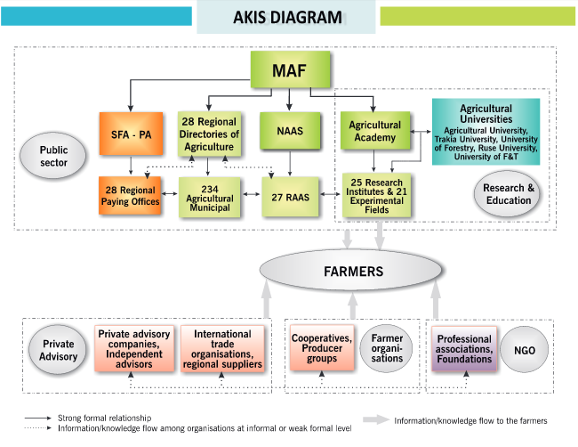
Figure 1: AKIS diagram in Bulgaria (source: Dirimanova, V. (2014): AKIS and advisory services in Bulgaria. Report for the AKIS inventory (WP3) of the PRO AKIS project. Online resource: www.proakis.eu/publicationsandevents/pubs).

Sustainability challenges
Challenges that the main actors face:
- to make small-scale and medium vulnerable farms competitive. To combine the economic success with protection of the environment.
- to develop hydro-meliorations and irrigation infrastructure.
- to improve competitiveness of Bulgarian Agriculture producer on the European market.
- to be created working rules for sustainable land use and land consolidation.
- to be established effective insurance system in the sector.
- to be improved cooperation with researcher working on the issues related to sector/
- to develop the processing of cereal products
- to facilitate entry of young farmers in the sector
- to improve effectiveness and sustainability of sector through innovations, including environmental innovations
- growing demand for food and raw materials in worldwide
- non-stable prices of grain goods in the world

Demonstration summary

The history of agricultural demonstration activities in Bulgaria is divided into two periods. The 1st is until year 1989 (state property of the land). It started the period of socio-economic change in the countries of Eastern Europe. The 2nd is after 1990, when private commercial companies for machinery, seeds, preparations for agricultural production start to enter the agricultural sector and make demonstrations in private farms and cooperatives. The main providers of demonstration are individual farmers, NAAS, Agricultural Academy, Agrarian Universities, Foundation for Organic Agriculture BIOSELENA (on the environmental issues) and supply chain companies. The farmers’ associations rarely organize demonstrations. The main types of demonstrations are related to new fertilizers, plant protection products, new varieties, new machines, new technologies, new equipment, and demonstrations on specific topics such as innovations in organic farming. Most demonstrations are led by actors different from farmers (experts from NAAS, researchers from Agricultural Academy and agrarian universities and representatives of supply chain companies). The main participants in the demonstrations are farmers and students from agricultural universities and more young farmers.
Especially for the current case, the demonstrations are organized basically by suppliers and Bulgarian Crop Protection Association. Bulgarian Crop Protection Association is set up with aim to support development of innovative plant protection products and technologies in the context of sustainable agriculture.
Demonstrations take place on experimental and demonstration fields in a commercial farm, which is specialised in crop production (wheat, rape, sunflower and maize). The farm name is Svetla Stoyanova - “HELGA” farm. The farm started its activity in 1998 as a small family farm business in the plant production sector. Over the years, the farm has grown, and it is gradually expanding and now it cultivated above 3 000 ha. The demonstrations on new plant protection technologies in grain crop production are held on the farm by 2015. Once or twice yearly.
The demonstrations address a whole range of problems that the farmers have with safety for humans and the environment use of plant protection products, with ensuring pollination of crops and with the protection of bees including wild bees.
The innovative plant protection products and technologies and other tools (flowering buffer strips and “wooden hotels” for wild bees) are demonstrated.
Image 1. Helga Farm
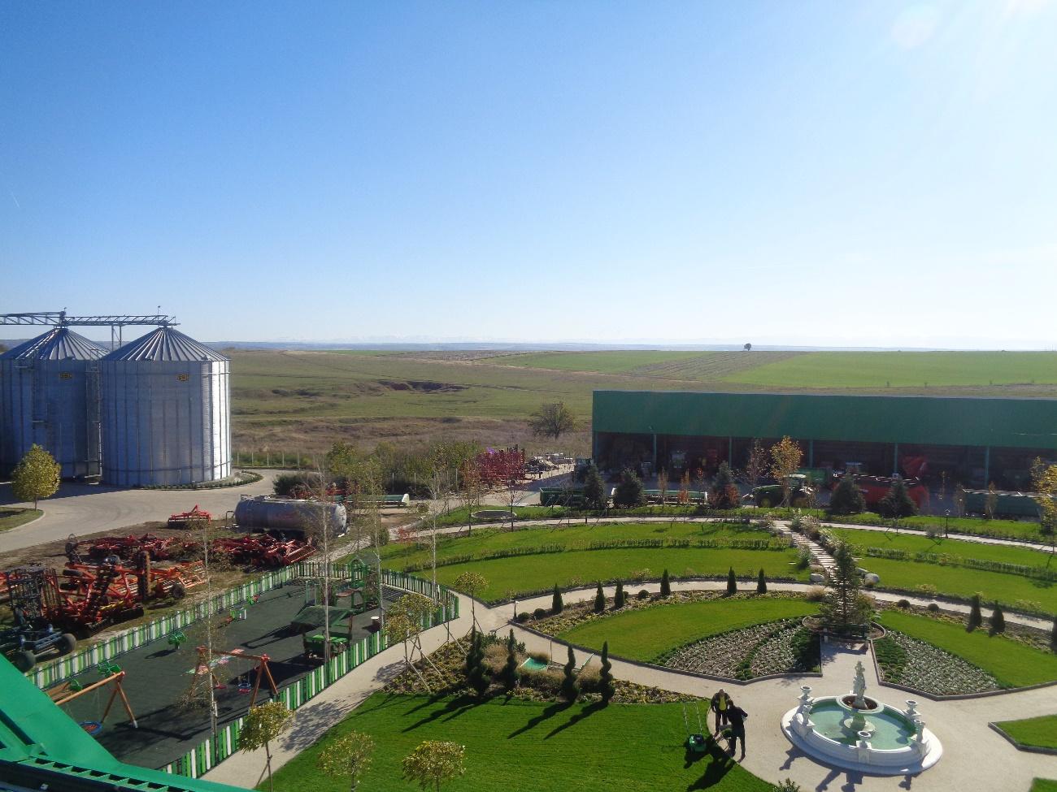
Author: NAAS PLAID Project team
Sustainability underlies most of the demonstration activities since most of farmers participated on demonstrations start to apply the principles of integrated plant protection on their farms and they also start to protect bees including wild bees, which pollinate plants. By this way it is giving priority to ecologically safer methods, minimizing the undesirable side effects and use of agrochemicals, and enhancing the safeguard of the environment and human health.
The demonstration objective is to share knowledge and to promote the use of innovative plant protection products and technologies and other tools (flowering buffer strips and “wooden hotels” for wild bees) in the context of a sustainable agriculture.
The targeted visitors are other crop production farmers from all regions and advisors.
Image 2. Participants in demonstration on the innovative plant protection technologies
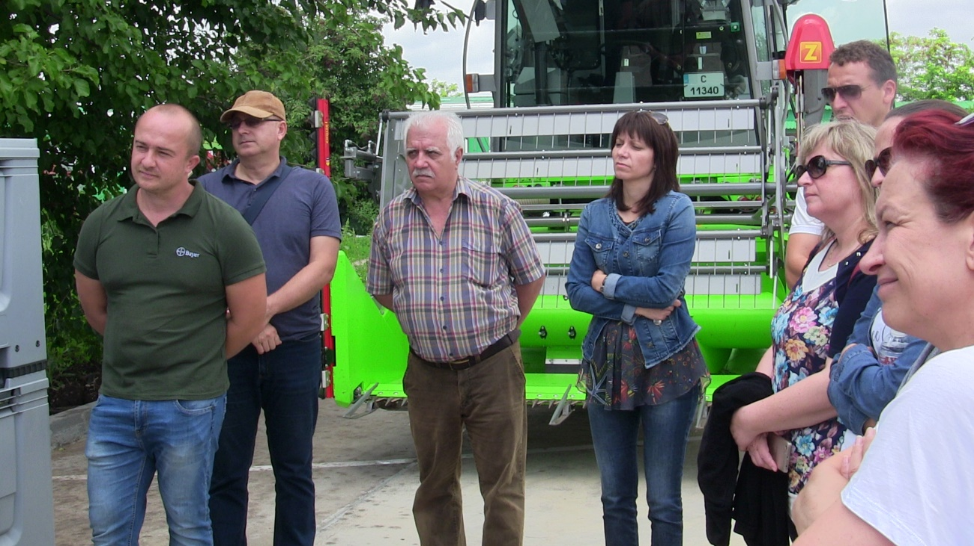
Author: NAAS PLAID Project team
This case study supports the PLAID project to learn about:
• how to compose an interesting program;
• what farmers learn and how;
• what advisors and suppliers learn and how;
• how advisors and field men from the suppliers use the knowledge in their contacts with the farmers;
• what is interesting for participants in demonstrations.
Also, this case study demonstrates good example for cooperation between farmers, advisors, suppliers and associations for promotion environmentally friendly practice.
Since this case study has been held by two years, it was gathered info on what farmers have applied into practice after participation in these demonstrations and it was developed recommendations for better application of demonstrated innovations. This case study also supports the PLAID project to learn good practise for dissemination novelties outside participants in the demonstrations.

Governance: set up and organisation

Organiser(s) and history
Demonstration on new plant protection technologies in grain crop production are organized basically by suppliers and Bulgarian Crop Protection Association. Bulgarian Crop Protection Association is set up with aim to support development of innovative plant protection products and technologies in the context of sustainable agriculture. In the organization of the demonstration are included the following people and entities: Mrs. Svetla Stoyanova – owner and manager of “HELGA” farm (commercial farm and host of demonstrations), Suppliers company innovation centre and Bulgarian Crop Protection Association. The demonstration is financed by plant protection suppliers’ company which set up innovation centre at “HELGA” farm. The equipment and other tools are provided by suppliers company. The demonstration is initiated by the Suppliers company and Bulgarian Crop Protection Association and the plant protection experts from the company are moderators. The demonstration is also result of willingness of company for enforce its social functions. The demonstration is related with other demonstration which organized at the same innovation centre, but on other topics. Demonstration on studying topic is organized once per year. The demonstrations are held on the farm by 2015. Experience from previous demonstrations indicates that the demonstration duration should be decreased from 3-4 hours to around 2 hours.

Funding
Demonstrations are free of charge for the participants. They should ensure their transport costs to the farm. All costs are covered by the suppliers company and the Association. All other costs are covered by the organizers and host farmer. As the main coast are covered by the organizers, they determine the topic and who to be invited.

Host(s)
The host of demonstrations is only one farm - the “Helga” farm. The address of the farm is village Gorna Mitropolia (postal code: 5869), Dolna Mitropolia municipality, Pleven District, Bulgaria. The farm is big crop commercial farm which is also functioned as demonstration farm. It is cultivated over 3 000 ha with mainly wheat, rape, sunflower and maize. The farm started as a small family farm but gradually it increased. The farmer Mrs. Svetla Stoyanova explained that her interest to be host is related with opportunity to be very close to innovation and to use free of charge new technologies and equipment from suppliers companies. The organizers of demonstration from the Association and the supply company have selected the farmer because the size of farm, appropriate cultivated crops and her willingness to give part of farm land for innovation centre.

Map 1 – Location of Gorna Mitropolia Village
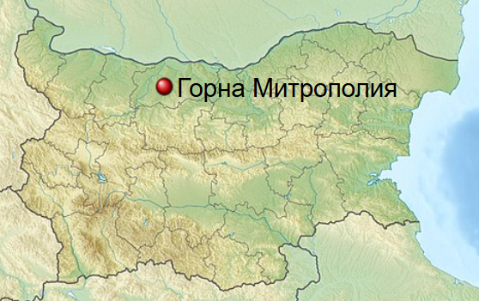

Gender
The owner of farm host is woman. The executive director of Bulgarian Crop Protection Association is also woman. Most of participants at the demonstrations are men. Participants at the demonstrations were round 60/40 men/women. Representatives of the NAAS are more women (three women and one man) who actively participated in the organization.

Objective(s)
The overall demonstration objective is to share knowledge and to promote more environmentally friendly use of plan protection materials. The concrete objective of the demonstration is to share knowledge and to promote the use of innovative plant protection products and technologies and other tools (flowering buffer strips and “wooden hotels” for wild bees) in the context of a sustainable agriculture.

Figure 1: The New plant protection technologies in grain crop production (Bulgaria) case in the PLAID typology of demonstrations

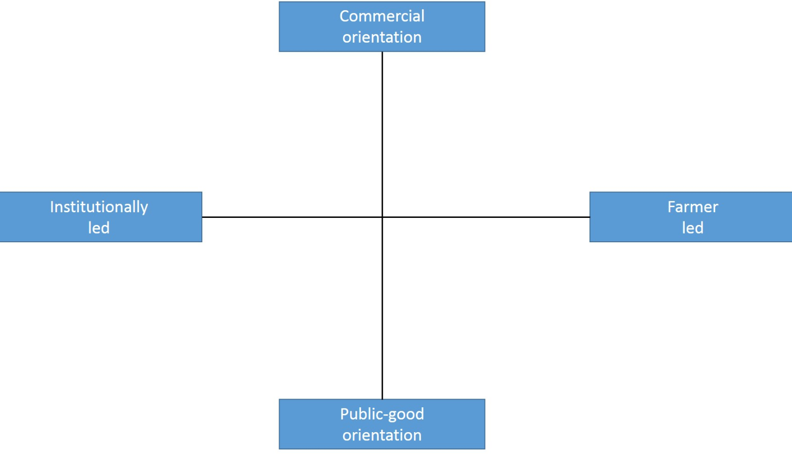
BG2

Regarding the PLAID typology of demonstrations, this demonstration is for public good and institutionally led (Figure 1). This demo is linked with environmental protection. The demo promotes the use of innovative plant protection products and technologies and other tools (flowering buffer strips and “wooden hotels” for wild bees) in the context of a sustainable agriculture and respectively the demonstration is public-good orientation. The demonstration is led mainly by the Association and the supplier company and respectively it is institutionally led.

Topic(s)
The innovative plant protection products and technologies and other tools (flowering buffer strips and “wooden hotels” for wild bees) are demonstrated. This topic was selected because it is future-oriented and environmentally friendly oriented. The other reason for selection of topic is to be promoted the sustainability agriculture and social function and responsibility of supplier’s company.
Image 3. “Wooden hotels” for wild bees
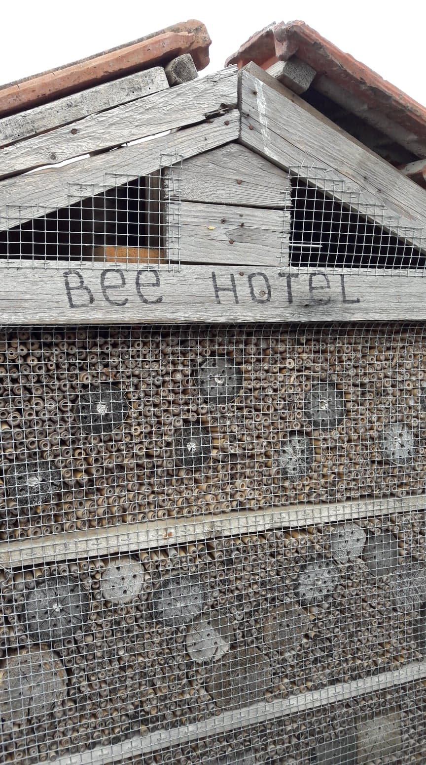
Author: NAAS PLAID Project team

Image 4. Flowering buffer strips
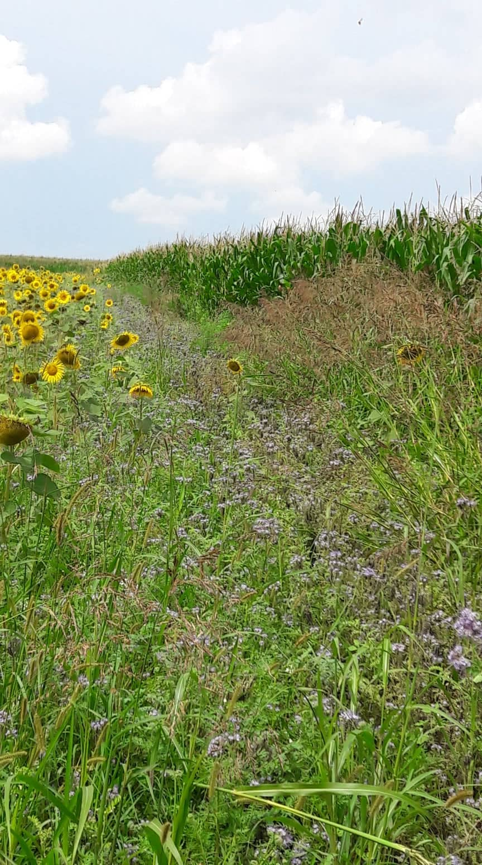
Author: NAAS PLAID Project team

Access
The targeted visitors are other crop production farmers from all regions and advisors. For increase accessibility of the demo for the target audience it was prepared special press release for agricultural medias and specialised press. It was also published information on organizer’s websites. For the last demonstration current year, the information was distributed to all NAAS district offices and respectively from the local NAAS experts to farmers. Everybody could participate on the demonstrations.

Demonstration event

Visitors
The number of visitors on the last demonstration held on 10 July 2018 was around 25. Most of them were advisors and others were farmers. The organisers expected more farmers, but some farmers used the sunny day for implementation farm activities because during this period most days was rainy, and they were behind harvest time.

Image 4: Visitors from NAAS and farmers
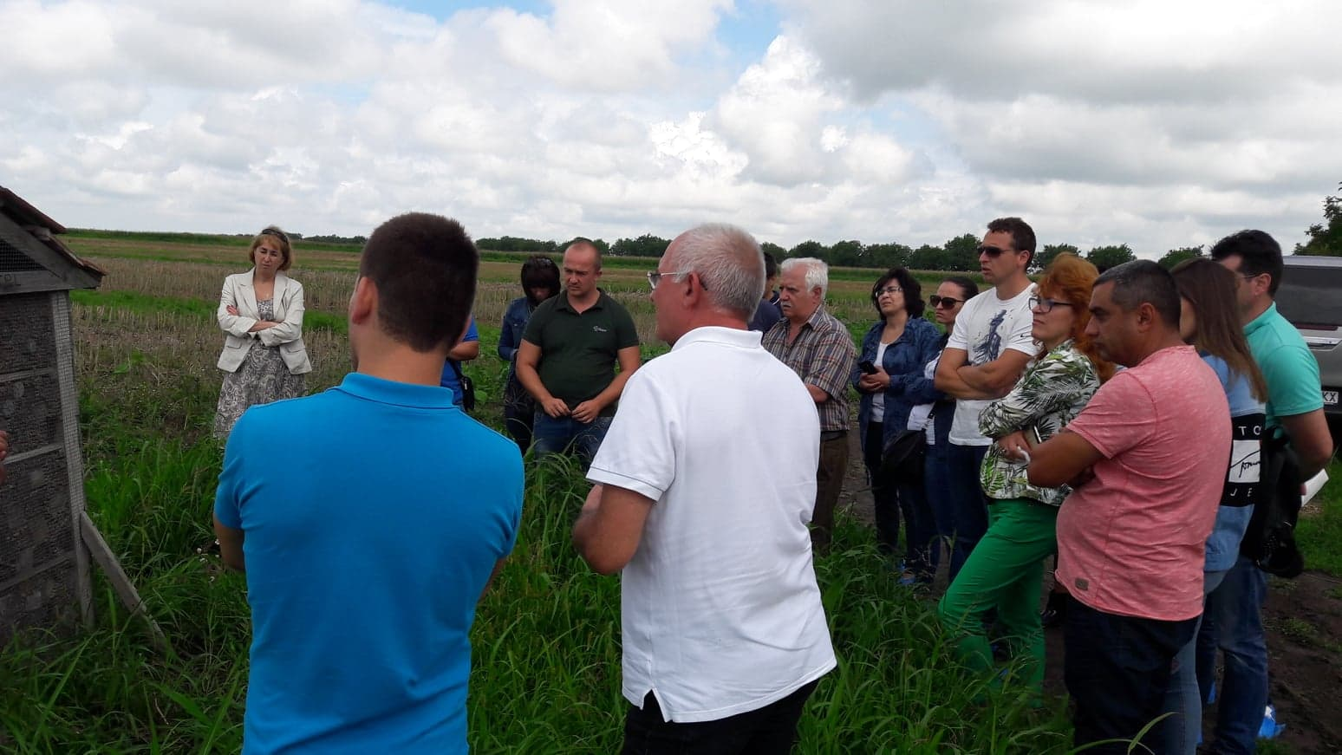
Author: NAAS PLAID Project team

Communication & Mediation
The demonstrations were led by representatives of supplier company and Bulgarian Crop Protection Association. There was a very short theoretical part at the start of demonstration on the farm. The lectures from supplier company explained what will be demonstrated and what was demonstration purpose. After that it was demonstrated the equipment, bee hives and flowers strips Flowering buffer strips. Participants asked questions. After the end of demonstration, it was held focus group for discussion on results from demonstration. The focus group was in building at the farm. This building is also used as place for rural tourism.

There are usually also selected information materials made freely available for the participants– e.g. information leaflets and CDs. They were developed by supplier company, Bulgarian Crop Protection Association and NAAS.

Active participation
Not all participants were active. Some advisors and some farmers asked a lot of question to the presenters and especially with host farmer during the demonstration. Mainly the participants talk between themselves. During the demonstration, there were many informal conversations and exchanges of information between advisers, lecturers, and farmers. The things they heard or saw during the demonstration were commented. Some visitors also took the opportunity to talk individually with attending counsellors and experts or with the farmer.

Doing business
During the demonstration participants have a chance to contact directly with product supplier and to order the showed products. Part of farmers express interest in some of the technics as bee hotel and buffer strip and the said that they will apply them in their farms.

Role of sustainability
This demo was linked with environmental protection and environmentally sustainability. There was discussion regarding the use of innovative plant protection products and technologies and flowering buffer strips and “wooden hotels” for wild bees in the context of a sustainable agriculture. The demo was not linked with social sustainability.

Unforeseen circumstances
The day before the demonstration event was raining day, which makes some difficulties during the day of demonstration, because the road to the demonstration field was flooded and for the participants was hard to get to the field. But organizer was prepared for that and they transfer participants by cars (the plan was to get to the field on foot).

Plans vs. practice
At the demonstration, the planned activities were fully implemented, and all objectives were achieved. All participants were quite active. More advisors and fewer farmers were very actively involved at the demonstration activities.
Usually, when it is planned farm demonstration days, it is expected demonstration to be visited by more farmers. We expected to participate more farmers in the demonstration events, but farmers were busy with their farms and they couldn’t participate. Although large numbers of visitors are generally a positive indicator of farmers' demand and common interest in this type of event and their willingness to devote time to participation, this requires further practical measures to ensure optimum working conditions.
All other expectations were covered. Farmers known about some useful technologies and exchange experience with other farmers with similar problems.

Participants feedback
Part of participants said that they will share the technics and technologies with other farmers; they will apply some technics in their farms – bee hotel and flowered buffer strip. Farmers share that when they go to demonstration event, they always find something which to apply in their farms.
But some farmers said that they won’t apply something because is expensive for them.
Advisors also share that the demonstration events are very useful and for them because they can learn something new and to transferred to their clients.

Motives, learning and networking

Reasons to attend demos
Attitudes and perceptions
- The main reasons to participate to demonstration events are to be learnt something useful and to be exchanged experience and information with people with similar activity and interest.
- On the demonstration events you can meet these people in one place and to look the technics and technologies with your eyes and to find answers of your question directly from presenters. In the other way you must find the information and to try to imagine how some technology will work in real.

There are also other various reasons for attending demonstrations on farms, depending on the visitor's profile. In addition to farmers, there are also advisors, representatives of non-governmental and governmental institutions in the demonstrations. They all have a different motivation to participate in such events. For example, advisors take advantage of the opportunity to meet farmers, other professionals and colleagues from other regional offices to learn new things from the field process to expand their social networks, improve their own knowledge base.
Our studies show that the motivation of farmers to attend demonstrations is related to the opportunity to meet and socialize.
As small farmers say, they are busy in their day-to-day work and do not feel comfortable starving their peers that they go to the other's farm and take up their precious time as this kind of public event offers the chance of informal networking outside of the daily farm.
In addition to the benefits of practical knowledge, farm days also provide visitors with the opportunity to travel and use the opportunity to see other farms and the results of the technological processes there.

On the demonstration event participate sole farmers. Most of the participants came alone as representatives of their farm / production. The reasons were that they have their own farm with crop productions, and the spouse or other family members had to stay home and take care of that. Some of these participants observed that they swap with family members.

Norms
Farmers participate, because they will learn something new which will be useful in their farms and will reduce their costs. Farmers participated at this event also to get new information, see what is happening in the market and with the productions, and to stay updated on the field. This also gives them an opportunity to see if they are doing something wrong, or to get a confirmation that they are doing something right (which they also appreciated).
The demonstration farm was good because the farm is big crop commercial farm. The farmer wants to be very close to innovation and to use free of charge new technologies and equipment from supplier’s company. The farm was selected because the size of farm, appropriate cultivated crops and farmer willingness to give part of farm land for innovation centre;
Advisors recommend the demonstration event and farmers didn’t know each other before the event;

Practicalities
For farmers was convenient to participate, because it was organised transport for farmers who live far away from demonstration farm and they travelled with advisors. There weren’t other demonstration events in that day and it also leads to increase the number of participations.
There are always several people who pre-register the event in response to the official announcement of the demonstration, but they do not come, as well as other people who attend the demonstration event without first notifying the organizers. There are, of course, different personal reasons most often related to sudden or urgent other farmers' tasks - a good time for sowing or harvesting, birthing and other unplanned activities. It's also just to forget about the upcoming event among the daily activities.
Farmer participation mostly requires the use of private means of transport in order to reach the demonstration site and given that many visitors come to the event together with other acquaintances, it may be the absence or change in driver plans may also impede the participation of others.
The farm is close to main roads and for participants is easy access to it.

Forms of learning
During the demonstration were used different forms of learnings. The presenters show technics and technologies verbal and physical. They explain all process and benefits of the method. Participants ask questions and receive answers from presenters.

During the demo it was used mainly oral presentations and demonstrations in practice of different technologies and techniques. The main forms of learning were through presentations and ask of question from participants in demonstration. As one of presenters was the farm owner she emphasized on the practical forms of learning with real examples of her practice.

Stimulating engagement or feedback is a good example of audience ownership and an opportunity to even better present the different aspects. Asking questions and seeking answers is a way to keep participants’ attention and interest until the end of the presentation.

Still, the experience of observed farm demonstrations shows that there are varied levels of actual engagement - while in some cases there were very few questions or comments, people were not willing to participate actively, others were developing much lively debates, largely dependent on theme.

In some cases, farmers are leaving the subject and are starting to share the various difficulties they encounter and start criticizing the administration, seeking answers to more global intrusions at national (political) level - a response that cannot be attributed to those present at this event.

In summary, the key feature of these demonstrations is that they are a live encounter with other practice-based colleagues in real-life situations. Participants see practically different good agricultural practices, can share and apply them.

Participants see on the field the real bee hotel and buffer strip.

Content of learning
The demo promotes the use of innovative plant protection products and technologies and other tools (flowering buffer strips and “wooden hotels” for wild bees) in the context of a sustainable.
The demo farmer wants to be very close to innovation and to use free of charge new technologies and equipment from supplier’s company.
Part of farmers aren’t ready to use the new technics because they will be expensive for them and will take a long time to realize some of the technics, but other farmers confirm that they will apply the demonstrated technologies.
According to the participants in the demonstration events, it is very important, and it is crucial for farmers involved in the demonstration to speak out about the problems and mistakes they face. Sharing, including negative experiences, is also important for effective peer education. Of course, this is often avoided by farmers, worried about publicly disclosing their problems.

Outcomes of learning
Participants in demo said that they will share with farmers what they learn today and will apply bee hotel and buffer strip in their farms. Advisors will disseminate information and main points of demo through their clients with similar activities.
They said that the demonstration was very interesting for them and learn a lot and will recommend to other farmers to participate in demonstration activities.
The assessment is subjective, depending on the interests and problems of the various demonstrators, which they found useful for the innovations presented.
The results of the study showed usefulness and applicability from the theoretical and practical part. It was shared that the significant factor for the results of the demonstration event is the scale and degree of development of the host holding.
The participants convince that some innovative plant protection technologies and other tools (flowering buffer strips and “wooden hotels” for wild bees) work as on a large farm, but also on a small or medium farm. Participating in such events and what they see there leads to an awareness of the importance of a problem in their own farms, a clearer understanding of the causes, and finding solutions. For example, after participation in current demonstration farmers understand the importance of environmental protection particularly importance of bee protection for crop production. They find easy and non-expensive ways to solve some their similar problems.

Networking
We have already noted that demonstration events are being attended in addition to learning and seeing something new and useful, but also about the opportunity to communicate with other farmers (social contacts) and specialists, as well as to meet new people. This holds true for newer and younger holdings whose managers need to learn different practices.

As noted by the participants, demonstration events facilitate rapprochement, with some of them even making friends.

Participation in the event also allows you to identify and get contact information from other farmers and their associations and / or various specialists in the crop production. These contacts can be used in a subsequent step if necessary.

Many of the participants attended the demonstration also to use the opportunity to meet advisors and experts from commercial companies in this field.

The farmers exchange experience with other farmers. For farmers it is important to see how some technology works in real farm and what is the opinion of the host farmer.

Anchoring: Application of demo lessons by participants

Anchoring related to the present demo
Some participants replied that they will introduce demonstration equipment and system if they found financial resources (especially for machines related to use of plant protection materials). Advisors could help them for the provision of financial resources, incl. through the development of projects for national and European support schemes and programs.

Most participants report a high probability of taking advantage of the acquired knowledge.

Some farmers mainly wanted to get more information and inspiration and make new contacts and meet other crop farmers in the region, with whom it could be useful to cooperate with or to exchange experiences with in the future.

The demonstration enabled the farmers who participated in it to get acquainted with equipment suppliers as well as to establish better contacts with the host farm of the event. In the future, they will be able to connect to them again, and to have the opportunity to implement the demonstrated techniques, technologies and tools much easier on their farms. They will even be able to visit the farm again to get acquainted with the details they have not noticed at their first visit.

Stimulating anchoring
The information on the demonstration results, its benefits and effectiveness has been published in several media - including on the suppliers website and the association website. It is also distributed on electronic devices and on paper. These publications are usually read by later not only those present in the demonstration event but also by people who are not among the visitors. After demonstration were prepared information about the demonstration events which were published in internet and was reported in the press. During the demonstration was made videoclip which will be edited and will be created short video for the demonstration and will be published in internet. The film will also be sent to advisory organizations and associations and it is expected to help other farmers and advisors to get acquainted with the demonstrated technologies and tools to solve issues in the field of plant and bee protection and environmental protection.

It was also noted that the advisors who attended a demonstration event later organized local seminars on these topics in their regions. Continuous repetition of things from one occasion to another and the use of different means of communication is considered important for the transfer of knowledge and its gradual absorption by the attendees.

Anchoring related to earlier demos
The discussions with previous participants in similar demonstrations have shown that most farmers at this stage plan to introduce into their farms only that part of the demonstrated techniques, technologies and tools that would have a very rapid impact on the economic viability of their farms. To a smaller extent, they would like to apply the lessons learned and the innovations in terms of environmental protection. Some of them have begun to introduce "bee hotels", as this does not require large financial resources and efforts on their part..

In this case, the part of demonstrated innovation practice – flowering buffer strips and “wooden hotels” for wild bees can be quickly and easily implemented without requiring complex technological changes on the farm.

This case seems to be a good illustration that it is difficult to be convinced most farmers to put in practice new knowledge in environmental and how important are advisors’ activities and organizing demonstration for this process.

The farmers need more time to fully understand the environmental results and benefits of what they see and to find practical applications for the advice provided by the experts involved.

The farmers realize the importance of the practice demonstrated but thinks that it is not necessary to be used by himself/herself and they don’t see the benefits for them.

Scaling: Application of demo lessons by the wider farming community

Retrospective examples of scaling

This case study demonstrations focus on important problems for EU including Bulgarian agriculture - soil pollution with plant protection products residuals and dramatic decline in bee populations. The case study demonstrations are initials steps for distribution knowledge and technologies and tools for solving these problems. They are good example how industrial crop production and environmental sustainability (special attention on soil quality and bees protection) could be combined and that they are not “enemies” if farmers use appropriate equipment and apply appropriate technology and tools. It is also good example how industrial association and plant protection products suppliers could be attracted to support environmental demonstrations and to promote environmental sustainability in their activities.

There are farms that are not yet resilient and motivated to make additional investments or at least small efforts for environment protection because most of them are afraid of output and respectively profit loss and they want financial means to improve the parameters of the production process, plant protection and environmental issues.

Also, participation in demonstrations of plant production advisors from NAAS will increase significantly the distribution of demonstrated topics as NAAS offices cover whole Bulgarian territory. Some NAAS advisors plan to organize demonstrations on similar topics in their region. The demonstrations allow advisors to link with experts on environmentally friendly use of plant protection products and to invite them to participate on other demonstrations on this field.

Prospective assessment of scaling: Impact pathways
The current case study promotes the wider use of knowledge and concrete innovations demonstrated during the events and distributed to the farmers through creating new free online follow-up material on the results of each event. The information about demonstration events and demonstrated innovations is uploaded at the sites of the agricultural medias in Bulgaria (for example - www.agrotv.bg, www.fermer.bg, etc.). Also, the institutions which are involved in organizing these demonstrations are an important tool for promoting and exchanging good practices especially NAAS with its full coverage of Bulgarian territory.

Another official route is the free printed brochures and leaflets of supplier company, NAAS and Bulgarian Crop Protection Association.
Significant scaling potential is also contained in the short online video of the project and its output, produced and promoted by the project team, which is a tool that can be used even more intensively.

Due to the low level of knowledge and training of small farmers and young farmers and the limited opportunities for professional education in livestock breeding, NAAS experts carry out information and training events together with the agricultural academy and agricultural universities. In addition, the NAAS provides them with a comprehensive advisory service - packages on different aspects of agricultural production, protection of the environment and development of their competitiveness.

The information is also distributed through AKIS in Bulgaria. Some of main actors of AKIS in Bulgaria (NAAS, FBOs – co-operatives and few producer groups, Research and Education organisation and Non-government organisations) distributed the information. Private advisory services and independent advisors are not so active in distribution. It is best to use agricultural associations to inform their members about the demonstrations, as well as the suppliers / distributors of fertilizers, plant protection materials and machines.

From year 2015 NAAS started a new activity related to dissemination among farmers of information and innovations news in the field of agriculture including for current case study, through the setup of the "Farming circles" to every office. The purpose of "Farming circles" is to spread among farmers useful information and to promote best practices in the field of agriculture and the application and implementation of projects under the RDP as well as to increase the efficiency of advisory services provided by the NAAS for a larger number of farmers. In Farming circles are involved active farmers from the relevant region. They disseminate information and innovations news among other farmers. From year 2015, 27 farmers circles were set up (one for each NAAS regional office) and over 400 farmers participate in them. The existing farming circles cover 165 municipalities out of total 265 or 62% of all municipalities in Bulgaria.

Case study reflection
In our case study we are addressing the following four topics:
- Governance of demonstrations and learning;
- Facilitating and impeding factors for successful demonstrations;
- Accessibility of demonstrations;
- Impact of demonstrations.

Facilitating and impeding factors for successful demonstrations
Based on discussion and interviews with organizers, participants and other stakeholders connected with current case study we identify the key indicators for successful organisation and implementation of the demonstration activity
They are structured along the following three groups of factors, as put forward by the PLAID conceptual framework:
- inputs (infrastructure, finances, human resources);
- access (geographic, social, economic);
- demonstration process (methods, content, interaction form).

8.1.1. Inputs
- Good organization / logistics /;
- Practical direction of the demonstration;
- Preparation and distribution of supporting information materials to the participants;

8.1.2. Access
- Proper audience selection;
- Free of charge participation;
- Appropriate time for start of demonstration;
- In advance check of crop field situation.
In current case study accessibility of demonstrations is facilitated by the fact that participation is free of charge..

8.1.3. Demonstration process
- Appropriate duration of the demonstration;
- A suitable moderator
- Predicting and holding a discussion after the demonstration;
- Artistic presentation of the demonstration;
- Provide visual material, data, schemes demonstrating cost-effectiveness and economy of innovation, investment cost data, system maintenance

8.1.4. Conclusions

One of advantage of this case study demonstration is including of host farmer as presenter. This increases farmers' confidence in the applicability of the demonstrated technologies, equipment and tools. In addition, the farmer uses a more comprehensible language for presenting the activities.

The number of participants should not exceed 20-30 participants for the learning process to be effective.

Both case studies in Bulgaria confirms that the main factors for success the demonstrations are:
- Good organization / logistics /;
- Practical direction of the demonstration;
- Proper audience selection;
- Appropriate duration of the demonstration;
- A suitable moderator and presenters.

Impact of demonstrations
Analysis of direct and indirect impacts of the studied demonstrations outside participants and organizers is very difficult. The organizers explained that they have information that very small part of farmers start to introduce the demonstrated equipment and system. The farmers are not convinced that they should separate part of their land for flowering buffer strips and “wooden hotels” for wild bees. From other side big number of participants attended on conducted demonstration shows that there is interest to use innovative plant protection products and technologies and other tools. They notice that the interest increases every year. One of big advantage of this case study is selection of appropriate farm and of organizers and lecturers. The farmer Mrs. Svetla Stoyanova explained that her interest to be host is related with opportunity to be very close to innovation. The organizers of demonstration from the Association and the supply company have selected the farmer because the size of farm, appropriate cultivated crops and her willingness to give part of farm land for innovation centre.

This case study is example how most farmers focus mainly on the first impact domain from the PLAID conceptual framework demonstration, namely: Productivity & profitability. Firstly, they would like to know how demonstrated innovative plant protection products and technologies and other tools (flowering buffer strips and “wooden hotels” for wild bees) will improve their profit and economic effectiveness. On the second place are quality of live and resilience. Environmental sustainability is next. Because of this when the focus on demonstration is environmental sustainability it is necessary more explanations on this issue and public benefits. Also, it is necessary to be explained the economic benefits for farmer from demonstrated environmental equipment, techniques and technologies (if it is available). For example, the bee protection will lead to increase the crop outputs.

Key lessons from this case study
Lesson 1: Most farmers participating in demonstrations plan to introduce into their farms only that part of the demonstrated techniques, technologies and tools that would have a very rapid impact on the economic viability of their farms. To a smaller extent, they would like to apply the lessons learned and the innovations in terms of environmental protection. It is difficult to be convinced most farmers to put in practice new knowledge in environmental and because of this it is very important the advisors’ activities and organizing demonstrations for this process.

Lesson 2: The demonstrations enabled the farmers who participated in them to get acquainted with equipment suppliers and advisors as well as to establish better contacts with the host farm of the event. In the future, they will be able to connect to them again, and to have the opportunity to implement the demonstrated techniques, technologies and tools much easier on their farms. They will even be able to visit the farm again to get acquainted with the details they have not noticed at their first visit..

Lesson 3: The success of demonstrations related with environmental sustainability issues in crop production requires all organizers and presenters (including farmers, suppliers, industrial associations) to be convinced in benefits of use environmentally friendly equipment, techniques, technologies and tools. The industrial association and crop input products suppliers should be attracted to support environmental demonstrations and to promote environmental sustainability in their activities.

Acknowledgements
We would like to thank:
Mrs. Svetla Stoyanova – owner and manager of “HELGA” farm;
Mrs. Nelly Yordanova - Director General Bulgarian Crop Protection Association;
Mrs. Krasimira Evstatieva – Bayer Crop Science company;
Mr. Ivelin Tonchev - Bayer Crop Science company

Annexes

Data sources
It was used different data sources. Voice recordings from interviews with participants, experts and organisers have been important sources. The invitation to the demonstration has also been used as an information source. It was also prepared minutes from the meeting on the focus group for discussion on current case study. The meeting was held on 10.07.2018.

https://www.agronet.bg/agro/19410-5ce2adcb3fafc8af505a843f95d1480a.html
http://www.plant-protection.com/article.xhtml;jsessionid=02090bb6f9b8eb30a8ac17afc653?categoryId=10&articleId=425&activeMenu=3
https://www.youtube.com/watch?v=ZnXvShz1s54
https://www.youtube.com/watch?v=GBAAV4WCEhA
www.bgcpa.eu
https://www.cropscience.bayer.bg/
https://fermer.bg/novini/kak-da-postroim-hotel-za-pcheli
https://www.bayer.bg/bg/media/press-releases/center-for-agroinnovations.php
https://www.naas.government.bg/bg/57/3805/3901

Data collection methods
The data collection for the case study included the following methods:
- Research - Collection and analysis of relevant national statistical data, information on the project and the demonstration activities in online and published resources (incl. other studies as well as outputs generated by or produced on the project).
- Visit on the demonstration events - Attendance of the demonstration day on July 2018.
- In-depth interviews - between March and October 2018, it was conduct interviews with individuals involved in the organisation and implementation of demonstration (including Mrs. Svetla Stoyanova – owner and manager of “HELGA” farm, Mrs. Nelly Yordanova - Director General Bulgarian Crop Protection Association; and Mr. Ivelin Tonchev - Bayer Crop Science company);
- Focus group – It was hold in July 2018. It was participated farmers, demonstration organizers, advisors and researchers.

Main case study questions

Research
- Most important actors in the subsector
- Typical farm characteristics of the sector
- AKIS in the region (desktop research
- Social, climate and economic sustainability issues
- Summary of the demonstration activity
- What is the background (history) of the demonstration organizers/funders?
- Demonstration farm type
- Fit the farm type into the Plaid typology diagram
- What is the topic of this demonstration?

Observation of demonstration event

- What happened during the demonstration?
- How many people attended the demonstration?
- How many women are present?
- What methods were used?
- Did anything unforeseen influence what happened?

Interviews/questionnaires with organizers/demonstrators

- What is your role in the organization?
- What is the history of your organization?
- What demonstration methods do you (personally) prefer to use?
- Who initiated the demonstration?
- What is the topic of this demonstration?
- What is your role in the demonstration?
- What are the objectives of this demonstration (what do you hope to achieve)?
- Who were the targeted audience and how were they approached?
- Why/how was this identified as a in important topic?
- How is this demonstration funded?
- How many people attended this demonstration?
- Are women involved in this demonstration?
- Were your expectations of the demonstration fulfilled?
- Describe demonstration events in which you were involved, and they were successful?
- Describe demonstration events in which you were involved, and they were not successful?
- What measures do you have in place to support farmers after the event?
- What can be improved when running the demonstration?
- What would you apply from the demonstration”?
- What demonstration do you think cannot be applied and why?

Interviews/questionnaires with farm visitors
- How do you learn about the demonstration?
- Why did you attend the demonstration?
- Was the topic of the demonstration the most important factor? Which are other factors?
- Are you looking to introduce demonstrating equipment and technologies now or you just want to be informed?
- Did you like the demonstration? Was the demonstration covered you expectation?
- How useful was this demonstration for gaining new knowledge?
- How useful is this demo for new contacts?
- Do you like to visit demonstration events?
- What types of demonstration events do you like the most?
- Does your decision to attend demonstrations depends from travel costs and distance?
- Do you change your farming practices because of a demonstration event?
- What other sources of information do you use?
- Are there other family members that attend demonstration events?
- What can be improved when running the demonstration?
- What would you apply from the demonstration”?
- What demonstration do you think cannot be applied and why?

