Date: 30.11.2018

Country report: Bulgaria

Case Study: BG1 & Renewable energy sources (RES) in milk production

WP5: Case studies of demonstration activities in commercial farms

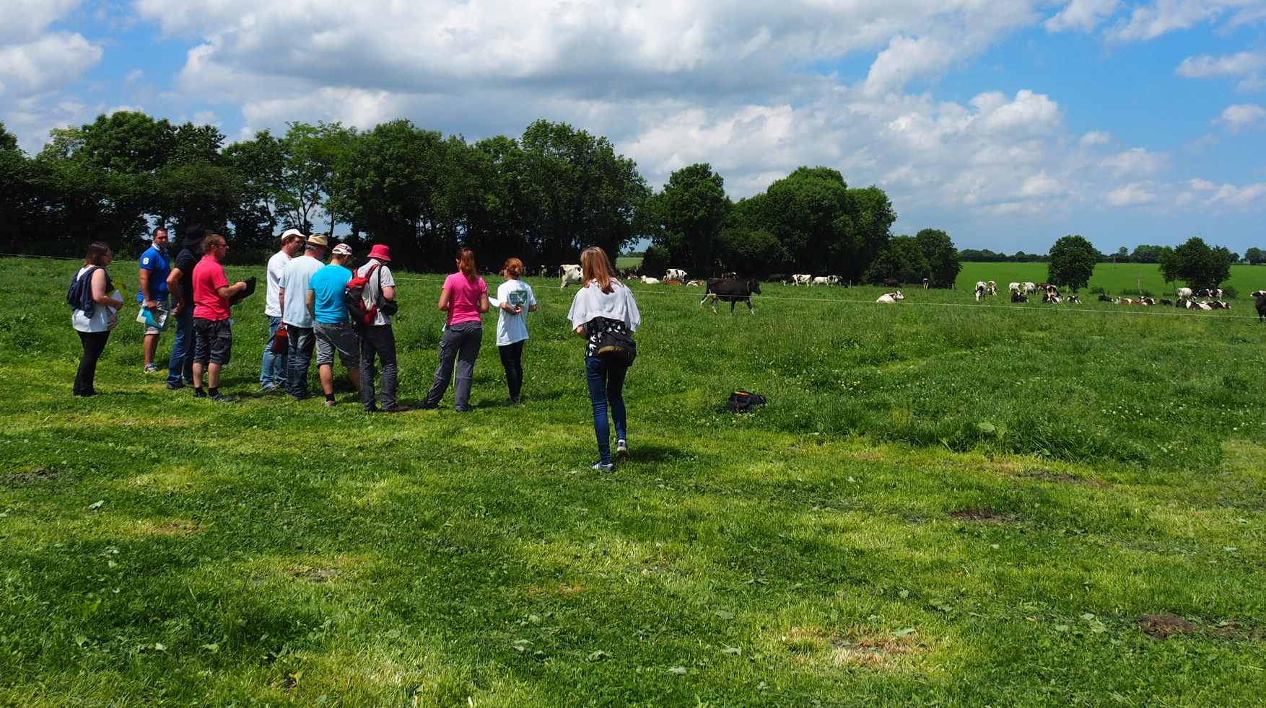
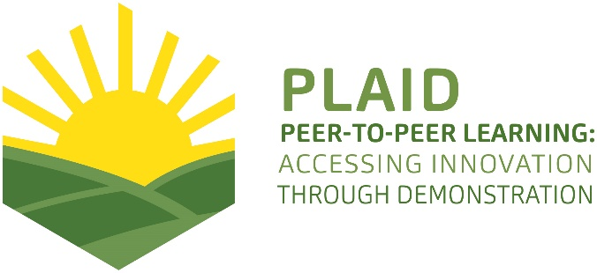
This project has received funding from the European Union’s Horizon 2020 research and innovation programme under Grant Agreement No 727388.
This project has received funding from the European Union’s Horizon 2020 research and innovation program under Grant Agreement No 727388

PLAID PARTNERS

Advisory Service Croatia ASC | 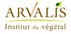  ARVALIS Institut du Végétal | Association de Coordination Technique Agricole ACTA
Institute for Rural and Regional Research | Chambers of Agriculture | Delphy
European Forum for Agricultural and Rural Advisory Services EUFRAS | Innovatiesteunpunt ISP | Institut de l’Elevage – Idele
Instituto Navarro De Tecnologías E Infraestructuras Agrolimentarias | Linking Environment and Farming LEAF | 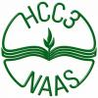  National Agricultural Advisory Service
Nodibinajums Baltic Studies Centre (BSC) | Research Institute of Organic Agriculture (FIBL) | Stichting Wageningen Research
The James Hutton Institute | VINIDEA

DOCUMENT SUMMARY

__________________________________________________________________________________
Milestone Title: 24 Case Studies
__________________________________________________________________________________
Case Study Title: Renewable energy sources (RES) in milk production (Bulgaria)
__________________________________________________________________________________
Version: 1
__________________________________________________________________________________
Task Lead: WUR
__________________________________________________________________________________
Related Work package: WP5
__________________________________________________________________________________
Authors: Dimitar Vanev, Galina Metodieva, Emanuela Dimitrova and Petya Kumanova
__________________________________________________________________________________
Grant Agreement Number: 727388
__________________________________________________________________________________
Project name: PLAID
__________________________________________________________________________________
Start date of Project: January 2017
__________________________________________________________________________________
Duration: 30 Months
__________________________________________________________________________________
Project coordinator: The James Hutton Institute

ABSTRACT

The history of agricultural demonstration activities in Bulgaria is divided into two periods. The 1st is until year 1989 (state property of the land). The 2nd is after 1990, when private commercial companies start to enter the agricultural sector and make demonstrations. The main providers of demonstration are individual farmers, NAAS, Agricultural Academy, Agrarian Universities, Foundation for Organic Agriculture BIOSELENA and supply chain companies. Especially for the current case, the demonstrations are organized by BIOSELENA and Trakia University - Stara Zagora. The demonstrations address problems that the farmers have with non-effective energy use and big energy consumption costs and with the milk quality and compliance with hygiene standards. It is demonstrated using renewable energy sources (RES) in milk production especially using RES for production of hot water for washing and cleaning is demonstrated. Sustainability underlies most of the demonstration activities since most of farmers participated on demonstrations could start use the similar RES. It is giving priority to ecologically safer methods, minimizing the use of non-renewable energy, and enhancing the safeguard of the environment. This case study supports the PLAID project to learn about:
• how to compose an interesting program;
• what farmers learn and how;
• what advisors and suppliers learn and how;
• what agrarian speciality students learn and how;
• how advisors and field men from the suppliers use the knowledge in their contacts with the farmers;
• what is interesting for participants in demonstrations.
This case study also supports to learn good practise for dissemination novelties outside participants in the demonstrations.
TABLE OF CONTENTS

1 Demo context 6
1.1 The value chain 6
1.2 Typical farm characteristics 6
1.3 AKIS 7
1.4 Sustainability challenges 8
2 Demonstration summary 9
3 Governance: set up and organisation 12
3.1 Organiser(s) and history 12
3.2 Funding 12
3.3 Host(s) 13
3.4 Gender 13
3.5 Objective(s) 14
3.6 Topic(s) 14
3.7 Access 15
4 Demonstration event 15
4.1 Visitors 15
4.2 Communication & Mediation 16
4.3 Active participation 17
4.4 Doing business 17
4.5 Role of sustainability 17
4.6 Unforeseen circumstances 18
4.7 Plans vs. practice 18
4.8 Participants feedback 19
5 Motives, learning and networking 20
5.1 Reasons to attend demos 20
5.2 Forms of learning 22
5.3 Content of learning 23
5.4 Outcomes of learning 24
5.5 Networking 24
6 Anchoring: Application of demo lessons by participants 25
6.1 Anchoring related to the present demo 25
6.2 Stimulating anchoring 25
6.3 Anchoring related to earlier demos 26
7 Scaling: Application of demo lessons by the wider farming community 27
7.1 Retrospective examples of scaling 27
7.2 Prospective assessment of scaling: Impact pathways 27
8 Case study reflection 28
8.1 Facilitating and impeding factors for successful demonstrations 28
8.2 Impact of demonstrations 30
8.3 Key lessons from this case study 30
9 Annexes 32
9.1 Data sources 32
9.2 Data collection methods 32

Demo context

The value chain
Most important actors in the value chain:
- farming inputs (balanced ration, good environment, health protection, equipment and machinery): organizer of the demo (The farmer), visitor of the demo
- farmers: organizer (The farmer), visitor
- politicians and regulatory authorities: visitors
- consumer: visitor
The role of advisory service and research: some demonstration activities are supported by NAAS through seminars with demonstrations where the lectures are from Science and research institutes, universities and so.
The main characteristic of dairy subsector value chain is а weak market position of small and medium livestock farms (there are dominant number) and strong market position of processing plants. These farms are with high production and permanent costs and the same time they are operating on a market with limited consumer opportunities and institutional uncertainties. The cooperation between dairy farms and the number of dairy market producers’ groups is too limited.
Bulgaria is among the EU countries with the lowest milk yield per animal (average milk yield is 70% lower than the EU average), due to two main reasons: the available genetic resources and the way of keeping the animals. There are many weaknesses in the animal composition of the country, mainly in small and medium-sized family dairy farms. Dairy cows reared on farms with more than 100 animals represent only 23% of the total, while in most other holdings cows are reared non-systematically and without selection activities.

Typical farm characteristics
Main technologies and practices used: Renewable energy sources
Subsector: dairy milk
In Bulgaria the largest part in the total production cow's milk in 2016 occupies the South-Central Region - 25.4%, followed by the South-eastern - 20.9% and the North-Eastern regions -17.5%. The smallest part is in the Southwest region 7.5%.
In 2016, the number of dairy farms decreased with 13.1% compared with the previous year and the number of animals kept in them with 1.7%. All groups of dairy farms are decreased without the largest (with over 100 animals). By the end of the year the average size of dairy farms increased to 9.5 animals, with about 73% of dairy cows being kept on farms with 20 or more animals.
- Total dairy cows in Bulgaria (till 01.11.2016 – source: Agrarian report by MAFF in Bulgaria): 271,3 (thousand) cows
- Till 01.11.2016, there were 28,7 thousand farms with dairy cows.
- Mainly family farms
- About 203,7 thousand people are working in the agricultural sector in Bulgaria (2016)
A significant increase is reported by the Agro-statistics Department of the Ministry of Agriculture, Food and Forestry of the organic breeding animals. The change in the number of bovine animals for the 2014-2016 period is from 1 622 to 9 134 animals. All these animals are certified.

AKIS
Main actors of AKIS in Bulgaria are:
- The public sector – Ministry of Agriculture, Food and Forestry (MAFF) and its secondary structure, among other National Agricultural Advisory Service (NAAS);
- Private sector – private advisory services, independent advisors and so;
- FBOs – co-operatives and few producer groups;
- Research and Education organisation;
- Non-government organisations;
The Bulgarian AKIS main sources of funding the advisory services are: public funding for services provided by NAAS; mix-funding for services provided by research and education institutions; private funding for services provided by private and other advisors.
Main supplier of advisory services is National Agricultural Advisory Service (Public organisation).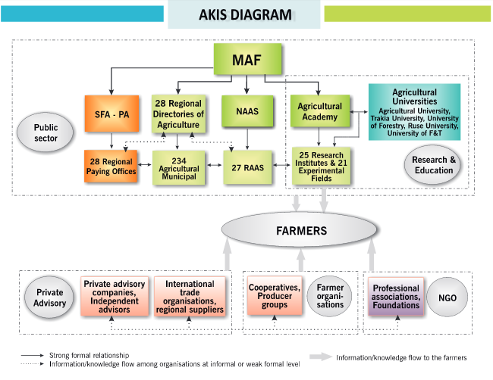
Figure 1: AKIS diagram in Bulgaria (source: Dirimanova, V. (2014): AKIS and advisory services in Bulgaria. Report for the AKIS inventory (WP3) of the PRO AKIS project. Online resource: www.proakis.eu/publicationsandevents/pubs).

Sustainability challenges
The number of livestock units (LSU) by type of livestock was 1 149 000. The cattle population, goat population and sheep population increase during the next two years - 2011 and 2012. The pig population, poultry and other LSU decreased in 2011 and 2012. In 2012, cows’ milk production and drinking milk increased compared with previous years, while cattle meat, pig meat, sheep meat and goat meat were almost the same.
Challenges that the main actors face:
- the most vulnerable holdings
- to make small-scale and medium vulnerable farms reared between 10 and 100 cows competitiveness. To combine the economic success with protection of the environment.
- to convince the farmers to cooperate;
- challenge to find the best option to sell their production on the market on good price.
- to cell direct to clients with good profit;
- sustainable production of food
The serious challenges facing the dairy subsector continue, and its performance is far from sustained. One of the biggest threats to dairy farming is the global competition and low competitiveness of dairy farms in Bulgaria. Other big issues are the low levels of raw milk price and milk yield per animal.

Demonstration summary

The history of agricultural demonstration activities in Bulgaria is divided into two periods. The 1st is until year 1989 (state property of the land). It started the period of socio-economic change in the countries of Eastern Europe. The 2nd is after 1990, when private commercial companies for machinery, seeds, preparations for agricultural production start to enter the agricultural sector and make demonstrations in private farms and cooperatives. The main providers of demonstration are individual farmers, NAAS, Agricultural Academy, Agrarian Universities, Foundation for Organic Agriculture BIOSELENA (on the environmental issues) and supply chain companies. The farmers’ associations rarely organize demonstrations. The main types of demonstrations are related to new fertilizers, plant protection products, new varieties, new machines, new technologies, new equipment, and demonstrations on specific topics such as innovations in organic farming. Most demonstrations are led by actors different from farmers (experts from NAAS, researchers from Agricultural Academy and agrarian universities and representatives of supply chain companies). The main participants in the demonstrations are farmers and students from agricultural universities and more young farmers.
Especially for the current case, the demonstrations are organized by Foundation for Organic Agriculture BIOSELENA (for farmers and advisors) and Trakia University - town of Stara Zagora (for students and researchers).
Demonstrations take place on commercial dairy family farm. The farm is owned by the Matanski family and all family work on the farm. The farm is headed by the father - Georgi Matanski. The farm buildings and premises cover an area of 0.8 ha. The cultivated agricultural land is 150 ha and is mainly used to produce feed for animals. It is breeding 80 cows, 20 heifers and 30 calves on the farm.
The demonstrations address problems that the farmers have with non-effective energy use and big energy consumption costs and with the milk quality and compliance with hygiene standards.
Using renewable energy sources (RES) in milk production especially using RES for production of hot water for washing and cleaning is demonstrated. The demonstration included the introduction of a combined installation to produce hot water from solar panels and the secondary use of the heat emitted by cooling the milk.
Image 1. Family Matanski Farm
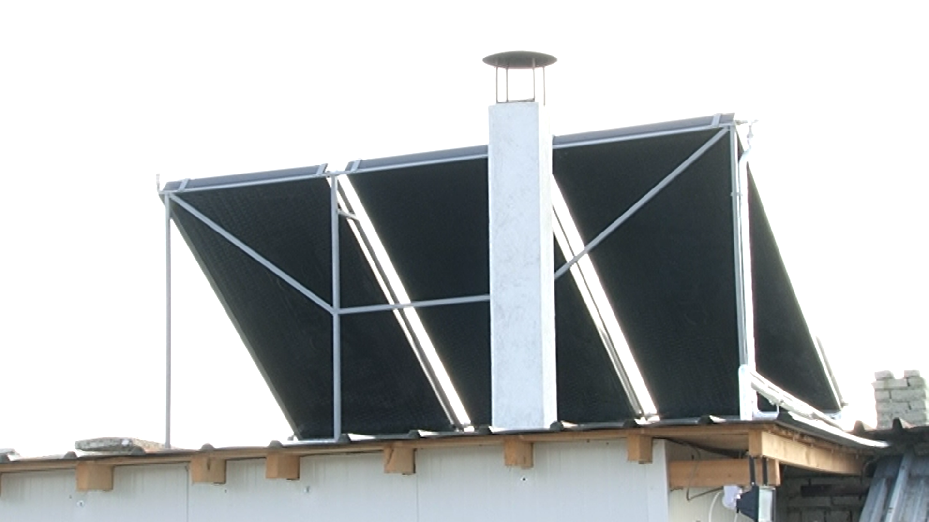
Author: Project “Energy efficiency and better milk quality for Bulgaria”
Sustainability underlies most of the demonstration activities since most of farmers participated on demonstrations could start use the similar RES for production of hot water for washing and cleaning and for other activities under their farms. Also, agrarian speciality students will be well acquainted with RES use in agricultural and when they graduate, they will use in their work. By this way it is giving priority to ecologically safer methods, minimizing the use of non-renewable energy, and enhancing the safeguard of the environment.
The objective of the demonstration is dissemination of knowledge about using renewable energy sources (RES) in milk production especially using RES for production of hot water for washing and cleaning. The demo will stimulate dissemination knowledge for more environmentally friendly use of energy in milk production which could also contribute in improving the quality of the milk produced by Bulgarian small and medium sized dairy farms.
The targeted visitors are other animal-breeding farmers from all regions, advisors and agrarian speciality students.
Image 2. Demonstration on RES equipment in Matanski farm
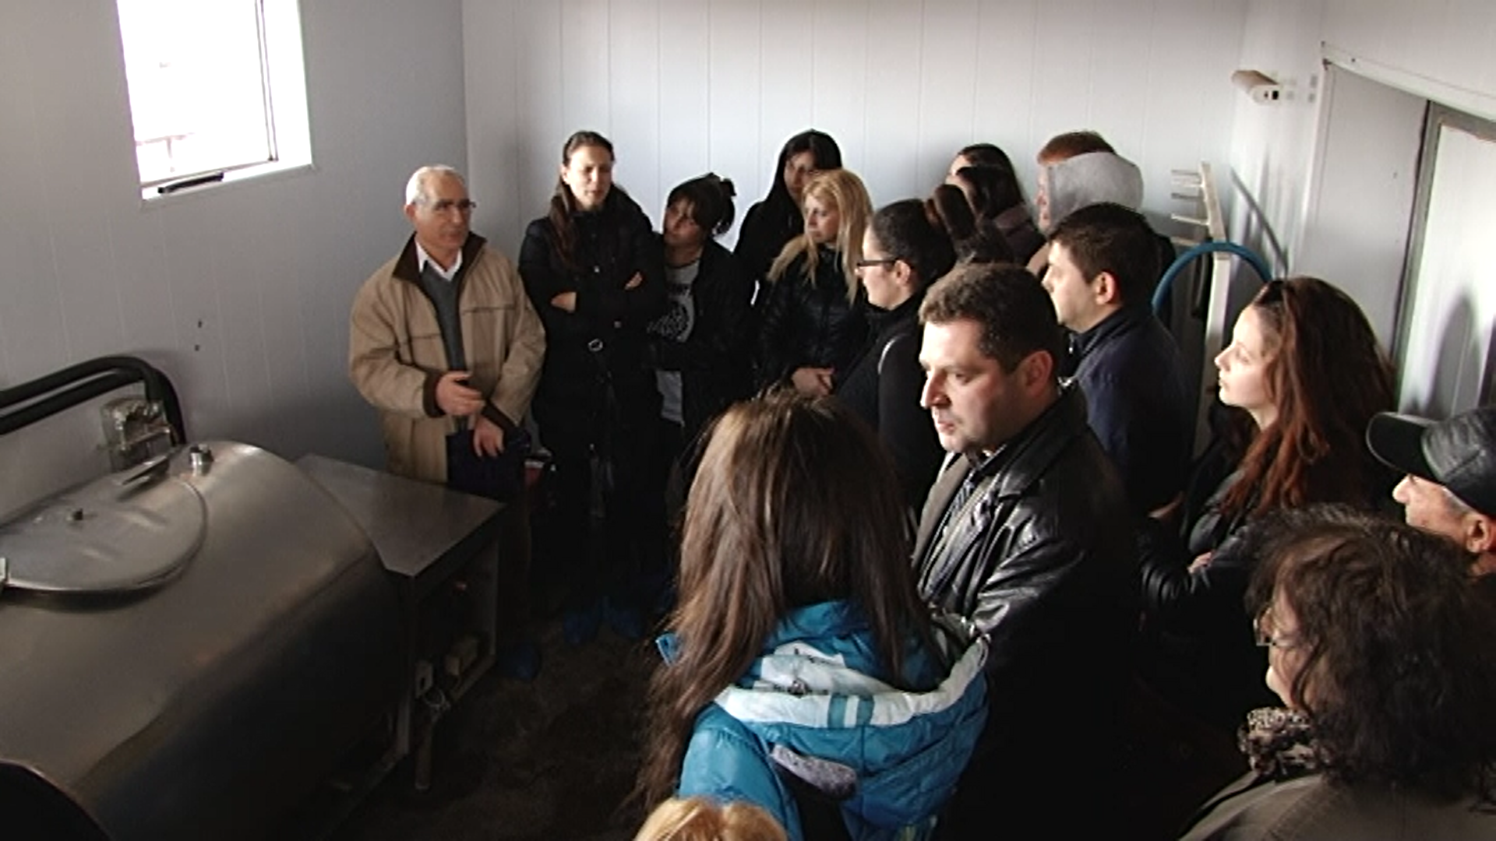
Author: Project “Energy efficiency and better milk quality for Bulgaria”
This case study supports the PLAID project to learn about:
• how to compose an interesting program;
• what farmers learn and how;
• what advisors and suppliers learn and how;
• what agrarian speciality students learn and how;
• how advisors and field men from the suppliers use the knowledge in their contacts with the farmers;
• what is interesting for participants in demonstrations.
Also, this case study demonstrates good example for cooperation between farmers, researchers, representatives of non-governmental organizations and advisors for promotion environmentally friendly practice. Since this case study has been held by two years, it was gathered info on what farmers have applied into practice after participation in these demonstrations and it was developed recommendations for better application of demonstrated innovations. This case study also supports the PLAID project to learn good practise for dissemination novelties outside participants in the demonstrations.

Governance: set up and organisation

Organiser(s) and history
The demonstrations are organized by Foundation for Organic Agriculture BIOSELENA (for farmers and advisors) and Trakia University - town of Stara Zagora (for students and researchers) from year 2015. Foundation for Organic Agriculture BIOSELENA is Bulgarian non-government organization. The Foundation was established in 1997. The main task of BIOSELENA is developing and supporting the sustainable and organic agriculture, biodiversity preservation and environment protection. Trakia University (TrU) is an autonomous state scientific and educational institution with domicile in Stara Zagora. Trakia University covers six of all areas of higher education - Agricultural Sciences and Veterinary Medicine, pedagogical, social, economic, nature and environmental, technical, health and sports. The demonstrated equipment was supported under the project “Energy efficiency and better milk quality for Bulgaria”. The project was financed under Norwegian Financial Support Instrument “Investments for a greener future. “The main project objective was reduction of energy consumption in small and medium-sized dairy farms through training and installing Renewable Energy Sources (RES) on selected farms. The project beneficiary was BIOSELENA. The Norwegian partner was Royal Norwegian Society for Development (Norges Vel). Total project budget in EUR was 221 545. Total grant approved in EUR was 200 000;
In the organization of the demonstration is also included Mr. Georgi Matanski – owner and manager of the farm. Demonstrations are led by researchers from TrU who are specialised in RES. Demonstration on studying topic is organized sometimes per year (in most cases 2 or 3 times). Experience from previous demonstrations indicates that the demonstration duration should be decreased from 2-3 hours to around 1.5 hours. The demonstration was part of a network of demonstrations related to the project “Energy efficiency and better milk quality for Bulgaria”. After the end of the project demonstrations continue as part of TrU practical study agenda and as demonstrations for NAAS advisors and NAAS consulted farmers.

Funding
First demonstrations (year 2015 and year 2016) the costs were financed under the project “Energy efficiency and better milk quality for Bulgaria”. Demonstrations are free of charge for the participants. They should ensure their transport costs to the farm but transport costs for TrU students were covered by the University. All other costs are covered by the organizers and host farmer. As the main coast are covered by the organizers, they determine the topic and who to be invited.

Host(s)
The host of demonstrations is only one farm. The address of the farm is village Momino, Rakovski municipality, Plovdiv District, Bulgaria. The farm is commercial conventional dairy cow farm. The farm buildings and premises cover an area of 0.8 ha. The cultivated agricultural land is 150 ha and is mainly used to produce feed for animals. It is breeding 80 cows, 20 heifers and 30 calves on the farm. The farm is owned by the Matanski family and all family work on the farm. The farm is headed by the father - Georgi Matanski. The farmer Georgi Matanski explained that his interest to be host is related with opportunity to show new technology which helps him to reduce his costs to other farmers. The organizers of demonstration have selected the farmer because farmer using renewable energy sources (RES) in milk production. Mr. Matanski is recognised as a successful farmer by the organisers and is referred to as a very good example in this field in the region. His son is an active young farmer, who is in the chairman of the National Union of Cattle Breeders in Bulgaria and he also participates in several working groups at the Ministry of Agriculture, Food and Forestry.

Map 1 – Location of Momino Village
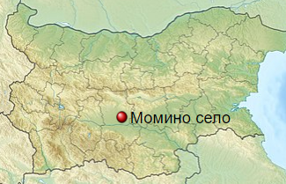

Gender
Regarding the gender perspective, men and women don’t play different roles in commissioning, organising and holding the demonstration. The farm is family and all family members (Georgi Matanski, his wife, his son and his daughter) are related to the farm activities. The representatives of Trakia university and Foundation for Organic Agriculture BIOSELENA are men. Participants at the demonstrations were round 60/40 men/women. Representatives of the NAAS are more women (three women and one man) who actively participated in the organization. Of all 28 participants at the last demonstration on the farm 15 were men and 13 were women.

Objective(s)
The overall demonstration objective is to share knowledge and to promote more environmentally friendly use of energy in milk production which could also contribute in improving the quality of the milk produced by Bulgarian small and medium sized dairy farms. The concrete objective of the demonstration is dissemination of knowledge about using renewable energy sources (RES) in milk production especially using RES for production of hot water for washing and cleaning. The presentation of the combined solar hot water installation and the secondary heat utilization of milk cooling also aimed to show that with a small investment, resources can be saved and to be improved economic performance. The other objective was a broad presentation of the possibilities, the technical aspects and the economic aspects. In this way the farmers acquire knowledge so that they are better equipped to make the decision to do this or not.

Figure 1: The Renewable energy sources (RES) in milk production (Bulgaria) case in the PLAID typology of demonstrations

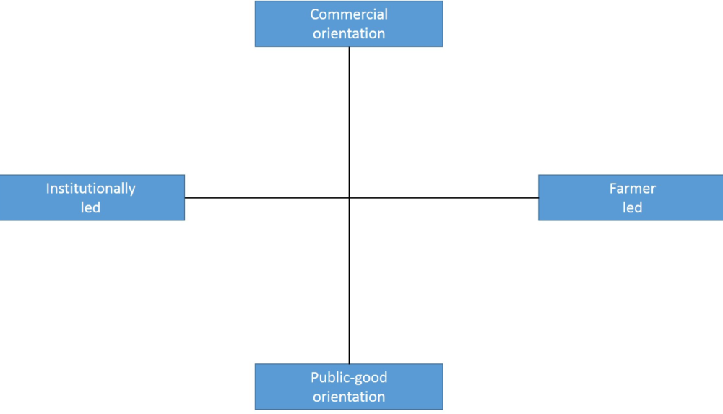
BG1

Regarding the PLAID typology of demonstrations, this demonstration is for public good and institutionally led (Figure 1). The farmer is also involved and has an active role in discussions, giving inputs and sharing experiences, but he is not responsible for conducting the theme day. In terms of orientation the project is primarily a public-good oriented one, since it does not aim to generate any direct income to the organisers through the uptake of the demonstrated practices.

Topic(s)
The topic of the demonstration was use of renewable energy sources (RES) in milk production especially using RES for production of hot water for washing and cleaning. This topic was selected because it is future-oriented and environmentally friendly oriented. The other reason for selection of topic is to be promoted the results from project “Energy efficiency and better milk quality for Bulgaria”.

Image 3. RES for production of hot water for washing and cleaning
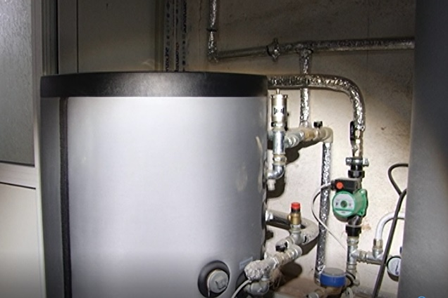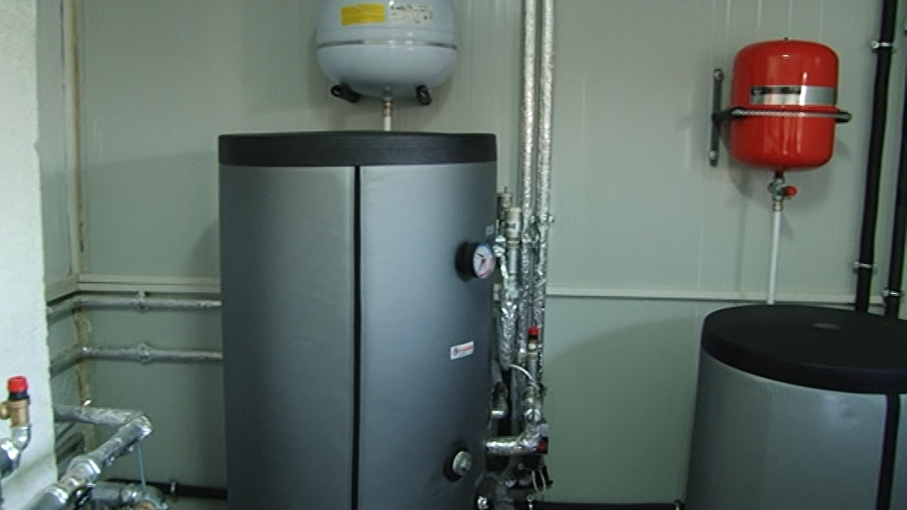
Author: Project “Energy efficiency and better milk quality for Bulgaria”

Access
The targeted visitors are other animal-breeding farmers from all regions, advisors and agrarian speciality students. For increase accessibility of the demo for the target audience it was prepared special press releases for agricultural medias and specialised press. It was also published information on organizer’s websites. For the last demonstration current year, the information was distributed to all NAAS district offices and respectively from the local NAAS experts to farmers. Everybody could participate on the demonstrations.

Demonstration event

Visitors
The number of visitors on the last demonstration held on 25 September 2018 was 28. Most of them were advisors, students and farmers. The organisers expected more farmers, but some farmers used the sunny day for implementation farm activities. Of all 28 participants at the last demonstration on the farm 15 were men and 13 were women

Image 4: Visitors from Trakia University
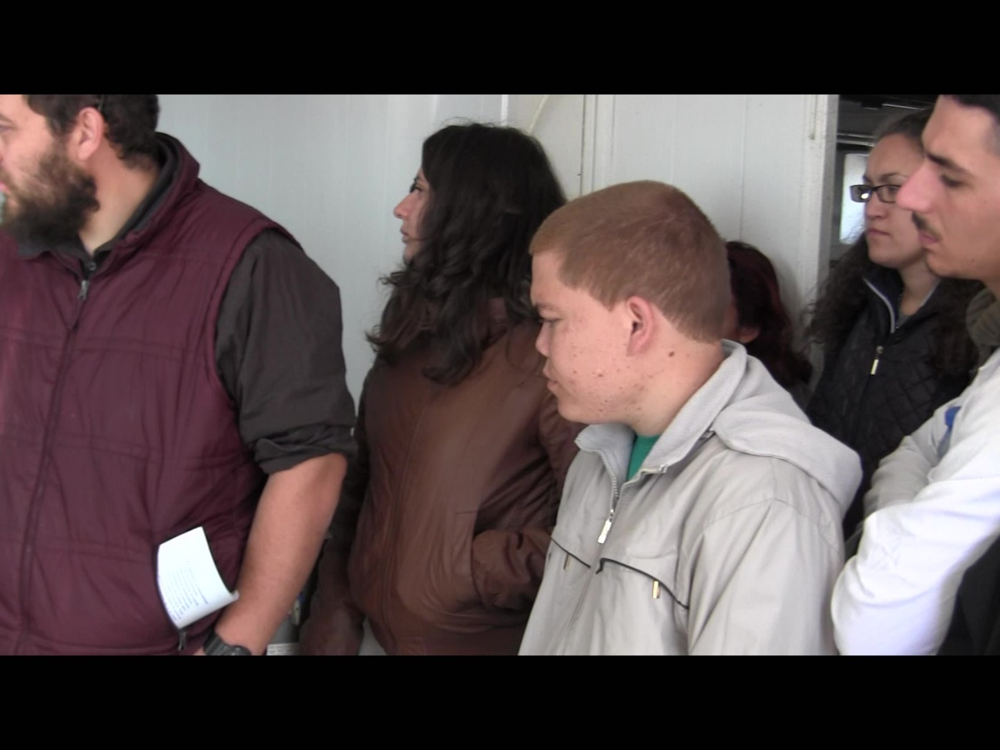
Author: NAAS PLAID Project team

Communication & Mediation
The demonstrations were led by researchers from TrU who have participated under the project “Energy efficiency and better milk quality for Bulgaria” and they were responsible for construction of RES equipment and its assembling in Matanski farm. There was a very short theoretical part at the start of demonstration on the farm. The lectures from TrU explained what will be demonstrated and what was demonstration purpose. After that it was demonstrated the equipment. Participants asked questions. After the end of demonstration, it was held focus group for discussion on results from demonstration. The focus group was in building outside the farm.

There are usually also selected information materials made freely available for the participants– e.g. information leaflets and CDs. They were developed under the project “Energy efficiency and better milk quality for Bulgaria”.

Image 5. Discussion on results from demonstration
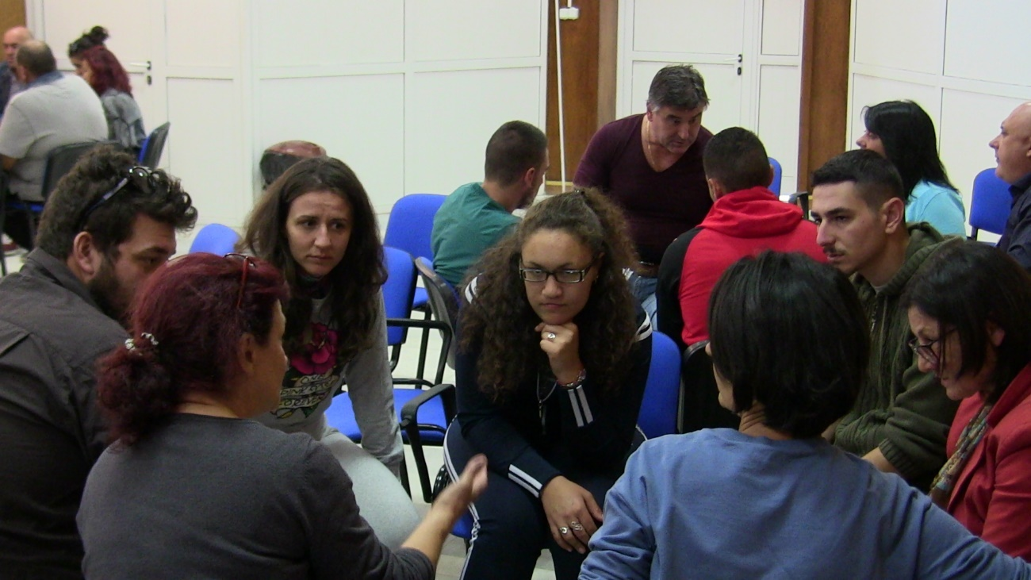
Author: NAAS PLAID Project team

Active participation
Not all participants were active. Students listen carefully and ask questions. Advisors were active and participate in demonstration and look around the farm and participate in discussions. Mainly the participants talk between themselves. During the demonstration, there were many informal conversations and exchanges of information between advisers, lecturers, and students. The things they heard or saw during the demonstration were commented. Some visitors also took the opportunity to talk individually with attending counsellors and experts or with the farmer.

Doing business
During the demonstration there isn’t an option to do business directly. It was demonstrated method using renewable energy sources (RES) in milk production not special product or technic.

Role of sustainability
Farmer explained to the participants the economic benefits of the method (with use of RES equipment he decreases his costs) and recommend it to other farmers.
In addition, the demonstration aims to promote livestock farming, considering environmental protection and resource conservation. Although sustainability as a concept is not used much in farmers' presentation, it does not automatically mean that the role of sustainability is neglected in field experiments and demonstrations. However, the focus is on economic sustainability, with the focus being on increasing the efficiency of livestock production regarding the use of energy resources.

The demonstration was used to show participants, especially students and the overall animal breeding technology, animal welfare issues, the welfare of animals as an important prerequisite for product quality.

Social sustainability as the third dimension of sustainability, however, is largely beyond the scope of the issues addressed by the demonstration.

Unforeseen circumstances
Demonstration starts 15 minutes later because there was repair activity on the road and NAAS organization team and other participants delayed, but during this time the farmer showed his farm to the participants who arrived on time.

At the demonstration itself there were no force majeure related to weather factors. Potential problems with force majeure in weather or with human factors are always on the agenda. At some point, some of the hosts are no longer motivated to participate in demonstration activities due to difficulties in complying with procedures and ensuring the necessary conditions of the process or the problems encountered by advisors in terms of efficiency or regular farming practices on the farm, account will be revealed to the wider community. This can lead to frustration for both the farmer and the advisors, sometimes posing a risk to future relations and prospects for cooperation

Plans vs. practice
At the demonstration, the planned activities were fully implemented, and all objectives were achieved. All participants were quite active. More students, advisors and fewer farmers were very actively involved at the demonstration activities.

Usually, when it is planned farm demonstration days, it is expected demonstration to be visited by more farmers. Sometimes some expected farmers don’t come, which is different from the expectations of the organizers. Experience shows that a group of 20-30 people is optimal and most suitable for a training format.

Although large numbers of visitors are generally a positive indicator of farmers' demand and common interest in this type of event and their willingness to devote time to participation, this requires further practical measures to ensure optimum working conditions. For example, during this demonstration because a big number of participants, the focus group and discussion was held in Rakovski, in a specially hired room.

It is very important the presentation of the information in front of farmers to be in an understandable language and to be new for them in order not to compromise with the planned and the real in practice. This is related to the fact that the level of specialized training of farmers is different.

It has also been acknowledged by the organisers from BIOSLENA that while the primary idea of the demonstrations has been to be focussed only on new approaches and practices in RES use, the overall level of farmers’ knowledge frequently requires reducing the ambition and the level of complexity of the provided information and to be explained activities outside RES, but which are related to animal breeding.

Participants feedback
The participants were divided in groups and every groups discussed and defined the five most important factors for a successful demonstration. Each group then presented the five factors determined by them for a successful demonstration.
The summarized factors that the groups identified as the most important are:
- Appropriate topic, location and time of the demonstration;
- Good organization / logistics /;
- Appropriate duration of the demonstration;
- A suitable moderator;
- Competent lecturer on the subject;
- Practical direction of the demonstration;
- Practical participation of the present (in working environment);
- Proper audience selection;
- Predicting and holding a discussion after the demonstration;
- Preparation and distribution of supporting information materials to the participants;
- Short, accurate and clear messages;
- Artistic presentation of the demonstration;
- Ensuring publicity through the media;
- Provide visual material, data, schemes demonstrating cost-effectiveness and economy of innovation, investment cost data, system maintenance.

During the focus group, a discussion was held on the factors for conducting a successful demonstration, the relevance of what was learned during the demonstration and the benefits of conducting demonstrations.

The participants' responses were summarized as follows:
For the question “What can be improved when running the demonstration?”:
- Dissemination of information about the upcoming demonstration;
- Send in advance the brief information about the systems which will be demonstrated;
- Ensuring assistance for farmers for introducing in their farms of demonstrated innovations;
- Enough space for participants to see and hear the presentation of the demonstrated RES equipment.

For the question “What would you apply from the demonstration”?
- Providing information about the innovation to interested farmers in order to facilitate their farm work and activities;
- Dissemination and providing information to other farmers about the benefits and applicability of the demonstrated RES system;
- Introducing the demonstrated RES system and equipment not only on the farm building but also at home buildings;

To the question ”What demonstration do you think cannot be applied and why?”
- Ensuring financial resources for introducing innovation.
- For smaller farms with 10-15 cows probably this RES installation is not financially profitable.

According to the survey results, the overall assessment of the events was very positive - both for the theoretical part and for the practical demonstration of innovation.

It was recognized that open farm demonstration days encourage the openness of farmers and the opportunity to ask each other questions, given the informal atmosphere these events pose.

It is also important to note the benefit of direct contact between university lecturers, advisors and farmers of such events - in direct contact and real farm situation. In addition, the benefit of the participation of students from the largest livestock university in Bulgaria is highlighted and the latter are using the opportunity to strengthen their knowledge in areas beyond their main specialization.

Motives, learning and networking

Reasons to attend demos
Attitudes and perceptions
The main reasons to participate to demonstration events is to learn something useful and to exchange experience and information with people with similar activity and interest. On the demonstration events you can meet these people in one place and to look the technics and technologies with your eyes and to find answers of your question directly from presenters. In the other way you must find the information and to try to imagine how some technology will work in real.

There are also other various reasons for attending demonstrations on farms, depending on the visitor's profile. In addition to farmers, there are also advisors, students, representatives of non-governmental and governmental institutions in the demonstrations. They all have a different motivation to participate in such events. For example, advisors take advantage of the opportunity to meet farmers, other professionals and colleagues from other regional offices to learn new things from the field process to expand their social networks, improve their own knowledge base. Students come to familiarize themselves with the theoretical knowledge they learn. Representatives of the local and state authorities are using the opportunity to meet the farmers personally and to learn about the problems that are being dealt with in the farms themselves.

Our studies show that the motivation of farmers to attend demonstrations is related to the opportunity to meet and socialize.
As small farmers say, they are busy in their day-to-day work and do not feel comfortable starving their peers that they go to the other's farm and take up their precious time as this kind of public event offers the chance of informal networking outside of the daily farm.
In addition to the benefits of practical knowledge, farm days also provide visitors with the opportunity to travel and use the opportunity to see other farms and the results of the technological processes there.

On the demonstration event participate sole farmers. Most of the participants came alone as representatives of their farm / production. The reasons were that they have their own farm with livestock productions, and the spouse or other family members had to stay home and take care of that. Some of these participants observed that they swap with family members.

Norms
Farmers participate, because they will learn something new which will be useful in their farms and will reduce their costs. Farmers participated at this event also to get new information, see what is happening in the market and with the productions, and to stay updated on the field. This also gives them an opportunity to see if they are doing something wrong, or to get a confirmation that they are doing something right (which they also appreciated).

The demonstration farm was good because the farm is dairy farm. The farmer wants to show the method to other farmers and students. This host farmer has a good reputation as a dairy producer – both the organisers and the participants explicitly expressed this. He has many years of experiences with animal breeding, his farm was included in several projects and the basis for him to want to try out new things. Even though, the reputation of the farmer was not crucial for attending the demo. Some of the participants said that they would have attended regardless of the site of the event. The organisers’ reputation and the demonstration theme were more important.

Advisors recommend the demonstration event and farmers didn’t know each other before the event, but the agricultural students they know each other.

Practicalities
As the most of participants were students and advisors there are very small number of people who pre-register the event, but they do not come, as well as small number people who attend the demonstration event without first notifying the organizers. It could conclude that in most cases. It can be concluded that in most cases when there is a pre-registration for demonstration from the pre-registered participants, farmers do not usually come in, whereas if the pre-registered participants are advisors and students almost all come. As well as farmers who have not confirmed in advance they come. The personal reasons are almost the same as in other case study and they are related to sudden or urgent other farmers' tasks - a good time for sowing or harvesting, birthing and other unplanned activities. It's also just to forget about the upcoming event among the daily activities.

Farmer participation mostly requires the use of private means of transport in order to reach the demonstration site and given that many visitors come to the event together with other acquaintances, it may be the absence or change in driver plans may also impede the participation of others. The students and advisors in most case come with common transport.

The farm is close to main roads and for participants is easy access to it.

Forms of learning
During the demonstration were used different forms of learnings. The presenters show technics and technologies verbal and physical. They explain all process and benefits of the method. Participants ask questions and receive answers from presenters.

Typically, as the presenters in this demo event were researchers and university lecturers and the style of presentation was a little scientific and with more theoretical data. Also, with many explanations in details of demonstrated techniques and technologies. Because of this it was emphasized on the theoretical forms of learning with detailed examples of their scientific practice.

Stimulating engagement or feedback is a good example of audience ownership and an opportunity to even better present the different aspects. Asking questions and seeking answers is a way to keep participants’ attention and interest until the end of the presentation.

Still, the experience of observed farm demonstrations shows that there are varied levels of actual engagement - while in some cases there were very few questions or comments, people were not willing to participate actively, others were developing much lively debates, largely dependent on theme.

In some cases, students are leaving the subject and are starting to share the various difficulties they encounter during the studying at a university. Also advisors starts to discuss other topics, which is not possible to receive answer at this event.

In summary, the key feature of these demonstrations is that they are a live encounter with other practice-based colleagues in real-life situations. Participants see practically different good agricultural practices, can share and apply them.

Content of learning
The objective of the demonstration is dissemination of knowledge about using renewable energy sources (RES) in milk production especially using RES for production of hot water for washing and cleaning.

No one confirm that he will introduce the method in his farm.

Although there are outlined themes that are part of the official program, it is inevitable to put other related issues. When the topic is part of a whole technological (milk production), it inevitably exceeds the officially defined topic. The question of energy efficiency on a farm is closely related to many other aspects of livestock farming and cannot be treated as a separate subject. Therefore, it is quite natural that during the demonstration numerous additional topics were raised and discussed and commented by the hosts, scientists, advisors and farmers - the system of nutrition and farming, the workforce on the farm, etc.

According to the participants in the demonstration events, it is very important, and it is crucial for farmers involved in the demonstration to speak out about the problems and mistakes they face. Sharing, including negative experiences, is also important for effective peer education. Of course, this is often avoided by farmers, worried about publicly disclosing their problems.

Outcomes of learning
It is difficult to assess the individual processing of the information provided and the learning outcomes of participants at the demonstration event. The assessment is subjective, depending on the interests and problems of the various demonstrators, which they found useful for the innovations presented.

The results of the study showed usefulness and applicability from the theoretical and practical part. Several demonstrators have said that without much investment they could improve their energy efficiency on the farm. Moreover, the demonstrated animal breeding RES technology helps them to improve some aspects of their farm work - food and hygiene, labor, and more.

It was shared that the significant factor for the results of the demonstration event is the scale and degree of development of the host holding.
If there is something working on a small or medium farm, then it is obvious that it is more likely to work on a large farm. This is not always the case, however.

For advisors participating in such events and what they see there leads to distribution information and knowledge between other colleagues-advisors and farmers and support solving the similar problem in farms, which they will visit. For example, after participation in current demonstration farmers understand the importance of RES not only for environmental protection but also for economic benefits from their use.

Networking
We have already noted that demonstration events are being attended in addition to learning and seeing something new and useful, but also about the opportunity to communicate with other advisors and agricultural students (social contacts) and specialists, as well as to meet new people..

As noted by the participants, demonstration events facilitate rapprochement between advisors, researchers and farmers, with some of them even making friends. Many of the participants attended the demonstration also to use the opportunity to meet advisors and researchers in this field.

Participation in the event also allows you to identify and get contact information from other animal breeders and their associations and / or various specialists in this field. These contacts can be used in a subsequent step if necessary (veterinary services, animal feed, various supplies of raw materials and materials, etc.).

Anchoring: Application of demo lessons by participants

Anchoring related to the present demo
Some participants replied that they will introduce demonstration RES equipment and system if they found financial resources. Advisors could help them for the provision of financial resources, incl. through the development of projects for national and European support schemes and programs.

Most participants report a high probability of taking advantage of the acquired knowledge.

It is important to emphasize that the presence of all members of the family farm demonstrator is an important prerequisite for attachment.

Some farmers mainly wanted to get more information and inspiration and make new contacts and meet other dairy farmers in the region, with whom it could be useful to cooperate with or to exchange experiences with in the future.

The demonstration enabled the farmers and advisers who participated in it to get acquainted with some of the best scientists working in the field of using renewable energy in livestock farming and to establish better contacts with the host farm of the event. In the future, they will be able to contact them again so they will be better able to apply the demonstrated technologies to their farms or if they are advisors to be able to easily and comprehensively present the information when providing advice and conducting information events. They will even be able to visit the farm again to get acquainted with details they have not noticed during their first visit, or to visit the university and see patterns of demonstrated technology there. Advisors will be able to organize similar demonstrations in their regions.

Stimulating anchoring
A key feature of this innovation demonstrations organized by the Trakia University and Foundation for Organic Agriculture BIOSELENA is that information on the demonstration results, its benefits and effectiveness has been published in several media - including on the TrU website and the foundation website. It is also distributed on electronic devices and on paper. These publications are usually read by later not only those present in the demonstration event but also by people who are not among the visitors.

The demonstration was shot with a video camera and a short video will be created. The film will be sent to advisory organizations and associations and it is expected to help other farmers and advisers to get acquainted with the demonstrated technologies and tools for the use of renewable energy sources and their benefits not only for the protection of the environment but also for improving the economic state of farms and their greater independence from electricity suppliers.
In addition, the demonstration was attended by a team of specialized national agricultural television (AGRO TV), which broadcasts a subproject report for the event and thus the results of the demonstration received national distribution. Regional media also attended, which also contributed to disseminating the results and topics of the demonstration.

It was also noted that the advisors who attended a demonstration event later organized local seminars on these topics in their regions. Continuous repetition of things from one occasion to another and the use of different means of communication is considered important for the transfer of knowledge and its gradual absorption by the attendees.

Anchoring related to earlier demos
Discussions with different showed that most farmers participating in previous demos have shown a willingness to implement demonstrated technology, but because of various reasons they have delayed it for the near future. On the one hand, the reasons are financial, on the other they have been hurried to get additional information and assurance in the results they will get. While participating advisors have implemented it directly in providing advice and organizing information events. Students have applied it to the development of their course works, and those who in the future plan to engage in agriculture are also willing to implement it on their farms

In this case, the demonstrated innovation practice - hot water installation can be quickly and easily implemented without requiring complex technological changes on the farm.

This case seems to be a good illustration of how anchor can be carried out and anchor associated with earlier demonstrations.

It is also noted that farmers need some time to fully understand the results of what they see and to find practical applications for the advice provided by the experts involved.

Sometimes, the farmer realizes the importance of the practice demonstrated, but thinks it is too complicated to be used by himself/herself.

Scaling: Application of demo lessons by the wider farming community

Retrospective examples of scaling
The case study demonstrations address problems that the farmers have with non-effective energy use and big energy consumption costs and with the milk quality and compliance with hygiene standards. These problems in Bulgaria are from many years and current demo events continue efforts for solving these problems especially in small and medium dairy farms. There are several small farms that are not yet resilient and motivated to make additional investments because most of them are not market-oriented and they don’t have financial means to improve the parameters of the production process and energy efficiency. These demonstrations could change their thinking.

Also, participation in demonstrations of animal breeding advisors from NAAS will increase significantly the distribution of demonstrated topics as NAAS offices cover whole Bulgarian territory. Some NAAS advisors plan to organize demonstrations on similar topics in their region. The demonstrations allow advisors to link with researchers in RES issues and to invite them to participate on other demonstrations on this field.

Prospective assessment of scaling: Impact pathways
The current case study has the potential to promote the wider use of knowledge and concrete innovations demonstrated during the events and distributed to the farming community through creating new and maintaining previously published free online follow-up material on the results of each event. For example, the video materials and information materials developed under the project “Energy efficiency and better milk quality for Bulgaria” financed under Norwegian Financial Support Instrument “Investments for a greener future. The information about demonstration events and demonstrated innovations is uploaded at the site of the agricultural medias in Bulgaria (for example - www.agrotv.bg, www.fermer.bg, etc.). Also, NAAS, Trakia University and BIOSELENA which are involved in organizing these demonstrations are an important tool for promoting and exchanging good practices.

Another official route is the free printed brochures and leaflets of Foundation for Organic Agriculture BIOSELENA, NAAS and Trakia University
Demonstration lessons, as well as information on demonstration farms, are also distributed through video material at regional TV stations and local press publications. Significant scaling potential is also contained in the short online video of the project and its output, produced and promoted by the project team, which is a tool that can be used even more intensively.

Due to the low level of knowledge and training of small farmers and young farmers and the limited opportunities for professional education in livestock breeding, NAAS experts carry out information and training events together with the agricultural academy and agricultural universities. In addition, the NAAS provides them with a comprehensive advisory service - packages on different aspects of agricultural production, protection of the environment and development of their competitiveness.

The information is also distributed through AKIS in Bulgaria. Some of main actors of AKIS in Bulgaria (NAAS, FBOs – co-operatives and few producer groups, Research and Education organisation and Non-government organisations) distributed the information. Private advisory services and independent advisors are not so active in distribution.

From year 2015 NAAS started a new activity related to dissemination among farmers of information and innovations news in the field of agriculture including for current case study, through the setup of the "Farming circles" to every office. The purpose of "Farming circles" is to spread among farmers useful information and to promote best practices in the field of agriculture and the application and implementation of projects under the RDP as well as to increase the efficiency of advisory services provided by the NAAS for a larger number of farmers. In Farming circles are involved active farmers from the relevant region. They disseminate information and innovations news among other farmers. From year 2015, 27 farmers circles were set up (one for each NAAS regional office) and over 400 farmers participate in them. The existing farming circles cover 165 municipalities out of total 265 or 62% of all municipalities in Bulgaria.

Case study reflection
In our case study we are addressing the following four topics:
- Governance of demonstrations and learning;
- Facilitating and impeding factors for successful demonstrations;
- Accessibility of demonstrations;
- Impact of demonstrations.

Facilitating and impeding factors for successful demonstrations
Based on discussion and interviews with organizers, participants and other stakeholders connected with current case study we identify the key indicators for successful organisation and implementation of the demonstration activity

They are structured along the following three groups of factors, as put forward by the PLAID conceptual framework:
- inputs (infrastructure, finances, human resources);
- access (geographic, social, economic);
- demonstration process (methods, content, interaction form).

8.1.1. Inputs
- Appropriate topic, location and time of the demonstration;
-
- Send in advance brief information about the system to be demonstrated;
-Enough space for participants to see and hear the presentation of the system;

8.1.2. Access
- Proper audience selection;
- Ensuring publicity through the media;
- Free of charge participation
In current case study accessibility of demonstrations is facilitated by the fact that participation is free of charge and there is organized transport for students and advisors..

8.1.3. Demonstration process
- Appropriate duration of the demonstration;
- Competent lecturer on the subject;
- Predicting and holding a discussion after the demonstration;
- Short, accurate and clear messages;
- Provide visual material, data, schemes demonstrating cost-effectiveness and economy of innovation, investment cost data, system maintenance.

8.1.4. Conclusions

In order to improve the quality of learning opportunities, it could be better in future the visitors of the case study demonstrations to be dived at least on two groups – students (1st group) and advisors and farmers (2nd group).

Both case studies in Bulgaria confirms that the main factors for success the demonstrations are:
- Good organization / logistics /;
- Practical direction of the demonstration;
- Proper audience selection;
- Appropriate duration of the demonstration;
- A suitable moderator and presenters.

Impact of demonstrations
Analysis of direct and indirect impacts of the studied demonstrations outside participants and organizers is very difficult. The organizers explained that they have information that very small other farmers start to introduce the demonstrated RES equipment and system. The basic impediment is lack of financial resources for buying the equipment. From other side big number of participants attended on conducted demonstration shows that there is interest to RES use in dairy sector. They notice that the interest increases every year. One of big advantage of this case study is selection of appropriate farm. As it is written above the farmer’s son is an active young farmer and he is the chairman of the National Union of Cattle Breeders in Bulgaria and he also participates in several working groups at the Ministry of Agriculture, Food and Forestry. This fact facilitates distribution of demonstration results and increase the demonstration impact.

This case study is good example for demonstration which combine all five impact domains from the PLAID conceptual framework:
(i) Productivity & profitability – use of RES decrease the costs for energy an increase the profit;
(ii) Resilience – use of RES support dairy farms to adapt to the frequent changes in the prices of conventional fuels, and in particular of electricity, which in Bulgaria there is unstable and constantly rising prices. In this way, farmers become more independent from external factors;
(iii) Environmental sustainability - use of RES support dairy farms to adapt to climate changes and improve the environmental protection. It improves also the hygiene conditions on the farm and respectively improve food security;
(iv) Quality of life – some of farmers participated in RES demonstrations (including host farmer) explain that they will use the demonstrated RES technology not only for production purposes but also in their houses and this will improve the quality of their life.
(v) Empowerment - Participants shared that they have acquired new knowledge that have improved their skills, and these new knowledges make them feel more confident in themselves.

Key lessons from this case study
Lesson 1: Most farmers participating in demonstration have shown a willingness to implement demonstrated technology, but because of various reasons they have delayed it for the near future. On the one hand, the reasons are financial, on the other they would like to receive additional information and assurance in the results they will get. It could be concluded that in most cases only one demonstration on the topic is not enough for most farmer to be convinced to apply demonstrated innovations. While participating advisors have implemented it directly in providing advice and organizing information events. .

Lesson 2: The case study demonstration enabled the farmers and advisers who participated in it to get acquainted with some of the best scientists working in the field of demonstration and to establish better contacts with the host farm of the event. In the future, they will be able to contact them again so they will be better able to apply the demonstrated technologies to their farms or if they are advisors to be able to easily and comprehensively present the information when providing advice and conducting information events. Finally, the case study is good example how demonstrations improve the link “Science-Advice-Agricultural Business“.

Lesson 3: The presenters in this case study demo event were researchers and university lecturers and the style of presentation was a little scientific and with more theoretical data. Also, with many explanations in details of demonstrated techniques and technologies and it was sometimes difficult for famers to understand the topic. It is appropriate via AKIS to be organized training for researchers and university lecturers on moderation and presentation techniques during demonstrations. .

Acknowledgements

We would like to thank:
Dr. vet. Stoilko Apostolov – Manager of Foundation for Organic Agriculture BIOSELENA;
Prof. Dr. Radoslav Slavov - Trakia University - town of Stara Zagora;
Assoc. Prof. Dr. Kancho Peichev - Trakia University - town of Stara Zagora;
Assoc. Prof. Dr. Rashko Georgiev - Trakia University - town of Stara Zagora;
Mr. Georgi Matanski – Head of Matanski Family Farm;
Mr. Rangel Matanski – Member of Matanski Family Farm and Chairman of the National Union of Cattle Breeders in Bulgaria

Annexes

Data sources
It was used different data sources. Voice recordings from interviews with participants, experts and organisers have been important sources. The invitation to the demonstration has also been used as an information source. It was also prepared minutes from the meeting on the focus group for discussion on current case study. The meeting was held on 27.09.2018.

http://www.bioselena.com/bg/news/view/127/
http://www.bioselena.com/bg/news/view/205/
http://www.uni-sz.bg/%D0%BD%D0%B0%D1%83%D0%BA%D0%B0/%D0%BD%D0%B0%D1%83%D1%87%D0%BD%D0%B8-%D0%BF%D1%80%D0%BE%D0%B5%D0%BA%D1%82%D0%B8/%D0%BC%D0%B5%D0%B6%D0%B4%D1%83%D0%BD%D0%B0%D1%80%D0%BE%D0%B4%D0%BD%D0%B8-%D0%BF%D1%80%D0%BE%D0%B5%D0%BA%D1%82%D0%B8/%D0%BF%D1%80%D0%B8%D0%BA%D0%BB%D1%8E%D1%87%D0%B8%D0%BB%D0%B8-%D0%BF%D1%80%D0%BE%D0%B5%D0%BA%D1%82%D0%B8/
www.naas.government.bg

Data collection methods
The data collection for the case study included the following methods:
- Research - Collection and analysis of relevant national statistical data, information on the project and the demonstration activities in online and published resources (incl. other studies as well as outputs generated by or produced on the project).
- Visit on the demonstration events - Attendance of the demonstration day on September 2018.
- In-depth interviews - between March and October 2018, it was conduct interviews with individuals involved in the organisation and implementation of demonstration (including Mr. Stoilko Apostolov (BIOSELENA), Georgi Matanski (farmer) and Prof. Dr. Radoslav Slavov, Assoc. Prof. Dr. Kancho and Assoc. Prof. Dr. Rashko Georgiev - Trakia University - town of Stara Zagora);
- Focus group – It was hold in September 2018. It was participated farmers, demonstration organizers, advisors, researchers and agricultural students.

Main case study questions

Research
- Most important actors in the subsector
- Typical farm characteristics of the sector
- AKIS in the region (desktop research
- Social, climate and economic sustainability issues
- Summary of the demonstration activity
- What is the background (history) of the demonstration organizers/funders?
- Demonstration farm type
- Fit the farm type into the Plaid typology diagram
- What is the topic of this demonstration?

Observation of demonstration event

- What happened during the demonstration?
- How many people attended the demonstration?
- How many women are present?
- What methods were used?
- Did anything unforeseen influence what happened?

Interviews/questionnaires with organizers/demonstrators

- What is your role in the organization?
- What is the history of your organization?
- What demonstration methods do you (personally) prefer to use?
- Who initiated the demonstration?
- What is the topic of this demonstration?
- What is your role in the demonstration?
- What are the objectives of this demonstration (what do you hope to achieve)?
- Who were the targeted audience and how were they approached?
- Why/how was this identified as a in important topic?
- How is this demonstration funded?
- How many people attended this demonstration?
- Are women involved in this demonstration?
- Were your expectations of the demonstration fulfilled?
- Describe demonstration events in which you were involved, and they were successful?
- Describe demonstration events in which you were involved, and they were not successful?
- What measures do you have in place to support farmers after the event?
- What can be improved when running the demonstration?
- What would you apply from the demonstration”?
- What demonstration do you think cannot be applied and why?

Interviews/questionnaires with farm visitors
- How do you learn about the demonstration?
- Why did you attend the demonstration?
- Was the topic of the demonstration the most important factor? Which are other factors?
- Are you looking to introduce demonstrating equipment and technologies now or you just want to be informed?
- Did you like the demonstration? Was the demonstration covered you expectation?
- How useful was this demonstration for gaining new knowledge?
- How useful is this demo for new contacts?
- Do you like to visit demonstration events?
- What types of demonstration events do you like the most?
- Does your decision to attend demonstrations depends from travel costs and distance?
- Do you change your farming practices because of a demonstration event?
- What other sources of information do you use?
- Are there other family members that attend demonstration events?
- What can be improved when running the demonstration?
- What would you apply from the demonstration”?
- What demonstration do you think cannot be applied and why?

