Date: 15/11/2018

Country report: Belgium

Case Study: BE3 Bayer Forward Farm

WP5: Case studies of demonstration activities in commercial farms

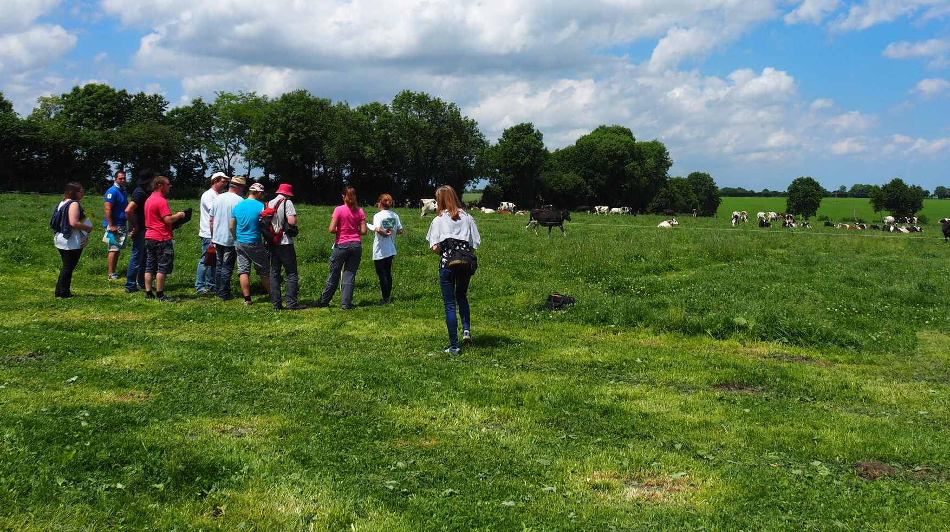
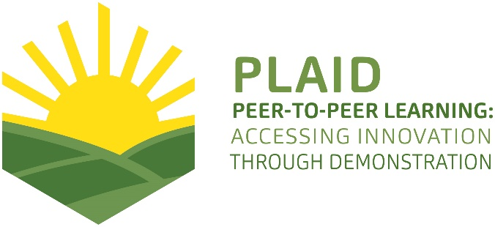
This project has received funding from the European Union’s Horizon 2020 research and innovation program under Grant Agreement No 727388

PLAID PARTNERS

Advisory Service Croatia ASC | 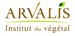  ARVALIS Institut du Végétal | Association de Coordination Technique Agricole ACTA
Institute for Rural and Regional Research | 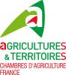  Chambers of Agriculture | 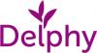  Delphy
European Forum for Agricultural and Rural Advisory Services EUFRAS | Innovatiesteunpunt ISP | 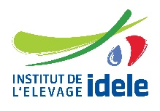  Institut de l’Elevage – Idele
Instituto Navarro De Tecnologías E Infraestructuras Agrolimentarias | 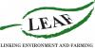  Linking Environment and Farming LEAF | 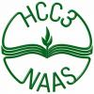  National Agricultural Advisory Service
Nodibinajums Baltic Studies Centre (BSC) | Research Institute of Organic Agriculture (FIBL) | Stichting Wageningen Research
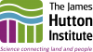  The James Hutton Institute | VINIDEA

DOCUMENT SUMMARY

__________________________________________________________________________________
Milestone Title: 24 Case Studies
__________________________________________________________________________________
Case Study Title: BE3 Bayer Forward Farm
__________________________________________________________________________________
Version: 1
__________________________________________________________________________________
Task Lead: WUR
__________________________________________________________________________________
Related Work package: WP5
__________________________________________________________________________________
Authors: Marleen Gysen, Koen Symons
__________________________________________________________________________________
Grant Agreement Number: 727388
__________________________________________________________________________________
Project name: PLAID
__________________________________________________________________________________
Start date of Project: January 2017
__________________________________________________________________________________
Duration: 30 Months
__________________________________________________________________________________
Project coordinator: The James Hutton Institute

ABSTRACT

This case provides an interesting example of a fruitful collaboration between a real working family farm and a commercial supplier in demonstrating innovative techniques. At the Bayer Forward Farm, visitors can have a look at the newest techniques in crop protection, smart farming, water protection etc. on a real working farm and under real conditions. Visitors benefit from both the practical experience of the hosting farmers and the expert knowledge of the Bayer advisors. Bayer is aware of the possible pitfall of such a collaboration. They guard the credibility of their demonstration activities by not doing business at all at the demos and by collaborating with other organisations. The topics of the demonstration events are all about economic, ecological and societal sustainability. The hosting farm was chosen by Bayer because they also believe in the integral approach of farming, they had been working on sustainability on their farm for a long time, they are open for new investments and also because of their close proximity to Brussels. Very interesting is that target visitors include farmers as well as advisors, food chain representatives, the general public, politicians and regulatory authorities. The demonstrators collaborate with other organisations to increase the access to the farm. At the farm, there is a room where presentations can be given and where visitors can find a lot of information. Outside, visitors can have a look at the different techniques, test fields and installations. At some places, extra information is given by information boards. Participants of the demos highly appreciate the mix of theory and practice. Interactive discussions are triggered by the demonstrator, by asking questions and by making use of voting boxes.
TABLE OF CONTENTS

1 Demo context 6
1.1 The value chain 6
1.2 Typical farm characteristics 6
1.3 AKIS 7
1.4 Sustainability challenges 8
2 Demonstration summary 9
2.1 Farm 9
2.2 Organisation of the demonstration activities 10
2.3 What is the main problem that is addressed? 11
2.4 What is demonstrated? 11
2.5 What role does sustainability play? 11
2.6 What is the objective of the demonstration? 11
2.7 Who are the targeted visitors? 12
2.8 What could be main lessons for the PLAID project? 12
2.9 Positioning of the case study 12
3 Governance: set up and organisation 13
3.1 Organiser(s) and history 13
3.2 Funding 13
3.3 Hosts 13
3.4 Gender 14
3.5 Objective(s) 14
3.6 Topics 15
3.7 Access 15
4 Demonstration event 16
4.1 Visitors 17
4.2 Communication & Mediation 17
4.3 Active participation 17
4.4 Doing business 19
4.5 Role of sustainability 19
4.6 Unforeseen circumstances 19
4.7 Plans vs. practice 19
4.8 Participants feedback 19
5 Motives, learning and networking 20
5.1 Reasons to attend demos 20
5.2 Forms of learning 21
5.3 Content of learning 21
5.4 Outcomes of learning 21
5.5 Networking 22
6 Anchoring: Application of demo lessons by participants 23
6.1 Anchoring related to the present demo 23
6.2 Stimulating anchoring 23
6.3 Anchoring related to earlier demos 23
7 Scaling: Application of demo lessons by the wider farming community 24
7.1 Retrospective examples of scaling 24
7.2 Prospective assessment of scaling: Impact pathways 24
8 Case study reflection 25
8.1 Demonstration-innovation narrative 25
8.2 Facilitating and impeding factors for successful demonstrations 27
8.3 Impact of demonstrations 27
8.4 Key lessons from this case study 28
9 Annexes 30
9.1 Data sources 30
9.2 Data collection methods 30

Demo context

The value chain
This case study is about demonstration at an arable family farm that takes part of the Bayer ForwardFarming program. This hosting farm is located in the Belgian region of Flanders. The most important actors (and their potential role) in the context of this demonstration are:
- farming inputs (seeds, fertilizers, crop protection substances, equipment and machinery): organiser of the demo (Bayer), visitor of the demo
- farmers: organiser (the hosting farm), visitor
- farmers’ organisations (Boerenbond, young farmers’ association Groene Kring, …): co-organiser, visitor
- beekeepers organisations, local birds organisations: co-organiser, visitor
- food processing industry: co-organiser, visitor
- politicians and regulatory authorities: co-organiser, visitor
- consumer: visitor
The role of research: some field tests at the hosting farm are also undertaken in cooperation with the University of Ghent and research institutes like ILVO, PCFruit, Inagro, Bodemkundige Dienst. CIPF does research on maize and crops. PROTECTO had a research program “Aquawal” on water pollution by fertilizers. The University of Ghent has a lecture chair on precision agriculture and soil health. There is also a cooperation with the European TOPPS projects (Train Operators and Promote best Practices and Sustainability) on water protection.

Typical farm characteristics
Besides the small pear orchard at the hosting farm, the main subsector in which the demo is held is ‘arable farming’. The demonstration activities are held in the Belgian region of Flanders. Arable farming in Flanders comprises a wide range of crops: cereals, industrial crops (like sugar beet, flax, rapeseed, ...), potatoes and dry harvested vegetables. Fodder crops such as feed maize are mainly grown for the cattle sector. Almost a third of the total Flemish agricultural area is for arable crops. Grain production represents the largest share of arable land.

Some characteristics of arable farming in Flanders (2015):
- Total arable land: 212.508 ha (of which potatoes represent 21%)
- Farms with arable crops: 15.676 farms (average size 13,56 ha; 37% owns less than 5 ha)
- Mainly family farms
- About 5.300 people are working on arable farms (which is almost 13% of the 41.000 people that are working in the agricultural sector in Flanders)
The farm has a holistic approach on farming. They want to integrate all technologies in the farming process that can contribute to integrated crop management. The main innovative technologies and practices that are used are digital precision farming solutions (e.g. disease protection, using farm-based weather protection).

AKIS
The demonstration activities are held in the Belgian region of Flanders. Visitors to the Bayer Forward Farm come from all over Europe.
The key actors of AKIS in the region of Flanders are:
- Universities of Ghent and Leuven
- Research institute ILVO
- Experimental stations (14)
- Department of Agriculture and Fisheries (ADLO) – Flemish Government
- Flanders Agency for Innovation & Entrepeneurship (VLAIO) – Flemish Government
- Advisory services
- Farmer’s associations
- Support systems
- Education
The Flemish AKIS benefits from important support from the regional government. This support can be differentiated in two instruments: basic funding (so-called “institutional funding”: 67% of total) and competitive calls (so-called “funding schemes”: 33% of total). The region also supports knowledge platforms aiming at connecting the different actors of AKIS, for instance for foresight exercises.

ILVO, the applied research institute, is a main beneficiary of the institutional funding. Experimental stations also benefit from regular subsidies from both the regional government and from the provinces. The second public funding is related to competitive calls.

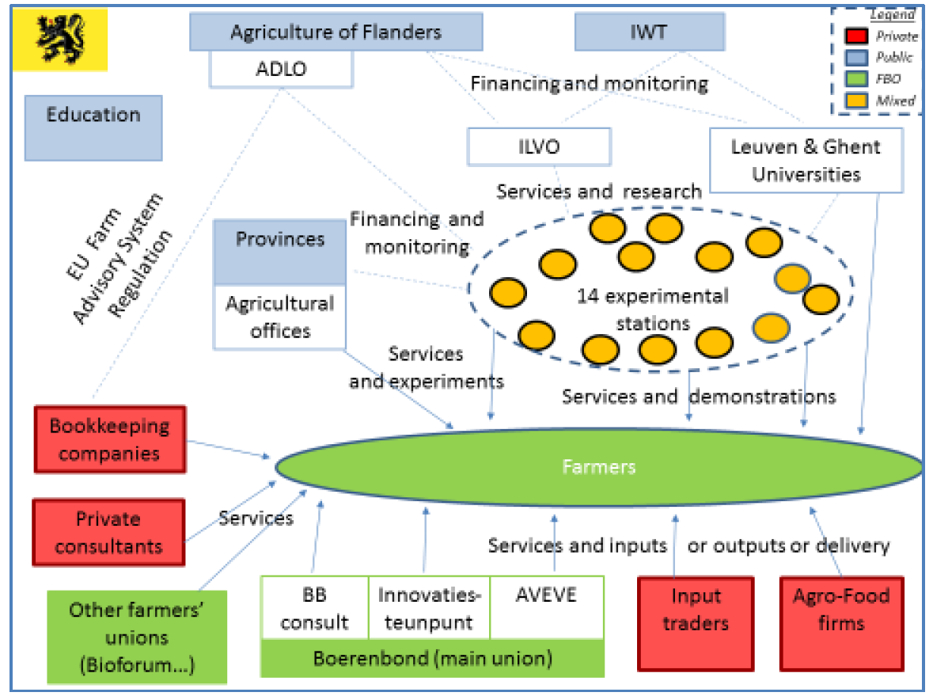
Figure 1: AKIS diagram in Flanders (source: Labarthe, P.; Moumouni, I. (2014): AKIS and advisory services in Belgium. Report for the AKIS inventory (WP3) of the PRO AKIS project)

Sustainability challenges
The challenges that the main actors of this demonstration activity face are:
- finding the balance between raising productivity on the one hand and maintaining the fertility of the field and protecting biodiversity by the responsible and correct use of crop protection products on the other hand: combining economic success with environmental and social responsibility
- societal challenges (sustainable production of food, environment-friendly crop protection products and pesticides)
The challenges that the subsector (arable farmers) face are the same as the farmers at the hosting farm.

Demonstration summary

Farm
The farm where the demonstration is held, is a fourth generation family farm (since 1890) that is located in a small village near Brussels in Belgium. The 150-hectare farm grows potatoes for the crisps industry in a four-year rotation across hilly fields on well drained and fertile sandy loam soil. Wheat, corn, sugar beet, oilseed rape and barley make up the other crops. In addition, the farm cultivates three hectares of apples and pears, which are mainly sold directly at the farm.
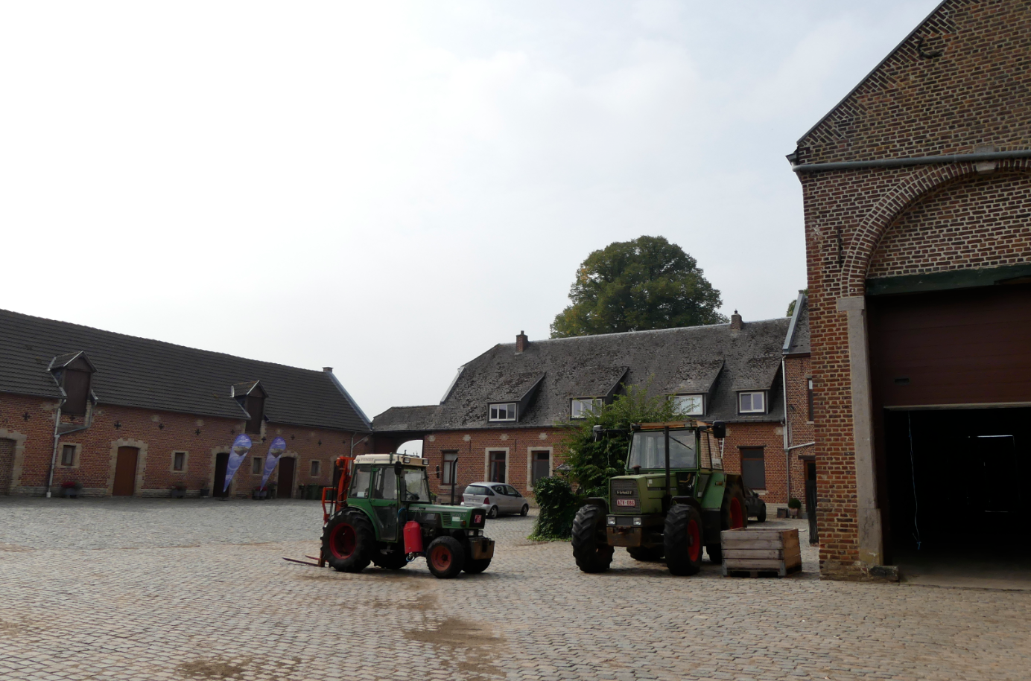
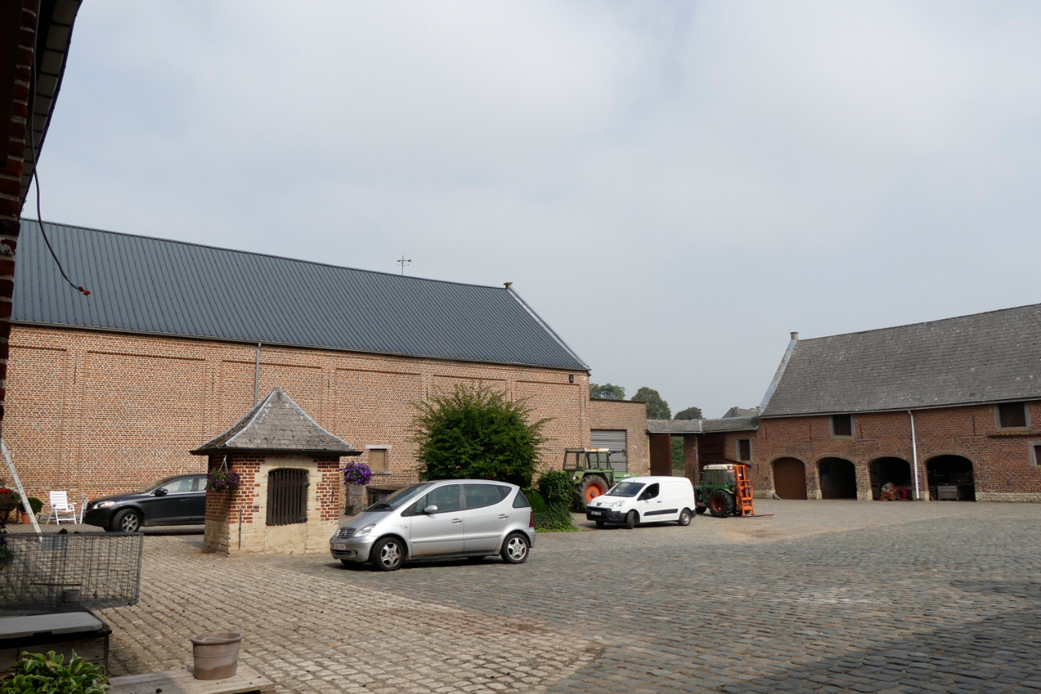
In 2011 they started participating in some projects on sustainability and on farm-research. The first demo was on erosion measures. The next step was a collaboration with the research farm PCFruit on research on a mixed hedge around the pear plantation.
In 2014, they became the first Bayer Forward Farm worldwide. Bayer joined forces with the farmers to test a number of innovative and sustainable agricultural concepts. For example, the farm makes use of advanced weather stations, in order to better estimate when the possible disease pressure in the crops increases. The tractors work with GPS-techniques to carry out the treatment of crops to a depth of 2 cm. A system was also installed to process the cleaning water in an environmentally friendly way, with residues of crop protection agents. In addition, insects are used at Hof ten Bosch to combat their harmful species and grass and flower zones are created between the fields to stimulate biodiversity.
In May 2018, the farm opened an educational beekeeping centre in collaboration with the Beekeepers Association of Vlaams-Brabant and the Bayer Bee Care Centre. They placed 6 bee hives, laid flower borders and planted mixed hedges.

Organisation of the demonstration activities
Some demonstrations at the farm are organised and led by Bayer advisors (in the context of the Bayer ForwardFarming program, which is the knowledge platform on sustainable agricultural practices of Bayer), some by the farmers themselves. Projects and field tests are also undertaken in collaboration with public and private partners, such as the University of Ghent, John Deere or Yara.

What is the main problem that is addressed?
The objective of the demonstrations is sharing good practices on sustainable field practices (mainly crop protection, new cultivations, low-drift nozzles, weather station data, precision farming, water protection).

What is demonstrated?
The farmers as well as Bayer experts demonstrate innovative solutions for sustainable agriculture by field demonstrations, documentation, training sessions, etc.: crop protection, new cultivations, low-drift nozzles, weather station data, precision farming, water protection, etc.
The figure below shows the visitor tour on the farm:
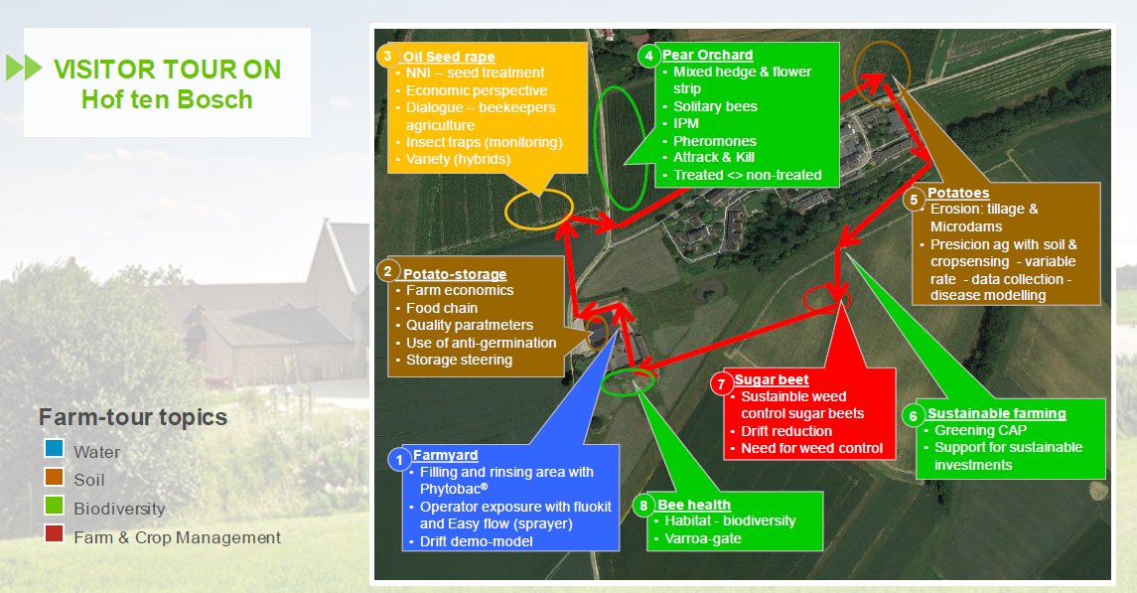
VISITOR TOUR

What role does sustainability play?
Sustainability is an integral part of the demonstrations. The hosting farm aims for a balance between raising productivity on the one hand and maintaining the fertility of the field and protecting biodiversity by the responsible and correct use of crop protection products on the other hand: combining economic success with environmental and social responsibility.

What is the objective of the demonstration?
The objective of the demonstrations for farmers is sharing knowledge and good practices on field practices. But the demonstrations also show regulatory authorities what is possible, how the very specialised technologies can reduce the impact of plant protection products on the environment.

Who are the targeted visitors?
The demonstrations bring together many stakeholders, including farmers, consumers, universities and schools, machine builders, food chain representatives like food processing industry and retailers, politicians and regulatory authorities from all over Europe. About 1/3 of the visitors are farmers, 1/3 are food chain stakeholders and researchers and 1/3 administrations and policy makers.

What could be main lessons for the PLAID project?
The case provides an interesting example of a fruitful collaboration between farmers and a commercial supplier. Visitors can have a look at the newest techniques in crop protection, smart farming, etc. on a real working farm. Very interesting is that visitors include farmers as well as food chain representatives, politicians and regulatory authorities.

Positioning of the case study
Commercial orientation

Farmer-led
Institutionally led
BE2
Public-good orientation

Governance: set up and organisation

Organiser(s) and history
The farmers of the hosting farm started collaboration with researchers on the topic of erosion in 2011. The first demonstration activities were on this topic. In the same period they started with a test of a mixed hedge to prevent wind damage in collaboration with the research farm PCFruit.

Most of the current demonstration activities on the farm are part of the Bayer ForwardFarming programme. The farm was the first Bayer ForwardFarming farm worldwide, launched with a conference in September 2014. From this moment on the demonstration activities were professionalised. A meeting room was installed on the farm. Lots of information tools and demo installations were placed on site.

First demos were on fyto and on erosion. Later on new demonstration activities on precision farming, biodiversity, drift, water protection, digital farming, Integrated pest management were added.

Funding
The investment in demonstration techniques is financed by Bayer. When there is a collaboration with a third party, the investment is done jointly. The farmers themselves also invest in new techniques, sometimes complemented by Bayer. For instance, the farmers partly paid for a GPS system but Bayer wanted to have a more advanced system. So they sponsored the more advanced technique. The financing by Bayer (and sometimes third parties) obviously influences the topics that are demonstrated. It also influences in part who is invited, in particular the target group of (European) policy makers.

In general, the demonstration activity is (partially) paid by the person or organisation taking the initiative for the demo. In some cases that will be Bayer ForwardFarming, in other cases costs are shared between the initiator (operating costs such as invitations and catering) and Bayer ForwardFarming (by deploying staff).

Only in some cases, e.g. when the initiator is a farmer’s organisation, subsidies for the demonstration event itself are applied for. Bayer ForwardFarming never does apply for subsidies.

De demonstration activities are always free for the visitors.

Hosts
The farmers had been working on sustainability on their farm for a long time. Their farm is a commercial farm with an integrated farming system.
Because of that and because of their close proximity to Brussels, they were an interesting farm for the Bayer ForwardFarm programme. The farmers are also open for new investments.
Since their collaboration with Bayer, the farm is continuing to improve sustainability and develop innovations on the farm. In particular, investments in digital and precision farming were made.

Gender
There is no specific role for men/women in commissioning, organising and holding the demonstration.

Objective(s)
The objective of organiser Bayer to set up Bayer ForwardFarming farms and to organise demonstration activities is not to sell or promote their products in the short time, but to become/stay known as a credible and reliable partner in a sustainable and responsible agriculture. In 10 years, they still want to have a ‘license to operate’.

Another objective of Bayer as well as the hosting farmers is to show the policy makers and the general public (consumers) that a lot is going on in agriculture regarding sustainability, biodiversity, etc.

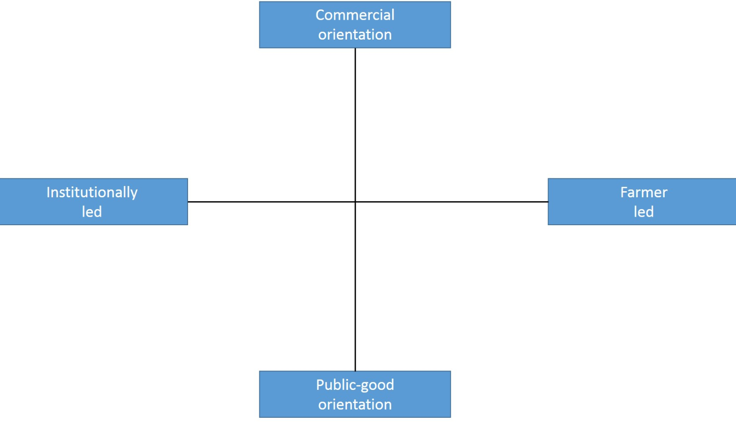

The demonstration events at the hosting farm are both led by Bayer and by the hosting farmers. We placed the demonstration event more near ‘public-good orientation’, because of the choice of the demonstrated topics. However, there is a certain ambiguity because Bayer also leads the demonstration. Though they are not explicitly selling their products, they work on building and keeping a ‘good image’. Therefore, the demonstration activity could also be placed more near ‘commercial orientation’.

Topics
There is a very broad collection of demonstrated topics:
- Customized agronomic solutions:
  - Seeds:
    - Need of seed treatment in IPC/ICM systems
    - Seeds as an integrated solution in a sustainable production
  - Crop protection:
    - Demonstrating the need/benefits of CPP
    - Integrated pest management -> integrated crop management
    - Integration of biological, chemical and precision application technology in order to optimize production
    - Impact on quality
    - Sustainable wheat growing
    - Application technology – demo kit
  - Supporting key services:
    - Weather station
    - Disease modelling – warning services
    - Soil and crop scans + yield mapping
    - Application technology
    - Trainings on water protection for schools, farmers, distributors
    - Study functional agro biodiversity e.g. greening
- Proactive stewardship:
  - Product integrity:
    - Certified seed and registered CPP
    - Anti-counterfeit
    - Container management
  - Human protection:
    - Safe-use training
    - Dress code
    - CPP storage facilities
    - EasyFlow
    - Drift reduction
  - Environmental preservation:
    - Micro-dams
    - Filling and rinsing: Phytobac®
    - Drift reduction
    - Biodiversity measures (hedges, nesting boxes, flowering strips, insect traps, shelters, buffer strips)

Access
The targeted and approached audiences are farmers, representatives of the EU, national policy makers, food chain and distribution partners, advisors, universities and schools, consumers.

By cooperating with other organisations like KVLV-Agra (organisation for female farmers) or Groene Kring (young farmers’ organisation), specific groups are targeted and also reached.

Demonstration event

We attended a demo event on the morning of 5th September 2018. This demo event was held for a ‘closed group’ of Groene Kring, a young farmers’ organisation. The participants were all arable farmers who know each other well. The day was mainly led by the advisors of Bayer ForwardFarming. The host farmers did not participate because of time shortage reasons. Normally they give a tour and an explanation on the sustainability aspects on their farm.

The demo event was about water protection training: ‘point pollution’, ‘spraying techniques’ and ‘runoff and erosion’. The group had chosen those topics from a list of techniques that Bayer demonstrates on the host farm.

The morning started with a presentation of Bayer ForwardFarming on those aspects. Later on, the group went outside for a demonstration of the discussed techniques (e.g. Phytobac) and best practices (e.g. setting spray nozzle).

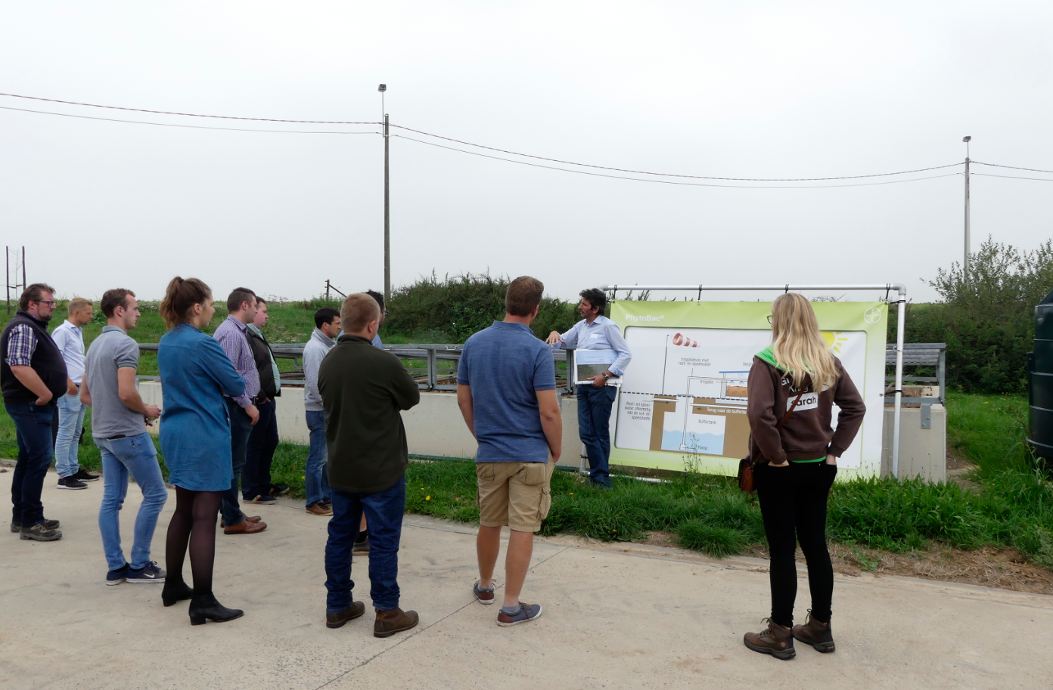

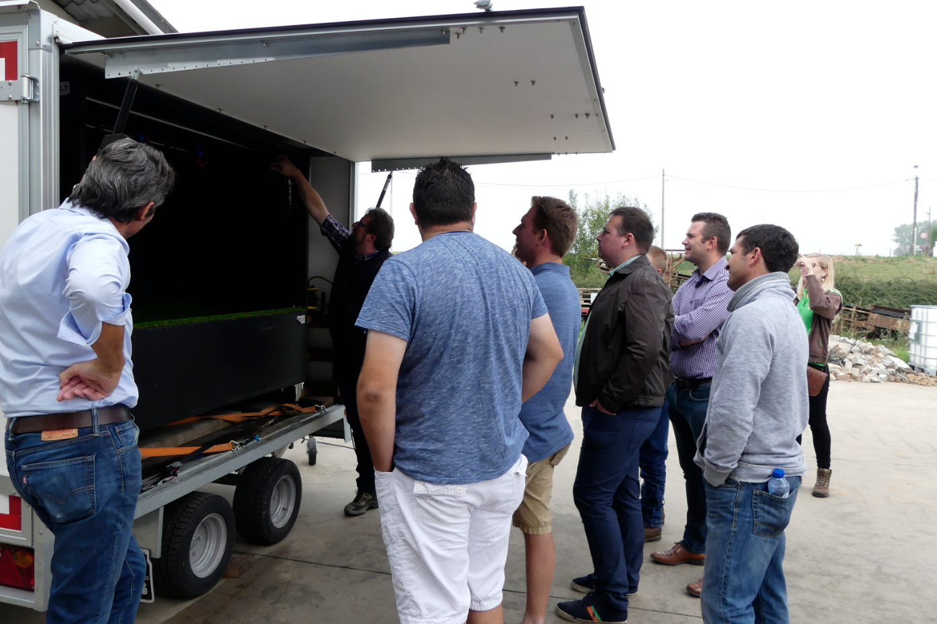

Visitors
There were 9 participants: 8 young farmers (all <35 years old) plus the secretary of their young arable farmers group. There was only 1 woman amongst those 8 farmers, which is a representative sample of the arable farmers population according to the secretary of this group. The young farmers come from all over the region of Flanders.

The group already knew each other, which certainly increased the interaction and open communication between the participants.

Communication & Mediation
At the beginning of the day, a Powerpoint presentation was given. The participants got a printed document of this presentation.

In the reception and meeting room for participants at demo events at the hosting farm, a lot of brochures on different topics are available. Information is also given by posters.

Active participation
During this morning presentation, there was a lot of interaction between the farmers on the one hand and between the farmers and the advisors of Bayer ForwardFarming on the other hand. The Bayer advisors also made use of an interactive voting system (wireless ticking boxes) with triggering questions to stimulate participation and interaction in the discussion.

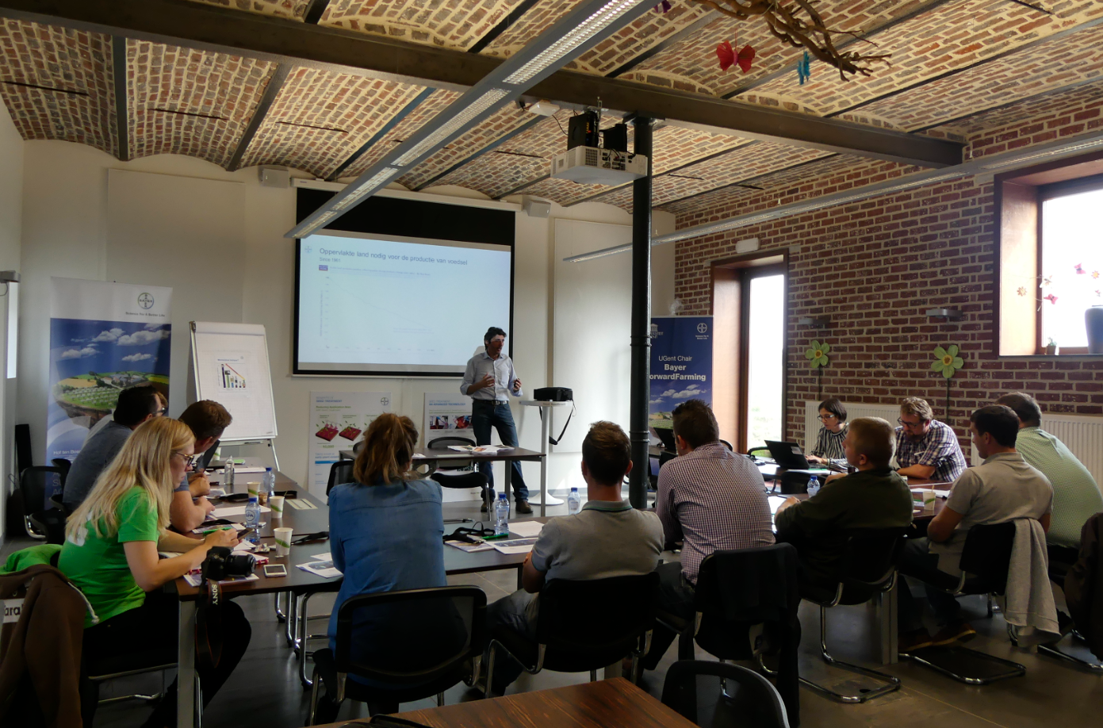

When the group was outside, the demo was heavily led by the Bayer advisors. There were no opportunities for the farmers to just walk around and see for themselves. Instead, they got a thorough explanation of every demonstrated technique.

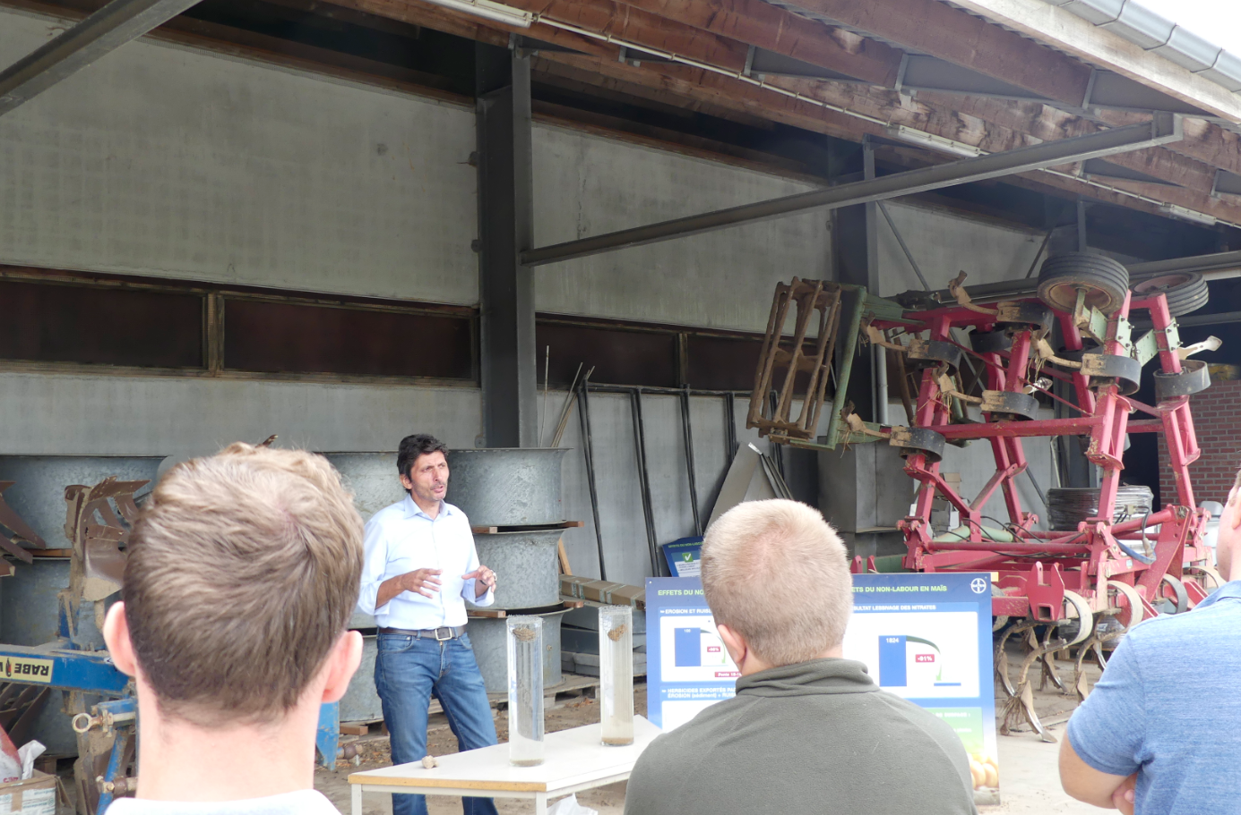

Doing business
The visitors could not do business during the demonstration day, nor did Bayer ForwardFarming demonstrate any of their products.

Role of sustainability
The demo activities were about water protection. Regularly, a link was made with environmental and social benefits and with social responsibility (e.g. good practices on cleaning sprinklers and tanks, how to use crop protection products in the vicinity of schools, communities, etc.). The ‘license to produce in the future’ was regularly stressed to stimulate a broad vison on the topic.

The visitors responded in a positive way, probably also because of their young age.

Unforeseen circumstances
Besides the hosting farmers not being available for a general tour on their farm, there were no unforeseen circumstances that had a significant influence on what happened.

Plans vs. practice
The organisers of the demo indicated that they adapt their demonstration activities to the group of visitors that comes to Hof ten Bosch. Because of the closed and specialised group, the focus of the day when we attended the demonstration activity was on in-depth learning and discussing. Hof ten Bosch and Bayer ForwardFarming also receive a lot of big groups. At those moments, the information that is provided is more general and the participation of the visitors (farmers, policy makers, consumers, etc.) is more ‘without obligation’.

Participants feedback
The participants were all convinced afterwards that the new insights will make a difference for their own farm. Some of the young farmers remarked that the shown techniques are not widely known, others said that the demonstration convinced them to work more on the prevention of point pollution by cleaning pesticides equipment or to be more careful when using pesticides (using adapted nozzles to reduce drift).

There were no points of critique. The visitors liked the combination of the theory and the practical explanation and demonstration. They also highly appreciated the direct interaction because of the small group.

Motives, learning and networking

Reasons to attend demos
Attitudes and perceptions
Visitors attended the demonstration for various reasons, but mainly for obtaining new insights and knowledge (multiple answers were possible):
- Obtaining new insights and knowledge: 8/9
- To visit this particular farm: 1/9
- Networking: 1/9

They indicated that other options to achieve the objective of obtaining new insights and knowledge on the topic of water protection are: mandatory phytolicence course, articles in farming magazines, information moments, study meetings with arable farmers groups, contacts with advisors, contacts with providers of pesticides, agricultural fairs, the internet.

Other options to achieve the objective of networking are: the young farmers organisation Groene Kring, agricultural fairs, phytolicence course.

Most visitors (8/9) said that other members of their farm also participate in demos from time to time. As a reason for that they mentioned: to stay in touch with novelties, to obtain new knowledge, to learn from other farmers, to hear different opinions and visions.

Norms
The hosting farmers are viewed as ‘good farmers’ because they are innovative, progressive, environmentally conscious and open for new projects according to the responses of the visitors. Visitors also appreciated that they organise tests on their farm and that they want to share new insights on the innovative techniques (“important for society”).

Half of the visitors know other farmers who are already applying the demonstrated innovative techniques.

The question whether other farmers participate or not in this demo was irrelevant because it was a closed group. The same applies for the questions on whether they knew of other farmers who would attend the event and how that influenced their decision to attend.

Practicalities
According to most visitors (8/9), this particular demonstration activity was at a convenient time. However, for half of the visitors the location was not so easily to reach (too far, traffic jams).

Half of the visitors said that they did not visit similar events because of time shortage. One farmer added that he did not visit similar events because of an overload of such activities.

Afterwards, the participants were all convinced that the new insights will make a difference for their own farm. Some of the young farmers remarked that the demonstrated techniques are not widely known, others said that the demonstration convinced them to work more on the prevention of point pollution by cleaning pesticides equipment or to be more careful when using pesticides (using adapted nozzles to reduce drift).

Forms of learning
The demonstration activity started with an interactive lecture. Participants were stimulated and encouraged to actively participate and discuss during this presentation: the organiser regularly asked questions and he also made use of an interactive voting system (wireless ticking boxes) with some triggering questions. This worked well, participants did not just ‘sit and watch’. (verbal)

After this presentation, the group went outside to the different places where protection techniques were demonstrated. At the Phytobac, the organiser was mainly talking about the techniques, thereby using information boards. When demonstrating the different nozzles, the participants got the chance to have a closer look. There was lots of time for questions by the participants. (verbal and physical)

There was no gender or age difference in who participated in the different types of activities.

Content of learning
The information and knowledge that is offered by the demonstrator was very detailed. The presentation contained a lot of information: lots of pictures, graphics, facts & figures, good practices, examples, context variables, etc. on point pollution, spray techniques, runoff and erosion. Participants got a printed version of this Powerpoint presentation. During the tour outside, the demonstrator also got into much detail about the installations on the hosting farm (why, how, etc.).

The participants considered the information ‘ready to use’.

Outcomes of learning
The participants were all convinced afterwards that the new insights will make a difference for their own farm (they all had actively considered how the demonstrated techniques would apply to their farm).

The demonstration certainly addressed a need that they have: the young farmers said that the demonstration convinced them to work more on the prevention of point pollution by cleaning pesticides equipment or to be more careful when using pesticides (using adapted nozzles to reduce drift).

As far as we can assess, the main outcome of this demonstration event was an increased awareness of a good ‘water protection management’ on their own farms.

Networking
Because of being a closed group and already knowing each other for a long time (arable farmers Groene Kring), there was no need to ‘meet new people’. Though they did respond in the questionnaire that networking was not an objective to go to this demonstration event, we observed that while walking from one demonstrated technique to another and during the lunch, a lot of time was spent on informal discussing other issues regarding arable farming, etc.

Anchoring: Application of demo lessons by participants

Anchoring related to the present demo
All participants responded that the new insights on water protection management will make a difference for their own farm when it comes to a changed attitude. The demonstration convinced them all to work more on the prevention of point pollution (by cleaning pesticides equipment) or to be more careful when using pesticides (by using adapted nozzles to reduce drift).

About implementing more costly or infrastructural measures, like the Phytobac, they responded that they would not implement them right away, but maybe when (re)building their farm.

Stimulating anchoring
There are no specific follow-up activities planned. More information on the demonstrated techniques can be found on the Bayer ForwardFarming website. Visitors are aware of that. Some have already used this source of information.

Anchoring related to earlier demos
From earlier demonstration activities, we heard that visitors of the hosting farm highly appreciated the combination of the practical experiences of the hosting farmers and the expert explanation of the Bayer ForwardFarming advisors.

Visiting farmers as well as other stakeholders can get the ‘facts & figures’ about the newest techniques at study meetings with arable farmers groups, at the mandatory phytolicence courses, by reading articles in the agricultural press or at the internet, by contacts with advisors, by contacts with providers of pesticides, etc. But at the Bayer Forward Farm, which is a ‘real working’ farm, the visitors can see those techniques ‘in real life’.

According to people of Boerenbond who often accompany groups of farmer members to a demonstration activity at the Bayer Forward Farm, most visitors are willing to implement some measures and small investments like spray nozzles in a short term (for investing in a technique like Phytobac, the cost of the investment is also important: they only will invest when they can include the investment in new construction plans). Important in that decision is learning from other farmers’ experiences (the hosting farmers as well as other visiting farmers), have a look at how measures can be implemented in practice.

Scaling: Application of demo lessons by the wider farming community

Retrospective examples of scaling
Actors of the Flemish AKIS do stimulate the uptake of water protection techniques in different ways.

In 2014, the Flemish government approved 3 projects within the framework of the demonstration projects (PDPO) in the theme of protection of surface water against point contamination and diffuse pollution. Projects within this theme had to focus on encouraging and supporting the farmer and horticulturist to apply measures to prevent this pollution by organising demonstration events. This was to raise awareness in the area of ​​bioremediation systems and buffer strips. Here, bioremediation systems such as a biofilter or a Phytobac were also demonstrated as a way to prevent point contamination. The support of the flemish government for diverse research stations in agriculture to organise demonstration activities helped to spread the use of Phytobacs. The research farms (AKIS) involved in these projects were:
- Project bioremidiatie west: Inagro, PCG, PCS en PCA
- Project bioremidiatie oost: Pcfruit, NPW, PCH, PSKW, LCV

Beside the support for demonstration, the Flemish Agricultural Investment Fund (VLIF) supports Flemish agriculture and horticulture by encouraging sustainable investments to improve the structure of agricultural and horticultural businesses, to ensure their profitability and to reduce the cost price. Phytobac systems get a support of 30% on the investment. Since 2015, VLIF received 33 applications on the VLIF code 'phytobac / biofilter / evaporator for waste water containing pesticides'.

- Arable farming: 9
- Arable + cattle: 6
- Arable + pigs: 2
- Tree nursery: 1
- Fruit growing: 9
- Floriculture: 1
- Horticulture: 5

Prospective assessment of scaling: Impact pathways
In connection with our demonstration case, following impact pathways seem the most plausible via which lessons from the demo become widely shared and may influence the farming community at large: via articles in agricultural press, via peer-to-peer contacts between farmers and via advisors.

Bayer ForwardFarming is very well aware that only organizing demonstration events on their own isn’t enough to raise real awareness on water protection within the farmer community. That’s why they seek active collaboration with research stations, farmers organizations,… to co-organize events and to collaborate in prevention. So advisors play a significant role.

Case study reflection

Demonstration-innovation narrative
The text below describes the innovation trajectory of the Phytobac system.

In 2011, the awareness raised that the main cause of water contamination by crop protection agents was point contamination. Lots of scientific studies indicated that that point contamination was responsible for more than 50% of the contamination. On the hosting farm they noticed that their pond was contaminated by crop protection agents. They decided to take action by installing The Phytobac™ system developed by Bayer. This system ensures that contaminants cannot get into sewage systems or nearby bodies of water when spraying equipment is filled or cleaned on the farm. The dirty water first flows into a mud tank, where the rough dirt settles as sediment. The clear residual liquid is stored in the second tank and fed in doses into the substrate container filled with farm soil and straw. The straw serves as an additional source of carbon which promotes microbial degradation. Measurement and control elements regulate the soil moisture levels, creating ideal living conditions for microorganisms such as bacteria and fungi. The enzymes in these tiny helpers break down residues of fungicides, herbicides and insecticides while the water evaporates.

The problem was the big investment in the technique (without any return on investment) and the fact that this innovative system wasn’t allowed by the government.

In 2012:
- design of the filling and washing area with buffer tank and phytobac installation by Bayer in collaboration with the host farmers (the farmers).
- Negotiation with the governement on the specifications for a licence
- buffertank calculation capacity and phytobac dimensions based on the filling and rinsing methods of the company
- patenting by 2 french constructors (Biotisa and Harmex)
- Contract with Biotisa for the installation

2013:
- Support for water protection measures in the the Flemish Agricultural Investment Fund (VLIF. This fund supports Flemish agriculture and horticulture by encouraging sustainable investments to improve the structure of agricultural and horticultural businesses, to ensure their profitability and to reduce the cost price. Fytobak systems get a support of 30% on the investment. VLIF code 'phytobak / biofilter / evaporator for waste water containing pesticides'.
- Construction approved by the governement
- Installation of the phytobac

2014:
- Follow-up action Phytobac - sampling / analysis residual water and substrate
- Approval of bioremediation systems by Flemish Government (VLAREM II)
- Negotiation patent extension for Benelux with Beutech Agro BV
- Development ForwardFarming Field Academy - Water Protection Training:
  - Intro problem statement
  - Module 1: Point pollution + Demo
  - Module 2: Spray technology (buffer zones, drift reduction) + Demo
  - Module 3: Rinsing and erosion + Demo
  - Expansion of Phytobac® demo with other bioremediation systems:
Phytobac® from Beutech Agro BV Biofilter

2015:
• Launch ForwardFarming Field Academy - Water Protection Training at the Bayer Forward Farm
• Expansion demo projects around Water Protection Training
• Partnership with TOPPS, INAGRO, PhyteauWall (PROTECT'eau), Flemish Government, Training Centers (AgroCampus, NAC), Agricultural Schools, Research Centers
• Expansion Water Protection Training outside the Bayer Forward Farm on location:
• During winter meetings
• Mandatory phytolycense training - startercourse

2016-2018:
Scale enlargement Water Protection Training
Contribution expertise of "Water monitoring and modeling project Grote Kemmelbeek" in the training program

Participants in the Water Protection Training:
2016:
- on farm demo: 1596
- Winter meetings outside the demo farm: 2433
- Total: 4029
2017:
- On farm demo: 1605
- Winter meetings outside the demo farm: 2759
- Total: 4364

Since 2015 VLIF received 33 applications on the VLIF code 'phytobak / biofilter / evaporator for waste water containing pesticides'. This proves that there is a wider uptake of this innovative technique.

Facilitating and impeding factors for successful demonstrations
What is a successful demonstration?
We asked the advisors of Bayer ForwardFarming about the key indicators to determine whether their demonstration activities are a success to them. They mentioned positive feedback, the level of interaction and also the number of visitors.

In the focus group, following input was given on the factors for a successful demonstration event:

Success factors for increased access:
- clear focus/objective of the demo event
- relevant topic for the target group
- collaboration with other organisations
- timing during the year/during the day
- strong communication / promotion
- location nearby Brussels (when inviting policy makers)

Success factors for an effective demonstration process:
- credibility of the demonstrator
- many practical examples
- interactive discussions
- mediation technique adapted to the group size
- enough informal moments (including food & drinks)

Impact of demonstrations
From this case study, we learned that the combination of a commercial company like Bayer and a commercial farm can lead to effective demonstration activities. Visitors can see the newest innovative techniques on a real working farm in a real context and with real conditions. Moreover, visitors can learn from the knowledge and experience of both the experts from Bayer and the hosting farmers.

However, potential organisers of demonstration activities should be aware of the possible pitfalls of such a collaboration. Therefore, it is important to make good agreements between the (co-)organisers. One of the principles could be that commercial companies should not solely co-organise or attend the demo to make a sale pitch, but also contribute in terms of knowledge and information provision. Involving more than one company of involving ‘neutral’ parties like non-commercial advisory services or researchers can contribute to the credibility of the demonstration event and thus the anchoring and the uptake of the demonstrated novelties.

Another interesting aspect of this case study is that the target group also includes food chain representatives, the general public and last but certainly not least policy makers and regulatory authorities. By watching what is going on in agriculture, they can make incentives (regulatory as well as financial) for an acceleration of the uptake of innovative techniques.

Key lessons from this case study
Main lessons from this case study on how to organise a successful demonstration and how to achieve maximum impact:

Broad target group
The visitors include farmers as well as food chain representatives, the general public, politicians and regulatory authorities. Therefore, both the hosting farmers and Bayer ForwardFarming collaborate with a lot of other organisations.

Good mix of theory and practice
The participants of this demonstration event got a very detailed and thorough explanation of the demonstrated techniques on water protection. They could see the techniques in real life.

A lot of interaction
The demonstrator actively engaged the participants of the demonstration event by asking triggering questions (i.a. by using wireless voting boxes). The group already knew each other before and were also open in their communication. Because they could choose the topic of the event, they were all engaged.

Relevant topic
The demonstration certainly addressed a need that the young farmers have: they all said afterwards that the demonstration convinced them to work more on the prevention of point pollution by cleaning pesticides equipment or to be more careful when using pesticides (using adapted nozzles to reduce drift).

Acknowledgements

We would like to thank the host farmers for their hospitality and their collaboration. Without them, there was no case study! We very much appreciate the input of Dirk Baets and Marc Sneyders from Bayer ForwardFarming, the visiting young farmers and the members of our NSCG. We had interesting discussion on the different aspects of the demonstration event and on peer-to-peer demonstration in general.

Annexes

Data sources
Literature:
- VILT, 29/05/2018: “Bayer toetst bescherming bijen aan landbouwpraktijk”
- Crop Production Magazine, 20/07/2017: “Digital farming – ForwardFarm provides precision pointers”

Websites:
- Website Bayer ForwardFarming
- Website Dag van de Landbouw 2017

Interviews:
- 20/06/2018: Marc Sneyders, Bayer ForwardFarming

Questionnaires for the visitors of the demonstration activities on water protection training at 5th September 2018:
- 5th September 2018
- 8th November 2018

Data collection methods
- Interview with Marc Sneyders, Bayer ForwardFarming (20th June 2018)

- Questionnaires for the visitors of the demonstration activities on water protection training at 5th September 2018 (5/9/2018 and 8/11/2018)

- Focus Group with farmers, Bayer ForwardFarming, research institute ILVO, research farms and a representative of the Department of Agriculture and Fisheries (9th November 2018)

