|  |
| --- |
| Date: Nov 18  Country report: Scotland (UK)  Case Study: Lothians Monitor Farm, Scotland (UK2)  WP5: Case studies of demonstration activities in commercial farms |

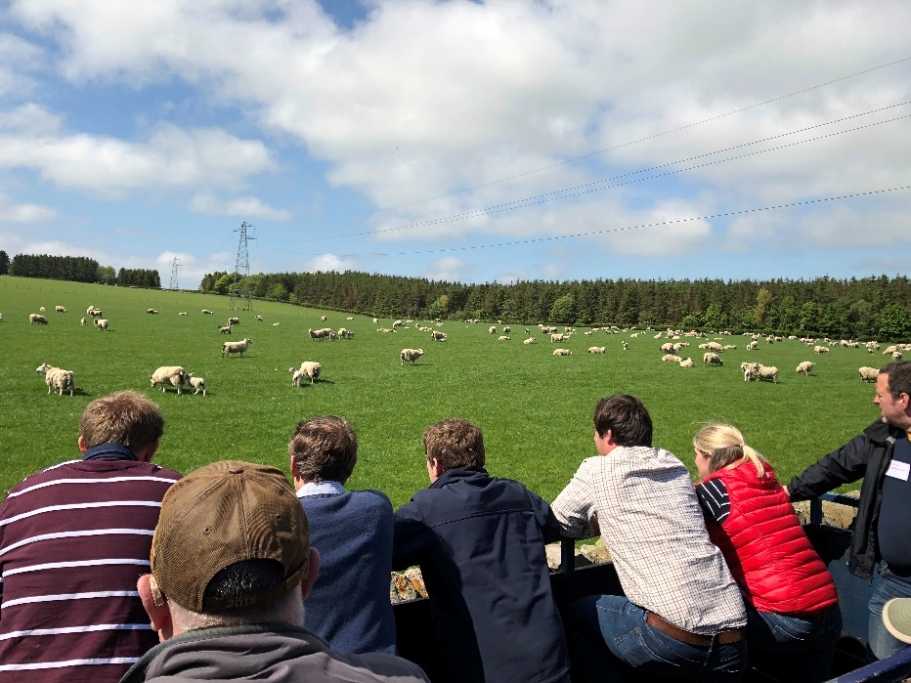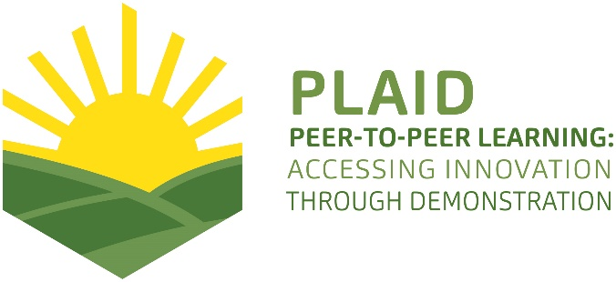

This project has received funding from the [European Union’s Horizon 2020](https://ec.europa.eu/programmes/horizon2020/) research and innovation program under Grant Agreement No 727388

PLAID PARTNERS

|  |  |  |  |
| --- | --- | --- | --- |
| [http://www.plaid-h2020.eu/sites/www.plaid-h2020.eu/files/styles/thumbnail/public/logos/LogoAdvisoryService.jpg?itok=I4li3kt3](http://www.plaid-h2020.eu/partners/advisory-service-croatia-asc)  Advisory Service Croatia ASC | [ARVALIS Institut du Vegetal image](http://www.plaid-h2020.eu/partners/arvalis-institut-du-vegetal)  ARVALIS Institut du Végétal | [Association de Coordination Technique Agricole ACTA image](http://www.plaid-h2020.eu/partners/association-de-coordination-technique-agricole-acta)  Association de Coordination Technique Agricole ACTA | |
| Institute for Rural and Regional Research | [Chambers of Agriculture image](http://www.plaid-h2020.eu/partners/chambers-agriculture-apca)  Chambers of Agriculture | [Delphy image](http://www.plaid-h2020.eu/partners/delphy)  Delphy | |
| [http://www.plaid-h2020.eu/sites/www.plaid-h2020.eu/files/styles/thumbnail/public/logos/EUFRAS_Logo_Long_7stars_bigger_europe.jpg?itok=_oilXHtY](http://www.plaid-h2020.eu/partners/european-forum-agricultural-and-rural-advisory-services-eufras)  European Forum for Agricultural and Rural Advisory Services EUFRAS | [Innovatiesteunpunt ISP](http://www.plaid-h2020.eu/partners/innovatiesteunpunt-isp)  Innovatiesteunpunt ISP | Institut de l’Elevage – Idele | |
| [Instituto Navarro De Tecnologias E Infraestructuras Agrolimentarias INTIA image](http://www.plaid-h2020.eu/partners/instituto-navarro-de-tecnologias-e-infraestructuras-agrolimentarias-intia)  Instituto Navarro De Tecnologías E Infraestructuras Agrolimentarias | [http://www.plaid-h2020.eu/sites/www.plaid-h2020.eu/files/styles/thumbnail/public/logos/LEAF_LOGO_with_text.jpg?itok=IwCrneqk](http://www.plaid-h2020.eu/partners/linking-environment-and-farming-leaf)  Linking Environment and Farming LEAF | [National Agricultural Advisory Service logo](http://www.plaid-h2020.eu/partners/national-agricultural-advisory-service-naas)  National Agricultural Advisory Service | |
| [Nodibinajums Baltic Studies Centre BSC image](http://www.plaid-h2020.eu/partners/nodibinajums-baltic-studies-centre-bsc)  Nodibinajums Baltic Studies Centre (BSC) | [Research Institute of Organic Agriculture (FIBL)](http://www.plaid-h2020.eu/partners/research-institute-organic-agriculture-fibl)  Research Institute of Organic Agriculture (FIBL) | Stichting Wageningen Research | |
| [The James Hutton Institute](http://www.plaid-h2020.eu/partners/james-hutton-institute)  The James Hutton Institute | [VINIDEA image](http://www.plaid-h2020.eu/partners/vinidea)  VINIDEA |  |

DOCUMENT SUMMARY

___________________________________________________

**Milestone Title:** 24 Case Studies

___________________________________________________

**Case Study Title:** Lothians Monitor Farm, Scotland (UK)

___________________________________________________

**Version:** 1

___________________________________________________

**Task Lead:** WUR

___________________________________________________

**Related Work package:** WP5

___________________________________________________

**Authors:** Sharon Flanigan (James Hutton Institute)

___________________________________________________

**Grant Agreement Number:** 727388

___________________________________________________

**Project name:** PLAID

___________________________________________________

**Start date of Project:** January 2017

_________________________________________________________________

**Duration:** 30 Months

_________________________________________________________________

**Project coordinator:** The James Hutton Institute

ABSTRACT

**Demonstrating innovation and collaboration through Monitor Farms Scotland**

Social innovation and breaking down traditional barriers in farming are of the essence at Lothians Monitor Farm (LMF) in Scotland. Building on the established format of regular community group meetings to explore topics selected from within that community, a key learning outcome at LMF is expected of the real-time experiment in collaboration between the two neighbouring farmers acting as hosts. Supported by key industry organisations and advisors, these farms represent the prevailing arable and livestock sectors in the region and also present an alternative approach to the reintroduction of mixed farming systems. Key lessons identified through observation and engagement in this case study include: the importance of effective facilitation for successful demonstration; the value of openness by demonstration host farmers; the significance of innovation in the way agricultural businesses are managed, as well as innovation in agricultural practices on the ground; the importance of how information is shared to encourage learning through engagement in demonstration activities and processes; and the value of bringing different farmer groups together, resulting new opportunities for exchange, improved access, and enhanced clarity in information shared. This case study exemplifies the inherent value of time being offered in the Monitor Farms programme, whereby farming communities can witness and contribute towards identifying the benefits of working together in pursuit of more sustainable farming futures. Time for trust to be built, time to identify and trial new and alternative solutions, and potentially time to see results in order that changes may also be implemented more widely by community group members.

TABLE OF CONTENTS

1 Demo context 7

1.1 The value chain 7

1.2 Typical farm characteristics 8

1.3 AKIS 9

1.4 Sustainability challenges 10

2 Demonstration summary 12

3 Governance: set up and organisation 13

3.1 Organiser(s) and history 13

3.2 Funding 14

3.3 Host(s) 14

3.4 Gender 15

3.5 Objective(s) 15

3.6 Topic(s) 16

3.7 Access 16

4 Demonstration event 18

4.1 Visitors 18

4.2 Communication & Mediation 19

4.3 Active participation 20

4.4 Doing business 21

4.5 Role of sustainability 21

4.6 Unforeseen circumstances 22

4.7 Plans vs. practice 22

4.8 Participants feedback 22

5 Motives, learning and networking 23

5.1 Reasons to attend demos 23

5.2 Forms of learning 26

5.3 Content of learning 27

5.4 Outcomes of learning 28

5.5 Networking 28

6 Anchoring: Application of demo lessons by participants 30

6.1 Anchoring related to the present demo 30

6.2 Stimulating anchoring 30

6.3 Anchoring related to earlier demos 31

7 Scaling: Application of demo lessons by the wider farming community 32

7.1 Retrospective examples of scaling 32

7.2 Prospective assessment of scaling: Impact pathways 32

8 Case study reflection 34

8.1 Demonstration innovation narrative 34

8.2 Facilitating and impeding factors for successful demonstrations 35

8.3 Impact of demonstrations 36

8.4 Key lessons from this case study 37

9 Annexes 40

9.1 Data sources 40

9.2 Data collection methods 40

# Demo context

This section describes the overall context that the case study operates within, including key factors that may influence farm demonstration both nationally and regionally.

From the perspectives of geography and demography, the case study lies within the Midlothian region, which is in the east of Scotland and on the southern periphery of the country’s capital city, Edinburgh (see Figure 1).

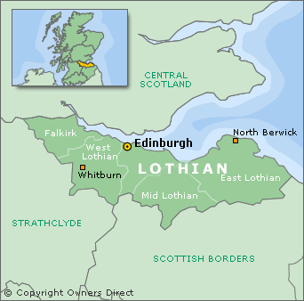

**Figure 1: Lothian region in Scotland**

Midlothian is often considered collectively with East and West Lothian in terms of Lothian or the Lothians, which is classified by the Scottish Government as an ‘accessible rural’ area (i.e. within a 30-minute drive of a settlement with over 10,000 people)[1]. The Lothians area is relatively small in area when compared with other rural regions in Scotland. As part of Edinburgh’s commuter belt, it has a has a relatively high population density (between 100-500 per square km) compared to large parts of Scotland which are more remote and sparsely populated (less than 50 people per square km)[2].

## The value chain

The value chains relevant to this case study relate to arable (barley, wheat, oats, oils seed rape) and livestock (beef and lamb) products.

Much of the Scottish barley crop produced (winter and spring varieties) goes to animal feed (in Scotland and beyond), with around a quarter going to Scottish maltsters via merchants and co-ops and the remainder going to maltsters outside of Scotland (though some re-enters to be distilled for whisky). Around half of the wheat produced in Scotland also goes to distilleries; of the remainder higher quality produce is milled for food (e.g. biscuits) and poorer quality produce is used for animal feed. Oats are predominately processed by two main millers in Scotland, for breakfast cereals and porridge, oatcakes, biscuits, and other food products, with some leaving the country for secondary processing. Biofuel and cooking oil are the key products of Scottish oil seed rape [3],[4].

The beef industry is the largest sector of Scottish agriculture and the country is world renowned for the quality of beef produced. Almost all cattle go to abattoirs in Scotland, with a large amount then being exported for consumption or further processing or consumption in the rest of the UK or abroad. Around a quarter of cattle stay in Scotland for consumption or further processing. Less than half of lamb produced in Scotland goes to Scottish abattoirs and more still leaves the country after slaughter for consumption or further processing. As lowland farms the case study represents the higher quality, finishing end of the meat production spectrum3,4.

Other key value chain actors relevant to this case study include private sector processors (of primary and secondary products), retailers (e.g. butchers, supermarkets), hospitality providers (e.g. hotels, restaurants) and suppliers (e.g. seed suppliers, livestock marts), quality assurance organisations (Quality Meat Scotland, Scottish Quality Cereals), public sector organisations responsible for monitoring and strategic development of the supply chain, levy boards, cooperatives (e.g. machinery rings, producer groups), and other product-specific and industry development agencies (e.g. Scotland Food and Drink, Scottish Agriculture Organisation Society, Scottish Enterprise, Agriculture and Horticulture Development Board).

## Typical farm characteristics

A significant proportion of Scotland’s land (73%) is in agricultural use, around 5% of which is in the Lothians. Land in the Lothians has been classified among the most productive in Scotland[5] and is intensively farmed for specialist cereals, lowland cattle and sheep, forage crops, and has areas of mixed farming and extensive cattle and sheep[6]. Around 36% of Lothians land area is in crops or fallow, representing a considerable proportion of the overall Scottish total[7]. A high degree of professionalism, mechanisation and technology exists in Scottish farming – particularly in the productive areas in the East. Just over 2% of agricultural land in Scotland is organic[8].

Of the nearly 1,500 landholdings in the Lothian region, almost half are less than 10 hectares (ha) and around a quarter each between 10-100ha and over 100ha[9]; though this is not necessarily an indication of overall farm size, as many farm businesses comprise of multiple holdings. Farming in the UK is traditionally undertaken in family units, whereby owners or tenants live on-site and often the farm is inherited through lines of succession. New entrants to agriculture face significant challenges to entry because of this, whereby access to land is a key barrier[10]. Most working farm occupiers in Scotland are over the age of 40, with over 30% aged 65 or older[11]. In the Mid and East Lothian areas between 1-5% of the population work in agriculture, decreasing to less than 1% in West Lothian.

## AKIS

In the UK, the prevailing AKIS and advisory system involves a wide variety of actors representing the public, private, charitable, research and education sectors, as well as other bodies (e.g. cooperatives, associations, unions) representing farmers’ and other land managers’ interests (see Figure 2).

Past research has found that AKIS coverage in the UK is ‘fairly good’, but there is a proportion of the farming population (estimated at 20% in Scotland) who are consistently not accessing advice through these means[12]. It is assumed that these are the same types of individuals who are unlikely to access on-farm demonstrations, such as the Monitor Farm programme. The report also showed that public policy on agricultural advice is fragmented, with no clear overarching national policy – especially public and private sector advice is seen to need more joining-up.

The report further shows that advice on the agri-environment and public goods is subsidised or fully funded by government, while general business advice, marketing and agronomic advice is generally paid for by farmers.

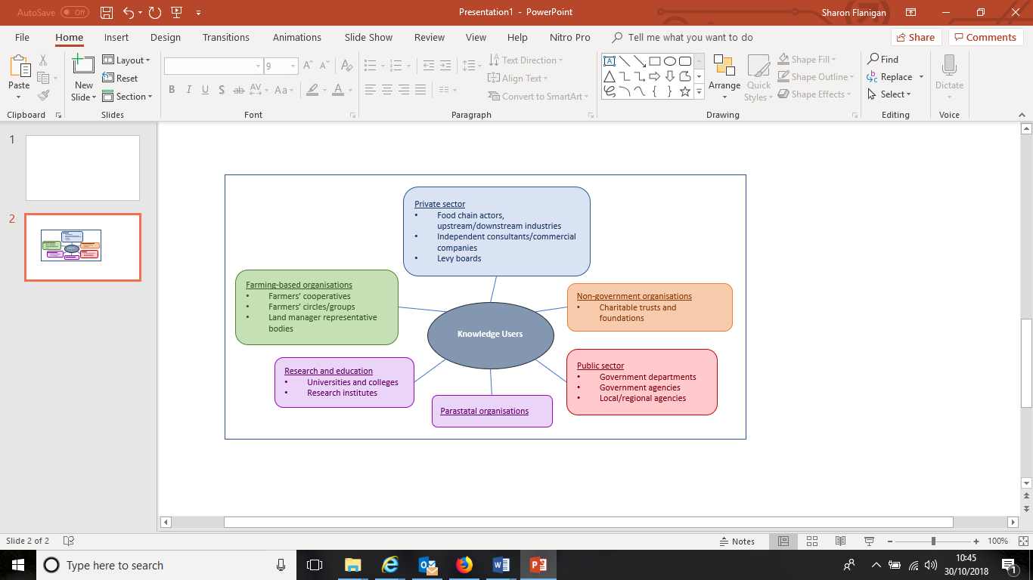

**Figure 2: AKIS in the UK[13]**

The wider context of Scotland within the UK is important from the perspective of key institutions and policies due to devolution. Agriculture policy is administered through the Scottish Government in Edinburgh and many of the significant AKIS organisations are also based in Scotland. Within Scotland, this case study is geographically central (located close to Edinburgh) and therefore has good access to the range of AKIS actors identified. The Lothians region itself is also relatively small in geographic terms (e.g. compared to the Highlands) and therefore supports opportunities for networking and interaction with others from the perspectives of distance and time.

As one of nine farms currently participating in the Monitor Farms programme, this case study is situated within the national AKIS in Scotland. This ensures attention and input by national-level actors (e.g. levy boards), which comes together with actors working at the local level (e.g. agricultural consultants) and supports the formation or facilitation of farmer groups that may persist as AKIS actors beyond the period of the programme.

## Sustainability challenges

Key sustainability challenges facing Scottish agriculture are set out in the report, A Future for Scottish Agriculture (2018). These include social, economic and environmental dimensions, and cover topics such as policy and payments, enhancing natural capital, improving productive efficiency, promoting career opportunities, and improving integration within the supply chain[14].

A significant challenge is to finding ways to farm that are environmentally sustainable but also provides for economically sustainable yields. Systems to improve soil structure and health are frequently discussed, as are ways to enhance biodiversity and improve ecosystem services on farmland[15]. Improving biosecurity and managing water quality can also be added to this list in terms of challenges Scottish farmers face[16]. Key social dimensions relate to the aging profile of the farming population[17] and barriers facing new entrants to agriculture[18]. Attention to mental health among farmers is also on the political agenda[19] as are issues specifically facing women in the sector[20].

# Demonstration summary

Lothians Monitor Farm (LMF) comprises two independently-run farm enterprises, which work collaboratively over the course of three years in the Monitor Farm programme. The concept for the programme was taken from New Zealand and allows farmers to share experiences and observe how their peers tackle problems and adopt best practice. The emphasis is strongly on practical farming and good business decisions rather than theory. The programme includes bimonthly demonstration days attended by the local farming community.

Funding for the Monitor Farm programme is provided by the Scottish Government and the European Union’s Knowledge Transfer and Innovation Fund (KTIF). Monitor Farms Scotland is jointly run by two national levy boards, which serve the arable and livestock sectors in Scotland: Agriculture and Horticulture Development Board (ADHB) Cereals and Oilseeds Division; and Quality Meat Scotland (QMS). A management group comprising the farm hosts and other local farmers and stakeholders determines the direction of the LMF programme, and a team of independent facilitators provide organisational support. There is a strong focus on the principle, ‘farmer led, farmer driven’.

The collaborative approach taken at LMF is novel in Scotland and underpins a central theme of the LMF demonstration programme. In addition, collaboration between the two neighbouring farms provides for joint focus on both the arable and livestock farming sectors. Demonstrations and discussions address a diversity of topics, ranging from soil testing and soil fertility management, to drought and flooding, and from grazing to flock/herd health. Topics generally have an underlying focus on the efficiency of farm businesses and aim to demonstrate new innovations and best practice. Sustainability is also an underlying focus.

Demonstration days are aimed at farmers and other interested stakeholders in the Lothians area; eight further Monitor Farms are currently in operation across Scotland, serving the regions they are located. Arable and livestock farmers are targeted in the Lothians, which are the main agriculture sectors in the region. Typically, demonstration days attract around 30-50 attendees. Interaction across traditional boundaries, between arable and livestock farming approaches, is an important feature of LMF in terms of terms of learning, networking, and collaboration between the different stakeholders involved.

The information presented in this report was primarily gathered by means of in-depth interviews with organisers and attendees involved at LMF, researcher observations made at demonstration days during the first two years of the programme, and supplemented with publicly-available reports and information available online.

# Governance: set up and organisation

This section provides information about the people and processes underlying Lothians Monitor Farm (LMF) in terms of its organisation and staging.

## Organiser(s) and history

The Monitor Farm Scotland (MFS) programme has been running since 2003. The fourth round of MFS, including LMF, is now more than half-way through the three-year programme period. Each programme round provides lessons for the next. The current programme was launched in autumn 2016 and LMF held its first demonstration day in February 2017.

The principal organisers of the programme are ADHB (Agriculture and Horticulture Development Board) Cereals and Oilseeds Division and QMS (Quality Meat Scotland). These are national levy boards serving the arable and livestock sectors in Scotland, respectively. A key aim of these organisations is to deliver the Monitor Farm (MF) concept in a way that is relevant for each region in a way that demonstrates a ‘whole farm approach’. Therefore, it was important to select a farm – or in this case farms – that could provide for demonstration of mixed farming systems, as well as specialist arable and livestock systems. Delivering demonstrations and content at the innovative and pro-active end of the farming spectrum (as opposed to developing rescue strategies for farms facing closure) is crucial to the organisers, to help farmers respond to change. It is also important to these organisers to ensure that farmers selected for participation in MFS represent the area and are willing for the farming community group to make suggestions and be involved in making change – not simply to use the programme as a platform to make already-intended changes on the farm. As such, collaboration between the two Lothians Monitor Farmers was particularly important to the organisers to explore and illustrate how farms of different types can work together to mutual benefit.

As is common for on-farm demonstrations across much of Europe (see WP3 report), multiple stakeholders come together to organise and deliver MFS. In addition to ADHB and QMS, who provide strategic direction, the host farmers (see Section 3.3 for more on the hosts) together with an LMF ‘Management Group’ (comprised primarily of local farmers) come together every four months to make practical decisions relating to plans for the host farms and demonstration topics to be undertaken with the wider farming community. The Management Group also provides peer support for the host farmers. The group is chaired by a local farmer, who plays a supporting role on demonstration days, leads Management Group meetings, and communicates with the programme facilitators as required. This role also has an important social component, whereby the chairperson welcomes attendees at demonstration days, and encourages wider social networking.

A team of independent facilitators, contracted to deliver and provide practical and organisational support and advice for the MF programme, are the other key organisers involved at LMF. This team of three individuals supports and challenges the host farmers and make the arrangements to deliver topics selected by the Management Group in a format and at a level appropriate to the community group. It is also their role (along with the Management Group) to ensure that the community group feel involved and have opportunities to contribute during demonstration days. The facilitators are key contacts for the community group, promoting demonstration days and communicating outcomes.

## Funding

Funding for MFS is provided by the Scottish Government and the European Union’s Knowledge Transfer and Innovation Fund (KTIF). For the current round, £1.25 million was secured to fund the nine Monitor Farms located across Scotland for the three years of the programme.

The funding does not limit or define topic selection or stakeholder involvement, except to ensure that they are progressive, innovative, relevant, and conducive to improved productivity and sustainability of farming.

## Host(s)

LMF is comprised of two neighbouring farms, represented by two farm managers and their teams. The two farms were formerly managed as one farm and are now owned separately due to familial succession. One farm is approximately 650 hectare of non-contiguous, predominately arable land (500ha), with some permanent pasture and woodland. The other is approximately 330 hectares of predominately permanent pasture, grazing 2,100 breeding sheep and 70 suckler cows, and smaller areas contracted-out arable land (60ha) and rough grazing (15ha).

At the outset, an individual application to become a MF host was made by one farm manager in relation to his livestock business. This became a joint-application with the arable business of the second farm when the organisers suggested that the application would be strengthened by collaboration, and by the addition of arable farming to the portfolio; making the MF more representative of farming in the Lothians area and therefore more relevant to a wider audience. It was also pertinent to the organisers, in the context of the overall MF portfolio across Scotland, that the two farms were operated by managers, as all the others in the current programme are operated under tenancies or owner-occupation.

Historically, the two farmers have a positive neighbouring relationship, including informal labour sharing and formal contracting arrangements. Since the start of the MF programme, collaboration between the farmers has increased to include aspects directly relating to delivery of the programme, and through new and innovative arrangements; for example, grazing livestock on land normally managed as arable on the neighbouring farm to improve livestock health through cleaner grazing while increasing arable fertility in the longer-term through increased organic matter.

Both these farmers are considered as ‘good farmers’ by the organisations involved in their selection for MFS and their peers. They are recognised for being both innovative and productive. Both are operative progressive systems (e.g. precision farming, paddock grazing) and are open to experimenting and changing practices for the purposes of demonstration in the MF programme.

## Gender

Overall, LMF is typically male-dominated. There are no women involved in delivery of the MF programme from the perspective of the facilitation team or host farmers themselves. There is, however, female representation in the Management Group, and (although small) women have had a presence at demonstration days and played a role in terms of providing advice and contributing to discussions.

## Objective(s)

The MF programme works to a shared aim, ‘to help improve profitability, productivity and sustainability of producers through practical demonstrations, the sharing of best practice and discussion of up-to-date issues.’ Within that broader aim, the Monitor Farmers have individual objectives for the programme and in relation to their own businesses, which fundamentally relate to analysing and challenging themselves and building on shared knowledge and learning with others in the agricultural community and industry to make better-informed decisions going forward. The importance of shifting farmers’ mindsets towards trying new things and making smart business decisions, as opposed to decisions driven by emotion or traditional practices, is also at the forefront of facilitators’ objectives for the LMF programme.

Within the remit of the MF motto that the programme is ‘farmer led, farmer driven’, LMF may be placed in the PLAID typology as per Figure 3. This positioning reflects the particular farmer-led and commercially-oriented inclination of LMF in terms of the topics of focus and the knowledge exchange imperative on learning between the farmers involved. This positioning also reflects the importance of institutional support, funding, and facilitation in the programme that help ensure that farmers are looking outside their comfort zones and the role that MFs aim to play in terms of scaling lessons and making practices more visible to a wider farming, policy and public audience.

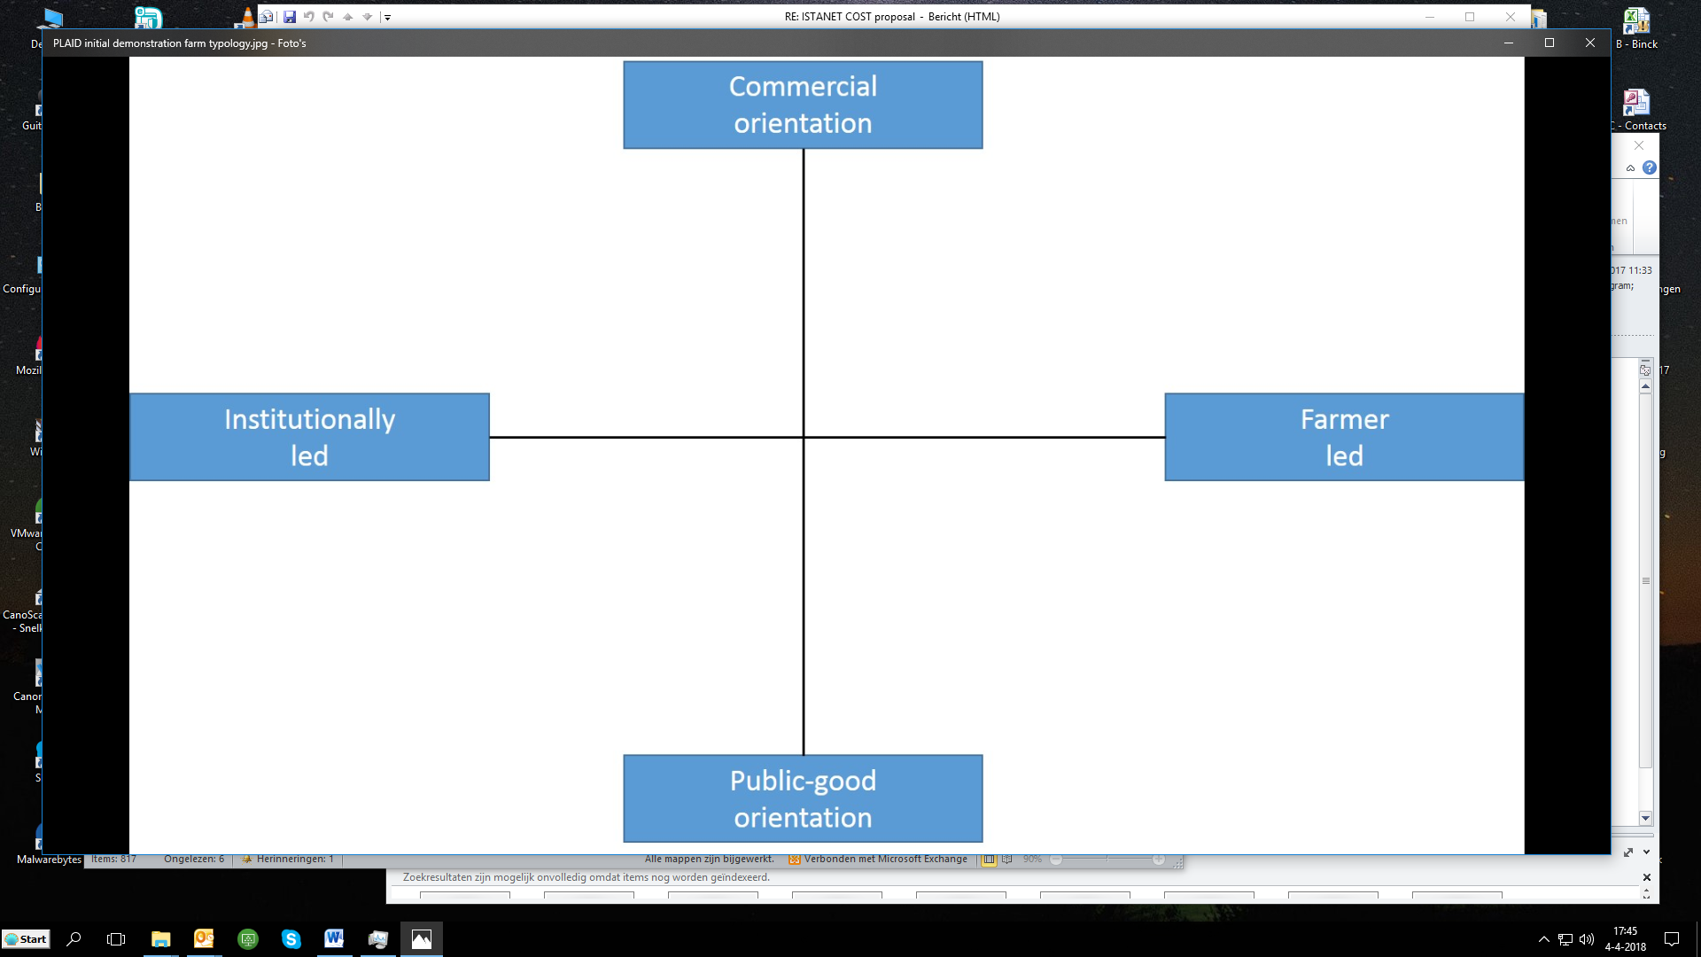

**LMF** (UK5)

**Figure 3: LMF positioned within the PLAID typology**

## Topic(s)

The programme of topics is driven by the LMF Management Group and implemented by the facilitators. To date, the following topics have been covered at community demonstration days:

* Introducing the host farms and farmers – farming and business practices and plans (succession, collaborative opportunities, benchmarking)
* Farm finances – business visions and performance data
* Soil health – soil management, nutrition, structure, mapping, and collaboration towards improved soil health
* Arable and livestock performance – strategies for crop protection and animal health, farm operations and marketing
* Collaboration of arable and livestock businesses – building relationships, supply chain collaboration
* Cover crops (benefits for livestock and arable farmers)
* On-farm diversification
* Drainage systems – investment, impact on yield
* Use of fertilisers
* Grazing management
* Machinery – finance, sharing, technology
* Challenging seasons – late drilling of crops, adjusting inputs, late lambing, condition loss, increased feed costs
* Links to research and scientific approaches

## Access

The target audience for LMF is farmers and others involved in the industry, primarily in the Lothians region. Both a strategic and localised approach to attracting community and management group members has been taken, including traditional media coverage, online promotion (e.g. through organisations’ websites), and word of mouth. It is common for Community Group members to have attended other MF meetings in the past and/or in other regions.

Monitor Farm community demonstration days are free of charge and unrestricted in terms of the audience who may access them, but facilitators ask that people confirm their attendance ahead of the meeting for the purposes of catering. Travel distances in Lothian are minimal in comparison to other parts of the country due to the geography of the area. In the current programme, there are four MFs within 100 miles of LMF, representing the south and central belt of Scotland.

The MFS programme is designed to provide opportunities for farmers to attend a farm that is broadly representative of farming in the region. LMF is reflective of this in terms of the prominence of arable and livestock farming in the Lothians area. However, the LMF Community Group also incorporates farmers from out with the Lothian region, who identify with the farms involved in terms of agricultural practices, and farmers from within the region with different farm types (e.g. dairy) but identify with programme in terms of agriculture fundamentals (e.g. soil management) and broader farm management practices.

# Demonstration event

This section describes the nature of demonstration days at Lothians Monitor Farm (LMF) in terms who attends, how events are conducted, and communication between hosts and participants.

## Visitors

Visitors at Monitor Farm (MF) demonstration days are known as Community Groups. On average, around 54 Community Group members attend demonstration days, which has reduced from a peak of 90 people at the initial launch meeting. It is important for meetings to attract a credible number of visitors to justify funding, but beyond a certain number it becomes difficult for facilitators to manage in a way that attendees can participate in a meaningful way.

LMF Community Group members have been described as a core group of around 30-40 members, around 20 members who dip in and out, and others who may attend as a one-off. A combination of arable and livestock (around 75% arable), predominately small and medium-sized farmers attends. Mostly local, but also coming from other neighbouring regions and sometimes beyond. Meeting topics can be determinative of interest and attendance. Attendance may vary across the day, whereby individuals visit only for the morning or afternoon session. Sessions are also attended by others with an involvement or interest in agriculture in the area, such as: different trades; industry and non-governmental organisations; education and research organisations – all of whom are believed to add value to the Community Group and MF programme. A certain type of people is said to participate in MF meetings, which has been characterised as progressive, like-minded, open-minded, interested, and less traditional than the farming community as a whole – which has been linked to the relatively younger age profile of this group. Considerable knowledge and experience are believed to be held and shared by the LMF Community Group.

Facilitators report ‘quite a few’ young farmers that participate in the Community Group – mostly in the 30-40 age group. Part of the reason for this is believed to be due to one of the Monitor Farmers being in this age category and involved in encouraging his peer group to come along. The group has attracted a few under 30s (a ‘rarity’ in the industry), which is believed to be important for the future of agriculture in the area, including mentoring and succession planning. A pro-active approach towards attracting participants through social media and from local societies and universities is believed to have contributed towards this younger age profile. However, it has also been suggested that more could be done to further reduce the age profile at agricultural events (including MFs, farmers clubs, markets, etc.) from the typically middle-aged and older category that remains dominant. Female members are also said to be involved as Community Group members and are believed to be a reasonable representation of women farming in the area. One estimation given was that the Community Group is roughly 10% female.

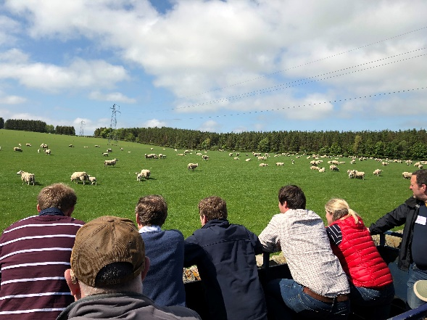

**LMF Community Group during demonstration day farm tour**

## Communication & Mediation

A strategic approach is being taken to communicating key messages that will raise the profile of the Monitor Farmers and build credibility and respect for what the programme and farmers have to offer. The approach taken is aimed at ensuring that information shared is appropriate and draws people’s interest, rather than turning them off through over-exposure or inappropriate or repetitive content.

A key conduit of information is the Monitor Farms Scotland (MFS) website (<http://www.monitorfarms.co.uk/>) which links to the nine current MFs. In addition, information and links to the programme are provided on the QMS (Quality Meat Scotland) and ADHB (Agriculture and Horticulture Development Board) websites. Press releases are posted before each meeting with information on the programme, topics being covered, and contact information for anyone interested in attending. Meeting reports are posted after events, with links to reports other resources.

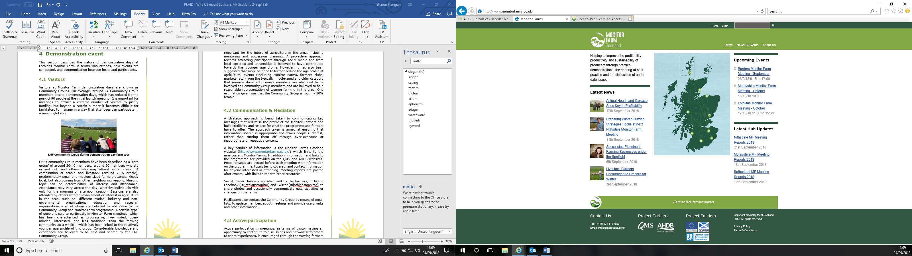

**Monitor Farm Scotland website, showing links to farms, news, events,**

Social media channels are also used by the farmers, including Facebook and Twitter, to share photos and occasionally communicate new, activities or changes on the farms.

Facilitators also contact the Community Group by means of email lists, to update members about meetings and provide useful links and other information.

## Active participation

Active participation in meetings, in terms of visitor having an opportunity to contribute to discussions and network with others to share experiences, is encouraged through the varying formats across the day, and through physically moving to different environments and spaces. Opportunities are provided for visitors to see progress on the farm first-hand (e.g. viewing animals or crops) and experience physical demonstrations (e.g. digging in fields to look comparatively at soil health indicators) where appropriate. A key benefit of this approach is engaging different learner and personality types.

Another important participatory role for Community Group members is through their involvement in decision-making, for example, where the Monitor Farmers might implement changes or new practices to demonstrate the effects at a later meeting. In doing so, the community group are also involved in supporting the Monitor Farmers and exploring the reasons why changes have had positive or negative effects for the farm.

A typical demonstration day might start socially with refreshments at a central meeting point. Introductory remarks and farm updates may take the form of oral or PowerPoint presentations with the opportunity for questions and discussion, followed by a land rover safari to a range of arable fields across the farm for the rest of the morning session to discuss specifics relating to crops and practices. Then a social lunch, for the Community Group to eat and chat, followed by presentations (e.g. invited speakers on agricultural markets or other topics of interest) and discussion with the opportunity for tea and coffee. Subsequently in the afternoon session the group might be taken for a tour around the livestock farm, again to discuss progress and examples in situ, using a tractor and trailer for transport.

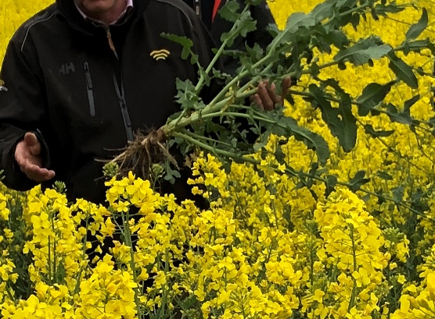

**Examination of plant roots in oil seed rape field**

## Doing business

Networking is the primary way for Community Group members (including trades) to make contacts to take forward in their business after LMF meetings. Though opportunities are present for individuals to do business at meetings, the established principle is that trades don’t attend meetings solely to make a sales pitch, but also contribute in terms of knowledge and information provision. For example, one regular LMF attendee who works professionally in an agricultural advisory role answers questions that other Community Group members ask him during meetings but is careful not to take advantage of the situation from a commercial standpoint. However, through his role in LMF meetings, participants have opportunities to see the type of service he offers to the host farmers should individuals want to approach him in a professional capacity.

## Role of sustainability

Sustainability is not the primary focus of the MFS programme, but it is explicitly confronted and implicitly underlies many of the progressive practices demonstrated at LMF.

The underpinning collaboration between the two Monitor Farmers is a central component in the structure and function of LMF that demonstrates the three sustainability pillars in practice. For example, by working together to implement traditional farming practices, such as rotational grazing on ordinarily arable land, attention is being paid to soil health through replenishment of organic matter. In a cyclical system, this improved soil health impacts on the productivity of land and thus impacts on economic sustainability. Economic and animal health benefits are also seen from the livestock farmer’s perspective. Explicating the collaborative relationship between the two host farmers demonstrates the importance and potential of consideration for social sustainability in farming. By incorporating collaboration into the range of topics in the LMF programme, opportunities for improved sustainability are shown directly through farming practices with tangible business benefits.

Sustainability is also addressed through direct topic foci on agri-environmental practices (e.g. pollinator project, farm woodland creation), economic topics and agricultural markets, and relevant social issues (e.g. mental health).

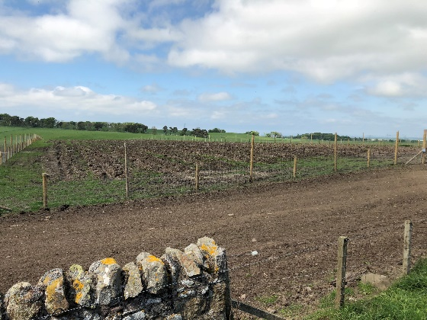

**Farm woodland plantation from trailer tour**

## Unforeseen circumstances

Facilitation for the MFS programme is provided by professional consultants who plan and organise the programme and demonstration days. Contingency planning and a flexible approach allow unanticipated occurrences on the day (e.g. higher numbers than expected) and unforeseen issues with timetabling (e.g. unusual seasonal weather, availability of host farmers) to be dealt with appropriately.

Due to the unpredictable nature of Scottish weather, participants are notified beforehand to dress appropriately for sessions being run outdoors. During winter months, it is customary that some meetings (in part or their entirety) are conducted indoors and cover other topics that do not require practical demonstration in situ (e.g. collaboration strategies).

## Plans vs. practice

The nature of the MFS programme, as a series of events, allows the organisers to adapt the demonstration set-up based on their own perception of, and feedback on, the success of demonstration days in terms of format and content. So, things which did not work (e.g. timings across the day, size of groups) have been adapted in subsequent events. Objective-setting is also relatively fluid over the course of the programme and over time the content and structure may be tailored to the demands and feedback of the Community Group as well as the host farmers and organisers.

## Participants feedback

Returning to LMF community demonstration days may be interpreted as a significant indication that participants consider their attendance as being beneficial.

Feedback indicates that participants appreciate the opportunity to see and hear about the MFs and compare and think about how the topics being discussed relate to their own farms. For example, having the opportunity to informally benchmark their own practices and experiences against others can help build confidence if their yield was good in comparison to others. Participants also appreciate the opportunity to learn new things, tips and practices, and MF meetings often give participants the stimulus to act on things that they might otherwise put-off.

The opportunity to get out and speak to others is also a key point of feedback, whereby it appears that a community feel has been built and farmers enjoy ‘catching up’ with each other.

*“There’s a buzz about what folk are going to talk about and what you’re going to get out of it… Sometimes there will be a speaker that’s as dull as dishwater, but you’ll always take something out of it.”*

**LMF Community Group member**

# Motives, learning and networking

This section discusses some of the motivations and rationales of participants attending Lothians Monitor Farm (LMF) meetings, including individual and social factors. These are principally related to participants’ business interests, but also include personal stimuli. Selected quotes are included at the end of each section to illustrate some key discussion points.

## Reasons to attend demos

Multiple rationales have been found to motivate attendance at LMF community demonstration days, which are discussed below in terms of individuals’ attitudes and perceptions, social norms that they perceive in relation to their area and community, and more practical reasons that prompted them to attend.

**Attitudes and perceptions**

Among LMF attendees a progressive and learning-centred ethos was pervasive. For Community Group members it is not uncommon to have attended another programme underpinned by principles of social learning before making their decision to attend LMF, including local benchmarking groups or other Monitor Farm (MF) programmes. The concept of peer-to-peer learning was prevalent, whereby the offering by host farmers was the principle counterpoint to compare with their own businesses, but opportunities to discuss ideas and experiences with other attendees was also seen as valuable.

Some of the more specific expectations associated with attendance were related to the topics or practices being demonstrated (e.g. grazing stubble turnips), which would influence decisions relating to which sessions to attend – or indeed influenced their long-term commitment to the programme to see results from specific changer of practice trials over time (e.g. ‘bringing livestock back to [arable] ground’). Seeing and hearing about processes of collaboration between the two farmers was also influential.

Some farmers expressed more general expectations for broadening their thinking and exposing themselves to new ideas to see if they can be of benefit in their own farming operations. This includes opportunities to see novel practical examples demonstrated by the host farmers and to acquire new information from industry experts. Indeed, it was suggested that the nature of the MF programme, in terms of targeting sessions to the needs of each specific group, and the links made to industry experts, means that the latest and most appropriate level of knowledge may be acquired. The importance of being exposed to new ideas and learning from peers was also recognised, in the context of a highly competitive market. For some, attending LMF also provided an opportunity to reinforce their own thinking.

Informal parts of demonstration days were believed to be an important opportunity to share experiences. In this respect, MF meetings were identified as an opportunity to mix with other farmers, helping to combat isolation in modern farming and boost morale.

Ultimately, attendees sought the opportunity presented by LMF to learn, compare, and potentially identify weaknesses and solutions for their own businesses in a social environment. Overall, this ambition was realised, and attendees described how they were able to pick up new pieces of information, make new contacts, and value some time away from the business.

*“A friend of mine was a [former MF] host farmer in Fife… he asked me to come and speak about my machinery sharing experience… that got my interest going, so I went along to two more Monitor Farm meetings in Fife, and when I heard there was one in the Lothians I thought, ‘well, I want to be involved.’”*

*“To get more information to identify areas of weakness in the farm. That’s what I was interested in. Potential of increasing growth in lambs. Different systems.”*

*“I would probably say the main motivation for me would be the collaborative farming. I like sheep, so it’s- I’ve been trying to justify them here, but it’s quite hard when you can make more money out of arable. So, it’s interesting to see how they’re going to balance trying to have some form of sheep.”*

**LMF Community Group members**

**Norms**

It was widely discussed that MF attendance is associated with farmers who are interested and open-minded. Learning was identified as the main purpose of the programme – including learning within the group, and through projecting an example of what farmers do and showcasing the sector to government and the public.

From the perspective of best practice, both host farmers were frequently described as ‘good’ or ‘technically good’ farmers and therefore worthy of attention. Most attendees are either arable, livestock, or mixed farmers so have a direct interest in practices being demonstrated and discussed. Attendees also showed an interest in the novel approach to collaboration the hosts are undertaking, including exploring the potential for evolution towards traditional rotational systems across farm boundaries. In this respect, there is also opportunity for attendees to scope potential collaborative relationships of their own.

The importance of reciprocity was identified by attendees. From the perspective of those who do attend, reciprocal sharing of information and experiences was identified as a fundamental component of learning within the MF programme – and with that it is accepted that a level of openness is necessary of all attendees. It was suggested that a preference for privacy and reluctance to share practices and experiences can be a defining characteristic of those who do not attend this type of group or programme. A common result of sharing has been trial or implementation of new practices; for example, decisions to conduct soil testing after seeing it demonstrated in practice and talking to others who have previously benefitted from doing it on their own farm.

There was also some discussion of the ‘type’ of person who would attend programmes and events like LMF, whereby several of the LMF Community and Management group members have been involved in others previously. Being part of such circles is also influential in terms of attendees ‘being asked’ to come along or see others go to when something new is started. For this group, many of the attendees have had previous acquaintance with others in the group and for others the group is an opportunity for attendees to meet people they were previously aware of but didn’t know to speak to.

Further to this, it was suggested that MFs are potentially a way to influence and change norms in farming practice, to more environmentally sustainable techniques.

*“We’re very lucky that the two host farmers are very good, very technically good at what they do. They are trying to integrate things with each other’s business that show the collaboration and I think that’s a real way – I think that’s how farming should evolve.”*

*“I think they realise that is you- because they’re coming to the is there has to be a level of openness to be involved in the Monitor Farm and then basically if you’re not that open then you wouldn’t go, yeah.”*

*“The Monitor Farm project is a good vehicle to do it, it shows how we can grow more sustainably – grow crops more sustainably and in an environmentally-sensitive way but maintain our margin. Because if we don’t do that, it’s not pointless, but how do we make a living and look after the soils? We’ve got to be able to do both.”*

**LMF Community Group members**

**Practicalities**

As the MF programme is run in regions across Scotland, it is possible to select one to attend based on locality, which was important for several members. Opportunity to attend all or part of the day depending on the type of farming system that individuals were interested in also makes LMF more accessible for some members.

*“Local… Interesting mix of farming practices, similar to my own. To learn new ideas and, yes, see if there’s things that could benefit me.”*

**LMF Community Group member**

## Forms of learning

Delivery and exchange of information is a fundamental component of the MF programme. A key element recognised by LMF facilitators is ensuring there is an appropriate balance in the modes of delivery/exchange used at demonstration days, whereby use of the time available and delivery formats adopted are most appropriate for engagement by the attending Community Group. The importance of catering for different learning styles is recognised and acknowledged both by organisers and Community Group members. Three key formats of delivery/exchange have become apparent, including discussion (catering for auditory learners), seeing examples in situ (visual learners), and participatory examples (physical learners).

Careful attention is also paid that the level of content being delivered and discussed is appropriate to the Community Group. This is particularly relevant where livestock and arable farmers, with different backgrounds and knowledge-bases, are involved together. The challenging nature of striking the right balance has been acknowledged. For example, it has been suggested that some people were alienated during some early discussions of a very technical nature, which resulted in changes to the language being used and examples given being more accessible, with more detailed technical talk often being saved for later discussion in smaller groups. In another example, however, it was suggested that the Community Group *should* be ‘bombarded’ with new information, which they could use as the stimulus for further discussion with their peers. Although ‘farm speak’ is identified as helpful, it is also evident that there are different types and levels of this.

Different formats have been trialled at LMF meetings, including different break-out groups. Pros and cons of combining or separating arable and livestock farmers have been identified. For some, there is inherent value in mixing both farming types together as they suggest that many fundamentals are the same (e.g. soil health, farm management) and therefore each group could learn from the other. However, others have suggested that they are not interested in topics that they see as not directly relevant to them. Allocating different parts of the day to more farming type-specific topics (e.g. arable AM and livestock PM, with lunch together) is one approach that has provided for farmers to attend arable and/or livestock topics as they chose.

Discussion is a central component, which is integral throughout demonstration days – and not restricted by location. For example, demonstration days include a great deal of discussion on different aspects of soil health, which has been approached in ways including presentations, field analysis of soil pits, examination of different soil samples, and participation in field digs. Through different opportunities to speak to experts and peers in large or small groups, attendees chose the time and place most comfortable for them and acknowledge that others are more comfortable speaking at different times. For example, one Community Group member said that he is happier listening in larger groups and speaking with his peers later about the information he has absorbed. Others feel very comfortable contributing to whole group discussions.

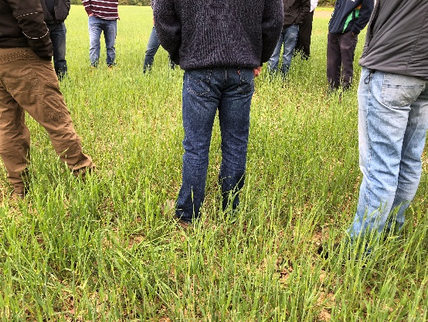The use of in situ experiments and demonstrations has been found to be particularly effective for communicating information while also providing the setting for further practice-based discussion. This is a strength of the MF programme, as farmers are provided with opportunities to learn and discuss new things in an environment that they are comfortable with.

**In situ discussion, catering for auditory and visual learners**

*“What you’ve got to remember here… people will take things in completely different- Some will take it in visually, some will take it- some will listen, some will read it. It just depends how they take it in. I think you’ve got to have a range, if you are out in the field and you can feel the soil and see it, and everything is visual and practical, yeah absolutely. Some people learn an awful lot from that, but likewise they might, some might be, love the science behind it. So, I think there’s benefit in both.”*

**LMF facilitator**

*“There was much more participation in the field because the farmers were in their comfort zone in the field, but you take them into a group inside a building and… much less comfortable. So, you have to make them more comfortable and the easiest way to do that is to have them in smaller groups with their neighbour or pal speaking to them rather than a facilitator or the host farm or whatever.”*

**MF programme funder**

## Content of learning

Facilitation and delivery at LMF are widely suggested to be well-pitched, in terms of the balance of expert-led and peer-to-peer learning opportunities that may be built on by individuals, and in terms of challenging attendees to think differently.

Practical examples are particularly appealing in terms of delivering new information, exemplified by interest shown in the demonstration of soil analysis in pits dug on the two farms, which has stimulated anchoring on Community Group members’ farms. Other opportunities to see physical samples (e.g. ‘tester pots’) and practical information leaflets to take home and refer to have also been well-received. In this respect, an important message relating to mindset change in terms of showing farmers that soil analysis doesn’t have to be costly or complicated appears to have been well-received.

*“A visual thing really gets to the point very quickly, rather than trying to describe it.”*

**LMF Community Group member**

*“The second week they were all down on their hands and knees poking at the soil – what a difference in the level of engagement… The fear factor is they don’t actually know what they’re supposed to look at because it’s always been deemed to be in this area of soil scientists and specialists: ‘It’s not something we can do anything about. We’re not soil scientists.’ When in actual fact, all they need is a spade.”*

**MF programme funder**

## Outcomes of learning

Equipping farmers with new knowledge upon-which they can make informed decisions was identified as an important motivator and outcome. One Community Group member described a situation where marketing messages have played-on a lack of knowledge relating to items being sold (or the problems they remedy), whereby LMF and other opportunities to absorb information from peers and independent sources can help instil decision-making confidence.

Another important lesson discussed related to the importance of reciprocity when contributing to farmer-led peer-to-peer learning, such as in the MF programme. An erstwhile example of an attendee consistently being used as a source of information, but not being the recipient of anything new was highlighted – but stating that is not the case for him at LMF due to the progressive and experimental nature of LMF and the host farmers.

*“I try to go to all of the meetings to learn more and to keep learning so I can be ahead of these guys [sales people].”*

*“I went irregularly to that [earlier group]. That was probably because I wasn’t getting a lot out of it. I was ending up- it wasn’t a bad thing- I was ending up giving more to it… And I felt like I was… not that I was being used, but I was… I wasn’t learning. I was giving information rather than learning, so I didn’t go too often to that.”*

**LMF Community Group members**

## Networking

The benefits of social interaction were frequently described by LMF Community Group members, from the simple pleasures of meeting or ‘catching up with over coffee and a bacon roll’, to boosting morale and mitigating against social isolation.

The importance of: meeting other farmers in an agricultural environment; providing opportunities to build relationships in an informal setting that might result in formal collaboration; and giving farmers a chance to share ideas, and see and hear about what other farmers are doing in their locality, all contributes towards the emphasis being put on informal parts of the day by the organisers, recognising the importance of social capital generated in this way from a social and business perspective. For example, one farmer described a situation where she was able call another LMF Community Group member between meetings to help answer a query that she had.

*“Farming is more isolated than it’s ever been because there’s less people and the more you can bring the people together, well, it boosts the morale in the farming industry, I think. But it also shares ideas and I think that’s – it’s a win-win.”*

*“So, I just phoned another member of the Monitor Farm group and quizzed him. And he’s a bit of a whizz-kid, so he reeled off…”*

**LMF Community Group members**

# Anchoring: Application of demo lessons by participants

This section discusses examples where learning and experiences at Lothians Monitor Farm (LMF) demonstration days have been, or will be, translated by attendees into new ways of thinking or acting on their own farms. This includes implementation of new practices and strategies and building on links generated with peers and other industry experts. Selected quotes are included at the end of each section to illustrate some key discussion points.

## Anchoring related to the present demo

In the case of LMF ‘the present demo’ relates to a session in the programme relating directly to soil health and management. During this session demonstration of soil analysis including pits dug on the host farms and using different tools and indicators to measure and assess different things in the soil (organic matter, compaction, cultivation depth, etc.) was well-received by Community Group members. Several examples of implementation were discussed. The practical nature of this session, direct point of comparison to their own farm, tools, and contacts presented appear to have been crucial in the appeal and application of lessons learned in the session.

A key point of interest from this session relates to comparison of pits dug on each farm. Although farmers selected which sub-group to join based on the farming type (arable or livestock) most relevant to them, a proportion of Community Group members took the opportunity to look at both, allowing for comparative analysis of soil health across farming systems to draw further lessons (e.g. relating to potential for new systems of rotation or potential collaboration). Indeed, the suggestion has been made that a further comparable session be conducted in the LMF programme, to look at both examples as a mixed group.

*“Straight away I was on the phone and I went to the soil company to get my- get two other tests done on my soil.”*

*“Since then I’ve actually had the soil scientist guy out at my own farm, just a couple of weeks ago, to do soil analysis and soil constitute parts and so I got a lot out of that… So, I’ve got work to do on my soils by introducing more organic matter… the information he’s given me could add another 2-3 tonnes per hectare, so that would be money massively well spent.”*

**LMF Community Group members**

## Stimulating anchoring

The nature of the Monitor Farm programme means that further sessions are planned based on the demands of the groups, therefore further opportunities to explore interesting topics or practices, whether informally or formally, can be planned. The notes from each meeting are also made publicly available for Community Group members to access, and further information and opportunities between meetings is communicated by email and/or social media.

## Anchoring related to earlier demos

Some lessons were evident in discussions relating to anchoring from earlier demonstration events, including the importance of topics and formats that appealed to attendees in a practical way, versus those that draw interest but are unlikely to result directly in change.

Demonstration of practices over time is an important benefit of the MF programme as Community Group members have the opportunity to see change and discuss the experiences of the Monitor Farmers. For example, having the opportunity to see and discuss an example of how paddock grazing systems work has drawn the interest of Community Group members. As has collaborative rotational grazing systems, which are being trialled during the MF programme with interest from Community Group members who are interested potential consequences for their own operations.

An example relating to Drone technology illustrated the potential lack of value in demonstrating interesting topics where the format and focus are not pitched correctly. In this instance it was suggested that demonstration to smaller targeted groups might be more appropriate to allow better insight into how individuals might use it in practice.

Another interesting, much more general perspective on anchoring relates to outcomes from immersion in social learning groups, such as in the MF programme, whereby individuals are inspired by their peers to come home and make improvements and try new things. Through new knowledge generated in the MF programme, it was also suggested that farmers may go home and trial techniques that others may also potentially benefit from seeing the results at some future time.

*“We looked at the rotational grazing of sheep, that was quite interesting. Moving the fences around the grass fields. So, that was useful, I might do that here, yep.”*

*“It was interesting to see, but I don’t know how many farmers left there saying, I’m going to go and get the drones.”*

*“I’m totally out with my comfort zone, but I can’t run this farm and continue to survive into the future the way I’ve always been doing it. I’ve got to keep learning. I can’t stand still. And the only way for me to keep learning is to put myself into a bunch of technical good operators, forward-thinking, dynamic guys that – yeah, push me out of my comfort zone. They make me think. They make me come home and want to do things better, do things differently, yeah, and set me that challenge. I need to be challenged.”*

**LMF Community Group members**

# Scaling: Application of demo lessons by the wider farming community

This section discusses the wider impacts of demonstration in at the regional farming community level. The impacts of on-farm demonstration on those who have not attended the event in person through those who have, and the networks they operate in. Selected quotes are included at the end of each section to illustrate some key discussion points.

## Retrospective examples of scaling

Identifying specific examples of scaling resulting from the current case study is problematic. The demonstration innovation narrative and timeline provided in Section 8.1 illustrates potential for scaling from demonstration sessions conducted in this case study programme. However, another example of scaling borne from a demonstration activity conducted at other events (including Monitor Farms) is a commonly referred to as ‘Soil my Pants’ (based on a viral social media trend originating in Canada), which uses cotton underwear buried in topsoil as a fun and simple mean of investigating soil health depending on how degraded the material is after a period of 8 weeks (the more degraded, the healthier the soil). It is suggested that the impact of implementing this simple test has been very effective and widespread in terms of assessing soil health in recent years.

*“It’s done more for soil health than fifty soil scientists over the last ten years. [Another regional] Monitor Farm…adapted it and they’ve got, is it Test my Vest or something? They are using vests. So, they were digging their vests up at the meeting last week, that’s all on grassland stuff, and exactly the same pattern came under grass; we had some vests that had completely disintegrated and others that had very little deterioration.”*

**Monitor Farm programme funder**

## Prospective assessment of scaling: Impact pathways

Part of the MF programme is to make farming more visible to the government and general-public, as well as inspire best practice in farming across the region. The prospective impacts and scalable benefits from Lothians Monitor Farm (LMF) are potentially great, owing to the people involved and the strategies in place. Recognition that the Monitor Farmers selected represent best practice examples of progressive arable and livestock farming in the region (they are ‘good farmers’) is evident in discussions with Community and Management Group members, as well as the MF facilitators and funders. In turn, a high degree of expertise is being attracted in the Community Group.

The importance of ensuring credibility is recognised by the facilitators and farmers in the way that the public profile of the farm and farmers is managed. One aspect of this is taking a strategic approach to what and when information is shared via traditional media and social media, to ensure that the right messages are presented at the right time. As well as a means of communication with Community Group members, social media has also proved successful in terms of attracting new demonstration day attendees and farming followers from different parts of the country who are interested in practices on LMF. Indeed, one LMF Community Group member discussed the significance of past MF reports posted on the internet to inform his own thinking and practices.

Both Monitor Farmers also share progress and lessons through social engagement and other opportunities as they present themselves – which may have a very powerful scaling effect as they are both well-networked individuals. The powerful effects of social norms developing following the adoption of new practices by other farmers – stimulated first by early adopters and innovators is recognised by LMF organisers. The role for Monitor Farms that they see is in explicating new practices and providing opportunities for farmers to explore and ask questions on how it could work in their own individual circumstances in order to make sound business decisions.

*“It’s the respect we gain from the people that come and respect from good farmers coming. That’s what’s encouraging about here is it’s a lot of good, good farmers that are coming. Now, if we weren’t doing it right here they wouldn’t come.”*

**LMF facilitator**

*“I’ve always looked at the reports throughout the UK online… it was just out of interest to see what drills they were using, how they were cultivating the soil, and what they were doing to the soil, that intrigued me as well.”*

**LMF Community Group member**

*“This informed decision-making process if what we are trying to encourage… they’ll see what’s happening but then they need to take that and apply it to their own business and rather than just assuming that it’s going to work for them just because it works for their neighbour.”*

**Monitor Farm programme funder**

# Case study reflection

This section provides some reflection on the importance of this case study relative to the topic of peer-to-peer learning in on farm demonstrations. It provides an overview that might inspire comparative reflection with other case studies in the project to help identify key factors for success and impact.

## Demonstration innovation narrative

Lothians Monitor Farm (LMF) fulfils several roles in terms of on farm demonstration and peer-to-peer learning. These include learning opportunities relevant to arable and livestock farming, including sector-specific and technical aspects and innovative approaches to producing animals and crops for the market. LMF also performs a networking function, bringing farmers together on a regular basis over a significant time-period which facilitates social capital-building in the region.

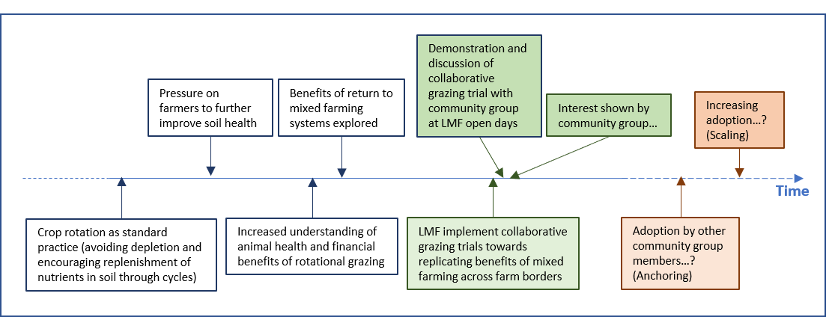In addition, through joint-hosting of LMF the farmers are demonstrating a real-time experiment in farm business innovation and collaboration. Though the results of collaboration trials being undertaken are as-yet uncertain, LMF could potentially contribute towards wider regime-level changes by exemplifying a workable alternative to individual farms returning mixed farming practices. The ‘innovation timeline’ in Figure 4 illustrates some of the factors that have contributed towards a collaborative grazing trial being undertaken and demonstrated at LMF and the prospective impact pathways resulting in uptake by other farmers in the Community Group (anchoring) and wider farming community in the Lothians area and Scotland more generally (scaling).

**Figure 4: Timeline for collaborative grazing systems towards cross-farm replication of mixed farm systems**

Demonstration opportunities associated with the collaboration trial being conducted are substantial, including exemplification of the practical agricultural benefits and issues of working together in this way (e.g. opportunities to improve soil health and increase clean grazing through rotation across farm boundaries, sharing and optimising resources), as well as offering a platform to explore the types of financial and governance measures that might be put in place to ensure an equitable share in the risks and rewards. Support provided by the facilitation team is particularly important in this respect, both in terms of providing practical advice relating to agricultural practices and governance arrangements, but also in terms of providing suitable mediation for the process.

The trial also brings together the results of other aspects of demonstration at LMF. For example, through considering the implications of demonstrations relating to soil health (e.g. Section 6.1 Anchoring), the collaboration trial illustrates an option towards improvement of soils depleted by years of prevailing cultivation practices. Before-and-after testing of soils on fields involved (e.g. 2-3-years grazing on ground normally cultivated for arable crops) could provide a particularly powerful example and illustrative tool towards increased anchoring and scaling in future years.

## Facilitating and impeding factors for successful demonstrations

Indicators of success in this case study combine qualitative and quantitative markers. While numbers at the start of the programme were somewhat higher, the persisting range in terms of participants numbers achieved (typically between 30-50 individuals) is believed to be more appropriate for the format. This number is sufficiently high to substantiate the public funding provided for the programme, but also a manageable number in terms of facilitating engagement in activities and discussions. The significance and value of engagement (to support learning), as opposed to mere attendance, underlies the approach taken at LMF. Good levels of engagement are evident at LMF and facilitation and session planning are managed in a flexible way and iteratively across the programme to help ensure that participant numbers are appropriate to the sessions and format adopted.

Collaboration between various AKIS actors underpins the successful implementation of the MF programme at a strategic level. This impacts on the potential of MFs in terms of the human and social capital available to them (experts, networks, etc.) Being part of the MF programme also includes other strategic benefits, including the benefit of lessons learned in earlier programme cycles. The scale, visibility and reputation of the MF programme also supports access to on-farm demonstration, through increased awareness of events and free-of-charge participation for farming communities and other interested parties. Access to the programme is also supported through a network of regional options; thereby reducing travel time and increasing potential for attendees to identify a demonstration appropriate to their individual needs. The audience LMF attract appears representative of farming in the region (proportionally more arable than livestock farmers) but is not exclusionary; illustrated by regular attendance of one of the small number of dairy farmers operating in the region, who also participates in the LMF management group.

Collaboration between the host farmers also contributes to success in this case study. Sharing responsibility in terms of providing infrastructure and content for demonstration days, as well as presenting themselves as a real-time case study of new and innovative collaboration in practice. Like the facilitation team, the host farmers bring different qualities to the MF programme and demonstration days. In terms of access, this case study benefits from the existing and complimentary networks of the two farmers (one of whom is a young farmer and new entrant with peers in those target groups important in terms of improving social sustainability in the sector). While there is not a large female presence in the case study farm, a congenial, inclusive and equitable atmosphere between genders is palpable. Joint-hosting in this case study also provides for a mutually-supportive relationship, including opportunities for practical assistance as well as sharing the emotional burden of putting their farms and themselves in the spotlight.

## Impact of demonstrations

Assessing the potential impact (and ‘success’) ultimately depends on exchange as a key dimension underpinning learning in on-farm demonstration activities. Though the application of lessons learned cannot be easily measured, the anticipated impact of demonstration at LMF may be considered in terms of improved productivity and profitability, resilience, sustainability, quality of life, and empowerment at the farm and wider community levels.

A key element at LMF is sharing experiences and promoting discussion on the factors influencing productivity and profitability. For example, in the case of the arable farm unit, this is addressed through field visits and in situ discussion of topics such as product selection (seed, fertiliser, pesticides, machinery…) and practices adopted (drilling, tillage, spraying, harvesting…) through the season from preparation and planting to harvest and sale. Attention to technical aspects, new innovations available, contingency planning (etc), in discussions and seeing practical examples may impact on thought-processes and decision-making going forward. Learning from others about how to read the markets and how to enter them to further enhance profitability also forms a significant opportunity in the context of LMF demonstration days that may have a positive impact through application of learning in seasons to come.

Through development of social capital in the LMF community and management groups (and in the collaborative relationship between the host farmers themselves) capacity to adapt to change is increased through increased connectiveness to people and information that will support individual farm businesses in the longer-term. This is a significant benefit of the Monitor Farms approach, which provides for relationships, trust and confidence (to speak, to act, to approach) to be built over time. In terms of impact, quality of life may also be improved through social learning opportunities such as the MF programme provides, to spend time away from the farm in a justifiable (to oneself) and productive manner. In this respect it is an efficient means of empowerment, whereby social (networks) and human (knowledge, mental health) capital may be built in a way that may be taken home and anchored in individual businesses (e.g. implementation of new practices) to improve physical capital (soil, animal health) and financial (harvest results, sale weight) prospects as a result.

Promoting resilience through an adaptable approach based on changing conditions (e.g. across the season) is also demonstrated at LMF. For example, in a difficult season for crop establishment discussion of the relative benefits of applying new solutions to help establish the crop in the ground or cutting losses and changing tack with time in the season to try something else.

Environmental sustainability is not high on the agenda at LMF relative to productivity and economic sustainability of farm businesses. Techniques to improve environmental quality (e.g. minimum tillage, rotational grazing) are commonly discussed in the suite of options available to farmers. Adherence to agri-environmental policy measures (e.g. nitrate vulnerable zones) also feature in discussions. Specific agri-environmental projects and schemes also form part of the agenda but appear to be considered in somewhat separate terms. In terms of impact, the agri-environment may be improved through uptake of certain innovations that also prove to be economically feasible for farmers to consider.

## Key lessons from this case study

Importance of effective facilitation

* The facilitation team in this case study bring complimentary skills, are informative, approachable, and effectual in the organisation and assistance they provide.
* This not only includes their role on the day, but in their preparation ahead of time and their involvement with the host farms as part of the MF programme (i.e. contribution to management group meetings, prompting and supporting new innovations for the benefit of the host farms and the wider community group).

Openness of host farmers

* In respect to their businesses and what they are willing to share, the host farmers in this case study are open about successes and failures on the farms.
* The farmers are also keen to work with and learn from the community group, including involving them in decision-making processes.
* As well as inspiring innovation (e.g. adoption of new practices with the support of the group and facilitators), through this candid approach, a sense of trust and community (in the wider sense) is instilled and provides the foundations for network continuation beyond the period of the MF programme.

Demonstration of new collaborative approaches in farming

* This fulfils an important role in showing farmers what might be possible by working together.
* The type of approach demonstrated builds on the traditional concept of neighbouring in ways that both parties involved share risks and rewards in the pursuit of innovative new ways of working.
* From the audience perspective, it exemplifies the importance of innovation in business management practices as well as agricultural practices in pursuit of sustainability in agriculture.

Interpretation that encourages engagement with the topic

* The way that information is shared is important. Practical presentations that allow farmers’ sensory experience are particularly effective, including opportunities for physical participation.
* Discussion in situ is also effective in terms of understanding and relating what is being said to practice – particularly where opportunities are also presented for the group to engage in decision-making and future directions.
* Timely and appropriate sharing of resources (e.g. field diagrams, figures, comparator photographs, etc.) is also effective as a means of communicating specific information or replicable practices, as well as stimulating recall after the event.

Opportunities with mixed farming groups

* Mixing traditionally distinct farming types presents new opportunities for exchange and enhanced clarity in the presentation of information.
* In this case study, the mixed group of arable and livestock farmers illustrated opportunities for shared and comparative discussions relating to topics (e.g. soil management, business practices), which are relevant across the spectrum of farming types but are typically considered separately. In this, potentially new innovative or collaborative solutions may be explored.
* By lowering communication barriers, such as reducing or explicating jargon and providing plainer explanation of processes to aid wider understanding, demonstrations cater to a broader audience range (e.g. new entrants, individuals unfamiliar or uncomfortable with technical or scientific terminology) and create a space where people feel more comfortable in asking questions or clarification.

**Acknowledgements**

We would like to thank all at Lothians Monitor Farm (LMF) for their cooperation and involvement in this case study; we are particularly grateful for the support of the organisers, including AHDB, QMS, the facilitation team, and host farmers who welcomed us into the Community Group from the outset; everyone who gave up time to be interviewed about their involvement in and perceptions of LMF; and to everyone who engaged with us the community demonstration days.

Data collection for this case study was conducted in conjunction with the Scottish Government's Rural and Environmental Science and Services Strategic Research Programmes (2016–2021).

# Annexes

## Data sources

The following primary data sources were used in this report:

* 12 in-depth interview transcripts, including host farmers, facilitator, funder, management group chairperson, management group members, community group members.
* 7 participant observation field-note scripts

Secondary sources were also used and referenced in footnotes where applicable.

## Data collection methods

Primary data presented in this report was collected by means of in-depth interviews with a range of stakeholders (noted in section 9.1). These were recorded and transcribed for the purposes of analysis. In addition, participant observation was conducted, whereby basic notes were made, and photographs taken in situ, and more detailed field notes were scribed after the event; these include notes on the content being demonstrated and analytical thoughts relating to demonstration processes, implementation, and conversations with attendees.

Secondary data was collected by means of internet searching to document the wider demonstration context (primarily presented in Chapter 1 and referenced in footnotes). The online presence of LMF was also explored (including websites Twitter, Facebook) and information included where appropriate. Past research reports and papers provided further information relating to the AKIS and Monitor Farms programme where also used and have been referenced in footnotes.

1. Scottish Government 2016: <https://www.gov.scot/Resource/0053/00533588.pdf> (accessed 30.10.18)
2. National Records of Scotland 2018: <https://www.nrscotland.gov.uk/files//statistics/population-estimates/mid-17/mid-year-pop-est-17-publication-revised.pdf> (accessed 30.10.18)
3. Scottish Executive 2007: <https://www2.gov.scot/Resource/Doc/196509/0052657.pdf>

   (accessed 31.10.18)
4. NFUS 2016: <https://www.nfus.org.uk/farming-facts/farmings-contribution-to-the-countryside.aspx> (accessed 31/10.18)
5. The James Hutton Institute: <http://www.hutton.ac.uk/sites/default/files/files/soils/lca_leaflet_hutton.pdf> (accessed 1/11/18)
6. Scottish Government 2018: <https://www2.gov.scot/Topics/Statistics/Browse/Agriculture-Fisheries/PubEconomicReport/TimeSeries/ERSAC1> (accessed 31.10.18)
7. Scottish Government 2017: <https://www2.gov.scot/Topics/Statistics/Browse/Agriculture-Fisheries/agritopics/LandUseAll> (accessed 31.10.18)
8. Scottish Government 2018: <https://www2.gov.scot/Resource/0053/00535474.pdf> (accessed 31.10.18)
9. Scottish Government 2018: <https://www2.gov.scot/Topics/Statistics/Browse/Agriculture-Fisheries/PubEconomicReport/TimeSeries/ERSAC5> (accessed 31.10.18)
10. The James Hutton Institute 2018:

    <https://landcommission.gov.scot/wp-content/uploads/2018/05/McKee-et-al.-Final-report-to-SLC-Increasing-land-availability-for-new-entrants-2.5.2018.pdf> (accessed 1/11/18)
11. Scottish Government 2018: <https://www2.gov.scot/Topics/Statistics/Browse/Agriculture-Fisheries/PubEconomicReport/TimeSeries/ERSAC20> (accessed 31.10.18)
12. Prager and Thomson 2014: <http://proakis.webarchive.hutton.ac.uk/sites/www.proakis.eu/files/Final%20Draft-%20Country%20Report%20UK(1).pdf> (accessed 31.10.18)
13. Adapted from ‘AKIS and advisory services in the United Kingdom’: <http://proakis.webarchive.hutton.ac.uk/sites/www.proakis.eu/files/Final%20Draft-%20Country%20Report%20UK(1).pdf> (accessed 30/10/18)
14. Scottish Government 2018: <https://www.gov.scot/publications/future-strategy-scottish-agriculture-final-report-scottish-governments-agriculture-champions/> (accessed 31.10.18)
15. Centre for Sustainable Cropping 2017: <http://csc.hutton.ac.uk/wordpress/wp-content/uploads/2017/05/CSC-handout.pdf> (accessed 1/11/18)
16. <https://leafuk.org/farming/simply-sustainable-series>
17. Scottish Government 2018: <https://www2.gov.scot/Topics/Statistics/Browse/Agriculture-Fisheries/PubEconomicReport/TimeSeries/ERSAC20> (accessed 31.10.18)
18. The James Hutton Institute 2018:

    <https://landcommission.gov.scot/wp-content/uploads/2018/05/McKee-et-al.-Final-report-to-SLC-Increasing-land-availability-for-new-entrants-2.5.2018.pdf> (accessed 1/11/18)
19. NFUS 2018: <https://www.nfus.org.uk/news/news/mental-health-and-wellbeing-just-as-key-as-physical-health-and-safety-on-farms> (accessed 1/11/18)
20. Scottish Government 2017: <https://www.gov.scot/publications/women-farming-agriculture-sector/> (accessed 1/11/18)