Date: 14th November 2018

Country report: UK1

Case Study: UK1, LEAF IFM Field Event

WP5: Case studies of demonstration activities in commercial farms

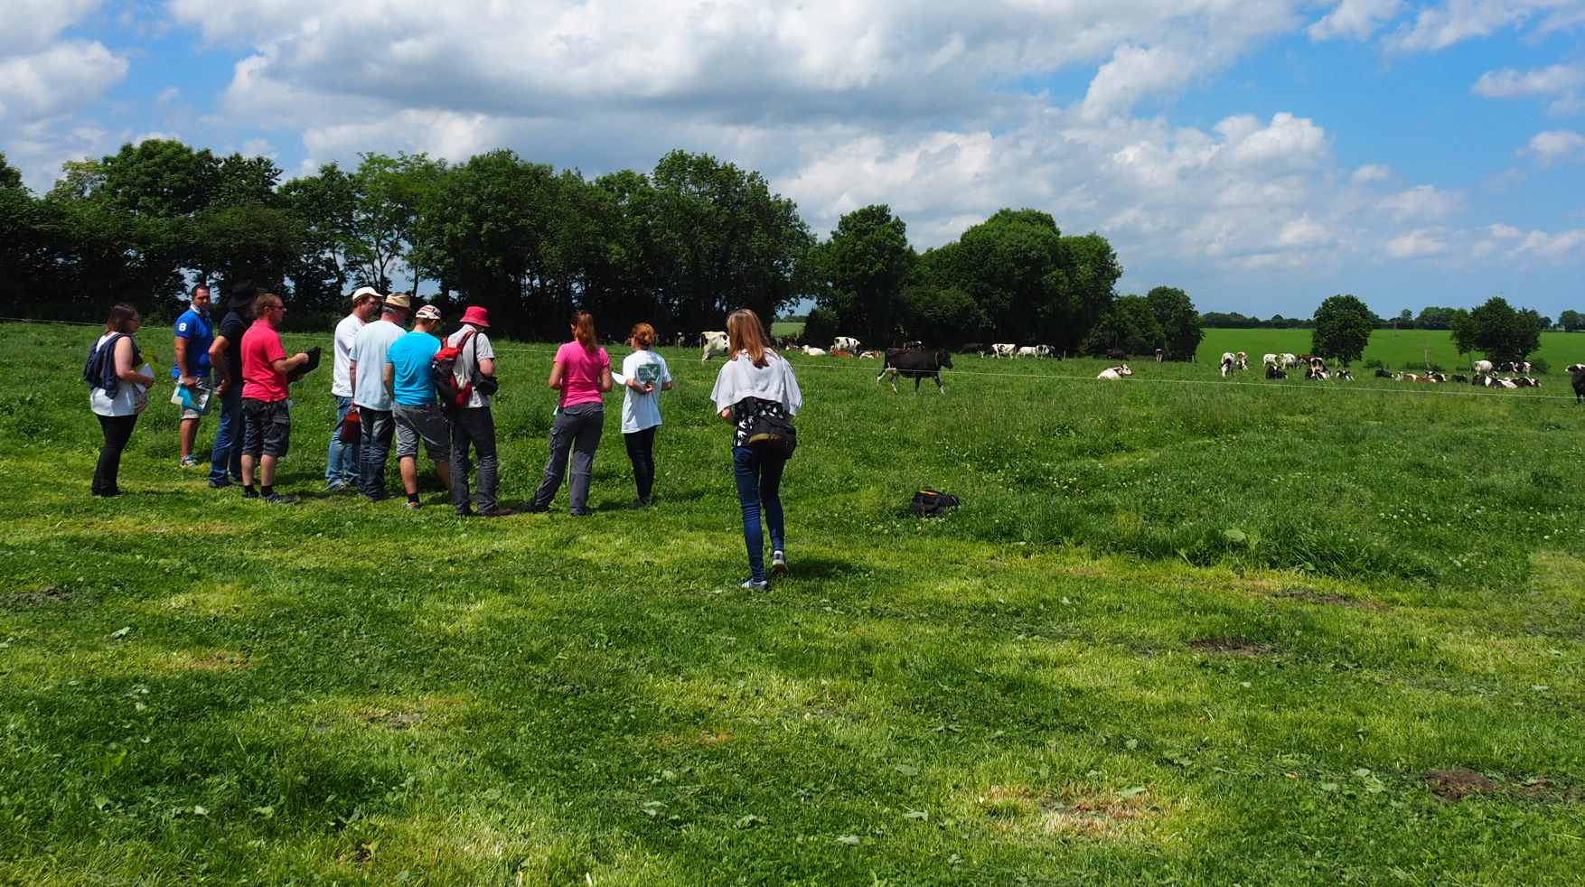
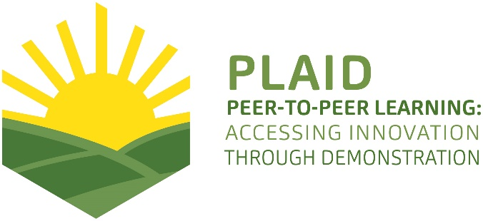
This project has received funding from the European Union’s Horizon 2020 research and innovation program under Grant Agreement No 727388

PLAID PARTNERS

Advisory Service Croatia ASC | ARVALIS Institut du Végétal | Association de Coordination Technique Agricole ACTA
Institute for Rural and Regional Research | Chambers of Agriculture | Delphy
European Forum for Agricultural and Rural Advisory Services EUFRAS | Innovatiesteunpunt ISP | 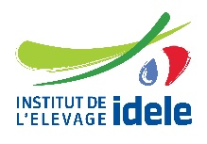  Institut de l’Elevage – Idele
Instituto Navarro De Tecnologías E Infraestructuras Agrolimentarias | Linking Environment and Farming LEAF | National Agricultural Advisory Service
Nodibinajums Baltic Studies Centre (BSC) | Research Institute of Organic Agriculture (FIBL) | Stichting Wageningen Research
The James Hutton Institute | VINIDEA

DOCUMENT SUMMARY

__________________________________________________________________________________
Milestone Title: 24 Case Studies
__________________________________________________________________________________
Case Study Title: LEAF IFM Field Event (UK)
__________________________________________________________________________________
Version: 1
__________________________________________________________________________________
Task Lead: WUR
__________________________________________________________________________________
Related Work package: WP5
__________________________________________________________________________________
Authors: Laura Tippin (LEAF)
__________________________________________________________________________________
Grant Agreement Number: 727388
__________________________________________________________________________________
Project name: PLAID
__________________________________________________________________________________
Start date of Project: January 2017
__________________________________________________________________________________
Duration: 30 Months
__________________________________________________________________________________
Project coordinator: The James Hutton Institute

ABSTRACT

There are many demonstration events held throughout the year, across the United Kingdom, which are hosted and organised by a variety of organisations including NGO’s, advisors, Levy boards, research institutions and commercial companies. The main messages attendees take away from demonstration events include learning more about a specific approach or practice, gaining more general knowledge and hearing experiences from host farmer and other attendees through networking.

Attendees to demonstration events are likely to be people who are already engaged and tend to be the new or early adopters of innovations. Demonstration events do not cover all learning styles but focuss more on visual, verbal and physical learning styles which may influence who attends events. Likewise, location, season and timings will influence attendance to the demonstration event.

Demonstration events are able to influence the uptake of novel innovations by demonstrating on-farm best practice, providing context to an approach and showing an approach in action. Combining demonstration events with other impact pathways, such as videos, articles and social media helps to further disseminate the benefits and applications of a novel approach.

Recommendations for future demonstration events, where possible, is to offer follow up discussion groups and events which help track progress and innovation uptake within a group of farmers, ensuring they use the information demonstrated on their own farm where appropriate. Utilising videos and virtual demonstration will help to reach other people who may not be able to attend an event, helping to remove geographical barriers and reinforce key messages to attendees. Working with actors across the supply chain will help to share experiences and expertise across the sector. Working with other impact pathways will help to further demonstrate and share innovations to a wide range of stakeholders.

TABLE OF CONTENTS

1 Demo context 6
1.1 The value chain 6
1.2 Typical farm characteristics 7
1.3 AKIS 8
1.4 Sustainability challenges 8
2 Demonstration summary 9
3 Governance: set up and organisation 10
3.1 Organiser(s) and history 10
3.2 Funding 10
3.3 Host(s) 11
3.4 Gender 11
3.5 Objective(s) 11
3.6 Topic(s) 12
3.7 Access 13
4 Demonstration event 13
4.1 Visitors 13
4.2 Communication & Mediation 14
4.3 Active participation 15
4.4 Doing business 16
4.5 Role of sustainability 16
4.6 Unforeseen circumstances 17
4.7 Plans vs. practice 18
4.8 Participants feedback 18
5 Motives, learning and networking 20
5.1 Reasons to attend demos 20
5.2 Forms of learning 22
5.3 Content of learning 23
5.4 Outcomes of learning 23
5.5 Networking 24
6 Anchoring: Application of demo lessons by participants 24
6.1 Anchoring related to the present demo 24
6.2 Stimulating anchoring 25
6.3 Anchoring related to earlier demos 25
7 Scaling: Application of demo lessons by the wider farming community 27
7.1 Retrospective examples of scaling 27
7.2 Prospective assessment of scaling: Impact pathways 299
8 Case study reflection 30
8.1 Facilitating and impeding factors for successful demonstrations 30
8.2 Impact of demonstrations 31
8.3 Key lessons from this case study 31
9 Annexes 32
9.1 Data sources 32
9.2 Data collection methods 323

Demo context

The value chain
The IFM field event was hosted on a large root vegetable and cereal farm located in Norfolk, England on 16th May 2018 organised by Linking Environment And Farming (LEAF) in partnership with the host farm. The demonstration event introduced, and highlighted farm practices and methods aimed to optimise functional biodiversity and lead to business benefit within an Integrated Farm Management (IFM) approach.

IFM is a whole farm approach helping to deliver more sustainable farming. It combines the best of modern technology with traditional methods to deliver prosperous farming that enriches the environment and engages local communities.

The value chain of a sustainable farming approach(es) such as IFM includes producers, advisors, policy, researchers, end users and commercial companies. Within this value chain, farmers and producers were the most important actors for this event to target as they are directly influenced by the methods demonstrated. Approaches producers use on their farm will directly influence and be influenced by biodiversity and other aspects (such as soil health and water quality) on-farm and in the surrounding area.

Independent farm advisors and commercial agronomists, are important actors within the value chain. There are a wide range of independent advisors providing environmental advice to the farming community, whilst commercial agronomists provide detailed analysis and recommendations on specified crops. Both types of farm advisor directly influence the practises and methods farmers implement on their farm.

Non-governmental organisations are important actors within the value chain and also important to have in attendance at the demonstration event. These organisations work closely with networks of farmers and producers providing advice, and hosting demonstration events of their own. Approaches demonstrated at the event in May can be passed onto farmers in these networks as well as providing opportunities for future joint demonstration events.

The role of researchers and research institutions within the value chain is to shape and develop innovative farming practices which can be used on-farm as well as helping to substantiate the benefits of new farming approaches. Researchers work with farmers to trial methods on commercial farms and provide advice and guidance as well as learning from the expertise and experiences of farmers to direct their research. Demonstration events, such as the one hosted in May, provides researchers opportunities for ground truthing research and to gain an insight into practicalities involved.

Policy influences what farming practices can be used on-farm and what stewardship and other scheme options are available for farmers. An example of this is Countryside Stewardship. This provides funding to farmers and land managers in the UK to make environmental improvements, which will determine the practices farmers can or cannot use under Countryside Stewardship. The IFM Field Event demonstrated and provided suggestions or inspiration of approaches that farmers could use within their Countryside Stewardship.

Other organisations such as water companies, seed producers and machinery manufacturers are also actors within the value chain. Water companies often have schemes and initiatives working with farmers to help improve water quality. For example, there are schemes working with farmers to reduce Metaldehyde concentration in water courses. Seed producers help to provide farmers with diverse seed mixes for cover crops or margin management including species beneficial to pollinators and beneficial insects. They also provide new or more resilient crop varieties to a range of stressors such as water and nutrient stress.

Machinery manufacturers are constantly developing technology aimed at targeting the application of pesticides and fertilisers for smarter approaches to pest management and also help to improve soil health and conserve the environment.

Whilst the demonstration event was primarily aimed at farmers; it is important all areas of the value chain identified were also in attendance. This allows messages and outcomes of the demonstration to be reinforced to other farmers and wider groups who may not have attended the event. It also allows for networking opportunities across the value chain enabling knowledge exchange across the sector.

Typical farm characteristics
The IFM Field Event host farm is a large root vegetable and cereal producer located in Norfolk in the East of England. The estate is one of the largest single farm units in lowland Britain comprising of 9,100 ha of which 50% is farmed. Potatoes, onions, carrots and parsnips are the primary output of the farm, with cereals largely grown as a break crop. All produce is LEAF Marque certified and they follow LEAF’s IFM approach. Furthermore, the IFM Field Event host farm is a LEAF Demonstration Farm within LEAF’s Demonstration Network.

IFM is a framework that encourages farmers to use a wide range of technologies and practises within its whole farm approach. IFM is not prescriptive but allows farmers to use site specific techniques most suited to their farm. The framework encourages farmers to consider 9 sections of the farm business:

- Soil Management and Fertility practices such as cover cropping, intercropping, diverse rotations, minimum tillage and lower weight machinery.
- Crop health and protection including Integrated Pest Management (combination of biological, cultural, mechanical, thermal and chemical pest control measures), crop diversification and crop variety
- Pollution and by-product management. Reduce, reuse and recycle.
- Animal Husbandry for example grazing management (Permanent grassland, alternative forage), and mixed farming systems
- Energy Efficiency including anaerobic digestion, other renewable energy and precision farming
- Water Management practises such as buffer strips, catchment sensitive farming and ensuing good land drainage.
- Landscape and nature conservation approaches including wild flower mixes, well maintained margin and beetle banks
- Community engagement activities such as LEAF Open Farm Sunday, keeping permissible pathways maintained and school visits.
- Organisation and planning includes staff training and ensuring all plans and health and safety records as kept up to date.

LEAF currently has a total of 2,052 members globally with 1,032 of the members LEAF Marque certified. LEAF Marque is an environmental assurance system recognising more sustainably farmed products produced by farmers using an IFM approach. Other organisations also promote sustainable farming practises and IFM.

AKIS
AKIS within the East of England is very large due to the high concentration of farmers within the region and the resulting high concentration of demonstration networks and events located here. The East of England is a highly productive area of the UK nicknamed the ‘bread basket of Britain’ with arable and horticultural systems dominating production in the region. LEAF members in the area total 292.

The LEAF Demonstration Network has a total of eight LEAF Demonstration Farms and one Innovation Centre located in the East of England. There are also a number of other demonstration networks located in the East of England coordinated by a number of other agricultural companies including Non-Governmental Organisations, commercial companies, research and Levy boards. The IFM Field Event host farm is a LEAF Demonstration Farm and a Strategic Farm within another network.

The large number of demonstration events in the region means there is a range of events covering many farming sectors prevalent in the region, including arable, horticultural and mixed farming. These events are therefore regularly available to farmers in the region and do not require long distances to travel in order to attend. Farmers from other regions within England may not have as much access to demonstration events and often face a geographical barrier to attending.

The IFM Field Event host farm hosts many events throughout the year, hosting over 400 visitors to the farm in 2017. These events are primarily focused at peer to peer learning, where farmers can learn from other farmers and see in practice the innovative approaches going on at the host farm. Demonstration events at the host farm also target farm advisors, researchers and industry experts to attend.

Sustainability challenges
One of the biggest challenges facing not only the subsector but farming in general is finding the balance between short term yield benefits and long-term sustainability of the crop, the environment, and farm business. The goal for farming approaches such as IFM is to create resilient cropping systems which are able to withstand environmental, climatic or economic pressures, whilst optimising potential yields.

Changing on-farm practice can have unknown consequences and the farmer perceived/ actual risk can be high. Often, approaches may not have set prescriptions for use, may not have proven results from commercial testing or simply are not well known within the sector.
Another challenge facing the sector is changes to policy impacting Agri-environment schemes. These schemes, such as Countryside Stewardship determine what approaches farmers can or cannot use on farm as part of the Agri-environment scheme. This means an approach used and supported one year may not be supported long term, leading to fluctuations in commitments.
Volatility of market, in particular over the next 5 years with the British withdrawal from the European Union is another big challenge within UK agriculture. The uncertainty of policy and trade is hard to plan for and fluctuations in exchange rates directly affect farm gross margins. In combination with this, the changing diet and demand of consumers brings further unknowns.
Finally, the impact of more extreme weather events as a result of climate change is a big challenge for European and UK agriculture. In order to mitigate the effects of these events farms have to build more resilient farming systems, a key objective of IFM.

Demonstration summary

The IFM Field Event was hosted 16th May 2018 organised by LEAF. The host farm is a 9,100 ha farm located Norfolk, East of England and is a LEAF Demonstration Farm.

As a LEAF Demonstration Farm they host and organise a range of demonstration events throughout the year, from small independent visits to larger demonstration events. During events and visits they highlight LEAF’s whole farm IFM approach to attendees. The primary role of these demonstration visits and events is farmer to farmer learning but they also host visits for advisors, researchers, university students, policy and school groups throughout the year. Throughout 2017 Elveden Farms hosted a total of 21 visits and events to 480 people.

The IFM Field Event focused on the practices and technologies farmers and researchers are trailing to harness and maximise the use of biodiversity on-farm. This is key to maintaining farm level natural capital. Practices and technologies demonstrated were broadly sectioned into three areas;
- Harnessing biodiversity for soil and water management,
- Using biodiversity in crop health and protection,
- Promoting biodiversity for human health.
The demonstration event was led by the host farm manager and there were also a range of speakers from throughout the value chain at various stops on the tour, illustrating a specific approach or piece of research in relation to the 3 areas of the day.

The case study provides an interesting example of farmer led demonstration covering a whole farm system, including best practice, and highlighting interesting and new innovations on farm, as well as bringing in other practices and innovations from external speakers across the value chain. An important aspect for PLAID would be the vast experience of the host farm manager of hosting demonstration events. The host farm is able to carry out best practice IFM to deliver sustainable farming, communicate messages in a practical and engaging way and host well planned and timed events, offering a variety of well targeted messages. The host farm is also involved in a number of farm trials with different institutes and companies. He is actively involved in the running and demonstrating of the trials.

Governance: set up and organisation

Organiser(s) and history
The IFM Field Event hosted in May was organised by LEAF in partnership with the host farm. Invited speakers were consulted with during the planning of the event in order to tailor their talks and ensure they were happy and aware of the layout of the event.

LEAF has previously run an annual indoor IFM conference. Based on feedback LEAF changed the configuration of the event to an outdoor field event. Participants preferred the more interactive and practical sessions which were discussion led between attendees and speakers.

Both the IFM Field Event and previous IFM conferences are held as part of one of LEAF’s core pillars, “Facilitating sustainable farming knowledge generation and exchange”. The IFM conference and IFM Field Event have some characteristics in common, namely focussing on a particular area of IFM and having speakers from a range of organisations and sectors, sharing their expertise and experience to a particular approach or practice within IFM.

The objective of the IFM Field Event was to highlight some of the approaches, experiences and research being undertaken within IFM where biodiversity is being harnessed and promote the benefits to businesses. The event focussed on how farmers can optimise biodiversity to bring business benefits across the farm, with a particular focus on the interconnections between biodiversity, soil, water and crop health.

The host farm was chosen because they are a LEAF Demonstration Farm (Since 2013), use an IFM approach, cover several farming sectors (Horticulture and arable) and are experienced at hosting demonstration events.

Funding
All funding for the demonstration event was covered by LEAF. Previous IFM conferences have been partially funded by other organisations, allowing them to feature on the event program or partake in the event as a speaker.

The host farm received no funding for hosting the demonstration event. As a LEAF Demonstration Farm, the farm volunteers their time for free not only to this event but also to any other demonstration events in connection with LEAF (costs are at the discretion of the particular LEAF Demonstration Farm).

Due to costs being covered solely by LEAF, there was no specific requirements on who can attend or the topics demonstrated, which may occur with external funders. The demonstration event was free to attend and open to both LEAF members and non-LEAF members. The topics covered within the demonstration event all followed LEAF’s IFM principals and speakers had a varying degree of prior interactions with LEAF. Speakers included LEAF Demonstration Farmers and researchers from LEAF Innovation Centres.

Host(s)
The host farm was chosen for the IFM field event for several reasons. The first was they are a very active member of the LEAF Demonstration Network attending and hosting a number of LEAF meetings and events throughout the year. It is a very innovative farm, working with a number of researchers to trial different approaches or varieties as well as trialling new approaches and analysing crop data independently. There are very influential in the local community and further afield. The farm manager is very experienced with hosting on-farm demonstration events and has a good reputation amongst other farmers as well as with advisors and researchers. In 2017 the farm manager won the Arable Innovator of the year at the British Farming Awards.

The size and range of cropping systems on the farm enabled the demonstration event to demonstrate practices applicable to farmers across several farming sectors. This allowed for interactions and networking opportunities for farmers and stakeholders from across farming sectors who may not normally attend the same demonstration events.

Gender
LEAF has a higher proportion of female employees than men with a gender balance of 3:1 female, male. The staff involved with organising the demonstration event were all female headed up by LEAF’s IFM Manager.

The host farm’s main contact and who contributed to the planning of the event was their farm manager who is male and his personal assistant (Female) also helped to book any rooms, catering and transport needed as part of the event.

There was a higher proportion of speakers who were male compared to female. The gender balance of speakers was 5:9 female to male.

Objective(s)

The primary objective of the IFM Field Event was to provide an opportunity for knowledge exchange and generation across a range of actors within the supply chain with a focus on farmers. The demonstration event aimed to demonstrate and highlight a number of practices, experiences and current research being undertaken within IFM, focussing on biodiversity and how it can be harnessed for commercial business success.

The event included a number of field stops highlighting new trends, best practice and the latest thinking and knowledge in the industry in a format which would allow for farmers to deploy demonstrated practices onto their own farm business. An approach was introduced and explained by a speaker at a tour stop and then demonstrated in-field. This allowed for attendees to see an approach applied in a real-world situation and give an idea of how it could work within their farming system.

The demonstration event aimed to encourage discussion throughout the whole event during breaks and at each tour stop in order for attendees to share their experiences, challenges and success stories. Questions were also encouraged throughout the event.

Within the PLAID typology of demonstration, the IFM Field Event was primarily farmer-led with inputs from institutions, namely through the speakers at the event.

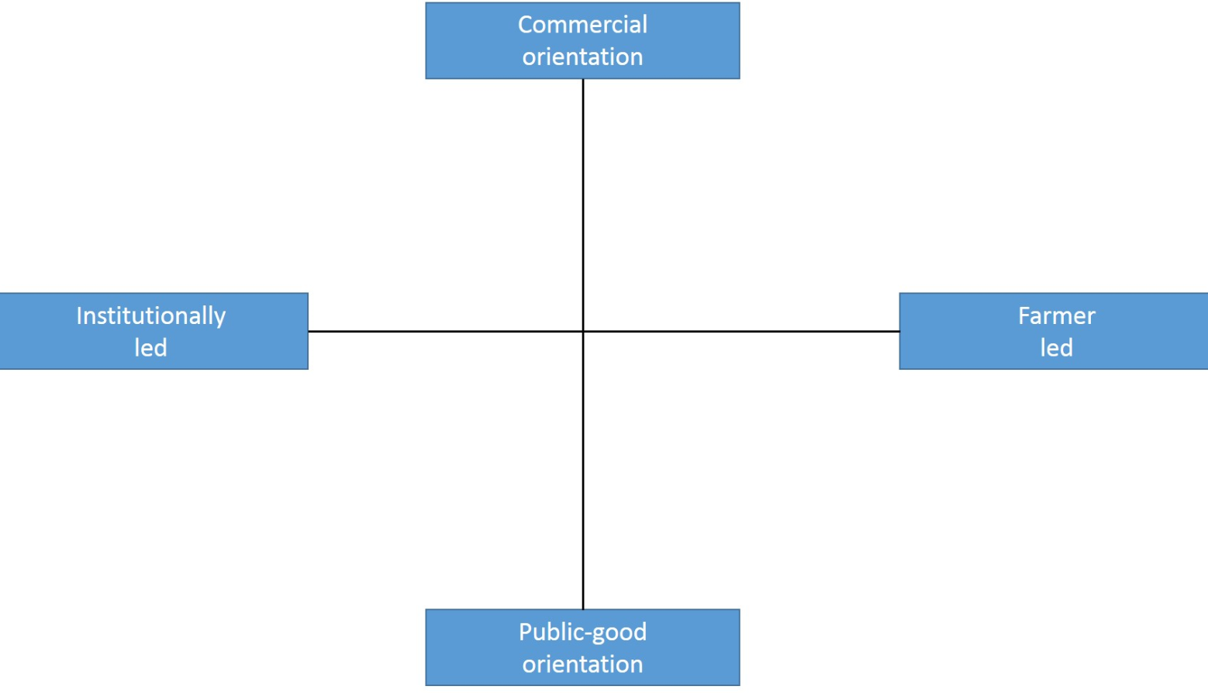
UK1

Topic(s)
The topics covered at the demonstration event was diffuse, covering a broad range of topics and approaches. The demonstration event had a number of farm stops which covered three topics

- Harnessing biodiversity for soil and water management,
- Using biodiversity in crop health and protection,
- Promoting biodiversity for human health.

Within the soil and water management section, crop diversification strategies were demonstrated, such as leys in rotation and intercropping. Biodiverse forages were also demonstrated as well as the importance and ways of maintaining soil biodiversity.

“Using biodiversity in crop health and protection” demonstrated the various benefits of margins for pollinators and beneficials, how to implement them and how to monitor them. The role of diversity in rotations was demonstrated, in particular within mixed systems.

There was also a stop which solely focussed on biodiversity at Elveden farms and the approaches they use to protect and enhance wildlife. A short panel session was held to end the event discussing the role of biodiversity for human health and a short summary was given by the LEAF chairman.

Over the past 2-3 years the importance of protecting and enhancing natural capital has been highlighted. The demonstration event leads on from previous work and LEAF events on natural capital, demonstrating how protecting and enhancing a farm’s natural capital can boost a farm’s success.

Whilst IFM and biodiversity management (habitat and landscape management) will be very familiar to the majority of the attendees to the demonstration event, the specific approaches and research highlighted are at the cutting edge of farm research and practice.

Access
The event was free to attend and open to people across the supply chain. Attendees did not need to be LEAF members; however, invites were targeted at LEAF members.

Two email invitations were sent out to LEAF contacts and was also included in the LEAF newsletter, LEAF E-news and LEAF E-Brief which were also emailed out to LEAF’s email list. The LEAF website had a dedicated page advertising the demonstration event and a number of social media posts were produced to advertise the event. Attendees were required to book onto the event by emailing LEAF. A limit of 90 attendees was in place to ensure space on the tractor trailer.

The target audience for the demonstration event was farmers. Other actors were also welcome to attend including advisors, researchers and policy. Due to its location in the East of England it was expected that the majority of attendees would be from the region (due to travel requirements) with a few coming from further afield.

Demonstration event

Visitors
The demonstration event was limited to 90 people due to constraints with space on the tractor trailer. In total 75 people signed onto the demonstration event which included:
- 10 speakers,
- 5 members of the LEAF team attending (including the LEAF Chairman and LEAF CEO) and the farm manager,
- 27 farmers,
- 15 researchers,
- 6 supply chain actors,
- 2 NGO’s,
- 2 policy,
- 23 other agribusinesses and consultants.

A total of 51 people attended the demonstration event (including the 10 speakers) meaning a total of 18 people signed up but did not attend the event.
Of the 51 attendees:
- 19 were farmers
- 20 attendees directly involved in the LEAF Demonstration Network (10 attendees from LEAF Demonstration farms and 10 from LEAF Innovation Centres).

The majority of attendees were male (36 attendees). This balance of males to females was expected due to a higher proportion of males working in UK agriculture. From observations on the day the majority of attendees were between 35-55 and the age range of those who completed the evaluation form were:
- 6 between 26-35 years old
- 8 between 36-50 years old
- 8 between 50-65 years old,
- 1 above 65 and
- 2 no answers.
The demonstration event had a higher proportion of younger attendees compared to the average age distribution of workers within UK agriculture, where the majority would be classed into the older categories. Anecdotical evidence suggests more innovative farmers who are trying new approaches on farm and attend demonstration events on average tend to be younger than the average working age in agriculture. This is reflected at IFM Field Event where 56% of the attendees were aged between 26- 50.

From completed evaluation forms, the vast majority of attendees were from the East of England. A small number of attendees came to the demonstration event from the East Midlands, South East, Yorkshire and Humber, North East, South West, West Midlands and Scotland. There was also representation from further afield with one attendee coming from the UK Crown Dependency Jersey.

Communication & Mediation
A number of communications were produced prior to the demonstration event to advertise the event as well as a number of communications produced on the day.

Twitter was a key tool used to communicate and promote the demonstration event. The use of twitter included:
- 5 tweets prior to the event to advertise the event,
- 13 tweets on the day of the demonstration event to highlight the key outcomes and approaches demonstrated,
- 4 tweets after the event to highlight post-event communications and key outcomes,
- retweets of LEAF tweets by other twitter users (6 retweets before, 31 during and 6 after the event)
The reach of these twitter posts were 5,505 impressions before the event, 11,128 impressions during the event and 5,127 impressions after the event.

Within the LEAF website there was:
- a total of 8,989 website impressions, equating to views on the LEAF pages which contained any information of the event.
- 322 visits to the IFM Field Event page on the LEAF website before and during the event.

Props were used by speakers throughout the event to further enhance the demonstration, including crop samples taken from different fields at Elveden. Photos were displayed during lunch illustrating other aspects of Elveden which were not visited during the event and a video launching Simply Sustainable Biosecurity was also played over lunch. There were a small number of handouts available on LEAF and Elveden which attendees could take away with them.

A short video was produced post-event to highlight why attendees found the event useful and enjoyable. This was shared on LEAF social media accounts and uploaded to YouTube (https://www.youtube.com/watch?v=WqYngnrv5hE). A local press outlet with a reach of 51,000 readers also produced a short article on the IFM Field Event post-event.

Active participation
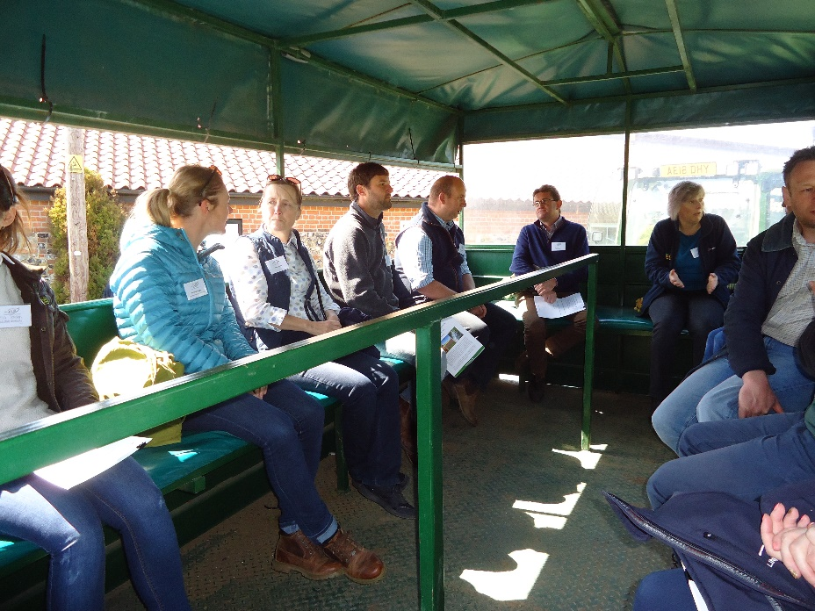
The IFM Field Event mainly involved a tractor trailer tour of the estate and three organised farm stops where attendees were able to get off the tractor trailer. At two of the three farm stops, three speakers demonstrated and presented a specific subject around the farm stop topic. The biodiversity at Elveden Farms farm stop had one speaker.
Figure 1.0- Attendees networking during tractor trailer ride to demonstration farm stops.

The aim for each of the farm stops was to generate knowledge exchange and encourage discussion between the group, sharing their experiences and asking questions, rather than just presenting an innovation or approach to them. Additional speakers from the audience were called on if it was felt they would have additional information to bring to the topic or discussion. During one farm stop a ‘show of hands’ was used to find out how many attendees had adopted a practice in question. There was an opportunity for attendees to walk around during each farm stop and were also given the opportunity to have a go at insect trapping during one stop. Soil samples were also passed around during the soil health session.
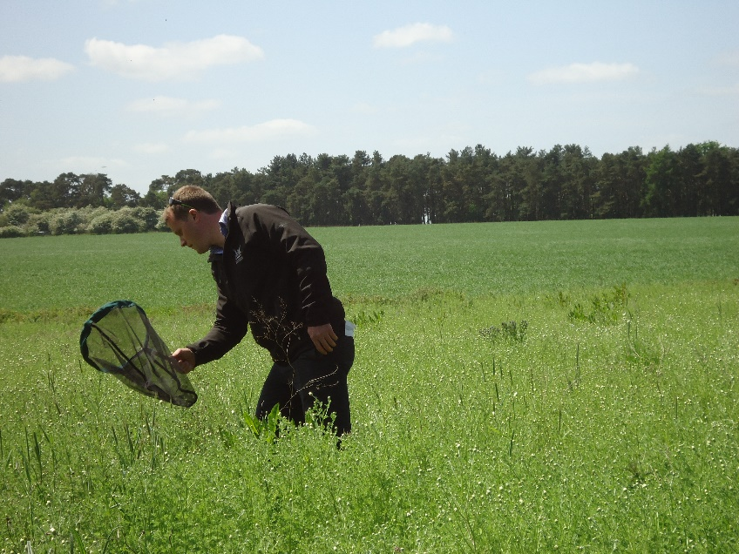

Figure 2.0 Insect trapping at the IFM field event

There were several periods across the demonstration event which allowed and promoted networking between attendees. There were networking opportunities on the tractor trailer when travelling to the next farm stop which split the group into smaller groups of 15-20 people. There were also networking opportunities during lunch, at the arrival tea and coffee and during closing refreshments where attendees split into smaller groups to talk to one another. Lunch was held in a barn and straw bales were provided to sit on, enabling attendees to sit and talk. All attendees who completed the evaluation form stated that the networking opportunities were excellent, minus two attendees who felt the sessions were too managed limiting their opportunities to speak to people who they would have liked to speak with. They also felt the tractor trailer meant they could only speak to the people they were sitting near.

The atmosphere of the IFM Field Event was very lively with lots of discussions, questions and interest in the speakers across the whole event. The attendees were engaged throughout the day with conversations during lunch about the demonstrated approaches and questions asked at each farm stop, indicating attendees were engaged and interested in the approaches demonstrated.

Doing business

Attendees were able to sign up to LEAF communications (such as the LEAF E-Brief and newsletter) at the IFM Field Event which will provide them with information on future LEAF activities and events. Guidance and advice documents were available to take away such as the LEAF Simply Sustainable Series and Integrated Farm Management guide.

Role of sustainability
The demonstration event actively confronted aspects of sustainability due to it’s topic of boosting business success through biodiversity, as part of an IFM approach. Each of the three farm stops focussed on the environmental and economic benefits of a range of approaches, with particular focus on soil health, water quality, crop health and protection and habitat conservation. The panel session after lunch focussed more on the social benefits of increased biodiversity on-farm in relation to human health, such as diversity within diets.

From the completed evaluation forms, the biggest topic of interest prior to the event was Integrated Farm Management, closely followed by targeted use of biodiversity, soil management and sustainable farming. Interests from attendees directly fitted the approach and topics demonstrated at the event. The overall feedback from attendees on the length and depth of discussion at each of the farm stops were described as ‘just right’ indicating they responded well to the subject topics during the demonstration event.

Unforeseen circumstances
The village hall booked for arrival and closing refreshments was unfortunately double booked due to a miscommunication during booking. This meant a replacement venue needed to be located on the day of the event. The replacement venue, the farm shop, was quite noisy, slightly limited on space and was not exclusively used for demonstration event attendees. This may have slightly affected the networking potential of the arrival drinks although it was not mentioned by any of the attendees.

Tractor trailers were covered, and refreshments were provided indoors, enabling the event to continue should the weather have been poor. No bad weather was forecast for the day of the demonstration event. The weather at the demonstration event was very sunny which caused the lunch venue to have too much light affecting the visibility of the video played during lunch as well as affecting the panel presentations.

Attendees were very engaged during the periods of networking which made it hard to move attendees on to the next session, resulting in some sessions overrunning. As a consequence, the last session of the demonstration event did not have time for questions and answers.
No microphones were used for questions from attendees at the demonstration event meaning speakers were asked to repeat questions before answering them. At periods the lack of microphone meant it was hard to follow discussion, which may have affected the quality of discussion at times.

Plans vs. practice
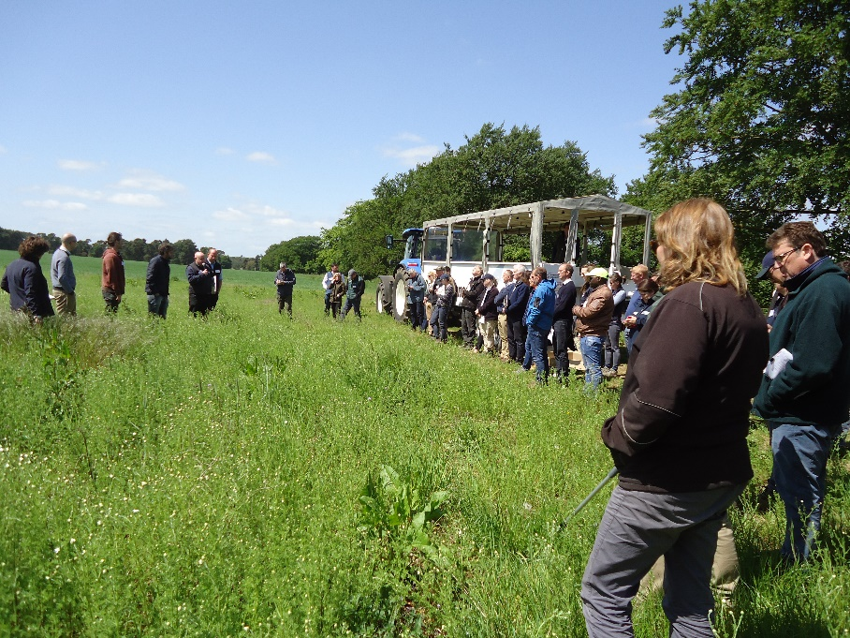
The objective of the IFM Field Event was to generate knowledge exchange and encourage discussion. The event provided an opportunity to share new ideas and practices from both commercial farms and research organisations. These objectives were largely met where attendees agreed they were demonstrated throughout the day. Providing networking opportunities was another objective of the demonstration event where 90% of attendees (who completed the feedback form) felt they were provided with enough networking opportunities and also felt it is one of the most important outcomes of a demonstration event.
Figure 3.0- Attendees at Farm stop 2- Biodiversity at Elveden

The farm stops worked very well, allowing for discussion whilst demonstrating a novel approach, with the majority of attendees feeling these sessions where equally practical and theoretical and overall happy with the quality of the sessions. The planned panel session after lunch was less well received as it did not allow for as much time for discussion.

Participants feedback
The overall feedback from attendees to the demonstration event was positive. Of the completed evaluation forms:
- 80% of attendees felt the demonstration event demonstrated a great deal of environmentally sustainable farming approaches.
- The remaining 20% felt it adequately demonstrated environmentally sustainable farming approaches.

Of the organised sessions, the majority of attendees felt the level of detail in each session was enough. 17% of respondents felt the Soil and water management session and the Simply Sustainable Biosecurity launch did not contain enough detail, the highest of any sessions. A 100% of attendees felt the biodiversity at the host farm session had enough, detail scoring the best out of all sessions.

Figure 4.0- Overall respondent feedback on IFM Field Event session depth of discussion

The biodiversity for human health session was the only session were no one felt it was too long but 21% did feel it was too short, the highest percentage of all the sessions. On average the majority of respondents felt session length was just right.

Figure 5.0- Overall respondent feedback on IFM Field Event session length

Attendees stated a number of different things which they enjoyed as part of the demonstration event including:
- having a wide range of activities and topics discussed
- having access to a farm where activities and topics can be demonstrated/ seen
- discussion in-field
- networking

Areas of improvements included demonstrating examples of the research discussed, as it was felt where they were speaking did not always relate directly to context. Additional comments from the evaluation form noted that the audience seemed more heavily research weighted compared to the number of farmers attending the event. One attendee mentioned they would have liked the event to be more applied, with more emphasis on the establishment and management of the approaches demonstrated instead of science behind them. For more information on participant feedback and main learning visit section 5.1.

Motives, learning and networking

Reasons to attend demos
Attitudes and perceptions
European agriculture is under a lot of pressure from policy changes at a EU and national level, as well as changing consumer demands and pressure to produce more with less. This has led to greater uncertainty within agriculture and more farmers seeking resilient, sustainable farming systems. Demonstration around the topics of public money for public goods and environmental farming approaches such as IFM has increased in response to potential changes in policy. Attendees to the LEAF IFM Field Event identified this as one of the reasons for attending the demonstration.

Leading on from this, another reason attendees citied to attend demonstrations is to find alternative approaches or methods that can be used instead of chemical Plant Protection Products. Over the past 5 years many active ingredients used for pest control and crop health are no longer legal to use and this trend is likely to increase in the future. Demonstrations help to highlight the alternative approaches that can be used, for example, the LEAF IFM Field Event demonstrated the benefits of beneficial insects and cover crops within rotations for improved crop health and protection.

Other reasons to attend demonstrations identified by IFM Field Event attendees included the reputation of the farm and LEAF. It was noted that LEAF carries a lot of weight within the topic of integrating wildlife and farm management so attendance to the event was important to the attendees as they felt the information would be useful and could be implemented on their own farm.

Attendees were interested to see how a large estate, such as the host farm, is able to increase its biodiversity and the ways in which it implements IFM on-farm. Seeing a demonstration farm which is a similar farm business was of interest to some, whilst attending a demonstration of a farm very different to their own was interesting to others. Networking was also identified as a reason to attend as it allows attendees to gather knowledge, experiences and the successes and failures of others which they can learn from and take back to their own farm.

When asked what they hoped to gain from the demonstration event, attendees identified knowledge exchange and generation and networking as the main reasons for attending. Knowledge exchange and generation can be spilt into 3 different types.
- The first is learning about a specific approach or practice with IFM. Specific areas which attendees wanted to learn more about from the demonstration included ways to improve soil health, biodiversity and the benefits to crop health as well as the use of cover crops/ companion crops within a productive farm.
- The second type of knowledge exchange and generation was gaining more general knowledge on the benefits of IFM as a whole and learn more about LEAF the company.
- The third type of knowledge exchange and generation identified was learning how the host farm implements IFM in the field and “having a look around another farm”.

Networking was identified as the secondary reason to attend as a way to meet, share ideas and learn more from other people as well as making contacts with people across the sector. A total of 23% of respondents stated networking their main reason to attend the demonstration event.
Norms
Farmers participating and attending in demonstrations may not be the people who need to be engaged, rather they are the ‘usual suspects’ who are likely to attend several demonstrations throughout the year. These attendees tend to be new or early adopters of innovations.

The lack of new attendees could be due to differences in learning styles, in which demonstrations attract a certain type of person by fulfilling a specific learning type. Because of this, others may prefer to gather knowledge through different mediums such as talking to friends, reading articles or trial and error. Other factors such as behavioural traits and social pressures will also influence who attends demonstrations. For example, if a person’s social circle does not engage with demonstration events or has a negative view of them it is likely to influence a person to also not engage with these events. For people who attend demonstrations the opposite is likely to be true with their friends or family also likely to attend demonstration events.

Where a demonstration is hosted will also impact who attends the demonstration. The reputation of the host farm will influence who attends and the number of people booked onto the demonstration. A farm with a good reputation and is well known within the sector is likely to draw a bigger crowd than a less well-known farm. However, if the farm is too well known and most people have previously attended an event on the farm, the number of attendees will tail off and reduce over time.

The host farm for the IFM Field Event has a very good reputation and has won several farming awards including farmer of the year in 2017. Attendees to the IFM Field Event mentioned they felt that the host farm is a pioneer within the sector, an inspiration and a very interesting farm to visit which they hear a lot about within the sector.

Practicalities
Time and location of a demonstration event is very important when attending an event. If an event is located in an area with higher densities of farms it is more likely people will attend the demonstration versus an event which requires a lot of travelling. The type of farming potential attendees’ practice will also influence how far a person is willing to travel to attend an event. Dairy farmers, for example, need to milk in the morning and afternoon so are restricted to how far they can travel for an event.

The time of a demonstration event will also influence who is likely to attend and overall numbers. Timings of an event needs to be tailored to fit farming type, for example, livestock farmers are more likely to attend an afternoon/ evening event versus one that commences at 10am due to their daily farming schedule. The LEAF IFM Field Event was located in a region of high arable and horticultural growers so the event was hosted from 10am until 3pm to minimise timing issues for potential attendees.

The time of year is also an important factor when attending a demonstration event. Arable and horticultural farmers are typically extremely busy with harvest (in the UK) during late June, July and August so are less likely to be able to attend a demonstration event. During winter and early spring arable growers would generally be freer to attend an event but there would be less to see on the farm due to the time of year. It is therefore imperative demonstration events balance the time of year where things can be seen on farm but does not clash with busy farming periods.
The IFM Field Event achieved this by hosting the event in May.

Weather can also play a part in whether people attend a demonstration event. If the weather is dry after a long period of wet or cold weather less people are likely to attend an event, because they are keen to undertake tasks on farm they haven’t been able to, do due to previous weather conditions, regardless of if they have booked onto the event.

Within the UK there is an increasing number of demonstration events being hosted which may led to ‘farmer fatigue’ where they no longer want to attend demonstration events or do not know which events to attend.

Forms of learning
The IFM Field Event promoted and focussed on interactive sessions and discussion. At each stop of the farm tour discussion between the attendees and speakers was promoted to allow people to share their own experiences and ask any questions. Farmer to farmer learning was facilitated through these discussions. The range of other speakers (including researchers and advisors) enabled attendees to learn through advisor- farmer and researcher-farmer learning, as well as enabling speakers to learn from attendee’s experiences and thoughts.

Demonstration events are able to cover several learning styles such as verbal (hearing the host speak about an approach), visual (seeing something in action) and physical (attendees able to ‘have a go’ at an approach). Other learning styles may not be covered at demonstration events such as logical (relationships between approach and other aspects of farm) and theoretical (reflection, how it can be applied on their own farm) learning types. By not being able to cover these, some people may be excluded from demonstration events, where they either do not attend as they feel it would not suit them or do not take-home key messages when attending demonstration events. This means demonstration events are likely to bias attendees based on their preferred learning styles.

The IFM Field Event was able to cover several learning styles throughout the day. Verbal learning styles were catered to throughout the day with the range of speakers on the farm tour as well as the panel discussion. The panel discussion also had presentation slides to further reinforce key messages. Visual learning styles were accommodated though the farm tour, enabling attendees to see what was being discussed by the speakers. Physical learning styles were catered through the chance to have a go at insect catching during one of the farm stops as well as allowing attendees to walk around the farm during each stop. Theoretical learning styles were partially covered as there was a selection of resources available providing guidance for implementing IFM which could be taken home post event.

Of the different approaches, attendees noted they really enjoyed the visual aspects of the demonstration which they feel helped them to see how they could make changes on their own farm. The range speakers and the use of props was mentioned as really useful and attendees enjoyed the length of talks (being “short and sharp”).

Content of learning
Attendees to the IFM Field Event felt information given during the event was interactive and had a mix of practical and theoretical talks during the farm stops. The event provided information on how approaches had been implemented on the host farm as well hearing other attendee’s experiences which attendees could take back to their own farm. The event also provided more theoretical information on research trials taking place and the theory behind why practises such as intercrops are beneficial to farm businesses. Attendees to the IFM Field Event felt the event adequately demonstrated and focussed on Environmentally sustainable approaches.

Other than the farm tour and panel session there were also a number of take home resources attendees could take away with them, including the Simply Sustainable Series (https://leafuk.org/farming/simply-sustainable-series), IFM guide (https://s3-eu-west-1.amazonaws.com/leaf-website/IFM_FLYER_110315.pdf) and trial opportunities. These resources provide tips and guidance on implementing IFM on-farm and highlight small approaches that can be done on farm to improve soil health, biodiversity, water management and biosecurity.

Outcomes of learning
The main learnings or outcomes from the IFM Field Event changed depending on the attendee. Attendees identified a range of new approaches they took away from the event as their main key messages, which included:
- The benefits of crop diversification strategies such as mixed cropping, intercropping and cover cropping
- Headland management and pollinator strips, in particular optimising areas of unproductive land (such as headlands) and “putting them to use” with pollinator strips
- Implementing pollinator/wild flower mixes around potato headlands as a way to improve biodiversity and soil structure in the field
- Use of pollinator strips in field and one attendee interested to integrate into their monoculture sugar beet post event
- Importance of soil health and sustainability, in particular balancing soil health with sustainability and profitability
- Emerging and new market opportunities, in particular integrating cultivation of naked barley in rotation
- Better awareness for biodiversity and wildlife audits. One attendee noted that they need to be more aware of auditing species on their farm, so they know exactly what species they have on farm, why they have them and identify their main food source to help conserve them

General learnings from the event included better awareness of IFM and LEAF as well as being able to see practises in use at a large scale versus small research plots. Increased awareness of current research and ways to get involved was also identified as key learnings for attendees. Research or expert contacts was the key take home for one attendee which will help them with implementing cover crops on their own farm going forward.

Not all attendees felt they had learned something new from the IFM Field Event or had a key take home message which they could use on their own farm. Two attendees were from a different farm type to the host farm (glasshouse and soft fruit systems) and whilst they found the day interesting, there was nothing they felt they could directly use within their growing system. Other comments from attendees included feeling there wasn’t anything novel or new of the approaches demonstrated at the event but enjoyed hearing other people’s successes and liked being able to interact with likeminded people.

Networking
The IFM Field Event provided many networking opportunities throughout the day such as lunch and breaks as well as the tractor trailer to the different sessions. Attendees noted they were able to interact with likeminded people sharing different experiences, ideas and solutions to problems. For attendees who have previously met, the demonstration event gave them an opportunity to ‘refresh’ contacts and catch up with them. New contacts were also made, with one attendee remarking they will get in touch with a couple of the researchers post event to find out more about their research.

Anchoring: Application of demo lessons by participants

One month following the event five attendees were interviewed by phone to establish what they remembered from the event and how they felt one month on (and gather past experiences with innovation uptake) feeding into anchoring and scaling (two experts were also consulted through interviews).

Anchoring related to the present demo
Attendees from the IFM Field Event obtained a number of new learning and messages which were applicable to their farming system which are detailed in section 5.4. Of these new learnings and approaches, a number of the attendees identified areas from the demonstration which they would consider using on their own farm.

Crop diversification and rotation were the most common approaches from the demonstration event which attendees are considering using on their own farm. These approaches include:
- strip margins
- pollinator mixes
- herbal leys
- break crops
- diversified crop rotations
Reasons for considering these approaches include opportunities to make the business more sustainable and improve soil health and structure. Break crops were identified as a considered approach for one attendee post event to help them reduce input costs (such as fertilisers) and increase biodiversity on farm. Other areas of interest included the potential use of naked barley for cattle feed and improved headlands for increased beneficials on farm.

Three attendees interviewed one month after the event, felt there was not a particular approach that they would be able to use on their own farm. Two of the three attendees felt none of the approaches were applicable to their farm, due to differences in farming type compared to the demonstration host farm. The third attendee noted that they already use many of the approaches demonstrated at the event as they are implementing IFM at a farm scale.

When asked whether they enjoyed the IFM Field Event one month on 100% of respondents answered positively noting they enjoyed the event and it was informative to them. One respondent remarked that it was very interesting to see what novel and innovative approaches other farming sectors are using which is different their own. Another remarked that it was interesting to see practices at a whole farm scale and to see a range of techniques and approaches at one demonstration event. This inspired the attendee post event to look critically at their own farming system, as opposed to previous events they have attended which only demonstrated one or two approaches.

Stimulating anchoring
Post event, a number of resources was produced by LEAF and local farming media. A full review of these resources can be found in section 4.2. Phone interviewees were asked which resources and communications they were aware of. From responses, all attendees interviewed were aware of LEAF’s various social media posts regarding the event. Four out of five interviewees were aware of the LEAF IFM Field Event video on YouTube and Twitter posts which shared the video. Two attendees were aware of the farming press articles and one was aware of the LEAF blog on the outcomes and key messages from the event.

Social media and videos were the main sources of information post event for attendees. It was noted these were useful as they provide short snippets of information post event and helped spread messages from the day further.

There are no planned follow up meetings or discussion groups leading on from the event. PLAID’s English national stakeholder group highlighted follow up events as an effective method for innovation uptake post demonstration event.

In 2019 the IFM Field Event will be hosted in May on a different LEAF Demonstration Farm, in the East of England. This event will follow a similar format to this year’s IFM Field Event with farm stops and a range of speakers. The topic of this event will follow LEAF’s IFM principles but will have a focus on another area of IFM.

Anchoring related to earlier demos
Demonstrations can help influence on-farm decision making and innovation uptake of attendees. Phone interviews with five attendees to the IFM Field event one month on as well as experts in the sector, were asked to what degree do demonstrations influence the uptake of innovations and what characteristics of demonstrations need to be present in order to influence on farm decision making and innovation uptake.

Respondents noted that demonstrations need to highlight best practice, and the influence of a demonstration to on-farm decision making will depend on the approach, relevance to farm business and degree of change needed. For example, a small change which doesn’t require any additional capital is more likely to be integrated into a farming system post event than an approach which requires a lot of time and financial investment.

Demonstrations need to be practical and provide context. This enables attendees to take home clear and simple messages about how to apply them in their own system. This is also important for advisors to be able to explain the approach clearly to clients post event.

Learning from others, either through discussion with other attendees and speakers at demonstrations or conferences, influences on-farm decision making. Attendees are able to gather experiences, successes or failures of an approach or hear new ideas. This networking is important not just at demonstration events but in all aspects within the farming sector. As well as sharing ideas, networking allows farmers to meet others within the sector that could help or contribute to solving an issue on farm as well as offer advice.

Gathering knowledge from farmers was highlighted as important for decision making on farm. This is because farmers are comfortable talking with other farmers, can understand each other easily, can ask questions and have a shared understanding of issues on farm.

When influencing decision making on farm, demonstration farms are important as they provide:
- Visuals. The benefits of seeing practices in action and context is provided. Explaining an approach alongside seeing it in action has a greater effect than just reading or hearing about on approach.
- Context. Demonstration provides context to an approach or technique. At demonstrations, a farmer can see how an approach works and how it is affected by soil type, different fields, different farming types etc.

The interviewees were questioned about what farm practices had been influenced by demonstration. They suggested:
- Cover cropping within rotations (at a research and commercial scale)
- Machinery based approaches, such as precision agriculture and direct drilling, (New information gained affecting decision making on farm but may not result in the purchase of equipment due to the commitment and capital needed).
- Enhanced nutrition management of crops through rotations and varieties
IFM Field Event attendees interviewed felt that they largely take away snippets from each demonstration event they attend rather than ‘game-changing’ information. These snippets might influence small changes on farm or contribute to overall learning or decision making.

IFM Field Event attendees interviewed were also asked about any barriers to the uptake of innovations which have been previously demonstrated. Innovations identified were largely practical and summarised in the table below.

Table 1.0 Demonstrated Innovations and identified barriers for innovation uptake

Practice | Rational
Irrigated Barley | Respondent would not use this and would also not encourage using this in other businesses.
Intercropping and mixed grasses into arable systems. | Whilst interested in this approach the respondent felt they do not have the best climatic conditions to implement this effectively on their own farm
Arable approaches | One respondent from a horticultural farming system mostly attends arable demonstration events due to a lack of horticultural demonstration events in their region so while approaches demonstrated are interesting, they are not applicable to them.
No approaches used on farm. | Respondents felt their farm is different to the demonstration farm, due to differences in soil types and region so are unsure of the effectiveness of the approach within their farm.  A lack of overall knowledge and experience of advisors on demonstrated approaches also stops them from applying a demonstrated approach on their own farm.
Whole approaches | Respondent prefers to take small snippets from events and is more likely to use these than completely changing the way they farm in order to fully integrate a new approach that has been demonstrated.

Attendees to demonstrations are attracted to events showcasing radical or novel approaches. Others are more interested in the sustainability or profitability of an approach. No assumption can be made on the effect of gender on the importance of radical information and the likeliness/ experiences of using a demonstrated approach on farm.

Scaling: Application of demo lessons by the wider farming community

Retrospective examples of scaling
IFM is a whole farm approach which supports the use of a variety of practises and approaches, using the best of modern technology and traditional methods to deliver more sustainable farming. The means IFM allows for new practices or techniques to be used, based on what suits a farm best (site specificity).

Over the past five years practices and techniques used within IFM have changed, been introduced or adapted. Many of the approaches which are now used by a large number of arable farmers either came about as a way to solve a common agricultural problem such as blackgrass prevalence or are niche practices which have been created due to development in technology and machinery.

Examples of approaches which have become more widely used in the last five years include:
- Diversification of rotations
- Alternative cultural controls, such as integrating leys into rotation
- Reduced and no tillage
- Lower input systems
- Cover crops
- Flexible precision machinery
- Mixed Farming systems
- Changes in plant varieties

All of these approaches have been widely demonstrated at demonstration events across the UK including the East of England. These events are well distributed across the UK with a higher density of them occurring where there are large numbers of growers (such as the East and South of England and Midlands).

Demonstration events have influenced the uptake of these approaches. A good example of this is blackgrass control and soil health. Increasing problems with blackgrass control in the UK and increasing restrictions on chemical controls have forced farmers to change the approaches they use on farm. Demonstration events focussing on blackgrass control have become more common over the past 2-3 years feeding into the change of controls used on farms. Likewise, the rise in soil health demonstrations have arisen as a result of increasing concerns around soil compaction, lack of organic matter and soil microbiology. Dedicated soil days and joint events between different organisations have been hosted to try to present solutions or ways of enhancing soil health.

Not all demonstration events will be organised or hosted by advisory services, NGO’s, researchers or Levy boards. Commercial companies such as seed companies, will sometimes pay for an event and therefore some demonstration events will be market driven. These events will look to influence what farmers are buying and do not always provide positive outcomes post event. One interviewee noted a previous demonstration event they attended which demonstrated cover crops, and specific mixes to be used in sugar beet production, but it was later discovered the species mix was poor establishing and increased weed burden in sugar beet crops.

Many demonstration events have accompanying resources such as videos, farming press articles and guidance documents for attendees to take away to further share key approaches or techniques.

Events involving a small number of farmers, where they each host meetings to increase discussion and trialling of solutions to a specific problem are increasing in the UK. These groups allow farmers to test an approach out on a range of soil types, farm types and fields, whilst spreading the risk of a new approach (a group trialling an approach is more likely to have success compared to 1 farm trialling alone). Whilst the farmers trialling an approach may be limited to 7-8 farmers, anyone can attend the meetings, see the approaches in action and listen to experiences so far.

Discussion groups or follow up events are identified as a way of increasing the uptake of an approach demonstrated. If at these meetings progress of an approach is reported by each attendant, a farmer will be more likely to make changes on their farm compared to a one-off event with no follow up communications and therefore no pressure to change. This is because if a farmer has to report on their progress, they may feel some pressure from the group to make changes/ progress prior to the next meeting.

Impact on economic efficiency and agronomic productivity are key indicators for farmers. Influence on farm resistance is also a key area of interest. An approach which can improve a farmer’s quality of life by providing more time off or will improve safety on farm can be a factor that influences the uptake of a demonstrated approach. The most progressive and innovative farmers will be looking for innovations which cover all these areas.

Prospective assessment of scaling: Impact pathways
There are a number of impact pathways where approaches demonstrated can be shared to those who did not attend the event. The first is the farmer to farmer impact pathway. In this pathway farmers are able to see what their friends, neighbours or ‘innovative farmers’ are doing on their farm, including changes they make as result of learnings from demonstration events. Likewise, hearing the opinions and experiences from other farmers either in a formal setting (such as a discussion group or meeting) or an informal setting is also likely to influence the uptake of a demonstrated approach.

Further information provided by organisations on a demonstrated approach is another important impact pathway. These sources often provide prescriptions on how to apply a demonstrated approach on different farms. This information is vital for the uptake of a demonstrated approach as lack of applicability has been identified as a barrier to innovation uptake for farmers.

The impact the internet can have on innovation uptake is often underestimated, where a person is likely to have a ‘quick google’ if they want to find out more information on an approach. The internet allows people to have a quick search as well as being able to have a in depth review an approach.

Videos allow a demonstration event to share the main findings of the day as well as promote the approach and how to use it on farm. An increasing number of videos are produced by different organisations throughout the year and shared across the agricultural sector through social media (Facebook, Twitter, Instagram) as well as YouTube and uploaded onto company websites. Videos have previously received positive feedback from farmers but the level of impact they have on innovation uptake is unknown. The most likely impact of videos is sparking an interest to an approach where farmers then research the approach further. Furthermore, there is an increasing number of videos produced by farmers highlighting approaches they use on farm they want to share. These videos help to further share novel approaches to a wide range of farmers regardless of any previous geographical barriers.

In combination with the video impact pathway, social media is another important impact pathway. Social media provides short snapshots of the event and approach, as well as allowing for discussion between people through comments and on some social media such as Facebook group pages.

Farming press such as farmers weekly and farmers guardian as well as local newspapers and sector specific papers are another impact pathway for demonstrated approaches. Articles and news items are produced about the demonstration event providing a brief overview of the event, approach and main outcomes. This allows farmers to research further using other impact pathways such as internet, videos and farmer to farmer.

The IFM Field Event used video, social media, internet and media impact pathways. To achieve this, a short video was created on the IFM Field Event which was used on social media to share the event and sign post to post event materials such as a LEAF blog post. Local newspapers covered the event with articles featured in one newspaper with a reach of 51,000 people. The internet impact pathway was used with several online articles and resources produced about the event on the LEAF website as well as signposting to resources with more information and guidance on the demonstrated approaches. Whilst all impact pathways are important, in order to have the greatest impact a number of the pathways need to utilised and used in combination.

Word of mouth was identified by interviewees as an important way of learning novel farming innovations, especially hearing how these approaches work on different soil types, landscapes and sectors. Social media was also identified as an important way of gathering general information, in particular Twitter and Facebook. Press and videos are good at giving a snapshot of an approach and consultation with advisors is also important to hear their experience and guidance.

Decision making on farm will often involve multiple people. These include both family and farm staff and external advisors. Landowners, advisors and agronomists are the most common people to be involved in decision making on farm. Supportive and innovative land owners are needed in order for farmers to feel they can make changes on farm. Similar to this, a board of directors are also often consulted within large estates. In both tenanted and owned farms, the advice, guidance and expertise of advisors and agronomists is also extremely valuable to farmers when they are looking to change an approach or practice on farm.

Despite involvement however, an attendee to the IFM Field Event noted that they are from a large farm and whilst many different types of people are consulted with, ultimately, they are responsible for decision making on farm.

Case study reflection

Facilitating and impeding factors for successful demonstrations
A successful demonstration provides attendees with ideas and key messages that they are able to take home and action or to spark interest to investigate an approach further. Successful demonstration events allow attendees to network, hear other’s experiences, as well as make contacts which may help them in the future. Demonstration events that are successful should provide farmers with additional information materials post event and use with other impact pathways to maximise impact.

Having continency plans (for poor weather, power shortages etc) and practicing the main points of the demonstration pre-event is important for the smooth running of a demonstration event. Having sufficient budget and appropriate personnel (expertise and number) present at the event is important. Infrastructure required to host the demonstration needs to be thought of and provided, including transport (such as tractor trailer), meeting rooms and any special requirements (such as chairs for those less able to stand). The set-up of a demonstration should be well thought through. Larger groups may need to be split into smaller management sizes.

There are a number of indicators that can be used to determine whether a demonstration event has been a success. The number of attendees that attend the demonstration event can be a good indicator of interest in the event as well as highlight the success of any promotion take took place.

The number of attendees that attend subsequent events (if applicable) is another indicator of how interesting an event was to attendees.

Gathering attendees’ thoughts and main take home messages is an important way of evaluating the success of the event and inform the organisation what attendees take away which can feed into the running of future events. These can be gathered through evaluation forms or short follow up emails/ calls with a select number of attendee’s post event. Post event attendees can be asked whether they have learnt something new, have changed or may change something on farm

The level of discussion and questions asked throughout the demonstration event is another good indicator that attendees are engaged and interested in the event.

Impact of demonstrations
Demonstration events are able to impact on farm productivity and profitability, resilience, environmental sustainability, quality of life and on farm empowerment.

Demonstration events are able to demonstrate the effects of an innovation on different farm types, systems and soils highlighting how an innovation may impact productivity or profitability within different farm types. Demonstrations are able to provide attendees with more information on costs associated with implementation as well as show where within farm businesses impacts to productivity and profitability are felt (for example increased yield versus marginal gains/ cost saving across the business).

Approaches that contribute to environmental sustainability are well covered within demonstration events, as it is a core objective for many organisers involved in demonstration. Demonstration events are able to show the benefits an approach may have on the local environment as well as linking these benefits with other aspects of a farm business, such as an increase in on-farm productivity.

New innovative farming approaches may be able to improve quality of life within the industry and it is important these benefits are demonstrated to farmers. Benefits could include less time needed in the field or increased safety of new approaches. Demonstration events do not highlight this impact as frequently as the other impacts (such as productivity and profitability and environmental sustainability). In the future demonstration events (as well as other knowledge exchange pathways such as articles and videos) should highlight and present these benefits of demonstrated approached more widely.

New innovative approaches may help to empower people across the sector. In order to do this it is important demonstration events are able to demonstrate the impact of an innovation to empowerment. It is also important demonstration events encourage and promote all decision makers to attend demonstration events, ensuring genders are adequately represented. Empowerment and the effect of demonstration events has not been widely investigated.

Key lessons from this case study
- Ensure the demonstration event provides sufficient networking sessions for attendees
- Demonstration events should be organised with a focus on discussion and interaction as opposed to presentation led
- Ensure demonstration events are visual, engaging and provide information on how measures might be carried out on other farms.
- Work with other actors in the supply chain to allow for experiences and expertise across supply chain to be shared (either in the preparation of a demonstration or by inviting them to speak at event).
- Work with other impact pathways, in particular social media and videos, to ensure information is provided to attendee’s post event and also engage with farmers who did not attend.
- Where possible, host follow up events or discussion groups to see whether attendees have implemented something new and if so, hear their experiences so far.

Acknowledgements

We would like to thank the IFM Field Event host farm; Green shoots and LEAF Technical team who helped with data collection on the demonstration day; LEAF’s Demonstration Farmers and attendees to the IFM Field Event for taking part and completing evaluation forms and telephone interviews. Thank you to those interviewed for sharing their experiences and expertise with hosting demonstration events and all attendees of our National Stakeholder Group meeting where the impact of demonstration on innovation uptake was discussed.

Annexes

Data sources
LEAF website (https://leafuk.org/),
LEAF Technical and Marketing team,
IFM Field Event Evaluation (from attendees)

Data collection methods
IFM Field Event Evaluation form:
- How often do you visit demonstration events?
- What would you say is your biggest interest in the day is?
- What did you hope to gain from today?
- Please rate todays sessions in terms of depth and length of discussion.
- Did you find today provided good opportunities for networking?
- To what extent do you feel today’s event demonstrated environmentally sustainable approaches to farming?
- Did you feel today’s event was more practical or more theoretical?
- How interactive did you find today?
- What do you think are the most important outcomes of a demonstration event?
- What new information did you learn today that you will find relevant to your business?
- When thinking about the event as a whole, what was the most interesting part of the day and why?
- Please let us know of any other comments you have

IFM Field Event attendees’ interview filmed (on day of event):
- What would you say is your biggest interest in the day is?
- What are your motivations to come to today’s event?
- What is the most important outcome(s) of a demonstration event?
- What new information did you learn today that you will find most relevant to your business? How did you obtain this information and why is it particularly relevant to you?
- Thinking about the whole event, what was the most interesting part of the day?

IFM Field Event attendees’ interview non-filmed (on day of event):
- How often do you attend demonstration events?
- What would you say is your biggest interest in the day is?
- Why are you attending today? What did you hope to gain?
- Did you find today provided good opportunities for networking?
- Did you feel today’s event demonstrated environmentally sustainable approaches?
- Did you find the information was more theoretical/abstract or more practical/ ready to use?
- How interactive did you find today?
- Did you find today engaged you in a way you find useful?
- In your opinion, what are the most important outcome(s) of a demonstration event?
- What new information did you learn today that you will find most relevant to your business? How did you obtain this information and why is it particularly relevant to you?
- Thinking about the whole event, what was the most interesting part of the day?
- When you are thinking about making a change to your business, how much does demonstration help you to do that?
- Has there ever been new information that you have learned at a demonstration event that you now include in your farm business?
- Has there ever been new information that you have learned at a demonstration event that you have actively NOT included in your farm business?
- How much does the ‘radicalness’ of the new information play in the decision making?
- In your knowledge, are there any important innovations that were once new but are now widely adopted in your area?
- Did these innovations seem quite ‘radical’ or where they building on other ideas?
- Do you know whether these been included in demonstration events in the past?
- Who was involved in hosting these events or communicating these innovations?

IFM Field Event attendees’ interview (1 month after):
- Looking back a month, how did you find the IFM field event?
- Have you or are you considering using any of the demonstrated approaches from the IFM field event on your farm? If so/not why?
- Are you aware of the post IFM field event materials providing more information?
- Thinking about past events. Have you applied anything you have seen at a demonstration event onto your farm?
- If not, what are the reasons for this? What are the barriers to using a practise you have seen demonstration on farm?
- If so, what were the reasons for this? What was the innovation/ approach/ technique?
- Who else is important in your decision to use what you have seen at a demonstration event on you own farm?
- Other than demonstration events, what other resources do you use to learn about novel farming techniques or approaches?

Demonstration organisers interview (Experts):
- From your experience, what are the benefits of farmers going to demonstration events?
- For the farmers attending, which of these benefits do you think is the main benefit to them?
- For the farmers you know, what methods do they use to gather information?
- In your field of expertise, can you think of any general change to practises or machinery over the last 5 years?
- Has demonstration events influenced this change?
- If so, where and how often has it been demonstrated to farmers and other stakeholders?
- Who influences the adoption of demonstrated approaches/ machinery to the wider farming industry (so not just people who attend a demo event)?
- If so how have they influenced the uptake of demonstrated practices?
- In you experience, what other resources influence the adoption of demonstrated approached/ tools to the wider farming community?
- In your opinion, what other factors influence the uptake of demonstrated approaches/ tools?

