Date: 15-11-2018

Country report: Poland

Case Study: PL2 Feast of onion and potato

WP5: Case studies of demonstration activities in commercial farms

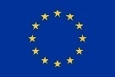
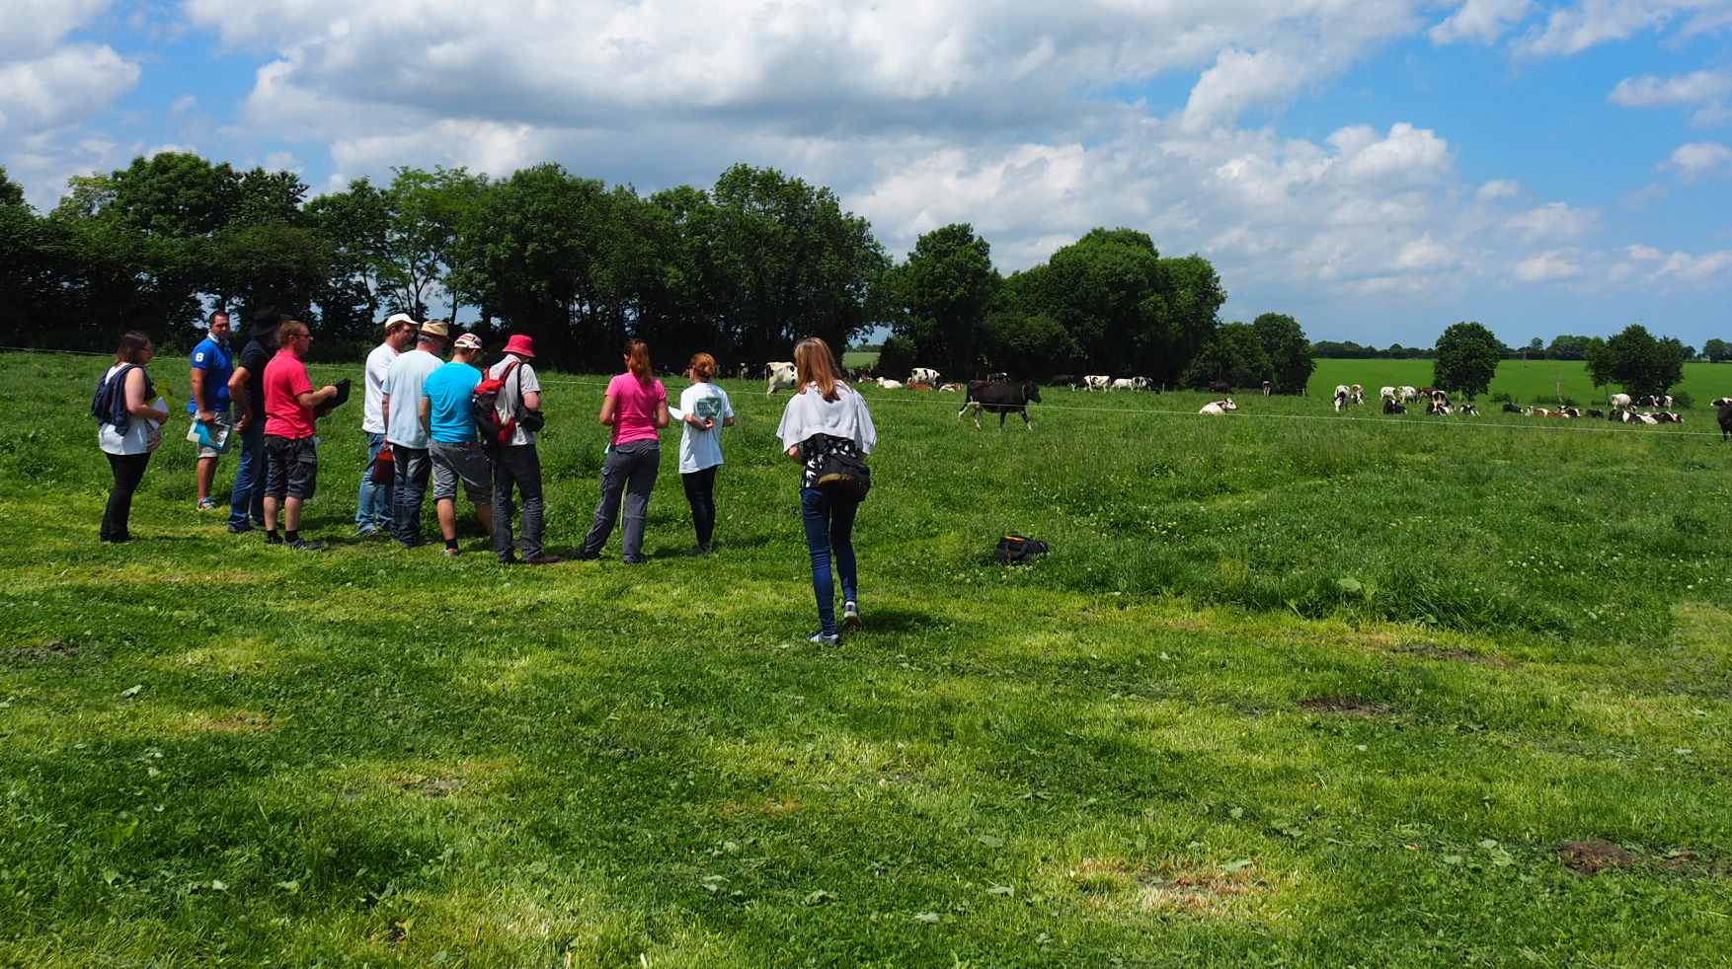
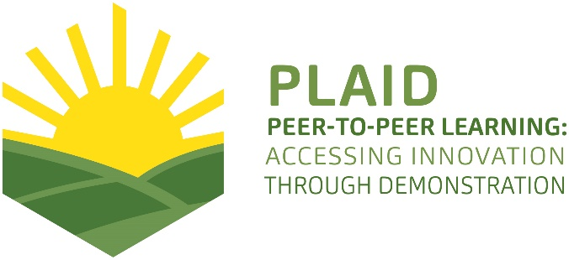
This project has received funding from the European Union’s Horizon 2020 research and innovation programme under Grant Agreement No 727388.
This project has received funding from the European Union’s Horizon 2020 research and innovation program under Grant Agreement No 727388

PLAID PARTNERS

Advisory Service Croatia ASC | 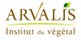  ARVALIS Institut du Végétal | Association de Coordination Technique Agricole ACTA
Institute for Rural and Regional Research | 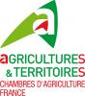  Chambers of Agriculture | 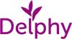  Delphy
European Forum for Agricultural and Rural Advisory Services EUFRAS | Innovatiesteunpunt ISP | 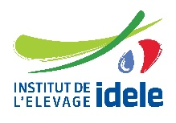  Institut de l’Elevage – Idele
Instituto Navarro De Tecnologías E Infraestructuras Agrolimentarias | 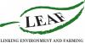  Linking Environment and Farming LEAF | 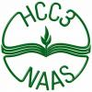  National Agricultural Advisory Service
Nodibinajums Baltic Studies Centre (BSC) | Research Institute of Organic Agriculture (FIBL) | Stichting Wageningen Research
The James Hutton Institute | VINIDEA

DOCUMENT SUMMARY

__________________________________________________________________________________
Milestone Title: 24 Case Studies
__________________________________________________________________________________
Case Study Title: Feast of onion and potato
__________________________________________________________________________________
Version: 1
__________________________________________________________________________________
Task Lead: WUR
__________________________________________________________________________________
Related Work package: WP5
__________________________________________________________________________________
Authors: Harm Brinks, Emiel Kamminga, Tomasz Krasowski
__________________________________________________________________________________
Grant Agreement Number: 727388
__________________________________________________________________________________
Project name: PLAID
__________________________________________________________________________________
Start date of Project: January 2017
__________________________________________________________________________________
Duration: 30 Months
__________________________________________________________________________________
Project coordinator: The James Hutton Institute

ABSTRACT

Since 2003 the Nowak family in Henrikowo organizes a demonstration event. Originally it started as a demonstration event for onion varieties: compare the different onion varieties under practical growing conditions. In the beginning only for onions, since 2009 also for potatoes. In 2017 the 14th edition was held. The event develolped into a bigger event, with machine demonstrations and demonstrations of fertilizers and crop protection products. Target group of the event is in the first place onion growers, and since 2009 also potato growers, and in the second place people working in the value chain. The demonstration of different varieties from different seed suppliers in a practical context, gives the growers a very good impression about how the varieties perform in similar climate and soil conditions as on their own farm. More information about the farm and the demonstration can be found on 'http://www.henrykowo.pl/index.php/home'. This demonstration is organized by a farm, the Nowak family. As the event became bigger and bigger, also the effort for the organization became bigger and bigger. Early 2018 the organizers came to the conclusion is that the impact of the organization of the event on the farm becomes to big, which lead to the conclusion to cancel the 2018 edition. Seed suppliers, demonstrating their varieties in the event, were positive about the event and would like to participate again in the future if possible. Also for seed suppliers demonstration activities like in Henrikowo, with a high percentage of the visitors being professional onion growers or people working in the value chain, offers a nice opportunity to present and promote their varieties.

TABLE OF CONTENTS

1 Demo context 5
1.1 The value chain 5
1.2 Typical farm characteristics 5
1.3 AKIS 7
1.4 Sustainability challenges 10
2 Demonstration summary 10
2.1 Organiser(s) and history 14
2.2 Funding 14
2.3 Host(s) 15
2.4 Gender 15
2.5 Objective(s) 16
2.6 Topic(s) 16
2.7 Access 17
3 Demonstration event 19
3.1 Unforeseen circumstances 19
4 Motives, learning and networking 19
4.1 Forms and content of learning 19
4.2 Networking 19
5 Application of demo lessons by participants 19
5.1 Anchoring related to earlier demos 19
6 Scaling: Application of demo lessons by the wider farming community 20
7 Case study reflection 20
7.1 Key lessons from this case study 20
8 Annexes 21
8.1 Data sources 21
8.2 Data collection methods 22

Demo context

The value chain
Poland still has a rather under developed agriculture, with a large number of small farms. In the arable value chain many of these farmers produce for own use and for regional markets. Since Poland became member of the EU modernization of the arable sector started and professional farms developed, growing crops like potatoes, onion, carrots, red beets, cabbage, salads. Markets changed, as big retails organizations and processing industry became important product buyers. And also export to other EU countries developed. With support of EU funding a lot of investments were done by farmers: building ware houses, washing and packing lines, entering new markets. Over the last decade a few hundred producer organizations developed, making it easier to get EU subsidies for investments. Looking at the potato value chain, subject of this case study, the most important actors in the value chain:
- Bigger and modernized farms. To meet the requirements of the market investments are necessary (new machinery, store facilities, specific potato varieties, irrigation). These investments can only be made by the bigger farms.
- Supermarkets. Super markets have a fast growing share of the market for fresh vegetables. The quality requirements ask for a high and stable product quality.
- Input suppliers (seeds, fertilizers, crop protection products, equipment and machinery). All the suppliers from Western Europe entered the Polish market over the last decades: tractors, combines, potato harvesters, potato breeders, seed companies, pesticide producers. Poland is an interesting market in facilitating modernization of Polish potato sector.
- Farmers

Typical farm characteristics
Poland is a big country, also for agriculture. It has a territory of 312,684 square km (31,270,000 hectare) that is around 7,5 times the Netherlands. Approximately 53% of Polish soil consists of ‘podzol soils’. The average annual temperature in Poland is 6 to 8 degrees. In the West, it is warmer by influence of the ocean climate, in the East, it is colder because of the continental climate. In July, average temperatures across the country can rise to around 22 degrees. Average annual rainfall in Poland varies from 450 – 700 mm, most of it in the summer season.

Polish agriculture is characterized by high fragmentation - the average area of ​​agricultural land per one farm increases gradually and in 2015 amounted to 10.3 ha of agricultural land (in 2011 - 9.1 ha, and in 2002 - 5.8 ha) . Despite some acceleration of concentration, slightly more than half of farms in Poland (51.9%) use no more than 5 ha of agricultural land. There is 12.8% of agricultural land on these farms. Almost 3/4 of farms (74.9%) use less than 10 ha of agricultural land, and their total share in arable lands is 28.3%. These farms usually conduct production using traditional methods, with low mineral fertilization and the use of chemical plant protection products, as well as industrial feed in the nutrition of farm animals, especially cattle. The next 31% of agricultural land is located on 10-30 hectare farm. Besides these small and medium size farms Poland has also medium and large scale farms. The large scale farms are the successors of the formal state owned collective farms.
Aproximately 33.000 farms cultivate 50 ha or more, aproximately 600 of these farms cultivate more than 1000 ha. These small and medium size farms are found mainly in the North, centre and South West of Poland.
The acreage of organic is still rather small in Poland, but growing fast. In 2000 Poland only had 22.000 organic managed land, nowadays this is around 500.000 ha (+/- 3%). Arable crops have a share of 35-40%. Over the last few years an annual increase of 20% of organic sales is mentioned. But this is still less than 1% of the total food market, compared to 2-8% in other EU countries.
The total number of farms is decreasing in Poland, 1 to 1.5% per year.

Number of farms and area of agricultural land in 2015

Acreage in ha | Number of farm x 1000 | Agricultural area x 1000 ha
1-5 | 708 | 1840
5-10 | 323 | 2260
10-30 | 282 | 4508
30-50 | 38 | 1451
> 50 | 33 | 4466
Total | 1404 | 14545
Source: Rolnictwo in 2015, GUS, Warsaw 2016.

Average area of ​​agricultural land per 1 agricultural holding per region

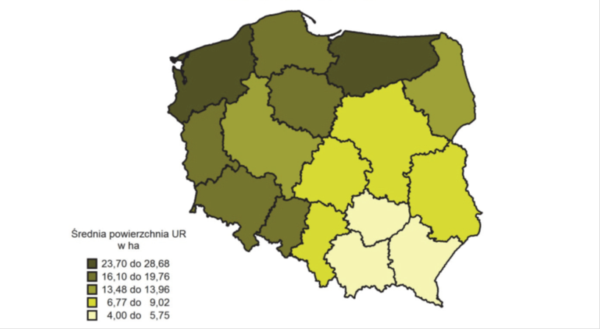

Onions
The world's largest producers of onions are China, India and the United States. In Europe, the Netherlands, Poland, Spain, Germany and Ukraine are the biggest producers. Currently, the regions in Poland where the most of this vegetable is grown are Wielkopolska and Kujawy. 2017 was a very difficult year, because the summer was very wet, which resulted in diseases and problems with the harvest and caused great problems with drying the onions, especially on the fields, hence the quality of the harvested vegetables dropped.

Onions, acreage (ha) and onion production (ton)

Year | Acreage | Yield/ha | Total yield
2000 | 35.000 | 21 | 721.000
2014 | 24.700 | 26 | 651.000
2016 | 26.500 | 25 | 651.000

Area cultivated onions in Poland in the years 1995-2016 [thous. ha]

The most important onion markets are for fresh consumption and for the industry. The markets request more and more a higher and minimum product quality and a homogeneous product. In recent years more and more professional packing stations have been developed, also by producer organisations in Poland. These quality requirements in general can be met better by bigger and modernized farmers, who have the ability to invest in new machinery and store facilities. This modernization of farming/farms offers good opportunities for suppliers of inputs, machines and equipment. These companies have an interest in showing their products to professionals, demonstration events offer such opportunities.

AKIS

The AKIS system in Poland significantly changes since the fall of the communistic regime in the nineties of the 20th century (PLAID country report Poland) on demonstration).
During the Sovjet time, the focus was on collectivization of farming, promoting methods of intensive agriculture from the Sovjet Union. After 1990 a new situation developed. During the nineties many big international suppliers of seeds, fertilisers, crop protection products and machinery entered the market in the East European countries and started to organise demonstration activities. Since these private companies entered the ‘extension market’ product promotion is an important aspect of ‘knowledge transfer’. Demonstration activities are part of this promotion. Demonstration objects on events like ‘the feast of onion and potato’ in Henrikowo, but also demonstration fields in cooperation with clients, where they show what they have to offer to the farmers. This type of knowledge transfer is not independent, impartial, but coloured by the commercial interest of the company.
In Poland, before 1989, every region had their own demonstration farms as instrument to disseminate knowledge and new practices to farmers. Nowadays there still are quite a number of demonstrations farms that cooperate with public agricultural advisors. Also research organisations run demonstrations on research locations, often in cooperation with public advisors. On the other hand we see farmers that signed a contract with commercial companies for demonstration activities on their farms.
Based on personal experience it seems that the value chain partners play a more important role in knowledge transfer than the public advisors, especially for the modernized farms. An important part of the work of public advisors is to help farmers with EU regulation requirements.

Role of demonstration farms.
There are three main factors influencing the current stage of demonstration farms development in Poland:
- Before the transition period from central to market economy (before 1989) every branch of public agricultural advisory services operating in a network of regional offices managed their own demonstration farms as an instrument to disseminate knowledge and new practices amongst farmers. As a result of changes being part of wider socio-economic transformation in the nineties of the 20th century substantial majority of demonstration farms connected to public agricultural advisory services were closed. Agricultural advisors, therefore, had to maintain the developed network of farms closely cooperating with public advisory farms as demonstration venues. This trend is mirrored in the substantial number of demo farms cooperating with public agricultural advisors;
- Partly due to speeding up of farming sector development after accession of Poland to EU, commercial companies selling all types of material used in agriculture (i.e. fertilizers, plant protection chemicals etc.) developed a network of dealerships operating across the whole country. They applied a dual approach to demonstration farms, 1) running their own company managed demo farms; 2) signing contracts with farmers (mostly bigger farms) regarding providing part of their farm for demonstration activities, at least partially, managed by a given commercial company;
- Additionally, there is a long tradition of demo farms run by research organisations related to agriculture. Their activities are directly related to their research programmes. Moreover, part of institutes funded from public resources within the framework of cooperation with the Polish Ministry of Agriculture and Rural Development are involved in multi-annual cooperation with public advisory service concerning organising open days for farmers. The national potato day in Bonin, organised by IHAR, is an example of such an event.

The main players in the AKIS system are (based on country AKIS report Poland):
- Provincial advisory bodies, 16 in total
- Research institutions and agricultural universities
- Commercial private sector advisors from the supply industry (crop protection, fertilisers, seeds)

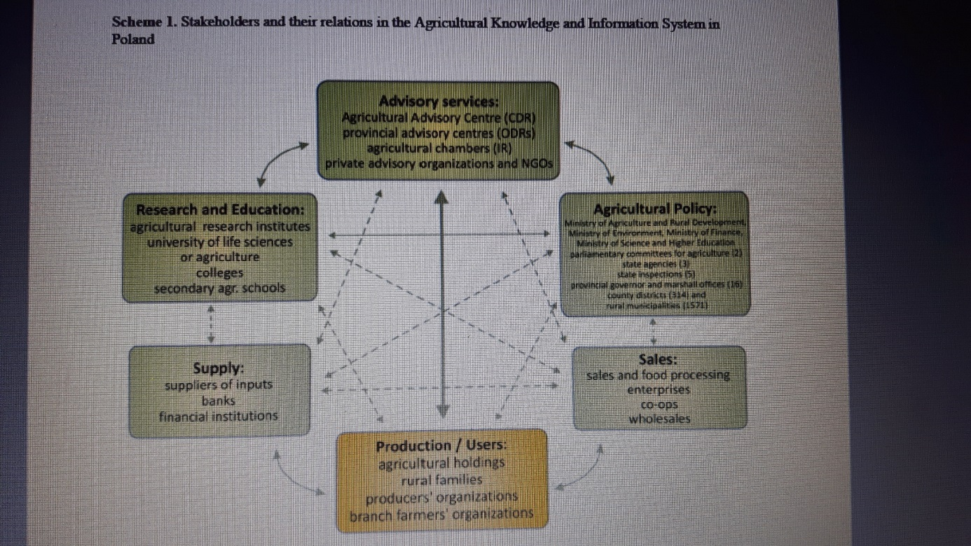
Source: Advisory services in European AKIS, country report Poland.
Very strong relation
Strong relation
<- - - - - - - > Weak relation

Sustainability challenges
Polish agriculture is still in a process of modernization by improvement of production techniques. Most important sustainability issue at the time is economic sustainability, less important are social (labour) and environmental sustainability (bio diversity and natural land management, pesticide impact, N and P emission). In Poland only a small region is distinguished ‘nitrate vulnerable’, where additional rules are in place. In the other parts of Poland the use of N and P is not limited by regulation.
Looking at the long term perspective of farmers, there are some sustainability issues that ask for attention:
- Water. The availability of ground and/or surface water for irrigation in certain areas is limited. And when available, farmers might have to pay for using ground water. This can become a incentive for sustainable water use.
- Product certification (Global G.A.P., ISO 9001:2000 and HACCP). A strong impact/request from the buying companies, for the domestic market and export. More and more product buyers request Global GAP or other type of certification. Slowly sustainability issues are introduced in these schemes.
- Soil fertility and soil quality. Often, farmers that invested in specific crops, like carrots, onions, potatoes tend to grow these crops too frequent, causing serious problems for product yield and quality: nematodes and soil borne fungi. Crop frequencies for potato, onion and carrot once every 3 year are often seen.
- Finding the balance between raising productivity on the one hand and maintaining the fertility of the field and protecting biodiversity by the responsible and correct use of crop protection products on the other hand: combining economic success with environmental and social responsibility
- Water quality in the nitrate vulnerable zones (Nitrate Directive), small part of Poland

Other sustainability issues: the economic challenge because of:
- Strong raising prices for agricultural land
- Increase in wages
- Decreasing availability of qualified personnel
- Low product prices for a few years

Demonstration summary
The demonstration activities are held in middle Poland (Wielkopolska). Although people from whole Poland come to the event, most of the visitors come from the Wielkopolska region. This year, 2018, the event will not take place because participants demand free or lower participation costs and the number of visitors was unfortunately decreasing over the last years.

A short description of the last 3 events is following.

The Festival of Onion, Potato and Soya in Henrykowo, August 2012.
On August 18 and 19, 2012 in Henrykowo near Środa Wielkopolska, on the holding of the farm of Monika and Michał Nowak, the 10th Festival of Onion, Potato and Soya took place. In two days, at least five thousand visitors (farmers, families with children’s) from all over the country visited the event. Topics on the event were new products for the onion, potato and soy bean production.
The Nowak family farms over 90 ha, of which 85.5 ha are arable land. The owners grow cereals - approx. 48 ha, onions - approx. 24 ha and potatoes - this year approx. 11 ha. In addition, more than 3 ha of soybeans were experimentally planted this year.
On the demonstration field the visitors could see plots with 64 varieties of onions, 32 varieties of potatoes and 5 varieties of soybeans. The visitors could personally compare the properties of the different varieties, resistance to pathogens and yielding of various varieties of onions, potatoes and soybeans in the conditions of Wielkopolska. The availability of different varieties ensures an even level of yield, as each variant reacts differently to difficult and changing weather conditions and enables meeting the requirements of consumers by offering varieties in different colours, juiciness and taste.
The interest in soy bean was high due to the fodder value of this plant, but also because of the possibility of obtaining additional co-financing offered as part of the direct payments to legumes. On the soy plots, a soil excavation was made showing the extensive soy root system.
Visitors could get up-to-date information about the latest generation of potato harvesters and get acquainted with the latest offers of tractors and agricultural machinery: machines for harvesting, sorting and packing potatoes and vegetables.

- XIII Festival of Onion and Potato in Henrykowo, Agust 2015
The topics that were raised during the meeting include fertilization, agrotechnics, crop protection of potatoes and onions. In addition, expert advice was provided by seed and fertilizer advisers, machine companies and advisers involved in agriculture. In the field part you could see several onion varieties and see how they dealt with drought.
Film: https://www.youtube.com/watch?v=cCrv_hcTEeA&feature=youtu.be

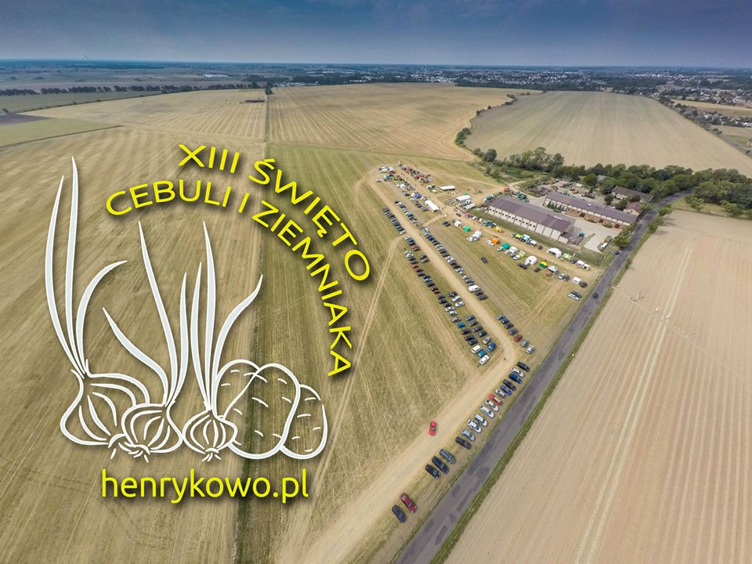

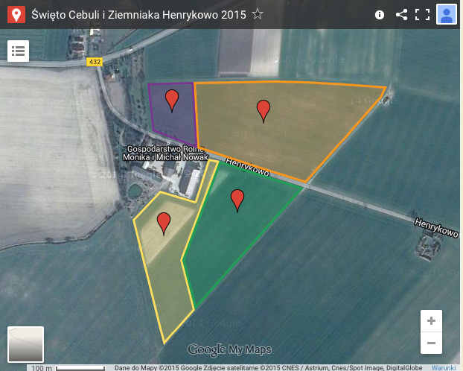

- XIV Feast of Onion and Potato in Henrykowo, August 2016
58 onion varieties and several potato varieties were presented in the show fields in Henrykowo. The crops appeared on a fairly large area - 6 hectares. In addition, representatives of fertilizer, machine, seed and chemical companies invited to their stands. There were lectures on onion foliar fertilization technology, very early potato varieties, about threats in agro-vegetable rotation and about potassium as an important mineral component of plants. During the event, the project "Improvement of fire safety in rural areas of the province. Wielkopolska " was also presented.
Film: https://www.youtube.com/watch?v=z3k4oIUkW6A
https://www.youtube.com/watch?v=795QUdt4xpc

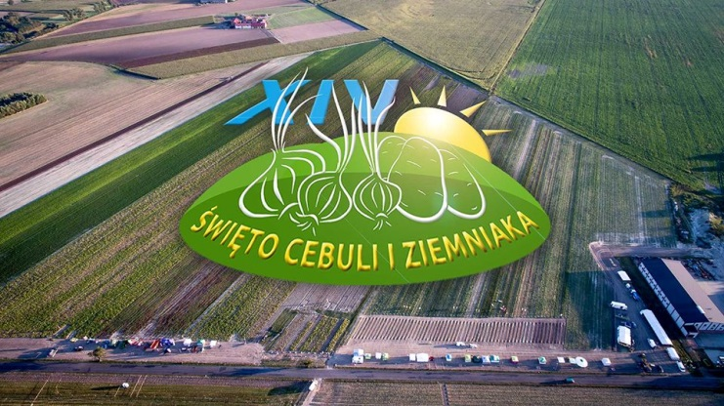

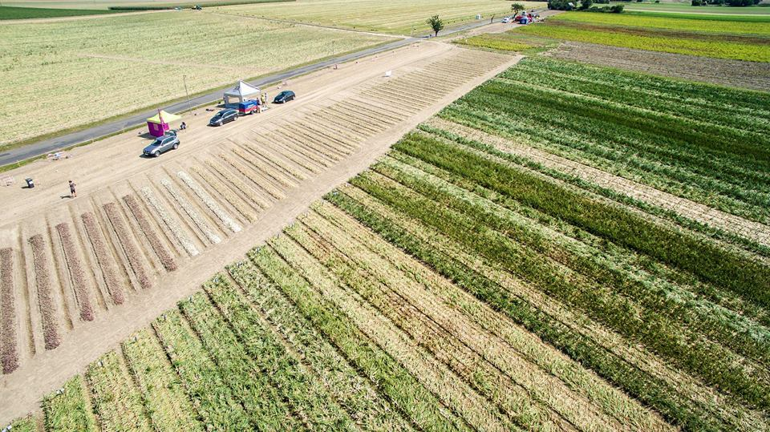

The demo methods used are:
- Small fields, several fields next to each other, where companies showed their products.
- In field demonstrations of machines and equipment.
- You tube videos from earlier events give information about the methods used.

Organiser(s) and history
Monika and Michał Nowak from Henrykowo are the ninth generation of the hosts. Mr. Michał took over the farm from his parents. Since 2001, he has been running them together with Ms. Monika. Both of them are graduates of the University of Life Sciences in Poznań.
Since 2003 they have been organizing weekend meetings for professionals called "Days of Onions". The organization was the full responsibility from the Nowak family. Since 2009, they have expanded the offer of meetings. Experts from potato cultivation joined the onion specialists. Since then, producers of onions and potatoes from all over Poland have been coming to the farm. An exhibition of agricultural machinery takes place. Questions regarding cultivation and varieties are answered by scientists from the University of Life Sciences in Poznań. To Henrykowo, because it is so commonly said about the Nowak's farm, students also come. They watch weeds on the fields, and the hosts talk about growing onions. Growers can see for themselves how the latest varieties are doing in the fields. The Nowak farm shows in their fields, without any "polisher", how the varieties behave in crisis or stress and without irrigation.

Other partners for the event, stakeholders and commercial companies in the value chain:
- WODR. The Wielkopolska Agricultural Advisory Center in Poznań (WODR) is a state organizational unit that provides agricultural consulting in the province of Wielkopolska.
- Centrum Nasienne FARMA, seeds trade company of Nowak in Henrykowo
- HZPC, Dutch potato breeder, they export seed potatoes to Poland, mainly for table and processing industry. They work with local people, representing HZPC in Poland.
- Agro Profil, Agricultural Magazine Editors, they share their expertise and they adapt the articles to the growing needs of Polish farms.
- Powiat Średzki, government of the region in the central part of the province of Wielkopolska. Its reach covers five municipality.
- Środa Wielkopolska, municipality were the demo was located.
- ADOP is a producer of liquid and solid fertilizers. Is an exporter of fertilizers in over 80 countries. It is also an importer of fertilizers and chemical raw materials for various industries.

Funding
The demo is funded by the Nowak family (a lot of time) and by several sponsors. The event has a few main sponsors and several other sponsors, mainly suppliers in the value chain.
Stand holders pay a fee and additional money for demonstration fields and machine demonstrations.
Companies present on the event:
Bejo Zaden, Hazera Poland, Kees Broersen Zaden, Procam, Syngenta, Plantico Zielonki, Hm Clause Polska, LGD Lider Zielonej Wielkopolski, Delphy Poland, Kurka, Bayer Sp. z o.o., Eugeniusz Bogdan Żurański (EBŻ), Pazal, Ożarów Mazowiecki Pnos, Mooij Vegetables.

Demonstrators of equipment:
KMK Agro, Sorpac, selling a wide range of machines and equipment for farmers, including irrigation systems.
Omnivent, product storage facilities, building and technical installation
Woj-Tech Maszyny, selling a wide range of machines and equipment for farmers
Pitern Sp, z o.o. producer of sustainable energy systems

How did it all start?
In 2003, Wojtek Grzelka, an adviser to ODR in Środa, came to their farm and urged them to plant several varieties of onions. They did not really want to, because sowing a few varieties, care, harvesting and storage is not an easy matter. The varieties are very different, some ripen faster, have different shapes, hull color, are useful for short or long storage, are small, large, oval, soft, hard - there are many factors. The same is true for potatoes. Each year in agriculture is different. The event and experimentation help them in the selection of varieties and they want to share this knowledge with other farmers.
From the beginning, that is from 2003, they got support from the local authorities.

The event was free of charge for the public.

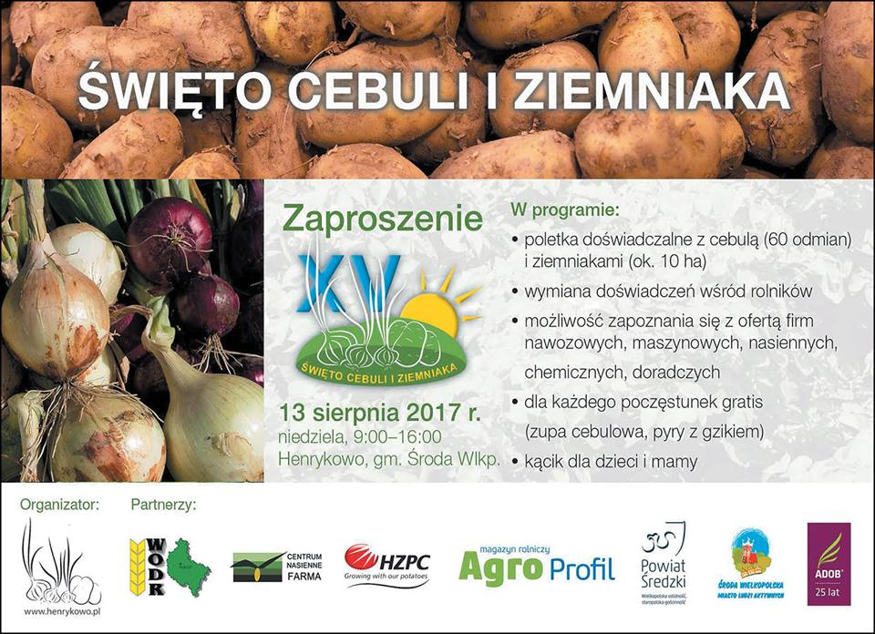
Organisation and sponsors of the event

Host(s)
Monika i Michał Nowak is an agricultural farm that organizes the event on its own fields, next to the farm in Henrykowo, near Środa Wielkopolska, province Greater. The company website: http://www.henrykowo.pl/

Gender
As the event didn’t take place in 2018we don’t have exact information on gender issues. The event is always organized for professional arable/vegetable farmers. The majority of the visitors was male.

Objective(s)

The objective of the demonstrations is to share knowledge, show the potential of new varieties, for improvements in onions and potato production. The event is also meant to promote products from the sponsors and partners. Visitors can personally compare the appearance of plants, resistance to pathogens and yield of various varieties of onions, potatoes and soybeans (2012) in the conditions of Wielkopolska.
The basic role of the organized event is to exchange experiences among farmers, compare the varieties of onions and potatoes located on experimental plots, as well as to familiarize with the offer of fertilizer, machine, seed, chemical and advisory companies. As farmers themselves, they want to show different varieties to other farmers. All varieties are treated in the same way, they propose different solutions. Besides demonstrations in the field specialist give lectures on specific topics.
The event is sponsored by several commercial companies, objectives are mainly product promotion and networking. The sponsors determine what products they want to show and demonstrate to the visitors.

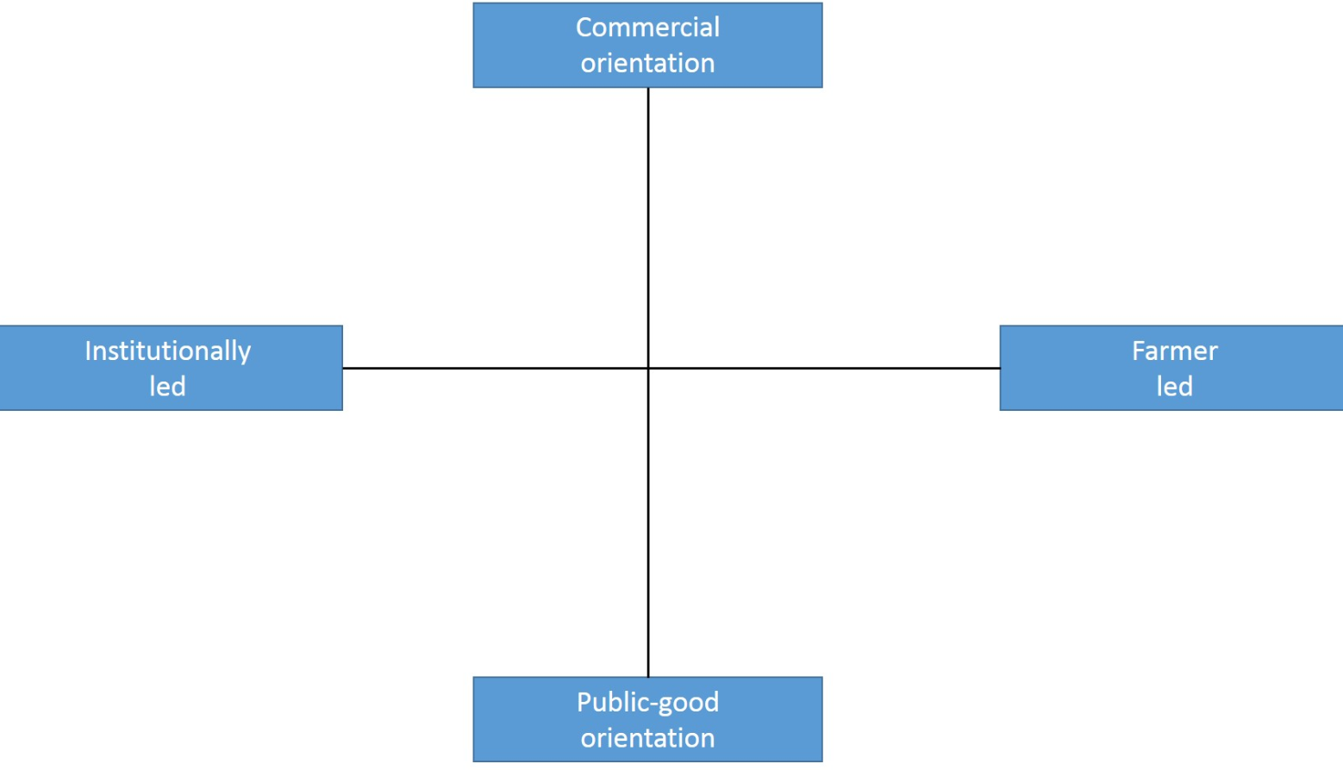
X

The event has a commercial orientation, the organization is in hands of farmers, fam. Nowak.

Topic(s)
Topics of the event over the years were:
- Demonstration and comparison of potato and onion varieties under practical circumstances. No variety specific treatment, just as the farmer grows his crops.
- Demonstration of commercial products from commercial companies, with different fertilisers, various fertilizer doses, different sowing dates and crop protection products.
- Field performance of varieties, resistance to drought, pathogens and yielding of various onion, potato and soy varieties.
- Demonstration of potato harvesters.
- Showing the latest tractors and agricultural machines: machines and equipment for harvesting, storing, sorting and packing potatoes and vegetables.
- Onion foliar fertilization technology, with very early onion varieties.

Access
The target audience was: professional onion and potato farmers, regional and national and people working in the onion and potato value chain. The location of the event was 30 km southwest from Poznan, easily reachable by car, not so easy by other means of transport.

The target group was invited through several channels, the website from family Nowak, through the website and networks of the participants and stakeholders and farm journals.

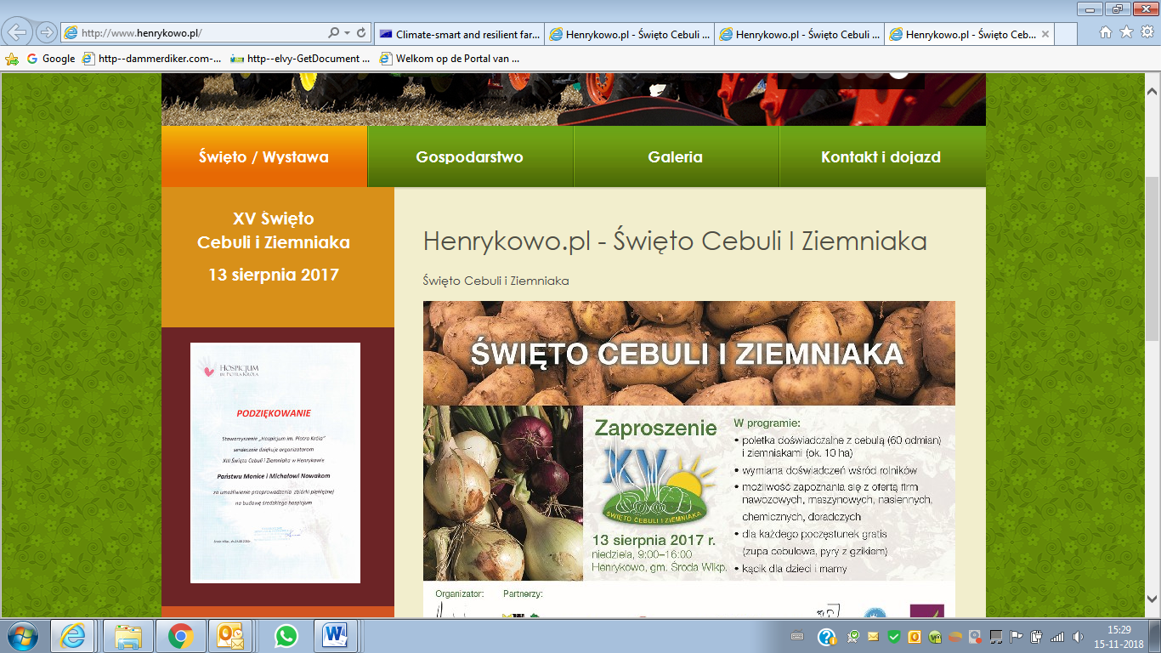
Website of family Nowak
Film (7 augustus 2017): https://www.facebook.com/henrykowo1/

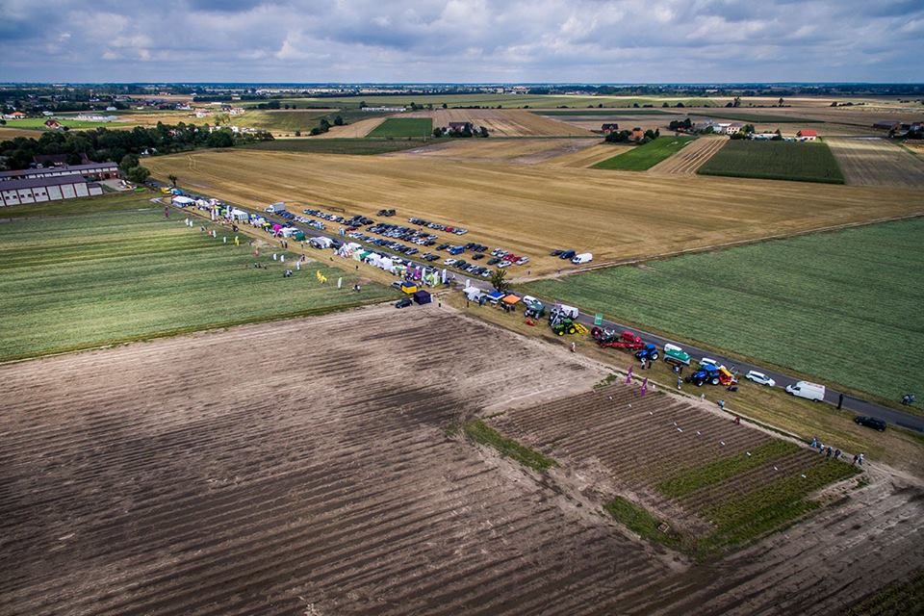
Photo from an earlier event

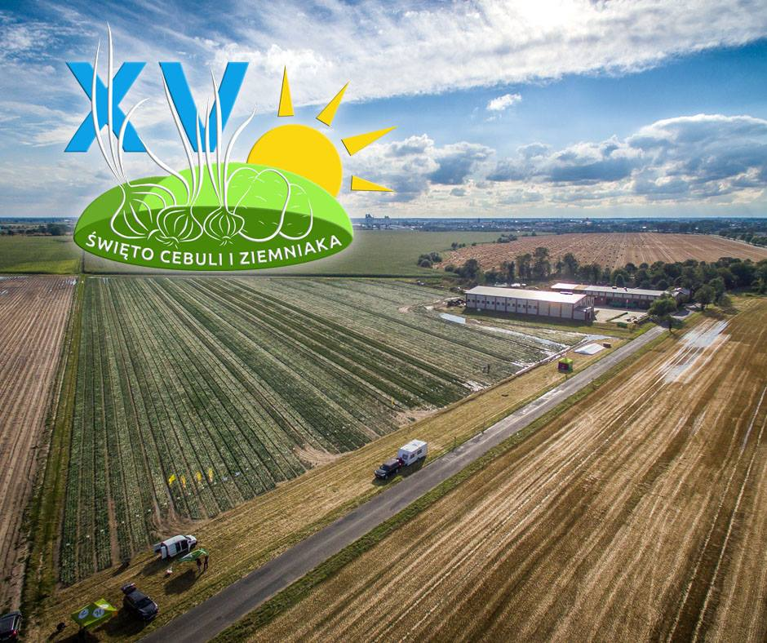
Promotion picture

Poster of the event

How experienced are organisers in organising demos?
Since 2003, they have been organizing a weekend of professionals meeting, called "Days of Onions". Since 2009, they have expanded the scope of the event by including potatoes to the program. Specialists in potato cultivation have joined onion specialists. Since then, the producers of onions and potatoes from all over Poland have been coming to the farm.

Demonstration event

Unforeseen circumstances
As we chose the event as case we didn’t know that the organization was cancelled a few months later.

Motives, learning and networking

Forms and content of learning
The earlier events were dedicated to field demonstrations of different varieties. Show how varieties perform under practical conditions and exchange information among farmers was the main purpose of the event. Besides this there were also product demonstration (fertilizers, pesticides) and machine demonstrations. And several stakeholders with a booth or product promotion.

Networking
Networking was an important aspect of the demo events. Exchange of information among farmers was the original idea for the event. Expanding their network through the events was an important benefit for the Nowak family.

Application of demo lessons by participants

Anchoring related to earlier demos
Field demonstration of new varieties is an important promotion activity for breeders.
For breeders of onions and potatoes, demonstrations like in Henrikowo are interesting events for the introduction of new varieties and promotion of existing varieties. Demonstration activities are often used to show the potential of new varieties to value chain partners. These partners can decide to introduce a variety in their portfolio, by testing a small acreage. When a variety has added value for them, they introduce it to the farmers they work with. An interesting model for breeders to raise acreage of their varieties.
Farmers looking for other varieties have a good opportunity to gather information on varieties from different suppliers/breeders under practical local circumstances (soil type and climate). Based on information they get farmers can decide to try a small acreage of a certain variety.

Scaling: Application of demo lessons by the wider farming community
We have no other information on this question than mentioned in the other case study.

Case study reflection

Key lessons from this case study
- The event was a private initiative from a farmer, back in 2003. Due to the success of this event it became bigger and bigger. More participants and demonstration objects, larger area, more visitors. But the organisers came to the conclusion that organising such an event takes a lot of time and effort, in the end no financial result and has a big impact on their private life (no summer vacation with the children for example).
- The added value for the organisers was/is: receiving valuable information, development of anextended network, meet many interesting people.
- As the 2018 edition was cancelled, the question is if the organisers have the ambition and intention to continue the organisation of the event or to stop. They still think about it, if and how to organise the event in a different/more professioanl way and also in a way that there will be a financial reward for all the work done. The organization is too much work for just the two of them.
- They always took care that the events were organized for professional people, fewer exhibitors, focus on what to see and learn, concentrate on the topic, and do not make festivals from the events. This is appreciated by the stakeholders

The initial main objective of the event was the demonstration of different onion varieties, later also potato varieties. The onion varieties still were a main subject of the latest editions. We therefore asked three onion breeders that participated in the edition of 2016, the reaction we got:
- A good opportunity to show our varieties. Demonstrations are an important factor in showing varieties to potential clients.
- Good location, central Poland, a region were many onions are grown.
- Practical demo, visitors get a good impression of the varieties under practical growing conditions.
- Visitors were mainly professional growers or working in the value chain. More visitors would have been even better!
- Communication with the organizers not always easy/not easy to reach.
- We will participate in the next edition, if organized.

Acknowledgements

We would like to thank Monika and Michel Nowiak for their cooperation.

Annexes

Data sources
The sources used for information:
Instytut Ekonomiki Rolnictwa i Gospodarki Żywnościowej – PIB
http://yadda.icm.edu.pl/yadda/element/bwmeta1.element.agro-f6189e8a-4ba9-42a8-9662-412bc86ae561/c/143-154.pdf
Sadyogrody.pl
http://www.sadyogrody.pl/handel_i_dystrybucja/106/polska_najwiekszym_unijnym_eksporterem_cebuli,12664.html
Agropogoda (GUS)
https://www.agropogoda.pl/gus-zbiory-warzyw-gruntowych-w-2
Charakterystyka gospodarstw rolnych_2016
https://stat.gov.pl/obszary-tematyczne/rolnictwo-lesnictwo/rolnictwo/charakterystyka-gospodarstw-rolnych-w-2016-r-,5,5.html
PRODUKCJA UPRAW ROLNYCH I OGRODNICZYCH W 2016 R.
https://stat.gov.pl/files/gfx/portalinformacyjny/pl/defaultaktualnosci/5509/9/15/1/produkcja_upraw_rolnych_i_ogrodniczych_w_2016.pdf
WODR
http://www.wodr.poznan.pl/powiaty/powiaty-r-z/zespol-doradczy-w-sredzkim/item/2162-x-%C5%9Bwi%C4%99to-cebuli-ziemniaka-i-soi-w-henrykowie
Wiescirolnicze
http://wiescirolnicze.pl/xiv-swieto-cebuli-i-ziemniaka-w-henrykowie-zdjecia/brak-zdjecia/
Agro-technika
http://agro-technika.pl/events/swieto-cebuli-i-ziemniaka-henrykowo/
http://agro-technika.pl/swieto-cebuli-i-ziemniaka-w-henrykowie/
Henrykowo
http://www.henrykowo.pl/
Środa Wielkopolska
http://sroda.wlkp.pl/asp/pl_start.asp?typ=13&sub=0&subsub=0&menu=36&artykul=3921&akcja=artykul
Facebook
https://www.facebook.com/henrykowo1/
Użytkowanie gruntów I powierzchnia zasiewów 2017 (Land use and sown area in 2017)
https://mir.krakow.pl/resources/articles/11212/uzytkowanie_gruntow_i_powierzchnia_zasiewow_w_2017_roku.pdf
Rynekpracy.org
http://rynekpracy.org/x/989321
StrefaAgro
http://www.pomorska.pl/strefa-agro/wiadomosci/a/ile-gospodarstw-w-polsce-ma-ponad-500-ha-najnowsze-dane-o-rolnictwie,12384992/
AriMR
http://www.arimr.gov.pl/pomoc-krajowa/srednia-powierzchnia-gospodarstwa.html

Data collection methods
Briefly describe the data collection methods that you have used for the various topics.
When you’ve used questionnaires, and/or question lists for interviews, provide the text of these.

- Internet analysis. We searched for information about earlier editions of the event.

- Media analysis. We have been searching for information that was published about earlier editions of the event in the media.

- In depth interview with the organiser. Early 2018 we had an in depth interview with the organiser about ambition, goals and content of the event.

- Photos in this document are from earlier editions.

- We interviewed three onion breeders that were present with a onion demonstration field in the 2017 edition.

