Date: 26-9-2018

Country report: Poland

Case Study: PL1 National potato day Bonin

WP5: Case studies of demonstration activities in commercial farms

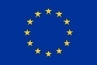
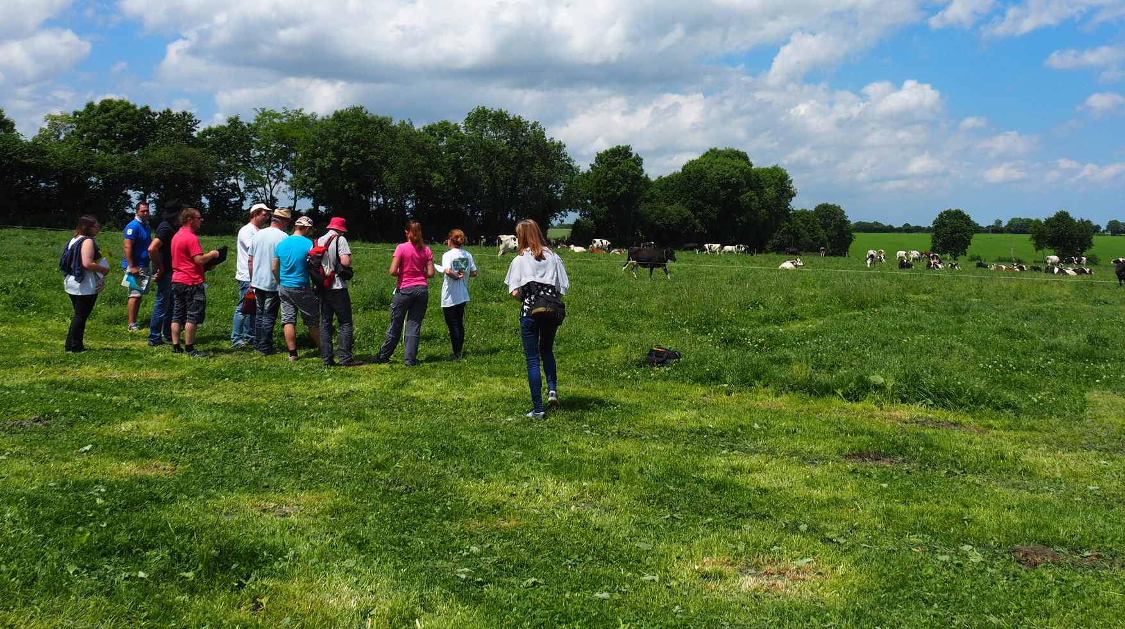
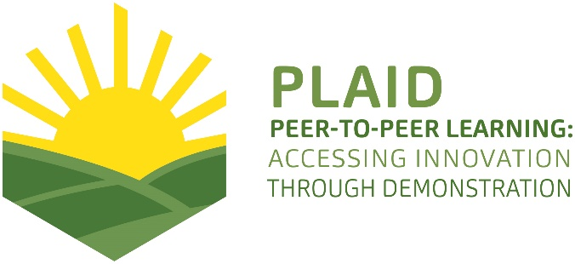
This project has received funding from the European Union’s Horizon 2020 research and innovation programme under Grant Agreement No 727388.
This project has received funding from the European Union’s Horizon 2020 research and innovation program under Grant Agreement No 727388

PLAID PARTNERS

Advisory Service Croatia ASC | 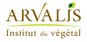  ARVALIS Institut du Végétal | Association de Coordination Technique Agricole ACTA
Institute for Rural and Regional Research | 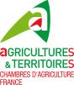  Chambers of Agriculture | Delphy
European Forum for Agricultural and Rural Advisory Services EUFRAS | Innovatiesteunpunt ISP | 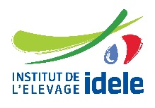  Institut de l’Elevage – Idele
Instituto Navarro De Tecnologías E Infraestructuras Agrolimentarias | 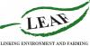  Linking Environment and Farming LEAF | 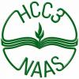  National Agricultural Advisory Service
Nodibinajums Baltic Studies Centre (BSC) | Research Institute of Organic Agriculture (FIBL) | Stichting Wageningen Research
The James Hutton Institute | VINIDEA

DOCUMENT SUMMARY

__________________________________________________________________________________
Milestone Title: 24 Case Studies
__________________________________________________________________________________
Case Study Title: Potato days Bonin, Poland
__________________________________________________________________________________
Version: 1
__________________________________________________________________________________
Task Lead: WUR
__________________________________________________________________________________
Related Work package: WP5
__________________________________________________________________________________
Authors: Harm Brinks, Emiel Kamminga, Tomasz Krasowski
__________________________________________________________________________________
Grant Agreement Number: 727388
__________________________________________________________________________________
Project name: PLAID
__________________________________________________________________________________
Start date of Project: January 2017
__________________________________________________________________________________
Duration: 30 Months
__________________________________________________________________________________
Project coordinator: The James Hutton Institute

ABSTRACT

The 'national potato days' in Bonin farmers could find demonstrations of different brands of potato harvesters, new potato varieties, fertiliser strategies in potato and crop protection strategies on potatoes. The event was organised in cooperation with several partners in the potato value chain: input suppliers, machine constructors and breeders. Stakeholders were invited to develop and demonstrate their products and strategies. Several potato harvesters were demonstrated: 2 and 4 row harvesters, tractor pulled and self propelled, machines with and without a bunker. Interesting differences concerning the qualilty of work were observed. There was also a demonstration of the transport line (tipper, conveyor belts and pré grading) , from harvester to the 'store'. Several companies demonstrated the effect of specific fertilizers and crop production products. Due to the very hot and dry summer no differences were visible in the field at the moment of the event. National and international potato breeders demonstrated their (new) potato varieties for the different markt segments (starch, table, processing). From each variety a few plants were harvested, this gave the farmers the opportunities to compare the different varieties concerning yield potential, shape, tuber quality, flesh colour and grade. On saturday a series of workshops/lectures was organised on specific topics: virus diseases in potatoes, how to increase competetiveness of the potato, potato diseases – old problems, new solutions, innovative weed control in potatoes.

TABLE OF CONTENTS

1 Demo context 6
1.1 The value chain 6
1.2 Typical farm characteristics 6
1.3 AKIS 8
1.4 Sustainability challenges 11
2 Demonstration summary 12
3 Governance: set up and organisation 15
3.1 Organiser(s) and history 15
3.2 Funding 15
3.3 Host(s) 16
3.4 Gender 16
3.5 Objective(s) 17
3.6 Topic(s) 17
3.7 Access 18
4 Demonstration event 19
4.1 Visitors 19
4.2 Communication & Mediation 20
4.3 Active participation 20
4.4 Doing business 20
4.5 Role of sustainability 21
4.6 Unforeseen circumstances 21
4.7 Plans vs. practice 21
4.8 Participants feedback 21
5 Motives, learning and networking 23
5.1 Reasons to attend demos 24
5.2 Forms of learning 24
5.3 Content of learning 25
5.4 Outcomes of learning 26
5.5 Networking 27
6 Anchoring: Application of demo lessons by participants 27
6.1 Anchoring related to the present demo 27
6.2 Stimulating anchoring 27
6.3 Anchoring related to earlier demos 27
7 Scaling: Application of demo lessons by the wider farming community 28
7.1 Retrospective examples of scaling 28
7.2 Prospective assessment of scaling: Impact pathways 29
8 Case study reflection 30
8.1 Demonstration – innovation narrative 30
8.2 Facilitating and impeding factors for successful demonstrations 32
8.3 Impact of demonstrations 33
8.4 Key lessons from this case study 34
9 Annexes 35
9.1 Data sources 35
9.2 Data collection methods 35

Demo context

The value chain
Poland still has a rather under developed agriculture, with a large number of small farms. In the arable value chain many of these farmers produce for own use and for regional markets. Since Poland became member of the EU modernization of the arable sector started and professional farms developed, growing crops like potatoes, onion, carrots, red beets, cabbage, salads. Markets changed, as big retails organizations and processing industry became important product buyers. And also export to other EU countries developed. With support of EU funding a lot of investments were done by farmers: building ware houses, washing and packing lines, entering new markets. Over the last decade a few hundred producer organizations developed, making it easier to get EU subsidies for investments. Looking at the potato value chain, subject of this case study, the most important actors in the value chain:
- Bigger and modernized farms. To meet the requirements of the market investments are necessary (new machinery, store facilities, specific potato varieties, irrigation). These investments can only be made by the bigger farms.
- Processing industry and supermarkets. The processing industry has factories in Poland (Farm Frites, McCain). The French Fry industry requests certain varieties, for example the variety Russet Burbank or Innovator for fries sold to MacDonald’s. Super markets require a higher product quality.
- Input suppliers (seeds, fertilizers, crop protection products, equipment and machinery). All the suppliers from Western Europe entered the Polish market over the last decades: tractors, combines, potato harvesters, potato breeders, seed companies, pesticide producers. Poland is an interesting market in facilitating modernization of Polish potato sector.
- Organizer of the potato event 2018: IHAR-PIB Instytut Hodowli i Aklimatyzacji Roślin w Boninie (Plant Breeding and Acclimatization Institute) and Pomorsko-Mazurska Hodowla Ziemniaków in Strzekęcin (Pomeranian-Mazury Breeding of Potatoes in Strzekęcin).

Typical farm characteristics
Poland is a big country, also for agriculture. It has a territory of 312,684 square km (31,270,000 hectare) that is around 7,5 times the Netherlands. Approximately 53% of Polish soil consists of ‘podzol soils’. The average annual temperature in Poland is 6 to 8 degrees. In the West, it is warmer by influence of the ocean climate, in the East, it is colder because of the continental climate. In July, average temperatures across the country can rise to around 22 degrees. Average annual rainfall in Poland varies from 450 – 700 mm, most of it in the summer season.

Polish agriculture is characterized by high fragmentation - the average area of ​​agricultural land per one farm increases gradually and in 2015 amounted to 10.3 ha of agricultural land (in 2011 - 9.1 ha, and in 2002 - 5.8 ha) . Despite some acceleration of concentration, slightly more than half of farms in Poland (51.9%) use no more than 5 ha of agricultural land. There is 12.8% of agricultural land on these farms. Almost 3/4 of farms (74.9%) use less than 10 ha of agricultural land, and their total share in arable lands is 28.3%. These farms usually conduct production using traditional methods, with low mineral fertilization and the use of chemical plant protection products, as well as industrial feed in the nutrition of farm animals, especially cattle. The next 31% of agricultural land is located on 10-30 hectare farm. Besides these small and medium size farms Poland has also medium and large scale farms. The large scale farms are the successors of the formal state owned collective farms.
Aproximately 33.000 farms cultivate 50 ha or more, aproximately 600 of these farms cultivate more than 1000 ha. These small and medium size farms are found mainly in the North, centre and South West of Poland.
The acreage of organic is still rather small in Poland, but growing fast. In 2000 Poland only had 22.000 organic managed land, nowadays this is around 500.000 ha (+/- 3%). Arable crops have a share of 35-40%. Over the last few years an annual increase of 20% of organic sales is mentioned. But this is still less than 1% of the total food market, compared to 2-8% in other EU countries.

Number of farms and area of agricultural land in 2015

Acreage in ha | Number of farm x 1000 | Agricultural area x 1000 ha
1-5 | 708 | 1840
5-10 | 323 | 2260
10-30 | 282 | 4508
30-50 | 38 | 1451
> 50 | 33 | 4466
Total | 1404 | 14545
Source: Rolnictwo in 2015, GUS, Warsaw 2016.

Potatoes
The area of potato cultivation in Poland (including the area of potatoes in home gardens) significantly reduced over the last 2 decades and seems to stabilize aroung 330.000 ha.

Potato yields are steadily growing, total yield in 2017 9.2 million tonnes and was higher by 15 % higher than the average harvest from 2011-2015.

Average potato yield per ha in 2017 was 28 ton/ha, 20% higher than the average yields in 2011-2015.

Area of cultivation, yield and potato harvest in Poland

Years | Acreage | Yield | Harvest
 | (x 1000 ha) | (t/ha) | (mln ton)
1991-1995 | 1694 | 16 | 27
1996-2000 | 1292 | 18 | 23
2001-2005 | 813 | 18 | 14
2006-2009 | 525 | 19 | 10
2010 | 401 | 21 | 8,5
2011 | 406 | 23 | 9,4
2012 | 373 | 24 | 9,0
2013 | 346 | 21 | 7,3
2014 | 277 | 28 | 7,7
2015 | 300 | 21 | 6,3
2016 | 312 | 29 | 8,9
2017 | 329,3 | 28 | 9,2

In the past, potatoes were considered a very cheap vegetable by all social groups.
Until the mid-1960s, the scale of potato production in Poland continued to grow to nearly 3 million hectares, and harvests were approaching 50 million tonnes per year. At that time, the Potato Institute was established, the Polish breeding and seeding of the potato grew dynamically. About 50% of the harvest was used for fodder, potatoes were the basic raw material in alcohol production for over 900 domestic distilleries and the starch industry was dynamically developing. Its consumption was very high and exceeded even 200 kg / person / year. At present, domestic consumption of potatoes is slowly but surely falling and is only 97 kg per person per year, while in other EU countries it is on average 50% less.

For over 40 years, the potato growing area in Poland has been gradually decreasing. The scale of this process is very large - unparalleled in any other European country. The reason was the mass outflow of labor from the countryside to the city, as well as the progressing mechanization and higher productivity in cereal production. Potatoes have become too expensive for pigs. In the 1970s, potatoes occupied an area of 3 million hectares in Poland, which constituted an 18% share in the crop structure. In terms of harvest, Poland was the second producer in the world. In 2016, according to IHAR-PIB, the area of potato cultivation in agricultural holdings was about 310,000. Ha, including 10.000 ha in home gardens.

However, there is a constant downward trend in the consumption of fresh potatoes as vegetables, while the consumption of food potato products (French fries, droughts, chips) produced by the processing industry increases [BGŻ 2015 Report]. The market for edible potatoes is also changing. The shopping offer of super market chains is getting richer in terms of offered varieties, size and type of packaging. The ongoing changes transform the whole potato industry into concentration and professionalization of potato production.
The food processing industry needs about 1,100,000 tons of potatoes/ year. The largest processing industries in Poland are Lamb Weston and Farm Frites. The production volume of French fries, chips and dried food covers the current needs of the domestic market. The food industry produces ca. 160,000 tons of French fries, about 60,000 tons of chips and about 20,000 t dried food. A large part of these products is intended for export.
The industry requests a minimum product quality and homogeneous product. These quality requirements in general can be met better by bigger and modernized farmers, who have the ability to invest in new machinery and store facilities. This modernization of farming/farms offers good opportunities for suppliers of inputs, machines and equipment. These companies have an interest in showing their products to professionals, demonstration events offer such opportunities.

AKIS

The AKIS system in Poland significantly changes since the fall of the communistic regime in the nineties of the 20th century (PLAID country report Poland) on demonstration).
During the Sovjet time, the focus was on collectivization of farming, promoting methods of intensive agriculture from the Sovjet Union. After 1990 a new situation developed. During the nineties many big international suppliers of seeds, fertilisers, crop protection products and machinery entered the market in the East European countries and started to organise demonstration activities. Since these private companies entered the ‘extension market’ product promotion is an important aspect of ‘knowledge transfer’. Demonstration activities are part of this promotion. Demonstration objects on events like the potato days in Bonin, but also demonstration fields in cooperation with clients, where they show what they have to offer to the famers. This type of knowledge transfer is not independent, impartial, but coloured by the commercial interest of the company.
In Poland, before 1989, every region had their own demonstration farms as instrument to disseminate knowledge and new practices to farmers. Nowadays there still are quite a number of demonstrations farms that cooperate with public agricultural advisors. Also research organisations run demonstrations on research locations, often in cooperation with public advisors. On the other hand we see farmers that signed a contract with commercial companies for demonstration activities on their farms.
Based on personal experience it seems that the value chain partners play a more important role in knowledge transfer than the public advisors, especially for the modernized farms. An important part of the work of public advisors is to help farmers with EU regulation requirements.

Role of demonstration farms.
There are three main factors influencing the current stage of demonstration farms development in Poland:
- Before the transition period from central to market economy (before 1989) every branch of public agricultural advisory services operating in a network of regional offices managed their own demonstration farms as an instrument to disseminate knowledge and new practices amongst farmers. As a result of changes being part of wider socio-economic transformation in the nineties of the 20th century substantial majority of demonstration farms connected to public agricultural advisory services were closed. Agricultural advisors, therefore, had to maintain the developed network of farms closely cooperating with public advisory farms as demonstration venues. This trend is mirrored in the substantial number of demo farms cooperating with public agricultural advisors;
- Partly due to speeding up of farming sector development after accession of Poland to EU, commercial companies selling all types of material used in agriculture (i.e. fertilizers, plant protection chemicals etc.) developed a network of dealerships operating across the whole country. They applied a dual approach to demonstration farms, 1) running their own company managed demo farms; 2) signing contracts with farmers (mostly bigger farms) regarding providing part of their farm for demonstration activities, at least partially, managed by a given commercial company;
- Additionally, there is a long tradition of demo farms run by research organisations related to agriculture. Their activities are directly related to their research programmes. Moreover, part of institutes funded from public resources within the framework of cooperation with the Polish Ministry of Agriculture and Rural Development are involved in multi-annual cooperation with public advisory service concerning organising open days for farmers. The national potato day in Bonin, organised by IHAR, is an example of such an event.

The National Potato Day is an annual meeting of all people associated with the potato industry. In 2017, the event was organized in Kalinowo in the Sieradz district and attracted almost 10,000 people from Poland and abroad. This year, the 25th Jubilee edition of the National Potato Days took place August 25-26 in Bonin in the West Pomeranian Voivodeship in the Scientific Department, Plant Breeding and Acclimatization Institute - National Research Institute in Radzików (IHAR).

The main players in the AKIS system are (based on country AKIS report Poland):
- Provincial advisory bodies, 16 in total
- Research institutions and agricultural universities
- Commercial private sector advisors from the supply industry (crop protection, fertilisers, seeds)

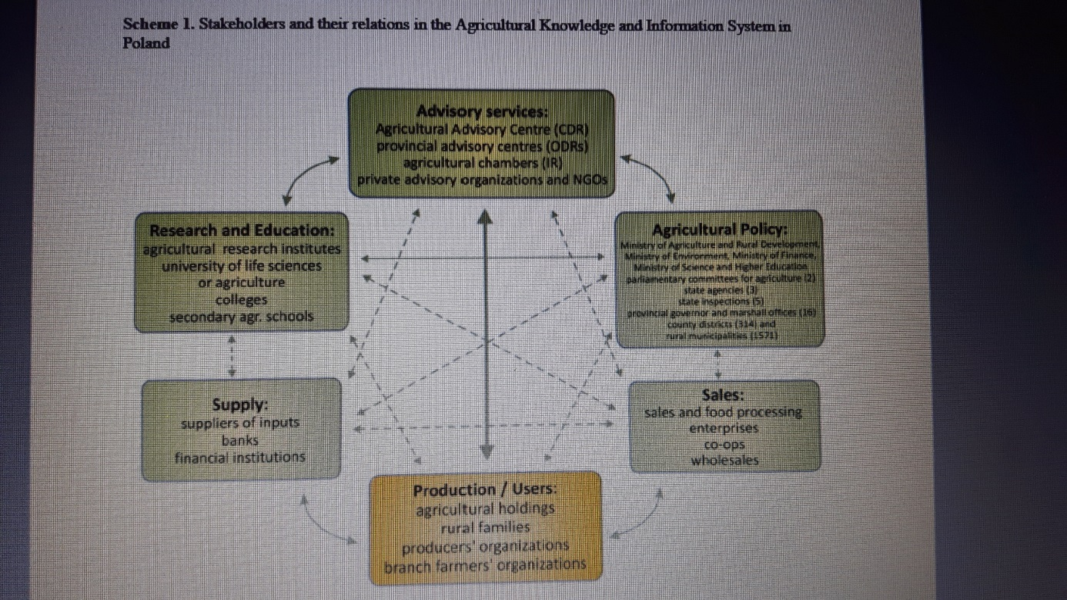
Source: Advisory services in European AKIS, country report Poland.
Very strong relation
Strong relation
<- - - - - - - > Weak relation

Sustainability challenges
Polish agriculture is still in a process of modernization by improvement of production techniques. Most important sustainability issue at the time is economic sustainability, less important are social (labour) and environmental sustainability (bio diversity and natural land management, pesticide impact, N and P emission). In Poland only a small region is distinguished ‘nitrate vulnerable’, where additional rules are in place. In the other parts of Poland the use of N and P is not limited by regulation. In the potato value chain there is a starting interest in achieving sustainability goals, but there are no specific sustainability requirements for the producers. An example of a value chain initiative is the world wide ‘flagship farm program’ of MacDonald’s, a potato growing farm in Poland is participant in this program. (https://www.flagshipfarmers.com/en/about-the-program/).
Looking at the long term perspective of farmers, there are some sustainability issues that ask for attention:
- Water. The availability of ground and/or surface water for irrigation in certain areas is limited. And when available, farmers might have to pay for using ground water. This can become a incentive for sustainable water use.
- Product certification (Global G.A.P., ISO 9001:2000 and HACCP). A strong impact/request from the buying companies, for the domestic market and export. More and more product buyers request Global GAP or other type of certification. Slowly sustainability issues are introduced in these schemes.
- Soil fertility and soil quality. Often, farmers that invested in speficic crops, like carrots, onions, potatoes tend to grow these crops too frequent, causing serious problems for product yield and quality: nematodes and soil borne fungi. Crop frequencies for potato, onion and carrot once every 3 year are often seen.
- Finding the balance between raising productivity on the one hand and maintaining the fertility of the field and protecting biodiversity by the responsible and correct use of crop protection products on the other hand: combining economic success with environmental and social responsibility
- Water quality in the nitrate vulnerable zones (Nitrate Directive), small part of Poland

Other sustainability issues: the economic challenge because of:
- Strong raising prices for agricultural land
- Increase in wages
- Decreasing availability of qualified personnel
- Low product prices for a few years

Demonstration summary
The national potato days are focussed on field demonstrations of:
- New potato varieties, several stakeholders have a small demonstration plot of different varieties they offer for the Polish market
- Machine demonstrations, mainly potato harvesters and equipment needed for transporting potatoes from the harvester to the store
- Demonstration field with fertilizer and plant protection strategies. Different suppliers demonstrate their products.
- Several stands with product presentations and product tasting.

Weblink for the event: http://krajowedniziemniaka-ihar.pl

The main primary reason for organizing this event was/is promotion of IHAR among farmers and companies in the potato value chain. IHAR has the ambition to be acknowledged more as an important research partner for the potato sector in Poland. The National Potato Days were seen as a good opportunity. The ultimate goal of the Polish National Potato Days was/is to take part in the organisation of the Potato Europe Event. This is a big yearly potato event, ‘traveling’ between Germany, France, Belgium and The Netherlands. But the organizers of Potato Europe are not interested to integrate Poland in the cyclus.

The demo methods used are:
- Small fields, several fields next to each other, where companies showed their products or strategies. There were no guided tours along these fields, to our opinion the lack of it reduced the attention for these fields. See pictures. These pictures also show that there was very little attention for these fields.

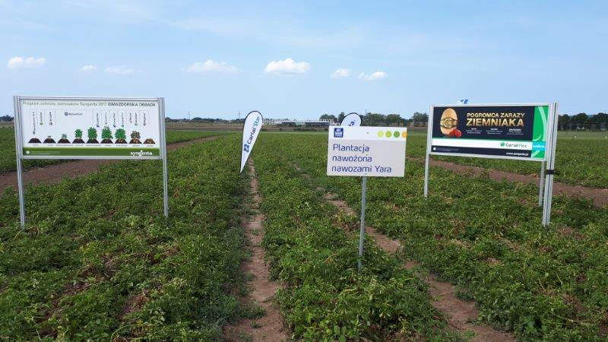

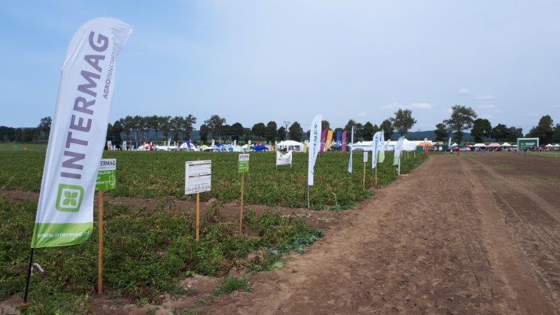

- Machine demonstrations, with a focus on potato harvesters. Several companies showed different types of harvesters, self propelled 4 row harvesters and tractor pulled 2 row harvesters. There was only general information about the machines, no information about technical aspects of the machines: best setting in relation to the situation in the field, quality assessment of the performance of the different machines, etc. The general information was told on the headland of the field. And the audience stayed also on the headland and didn’t go/where not directed into the field in order to see the results in more detail.
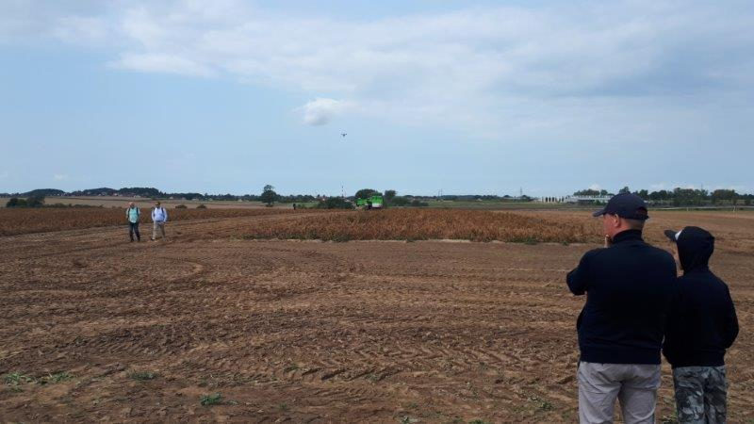

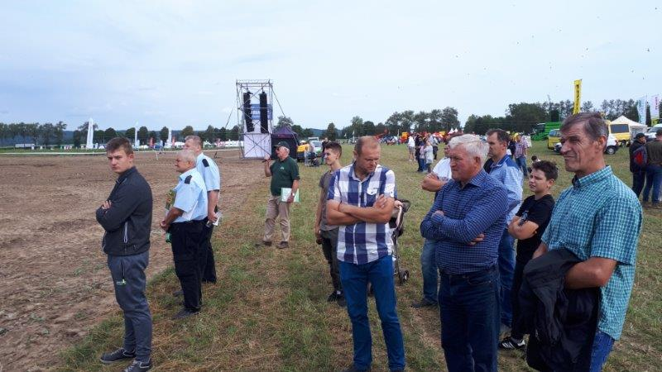

- Demonstration of the potato transport line from harvester to truck. There was a demonstration of a very modern set of equipment for professional handling of potatoes. This demonstration had the attention of quite a few people, but here again no explanation at all.

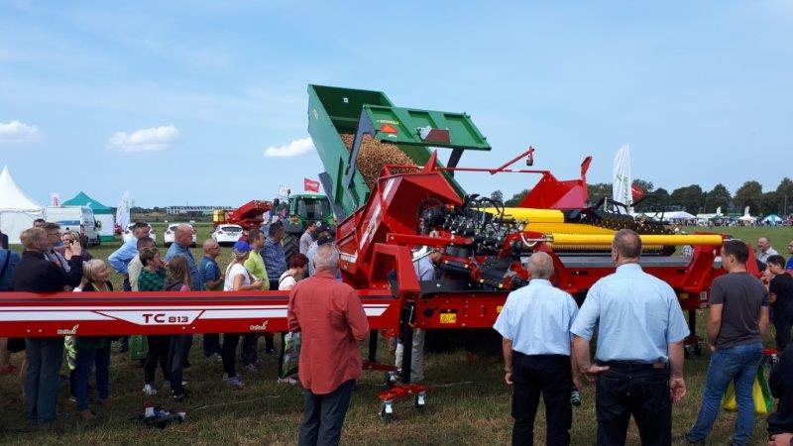

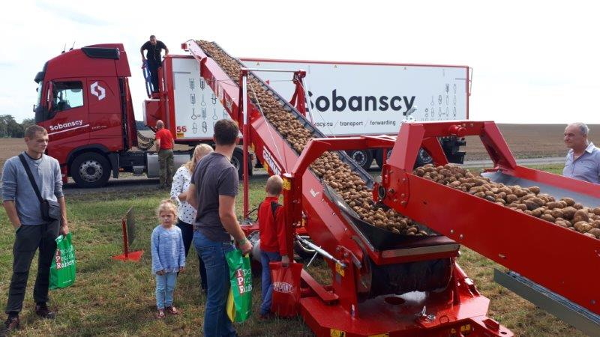

- Video recording from the field operations with a drone. The recording was real time visible on a big screen on the central platform. Through this videos the activities going on in the field could be watched, but of course no detailed information could be obtained.
- Video recording in the field. Some companies made short videos from the demonstration fields, in order to use them on other occasions.

Governance: set up and organisation

Organiser(s) and history
The 2018 national potato days is the 25th edition. The location of the demonstration changes from year to year. The 2018 edition is organized by IHAR-PIB Institute of Plant Breeding and Acclimatization in Bonin, the North of Poland. The 2018 edition of the National Days of Potato in Bonin will take place on August 25-26 on the fields of IHAR. Bonin is a place historically associated with a potato. It was in Bonin in 1966 that the Institute of Potato was established, whose task was to conduct research exclusively devoted to potato and is currently the only institute of agricultural research in the north of Poland. The unit in Bonin has one of the largest Potato Bank of Potatoes in vitro in Europe and the only one in Poland. About 1,600 healthy potato genotypes from around the world are maintained in the bank, which constitute a varietal basis for breeders and other Scientific Institutes and Universities. Since 2005, the Plant has been authorized by the Main Inspector of Plant Health and Seed Inspection in the field of testing plant protection products for the purposes of their registration in Poland. IHAR operates six research centers in Poland and employs around 500 people.

IHAR organizes open days every year, as a regional event. As the management person responsible for these events changed a few years ago the setup of the days changed. The intention is to promote the institute more under potato farmers and value chain partners. Therefore since 2017 stakeholders are invited to participate in the event, leading to several demonstration activities in the field in the 2017 edition. Evaluation with the stakeholders lead to the conclusion that the setup of the field demonstrations needed a change.
As the new management has the ambition to promote IHAR better organizing the National Potato Days was a good opportunity to do so.

Funding
The demo is funded by IHAR and by several sponsors. The event has a few main sponsors and several other sponsors, mainly suppliers in the value chain.
Stand holders pay a fee and additional money for demonstration fields and machine demonstrations. The stakeholders could determine their own company strategy for crop protection and/or fertilisation. The focus of invited companies are players in the potato value chain. But as the public was very diverse, and also from outside agriculture also a few consumer stands were present.
The event was free of charge for the public.

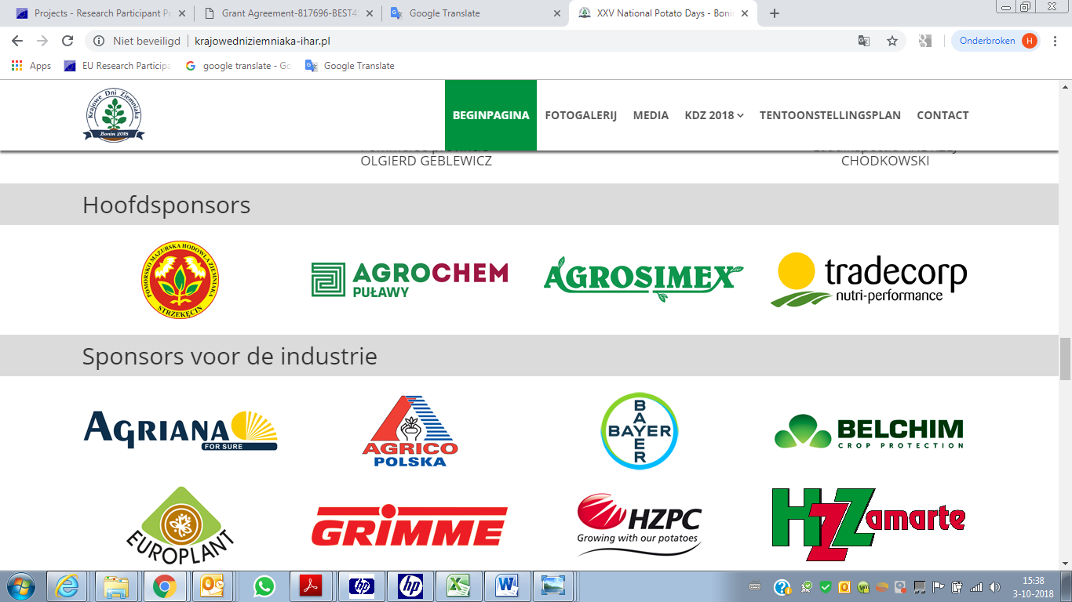

Host(s)
The host was IHAR, the event was organize on the fields of this research institute. As said before, this location was chosen for promotion of the institute. The institute has conventional management. The fields are located between Koszalin and Bonin, in the North of Poland.

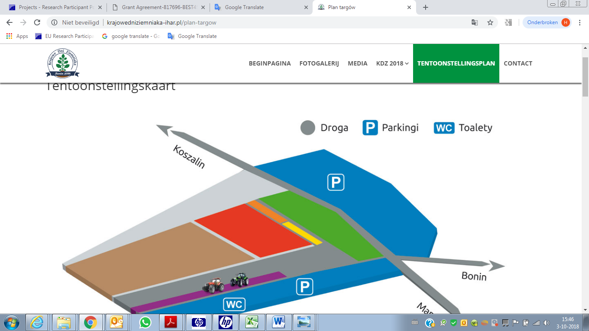

Gender
Responsible for organising the event is Agnieska Przedowodowska, member of the management team of IHAR. The people working for IHAR is a mix of man and women. The field work is mainly done by male employees.

Objective(s)
IHAR. IHAR organises an open day every year. The objective is to promote the institute among farmers and stakeholders. As Ms Przewodowska became responsible for the organization, a few years ago, she decided to change the setup of the event because of lack of results. Reasons for dissatisfaction:
- Quality of the organization was not good enough
- Very regional character of the event
- Too little money was collected/too much own money involved
- No or little involvement from external stakeholders

Specific goal for the event is to promote the institute and make clear that IHAR has a lot of relevant expertise for farmers and the potato sector. The setup up and organization changed:
- Since 2017 the potato business was attracted to participate in the event through demonstration or by having a booth.
- Try to attract farmers by showing and demonstrating interesting things for farmers.

The national potato days offered a good opportunity to support this ambition, therefore IHAR applied for the organisation of the national potato days. This is a yearly event, organized on different regions in Poland. The 2017 edition was organized in central Poland.

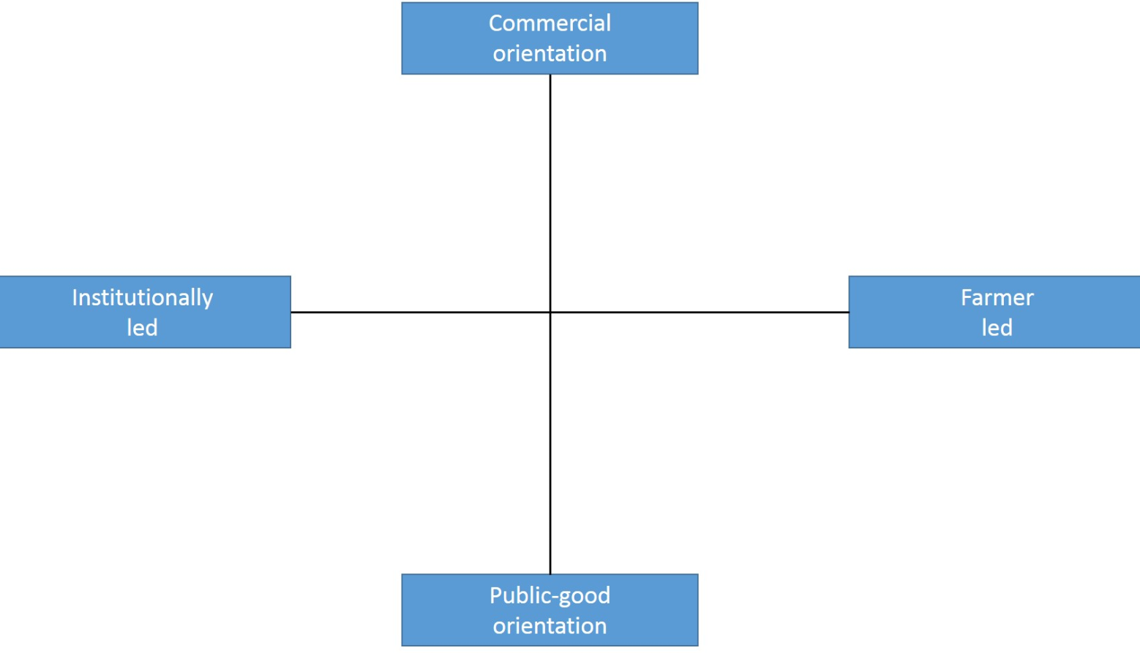

The event has a commercial orientation and is led by an institution, IHAR.

Topic(s)
Topic of the event were technical aspects of the potato crop. Varieties, fertiliser and crop protection products and strategies, and potato harvesters were the most important topics. These topics are a result of the ambition to show interesting aspects of growing potatoes to farmers and the involvement of potato value chain partners in the event. They were asked what input they would like to have on the event. As most stakeholders are commercial companies from the potato value chain, the demonstrations serve the commercial interests of these companies. The event was a mix of activities. In a central part of the field many companies were present with a stand/booth. The stands were dominated by value chain suppliers (seeds, pesticides, fertilizers). But also stands from outside agriculture were present. In this part a series of presentations/workshops on technical aspects were held.
In the field several were several activities:
- Demonstration of potato varieties. Several seed companies showed their varieties, in the field as well as in the stand.
- Machine demonstrations, demonstration of several type of harvesters from different manufacturers, and equipment for transport from machine harvester into the truck: tipper, conveyor belts, etc.
- Demonstration of plant protection strategies. The different pesticide companies were invited to show a crop protection strategy. The field work was done by the people from IHAR. Main disease in potato in Poland is also late blight. Due to a hot and dry summer the disease was not present in the field, and no differences visible between the different object.
- Demonstration of fertiliser strategies. The same setup as for pesticides. Also in these objects no visible differences between the strategies.

Access
The target audience was: potato farmers, regional and national and people working in the potato value chain. Besides this specific target group also the local community was invited. These type of events in Poland are often a family event. For this reason they are organized during the weekend. The location of the event was a few kilometres south of Bonin. Easily reachable by car, not so easy by other means of transport.

The target group is approached by several means:
- Website and network of IHAR
- The network of the stakeholders (f.e. https://aphgroup.com/event/national-potato-days-poland-2018/, https://avr.be/en/node/532, https://www.potatopro.com/potato-conferences-tradeshows/national-potato-days-poland-2018)
- Through media partners: regional radio and television, farm journals (Top Agrar Poland). The event has several media partners, see also the website.
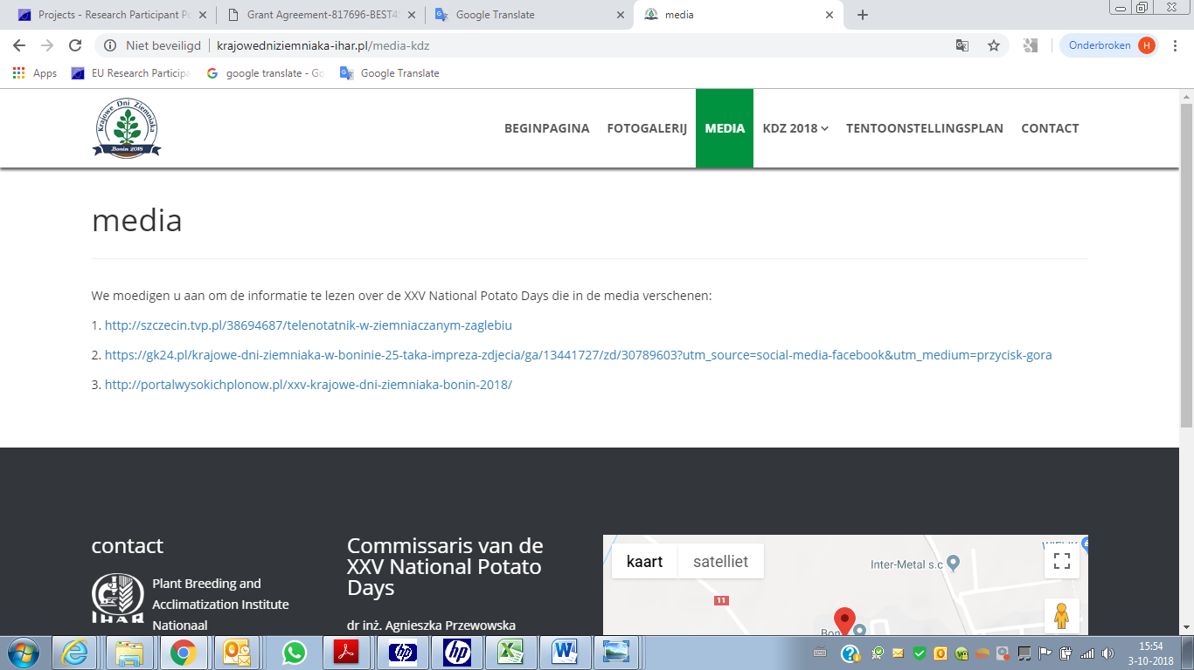

Demonstration event

Visitors
The organisation expected 5000 visitors, based on the number of people that visited the event in 2017. In reality there were far less visitors, around 2000.We spoke many stakeholders, all of them mentioned that there were far less people than during the 2017 event. For all of them this was disappointing. As we asked them for reasons, the most frequent answer was that the region was less suitable for the event, as the region has rather limited numbers of professional and modern potato growers.
The weather was perfect, and can not explain the low number of visitors.
The majority of the visitors did not belong to the most important target group, modern potato farmers, but were just people from the local community.
From the people we interviewed only 40% of the visitors were farmers. And they were intuitively‘ selected’, visitors that clearly were no farmers were not interviewed. Standholders estimated that only 10% of the total population was farmers.
From the interviewed, not being a farmer, approximately 50% is working in the agricultural sector.
All ages were present on the event, from young children to retired/grand parents.
The balance for the total event, for male and female was almost equal.

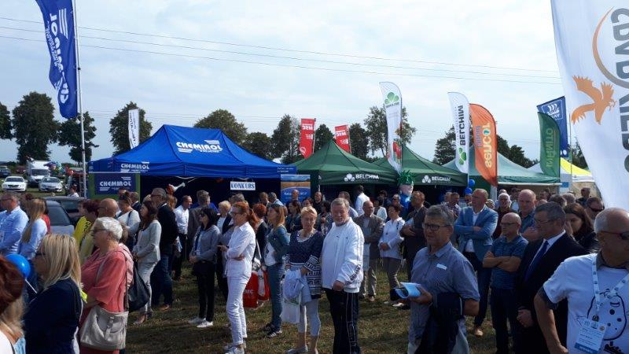
The central place, during the opening speech

In the field, were the demonstrations took place, a higher percentage of people were male, farmer and working in agriculture.

Public for the demonstration of potato harvesters

Communication & Mediation
In the central part of the event there was a large podium, this was used for the opening of the event, announcements, for a few presentations and some promotional activities. During demonstrations in the field the organization used a drone, recording the activities. Real time the recordings were shown on a big screen on the podium. There was rather limited attention for these videos. On the premises also a big tent was installed for workshops/lectures about technical aspects on Saturday, see also program of the event. Visitors didn’t have to sign up for these workshops, just could get in before or even during the presentations. The audience for the workshops was limited to 20-30 people. The method used in these workshops was power point presentations, with the opportunity to ask questions to the speaker. The presentations itself were not very interactive.
In de stands on the central field there were several ‘standard’ opportunities to see and taste all kinds of products.
There was no active mediation, to guide/attract people actively to the workshops or other demonstration activities.

Active participation
The visitors mainly walked around, and were nog actively attracted to the demonstration, demo fields, etc. To our opinion they missed many opportunities to make in more interesting for the visitors. In the field were many interesting issues to visit, but the people were not directed to the field, just on own initiative. Only the demonstration of the harvesters was announced, but the public was not guided to them. The consequence of this was that the majority of the people were in and around the stands .
Machine demonstrations: the different harvesters demonstrated one after another. A man with a microphone gave general information about the machine. During the demonstration the people stayed off the field, watching the harvesters from a relatively large distance. The organization missed opportunities to give relevant technical information about the machines to the visitors.

Doing business
The visitors could directly do business at the event, but this was rarely done, and also not usual at such events. We spoke to demonstrating companies and got the following remarks:
- HZPC, Dutch potato seed supplier. On the question why are you here: we cannot afford not to be present, as competitors are also present. They didn’t give a clear objective on the question what they want to achieve during the event. Their interest is to show their varieties, but the people were not very active in getting people into their stand or to the demonstration plots. They were disappointed by the small number of visitors. On the question will you come back next year the answer was no.
- Grimme, German manufacturer of potato harvesters, demonstrating potato harvesters. They are invited to many events, in several EU countries. They would like to visit less events, bigger events where they have the opportunity to meet their target group.
- WIOM, farm journal for the vegetable sector. Presentation of their products was their reason for attending the event. Didn’t expect to directly sell their products.
- Tradecorp Nutri-percormance. Product promotion was the reason for having a stand. Little attention for their products, due to the little number of potentional clients was their opinion of the event.

Role of sustainability
We didn’t find any explicit sustainability issues. The focus of the event was on technical options for optimizing production.

Unforeseen circumstances
The weather was perfect for such an event. As far as we can judge, there were no unforeseen circumstances.

Plans vs. practice
The event was very well organized. The demonstration field was managed very well, there were sufficient demonstration objects in the field. Many stakeholders were present, with a booth or a demonstration activity in the field.
The expectation of the organizers was to attract around 5000 people, no more than half of them are realized.
Based on the input we got from several stakeholders, 5000 visitors was too optimistic/whishfull thinking, as the region has too little professional potato growers, and growers from other parts of the country don’t take the effort to travel so far. Another point is also that there are many competing events for the specific target group. The professional potato farmers in Poland are oriented to other events, such as potato Europe and Agritechnica in Hannover.

Participants feedback
Allmost all stand holders we spoke told us that they were not satisfied, mainly because of too few visitors. Most participants couldn’t explicitly mention a clear objective for participation. The implicit way of thinking was that it will be a success when a large number of visitors show up. This can be understood as networking and talking to clients are reasons to join.
Companies with an activity in the field would have appreciated if the organization would have played a more active role in bringing people to the demonstration objects.
We asked stand holders and sponsors during and after the event.

At the beginning we asked them: What do you expect from the event? The answers we got came down to:
- to promote the company, company products, to convince clients to our brand
- many farmers, potential clients and industry in one place
- presentation of new potato varieties, to new and existing clients
- a stronger place on the agricultural market, meeting large farmers, potato market and value chain partners

After the event we called back 5 companies again, to get their opinion afterwards.

- What did you achieve during the event?
  - We did not achieve what we expected from this event, no financial transactions because few customers arrived, we can say that we have achieved some experience from the exhibitions shown
  - As of today, it is difficult to say anything because it was only a month after the event. We are at this point in the dead season, more can be said in the new season.
  - We do not know until the end, it depends on the sale, the advertising.
  - It was a small achievement for us, meeting only with a few clients

- What did you demonstrate
  - Potato harvesters, separator, planter
  - Several potato varieties
  - Fungicide treatment of potato tubers.
  - Effects of applying fertilizers.
- What did you learn from the event?
  - Nothing, everything was known, no great benefits, we are a trading company, we live with customers, we need clients to increase the company's income, we did not have any advantage from this event. The organizers are not interested in the needs of exhibitors, they just want to organize the event quickly.
  - We listen to customers, we try to be better, we did not manage to do this at these event. We met with the clients, we heard their comments, information about what on the market and what potato varieties have been used in the region
  - The first time they participated, we were disappointed because there were few farmers, and a lot of people who have nothing to do with agriculture, the event was not valuable.
  - The event did not stand out among other event, it was necessary to show yourself, and in particular when you want to advertise new products.

- What can we learn from the event/tips for the organisation?
  - Organizing better event, so that not only the organizers, but also the exhibitors have benefits, we do not want to participate in the event like this. Why do organizers organize event only to take money, subsidies? The organizers chose the wrong date of the event, just as last year they entered the event at the end of August, at the same time when farmers celebrate the harvest festival, customers will choose their own local events. We need broad thinking like grouped trips, the right place for the event, preferably in the center of Poland.
  - The organization was good, only the place was inappropriate. The location of the event is a region of producers, not customers. I have no further objections.
  - Lectures and demonstration shows accompany and attract customers to see the event, and this was missing at this event. The lectures that were shown were of little interest. Organization in Bonin should have more professional approach to the needs of the client, such as more professional demonstrations and lectures.
  - Another date of organizing the event, the best a central location, organizing collective events in order to be able to offer clients better knowledge, new technologies, and demonstration. It's not about talking to people, we want to advertise, pass the news and knowledge with professionals who will ask what kind of machine is it, what's the function ...? Entry fee to limit of a large number of visitors who just came to look.
  - First of all, proper location. The new machines were shown, if the companies (exhibitors) and customers will come, this will not be wasted time. Meeting among exhibitors is also an important factor, although the most important are and will be customers.
  - Low customer attendance. On Saturday, there were more customers than on Sunday. The producer focuses on clients, who were unfortunately not enough at the event. Not on the people who came to visit the event to see and taste.
  - Error connecting events. At this event, it was difficult to find valuable clients. It was not only the exhibitors of agriculture that could show up, but also exhibitors who had no connection with agriculture, such as the sale of jackets, honey ... The event should be aimed at farmers, and it was a party event, entertainment for residents.
- Do you use the event for further communication?
  - At the event we see the same faces, a very limited opportunity to reach new customers, better acquisition of clients through direct contact.
  - Yes, we try to get closer to the customer through the collected questionnaires, so that we can return to it with the commercial offer.
  - Yes, certainly some exchange of phones was with customers.
  - The most important thing is to communicate before the event, to encourage customers to visit, during the conversation to communicate the news, show. After the event, communication is not so significant, they are for sure but marketing contacts.

Motives, learning and networking

Reasons to attend demos
Attitudes and perceptions
Reasons we heard from visitors about why the attend:
- Curiosity, general interest in potatoes.
- See new varieties
- Interest in new products
- See new machinery and equipment
- Networking
- Entertainment

Norms
We didn’t ask the people these specific questions. But if we look at the art of the event and how it went, than our conclusion is that for most people it was a social event. This was also confirmed by the interviews we conducted.

Practicalities
Timing of the event. The event was organized in August, as also the previous events. Some of the interviewed stakeholders think this is the wrong moment. On the other hand, previous editions, in other parts of Poland got high number of visitors.

Does the demo made a difference to farm business
We talked to 80 visitors. Many of the were not practical farmers. From the farmers we spoke to, some of them showed specific interest in a specific machine, a potato variety, plant grow stimulators. But I don’t think that we can speak that the demo will make a diference for the farm business. Even if they decide to buy the machine, the variety of the plant grow stimulator.
People with interest for a new harvester had the opportunity to see different types and brand of machines. This might be interesting information for their decision, but that is not what we got out of the interviews.

The location was fine for local people, but apparently not attractive for people from other parts of Poland.

Forms of learning
There where different ways the information was presented to the visitors: lectures, product information in the stands, active demonstrations of machines in the field and passive demonstrations of fertilizer and plant protection strategies and potato varieties. But gathering information was to a large extent left to the initiative of the visitors. Little and only general explanation of the demonstrations. The demonstration fields had information posters, where people could read what the strategies applied were. On the podium, video recordings were presented. In a tent on the central field there were a series of workshops with power point presentations.

Content of learning
We have to distinguish between the different type of demonstrations:
- Potato harvesters. People could see the machines at work. But the information they got was very limited and not very specific. There was no interaction, no possibilities to ask questions. A demonstration/see a new potato harvester at work can be an interesting source of information but only is one of the steps in the buying process. See also the narratives in section 8. More ‘ready to use’ are products shown on the fields, such as fertilisers, crop protection products and varieties.
- Demonstration fields with fertilizer and crop protection products. There were no differences to see, as yield and quality was not measured, and will not be measured. There was no explanation in the field, is it not clear this was because there were no visitors or explanation was not foreseen. At least it was not organized.
- Demonstration of potato varieties. A few plants of all varieties were harvested, differences between varieties were visible. Also here no active explanation of differences and opportunities for the different varieties.
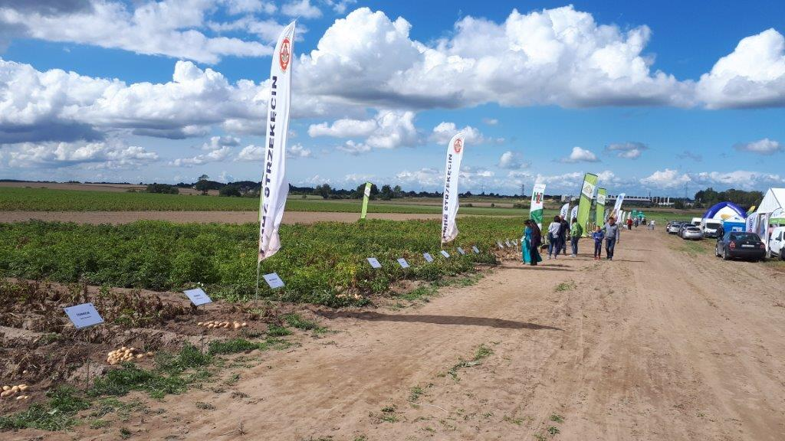

Outcomes of learning

We asked the people at the beginning of the event what they expected. When we focus on the farmers, quite a few of them had not specific expectations, came out of curiousity (no expectations at all). Others had more expectations, such as see new potato varieties, gathering new knowledge and information (not specific), watching new machines, get new contacts.

We asked people what they found most interesting, answers we got from farmers:
- Machinery
- New potato varieties
- New seed potato varieties (seed potato grower)
- Chemical products
And we asked them why, got some general answers and some specific:
- Searching a new potato variety
- Having problems with crop protecttion in potato, looking for new opportunites

And what do you take home:
- New varieties
- Potato harvester/other machinery
- Potato growth stimulator

What is the relevance of demonstrations for decision making on your farm
- Important, watching machines at work gives good impression
- Gives extended knowledge for decision making
- Orientation on new aspects, helps to take decisions

Other important sources of information:
- Newspapers and internet

And we asked them would you come back next year. Almost all of the answered yes. They were satisfied about the event, in contrast to the stand holders. This might indicate that the content of the event was interesting for farmers.

We asked the farmers we interviewed if we could call them back a few weeks after the event. But this was not easy, so far we only spoke to 2 farmers. They were both positive about the event, heard about the event on local radio and newspaper. One of them said he missed machines for small farmers, machines demonstrated were mainly for big farms.
And both farmers answered that they had seen interesting new potato varieties for their farm.
And we heard that there will be at least 2 articles in farm magazines.

Networking
From many of the visitors it was a social event. When asking the farmers, only a few answered that networking was one of the reasons to come. Most of them were technical oriented. We didn’t see a lot of discussions among the visitors during machine demonstrations or on the demonstration fields.

Anchoring: Application of demo lessons by participants

Anchoring related to the present demo
For the anchoring aspect we should distinguish between the different type of demonstrations and between products and investments.
- Use of new supplies. We got a few answers from farmers, having a problem with disease control in potatoes, that they were looking for new opportunities and that they found interesting new products (although this year was rather unfavourable for many potato diseases). It is to expect that they will use/test these products next year.
- Use of new varieties. New varieties were interesting for farmers, and I think that some of them will decide to try a new variety next year. As they could mention the names of the varieties, also after the event (‘Several varieties of potato that he would like to use on the farm, as: Asterix, late variety, industrial-fries. ‘Yes, potato varieties like Lord (mid-early variety), Bryza, Denar.
- Invest in new machinery. Farmers that plan to invest in new machines will not base there decision just on a demonstration but will gather information form more sources. A demonstration gives valuable information for taking such a decision. But although many farmers answered that the machine demonstrations were an interesting aspect of the event, non of the answered that they will buy a new machine as result of the demo.

Stimulating anchoring
The only follow-on activities we are aware of are publications on the web and press articles. Interviewed people answered that internet and newspapers are important sources of information.

Anchoring related to earlier demos

We have no other insights here as anchoring related to the present demo. Demo’s are in important source of information, for sure not the only one. Internet is of growing importance

Scaling: Application of demo lessons by the wider farming community

Retrospective examples of scaling

When we look at the Polish arable sector we see many changes in this century. Demonstrations for sure played a role in these changes:
- As the potato industry was introduced , they requested specific varieties. Demonstration fields of potatoes for the industry are organised by many different, mostly commercial, companies: the industry itself, testing different varieties, and the breeders/owners of the varieties (mostly from West European countries).
- Modernization of the bigger arable farms. Many new machines are bought by arable farmers. Old machinery, from the communistic period, was replaced by modern machines: sprayers, planters, harvesters, storage buildings en equipment. All the big Western European machine industry is represented in Poland (Grimme, John Deere, AVR, Agrifac, etc.) Demonstrations, national and international (Agritechnica Hannover, Potato Europe) demonstrations will have played a role in the decision making process.
- Use of pesticides and fertilizers. Here the same story, the big international suppliers are present with a sales organization: Yara, Syngenta, Bayer Crops Science, Adama, etc. ALs these companies have their own demonstration fields. There are little demonstrations supplying ‘independent’ information.

Prospective assessment of scaling: Impact pathways
The most important impact pathways to our opinion:
- Commercial advisors from suppliers of seeds, machinery, fertilizers and pesticides. These commercial players organise all kinds of promotion activities in order to sell their products.
- Peer to peer. Experiences and opinions from colleagues are an important source of information.
- Internet is of growing interest, more and more farmers search for information on internet.
- Newspapers still are a source of information, Top Agrar Poland is an example.
- Internet and newspapers are relevant sources of information, but not crucial for the decision whether or not to invest in an innovation.

Case study reflection

Demonstration – innovation narrative
Time line for the investment in a new potato harvester

Try out on own farm
2018
Contact dealer
2017
New machine on market
2015

________________________________________________________________
Investment decision
2019
See the machine at work
2017
Machine demonstrations
2016-2017

A big potato farmer in Poland has the intention to buy a new potato harvester, a 4 row harvester, self propelled, for 90 cm row distance. They search for the best machine available on the market. With this investment, a lot of money is at stake, Specific requirements are ‘soft treatment’ of the potatoes (little damage occurs during harvesting) and ability to deal with stones.
In 2015 a new innovative potato harvester was introduced in the market, with a special unit to separate stones from the potatoes. This machine is demonstrated by the producer at several demonstration events in Europe. Demonstrations are an important source of information for the farmer because one can realy see the machine at work and get a good impression on how the machine performs in practice. As a large grower, they gather information not only in Poland but also on international activities, for example on Potato Europe in 2017 and Agritechnica Hannover.
When there is an interest for a specific machine, the manufacturer is contacted, with the request to see the machine at work in practice, by other farmers using the same machine. Practical experience from peers also is an interesting source of information. As the machine was demonstrated also on the potato event in Bonin, august 2018, the manufacturer was asked for the opportunity to test the harvester at their own farm, not to far away from Bonin. They got this opportunity, and tested the harvester for 1 day on their farm. Also another interested farmer joined this test, a direct effect of the demo event in Bonin. The performance of the machine was tested and compared to the machine to replace: yield capacity, handling aspects, quality of work (especially product quality aspects like skin damage and internal bruises are assessed). If this test is positive the manufacture, and a competitor, is asked to make an offer. Based on all this information the final investment decision will be made.

Time line introduction new potato variety in the value chain
Test on larger scale (2 ha) few fields 2018 - 2019
Scaling up production
2020-2022
Potato days from breeders
Nov 2015

________________________________________________________________
New variety in the value chain
2023
Testing in processing
2019-2020
Variety testing small scale trial field 2016-2017

Fast food companies like McDonald’s use a lot of French fries. They have specific quality requirement for this product, the processing industry has to comply to these requirements. In practice this means that they only accept a limited list of varieties. Some of the most important varieties have ‘practical’ problems, they are not easy to grow or to store. The French fry industry, in Poland as well as in other countries, is therefore always looking for new varieties that match the requirements of the end user and are a better alternative for the growers and the processors.
Potato breeders have great interest to get their varieties on the positive list from the processors or other value chains (table potato or starch). Every year they show their new varieties. For example all the NL breeders and some from other countries show their varieties during the ‘national seed potato days’, every year in November in Emmeloord, The Netherlands. Breeders invite their clients from all over the world. Growers, but even more value chain partners.
Example of the French fry industry in Poland: they ask the breeders what interesting varieties they have to offer for a potato variety trial the next year: small fields where they test and compare several varieties form different breeders. Looking at yield and product quality (shape, length, dry matter, flesh colour, internal brown spots, hollow hearts, processing quality in lab tests). New varieties are tested a few consecutive years. The most promising varieties are selected and tested on a bigger scale: 2-5 ha. This mostly is done on a few different locations, in order to get information about the performance of a variety on different soil types. With this product there is also a test run conducted in the factory, to look at several aspects of processing and to assess the end product. The variety that stands all these tests can be put on the accepted variety list and scaling up the production among other (contract) growers can start.
During the phase of testing, growers get the opportunity to visit the trial fields. This is organised by the industry.
Breeders on the other hand also demonstrate the whole range of their varieties (from table to starch and processing varieties) in/on events like the national potato days in Benin and other events. Farmers are an important target group for these events. But in most cases product buyers determine what varieties they accept, and farmers always have to negotiate with the buyer of their product. In most cases farmers don’t have a free choice of variety.
Another aspect of the introduction of a new variety is the availability of sufficient seeds. Once a new variety is accepted in a certain value chain the breeder has to scale up the production of seeds. With help of rapid multiplication techniques this process goes much quicker than year ago, but it still takes a few years before sufficient seeds for a few hundred hectares in practice are available. The total period from a new variety up to large scale market introduction takes about 15 years.
As different varieties ask for different management practices, knowledge transfer about best practices for each variety is a crucial success factor in scaling up the acreage of a variety. Most of the breeders take responsibility for this knowledge transfer, being a crucial aspect of a successful introduction of a new variety.

Facilitating and impeding factors for successful demonstrations

What is a succesfull demonstration. This really depends on who you ask this question. Based on the interviews we had during the event with different stakeholders we come to the following indicators:
- High number of visitors. This indicator is mentioned by al people we talked to.
- Good location of the demonstration. Travel distance to the event should not be too long.
- Interesting/relevant demonstration objects for farmers and other interesting information visitors can get
- Just type of public. In Bonin a large number of visitors were not professionally interested in the potato crop. The appearance was more a family event than an event for professional potato growers.
- Strong interaction with the visitors.

Facilitating factors
- Several stakeholders from the potato value involved, with many different kinds of demonstrations. Demonstrations in the field and in the stands from the stakeholders
- Machine demonstrations. Machine demonstrations are attractive for farmers, always get attention in the agricultural sector.
- Good organisation of the event. The demonstration fields were well managed. The location gave good opportunities for machine demonstrations.
- Good/perfect weather

Impeding factors
- The location. Many stakeholders told us that in the Bonin region there are not too many professional potato growers compared to the central part of Poland, where the event was organised in 2017.
- Little interaction with the visitors. There was no active guidance of the visitors to the various demonstration objects. It was left to the visitors to go their way.
- Little of no explanation about the demonstration objects. This point is linked to the previous points, no organised interaction with the visitors. Visitors of the demonstrations didn’t get all the information that was there.

Impact of demonstrations

The event in Bonin had many interesting demonstrations and many stakeholders of the potato value chain were present. But most of the stakeholders we talked to were not satisfied about the event. From our point of view we recommend the organisers to consider the following point:
- Profile of the event. What kind of event should it be, and for what target group. The content of the event was mainly for professional potato growers, but the audience was mainly not professional related to the potato crop (farmers and partners in the value chain). Many of the visitors didn’t go into the field to visit the various demonstration fields and machine demonstrations.
- Organise a guided tour along the demonstration activities and give the stakeholders the opportunity to explain their demonstration object.
- Give more specific explanation during the machine demonstrations. For example, what are important aspects during harvesting potatoes, and what options do the different harvesters have on board. What are the best machine settings taking in account the specific field conditions. Judge the result of the different machines in the field, etc.
- Ask the stakeholders what they want to achieve during the event and discus how to facilitate this during and after the event.
- In order to achieve anchoring and scaling it could be interesting to collect specific information (in text, video, photo) from the demonstration objects, publish it on the website, perhaps in farm journalist and give it to the demonstrating partners for further use.

Impact domains
- Productivity & profitability. The demonstration activities and objects were related to technical aspects of the potato crop: inputs (fertilisers and pesticides), varieties, machinery.
- Resilience
- Sustainability. Sustainability was not a topic of the event.
- Quality of life. Was not addressed
- Empowerment. Was not addressed

Key lessons from this case study
The main lessons learnt from this case study:
- The event was organised very well, the demonstration field was well maintained and the demonstration objects were interesting and informative for farmers.
- Determine the target audience of the event and focus on the target group for promotion activities. The impression we got is that it was more a family event than a professional demonstration event for (potato) farmers. Stakeholders’ expectation and interest is to get in contact with existing and potential new clients. A high percentage of the visitors did not belong to the target group of the sponsors and stakeholders.
- Organise more interaction with the public. For example organise guided tours along the demonstration objects. This helps the visitors to get more information out of the event and is attractive for the stake holders. For example every 30 minutes/hour a small groups (10-20 people) go with an accompanist along all the objects. These tours should be announced by the audio installation: ’in 10 minutes the next tour leaves from….)
- Give more explanation at the machine demonstrations. Machine demonstrations attract farmers, it gives them a good opportunity to see a machine at work under field conditions. The information provided in Bonin was rather general and not specific. Farmers like to hear specific information about the machines and also like to hear comments on the quality of work of the machines. It would be good to have a independent specialist that gives explanation about all the machines.
- Stakeholder consultation and participation is important, as they have a good feeling for what’s going on in practice and what is interesting to show/demonstrate.
- Organise an evaluation with all the sponsors and stakeholders. Too many of them expressed their dissatisfaction with the event to us. All of them expected more professional visitors, and compared to the event in 2017, where most of them were also present.
- Gather and present, on the website, the results of the demonstration objects to the farmers community after the event. Including the presentation in the seminars.

Acknowledgements

We would like to thank Agnieska Przewodowska (IHAR), Engel Louwes (HZPC), Holger Lücke (Grimme), Gerhard Meiborg (Farm Frites), Piotr Kotowski (tradecorp), Tomasz Krasowski, Patrycja and Emiel Kamminga.

Annexes

Data sources
Here you can list the sources used, e.g. literature, websites, activities you visited, people you interviewed. You may also provide a copy of information briefs (e.g. from the organisers) on the demo.
- Several websites, the IHAR event website in particular
- Observations during the 2 days of the event
- Interviews during the day
- Telephone calls a few weeks after the event

Data collection methods
Briefly describe the data collection methods that you have used for the various topics.
When you’ve used questionnaires, and/or question lists for interviews, provide the text of these.

- Internet analysis. Before the event we searched for information about the event over the last years.

- Media analysis. We have been searching for information that was published about the event in the media.

- In depth interview with the organiser. Three months before the event we had an in depth interview with the organiser about ambition, goals and content of the event.

- Participatory observation during the event. During the event we observed several aspects of the demonstrations, what type of demo’s, the methods used, the organisation around the demos.

- Interviews during the event based on a questionnaire. Several visitors were interviewed during the event. As there were many visitors from outside agriculture we tried to select expected practitioners (not the grandfathers with their grand children)

- Interviews after the event based on a questionnaire. We called back a few visitors we interviewed during the event. We asked their consent for doing this at the event.

- Photography during the event. Several pictures were made during the event. Some of them are used in this report.

- In depth interview with stakeholders a few weeks after the event. Early November we interviewed three stakeholders who were present at the event.

