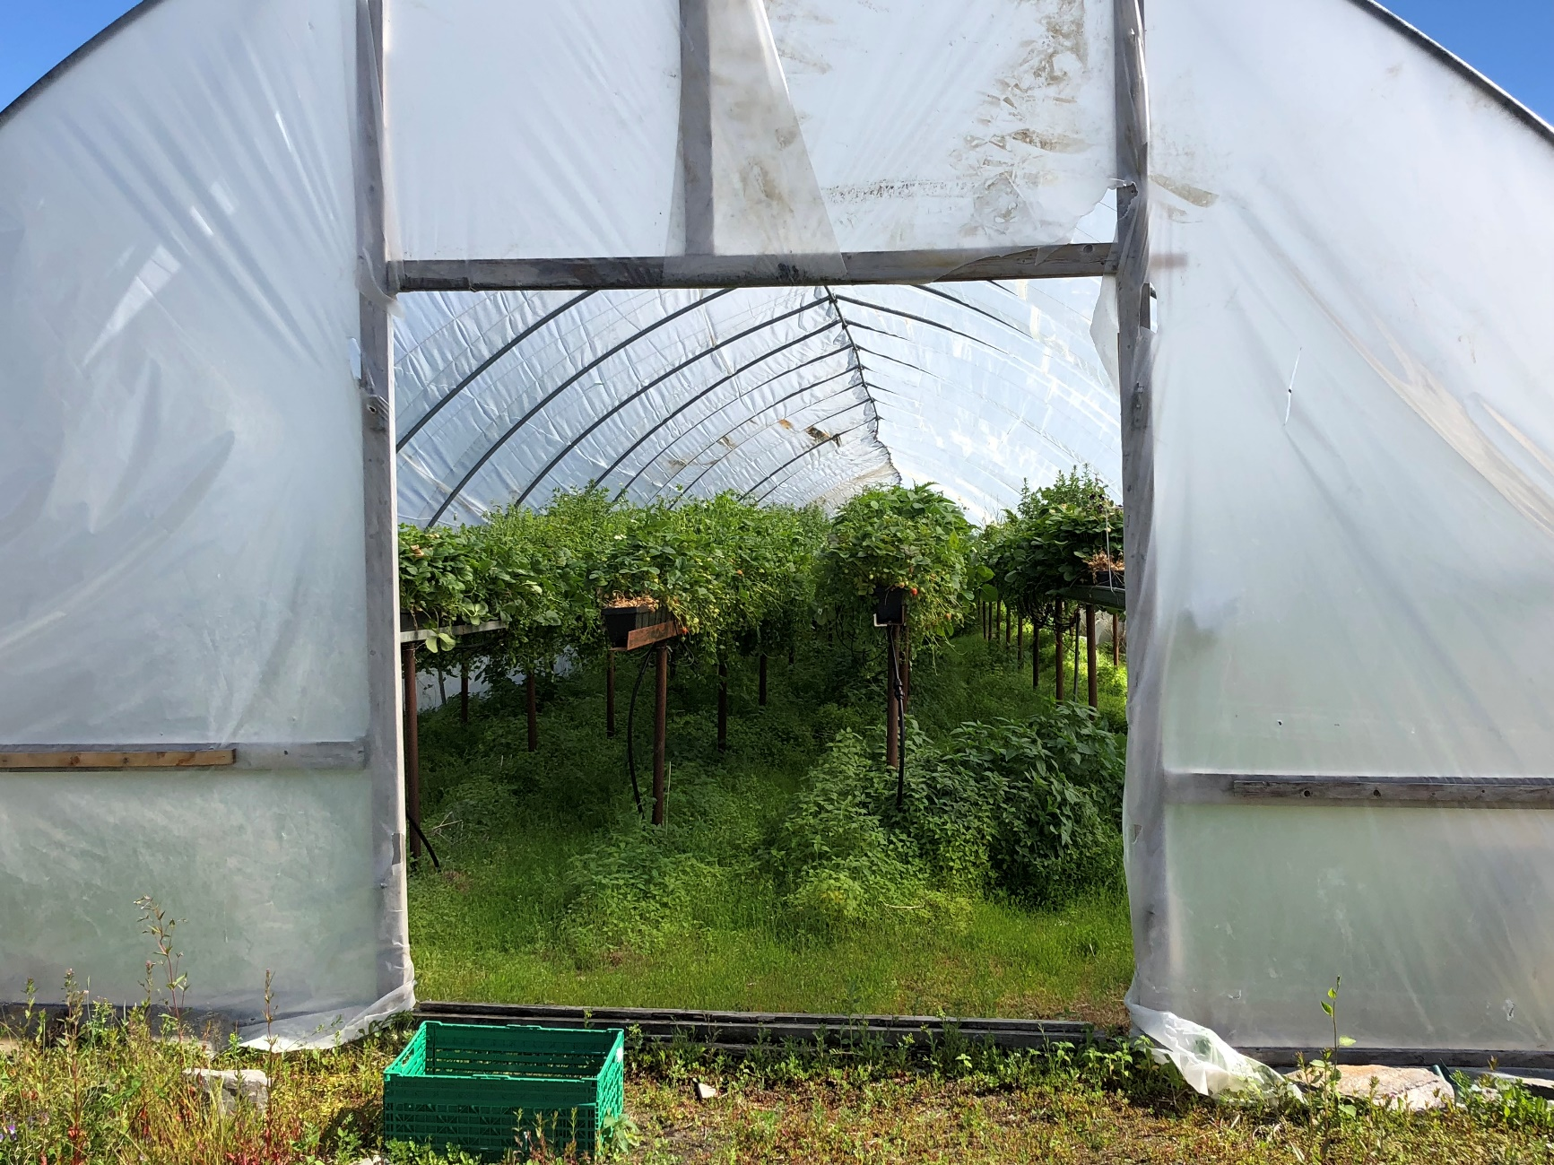

Date: November 2018

Country report: Norway (NOR)

Case Study: NOR2: Theme Day - Berry production in plastic tunnels

WP5: Case studies of demonstration activities in commercial farms

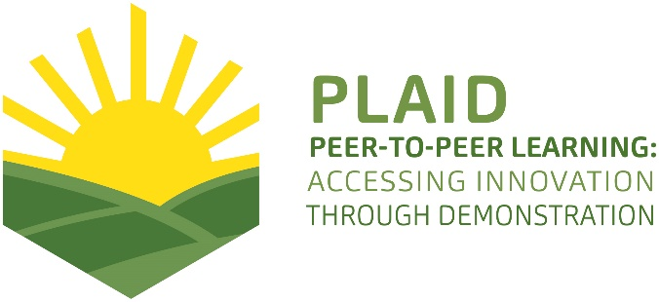
Photo: Marit S. Haugen
This project has received funding from the European Union’s Horizon 2020 research and innovation program under Grant Agreement No 727388

PLAID PARTNERS

Advisory Service Croatia ASC | 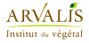  ARVALIS Institut du Végétal | Association de Coordination Technique Agricole ACTA
Institute for Rural and Regional Research | 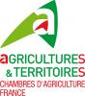  Chambers of Agriculture | Delphy
European Forum for Agricultural and Rural Advisory Services EUFRAS | Innovatiesteunpunt ISP | Institut de l’Elevage – Idele
Instituto Navarro De Tecnologías E Infraestructuras Agrolimentarias | Linking Environment and Farming LEAF | 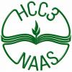  National Agricultural Advisory Service
Nodibinajums Baltic Studies Centre (BSC) | Research Institute of Organic Agriculture (FIBL) | Stichting Wageningen Research
The James Hutton Institute | VINIDEA

DOCUMENT SUMMARY

__________________________________________________________________________________
Milestone Title: 24 Case Studies
__________________________________________________________________________________
Case Study Title: Theme Day - Berry production in plastic tunnels (NOR2)
__________________________________________________________________________________
Version: 1
__________________________________________________________________________________
Task Lead: WUR
__________________________________________________________________________________
Related Work package: WP5
__________________________________________________________________________________
Authors: Rita Moseng Sivertsvik, Marit S. Haugen
__________________________________________________________________________________
Grant Agreement Number: 727388
__________________________________________________________________________________
Project name: PLAID
__________________________________________________________________________________
Start date of Project: January 2017
__________________________________________________________________________________
Duration: 30 Months
__________________________________________________________________________________
Project coordinator: The James Hutton Institute

ABSTRACT

Demonstration activities related to agriculture in Norway primarily involve field days, field walks and experimental fields. Events are commonly organised by the Norwegian Agricultural Extension Service (NLR) in cooperation with host farmers, but often also involve county officials, experts and other agricultural organizations as partners. Through these events, the NLR promotes cooperation between farmers by providing a meeting place for farmers with different knowledge and experience, as well as advisors and experts with research-based knowledge and knowledge of local conditions. By sharing experiences, participants are able to develop a better understanding of both the theory and practice behind the activity and thus improve outcomes. Two Norwegian case studies will investigate how demonstration days are organised, who participates, what issues are of interest, how knowledge is generated and how participation promotes long-term change. We will pay particular attention to the gender perspective – examining womens’ integration in demonstration activities and their role in knowledge networks. Findings from the Norwegian study in combination with those from other parts of Europe will help improve the organisation and effectiveness of demonstration in Norway. This case report (Case 2) will describe a theme day about berry production, and how Norwegian berry farmers are encouraged to increase the production of berries in tunnels, extend the berry season and optimize the use of fertilizer and pesticides (i.e. reduce the use of conventional pesticides). The demonstration was held on a farm where the host farmer produces strawberries in plastic tunnels using a table-top system. The demonstration day was a combination of practical and theoretical input.

In Norwegian:
Demonstrasjonsaktiviteter knyttet til landbruket i Norge har først og fremst vært knyttet til markdager, feltvandringer og forsøksfelt organisert av Norsk Landbruksrådgivning i samarbeid med vertsbonde, men ofte også med fylkesmannen, fagpersoner og andre landbruksorganisasjoner som partnere. Gjennom slike demonstrasjonsdager og markvandringer fremmer NLR samarbeid mellom bønder i regionen, og legger til rette for en møteplass mellom bønder som sitter på ulike erfaringer, samt rådgivere og fagfolk som har forskningsbasert kunnskap og relevante kunnskaper om de lokale forholdene. Dette legger til rette for at man under både den teoretiske og praktiske delen av demonstrasjonen deler kunnskaper og erfaringer som kommer alle til gode, som videre vil gi utvikling og forbedring av praksisen. To norske casestudier vil undersøke hvordan demonstrasjonsdager er organisert, hvem som deltar, hvilke temaer som er av interesse, hvordan kunnskap genereres og hvordan deltakelse fremmer langsiktig endring av praksis. På grunn av det relativt store antallet kvinner i landbruket i Norge, legger vi særlig vekt på kjønnsperspektivet, og undersøker kvinners integrasjon i demonstrasjonsaktiviteter og deres rolle i kunnskapsnettverk. Resultater fra den norske studien i kombinasjon med de fra andre deler av Europa vil bidra til å forbedre organiseringen og effekten av demonstrasjonsaktiviteter i Norge. Denne rapporten vil beskrive Case 2 som er en fagdag om bærproduksjon, og hvordan bruk av plasttunneler og «table-top» systemer kan bidra til økt produksjon, lengre vekstsesong, reduksjon av gjødselbruk og sprøytemidler i bærproduksjon. Fagdagen besto av en praktisk og en teoretisk del.

In making this report, we have used different sources of information. The main sources are observation made by researchers during the demonstration event, informal conversations with the organisers, experts and participants during the event, telephone interviews with the local organiser, external expert and four participants after the demonstration event, and one on-site interview with one participant after the demonstration event. All the interviews were recorded and transcribed.

TABLE OF CONTENTS

1 Demo context 8
1.1 The value chain 8
1.2 Typical farm characteristics 8
1.3 AKIS 9
1.4 Sustainability challenges 10
2 Demonstration summary 11
3 Governance: set up and organisation 16
3.1 Organiser(s) and history 16
3.2 Funding 17
3.3 Host(s) 17
3.4 Gender 17
3.5 Objective(s) 18
3.6 Topic(s) 19
3.7 Access 20
4 Demonstration event 22
4.1 Visitors 22
4.2 Communication & Mediation 22
4.3 Active participation 23
4.4 Doing business 23
4.5 Role of sustainability 23
4.6 Unforeseen circumstances 25
4.7 Plans vs. practice 25
4.8 Participants feedback 26
5 Motives, learning and networking 27
5.1 Reasons to attend demos 27
5.2 Forms of learning 29
5.3 Content of learning 31
5.4 Outcomes of learning 31
5.5 Networking 31
6 Anchoring: Application of demo lessons by participants 33
6.1 Anchoring related to the present demo 33
6.2 Stimulating anchoring 35
6.3 Anchoring related to earlier demos 35
7 Scaling: Application of demo lessons by the wider farming community 36
7.1 Retrospective examples of scaling 36
7.2 Prospective assessment of scaling: Impact pathways 36
8 Case study reflection 37
8.1 Facilitating and impeding factors for successful demonstrations 37
8.2 Demonstration-innovation narrative 39
8.3 Impact of demonstrations 41
8.4 Key lessons from this case study 42
9 Annexes 44
9.1 Data sources 44
9.2 Data collection methods 44

Demo context

The value chain
The demonstrations held during the theme day about berry production in tunnels addressed various challenges, opportunities and problems associated with this theme. The value chain consists of companies who sells the berry plants (in this case strawberries), and companies dealing in fertilizers, pesticides and equipment – such as table top-systems and irrigation systems. A very important actor in relation to knowledge dissemination, expertise and advice in the field is the Norwegian Agricultural Extension Service (NLR), who is responsible for organising theme days/field days like this. NLR covers 10 regions with 260 advisers, with 57 employees located in the region of Trøndelag. On the theme day NLR was represented by two local organisers and one external expert in the field. The external expert came from a NLR unit in Southern parts of Norway. Another important actor on the theme day was the host farmer who provided his fields for demonstration. Other actors include the target market audience; farmers interested in agriculture that are engaged in berry production. In this case these actors were mostly other farmers engaged in berry production, both beginners in the field and actors with more experience. Their role was to gather knowledge, share experiences and challenges together with the adviser, the host farmer, the organisers, and the other farmers present on the theme day. This group jointly explores solutions, raises the quality of this type of production and improve their own practices.

Typical farm characteristics
In the year 2000 there were 1200 strawberry farmers in Norway. In 2016 there were only 358. Norway is losing berry producers and is having to import more strawberries. Strawberries are the most important berries in Norway, accounting for about 70% of all berries grown in the country. In 2017, 8500 tons of strawberries were produced by Norwegian farmers. Most of the berries are produced for the consumers to buy, either through direct sales or via grocery stores and the like. Some of the crop is delivered to industry. Organic production is a small part of strawberry production in Norway. By 2017, the area of ​​strawberries was 15,000 acres, of which only 78 acres were organic or produced during conversion to organic farming. Strawberries are grown in all counties, but the counties with the largest productions are situated in eastern Norway. Most strawberry farmers are large-scale producers, with cultivation in kitchen gardens for self-consumption only a small percentage of production.

AKIS

The NLR field days/theme days promote cooperation between farmers in the region by providing a meeting place for farmers with different experiences, as well as advisors with research-based knowledge and relevant knowledge of local conditions. This facilitates the sharing of knowledge and experiences that will benefit everyone on the field days and further develop and improve the practice. The NLR field days therefore facilitate knowledge dissemination, development and innovation, as well as networking between actors/farmers. Knowledge is developed through a collaboration between farmers, advisors and researchers, through dialogue, discussion and demonstration of practice.

In the NLR there are 16 advisors with expertise in berry production. These advisors cover most of the country. In Mid-Norway there are four advisors on berry and fruit, three women and one men. The consultants have a close cooperation coordinated by the fruit and berry coordinator, and the Committee for Fruit and Berries in NLR.

The NLR also has cooperative agreements with research and development organisations (R&D). NIBIO (Norwegian Institute of Bioeconomy Research) is the most important partner, and representatives from the different organisations meet regularly for professional discussions.

Other important organisations that cooperate with the NLR are the county governor's agricultural departments (development of project ideas and funding), the milk cooperative TINE (counselling and competence building), and Nortura (counselling and competence building). Felleskjøpet Agri (Norwegian Agricultural Purchasing and Marketing Co-operation), Norgesfôr and YARA, The Green Producers' Cooperation Council (GPS), the Norwegian Food Safety Authority, the Agriculture Directorate, the Joint Committee for Experimental Equipment (FFU), the Student Association and Society, the Norwegian Agricultural Cooperative, and ‘Nationen’ (a newspaper targeted at farmers that reports weather and growth levels) provide additional support.

Sustainability challenges
In the last ten years, the number of strawberry farmers has been reduced, and uncertainty related to crops and that it is time- and resource-intensive are probable causes. This relates to both the environmental, social and economic aspects of sustainability. Use of tunnels reduces the uncertainty and risks for losing the crop, and the table-tops in the tunnels improve the work environment and make the picking of strawberries more efficient and pleasant. Regarding the environmental aspect, climate creates challenges for berry production. High temperatures and droughts, as well as precipitation and humidity have been key issues in several theme days in this field. This will be elaborated more in section 4.5.

Demonstration summary

The theme day was organised by the Trøndelag branch of the Norwegian Agricultural Extension Service (NLR). The NLR is an organisation that provides impartial advice to 3800 members in the Trøndelag region. The organisation has competences in, among other areas, soil and plant protection, agricultural economics, accounting and health and safety issues. Advice provided is based on research, local conditions and long experience. Technically speaking, the NLR organises the theme day, but even though farmers place their fields/areas in the hands of the NLR, they contribute themselves to knowledge formation. Two local organisers and one external expert from the southern region will in this case represent the NLR.
The theme day was held on a quite large farm in a municipality in the northern parts of Trøndelag. The demonstration and the theme day focused on berry production, mainly strawberries, and the use of tunnels for cultivation. The initiator was the local advisory organization for berries, which is a part of the Norwegian Agricultural Extension Service. According to the organiser the target group was established berry producers, mainly strawberry producers, and those considering starting such production. The purpose of the theme day was to show the producers/farmers the opportunities they have, how berries can be produced in a more reliable (weather wise) and more cost-effective way by using tunnels, but also to give the participants the opportunity to ask questions and exchange experiences.

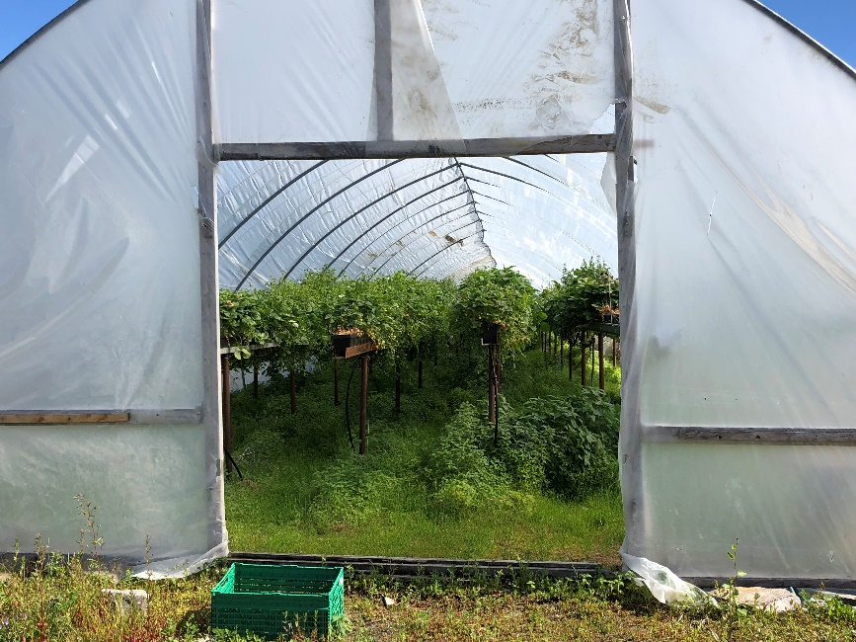
Photo: Marit S. Haugen

Regarding the Plaid-project, this case will make an important contribution to Plaid by illustrating a typical method of demonstration in Norway. It provides a useful example of how to organise and facilitate high-quality knowledge dissemination between farmers in a country with large geographical distances, landscape and climate inequalities, and thus different regional challenges. Farmers are able to find an overview of field days in their local region on the NLR’s website and can choose demonstrations that suit their own operations, knowledge and location. This approach seeks to minimise the long distances required to travel that Norway experiences – providing an example of how this issue is resolved in the Norwegian context.
At the theme day, the local organisers started with a short welcome-speech in the farmyard. They did a presentation of the host farmer and the external expert – who had travelled from another region in Norway. Then there was a presentation round of all participants, each telling where they came from and what kind of production they were running/engaged in. As researchers participating at the theme day, we also presented ourselves, and informed the participants about our role – that we were there to learn about how such demonstrations take place, and what kind of information and knowledge is being exchanged.

The host farmer noted that he took over the farm in 1990, and started quite quickly with berry production, first open field cultivation, before gradually diversifying to tunnels. During the presentation round, he spoke about various challenges he had encountered over the years, about cultivation in tunnels, and the berries that he produces. He has made the most progress in the field and has worked with strawberry-production in tunnels for more than ten years. He is a large-scale producer, and a pioneer in tunnel farming in Trøndelag.

We noticed that several of the participants greeted each other when they arrived, and many of them in such a way that it appeared to us that they had met before. It emerged that several were part of the same berry- / fruit-growing network.

After the presentation round, we went for a few hours field walk to see and learn about how tunnel production works, and look at and learn about the characteristics of the different types of strawberries the host farmer produces. We stopped a lot along the way and walked into the different tunnels, but also looked at the crops in the open air. Both the visiting expert and the host farmer told us about the challenges with cultivating in tunnels, the pros and cons of the different types of strawberries, and showed us the different varieties.

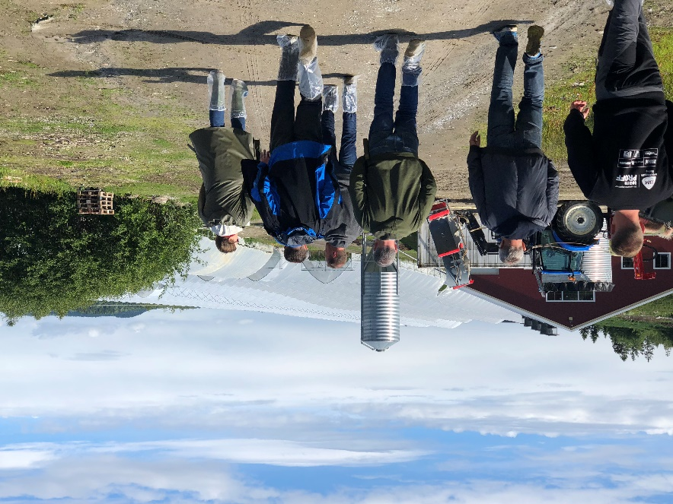
Photo: Marit S. Haugen

Other topics dealt with the use of fertilizers and the use of irrigation-system, and which systems may be appropriate. The importance of airing and keeping the right temperature in the tunnels, crop yields of the different strawberry varieties, what pests and insects can be challenging, production methods, economic aspects of such production, as well as tips and solutions for how this can also be done on a smaller scale were also topics. There was a lot of questions and talk about the tunnels, such as the cost of building tunnels and the practical details about the layout of the pipe constructions and the plastic deck that has to be taken down every winter. The host farmer demonstrated how he had built and made his own "table-top" system in some of the tunnels. The “table-tops” are expensive to purchase, which makes it profitable to make them themselves. It was also possible to taste berries along the way and there were some discussions about strawberry varieties, taste and quality.

At one of the stops we took a closer look at the irrigation-system. The last part of the field walk was raspberry production, mainly in the open air. Most of the participants attended the theme day to learn about strawberries, but some were raspberries producers and therefore were mainly interested in learning about how the host farmer produces them, and looking for tips about good methods of fertilization and irrigation.

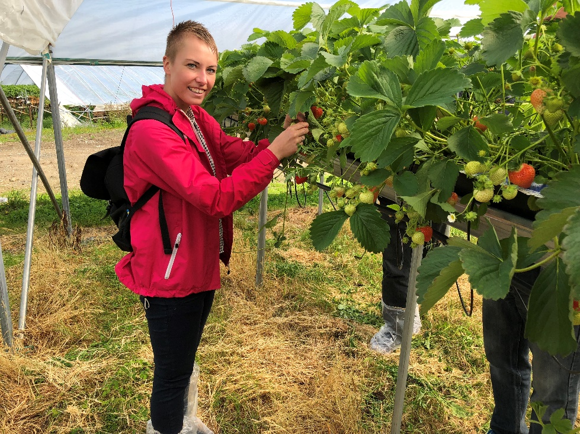
Photo: Marit S. Haugen

The expert conveyed the various themes and aspects in an educational and understandable manner to the participants. We noticed that the participants asked both the host farmer, the expert and each other, both during each stop, but also along the way as we walked between the different places. They asked each other about tips and advices, exchanged experiences, and discussed practical approaches to different challenges. For instance, two of the farmers discussed the opportunities to cooperate when buying tunnels and hiring a construction firm to build the them in order to reduce costs. Both positive and negative experiences were shared. It seemed very natural for all participants to talk to each other and to ask questions to both the farmer and the advisor. Naturally, several smaller groups were established during the walk, where those with similar productions found each other and discussed experiences along the way. Here we became aware that women spoke mainly with other women and men with each other.
Photo: Marit S. Haugen
The last part of the program was indoors, in the lunchroom for the workers on the farm. The local organisers offered coffee and sandwiches, fruit and biscuits for all he participants, and many of the participants continued the informal discussions from the field walk while eating. Furthermore, one of the female advisors in NLR Trøndelag held a lecture before the visiting professional advisor took over and held a lecture about strawberry production in tunnels. He showed pictures, film clips and shared experiences from similar production from other parts of the country. The participants could ask questions during the presentation and afterwards. When the presentations were finished, the local advisors thanked for the attendance, and emphasized the importance of so many people attending, which is an important signal of continuing with such theme days. Some of the participants were standing outside talking afterward, and the experience exchange seemed to continue until they left the place.

Governance: set up and organisation

This section provides information about the organiser of the theme day, information regarding general conditions and framework for completion of the day, and information about how the theme day was organised. The section also includes reflections and information upon gender perspectives, objectives and topics, and the targeted and approached audiences.

Organiser(s) and history
The theme day was organised by the Trøndelag branch of Norwegian Agricultural Extension Service (NLR). NLR is an organisation that provides impartial advice to 3800 members in the Trøndelag region. The organisation has competences in, among other areas, soil and plant protection, agricultural economics, accounting and health and safety issues. Advice provided is based on research, local conditions and long experience. NLR arrange field days about various topics all over the country and in all the different regions several times throughout the year, depending on which production who is relevant at that time/season. Some of the theme days are organised like this one, with both a field walk and then some theory/lecture. Others are only organised as field walks.

Technically speaking, it is the NLR that organises the field day, but even though farmers place their fields/areas in the hands of the NLR, they contribute themselves to knowledge formation. NLR had two local organisers at this theme day, and one expert from the Eastern region of NLR. One of the local organisers from NLR Trøndelag is an expert on berry production and initiated the theme day. It is part of her role as an advisor to have contact with the members. She regularly visits the members engaged in berry production, identifying the challenges they face, and gives professional input and advice where there is a need and desire for it. In addition, she has a wide network of other advisors in berry production throughout the country, and through her network she gets input regarding what kind of theme days may be appropriate to arrange.

The theme day on the strawberry farm was the second day of two theme days on this topic. The first day was theoretical, while this one was a more practical demonstration of using tunnels, in addition to expert advice. The local organiser’s role was to organise and coordinate all that was happening during the theme day. She had sent information to all the members interested in the theme, as well as people who are not members in NLR, but who participates in various berry projects and therefore might be interested. She made the appointment with the host farmer, arranged for catering, sent out invoices after the event, and she wrote a report to the NLR. The other local organiser, also a woman, works mostly with organic farming on berries, fruits and vegetables. She has the overview of those involved in organic farming, and made suggestions about relevant famers to invite. She also wanted to attend the theme day herself, and participated in the discussions and also helped with the practicalities during the day.

The expert hired from the eastern region of the NLR, also lecturered during the first theme day three months earlier on the same topic (part 1). He worked many years as an advisor in the field of berry production and production in tunnels. He has also written articles in the Norwegian “Frukt & Bær” (fruit and berries) magazine and contributes at the annual Berries seminar. He was leading the theme day and the field walk.

Funding
There were various sources of funding of this theme day. NLR paid for some of it through its “green funds”; government funds given to NLR to use within the vegetable sector and given to organise such theme days. NLR also received contributions from the county administration. Each participant also had to pay a participation fee of 700 NOK (70 Euro).

Host(s)
The local organiser chose this host farmer because he has most experience with cultivation of berries in tunnel in the region. In addition, he has participated in a number of projects about production of berries in tunnels. He has a broad background for the choices he has taken and the basis for trying out new things. He is the largest producer in this region. He is recognised as a successful farmer by the organisers, and is referred to as a pioneer in this field in the region: “he is future-oriented, and he can inspire people”.

Gender
Regarding the gender perspective, men and women played different roles in commissioning, organising and holding the demonstration. The two local organisers were women, and the external expert and host farmer were men. The women took care of the practical aspects of the completion of the theme day, such as start-up and welcome. They brought the technical and practical equipment for the indoor presentations and organised this, organised the food service and monitored the time spent on the various parts of the day. The main organiser also held one of the two academic presentations. Both women were active and involved in the field walk, and contributed with input and professional reflections where it was natural.

The external expert and the host farmer were men. The expert was leading the field walk and he held the main academic presentation. He was not involved in the practical aspects of the organizing. The host farmer attended both the field walk and the lectures, and his role was to inform about his production, give some input at the different stops during the field walk, and answer questions from both the expert and participants. He provided the meeting room in one of the farm buildings.

Of the ten participants, there were eight men and two women. The two women were both farmers operating a farm. According to the organiser, it is the farm operators that usually attend theme days like this, and women farmers are still a minority in Norway. The expert told us that usually it is between 20-30 percent women attending theme days like this one, but when they organized a course in organic red raspberry production 90 percent women attended. He confirmed that most traditional berry producers are men, but in the case of organic farming women are more interested than men.

Objective(s)
The objective of the organisers at the theme day was to inform relatively broadly about the use of tunnels in berry production. This is quite new in this field, and there are not many doing this in this region. The objective was a broad presentation of the possibilities, the technical aspects and the economic aspects. In this way the farmers acquire knowledge so that they are better equipped to make the decision to do this or not. The host farmer has such a versatile production within this field that it became possible to show how this is done in practice and that there are many ways to do it - this should only be an example – but a good one. Furthermore, the objective with field days in general on this topic is to increase the prevalence of berry farming in Trøndelag - either starting-up new producers or expanding the production of those who already operate in this field. The organisers all shared these objectives.

Production can be vulnerable to generational change, so it is also important to involve the next generation. The organiser therefore had an implicit goal of reaching out to younger generations. It was also important for the organisers to facilitate in a manner that encouraged participants to get to know each other. As there are so few farmers within this field, it is important to create a friendly environment and facilitate cooperation.

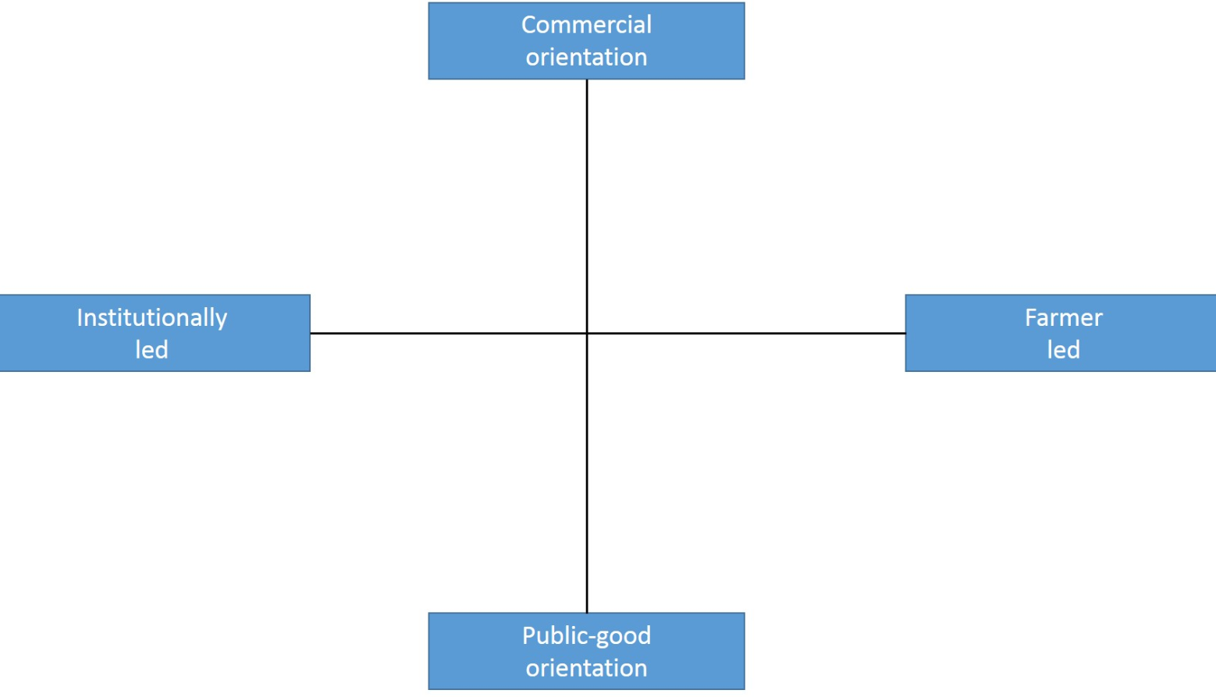

Figure 1: The berry production case in the PLAID typology of demonstrations

Regarding the PLAID typology of demonstrations, this demonstration is for public good and institutionally led (Figure 1). The farmer is also involved and has an active role in discussions, giving inputs and sharing experiences, but he is not responsible for conducting the theme day.

Topic(s)
The topic of the demonstration was berry production in tunnels. This topic was selected because it is future-oriented, and at the same time one of the safest productions economically to engage in. The local organisers also chose this topic to facilitate that those who wish to start with berry production or to expand their production get the necessary information on how they can do it. This is part of the strategy of motivating and inspiring more people to start with berry farming, and increase the number of producers in this region.

Access
The targeted audience were established berry producers and the ones who are considering starting with such production. The use of tunnels is a new aspect for many berry farmers, and something future-oriented. There are not many farmers in this region doing this. That might have been an important factor to make the theme day attractive. The host farmer is also well known in the region, and it is well known that he has a lot of experience. This was the second day of two theme days about the same topic, which also attracts the attendants to return and to meet their colleagues from last time. Six of those who attended this theme day participated also the first day some months before.

Each region has a membership system where they check for what production types the members are engaged in. Members are contacted directly by one of NLR's advisors when a theme day is organised within their production field. In addition, a public invitation is sent out through the NLR website and one through the email list of all members. In this way, the organisers know they will reach the target audience. They also send out the invitation to the municipalities in the relevant areas. This is not done consistently, but they are trying to improve that.

The organisers chose to hold the demo in daytime, to be able to reach out to most farmers. However, this might exclude those having additional jobs at daytime, and sole farmers who need someone to look after the farm while he/she is gone. It might be more difficult to get help at daytime while most people are at work.

Another aspect is the host for the theme day. He is a large scale producer with a lot of experience. One of the participants stated in the interview after the demonstration day that one could lose the courage because one is a small-scale producer. Coming to this farm learning how to improve or expand the production, and learning about the benefits of investing in new equipment, may seem far away – even though all the improvements presented at this day also are possible to do for small scale producers, which the advisors and the host also stressed several times. It may seem dissuasive and signal that you need to have a lot of experience to make it happen, even if it is not the purpose. Some possible participants may think that it does not fit small scale producers or those in the start-up phase. However, only one of the informants mentioned this, and there were also small-scale producers in the start-up phase attending the demonstration day.

Regarding who did not attend the event, relevant stakeholders like Innovation Norway, plant manufacturers and fertilizer manufacturers could have been contacted and participated. They are the facilitators, and should know what kind of support the farmers need, equipment needed and so on.

Demonstration event

This section provides information about the theme day, including information about the visitors, communication between the participants, the advisors and the host, and how the theme day was conducted.

Visitors
The number of visitors at the theme day were 10. According to organisers, it is common that the number of participants is around 10 on such days. It can be expected up to 30 during theme days / field days for cereals, potatoes, and if machines are involved. This is because these are larger industries.

Out of the 10 participants, two of them were female. Initially three women had signed up, but one of them was prevented from coming. The women participated in the same way as the other participants, and were as much involved in the exchange of experiences and questions as the male participants. The organisers contend that usually attendance is between 20-30% women. On the other hand, there is an overproportion of women who engage in organic berry production, up to 90 %. Nevertheless, it is clear that it is mostly men engaging in berry production. Between 20-30% run the production together with spouse / partner, half is run only by men. Nevertheless, a high proportion of women engage in berry production compared to other productions. That may be because berry farming has traditionally been women’s responsibility to a greater extent than men’s.

The organiser explains:

This [berries] is probably a type of production that attracts women. Gardening, something in between, they do not want large-scale, rather a little bit smaller scale, and may be processing. Contrary to men who want to operate in a larger scale. You might say that gardening probably is a type of production that appeals more to women. There are only a few women who are responsible for operating a farm. Those who were here today were both responsible for operating the farm. And that is what characterize those who participate, it is those that are responsible for operating the farm that participate. Sometimes couples participate, if both are involved in the operation.

Communication & Mediation
The theme day had a theoretical part at the end of the day with two lectures by one of the local organisers and the external expert. The lectures were held inside in one of the farm-buildings, combined with some food serving. The presenters used power-point with pictures, videos and written explanations and examples. It was possible to ask questions both during and after the presentations. In the aftermath of the theme day, the organiser sent her power-point presentation (about plant protection) by e-mail to all the participants. Regarding tasting of relevant products, the participants were allowed to taste the different types of strawberries produced in the tunnels as a part of one of the stops during the field walk.

Active participation
The first part of the theme day was organised as a field walk of approximately two hours. The host farmer and the external expert were leading the walk, and the expert had planned stops along the various berry fields and different tunnels where he addressed different topics. Both the host farmer and the participants asked questions to the expert during these stops, and shared their own experiences. The informal setting outdoors made it easy for the participants to talk to each other and to the advisor and host farmer along the way. They asked other participants about tips and advices, exchanged experiences, and discussed practical approaches to different challenges. Both positive and negative experiences were shared. Naturally, several groups were established along the way, where those with similar productions found each other and discussed their experiences. Here we became aware that the women spoke mainly with other women and men with each other.
Photo: Marit S. Haugen
During the indoor session, many of the participants continued the experience exchange from the field walk before and after the lectures. Several of them were also standing outside talking after the theme day were formally over, and the experience exchange seemed to continue until they left the place.

Doing business
This was not a commercial theme day, and the participants could not directly ‘do business’ at the demo, and nothing was sold during the theme day.

Role of sustainability
The role of economic sustainability were discussed throughout the day. It is quite expensive to invest in the tunnels and the equipment needed (between 8000-9000 euros per hectare), but there were many who considered to start with this and had questions about what a small-scale farmer would expect to invest. Both costs and earnings were discussed with the expert and the host farmer. The advisors and the expert tried to convince the attendees that it is economically feasible to do this kind of production, and tried to motivate the farmers to start with this – if only at a small scale to begin with.

The production method using “table-top” was a topic regarding social sustainability and the health aspects of the berry-pickers as they can pick berries standing upright. This host farmer explained the functionality and the advantages of using table-tops. He also demonstrated how he had produced some of the table-tops himself, which could be a good idea to save some investment costs.

Time spent and workload were also discussed from the perspective of social sustainability. An important question is whether the farmer would need many employees or not, and to what scale he/she might be able to operate on their own. The health aspect is important here. Regarding workload, it requires some work to set up the tunnels, and many farmers hires external help to do this. There is also a lot of work required to put on and remove the plastic film. Annual total cost, including labour, are about 1400 Euros per hectare. The host farmer is a large-scale producer, and the participants could see that he had many employees who worked during the field walk. Participants therefore had questions about how labour intensive this is, time spent on picking, irrigation, fertilization, and how the host farmer experienced the work situation as a big berry producer and employer.

Pest control was an important topic regarding environmental sustainability. One goal regarding this type of production is to use as few pesticides as possible. The use of predator mites, oil and soap and netting were discussed as solutions. The external expert, the host farmer and the participants discussed various solutions and experiences about pest control during the field walk. One of the lectures held inside at the theme day revolved around integrated plant protection, this also related to the environmental aspect.

Climate was not explicitly a theme, but challenges with high temperatures and droughts, as well as precipitation and humidity were key issues along the way. These were topics that the farmer shared his experiences about, and the participants had a lot of questions about during the field walk. The weather conditions can strongly affect production and crop yields, and cultivation in tunnels can be a solution to some of these challenges. At the same time, farmers in eastern Norway had faced major challenges with tunnel production when temperatures became too high due to long periods of very hot weather. This was especially relevant this year when temperatures have been much higher than usual at the beginning of the season. The participants had questions regarding if this would be a problem in this region, and how the farmers could prepare for this. The expert gave advices, and practical solutions were discussed.

Unforeseen circumstances
There were no unforeseen circumstances that had a significant influence on what happened during the day.

Plans vs. practice
According to the demo set up, the outdoor field walk took longer than what was on the agenda, and the indoor lectures took less time than expected. This was due to many questions, discussions and interesting conversations outdoors, and may be seen as a positive sign that the organisers had reached the target group and that the topics were of great interest. The local organiser was satisfied with the day, and her expectations were fulfilled. The host farmer had such a versatile production within this field that it became possible to show how this is done in practice, and demonstrate good examples of how to succeed within this field. The local organiser and the expert were satisfied with how this worked in practice. The implicit goal of reaching out to younger generations was met to a certain extent. There was an example of both father and son participating to learn more about berry production and future solutions, with the idea that the son eventually would take over the production. The objective of encouraging participants to get to know each other, to create a friendly environment and facilitate cooperation can certainly be said to have been fulfilled. Our observations showed that the participants were actively involved throughout the whole day, asking questions, discussing with each other and the expert and the host farmer, exchanged experiences with other participants and participated in many informal conversations with each other.

Participants feedback
I find it very useful, in combination with some theoretical input. To see well established fields of berries and at the same time the farmer explains the field and an expert comments and bring in theoretical knowledge is very good. It is something different to see the production in practice than to sit in a class-room. It is so good to see it in practice (female participant)

Overall, the participants found the theme day very useful and beneficial to them. Some even thought that it was better than they expected it to be, because they were able to study everything up close. The only point of critique was that one of the participants wished that someone had asked the host farmer more about how he operates. Some of the participants would also have had more focus on raspberry as that was their main production, but understood that the focus had to be on strawberries in tunnels. It was also a matter of prioritization for some of the participants, because they had their own farm with other forms of production such as livestock, and could not be away from the farm for too long.

Motives, learning and networking

This section discusses the participants’ motivations for attending the theme day, associated with both individual and social norms and factors. This section will also take a closer look on the different mediation techniques used during the theme day, and what type of information and knowledge the organisers disseminated.

Reasons to attend demos
The participants’ motivations for attending were varied, but several highlighted similar motives and factors for participation. Individual attitudes and perceptions for attending are discussed below, in addition to individual and social norms and practical reasons that affected participation.

Attitudes and perceptions
There were various reasons for why these farmers participated at this event. Overall, they look at this as a channel to get new information, see what is happening in the market and with the productions, and they want to stay updated on the field. Many of the participants were considering changing the way they produce strawberries, and therefor this demonstration could give them the necessary input to go on. One of the participants said that the topic of the demonstration was an important factor for attending as he had noticed that: ”the shops want the producers to grow berries under a roof, in order to have better control of the production, and to ensure that we do not use much pesticide”.

Several of the participants pointed out that they liked the combination of theory and practice, with both field walk and lectures.

Some of the participants pointed out that on such a day they can see if they are doing something wrong, or they get a confirmation that they are doing something right. Networking is also something they see as very important as they are few producers within this field in this region, and therefore want to share and gather experiences from others. They also feel less alone and feel they become part of a larger context. They find such theme days as very beneficial in that case.

It was also a positive aspect that the organisers (NLR) has a good reputation. The same professional organization has the advisory service and also the role as the local organiser. The farmers know that NLR possess a lot of expertise in the field and are good at supervision. Thus, they are assured that the event organised by NLR is of high quality. At the same time there are not many advisors within this field in the region, so many of the participants saw this as an opportunity to learn more. The host farmer is also well known for some of the participants, and they have visited him before. Many of the participants go to these events to find inspiration and see good examples of how it can be done.

The participants also mentioned other sources of information and options for gaining knowledge. Some of them subscribe to journals, and there are also two theme days a year called “berry-days” which last over two days. NLR is one of the organisers. There are great exhibitors and lecturers from home and abroad at these meetings. Some of the farmers have contacts with companies selling fertilizers, plants etc., who come to visit at the farm or give them advises through phone calls. Some of these salespersons have previously worked as advisors in NLR, and they are very updated and have the same education as the advisors. The farmers also use the advisors in NLR in their region, or call other advisors within the field in other regions. Other sources are other farmers they meet who share their experiences. This could be meeting both privately and through networks or theme days. Some farmers also find relevant information on the internet. Some of the farmers also attend adult education-classes and other relevant courses. One of the farmers we interviewed told us that he uses the internet to find farmers in other parts of the country engaged in the same field, and visits them if he is in that part of the country.

Most of the participants came alone as representatives of their farm / production. The reasons were that they have their own farm with other productions such as livestock, and the spouse or other family members had to stay home and take care of that. Some of these participants observed that they swap with family members, so one of them could attend every time, and share the responsibility. Some were also sole farmer.

Norms
Farmers participated at this event to get new information, see what is happening in the market and with the productions, and to stay updated on the field. This also gives them an opportunity to see if they are doing something wrong, or to get a confirmation that they are doing something right (which they also appreciated). Networking with other berry farmers is also an important factor for attending, and this event serves as an arena to share and gather experiences from others.

This host farmer has a good reputation as a berry producer – both the expert, the local organisers and some of the participants explicitly expressed this. He has many years of experiences with cultivation of berries in tunnels, he has participated in a number of projects about production of berries in tunnels, and he has a broad background for the choices he has taken and the basis for trying out new things. He is the largest producer in this region, and is seen as a pioneer in this field in this region. Even though, the reputation of the farmer was not crucial for attending the demo. Some of the participants said that they would have attended regardless of the site of the event. The organisers’ reputation and the theme was more important.

At the start of the event it was clear that several of the participants knew each other beforehand. It turned out that several of them were part of the same berry and fruit growing network. This might be a reason for participation, because they knew that they would meet other farmers with relevant experience. Many pointed out that the networking-part and meeting other farmers were an important reason for them to attend. Talking to other farmers, listening to their latest news and the progress of their production were important to many of them. They saw it as motivating to get ideas from others, but also to contribute through sharing their own experiences.

Practicalities
Travel distance to the demonstration event was one of the topics we asked about during interviews with the participants. The participants had travelled between half an hour and two hours to this event. We asked if the travel distance plays a role in their decision to attend relevant demonstrations, but the farmers did not see the distance as a problem. Some of them said that it is easier to participate in a demo that is close to home, but as there are not many producers within this field, they are willing to travel up to two hours in order to participate in relevant demonstration days.

Forms of learning
Various methods were used during the theme day to engage the participants. The theme day was organised in two parts, with a practical demonstration as the first part. A field walk was held with many stops during the walk where the expert was addressing different topics related to what the participants could observe. It was opened for questions, input and exchange of experiences from both the participants, the host farmer and the advisors. Participants got the opportunity to take a closer look at the crops, and could see, touch and taste the various berries. The participants could also look at the irrigation system (indoor and outdoor) and the tunnels (walked inside), and were explained how this worked. During the field walk and at the various stops the expert also showed examples of signs on the plants of too little fertilization, methods of irrigation, optimal use of fertilizers, characteristics of fresh plants, and examples of plants attacked by pests and insects. This opened up dialogues, questions, exchange of various experiences and a very active learning and involvement of both the host farmer and the participants. There were many informal conversations along the way.

Part two of the demonstration was an academic post (lectures) inside. Before starting with the lectures, there was a coffee break and informal conversations. Both the local organiser and the visiting expert held one lecture each. Here they used a lot of pictures, video and examples from other farms in other parts of the country, which made the presentation interesting, relevant and engaging. Many of the participants asked questions during the presentations and afterwards, and the informal setting opened for a dialogue more than a lecture. The participants were free to ask questions and make suggestions, and the informal setting during the day made it easy for the participants to talk to each other, to the expert and to the host farmer.

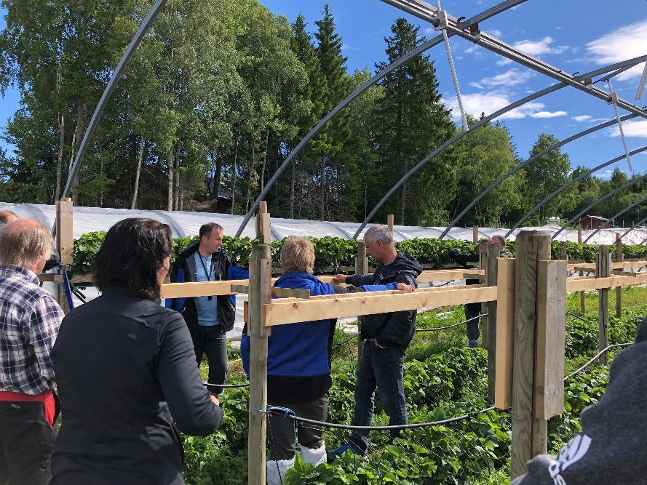
Photo: Marit S. Haugen

Content of learning
The NLR is known for having a high level of knowledge, and advisors with high expertise in their fields who are also good at communicating and spreading this knowledge further. The advisors want to have a dialogue, and are interested in the participants’ experiences and challenges. Here, the information was given through a combination of theoretical explanations and use of practical examples. The information related to specific aspects of production was given in such a way that the participants could see in practice how they could do it themselves, or it was explained in detail in a way that made it very understandable. Both the host farmer and the participants could provide input and questions to the expert, and exchanges of experiences were made both ways throughout the theme day. Much of the information and knowledge provided by NLR was linked to practical solutions and examples of how the production could be done, and therefore largely perceived as ready to use by the participants we interviewed. What was perceived as an obstacle for some farmers was the economic aspects, and the extent of investments linked to some of the solutions that were presented.

Outcomes of learning

During the interviews with the participants, several told us that the information they had received during the demonstration was very useful. Some of them needed information about how to start up with the use of tunnels, and were determined to do so (in a smaller scale), after the demonstration. Others wanted to start, and got the information they needed to do so, but for them it was a question of cost. Some of them also found out that to start with tunnels was a longer process than expected. For instance, they had to start the planning now and order plants for the next season. Others, who had already started with growing berries in tunnels, just wanted to see if they were managing their crops in the correct way. Further, many were eager to learn more in order to improve their business. They wanted to use this as a motivation to continue to produce berries, and maybe in the future expand the production because they learnt that it was possible to succeed within this field.

Networking
Many of the participants attended the demonstration also to use the opportunity to meet advisors in this field, because there are quite few advisors in berry farming in this region at the moment. Also the fact that a well known expert from another region was coming made it more interesting for some of the visitors, as he could share new knowledge and experiences from other parts of the country.

Many of the farmers that are quite new to berry farming wanted to meet other farmers in this region to learn how they are doing things and how they solve the different challenges. Some of them are also in the same “berry farmers network”, and often meet each other at similar events. The social aspects of meeting someone with the same interests, similar challenges and other perspectives were also reasons for attending the event.

Just to talk with other berry farmers, and learn how they are doing and exchange experiences. There are always some ideas to pick up here and there, and then you feel that you might contribute with some ideas yourself to others. In addition, I can call other berry farmers if I have some questions.
(Female participant)

This theme day was also a channel for new information for the participants. They wanted to see what is happening in the market and with the productions, what was new and innovative within the field, and what the advisors and experienced farmers focus on.

Anchoring: Application of demo lessons by participants

This section discusses how and if farmers attending this and other demonstration days translate their new knowledge into changes in their own practice and at their own farm.

Anchoring related to the present demo
Regarding implementing their new knowledge into their own practices and at their own farm, the visitors had different intentions after this theme day. For some of the participants the new knowledge and increased insight into how to proceed were enough to reach a decision to set up tunnel. For others it was still a question of economics that needed further examination after the demo to form part of a long-term plan. The expert at the theme day reflected upon this in an interview with us:

On theme-days like this, we learn about what people are thinking. They ask questions all the time and they can see what exists and what methods there are. And they plan, but that often takes a long time. We see that repetitions are important. It takes time. It requires patience, it does not happen overnight. We might see an effect among those participating now in three – four years. It requires a lot of investments and adjustments of the situation they are in now, so it simply requires time (male expert)

Many of the participants had been to lectures about the same topic before, but they wanted to actually see how it works and what it is like in practice. Many of the participants search for confirmation of methods they use, that they are doing it right – almost like benchmarking. In addition, to see what is possible to do, to get inspired and motivated to do changes or improve their practice. Informal conversations with the other farmers about their experiences and their practice are therefore one of the most important parts of the demo day, and also the host farmer’s experiences and what he emphasizes as good practice – whether he/she are doing something similar or something completely opposite of themselves.

One farmer was planning to set up a tunnel in a year or two. The same farmer also was thinking of expanding, but not for about three to four years. He told us that he needs more knowledge and financing, may be barriers to adoption. He wants to apply for financial support from Innovation Norway, but must first decide on the type of tunnel to choose and gain more knowledge about it. He has to make a good plan and a cost estimate.

Some of the other farmers were still in the planning phase after the demo, but have a long-term perspective of setting up tunnels. Before making changes and before they decide, they told us they have to obtain offers from suppliers and contact Innovation Norway. Two farmers told that they are collaborating when it comes to knowledge exchange and they were now working together in planning to build tunnels and obtain offers from suppliers.

Not everyone had reached a decision whether this was something they wanted to start with or not, but many were inspired to set up some tunnels in a long-term perspective. Economy and labour force were the main obstacles. For these farmers it was important to look at the possibility of financial support before making further plans.

Some of the farmers wanted to implement some of the systems and solutions presented at the theme day, but not set up tunnels. One farmer wanted to change his irrigation system after learning more about irrigation and the potential damage of overwatering, and what should be the proper fertilizer amount in relation to the amount of water. This was more a change in attitude based on more knowledge. After the theme day, he learned that he should be more careful about irrigation on open-air production. He would also pay attention to the use of fertilizers, and to get enough fertilizer when use of less water, as he usually fertilizes through the water as well. Another farmer saw a “new invention” at this farm. She noticed how the berry-pickers used rebuilt prams during harvesting to sort the berries in different boxes. They had removed the upper part and welded on a frame on the undercarriage to put the brackets on. She intended to do this herself after the demonstration.

Some farmers mainly wanted to get more information and inspiration, and make new contacts and meet other berry farmers in the region, with whom it could be useful to cooperate with or to exchange experiences with in the future. They had no plans for implementing instant changes on their own farm.

Stimulating anchoring
No follow-up activities to the demonstration were planned. This theme day could be considered as a follow-up or a “part two” of a former theme day three months ago, which also had the theme of berry production, involving the same organisers and expert. Most of the participants had been to this first theme day, and attended this one to get even more information, and to get a closer look at one of the most successful berry farms in the region, and learn how it can be done at a larger scale.

Anchoring related to earlier demos
Related to earlier demos, and what kind of information and sources that were important and influenced the farmers’ decisions, the other farmers at the event is often pointed out to be a very important factor for future decisions. The knowledge, experiences and attitudes conveyed through conversations on such days, affects how other farmers think about further development on their own farm. It is important for the farmers to meet others who are engaged in the same type of production to learn about how they do things, what works good and not, and what kind of experiences they have. Also to see good examples in practice and learn from other farmers success and challenges were emphasized as important for their own practice and future decisions.

In earlier demos about the same topic, some of the farmers saw examples and received information about how one can avoid resistance related to chemical pesticides, what one should think of related to tethering of the plants, space between the plants, drip / irrigation, and pruning. Others learned about the benefits of planting on canvas, and began to do this in a greater extent. Some farmers also changed their practice after talking to peers who had attended a field day, and had learned about a specific method. One of the examples was the use of oil and soap against plant diseases, which they started to use after learning about it from someone else. Often these specific examples of production methods and new systems influence the participants to change or improve their own practice. This might be because they learn specifically how it is done, how it works, and in a concrete way to proceed to implement it themselves. In our interviews, several farmers mentioned that theoretical examples do not work as well as practical examples to get someone change their practice, as it is harder to imagine how it is done and how it will work in practice.

Scaling: Application of demo lessons by the wider farming community

This section discusses the possible impacts of demonstrations in the wider farming community.

Retrospective examples of scaling

This section will be illustrated by a timeline under section 8.2, and elaborated there.

Prospective assessment of scaling: Impact pathways

This section will be illustrated by a timeline under section 8.2, and elaborated there.

Case study reflection

This section reflects upon the main findings from our case study regarding four topics:
- Governance of demonstrations and learning;
- Facilitating and impeding factors for successful demonstrations;
- Accessibility of demonstrations;
- Impact of demonstrations.

Facilitating and impeding factors for successful demonstrations

We asked the local organiser what she thought is the best way to learn, and how to succeed with demonstrations:

To be outdoors and see what is going on in the field is in my opinion the best way to learn. And if we [the advisors] at the same time succeed in getting an experience exchange between those who participate, and that we as advisors can contribute with knowledge about the actual theme…

She also had some thoughts about what could explain low numbers of participants, and possible issues related to access. The theme has to be interesting enough for people to prioritize. Another aspect is the time of day the demonstration is held. There are both pros and cons for daytime and evening, because they are busy with their own farm, other jobs and/or family. Time of year could also be a factor, and they are trying to organise demonstrations when it is not the busiest season for farmers. Here, it was clear that they succeeded by getting the expected number of participants and the participants were in the target group. It was both experienced and inexperienced among those who participated, indicating that the demonstration was considered to be interesting to everyone in the field.

Other successful aspects were the combination of theory and practice, which is important to engage the participants. Not just being told and hearing talk about how it works, but seeing the crops and tunnels in practice was important for many of the participants. In addition, it is important with professionals who are well prepared and good at their field, and it was obvious that they had succeeded. Time and opportunities for informal conversations, questions and discussions with professionals and other participants are also crucial. This was possible throughout the whole day, both during the field walk and the theoretical part inside. An important reason was probably that it was made a spacious schedule, and that they had someone who monitored the time. A clear signal that the organizers managed to facilitate knowledge dissemination and exchange of experience was that the participants throughout the day got together and talked, asked questions to the expert and stayed after the program was formally over to chat and discuss further with other participants.

In terms of a follow-up after the demonstration, this was something the local organisers and advisors said that they offer, but this was, as far as we know, not communicated explicitly to the participants. This could have been done, especially regarding those who are new in this field, and perhaps need more support and who might not be aware of what kind of opportunities they have for getting help and assistance. It could also be useful to send out an e-mail afterwards to all participants-Then they had received contact information for advisors, expert and host farmer. We asked for a participant list, and it is also possible that this was sent to the other participants. This allows participants to contact other participants afterwards if they have questions or wish to discuss matters further. These lists can also be used by the participants’ networks, and they can give tips to others who want more information on the topic.

Demonstration-innovation narrative
Timeline for farming innovation related to berry production and the use of plastic tunnels, and possible impact pathways:

2015
2016
2018
2014
2001
2006
2007
Time

Farmers planning to invest in plastic tunnels
Production:
18 tons strawberries
New legislation
Systematic production of strawberries in tunnels
Greenhouse cultivation
Research projects
Demonstration/
Theme day

New legislation
Long term
Production:
4604 tons strawberries
“Strawberry crisis”
1-2 years

In 2001, Norwegian farmers produced 18 tons of strawberries, sold to wholesalers. There was and still is a desire to use as much Norwegian production as possible, but at that time not enough was beign produced to meet industry demand. In the years that followed, several aspects considering production methods and new legislation probably had an impact on the further berry production.

Around 2006, there was an increase in the use of greenhouses for cultivation. About one year later one of the first systematic strawberry production in tunnels was started in Trøndelag, and the farmer became a pioneer in the region (the host farmer for this case). In 2014, new legislation to increase duty free import quotas for berries came into force. This reduced the customs costs for the berry industry, and strengthened Norwegian berry producers who rely on a well-functioning processing industry. In 2015, further legislation concerning strawberry producers in particular came into force. It was now allowed to import strawberry plants into Norway. Production-ready plants made it possible for the strawberry farmers to start producing berries already during the plant year. This gave them the possibility of earlier production and a longer season, and several farmers began to make use of this. The amount of strawberries produced has increased significantly since 2001. In 2016, Norwegian farmers produced 4604 tons of strawberries, sold to wholesalers. This was an increase of 1500 tons since 2005. However, the same year the "Strawberry Crisis" occurred. This was because of the plant disease Botrytis that destroyed much of the season for farmers across the country. Those who were hardest hit were those producing strawberries in the open air. Less affected were the farmers using plastic tunnels. This makes an important part of the background for the need for demonstrations on how to improve strawberry production in Norway. This is in terms of both increasing production and the number of producers, but also how to prevent problems associated with high rainfall and plant diseases that particularly affect those who produce in open air. This clarified the benefits of using plastic tunnels for cultivation.

In 2018, the Norwegian Agricultural Extension Service organized a theme day/demonstration about berry farming in plastic tunnels. The host farmer of the demonstration was the pioneer in the region from 2007, today he is an employer with many employees, and he has to handle many tasks. The aim of the demo was to inspire and encourage farmers to increase the production of berries and to consider tunnel production of berries if they not yet have started with tunnels. The farmers were assured that they could improve their income, as they will get higher value crop, better qualities and great tasting berries, much earlier and longer season crops, and better prices in the market. The market for fresh berries is increasing, and there seems to be a promising production future for berries. However, the farmers know that the decision to start (or increase) the production will have implications for their labour situation. For instance, they might need to hire (more) seasonal labour and become employers, and they will need to handle supply contracts and terms of delivery to a larger extent.

Research projects specifically related to the subject of berry production in tunnels also started up in 2018. In one of the most relevant projects, run by the research institute NIBIO, the technique of this cultivation method is to be tested and developed. As part of the project, producers and advisors will also meet frequently to exchange experiences. After the demonstration, several of the farmers expressed in interviews with us that they are planning to start using of plastic tunnels for strawberry production, some in a long-term perspective, but others within 1-2 years.

Impact of demonstrations

Regarding the five impact domains from the PLAID conceptual framework (productivity & profitability, resilience, sustainability, quality of life, and empowerment) we will try to assess to what extent these impacts were realized.

Regarding both productivity, profitability, resilience and sustainability, adaptations to climate change are important for berry producers. By setting up plastic tunnels the farmers can extend the season, prevent major damage to crops due to heavy rain or droughts, and ensure the production to a greater extent. However, investing in tunnels is very expensive, and you have to go all in in order for it to be profitable. Not everyone got the opportunity to take such risks, and not everyone has the capability or desire to hire employees, change their role, and to convert to a more large-scale production. For these people such a theme day is important to learn also about other aspects that can increase productivity without the major changes, such as more knowledge about irrigation systems and fertilization. Research projects addressing challenges related to climate change and resilience regarding crops, will also be helpful for berry farmers in the future, and hopefully motivate more people to engage in berry production. Regarding quality of life and empowerment, it is important to find solutions for berry farmers for them to continue to engage in this, and to believe in the importance of the production. This includes both future tools and solutions for securing production against destruction, making it economically profitable - or at least preventing major losses for those who invest in this, and continuing the work of meeting places between experts and farmers to find common solutions to the challenges that appear. It was observed that there are few advisors in the field of berry production in this region. A greater focus on this and more funding could have positive effects on all of the impact domains, and also be a security both for those who are new producers and those who have more experience and wish to develop further. Financial support schemes could also be a solution and a political discussion to promote the growth of berry producers in Norway.

Key lessons from this case study

This case study provided useful information on how a successful demonstration day can be organized. It was evident that the theme day was well planned, and there was a clear division of roles between those involved. Time management is very important, and here one of the organisers had the role as a moderator to keep track of time. The fact that there were the number of participants they had expected including variation in gender, age and experience gave a signal that they had reached their target audience. They had been aware of using different channels to reach out with information about the theme day. They were able to engage the participants by making time for dialogue, questions and informal conversations during the theme day, and by combining practical demonstrations/field walks and lectures. The participants were also able to take a closer look at the crops, irrigations systems and tunnels, and use various senses during the day.

Acknowledgements

We would like to thank the NLR Trøndelag and the organisers/advisors for letting us participate at the theme day, and for important information and knowledge through both informal conversations and interviews. We would like to thank all informants and participants for sharing your thoughts and reflections during interviews, and for providing us information both during and after the theme day. We would also like to thank Rob Burton and other colleagues for input, suggestions and contributions along the way.

Annexes

Data sources
Working on the case study and this report, we have used different data sources. Voice recordings from interviews with participants, experts and local organisers have been important sources, along with transcripts from these voice recordings. The invitation to the demonstration day has also been used as an information source. To obtain information about historical facts related to strawberry production, the roles of the different organizations involved, ongoing research and other knowledge for increased insight into the field, we have used articles produced by the NLR and similar organizations, information from the NLR’s webpages, information from relevant research organization’s websites, and articles on the topic from local newspapers.

Data collection methods
We have collected relevant data through participatory observation during the demonstration day, informal conversations with the participants during the demonstration day, informal conversations with the local organizer during the demonstration day, journal notes/observational notes written after the demonstration day, and document analysis (web pages, information materials, etc.) before and after the demonstration day. In addition, the most important method have been semi-structured telephone interviews with participants, local organiser and the expert after the demonstration day, and also one interview on-site with one of the participants. The interview guide is attached on the next page.

Case study questions

Desktop research

- Most important actors in the subsector (desktop research)
- Typical farm characteristics of the sector (desktop research)
- AKIS in the region (desktop research)
- Social, climate and economic sustainability issues (desktop research)
- Summary of the demonstration activity – partly from inventory data
- What is the background (history) of the demonstration organisers/funders?
- Demonstration farm type
- Fit the farm type into the Plaid typology diagram
- What is the topic of this demonstration?

Observation of demonstration event

- What happened during the demonstration?
- How many people attended the demonstration?
- How many women are present and what do they appear to be doing?
- What methods were used to engage people?
- How “hands on” were the demonstrations?
- Did any sales take place at the event?
- Were environmental sustainability, social sustainability or climate change a topic in the demonstration?
If yes, in what way …
- Did anything unforeseen influence what happened?

Interview with organiser/demonstrators

In general on the organisation

- What is your role in the organisation?
- What is the history of your organisation?
- What demonstration methods do you (personally) prefer to use?

On this demonstration event

- What is the topic of this demonstration?
- What is your role in the demonstration?
- What are the objectives of this demonstration (what do you hope to achieve)?
- Who initiated the demonstration?
- Who were the targeted audience and how were they approached?
- Why/how was this identified as a in important topic?
- How is this demonstration funded?
- How many people attended this demonstration?
- Why was this farmer chosen to host the event?
- Are women involved in this demonstration?
- If yes, what roles do they do (e.g. commissioning, organsing, demonstrating)?
- What methods have you used to engage people?
If yes, please explain.

- Did any sales take place at the event?
- Did the demonstration specifically deal with sustainability issues (e.g. environmental, social or economic)?
If yes, in what way? …
- Did anything unforeseen at the event influence what happened?
- Were your expectations of the demonstration fulfilled?
If not, what would you have preferred happened differently?

On demonstration events in general or past evets

- Can you give an example of demonstration event you were involved in that was successful?
If yes, why do you think it was successful? …
- Can you give an example of a demonstration event that failed?
If yes, why do you think it failed? …
- What measures do you have in place to support farmers after the event?
- What proportion of women attend demonstrations you are involved in on average?

Interview with farm visitors

On this demonstration event

- Where do you come from?
- Why did you attend this demonstration event?
- Was the reputation of the farmer an important factor?
If yes, in what way …
- Was the reputation of the organiser an important factor?
If yes, in what way …
- Was the topic of the demonstration an important factor?
- Are you looking to make changes now or were you just curious?
- Was the demonstration what you expected?
- Was the demonstration as good as you hoped?
If no, what could have been improved? ….
- How useful was this demo for gaining new knowledge?
- Will you implement changes immediately?
If not, what would you have to do or need to know before making changes? …
- Will you discuss the knowledge you have gained with anyone?
If yes, who and why ….
- How useful is this demo for networking/meeting friends and colleagues?

On demonstration events in general or past evets

N.B. Get them to use examples of past events as much as possible

- What is it you like about attending demonstration events?
- What types of demonstration (e.g. field days, lectures, etc.) do you like the most?
- What role does travel distance play in your decision to attend demonstrations?
- What role does similarity to your farm play in your decision to attend demonstrations?

- Have you ever changed your farming practices because of a demonstration event?
If yes, explain what happened …
- Has information you have gained at a demo ever led to a neighbouring farmer changing their practices?
If yes, explain what happened …
- Have you ever acted on information someone else gained from a demonstration event?
- If yes, explain what happened …
- Can you think of an innovation that has been taken up in your area during your lifetime?
If yes.

- Do you know if demonstration activities played any role in promoting it?
- How did they affect the uptake?
- Did the demonstration initiate the activity, or help farmers to improve the activity once it was widely practiced?

- Can you think of an innovation that has failed to be taken up in your area despite demonstration activities?
If yes, explain what happened …

- What other sources of information do you use?
- Are there other family members that attend demonstration events?
- Would you attend more demonstrations if they were available?

