Date: 15/11/2018

Country report: Belgium

Case Study: BE1 Open Energy Day

WP5: Case studies of demonstration activities in commercial farms

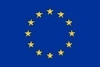
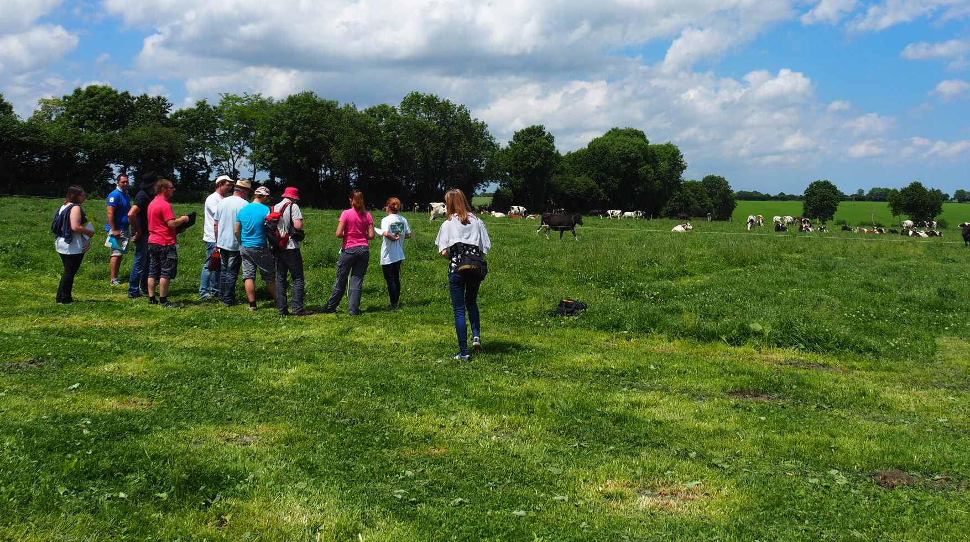
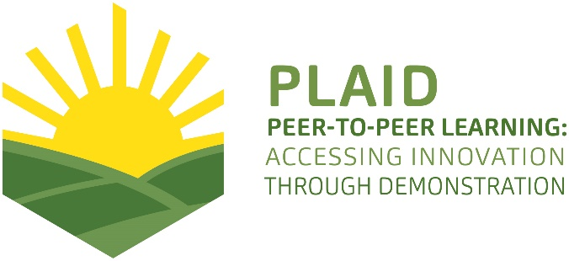
This project has received funding from the European Union’s Horizon 2020 research and innovation program under Grant Agreement No 727388

PLAID PARTNERS

Advisory Service Croatia ASC | 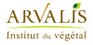  ARVALIS Institut du Végétal | Association de Coordination Technique Agricole ACTA
Institute for Rural and Regional Research | 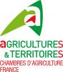  Chambers of Agriculture | 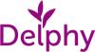  Delphy
European Forum for Agricultural and Rural Advisory Services EUFRAS | Innovatiesteunpunt ISP | 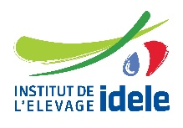  Institut de l’Elevage – Idele
Instituto Navarro De Tecnologías E Infraestructuras Agrolimentarias | 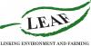  Linking Environment and Farming LEAF | 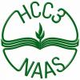  National Agricultural Advisory Service
Nodibinajums Baltic Studies Centre (BSC) | Research Institute of Organic Agriculture (FIBL) | Stichting Wageningen Research
The James Hutton Institute | VINIDEA

DOCUMENT SUMMARY

__________________________________________________________________________________
Milestone Title: 24 Case Studies
__________________________________________________________________________________
Case Study Title: BE1 Open Energy Day
__________________________________________________________________________________
Version: 1
__________________________________________________________________________________
Task Lead: WUR
__________________________________________________________________________________
Related Work package: WP5
__________________________________________________________________________________
Authors: Marleen Gysen, Koen Symons
__________________________________________________________________________________
Grant Agreement Number: 727388
__________________________________________________________________________________
Project name: PLAID
__________________________________________________________________________________
Start date of Project: January 2017
__________________________________________________________________________________
Duration: 30 Months
__________________________________________________________________________________
Project coordinator: The James Hutton Institute

ABSTRACT

During the Open Energy Day in 2016, Flemish farmers as well as installers, advisors and policy makers were introduced to a range of innovative sustainable energy techniques. 22 commercial farms and research farms, spread over the various provinces and across different sectors, took part in this day and showed innovative techniques for energy saving or sustainable energy production at their farm. These farms were selected by the organizing Enerpedia consortium, which includes the Flemish research farms, advisory service Innovatiesteunpunt and research institutes ILVO and Thomas More. The case provides an interesting example of an informal setup of demonstration. Few guidelines regarding the setup of the demonstration activities from the organizing consortium towards the hosting farmers were given. Moreover, the visits were mostly held in small groups. This resulted in a lot of opportunity for interactive discussions between the host farmer, the visiting farmers, the advisors of the Enerpedia consortium and in some cases also with the involved installer. This informal approach greatly stimulated the exchange of knowledge and practical experiences. The visiting farmers not only got the technical facts & figures, but at least as important was hearing ‘from first hand’ the experience of the host farmers with the practical implementation of the demonstrated sustainable energy techniques: difficulties with grid connections, building permits, applications for green energy certificates and other forms of subsidies; economic benefits; whether or not extra work that comes with the new technique; etc. The interactive discussions triggered them to reflect on how the demonstrated energy techniques would fit in for their own farm.
TABLE OF CONTENTS

1 Demo context 6
1.1 The value chain 6
1.2 Typical farm characteristics 6
1.3 AKIS 7
1.4 Sustainability challenges 8
2 Demonstration summary 9
2.1 Farms 9
2.2 Organisation of the demonstration activities 9
2.3 What is the main problem that is addressed? 9
2.4 What is demonstrated? 9
2.5 What role does sustainability play? 10
2.6 What is the objective of the demonstration? 10
2.7 Who are the targeted visitors? 10
2.8 What could be main lessons for the PLAID project? 10
2.9 Positioning of the case study 11
3 Governance: set up and organisation 12
3.1 Organiser(s) and history 12
3.2 Funding 12
3.3 Hosts 12
3.4 Gender 13
3.5 Objectives 13
3.6 Topics 14
3.7 Access 14
4 Demonstration event 15
4.1 Visitors 15
4.2 Communication & Mediation 15
4.3 Active participation 16
4.4 Doing business 17
4.5 Role of sustainability 17
4.6 Unforeseen circumstances 17
4.7 Plans vs. practice 17
4.8 Participants feedback 18
5 Motives, learning and networking 19
5.1 Reasons to attend demos 19
5.2 Forms of learning 20
5.3 Content of learning 20
5.4 Outcomes of learning 20
5.5 Networking 21
6 Anchoring: Application of demo lessons by participants 22
6.1 Anchoring related to the present demo 22
6.2 Stimulating anchoring 22
6.3 Anchoring related to earlier demos 22
7 Scaling: Application of demo lessons by the wider farming community 23
7.1 Retrospective examples of scaling 23
7.2 Prospective assessment of scaling: Impact pathways 23
8 Case study reflection 24
8.1 Demonstration-innovation narrative 24
8.2 Facilitating and impeding factors for successful demonstrations 25
8.3 Impact of demonstrations 25
8.4 Key lessons from this case study 26
9 Annexes 28
9.1 Data sources 28
9.2 Data collection methods 28

Demo context

This case study is about the demonstration of innovative sustainable energy techniques at 22 commercial and research farms, spread over the various provinces of Flanders and across different sectors. The demonstration activities took place in one day (Open Energy Day). The farms were selected by the organizing Enerpedia consortium, which includes the Flemish research farms, advisory service Innovatiesteunpunt and research institutes ILVO and Thomas More.

The value chain
The following actors were involved in the Open Energy Day 2016: farmers, energy technology providers, advisors, researchers, policy makers and local authorities.

The farmers were the main target group of the demonstration activity. All Flemish farmers were invited to visit one or more of the demonstration farms with an innovative and sustainable energy saving or energy producing installation. Because farmers often work in close contact with their installer (energy technology provider), there were also installers present. In addition to these installers as confidential counselors, there were also installers who wanted to learn more about the practice of a specific technique or measure on a farm. Consumers as such (individual consumers, households) did not participate in the Open Energy Day. However, many regional and local policy makers did visit the demonstration farms.

The role of research: the hosting farms were selected by the advisors and researchers of the Enerpedia consortium, based on the advisors’ frequent contacts with the agricultural sector and on their knowledge of newest energy techniques on farms.

Typical farm characteristics
The host farms where the Open Energy Day 2016 was held, are all part of energy-intensive sectors such as livestock breeding (dairy cows, pigs, chicken), fruit, chicory and horticulture under glass. This also applies for the former Open Energy Day, held in 2012.

The 22 host farms were rather high-tech farms. The main technologies and practices that were demonstrated:
- energy efficiency techniques like heat recuperation systems (4), led lighting (4), heat exchangers (2), ventilation systems (1), energy exchange between farms (1), cooling with ammonia (2), EXE greenhouses (1);
- renewable energy techniques like small scale digesters (3), PV solar panels (3) and the combination with storage in electrical batteries (1), thermal solar panels (1), biomass combustion (4), gas absorption heat pump (1).

19 of the host farms are family farms, 3 of them are research farms. The 22 host farms are located all over the region of Flanders.

AKIS
The demonstration activities were held in the Belgian region of Flanders. The key actors of AKIS in the region of Flanders are:
- Universities of Ghent and Leuven
- Research institute ILVO
- Experimental stations (14)
- Department of Agriculture and Fisheries (ADLO) – Flemish Government
- Flanders Agency for Innovation & Entrepeneurship (VLAIO) – Flemish Government
- Advisory services
- Farmer’s associations
- Support systems
- Education

The Flemish AKIS benefits from important support from the regional government. This support can be differentiated in two instruments: basic funding (so-called “institutional funding”: 67% of total) and competitive calls (so-called “funding schemes”: 33% of total). The region also supports knowledge platforms aiming at connecting the different actors of AKIS, for instance for foresight exercises.

ILVO, the applied research institute, is a main beneficiary of the institutional funding. Experimental stations also benefit from regular subsidies from both the regional government and from the provinces. The second public funding is related to competitive calls.

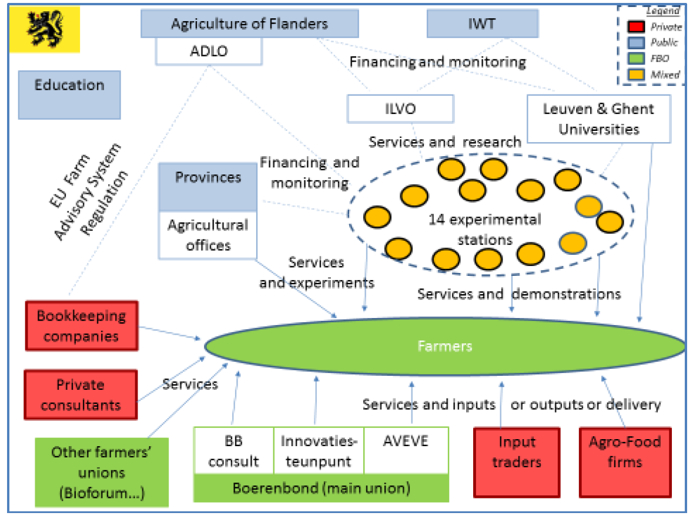
Figure 1: AKIS diagram in Flanders (source: Labarthe, P.; Moumouni, I. (2014): AKIS and advisory services in Belgium. Report for the AKIS inventory (WP3) of the PRO AKIS project)

Sustainability challenges
The challenges that the visiting and hosting farmers of the Open Energy Day face in relation to the energy management on their farm:
- economic challenges: high energy costs, self-sufficiency energy production, problems with grid connection, etc.
- societal challenges: sustainable use of energy for the production of food
- environmental challenges: sustainable production of energy, reduction of GHG emissions, reduction of the use of fossil fuels
The key opportunities for the farmers are:
- societal/environmental: farmers can play a key role in the energy transition in rural areas (they often have lots of space for renewable energy techniques like solar and wind; in many cases there is also biomass)
- economical:
  - energy efficiency: lower energy demand leads to lower energy costs
  - sustainable energy production: farmers can sell their own produced electricity
The barriers for the farmers to invest in sustainable energy techniques are:
- bad investment climate
- lack of knowledge among farmers and installers
- regulations (e.g. selling/buying electricity between farms and/or other companies and residential houses nowadays is not possible; farmers often face problems regarding the connection of their farm to the electricity grid)
- age issues (will the farmer have a successor who will take over the farm? is it still worth investing in new energy techniques?)

Demonstration summary

Farms
During the last Open Energy Day in March 2016, 22 agricultural and horticultural businesses (of which 3 farms are practice and research farms), spread across the whole region of Flanders in Belgium, opened their doors to introduce other farmers to innovative energy techniques that they have implemented on their farm. During the day several visits were organised per farm, giving farmers the opportunity to visit more than one farm. The hosting farms were selected by the advisors and researchers of the Enerpedia consortium, based on the advisors’ and researchers’ frequent contacts with the agricultural sector.

Organisation of the demonstration activities
The Open Energy Days of 2012 and 2016 were organised by the Enerpedia consortium, which includes the Flemish practice and research farms as well as knowledge and research centres Innovatiesteunpunt of the farmer’s organisation Boerenbond, Kenniscentrum Energie of the University college Thomas More and ILVO (the applied research institute funded by the government).
The Enerpedia consortium sensitizes and gives information and advice in the field of energy efficiency and sustainable energy production on farms to all farmers in the region of Flanders in Belgium. All their knowledge, study days announcements and news about energy in agriculture is bundled in one website www.enerpedia.be .

What is the main problem that is addressed?
The main problem that is addressed is sustainable energy in agriculture: the sustainable use of energy (efficiency – smaller demand for energy) and the sustainable own production of (renewable) energy.

What is demonstrated?
The implementation of innovative energy efficiency and renewable energy production technologies on the different farms, e.g.:
- Small scale digester with in-farm manure
- Solar panels rotating with the sun
- Energy exchange between tomato farm and fish cultivation farm
- Burning of miscanthus
- Cooling with ammonia
- Thermal solar panels for the preparation of the feed for the calf
- Heat recovery by dehumidification in greenhouses

What role does sustainability play?
Sustainability was the main driver for the demonstration activities. The demonstration activities were all about sharing good experiences with viable energy saving and energy production techniques on commercial farms (people, profit, planet). This will strengthen the farming community, mitigate climate change and enhance financial viability.
The EU 2030 “climate and energy framework” sets 3 key targets for the year 2030: at least 40% cuts in greenhouse gas emissions (from 1990 levels), at least 27% share for renewable energy and at least 27% improvement in energy efficiency. Therefore, innovation regarding measures for energy efficiency and renewable energy are also indispensable in agriculture. But it is mainly the rising energy bill that forces farmers to think about how best to handle energy on the farm.

What is the objective of the demonstration?
The main objective of the Open Energy Day is to share knowledge and experience on the implementation of innovative energy efficiency and sustainable energy production techniques on farms. Another goal was to inspire farmers, installers and policy makers with good practices, to show that it is possible to deploy the demonstrated techniques as viable methods to reduce GHG emissions and to reduce energy costs. Last but not least, part of the Open Energy Day was to make sustainable energy in agriculture more visible.

Who are the targeted visitors?
The targeted visitors are the Flemish farmers and other interested stakeholders in the ‘energy value chain’ like installers, providers of energy technology, advisors and regional and/or local policy makers.

What could be main lessons for the PLAID project?
The case provides an interesting example of an informal setup of demonstration. In 2016, there were few guidelines from the organizing consortium towards the hosting farmers and the supporting consultants regarding the setup of the demonstration activity. Moreover, the visits were mostly held in smaller (though not limited) groups. As a result, there was a lot of opportunity for interactive discussions between the host farmer, the visitors, the consultants or researchers of the Enerpedia consortium and in some cases also the installer who was involved in the installation of a specific technique. This informal approach greatly stimulated the exchange of knowledge and experience with innovative energy techniques. In a few cases, consultants from the consortium took a group of farmers to a number of host farms: they took them in a kind of guidance process during a day.

Positioning of the case study

Commercial orientation

Farmer-led
Institutionally led

BE1
Public-good orientation

Governance: set up and organisation

Organisers and history
The demonstration was initiated by the Enerpedia consortium. Although it had been agreed that on every farm there would be at least one staff member of the partners of the consortium, they were not actually leading the demonstration activities. In some cases, they accompanied the various rounds on the farms and provided some extra information or discussion issues or asked questions to trigger interaction. The hosting farmers were not involved in the practical organisation of the Open Energy Day in advance. At the day itself, they played an active role in guiding the visitors. The same applies to installers who explained energy techniques on 5 of the 22 hosting farms.

Though the Open Energy Day was organised before in 2012 (with 25 hosting farms), it is more or less a ‘stand alone’ demonstration: there is not a certain frequency and it is not part of a programme of demos. The concept of both Open Energy Days is the same and has not evolved.

The Enerpedia consortium learned from the previous edition in 2012 that it is useful to work with registrations in advance. At the 2016 edition, the consortium had a better view of how many visitors would come where and when. In this way it was still possible to adjust: for example extra advisors on farms with many visitors or the cancellation of certain visiting hours with very few or no people so that the host farmer did not have to keep this time off.

Funding
The Open Energy Day 2016 was one of the outcomes of a 3-year project, running from 2014 to 2017. This project was financed by the Flemish Climate Fund of the Flemish government in the context of the implementation of the Flemish Climate Plan 2013-2020. This obviously influenced the topic of the demonstrations.

The demonstration activities were free for all visitors.

The brochures and the ad campaign, the catering as well as the staff costs of the partners of the Enerpedia consortium were paid by the project resources. The hosting farmers got a small fee that was paid by NCBL (Nationaal Centrum voor Beroepsvorming in de Landbouw - National Centre for Professional Training in Agriculture).

Hosts
The selected farmers were recognised as ‘good farmers’ by the partners of the Enerpedia consortium. In many cases, they had collaborated with or had been advised by the advisors and researchers of the Enerpedia partners on the demonstrated energy technique on their farm.

Gender
There were no specific roles for men/women in commissioning, organising and holding the demonstration. There are about as many women and men among the staff of the organising Enerpedia consortium. However, most of the hosting farmers were men.

Objectives
The main objective of the Open Energy Day demonstrations is to share knowledge and experience on the implementation of innovative energy efficiency and sustainable energy production techniques on farms. This objective was the same for the organisers, the hosting farmers and the visitors. Therefore, the demonstrations were organized in such a way that there was a lot of opportunity to hold informal discussions.
Another goal for the organisers and the hosting farmers was to show farmers, installers and last but not least policy makers that it is possible to deploy the demonstrated techniques as viable methods to reduce GHG emissions and to reduce energy costs. Especially towards policy makers, the organisers wanted to demonstrate that agriculture is not only a big consumer of energy, but also part of the solution. Farmers work hard to make their production energy efficient. Moreover, agriculture has important advantages for the energy transition to more renewable energy: large roof areas, lots of open space and many farms also have biomass.
Finally, for visitors (farmers, consultants, installers and politicians) it was also a goal to network during the Open Energy Day: with the hosting and visiting farmers, researchers and advisors, installers and local policy makers. This goal was maybe not the main goal of the organisers, but not conflicting with their own objectives.

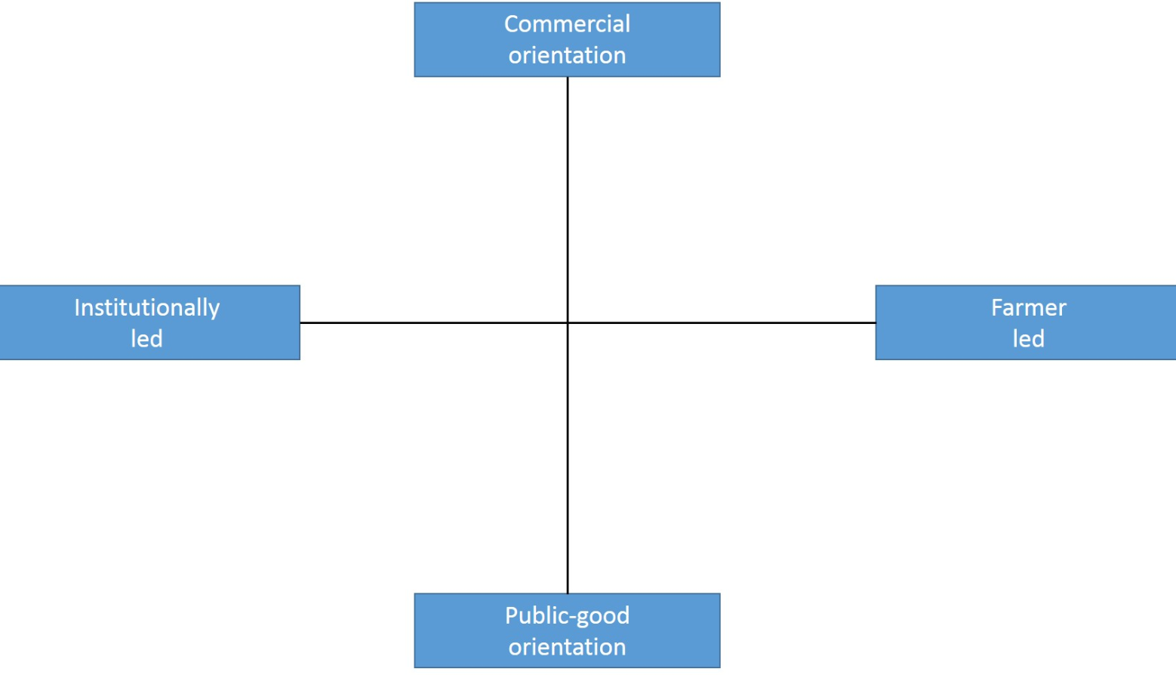

This demonstration event certainly had a public-good orientation. There was a clear focus on energy efficiency and sustainable energy production techniques. We place the demo more near ‘institutionally led’ than near ‘farmer led’: though in many cases it was the host farmer that told about his experiences, the advisors of the Enerpedia consortium had chosen the farms and the topcis and were rather ‘steering’ in the discussions (eg. by asking questions to actively engage the demonstrator and the visitors).

Topics
The Open Energy Day is on ‘innovative energy techniques in agriculture’. The different subtopics were selected by searching for good practices on farms in the joint network of the partners of the Enerpedia consortium. Each partner had to propose a few farms, based on their frequent contacts with the agricultural sector and often depending on the own specific knowledge of their research farm or research centre. For the final selection, the consortium looked at criteria like geographical spread, spread across sectors and spread over techniques.

The innovative topics in the list below (energy efficiency as well as renewable energy techniques) were demonstrated at the 22 farms:

- Small scale digester with in-farm manure
- Solar panels rotating with the sun
- Energy exchange between a tomato farm and a fish cultivation farm
- Burning of miscanthus
- Thermal solar panels for the preparation of the feed for the calfs
- Cooling with ammonia in fruit farms
- Led lighting
- EXE greenhouse (heat recovery by dehumidification)

Access
Farmers (from all over the region of Flanders) were the main targeted and approached audience. To increase the accessibility of the demo (easy to reach farms in a densely populated region with many traffic jams) and to make it attractive for them to attend, the Enerpedia consortium tried to select the different hosting farms in a way that
- different agricultural sectors were covered
- different technologies were covered
- different provinces were covered

During the agricultural fair ‘Agridagen’, one month before the Open Energy Day, the extended brochure with a presentation of all the hosting farms and their demonstrated technologies was launched.

The Enerpedia consortium published a special issue of the Ezine newsletter one month before the demonstration activity.

In addition, advertisements were also placed in agricultural magazines and newsletters: Landbouwleven, VILT, newsletter Groene Kring (young farmers), Fruitteeltnieuws, Management & Techniek, Boer & Tuinder, Proeftuinnieuws, Drietand. Finally, each partner also communicated on the Open Energy Day via their own channels.

A press release was also sent to the agricultural press, one week before the Open Energy Day.

Demonstration event

This chapter describes the activities on the Open Energy Day of 11th March 2016. This Open Energy Day was held on 22 hosting farms, spread over the 5 provinces of the region of Flanders. This is shown in the map below (the numbers on the map are the page numbers in the brochure).
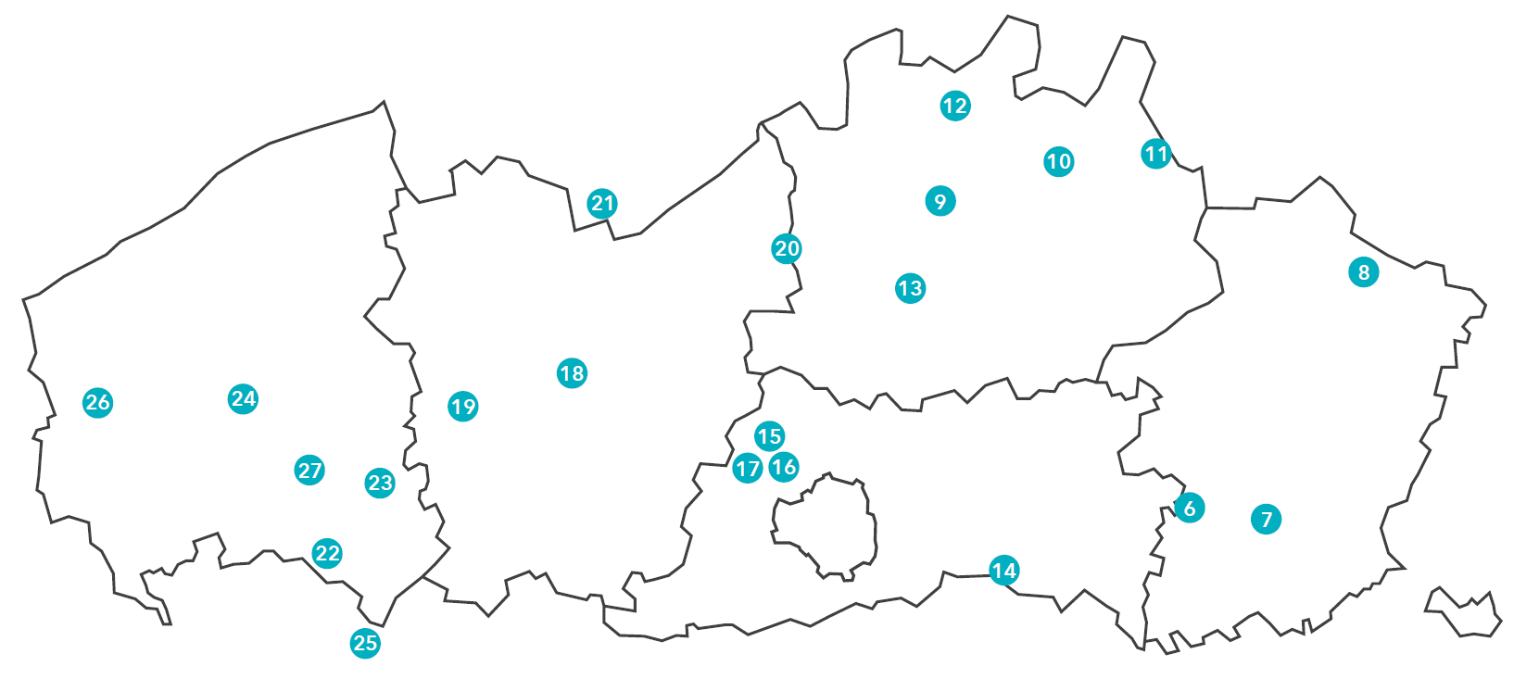

We attended demonstration activities on hosting farms number 10 (poultry farm with innovative heat exchangers) and number 11 (calf farm with thermal solar boiler).

Visitors
In 2016, about 200 visitors participated the Open Energy Day (without the hosting farmers and the partners of the Enerpedia consortium). This was less than the organisers expected or hoped for, but more than during the previous Open Energy Day in 2012.

About half of the attendees were farmers, the rest were mainly local authorities. The visitors were both men and women and a mix of all ages. The visiting farmers were mainly men, which corresponds to the expectations. The demonstrations were mainly about high-tech solutions. Our experience with the support of farms regarding their energy management shows that the technical aspect is mainly taken up by the men.

Communication & Mediation
Just as with the Open Energy Day in 2012, an extended brochure was made in 2016. In this brochure, each hosting farmer was shown with a general presentation of his/her farm and family, as well as a more technical ‘facts & figures’ sheet of the sustainable energy techniques on his/her farm. The brochure also presented a map with all the farms that could be visited and also the program of the day and how to register for the visits. These brochures were distributed by the various partners within their network about 5 weeks before the Open Energy Day.

On the day itself, some hosting farms had posters with information about the energy techniques. At the two demonstration events we attended, no extra material was provided or shown.

After the Open Energy Day several articles were published: in the magazines or newsletter of the partners of the Enerpedia consortium as well as in other agricultural press. There was also an interview with a farmer and an Enerpedia advisor on a regional television channel.

Active participation
At the two demonstration events we attended, the hosting farmers guided the (little) group of visitors and explained and discussed the energy technique(s) they use on their farm. When needed, the Enerpedia advisor added some extra information on the technical performances and requirements. From time to time, he or she also asked questions to trigger and encourage discussions.

There was a lot of interaction and discussion between the visitors and the hosting farmers and among the visitors themselves. Not only while visiting the demonstrated technique, but also during more informal moments like drinking coffee.

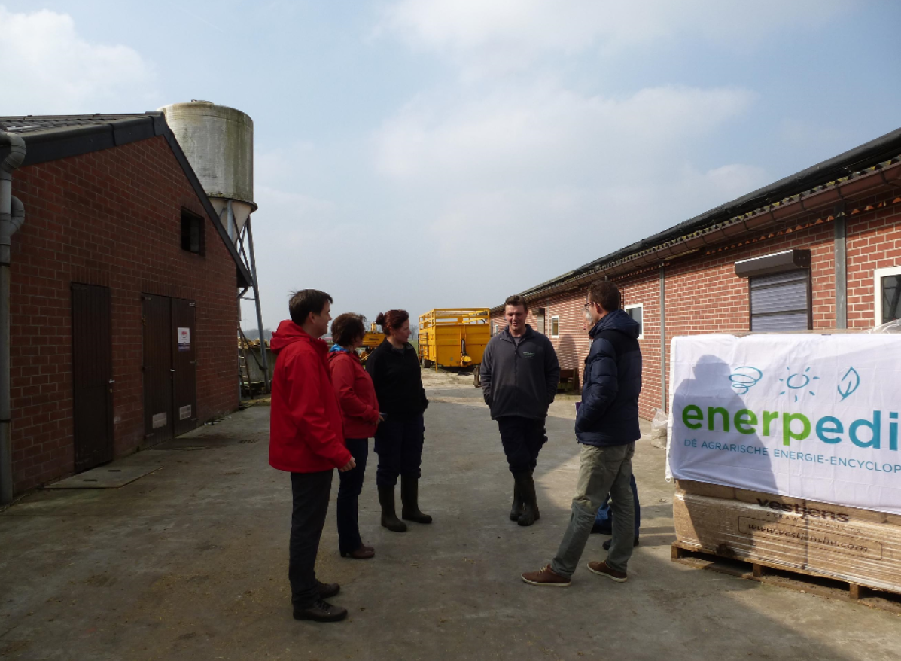

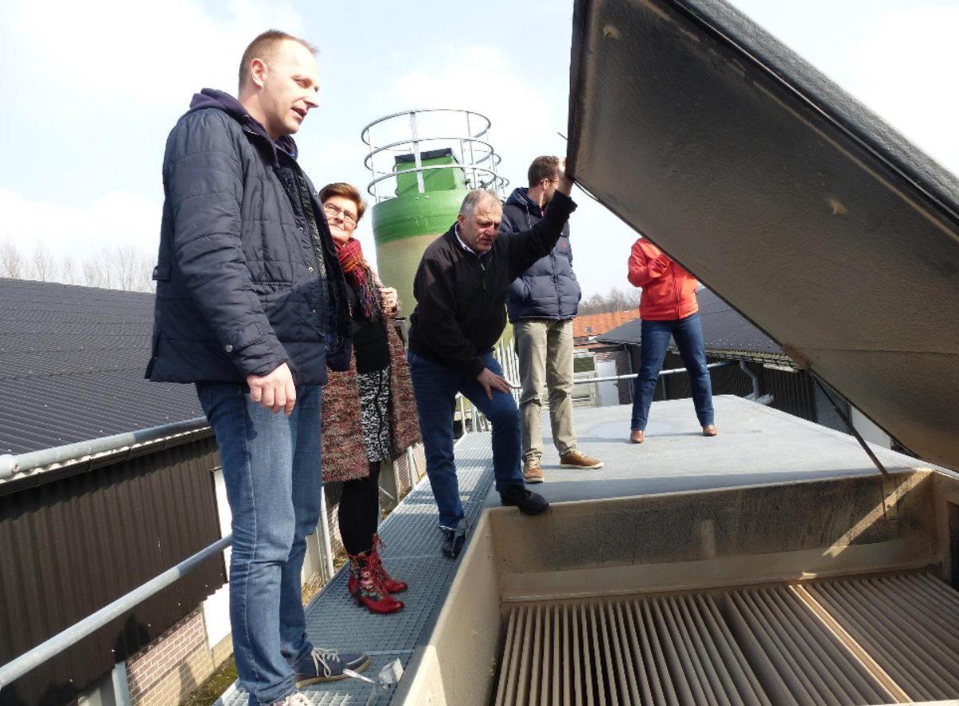

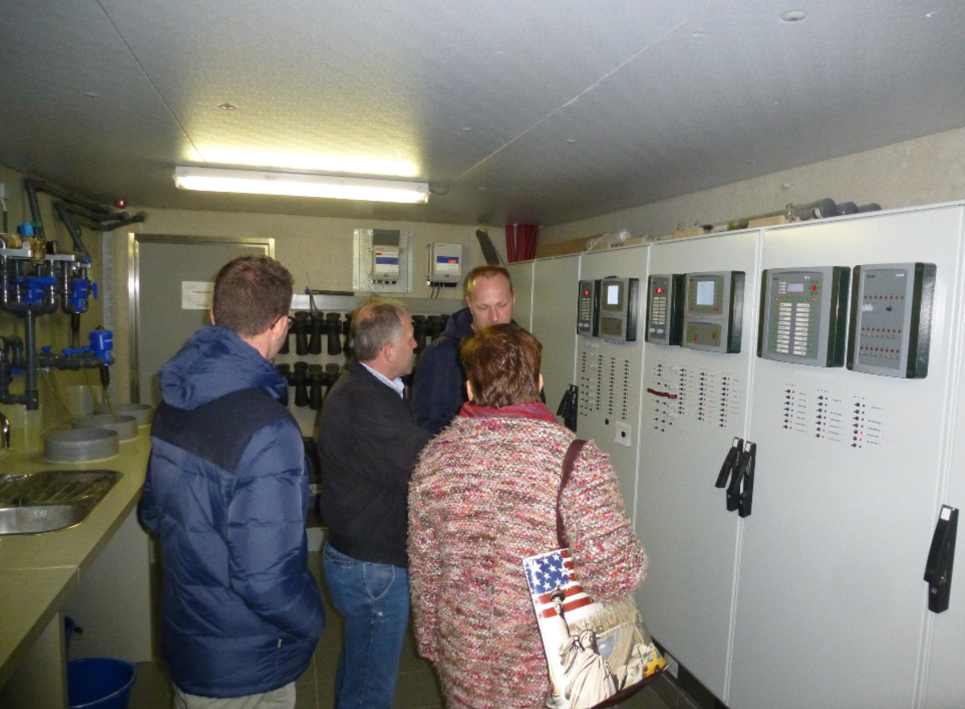

Doing business
On 5 of the 22 hosting farms, an installer or constructor was present. However, there was not the option of directly nor formally doing business at the demo itself. If commercial farms were present, the principle was that they did not solely attend the demonstration to make a sale pitch, but that they also contributed in terms of knowledge and information provision.

Role of sustainability
The different aspects of sustainability played a very important and explicit role during the Open Energy Day. The demonstrated techniques were all about energy saving and sustainable or renewable energy production technologies. Not only environmental benefits were discussed, but of course also the economic and societal benefits. Visitors were all very interested and responded in a positive way.

Unforeseen circumstances
As far as we can judge, there were no unforeseen circumstances.

Plans vs. practice
The organisers expected more visitors. In this respect, the objective of the organisers concerning reaching a lot of farmers at every hosting farm was not fulfilled.

It was foreseen that at each farm, there would be 3 demonstration moments during the day. Based on the registrations, some demonstration moments had been cancelled (not demonstration farms!). That did not influence the planned set-up at all.

The informal set-up of the demonstration activities certainly worked well, in some cases also because of the lower attendance: because of the smaller groups, there was a lot of interaction between the hosting farmer, the visitors, the advisor, the installer, the (local) policy makers, … In that view, the objective of exchanging knowledge and practical experience was definitely reached.

Participants feedback
All surveyed and contacted visitors of the Open Energy Day stated that the demo was interesting and useful for their own farm. Not in terms of immediate implementation of the demonstrated energy techniques, but in terms of inspiring examples and the learning and the exchange of practical experiences with the techniques. They answered that they were triggered to reflect on their own energy management on their farm, even if their situation was not quite the same as with the hosting farm.

Some farmers (visiting farmers but also hosting farmers!) mentioned that they were somewhat disappointed that not so many farmers had come up and that therefore few experiences could be exchanged.

Motives, learning and networking

Reasons to attend demos
Attitudes and perceptions
Most farmers visited the hosting farms of the Open Energy Day in the first place to learn from the hosting farmer his or her experience with the implementation of the demonstrated innovative energy technique. Other reasons that were mentioned were obtaining new knowledge (facts & figures), seeing the technique by themselves and networking.
They indicated that other options to discuss experiences of colleague farmers about the implementation of energy techniques are: local/regional meeting of the farmers organisation, subsectoral meetings.
To achieve the objective of obtaining new insights and knowledge (facts & figures) on the topic of innovative energy techniques, possible options are: articles in farming magazines, information moments, study meetings, contacts with advisors, contacts with installers, agricultural fairs, the internet.
The visitors said that other members of their farm also participate in demos from time to time. As a reason for that they mentioned: to stay in touch with novelties, to obtain new knowledge, to learn from other farmers, to hear different opinions and visions. At the two events we visited, there was a couple (man-woman) from the same farm and a father and son from the same farm.

Norms

The participants mentioned following reasons for other farmers not to attend this Open Energy Day: they have already visited this particular farm, bad timing or too much work on the farm, topic not relevant for them.

Being selected by the advisors and researchers of the Enerpedia consortium, gave the farms were the demos were held a certain credibility. The visitors of the two demonstration events we attended did not know the hosting farmers before.

Whether they knew of other farmers who would attend did not influence their decision to attend.

Practicalities
As the Enerpedia consortium had selected the 22 hosting farms in a way that the different provinces of Flanders, different agricultural sectors and different technologies were selected, it was possible to select a demonstration event to attend based on locality, type of farming system and the technology that individual farmers were interested in. Because there were 3 demonstration moments during the day, there was also an opportunity to attend one or more activities.

Forms of learning
At the two demonstration events we attended, the demonstration was led by the farmers themselves, sometimes experts added extra information. They did not make use of anything else than showing, explaining and discussing their innovative energy techniques. This certainly led to interactive communication and peer to peer learning. Visitors were actively engaged to participate at the discussions by the present member of the Enerpedia consortium. (verbal)

At some other places however (mainly at the experimental farms), information was also given by leaflets and information boards. Due to the nature of the techniques shown (led lighting, solar water heater, heat recovery systems, …), there was no possibility to do things ‘hands’ on by the visitors.
There was not a gender or age difference in who participated in the different types of activities.

Content of learning
The organisers of the demo (the Enerpedia consortium) worked out a brochure with short technical descriptions of the hosting farms. This information was already rather specific and detailed with facts & figures (installed capacity, production numbers, efficiency rates, etc.), but of course did tell nothing about the practical experience the farmers have with the implementation of the energy techniques on their farm.

The information the visiting farmers got, was not ‘ready to use’. When considering implementing the demonstrated technique on their own farm, they need own ‘tailor made’ dimensioning, taking into account their own specific energy needs, place available, etc. Therefore, they have to consult advisors and installers.

Most of the demonstrated techniques need a considerable investment cost to implement.

Outcomes of learning
The visiting farmers got an increased knowledge on the demonstrated energy techniques: not only about the technical facts & figures, but at least as important was hearing ‘from first hand’ the experience of the host farmers with the practical implementation of the demonstrated energy technique, i.a.:
- difficulties with technical connections to the distribution grid, with building permits, with applications for green energy certificates and other forms of subsidies, etc.
- economic benefits: lower energy costs, selling the own produced renewable electricity
- whether or not extra work that comes with the new technique

The interactive discussions triggered them to reflect on how the demonstrated energy techniques would apply to their own farm.

Networking
Networking was certainly not the main objective for the farmers that attended the Open Energy Day.

However, it was an important reason for the hosting farmers to have a demonstration event on their farm: contact with and visibility to other farmers, advisors, their own installer and last but not least (local) policy makers and (local) press.

Anchoring: Application of demo lessons by participants

Anchoring related to the present demo
Most visiting farmers did not have direct plans to implement the demonstrated novelties: most of the shown energy techniques require a substantial investment cost and also require a lot more study work with regard to the dimensioning, tailored to the own farm. However, some farmers mentioned they expect to invest in a near future because they believe in the economic, ecological and societal benefits of a sustainable energy management on their farm. The experiences of the hosting farmers and the information provided by the hosting farmers and by the advisors have strengthened them in this.

The visiting farmers also appreciated that they got to know advisors of the Enerpedia consortium as a new source of knowledge (and advice) to them. The same applies for the installers and policy makers that visited the Open Energy Day, they have made new or have strengthened the existing contacts and collaboration with the advisors of the Enerpedia consortium.

Stimulating anchoring
There were no specific follow-up activities like group activities planned. However, more information on demonstrated techniques could and can still be found in the brochure of the Open Energy Day and on the Enerpedia website. Visitors are aware of this and also use it. Moreover, because of the presence of the Enerpedia advisors and researchers at the hosting farms and the publicity for the (partners of the) Enerpedia consortium, the farmers as well as the policy makers know they can always ask for advice after the demonstration event.

Anchoring related to earlier demos
Most visitors mentioned they get the ‘facts & figures’ about new energy techniques from articles by Enerpedia partners or other agricultural press, from demonstration activities, from study moments and from their advisors or installers.

However, what is important and decisive for them in taking their final decision whether or not to implement innovative energy techniques, is learning from other farmers’ experiences. Visiting a demonstration event and have a look at how the energy technologies are implemented ‘in real life’ (e.g. where at the farm is the solar boiler installed, how much space is required for the storage of the woodchips, did the dairy farmer make adaptations to the floor of the cowshed…) works best to have interactive discussions and exchange of experiences. These discussions are also important for the hosting visitors.

Scaling: Application of demo lessons by the wider farming community

Retrospective examples of scaling
Actors of the Flemish AKIS do stimulate the uptake of innovative sustainable energy techniques in different ways:
- The different partners of the Enerpedia consortium (consisting of research institutes ILVO and Thomas More, the 14 research farms and advisory service Innovatiesteunpunt) often organise demonstration activities and information moments on energy novelties, whether or not in the framework of Enerpedia.
- Those organisations also give information moments and write articles on innovative energy techniques in the agricultural press.
- The Flemish Government subsidizes many of the demonstrated innovative energy techniques:
  - Departement Landbouw & Visserij (Department of Agriculture and Fisheries) gives investment subsidies on sustainable energy techniques like solar boilers, small scale digesters, etc. via the Flemish Agricultural Investment Fund VLIF (Vlaams Landbouwinvesteringsfonds): 30% for investments that contribute to a more efficient use of energy.
  - Vlaams Energieagentschap VEA (Flemish Energy Agency) gives exploitation support for renewable or sustainable production energy techniques like solar panles, solar boilers, heat pumps, biomass installations and cogeneration units in the form of green electricity certificates (electricity) and cogeneration certificates (heat)

Examples of successful implementations of sustainable energy techniques in the wider farmer community in Flanders as a result of these efforts are: photovoltaic solar panels (all subsectors), small scale digestion (dairy farms) and cogeneration installations (greenhouse agriculture). Demonstrations have certainly played an important role in this uptake.

Prospective assessment of scaling: Impact pathways
In connection with our demonstration case, following impact pathways seem the most plausible via which lessons from a demo become widely shared and may influence the farming community at large: articles in agricultural press, peer-to-peer contacts between farmers.

The organisers of the Open Energy Day are aware that articles in the agricultural press are important. Therefore, they prepared a press release and also invited journalists to visit the different demonstration activities. The Enerpedia consortium also regularly distributes a newsletter E-zine with articles on innovations in energy in agriculture, often showed during demonstration activities.

Peer-to-peer contacts between farmers are actively stimulated by the farmers’ organisations. They regularly organise formal and informal activities for farmers: local meetings with farmers of the same municipality or region and meetings with farmers of the same subsector.

Case study reflection

Demonstration-innovation narrative
The text below describes the innovation trajectory of small scale digesters with on-farm manure at dairy farms – also called ‘pocket digesters’ - in Flanders.

In 2009, the founders of Biolectric had the idea to produce green energy (electricity and heat) on the basis of own farm’s manure. Therefore, they developed a kind of ‘big bag’ where the farmer have to collect the manure and in which the biogas is produced in an anaerobic way. A small cogeneration unit of 10 kW (Sterling engine) converts the biogas into both electricity and heat.

Soon after the first proof-of-concept installation was built, pioneer farmers start to use the concept in a leasing concept. Already in May 2011, Innovatiesteunpunt wrote an article about a dairy farm that had installed such an installation. In June 2011, Innovatiesteunpunt organised a demo at that farm. Research farms Inagro and Hooibeekhoeve are also very active in disseminating knowledge and experiences on small scale digesters via demonstration activities and articles in newsletters.

In 2012, about 30 dairy farms in Flanders had installed a pocket digester. During the Open Energy Day in 2012, a pocket digester was one of the demonstrated novelties.

In 2012, it became clear that many ‘growing pains’ were associated with this technology. The freshness of the manure proved to be very crucial and was subject of many discussions between the farmers and Biolectric. The company made many efforts to improve their technology (eg. the manure bag became more of a fixed structure) and they also renovated the already existing 30 digesters. At the same time, they stopped leasing their system. Farmers could only buy the digester.

From 2013 on, many demonstration events were organised (initiated by research farms, advisory services like Innovatiesteunpunt, the company itself, …). The technique has also been shown several times during the annual ‘Dag van de Landbouw’ (Day of Agriculture), which is organized by Boerenbond - the largest agricultural organization in Flanders. The target audience of this ‘Dag van de Landbouw’ is mainly the general public (to show what agriculture actually is and to demonstrate where our food comes from), but is also highly visited by other farmers and by policy makers.

In 2013 the Flemish government announced a new investment subsidy of 30% for small scale digesters via VLIF (Vlaams Landbouwinvesteringsfonds – Flemish Investment Fund in Agriculture).

Because of the growing pains and because of the announcement (not yet implementation) of this new investment subsidy, farmers hesitate to invest. Almost no digesters were installed during the period 2012-2014.

In 2015, the new subsidy was enacted by the Flemish government.

Because of the relevance of the technique (economic and ecological sustainability) and because of the need for practical experience (how to handle the manure, how to maintain, what about the floor in the stable, etc.), the Enerpedia consortium decided to include again a dairy farm with a small scale digester in the list of demonstration activities of the Open Energy Day 2016.

Small scale digesters with on-farm manure or other leftovers are the subject of many Flemish and European projects or operational groups: eg. Pocket Power, Pocketboer, IEE BioEnergy Farm II, Enerpedia 2.0.

Because of all those efforts and despite many growing pains, the region of Flanders occupies an absolute leading position in Europe with regard to ‘pocket digesters’: in 2016 about 80 installations in Flanders, almost all built by the company Biolectric.

Facilitating and impeding factors for successful demonstrations
What is a successful demonstration?
We asked the partners from the Enerpedia consortium about what key indicators to determine whether the Open Energy Day was a success to them, when they were satisfied with the demo day. Though most partners responded that the number of visitors was not an indicator for them regarding to the learning of the demonstration event, one partner regarded the number of visitors as a measure for the relevance of the demonstrated topic. They all agreed that the level of interaction was the most important criterion for a successful Open Energy Day. Partners also mentioned positive feedback and the number of questions for advice.

In the focus group, following input was given on the factors for a successful demonstration event:

Success factors for increased access:
- clear focus/objective of the demo event
- relevant topic for the target group
- accessible location(s)
- timing during the year/during the day

Success factors for an effective demonstration process:
- demonstration on a commercial farm: experience of the farmer, credibility of the demonstrator
- many practical examples
- interactive discussions, involvement participants
- mediation technique adapted to the group size
- enough informal moments (including food & drinks)

Impeding factor for success: farmers mentioned that did not come to visit a farm because they had already seen the energy technique on that specific farm. Some of the hosting farms were already (too) frequently visited before.

Impact of demonstrations
From the case study, we learned that is very important that when taking important decisions on installing (expensive) energy techniques on their farms, farmers appreciate the knowledge and experiences of other farmers who have already implemented those technologies. This case provided an interesting example of a collaboration and meeting of different AKIS actors (the partners of the Enerpedia consortium, other advisors, policy makers) with hosting and visiting farmers. Those involved parties learned from each other by viewing the demonstrated techniques ‘in real life’ and by participating in the many interactive discussions at the different farms of the Open Energy Day. The 22 farms were selected in a way that every visitor had a wide choice in both topic (specific energy technique) and location.

Learning from other farmers in a real ‘farming context’ is important regarding the anchoring and the uptake of innovative techniques. The focus group emphasized the importance of supportive measures for the farmer-demonstrator:
- Financial support
- Support with regard to mediation techniques (‘train the trainer’)

Key lessons from this case study
Main lessons from this case study on how to organise a successful demonstration and how to achieve maximum impact:

Relevance of the event
Visitors of the Open Energy Day came to the demonstration events to learn from the experiences of the host farmers. Though they could find lots of (technical) information on the demonstrated energy techniques elsewhere, they wanted to listen to the hosting farmers and other experts and learn from their experiences. Last but not least, they could see ‘for themselves’.

Relevance of the topic
Farmers visited the Open Energy Day because sustainable energy is important for their farm (economic as well as ecological and societal benefits). But also a lot of policy makers came to have a look of what is going on in agriculture regarding sustainability. The latter can have a lot of impact on the anchoring and the scaling of the demonstrated energy techniques. After all, to make innovative sustainable energy techniques more widely adopted in agriculture, farmers need financial as well as regulatory incentives.

Credible demonstrator
The visitors ‘believed’ what they was told and demonstrated because the demonstrators told from their own experience. It was not a commercial message at all.

Interactive discussions
The hosting and the visiting farmers exchanged knowledge and experiences. The interactive discussions triggered the visiting farmers to reflect on how the demonstrated energy techniques would apply to their own farm.

Acknowledgements

We would like to thank the hosting farmers of the Open Energy Day. Without their efforts before and during the event, there would not have been an Open energy Day! We also appreciate their input for this report. Our thanks also goes to the visiting farmers and to the different Flemish AKIS actors of our focus group for their feedback and input on the Open Energy Day. We had interesting discussion on the different aspects of the demonstration event and on peer-to-peer demonstration in general. And last not but least, many thanks to the partners of the Enerpedia consortium who provided us with a lot of information on the different aspects of the Open Energy Day!

Annexes

Data sources
- Brochure Open Energy Day – 2nd March 2012: http://www.pcsierteelt.be/hosting/pcs/pcs_site.nsf/0/23B156F1B5061A6BC12578BE0035AB2F/$file/Brochure%20Innovatie%20in%20energie_PRAKTIJKCASES%202012.pdf
- Brochure Open Energy Day – 11th March 2016: http://www.enerpedia.be/websites/1/uploads/files/documents/012578-brochure-low_26-2-2016_13_23_11.pdf
- Meeting notes 15th January 2016 on the organisation of the Open Energy Day 2016
- Reports on the different demonstration events of the Open Energy Day 2016
- Attendance lists of the Open Energy Day 2016
- Website Enerpedia: www.enerpedia.be
- Interview partners Enerpedia (23th March 2018)
- Focus Group (9th November 2018)

Data collection methods
- Participatory observation on the demonstration day itself (11th March 2016): we attended 2 demonstration events (out of the 22 hosting farms)
- Face-to-face interviews with organisers (partners Enerpedia consortium) (23th March 2018)
- Questionnaire for the partners of the Enerpedia consortium (October 2018)
- Focus Group with farmers, partners of the Enerpedia consortium (research institution and research farms), representatives of the Department of Agriculture and Fisheries (9th November 2018)

