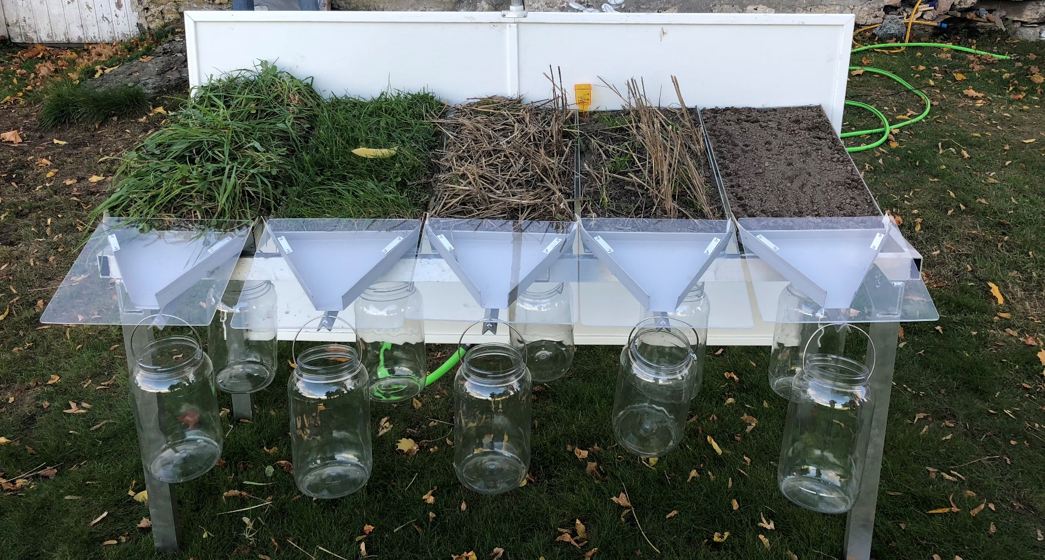

Date: November 2018

Country report: Norway

Case Study: NOR1: Optimal soil culture

WP5: Case studies of demonstration activities in commercial farms

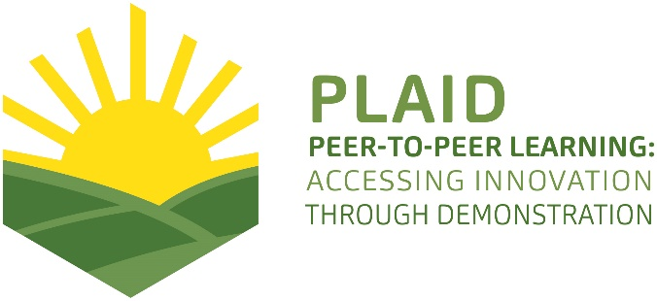
Photo: Marit S. Haugen
This project has received funding from the European Union’s Horizon 2020 research and innovation program under Grant Agreement No 727388

PLAID PARTNERS

Advisory Service Croatia ASC | 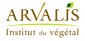  ARVALIS Institut du Végétal | Association de Coordination Technique Agricole ACTA
Institute for Rural and Regional Research | 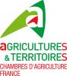  Chambers of Agriculture | Delphy
European Forum for Agricultural and Rural Advisory Services EUFRAS | Innovatiesteunpunt ISP | Institut de l’Elevage – Idele
Instituto Navarro De Tecnologías E Infraestructuras Agrolimentarias | Linking Environment and Farming LEAF | 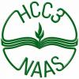  National Agricultural Advisory Service
Nodibinajums Baltic Studies Centre (BSC) | Research Institute of Organic Agriculture (FIBL) | Stichting Wageningen Research
The James Hutton Institute | VINIDEA

DOCUMENT SUMMARY

__________________________________________________________________________________
Milestone Title: 24 Case Studies
__________________________________________________________________________________
Case Study Title: Optimal soil culture (part of eco week) (NOR1)
__________________________________________________________________________________
Version: 1
__________________________________________________________________________________
Task Lead: WUR
__________________________________________________________________________________
Related Work package: WP5
__________________________________________________________________________________
Authors: Rita Moseng Sivertsvik, Marit S. Haugen
__________________________________________________________________________________
Grant Agreement Number: 727388
__________________________________________________________________________________
Project name: PLAID
__________________________________________________________________________________
Start date of Project: January 2017
__________________________________________________________________________________
Duration: 30 Months
__________________________________________________________________________________
Project coordinator: The James Hutton Institute

ABSTRACT

Demonstration activities related to agriculture in Norway primarily involve field days, field walks and experimental fields. Events are commonly organised by the Norwegian Agricultural Extension Service (NLR) in cooperation with host farmers, but often also involve county officials, experts and other agricultural organizations as partners. Through these events, the NLR promotes cooperation between farmers by providing a meeting place for farmers with different knowledge and experience, as well as advisors and experts with research-based knowledge and knowledge of local conditions. By sharing experiences, participants are able to develop a better understanding of both the theory and practice behind the activity and thus improve outcomes. Two Norwegian case studies will investigate how demonstration days are organised, who participates, what issues are of interest, how knowledge is generated and how participation promotes long-term change. We will pay particular attention to the gender perspective – examining women’s integration in demonstration activities and their role in knowledge networks. Findings from the Norwegian study in combination with those from other parts of Europe will help improve the organisation and effectiveness of demonstration in Norway. This case report (Case 1) will describe a demonstration day addressing issues regarding ecological sustainability, how to maintain fertility of the ground and protect the soil from rain and erosion. The demonstration day was a combination of practical and theoretical input.

In Norwegian:
Demonstrasjonsaktiviteter knyttet til landbruket i Norge har først og fremst vært knyttet til markdager, feltvandringer og forsøksfelt organisert av Norsk Landbruksrådgivning i samarbeid med vertsbonde, men ofte også med fylkesmannen, fagpersoner og andre landbruksorganisasjoner som partnere. Gjennom slike demonstrasjonsdager og markvandringer fremmer NLR samarbeid mellom bønder i regionen, og legger til rette for en møteplass mellom bønder som sitter på ulike erfaringer, samt rådgivere og fagfolk som har forskningsbasert kunnskap og relevante kunnskaper om de lokale forholdene. Dette legger til rette for at man under både den teoretiske og praktiske delen av demonstrasjonen deler kunnskaper og erfaringer som kommer alle til gode, som videre vil gi utvikling og forbedring av praksisen. To norske casestudier vil undersøke hvordan demonstrasjonsdager er organisert, hvem som deltar, hvilke temaer som er av interesse, hvordan kunnskap genereres og hvordan deltakelse fremmer langsiktig endring av praksis. På grunn av det relativt store antallet kvinner i landbruket i Norge, legger vi særlig vekt på kjønnsperspektivet, og undersøker kvinners integrasjon i demonstrasjonsaktiviteter og deres rolle i kunnskapsnettverk. Resultater fra den norske studien i kombinasjon med de fra andre deler av Europa vil bidra til å forbedre organiseringen og effekten av demonstrasjonsaktiviteter i Norge. Case 1 er en demonstrasjonsdag som omhandler temaene optimal jordkultur, jordforvaltning og hvordan man optimaliserer produksjonen. I tillegg inkluderer demonstrasjonen prinsippene for økologi og klimarelaterte problemstillinger. Demonstrasjonsdagen besto av en praktisk og en teoretisk del.

In making this report, we have used different sources of information. The main sources are observation made by a researcher during the demonstration event, informal conversations with the organisers, experts and participants during the event, and telephone interviews with six participants, the two experts and the local organiser after the demonstration event. The telephone interviews were recorded and transcribed.

TABLE OF CONTENTS

1 Demo context 8
1.1 The value chain 8
1.2 Typical farm characteristics 9
1.3 AKIS 10
1.4 Sustainability challenges 11
2 Demonstration summary 12
3 Governance: set up and organisation 17
3.1 Organiser(s) and history 17
3.2 Funding 17
3.3 Host(s) 17
3.4 Gender 18
3.5 Objective(s) 19
3.6 Topic(s) 20
3.7 Access 21
4 Demonstration event 23
4.1 Visitors 23
4.2 Communication & Mediation 23
4.3 Active participation 24
4.4 Doing business 24
4.5 Role of sustainability 24
4.6 Unforeseen circumstances 26
4.7 Plans vs. practice 26
4.8 Participants feedback 27
5 Motives, learning and networking 29
5.1 Reasons to attend demos 29
5.2 Forms of learning 31
5.3 Content of learning 32
5.4 Outcomes of learning 32
5.5 Networking 33
6 Anchoring: Application of demo lessons by participants 34
6.1 Anchoring related to the present demo 34
6.2 Stimulating anchoring 34
6.3 Anchoring related to earlier demos 34
7 Scaling: Application of demo lessons by the wider farming community 36
7.1 Retrospective examples of scaling 36
7.2 Prospective assessment of scaling: Impact pathways 37
8 Case study reflection 38
8.1 Facilitating and impeding factors for successful demonstrations 38
8.2 Impact of demonstrations 39
8.3 Key lessons from this case study 40
9 Annexes 42
9.1 Data sources 42
9.2 Data collection methods 42

Demo context

The value chain

The demonstrations held during the theme day about optimal soil culture did address various methods and challenges related to soil, good soil culture and best practice soil management for optimizing production. The value chain consists of the agriculture department at the county governor in cooperation with “Eco week” in this county, the eastern branch of the Norwegian Agricultural Extension Service (NLR), the County Governor of the neighbouring county, and the agricultural company of this region. The agricultural company is also the owner of the farm, and is a private society that acts as an umbrella for 27 of the county’s farming organisations. Six actors from within the farming sector are involved.

The main organiser, who initiated and coordinated the theme day, was a woman who is general manager of the agricultural company in the county and who works part time at the County Governor (agriculture and environmental department). In addition, there were a female advisor from the Norwegian Agricultural Extension Service (NLR), and a male advisor (expert) from the County Governor of the neighbouring county who held the demos. In addition, a female assistant contributed with practicalities during the meeting and two male assistants contributed in demonstration of the rain simulator and soil sampling.

Other actors include the target market audience; farmers or others related to and interested in agriculture that are engaged in soil management, what characterizes good soil and how to achieve optimal fertility. In this case, these actors were mainly eco-interested participants, and most of them were not farmers in traditional sense. Some had a kitchen garden, some were small holders, some worked as gardeners or were in the process of taking gardener education, one participant had a herb garden, and several were teachers in the natural resource use. The participants’ role is to gather knowledge, share experiences and challenges together with the advisors, teachers/gardeners, and the other farmers present on the theme day. This group jointly explores challenges, solutions, how to improve their own knowledge and practices. As many of them were teachers on an agricultural college, they will in turn share their (increased) knowledge to their students.

Typical farm characteristics

The farm is a “green” inspiration and meeting place for the agricultural sector as well as the general public in the region. The staff on the farm aim to promote sustainable and innovative thinking in agriculture. Part of the farm (10 hectares) is dedicated to urban cooperative farming with organic production of fruit, vegetables and berries. The farm is the third cooperative farm established in Norway. The first one was established in 2006, this farm in 2011. As of May 2018, there are 81 cooperative farms in operation in Norway, as far as the cooperative farming project in “Organic Norway” have registered. In this region, there are 5 cooperative farms. There is no formal requirement today that requires cooperative farming to be ecologically run, but so far it has been shown that it is usually this form of operation that the shareholders wish for. Therefore, it is almost without exception ecological operations found in cooperative farms around the world. In Norway, the cooperative farms can be organized in different ways. The shareholders run some, while the farmer who owns the land mainly drives others. The cooperative farms are of different sizes, ranging from 10 to 450 shareholders. This farm has 200 shareholders.

The farm has also the status of visiting farm, approved as a 4H farm (city farm), where you can get close contact with plants and animals, as well as learn about natural background and history, sustainability and biodiversity, cultivation and sustainable food. It is the only 4H farm in this county, and one of about 50 4H-farms (city farms) in the country.

AKIS

This demonstration day was a collaboration between the agriculture department at the county governor in cooperation with “Eco week” in this county, the eastern branch of the Norwegian Agricultural Extension Service (NLR), the County Governor of the neighbouring county, and the agricultural company of this region. It is common that these organisations collaborate. The county governor's agricultural departments regularly collaborate with the NLR to development project ideas, and to work with funding. The agricultural department is responsible for implementation of agricultural policy at regional and local level. The county governor shall assist the municipalities with competence raising and guidance so that quality and achievement are maintained in the solution of the tasks. The Agriculture Department is responsible for identifying challenges, initiating and implementing measures in cooperation with actors locally and regionally. The Agriculture Department has extensive expertise in agriculture, forestry and rural development with expertise in the management, planning and development of sedentary industry.

The NLR promote cooperation between farmers in the region by contributing on such demonstration days, providing a meeting place for farmers with different experiences, as well as advisors with research-based knowledge and relevant knowledge of local conditions. This facilitates the sharing of knowledge and experiences that will benefit everyone on the demonstration days and further develop and improve the practice. Knowledge in the network relevant for this demonstration is developed through a collaboration between farmers, teachers, advisors and researchers, through dialogue, discussion and demonstration of practice.

The NLR also has cooperative agreements with research and development organisations (R&D). NIBIO (Norwegian Institute of Bioeconomy Research) is the most important partner, and representatives from the different organisations meet regularly for professional discussions.

Sustainability challenges

This case-farm maintains a strong focus on promoting sustainability. Demonstrations are based on knowledge of sustainable and climate-friendly agriculture, society and nature. Principles of biodiversity, good public health and local food culture are also important aspects of the farm’s approach to demonstration, and related to both social, environmental and economic aspects. The farm management aims to promote increased ecological sustainability through knowledge development around dissemination of methods of production and use of resources. One focus is on the promotion of circular use of materials/products and, in particular, how farmers can develop farming systems that are less dependent on external inputs. Increasing knowledge about good soil culture and caring for the soil in order to use the land to its full potential is included in this. Climate change issues are also addressed in the demonstrations. Regarding climate change, one of the main themes at the demonstration was that the soil has the ability to store significant amounts of carbon - if we manage it properly. Recycling of carbonaceous material also strengthens humus formation in soil. Optimal soil culture is thus the way for a more climate-friendly and climate-robust agriculture, as well as for better cultivation and more nutritious growth. Healthy food and increasing food production on organic areas by stimulating and rebuilding the biodiversity and humus layer of top soil is linked to both economic sustainability goals and food safety, but also climate-related.

Demonstration summary

The demonstration was held on a farm in the southern parts of Norway. The farm is owned by the agricultural company of this region – a private society that acts as an umbrella for 27 of the county’s farming organisations. The farm has 10 acres dedicated to the organic production of fruit, vegetables and berries. The farm is the third cooperative farm established in Norway, with 200 stakeholders.

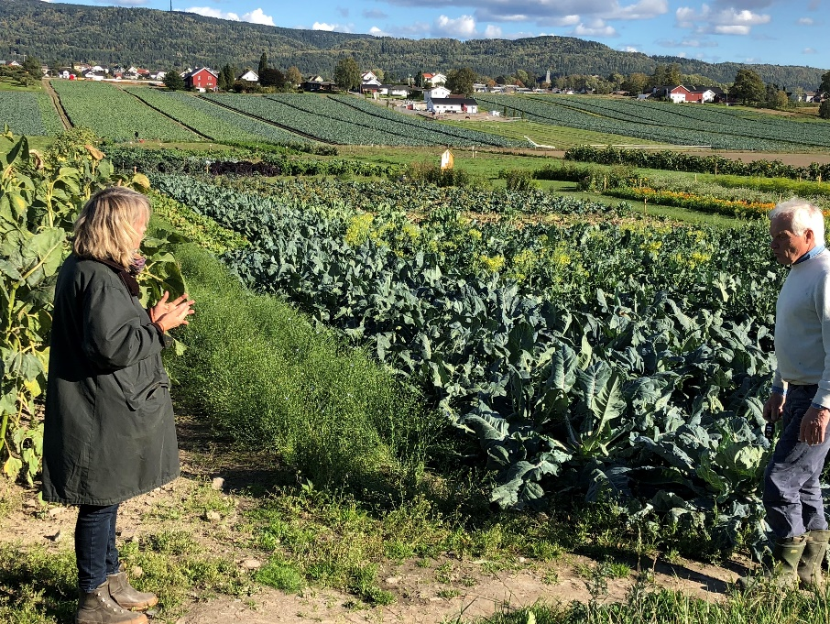
Photo: Marit S. Haugen

The demonstration event was a form of field day where experts demonstrated and conveyed knowledge about the soil, good soil management and the best possible ways to take care of the soil in order to optimise production. The approach involved a combination of theoretical presentations indoors and several practical demonstrations and field walks outside. The aim of the demonstration was to contribute to knowledge development and sharing between farmers/teachers/gardeners and advisors. A demo-day like this is a meeting place for farmers and others with connections to and interest in this theme, such that they can obtain relevant new knowledge and share experiences and thoughts with other farmers that they can apply to their own farms. The main aim is to raise the quality of production and products and increase the productiveness and competitiveness of farming in a sustainable way.

The theme day was organised by the agriculture department at the county governor in cooperation with “Eco week” in the county, the southern branch of the Norwegian Agricultural Extension Service (NLR), the County Governor of the neighbouring county, and the agricultural company of this region. The theme day started in the afternoon and lasted for four hours.

The researcher came to the farm a little earlier than the participants, and the organiser gave her a quick tour around the farm and explained how the farm was organised and the ideas about the demonstration day. Some practical preparations were carried out before the participants arrived. Equipment was set up for demonstration of the new rainfall simulator. The theme day started in the converted barn in nice meeting rooms with a small meal (hot soup) and coffee. The main program started half an hour later. The talk went lively, so it was evident that some knew each other from before. The main program started with a welcome speech and introduction by the initiator. She presented the two advisors/experts, and informed the participants that one researcher from Ruralis also was participating. This continued with a presentation round where all the participants presented themselves and informed shortly about their background. The researcher briefly informed the participants about the PLAID-project. She had already talked to some of the participants and agreed on interviews before the main program started, but repeated that she was interested to talk to several of the participants also after the theme day. She also informed about taking pictures during the day, and consent regarding this.

After the presentation round, a male expert from the County Governor held a lecture about experiences from a project about topsoil: soil as a living organic organism, how to stimulate and rebuild the biodiversity and humus layer in the top soil. He gave a presentation where he first presented the main principles for keeping the soil healthy based on ecological principles. He also explained the important, but often neglected, role of the soil microorganisms. He showed several examples of how soil is destroyed by heavy machinery (packing soil with little oxygen), and various forms of soil cultivation. He had an important message - there are opportunities to correct what is wrong and rebuild the soil - the soil has a wonderful ability to restart. He gave examples of how to do this. After his lecture, there were several participants asking questions, giving comments and sharing tips.

The next speaker was a female expert from the Norwegian Agricultural Extension Service (NLR) who worked on a project on soil carbon - development and dissemination of carbon-binding agricultural practices in Norway. Mold content decreases with 1% annually in grain districts in Norway (problems with drainage). Climate change and environmental aspects were themes in focus, such as carbon binding in the soil. She spoke of five principles regarding soil management, and concrete advices and tips to the participants of how farming could contribute.

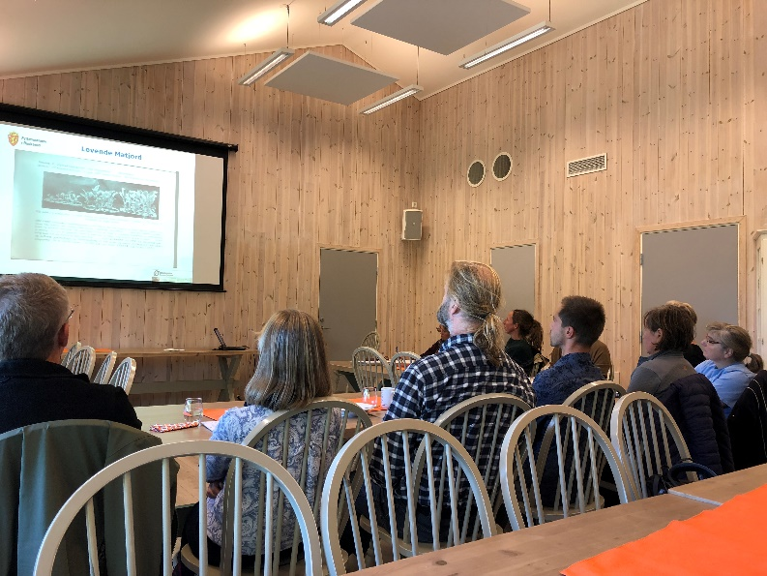
Photo: Marit S. Haugen

After the lectures, all the participants went outside for various demonstrations. The first stop was a demonstration of a rain simulator, pouring water over five different soil samples. It was the first performance of such a simulator in Norway, and everyone was excited about the result. The female expert showed and explained the different degree of soil erosion and the absorptive capacity of water in the samples. This illustrative exercise showed that freshly plowed soil was bad regarding soil drainage, of which "untouched" grassland was the best. The second demo showed some examples of various plants that were planted three weeks before.

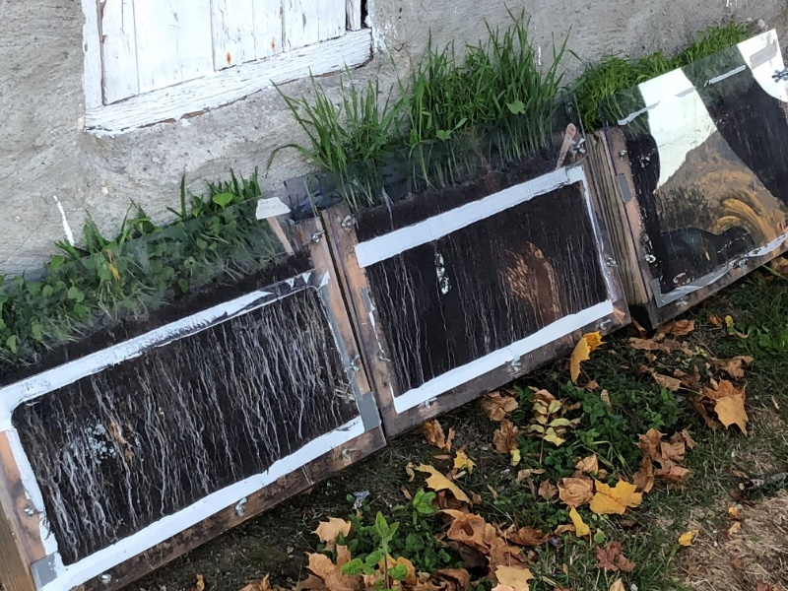
Photo: Marit S. Haugen

They were planted in some kind of “window boxes” (see picture above) so the participants could see how they already had developed root systems. These plants could be used as covering plants to improve the texture of the soil due to the good gripping effect produced by the roots.

The third stop on the field walk was at a piece of farmland where the male expert had prepared a demonstration of various soil qualities.

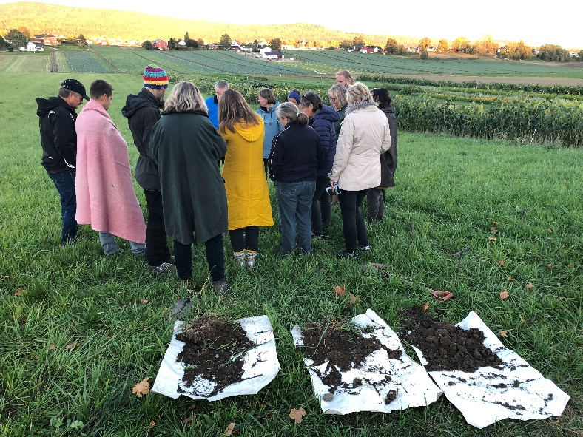
Photo: Marit S. Haugen

The expert first talked about a health card for soil, and handed out a written mapping tool so the participants could do the mapping work in their own fields as well. Then the expert specifically demonstrated how to conduct these soil samples, and the participants could learn how to study the quality of the soil, by for instance looking at the texture (hard lumps indicate mechanical damage by heavy machinery), counting earthworms, and smell the condition of the soil. Several participants got on their knees and smelled into the soil hole.

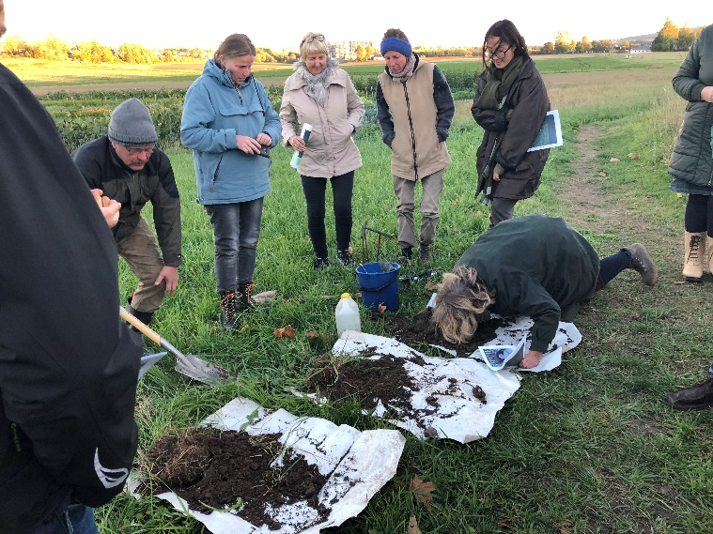
Photo: Marit S. Haugen

The expert also demonstrated the use of a simple tool to measure how many centimeters it was with porous soil before coming to hard (packed) soil.
Photo: Marit S. Haugen
The participants asked the expert many questions during and after the demonstration, but the weather was cold and limited probably the amount of questions that were asked. Many of the participants left the farm before the program was completed. Some of the participants and advisors continued the conversations inside the house, but the field day formally ended after the demo at the grassland. Inside the meeting room, one of the participants showed pictures of their own land that had been destroyed by large machines (in connection with road construction), and asked the instructors for advice on how to recover the damaged soil.
Photo: Marit S. Haugen

Governance: set up and organisation

This section provides information about the organiser of the theme day, information regarding general conditions and framework for completion of the day, and information about how the theme day was organised. The section also includes reflections and information upon gender perspectives, objectives and topics, and the targeted and approached audiences.

Organiser(s) and history
The theme day was organised by the agriculture department at the county governor in cooperation with “Eco week” in the county, the southern branch of the Norwegian Agricultural Extension Service (NLR), the County Governor of the neighbouring county, and the agricultural company of this region. The “Eco week” was first arranged in 2016 in this region. It is a celebration of Norwegian organic food that provides both raw materials, knowledge and inspiration. It will display the diversity of agriculture and food production in Norway and associate it with people's everyday lives.

Funding
There were various sources of funding of this theme day. The local initiator and organiser was present in her duties as an employee of the County. The southern branch of the Norwegian Agricultural Extension Service (NLR) have received regional environmental funds to be able to contribute at such theme days. These are funds from the agriculture department at the county governor. Each participant also had to pay a small participation fee of 200 NOK (20 Euro) to cover catering and seminar rooms.

Host(s)
The demonstration was held on a farm in southern Norway, a farm with multiple areas of use. An agricultural company of this region – a private society that acts as an umbrella for 27 of the county’s farming organisations, owns the farm. The farm is a “green” inspiration and meeting place for the agricultural sector as well as the general public. They desire to promote sustainable and forward-looking thinking in agriculture. They also chose this farm because of the possibilities of having demonstrations outside. This farm is also a cooperative farm, with 200 stakeholders. The farm has also the status of visiting farm, approved as a 4H farm (city farm), where you can get close contact with plants and animals, as well as learn about natural background and history, sustainability and biodiversity, cultivation and sustainable food. More than 1000 people visit the farm annually.

Gender
Regarding the different roles of men and women before and during the demonstration, the women were highly visible. There were 11 female participants, and 7 men. In addition, three women and three men were involved in the event as organisers, experts and assistants. It was a woman who had the main responsibility for the initiative and organisation of the theme day. She set up the program, contacted the experts, and was the chairperson. In addition, she had taken care of the practical with the event in advance (sent invitations, accepted entries, ordered soup). Another woman, who was the general manager of the farm, helped with the practical part regarding serving soup and cleaning up afterwards. In addition, there was a female expert who held one of two lectures, and she had the main responsibility to explain and demonstrate the rain simulator (a man set up the equipment in advance). Regarding the three men involved in the event, one held a lecture, the second one was the gardener on the farm, and the third had responsibility for the practicalities regarding the rain simulator. The female organiser had some thoughts about the gender perspective within agriculture:

Within agriculture, it is a tendency that men dominate. However, within [agricultural] counseling there are more and more women. The conventional agriculture with mechanization, extensive management and focus on tractors, may appeal less to women. But when it comes to organic farming, there are more women.

Regarding theme days related to organic farming, the male expert believes that women are somewhat overrepresented, rather than the opposite:

Women carry life, may have probably more understanding and intuition of what this is about, and what should be passed on to the next generation. Women are more interested in such questions than men are.

Objective(s)
The objectives of the organisers at the theme day were multiple. One was to inform the participants about what characterizes healthy soil and how to achieve optimal fertility. This includes demonstration of best practice soil management for optimizing production. This also has a climate perspective; focusing on the climate challenges we are facing today, and point out the importance of the soil as a resource and contributor in that context. How to solve challenges related to soil and drainage due to climate change were also implicit a part of this. Mold content decreases with 1% annually in grain districts in Norway, due to problems with drainage. The demonstration of the rain simulator and finding out which type of soil management that leads to least drainage, was a part of this and gave the participants some ideas about which factors making this problem larger or smaller, and perhaps some ideas about how to solve the problem.

One of the objectives of the demonstration was that the participants should get an attitude to and understand that the topsoil (humus) is a living organism on line with other living organisms, which we need to take care of. Show that this is an important part not at least in the future and the generations to come. If we do not succeed with this, we get lost (male expert)

A second objective, also related to climate, was to inform about and discuss solutions regarding the fact that the soil has the ability to store significant amounts of carbon - if managed properly. Recycling of carbonaceous material also strengthens humus formation in soil. Optimal soil culture is thus the way for a more climate-friendly and climate-robust agriculture, as well as for better cultivation and more nutritious growth. This theme day addressed solutions, examples and challenges regarding this.

A third objective was to give the participants an introduction to different methods to conduct soil samples themselves and analyse their own soil to see if they can improve the quality of the soil, and use the land to its full potential.

In addition, the initiator wanted to use the farm in the way they want it to work – as an important meeting place between the city and the countryside.

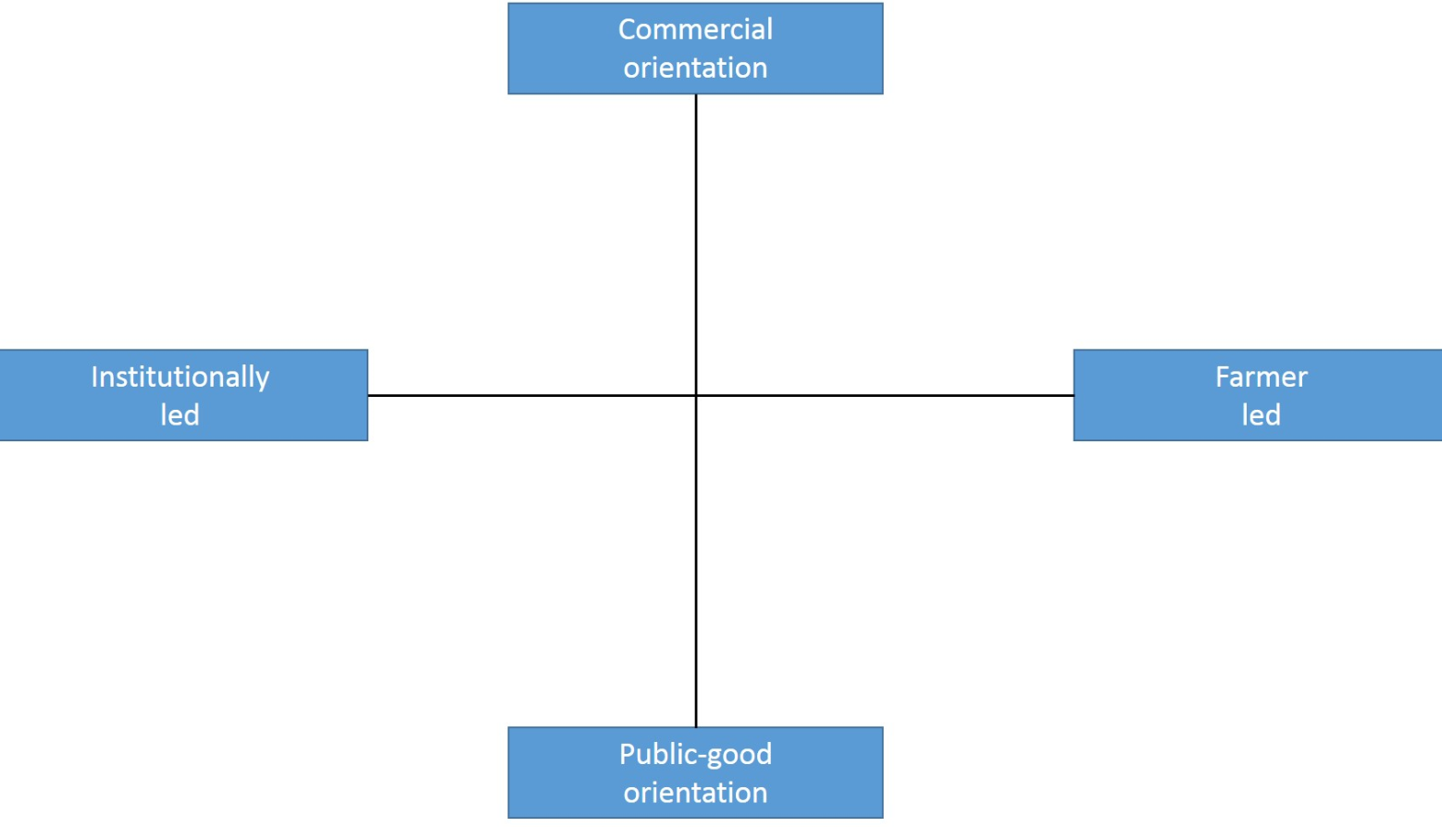

Figure 1: The optimal soil culture-case in the PLAID typology of demonstrations

Regarding the PLAID typology of demonstrations, this demonstration is for public good and institutionally led (Figure 1).

Topic(s)
The main topic for the demo was ecological sustainability, how to maintain fertility of the ground and protect the soil from rain and erosion. This included today's climate challenges and the importance of handling the soil as an important resource and contributor in that context, and how one can achieve optimal fertility and learning what characterizes good soil.

This topic was selected because of the many farmers and other who face challenges regarding climate change, and therefore to highlight what challenges and opportunities that exists related to good soil culture. The idea came after they had a visit by a lecturer on the farm a year ago, because they wanted to learn more about composting and finding good ways to circulate the organic material on the farm on the farm. He came in as a consultant. In March, the agriculture department at the county governor hosted a conference about soil conservation where this consultant was invited. This because of his knowledge of soil and the value of good soil culture, which has not been a focus area in this county earlier. Now there is more focus on climate and themes of good practice in climate-friendly farming. Soil is important in the context of carbon storage. During that conference, they had a new chat with this lecturer, and coordinated with the person working on climate-topics at the county governor. They agreed to arrange meetings in the county about soil and soil culture. This could also be combined with a soil carbon-project the eastern branch of the NLR started three years ago, to show what results have been achieved. They contacted one of the actors responsible for this. Then they could combine different topics related to soil; sustainable and fertile soil, and the NLR focus on carbon storage.

Access
The targeted audience were farmers, advisors, teachers, and others who are interested in climate challenges and the challenges and opportunities that exists related to good soil culture.

The target group was mainly contacted via direct emails and through Facebook events. Those the organiser specifically wanted to reach were contacted by email. The agricultural advisory service sent out information internally in the NLR. They also sent out information to the contact persons of all 27 member-organizations of the agricultural company. Information was also sent to the local Farmers' Association in the area.

The organiser admitted that perhaps they could have worked harder to contact the local farmers directly. They find it challenging to reach out with such information. The best way is to first send out e-mails and then call or send a SMS directly after. It is a challenge because people receive so much information today, making it harder to get through. One of the participants also mentioned this:

If I knew what I went to, I would probably have brought some [farmers] with me. […] There should have been many [famers] here. Farmers in the local area are large-scale producers, so I do not think they would have taken the trouble, but I think some could have had interest (female participant)

The organiser also invited the local press, but did not succeed.

The demonstration day was a part of the “Eco-week” in this county. This might have affected who came to the event and not. Regarding the farmers who participated, only organic farmers were present. It was not the intention of the organisers that they should exclude conventional farmers, because a lot of the information at the event could also be of great interest for them, but when the event was linked to the “eco-week” and as part of this, many conventional farmers may have perceived that they were not in the target group. The female expert reflected upon this. She sees the challenge of getting the two communities (eco and conventional) to merge more. She had also hoped to see more large-scale farmers and larger producers at the event, both organic and conventional. Instead, there were mostly small-scale farmers and small-scale producers attending.

It is probably many explanations; one is that the theme day was part of the Eco-week, part of an ecological arrangement- ant then often more small holders attend. The theme ‘soil’ has an appeal to small holders and kitchen garden enthusiasts and people who are interested in horticulture. Larger farmers find the theme difficult to relate to, because there are so many advices that are difficult to implement in practice, in a large scale, and it cost a lot (female expert)

Location was another factor that this expert pointed out. She said that there have been previous experiences of poor attendance in this region compared with other regions, without having any good explanation of why.

The male expert had some thoughts about time of day and time of year for such demonstration events. This event was held an afternoon in September. In his opinion, afternoon meetings are the best time for farmers, while daytime is better for teachers. However, there were more teachers than farmers present at the event. The expert did not find the time of year very attractive: “You cannot have sessions outdoors late in September in the evening, then it should be in August or early September, while temperatures are ok”. The fairly cold weather could be the reason why some of the participants left before the last session outdoor.

Demonstration event

This section provides information about the event, including information about the visitors, communication between the participant and the organisers, and how the event was conducted.

Visitors
The number of visitors at the theme day were 18 – 11 women and seven men (two married couples). In addition, there were three women and three men involved in the event as organizers, advisors and assistants. One of the three women were the local organizer, one were one of the advisors from of the Norwegian Agricultural Extension Service (NLR) (expert giving a lecture), and one was the general manager at the farm. One of the three men were an advisor from the County Governor (expert giving a lecture), one were the gardener at the farm, and one were one of the advisors (assistant) from NLR. It was eco-interested participants, and most were not farmers in a traditional sense. There was someone who had a kitchen garden, some were shareholders at a cooperative farm, some worked as gardeners or were in the process of taking gardener education, one had a herb garden, and several were teachers in the use of natural resources. Some of the teachers were also part time farmers. In addition to a relatively young couple (gardener and trainee), most participants were between 40-60 years. Many of the participants had foreign backgrounds (Belgium, the Netherlands, Germany and the United States).

Communication & Mediation
Those who held presentations used power point with pictures, written explanations and examples. After the lectures, it was possible to ask questions, give comments, advices and share experiences, and many did. Outdoors, the demonstrations were a combination of practical and illustrative examples, explanations and practical methods for learning more about soil and soil culture.

Some parts of the demonstrations were set up in a way that the participants could participate more actively themselves, like how the participants could conduct soil samples followed by a possibility to “learn how to look and smell the condition of the soil”. The expert encouraged the participants to get on their knees and smell the soil, and several participants did so.

Active participation
The event was a mix between theory and practical demonstrations. Because of a miscalculation of time, it was less time for questions during and after the presentations indoor than planned, but it was some time for questions and comments from the participants. In the session outside, the participants were not directly involved, but were able to see how things worked. The male expert also emphasized this: “I prefer demonstrations outdoors, showing in practice, and let the participants try themselves. Use simple methods and visualize how things happen”. In the soil sampling-session, the expert gave the participants the opportunity to look at the texture (hard lumps indicate mechanical damage by heavy machinery), and smell the soil. Normally, one part of testing the soil quality would be to count the earthworms (many earthworms is an indicator of a healthy soil), but because of the dry summer there were few earthworms to count in the samples. All the participants received a written mapping tool so they could do the mapping work in their own fields as well. The participants asked many questions, and many were eager to try themselves.

We believe that when people see how thing works in practice, they will try themselves. It was not time enough to day but at least the participants got some soil between their fingers. It is easy to have meetings and show nice power points illustrations, but it becomes more credible when you can see it and try it in practice. (…) I believe in this way to spread knowledge (female organiser)

Doing business
This was not a commercial theme day, and the participants could not directly ‘do business’ at the demo, and it was not sold anything during the theme day.

Role of sustainability
The main topic for the demo was ecological sustainability, how to maintain fertility of the ground and protect the soil from erosion. The visitors were explicitly and actively confronted with sustainability aspects of managing the soil. The male expert gave a presentation where he first presented the main principles for keeping the soil healthy based on ecological principles. He also explained the important, but often neglected, role of the soil microorganisms. He showed practical examples (pictures) of how the top soil is damaged by heavy machinery (soil compaction) and various forms of intensive agriculture and mono-cultivation. These examples were compared with examples of healthy soil favoured by cyclic crop rotation with other crops that increase the supply of nutrients in the ground, improving its chemical properties in terms of pH, minerals and organic substances. He gave many practical advices of how farmers could build up, stimulate and regenerate the biological diversity and humus layer in the soil. All these aspects are important and enable farmers to decrease the need for chemical fertilizers and other external contributions.

The female expert gave a presentation of a project she is involved in which is about agricultural practices to enhance carbon conservation in the soil. She explained the principles of how farming could contribute. Agriculture is an important part of the carbon cycle, and there is a need not only to reduce the carbon emission, but also to capture carbon in soil and aboveground biomass. One of her messages was that the damages and loss of soil is a global problem. “We need to go from consumption of the soil to using the soil” and explained that building up and enrich the soil is an important climate measure. She gave many advices to how the farmers can reduce the erosive effect of wind and water, such as; disturb the soil as little as possible, strengthen the soil with biodiversity, and keep the soil covered (with plants). One important and feasible action is to keep the ground covered as much of the year as possible.

Soil management is important, both directly and indirectly, to crop productivity, environmental sustainability, and human health. Some possible drawbacks with a more eco-friendly agriculture were also discussed, such as less crop (compared with conventional agriculture using more fertilizers and pesticides), more expensive seeds, less pesticides available).

The outdoor sessions were demonstrations that illustrated many of the points from the presentations. The rain-simulator showed what happened during a rain shower with various samples of soils covered with grass, plants, straws and open soil (without any plant). It illustrated different degrees of soil erosion and the absorptive capacity in the samples, which the participants could observe and learn about from the female expert explaining this. Another demonstration was the examples of various plants, which could be used as covering plants to improve the texture of the soil due to the good gripping effect produced by the roots. These were planted in some kind of “window boxes”, so the participants could observe that the sample with grass (taken from the edge of the field) absorbed water best and it was hardly any erosion, while the open soil sample showed most erosion and less capability to absorb water. The last session was demonstration a demonstration of various soil qualities, where the participants could learn how to take soil samples and how to study the quality of the soil, by for instance looking at the texture (hard lumps indicate mechanical damage by heavy machinery), smelling and counting worms.

Unforeseen circumstances
The weather did have some impact on what happened during the event. The weather was quite cold after sunset, and when it was time for the last demonstrations – the soil sampling-session, some participants had already left.

Plans vs. practice
According to the demo set up, it was spent longer time on the presentation rounds at the beginning than first planned. This had consequences for the experts’ lectures afterwards, giving them less time than they had prepared for. The organiser emphasized that she should have planned some more time for the presentation round. At the same time, she found it very useful for the speakers to know whom they are talking to and to know the participants’ background. It is also useful for the participants to know who else are present at the event, because it facilitates networking between them.

The outdoor demonstrations were affected by the cold weather, which might have been one of the reasons why some of the participants left before the last post on the program was finished.

The organiser was satisfied with the theme day, but said that one improvement could have been some more involvement by the participants in the practical demonstrations. One of the experts said that the best way of learning is to engage the participants and let them try themselves. However, it is necessary to plan for it, and divide the participants in smaller groups, for instance five and five.

Participants feedback
The participants emphasized that the content of the presentations and demonstrations were very good, and that the event gave inspiration and many reasons to continue to take care of the soil and cultivate it in a good way. The mixture of theoretical input and practical demonstrations were appreciated. Some pointed out the demonstration of the rain simulator as a very informative and good demonstration.
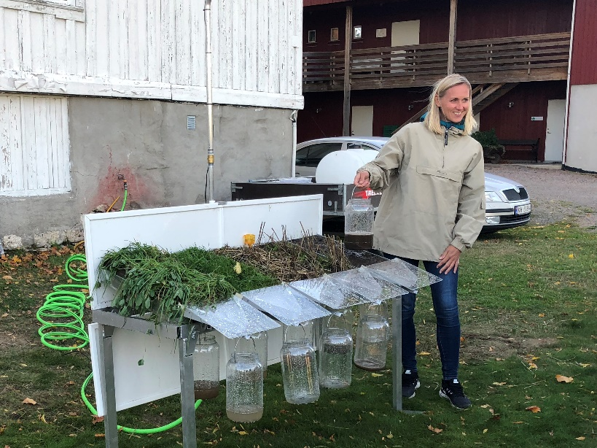
Photo: Marit S. Haugen

Others especially appreciated to learn how to conduct their own soil samples. Some participants emphasised the importance of achieving new, updated information, while others wanted to brush up their knowledge or getting confirmation that they are doing something right. Some told that they got more out of the event than expected.

In addition to the presentations, I got many practical advices how to restore the farmland that has been damaged by heavy machinery in connection with road construction (female participant)

I like demonstrations like this one, and field walks where the farmers meet at a farm with a relevant production, because then we have a basis for professional discussions. The theoretical presentations are useful, as the knowledge needs to be developed. Grain farmers know how to grow grain, but it is important to know, as one of the presenters pointed out, that if you only grow grain it would be a disaster (male participant)

I got more than I expected. I learnt to take soil samples already in the 1990’s so I thought I knew how to do it. However, I have not followed up the research in this field, and much has happened the last 25 years. Therefore, it was good to brush up my knowledge. The presentations were so interesting and informative (female participant)

However, there were some points of critique. One of the farmers who participated had hoped that there were more of his colleagues there – farmers, both organic and conventional ones. The networking part did not give him much because of very few participating farmers. The criticism was aimed at the invitation, which in his opinion largely was turned to a target audience of eco-interested participants, and not necessarily farmers, and at least not conventional ones. He had hoped to meet his fellow colleagues, those who actually engage in soil cultivation on a daily basis, and the generations who will engage in this in the future. He believed that these must learn more about how to reduce the use of fertilizers, and then such events must apply to conventional farmers.

Several participants noticed that the speakers (experts) had limited time, and thought it was a shame that they had to hurry through their presentations. It was very useful knowledge, but difficult to get along with all the information. Others had hoped for more time for discussions and exchange of experiences, but the cold weather outside affected this and some left before the event was finished. There were also some participants who had hoped for a more practical approach, and more specific advices. They found it more aimed at large-scale producers than those having a kitchen garden and small-scale producers. Some of the information presented were a bit too advanced for some of the participants, but the practical sessions were very useful.

Motives, learning and networking

This section discusses the participants’ motivations for attending the demonstration day, associated with both individual and social norms and factors. This section will also take a closer look on the different mediation techniques used during the event, and what type of information and knowledge the organisers disseminated.

Reasons to attend demos
The participants’ motivations for attending were varied, but several also highlighted the same motives and factors for participation. Individual attitudes and perceptions for attending are discussed below, in addition to individual and social norms and practical reasons that affected participation.

Attitudes and perceptions
There were various reasons for why these people participated at this event. Overall, most of them wanted to acquire new knowledge, be updated on the field and get concrete advices and practical examples of how they can provide good soil culture and how one can achieve optimal fertility without pesticides and fertilizers. Networking and meeting people interested in the same topic were also important factors. At such theme days, one has a “good reason” for talking to other famers, one said. Others sees demonstration days like this as crucial for networking:
It is extremely important to meet colleagues. I tell my students that before they start any production themselves, they need to visit research communities where people are doing the same production, those who operate, and they [the students] should ask questions. It is not sufficient to read books, you need to talk with people who are doing it in practice (male participant, both teacher and farmer)
Some farmers participated because of their perspective on food soil, as one farmer who told that he sees the soil as the basis for the food of humanity and therefore needs to be taken care of as a resource for society.
Many participated because they are teachers, gardeners, share farmers and/or have their own kitchen garden, and want to learn more about soil cultivation and ecological principles related to that. Others were landowners, not engaged in the cultivation themselves, but wanted to learn more about how to manage the property in a sustainable way.
Regarding other options for achieving knowledge about this topic, many of the participants use the internet – information-sites and blogs run by others who have their own kitchen garden or farm, and they read books and journals related to the topic. Personal contacts, both national and international ones, are also important sources. One participant highlighted a Facebook site only for female farmers, where you can ask about everything, and never be disapproved or criticized by others.
Norms
The participants attended this event mainly to acquire new knowledge, be updated on the field and get concrete advices and practical examples of how to improve soil cultivation. Meeting others interested in the same topic and networking were also factors.
For some, knowledge of the farm was an important factor for attending the event. Some were actively involved in the cooperative at the farm and wanted to get more knowledge about how to improve it. Others had friends or colleagues who had been stakeholders at the cooperative, or attended courses there before, and therefore had some knowledge about the farm. Many had heard a lot of positive things about the farm from others, and knew that the farm had a good reputation regarding knowledge dissemination. However, some participants did not focus on who the organiser was, but the content of the event and that it was part of the eco-week program.
Practicalities
Travel distance to the demonstration event was one of the topics we asked the participants about during interviews. Most people said they would not travel very far to attend such an event, and one hour was the longest they would like to drive. Those who had the longest route travelled between half an hour and one hour. Some of the participants told us that travel distance did not affect their decision to attend demonstrations, as long as the topics were interesting enough. Networking can nevertheless be a good argument for shorter travel distance, as one of the participants emphasized: “If you want to create an environment locally for those involved in the same production, it must be a short travelling distance”.

Forms of learning
There were used various methods during the demonstration day to engage the participants. The event was organised in two parts – one part with lectures inside, and one part with practical demonstrations outside. Two experts held one lecture each. They used power points with concrete examples from projects related to the topic, shared experiences from these, and gave concrete advices to the participants related to soil cultivation. They also included pictures and supplementary explanations to make the presentations interesting, relevant and engaging for the participants. It was possible to ask questions and give comments after the presentations, and many did.

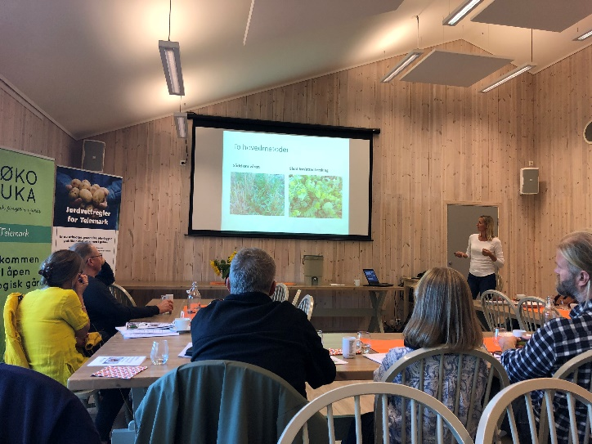
Photo: Marit S. Haugen

During the sessions outside, the experts used a combination of practical and illustrative examples, explanations and practical methods for learning. A demonstration of a rain simulator, pouring water over five different soil samples, was one of these illustrative examples. How to conduct soil samples was another practical example, and the participants received a written mapping tool so they could do the mapping work in their own fields as well. They also learned how to use their senses, e.g. to smell the soil, to assess the soil quality.
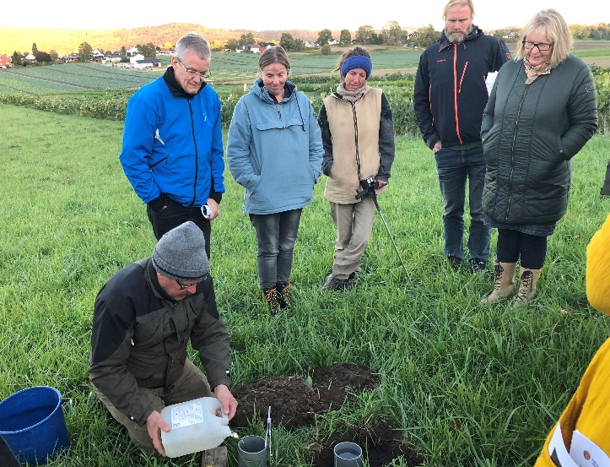
Photo: Marit S. Haugen

During all these sessions outside it was possible to ask questions to the experts, and to discuss the different topics and challenges.

Content of learning
The information and knowledge offered by the experts during the event were both theoretical explanations and practical examples. The theoretical explanations were very specific, using experiences and examples from projects related to the topic, and what kind of experiences they had so far. They also gave specific advices related to soil as a living organic material, how to improve the soil so that it can bind carbon, and specific examples of different types of soil cultivation. Regarding the practical examples, the experts used illustrative demonstrations and concrete examples with guidance of how the practitioners themselves could go forward and do the same. Some of the participants were teachers, and they found the knowledge “ready to use” after the event, and were going to use it in teaching already the next week. Others had their own kitchen garden, and could use the information directly as relevant input to make improvements there. Some of the participants told us that the practical examples were the sessions they learned the most of, and found most useful for direct use after the event. For others, what they learned were more like a confirmation that they were on the right track and that they should continue as they do.

Outcomes of learning
Through observations on site and interviews with the participants after the event, we confirmed that several of the participants thought the information they had received during the event had been useful. Some teachers would use the information and advices it in their teaching, and discuss it with their students. One of the participants got direct advices from the experts on how to repair damaged soil after soil compaction by heavy machinery. As mentioned before, for some of the participants the information they received were more like a confirmation that they were on the right track and that they should continue as they do. They did not necessarily learn something new, but it was useful as a refresher of previous knowledge. Some became more aware of the characteristics of soil, how they could optimize the soil themselves, improve fertility and contribute to climate-friendly soil cultivation. The practical methods and concrete advices were something several of the participants wanted to follow and to try out themselves.

Networking
Part of the reason why some of the participants attended the event was also to meet others interested in the same topic and to meet other colleagues. They wanted to use the opportunity to create network with others. Some attended to meet other organic farmers and to exchange experiences, because they are not a large group in Norway. Thus, occasions like this theme day was a nice opportunity to meet others with similar interests, in addition to get inspiration and new knowledge.

Some participants were a bit disappointed with the attendance of farmers, they thought that more farmers, conventional and organic, should have participated. Some thought the invitation was directed too much towards the public, and not towards the farmers who need to learn about these challenges, including the next generation of farmers.

Anchoring: Application of demo lessons by participants

This section discusses how and if farmers attending this and other demonstration days translate their new knowledge into changes in their own practice and at their own farm.

Anchoring related to the present demo
Regarding implementing their new knowledge into their own practices and at their own farm, the visitors had different intentions after this theme day. One female participant attended to learn more about soil improvement, and to implement this in her own garden. After the event, she got a greater understanding of how she could do this. Others would not make direct changes or implementations, but found the information useful anyway: “We are already about to do changes, but this [day] was a boost- not so much new, but confirm the knowledge we already have” (female participant with a kitchen garden). Some stated that they would not implement changes directly, but they are in a process where they try to acquire new knowledge, learn about alternative ways to run the farm, and more about organic farming. One of the female participants got many practical advices how to restore the farmland that has been damaged by heavy machinery in connection with road construction, and now she knows more about how to proceed.

Stimulating anchoring
There are not planned any follow-up activities to the demonstration.

Anchoring related to earlier demos
Related to earlier demos, one participant (a retired farmer) had attended a similar event about fifteen years ago at the same farm, and the message was more like the same: the importance of crop rotation to take care of the soil and to prevent drainage. Both the ecological perspective and the integrated perspective were mentioned also at that time. He has been very conscious about this himself, but expressed concern about whether the future generation is aware of this, and that there were not as many farmers who participated in this year's event that he had hoped for. He have used, and still uses every relevant occasion to discuss this topic and spread the message to other famers. He also discusses with his own son who now have taken over and runs the (organic) farm.

Several of the participants had never attended demonstration days like this before and had no earlier demos to compare with. However, many of these participate in forums and discuss different challenges with other famers and colleagues, and learn from other farmers experiences: “Knowledge building is a process. To put it into operation and see if it's workable” (female participant). Some of the participants have been discussing challenges related to soil cultivation for several years: “For the last 12-14 years we have been very concentrated on grass / clover in the cultivation. Must improve the harvest to preserve the industry” (female participant). She emphasized the importance of gathering knowledge, trying to learn from others’ experiences, and to discuss their own farming practice with others as often as possible: "Overall, I can say that it has affected how I operate" (female participant).

Scaling: Application of demo lessons by the wider farming community

This section discusses the possible impacts of demonstrations in the wider farming community.

Retrospective examples of scaling
In recent years, the discussions and awareness around climate change have involved all sectors in the society, not at least in agriculture. There have also been several political signals concerning climate and agriculture, which may have encouraged farmer networks to initiate theme days and demonstrations related to climate-related issues in agriculture. An example of such political signals came in December 2016, when a White Paper on agricultural policy was published, in which climate and agriculture were highlighted by turning agricultural policy in a more climate-friendly direction. The Norwegian Parliament dealt with the White Paper in April 2017, pointing out that agriculture's most important task related to climate is to reduce emissions per unit, increase the uptake of CO², and adapt production to a changing climate. A dialogue between agricultural organizations and the government has been initiated with the aim of reaching a political agreement on how much the agricultural sector should reduce its emissions by 2030. Several research projects related to agriculture and climate have also been started recent years, and research and development organisations (R&D) are important contributors in the process of acquiring new knowledge. In order to achieve the climate policy goals, practices must change on virtually every farm. Demonstration days and theme days can play a role in developing, sharing and promoting new knowledge about how this can be done, and address those who actively need to make changes.

Farmers themselves have experienced that their work has become more difficult due to periods of heavy rainfall and / or periods of much drought. Farmers have to adapt to a new everyday life with new knowledge and new criteria for choosing soil-working methods, timing of work on the farmland, and choice of gear and machines. This has led to several theme days and possible arenas for knowledge dissemination and exchange of experience between farmers, advisors and experts. The aim of the demo-day in this case, is a result of the ongoing work in increasing the knowledge and awareness among farmers and people related to the agricultural sector on this subject. The participants on this theme day were mainly people who had an interest in organic farming, small holders, gardeners, and teachers in agriculture studies.

Both non-profit organizations that address organic farmers, the NLR, the county governor's agricultural department in various counties and other organizations related to agriculture have focused on these themes in recent years. The following are some of the topics these theme days have dealt with: fertile soil and humus construction, soil and plant growth, how to assess soil, how to build a fertile soil, living top soil, biologically correct soil treatment, carbon binding and microbiological diversity.

Prospective assessment of scaling: Impact pathways
The organiser, some of the participants and the experts said that there should have been more conventional farmers present at the demo day. They believe, however, that some of the necessary changes start among idealists, and will spread to new groups. One of the participants gave a few examples of inventions that have started among organic farmers, but are now also used by conventional farmers (to spray plants /fruit trees with soap and oil instead of pesticides against codling moth, and use fiber cloth to cover and protect vegetables). A demo-day might not lead to immediate changes, but inspire the participants and contribute to the process of increasing awareness of how important sustainable farming practices are.

Demonstration days like the one described in this case, along with other similar events and increased focus on soil cultivation and climate issues in agriculture, have contributed to raising farmers 'awareness and knowledge about the theme. It has also affected other actors who are part of the farmers' networks, such as farmers’ advisory services, farmers’ organisations, politicians and researchers. According to one of the advisors in the southern branch of the NLR, farmers have never been more interested in nutrient supply and soil. This branch operates a series of experiments that look at the relationships between different types of compost and vegetable cultivation. The experiments have led to significantly increased attention about the value of organic waste resources at farm level, and increased use of, among other things, composting. Several such research projects are ongoing, and theme days and demonstrations related to this theme are planned ahead, and will be held by several of the country's NLR-branches, among others.

Case study reflection

This section reflects on the main findings from our case study regarding four topics:
- Governance of demonstrations and learning;
- Facilitating and impeding factors for successful demonstrations;
- Accessibility of demonstrations;
- Impact of demonstrations.

Facilitating and impeding factors for successful demonstrations

The participants appreciated the combination of theory and practice. Illustrative demonstrations and examples where the theory is shown in practice make it easier for participants to understand the knowledge disseminated, and to implement this in their own practice. Another important factor is to have skilled professionals and experts who are responsible for the academic content, which they succeeded with in this case. It is also crucial for a good demonstration that participants are actively involved. At the same time, this must be weighed against how long it takes if everyone should try to do everything themselves – to conduct their own soil samples, for instance. Here they solved it in a good way by having it shown and explained in an illustrative manner by the expert, and providing the participants with a written mapping tool to be able to do this themselves later. They also got the opportunity to take a closer look and to use their senses, e.g. to feel and smell the condition of the soil.

The local organizer had created participant lists with contact information for all the participants, which they shared at the start of the event. This facilitate contact between participants and experts afterwards if they have questions or wish to discuss matters further. These lists can also be used by the participants’ networks, and they can give advices to others who want more information on the topic.

Such demonstration days are also important for networking, but there needs to be room and time for this. Regarding this demonstration day, it would have been useful to have more time to spend on informal conversations, questions and discussions. A moderator to help the organisators and experts to keep the schedule would have been a good tool.

Who has access (or not) to the demonstration day is an important aspect. It is important that the organizer reaches the right audience and that the participants are the people they wanted to reach. Here they did so to a large extent, but both the organiser and several of the participants wished there were more farmers there, also those who operate conventionally. Choosing information channels and how one formulates the invitation is therefore very decisive in terms of participant composition.

Impact of demonstrations
Regarding the five impact domains from the PLAID conceptual framework (productivity & profitability, resilience, sustainability, quality of life, and empowerment), we will try to assess to what extent these impacts were realized or could be realized. Since climate issues is one of the main themes in this case, and also involving the areas mentioned above, it is most meaningful to discuss these issues as a whole.

Regarding both productivity and profitability, resilience, sustainability, quality of life, and empowerment, agriculture's adaptation to climate change are important, if not crucial. Farmers and others experience major challenges related to soil cultivation due to both drainage and drought, and there is a great need for knowledge about good soil culture and caring for the soil in order to use the land to its full potential, and in order to maintain the productivity needed for farming to be profitable. Recycling of carbonaceous material also strengthens humus formation in soil, and optimal soil culture is thus the way for a more climate-friendly and climate-robust agriculture, as well as for better cultivation and more nutritious growth. Regarding the political signals in recent years concerning the role of agriculture in relation to climate emissions and the importance of adapting the production to a changing climate, research, knowledge sharing and exchange of experiences between professionals and practitioners are of great importance. Forums such as this demonstration day where both experts, teachers, farmers and others who work with agriculture/horticulture meet will be important also in the future to find the best solutions and best practice to achieve these goals. Further, important knowledge will be developed in these forums and spread in the various channels where the practical work will be conducted, and where the changes will take place. Continued focus on the importance of advisory services for farmers and others who work within agriculture and soil cultivation will be important. In addition, it will be important to highlight the importance of theme days and demonstration days and support for research related to these topics. These aspects will all contribute with important knowledge, facilitate the dissemination of this knowledge, and create greater security for those engaged in agriculture and cultivation of soil, so that they continue to see soil as an important resource, and see how soil can be an important factor in climate adaptations.

Key lessons from this case study
This case has provided a good example of what works well on a demonstration day, but also some aspects that an organizer should seek to improve. They were able to engage the participants through a combination of theory and practice, and having several experts involved with different experience and knowledge. At the same time, they did not reach all the participants they wanted. There were few farmers, which seems a little strange considering the challenges the farmers in Norway have recently met related to both heavy rainfall and drought and thus soil related issues. Here it was evident how important it is to make a good effort in advance of the demonstration to reach the right audience, be aware of which channels you use, how you write the invitation, and perhaps explain to a greater extent who they want to attend if the invitation may seem more appropriate to a specific audience.

It was also clear that the time schedule should not be too tight, but one should make room and time for discussions and questions. If time is short, one of the organisers should have the role as a moderator to keep track of time, giving the experts the time they need to get their job done as they initially planned.

Acknowledgements

We would like to thank the organisers of this day for letting us participate at the theme day, the hospitality and for good cooperation both beforehand and afterwards. We especially want to thank the local organisers for important information and knowledge through both informal conversations and interviews. We would like to thank all informants and participants for sharing your thoughts and reflections during interviews, and for providing us information both during and after the theme day. We would also like to thank Rob Burton and other colleagues for input, suggestions and contributions along the way.

Annexes

Data sources
Working on the case study and this report, we have used different data sources. Voice recordings from interviews with participants, experts and local organiser after the demonstration day have been important sources, along with transcripts from these voice recordings. The invitation to the demonstration day has also been used as an information source. To obtain information about the roles of the different organizations involved, ongoing research and other knowledge for increased insight into the field, we have used information from websites such as non-profit organizations for organic farmers, the NLR’s website, the website of the county governor in the region, and the website of the agriculture directorate. We have also used the website and information material about the demonstration farm.

Data collection methods
We have collected relevant data through informal conversations with the participants during the demonstration day, informal conversations with the local organizer before the demonstration day, participatory observation during the demonstration day, journal notes/observational notes written after the demonstration day, and document analysis (web pages, information materials, etc.) before and after the demonstration day. In addition, the most important method have been semi-structured telephone interviews with participants, organiser and experts after the demonstration day. The interview guide is attached on the next page.

Case study questions

Desktop research

- Most important actors in the subsector (desktop research)
- Typical farm characteristics of the sector (desktop research)
- AKIS in the region (desktop research)
- Social, climate and economic sustainability issues (desktop research)
- Summary of the demonstration activity – partly from inventory data
- What is the background (history) of the demonstration organisers/funders?
- Demonstration farm type
- Fit the farm type into the Plaid typology diagram
- What is the topic of this demonstration?

Observation of demonstration event

- What happened during the demonstration?
- How many people attended the demonstration?
- How many women are present and what do they appear to be doing?
- What methods were used to engage people?
- How “hands on” were the demonstrations?
- Did any sales take place at the event?
- Were environmental sustainability, social sustainability or climate change a topic in the demonstration?
If yes, in what way …
- Did anything unforeseen influence what happened?

Interview with organiser/demonstrators

In general on the organisation

- What is your role in the organisation?
- What is the history of your organisation?
- What demonstration methods do you (personally) prefer to use?

On this demonstration event

- What is the topic of this demonstration?
- What is your role in the demonstration?
- What are the objectives of this demonstration (what do you hope to achieve)?
- Who initiated the demonstration?
- Who were the targeted audience and how were they approached?
- Why/how was this identified as a in important topic?
- How is this demonstration funded?
- How many people attended this demonstration?
- Why was this farmer chosen to host the event?
- Are women involved in this demonstration?
- If yes, what roles do they do (e.g. commissioning, organsing, demonstrating)?
- What methods have you used to engage people?
If yes, please explain.

- Did any sales take place at the event?
- Did the demonstration specifically deal with sustainability issues (e.g. environmental, social or economic)?
If yes, in what way? …
- Did anything unforeseen at the event influence what happened?
- Were your expectations of the demonstration fulfilled?
If not, what would you have preferred happened differently?

On demonstration events in general or past evets

- Can you give an example of demonstration event you were involved in that was successful?
If yes, why do you think it was successful? …
- Can you give an example of a demonstration event that failed?
If yes, why do you think it failed? …
- What measures do you have in place to support farmers after the event?
- What proportion of women attend demonstrations you are involved in on average?

Interview with farm visitors

On this demonstration event

- Where do you come from?
- Why did you attend this demonstration event?
- Was the reputation of the farmer an important factor?
If yes, in what way …
- Was the reputation of the organiser an important factor?
If yes, in what way …
- Was the topic of the demonstration an important factor?
- Are you looking to make changes now or were you just curious?
- Was the demonstration what you expected?
- Was the demonstration as good as you hoped?
If no, what could have been improved? ….
- How useful was this demo for gaining new knowledge?
- Will you implement changes immediately?
If not, what would you have to do or need to know before making changes? …
- Will you discuss the knowledge you have gained with anyone?
If yes, who and why ….
- How useful is this demo for networking/meeting friends and colleagues?

On demonstration events in general or past evets

N.B. Get them to use examples of past events as much as possible

- What is it you like about attending demonstration events?
- What types of demonstration (e.g. field days, lectures, etc.) do you like the most?
- What role does travel distance play in your decision to attend demonstrations?
- What role does similarity to your farm play in your decision to attend demonstrations?

- Have you ever changed your farming practices because of a demonstration event?
If yes, explain what happened …
- Has information you have gained at a demo ever led to a neighbouring farmer changing their practices?
If yes, explain what happened …
- Have you ever acted on information someone else gained from a demonstration event?
- If yes, explain what happened …
- Can you think of an innovation that has been taken up in your area during your lifetime?
If yes.

- Do you know if demonstration activities played any role in promoting it?
- How did they affect the uptake?
- Did the demonstration initiate the activity, or help farmers to improve the activity once it was widely practiced?

- Can you think of an innovation that has failed to be taken up in your area despite demonstration activities?
If yes, explain what happened …

- What other sources of information do you use?
- Are there other family members that attend demonstration events?
- Would you attend more demonstrations if they were available?

