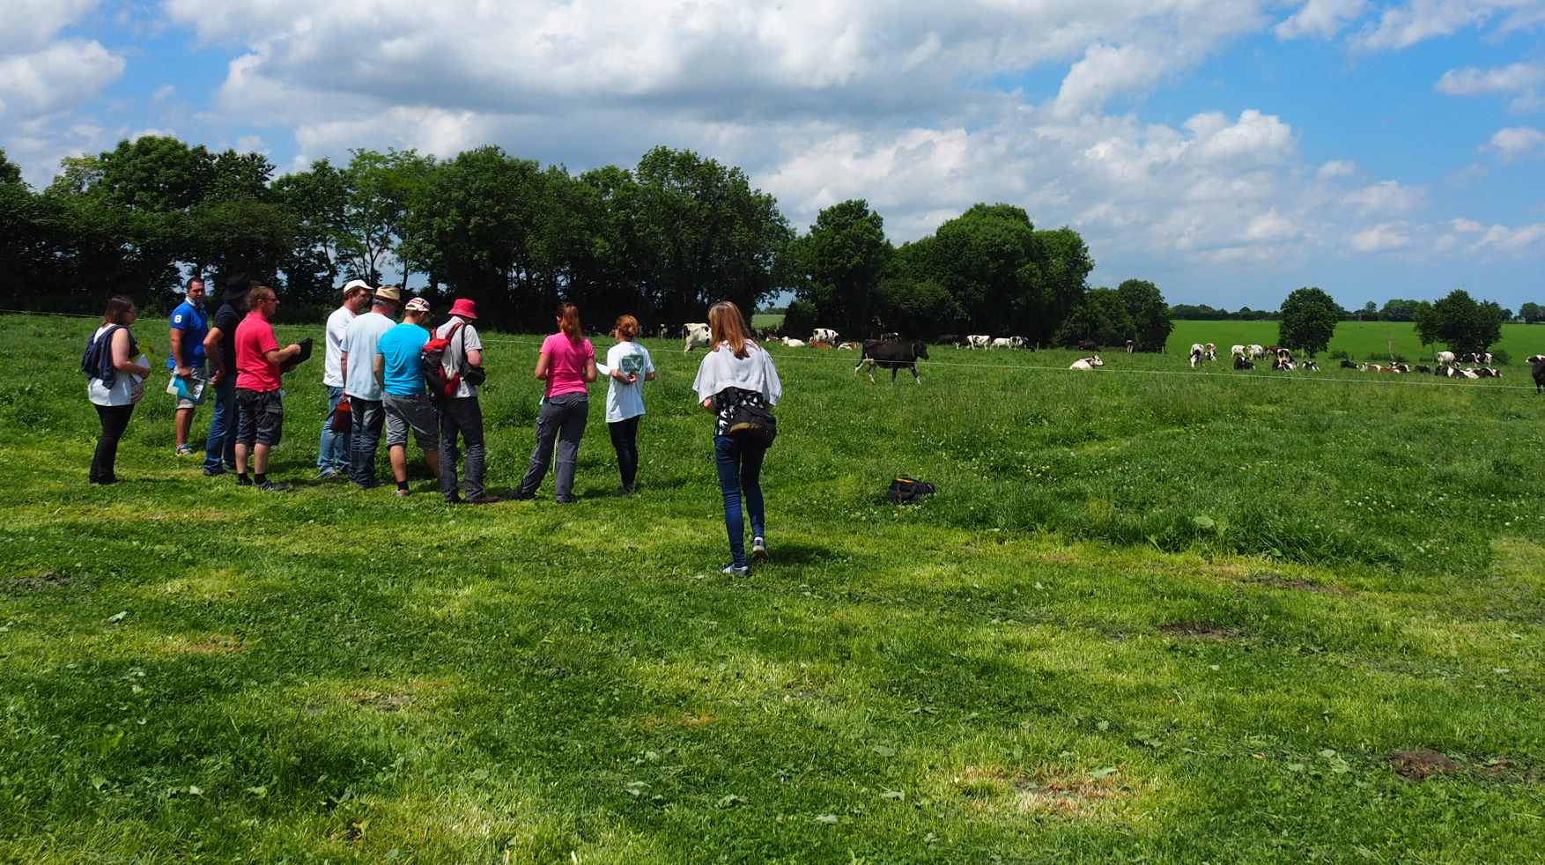

Date: January 2019

Country report: Latvia

Case Study: LAT2 Herbivore project (Network of demonstration farms in animal husbandry)

WP5: Case studies of demonstration activities in commercial farms

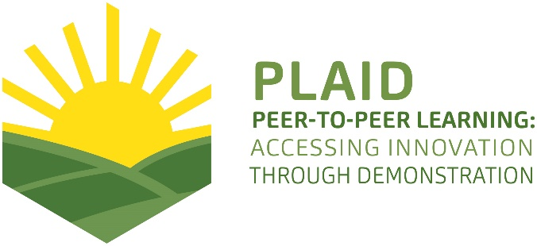
This project has received funding from the European Union’s Horizon 2020 research and innovation program under Grant Agreement No 727388

PLAID PARTNERS

Advisory Service Croatia ASC | 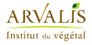  ARVALIS Institut du Végétal | Association de Coordination Technique Agricole ACTA
Institute for Rural and Regional Research | Chambers of Agriculture | Delphy
European Forum for Agricultural and Rural Advisory Services EUFRAS | Innovatiesteunpunt ISP | Institut de l’Elevage – Idele
Instituto Navarro De Tecnologías E Infraestructuras Agrolimentarias | Linking Environment and Farming LEAF | National Agricultural Advisory Service
Nodibinajums Baltic Studies Centre (BSC) | Research Institute of Organic Agriculture (FIBL) | Stichting Wageningen Research
The James Hutton Institute | VINIDEA

DOCUMENT SUMMARY

__________________________________________________________________________________
Milestone Title: 24 Case Studies
__________________________________________________________________________________
Case Study Title: Herbivore project: Network of demonstration farms in animal husbandry (Latvia)
__________________________________________________________________________________
Version: 3
__________________________________________________________________________________
Task Lead: WUR
__________________________________________________________________________________
Related Work package: WP5
__________________________________________________________________________________
Authors: Anda Adamsone-Fiskovica, Mikelis Grivins, Emils Kilis
__________________________________________________________________________________
Grant Agreement Number: 727388
__________________________________________________________________________________
Project name: PLAID
__________________________________________________________________________________
Start date of Project: January 2017
__________________________________________________________________________________
Duration: 30 Months
__________________________________________________________________________________
Project coordinator: The James Hutton Institute

ABSTRACT

On-farm demonstrations in animal husbandry in Latvia
Field trials and demonstrations on commercial farms in animal husbandry (beef and dairy cattle, sheep, goats) have been organised between 2013-2018 in the framework of the Herbivore project headed by the Competence Centre in Animal Husbandry of the Latvian Rural Advisory and Training Centre. This project funded by the National Rural network was aimed at providing systematically organised and thematically comprehensive object-lessons presented to the wider farming community in boosting the efficiency of production in livestock-breeding. In total 25 field trials on 29 farms all over Latvia have been held, each focusing on a specific topic and mostly lasting for 2 years, with altogether 58 public demonstration events held on these farms. The programme of these Farm days (4-5 hours) usually included a theoretical and a practical part, combining an in-doors seminar with an on-farm visit. Implementation of each trial theme on the selected farm has been pursued in cooperation with an advisor, a scientific expert and a host farmer. The case study revealed that the major challenges have been related to (i) identifying the trial themes deemed relevant by both specialists and individual farmers; (ii) finding the right host by balancing top-down and bottom-up recruitment of potential candidates; (iii) achieving efficient implementation of trial procedures through the tripartite model by balancing the available funding, the research agenda, and the partners’ differing commitment for engagement; (iv) dealing with the impact of various unexpected (force majeure) factors on the process and outcome of the trial; and (v) addressing the tensions between the quantity of visitors and the quality of learning opportunities at the public events.
TABLE OF CONTENTS

1 Demonstration context 6
1.1 The value chain 6
1.2 Typical farm characteristics 8
1.3 Agricultural Knowledge and Innovation System 9
1.4 Sustainability challenges 10
2 Demonstration summary 11
3 Governance: set up and organisation 13
3.1 Organiser(s) and history 13
3.2 Funding 14
3.3 Host(s) 15
3.3.1 Criteria for host farm selection 15
3.3.2 Motivation for hosting a demonstration 16
3.4 Gender 17
3.5 Objective(s) 18
3.6 Topic(s) 19
3.7 Access 20
4 Demonstration event 23
4.1 Visitors 23
4.2 Communication & Mediation 25
4.3 Active participation 26
4.4 Doing business 27
4.5 Role of sustainability 28
4.6 Unforeseen circumstances 28
4.7 Plans vs. practice 30
4.8 Participants feedback 30
4.8.1 Feedback by host farms 30
4.8.2 Feedback by visitors 32
5 Motives, learning and networking 33
5.1 Reasons to attend demos 33
5.1.1 Attitudes and perceptions 33
5.1.2 Norms 34
5.1.3 Practicalities 34
5.2 Forms of learning 35
5.3 Content of learning 38
5.4 Outcomes of learning 40
5.5 Networking 41
6 Anchoring: Application of demonstration lessons by participants 43
6.1 Anchoring related to the present demo 43
6.2 Stimulating anchoring 45
6.3 Anchoring related to earlier demos 45
7 Scaling: Application of demonstration lessons by the wider farming community 47
7.1 Retrospective examples of scaling 47
7.2 Prospective assessment of scaling: Impact pathways 47
8 Case study reflection 49
8.1 Facilitating and impeding factors for successful demonstrations 49
8.1.1 Inputs 49
8.1.2 Access 50
8.1.3 Demonstration process 51
8.2 Impact of demonstrations 52
8.3 Key lessons from this case study 53
9 Annexes 56
9.1 Data sources 56
9.2 Data collection methods 57
9.3 Survey results 60

Demonstration context

The value chain
The agricultural profile in Latvia is characterised by the prominence of two main sectors, namely, grain and milk, each making up 31% and 19% of final agricultural output (see Figure 1). Combined, dairy farming and animal products account for 38% of final agricultural output.
Figure 1. Final agricultural output in 2016 (at base prices)
Source: CSB (2017).
The situation in the value chains of various agricultural sectors related to animal husbandry differs. As revealed by Figure 2, the structure of livestock herds in Latvia is dominated by cattle (66%), followed by pigs (18%), poultry (11%), and minor shares of other livestock. Herbivores (cattle, sheep and goats) account for 69% of all livestock herds.
Figure 2. Structure of livestock herds at livestock units; at the end of 2016

Source: CSB (2017).
Dairy sector, which is the second biggest in terms of agricultural output, is fragmented (in 2016, 17286 dairy farms were registered with on average 8.9 cows per farm (see CSB 2017)) and shows a pronounced movement towards greater centralisation (CSB 2018c). This is also reflected in the growing output of milk (CSB 2018a). Meanwhile, the number of milking cows in the region is dropping (CSB 2018b). The peculiarity of the sector is the high number of small farms – currently, around 3/4 of the dairy farms have less than five dairy cows (CSB 2017) (which is less than the EU average (around 15 cows per farm) and significantly less than the average in countries dominating in dairy production in the EU (Eurostat 2017)). During the last few decades the sector has experienced a number of shocks – fluctuations in milk prices, new regulations, trade restrictions, bankruptcies of several processors (leaving debts to farmers unpaid) are just a few examples of turmoil the sector has been going through. These processes have pushed farms (and especially, the smallest farms) out of the sector. Thus, the number of the very small farms (the trend can be felt especially strong among farms with five or less cows (Ministry of Agriculture 2017)) and consequently the share of very small farms has been rapidly decreasing during the last few decades. Farmers operating in smaller farms also usually do not have agricultural education. However, there is also a tendency for small farms with low productivity and often questionable milk quality to leave the sector, and for the average and large farms to invest in productivity increasing measures (improving genetic quality of cows and fodder, analysing their farming practices and modernising farms). This has ensured that the average number of cows per farm, the average milk yield per cow and the national milk output has been increasing (see CSB 2017).
The meat sector, in turn, is still developing. Latvians are consuming less meat than an average European (Šteinfelde 2018). The historical trade channels with Russia have been recently lost due to the trade ban imposed by Russia, yet only a few new markets have been found. Still, export markets are developing. The meat sector is forming only a small share of the overall agricultural output. During the last decade, there has been an increase in the amount of beef and sheep meat produced in slaughterhouses (CSB 2018a). Currently, involvement in the meat sector is considered a promising opportunity offering a possibility to ensure relatively safe returns. Although in the meat sector small farms dominate, this trend is less pronounced than in the dairy sector. Many of the farms operating in the sector are still new to animal breeding. This is partly related to the fact that during the recent milk price crisis farmers were encouraged to shift their specialisation to meat production which some of them did. Furthermore, various breeds for meat production are still new to Latvia and farmers are still learning about their characteristics and exploring various farming models.
Breeding of beef cattle is gradually developing and improving in Latvia. The sector aims at production of quality beef, provision of consumers with meat from animals reared in Latvia as well as improvement of competitiveness and export possibilities. Currently, the production volumes are not high because the beef production cycle is relatively long, and it is not possible to rapidly increase the output. Beef animal breeders are able to develop due to increasing exports of beef animals. Diversity of breeds of beef cattle bred in Latvia is continuously increasing.
Sheep breeding in Latvia is still developing, and the proof of this is an increasing number of registered sheep (CSB 2018b). This growth is due to a growing demand for mutton both in internal and external markets, as well as to exports of live sheep to EU countries. The sector is aiming to develop a stable sheep breeding and processing sector that is able to produce high quality and competitively priced meat and wool products for internal and external markets. Because the market situation has changed and the major focus in sheep breeding has become meat production, now the main objectives are to increase the fertility of ewes, maintain lambs and focus on an intensive production of mutton.
Goat breeding is developing rather slowly. The number of goats has remained stable over the past few years, and there is no indication of any notable upward or downward trend. The majority of economically active goat breeding farms are organic farms, which are oriented towards home-based production, offering goat milk products on the market. Lately, there is an increasing interest in the production of goat meat.

Typical farm characteristics
As indicated above, there are significant differences between livestock sectors. If looking at the farm structure in terms of the number of livestock units by the size of agricultural holdings for herbivorous animals, there is a considerably larger share of small farms in sheep and goat breeding, whereas in the case of beef and dairy cattle almost half of all livestock units are concentrated in large farms (see Figure 3). Still, if compared to pig and poultry farms, the role of large farms is considerably lower.
Figure 3. Number of livestock by size of agricultural holding; at the end of 2016
Source: CSB (2017).
The average dairy farm in Latvia is smaller than the EU average dairy farm both regarding heads in the herd and the average milk yields. However, this differs between Latvia’s regions (CSB 2018d). While in the Eastern part of Latvia there is a pronounced dominance of extremely small farms with low productivity, the central part of Latvia has significantly bigger farms with average productivity reaching the EU level. The differences between regions are also reflected in knowledge needs and the structure of supply chain – in the Eastern part, a significant share of dairy products is used for domestic consumption. Most of these farms are not specialised in dairy production. Meanwhile, the actors located in the central part of Latvia have been working to penetrate the global markets. In this territory, new processing facilities have been opening.
Despite the fact that the average dairy farm is small, the dairy sector is witnessing slow yet strong structural changes – during the last couple of decades, farms have become significantly bigger and, while in 2002 only 0.3% of all farms had more than 50 dairy cows, in 2017 already 3.1% of farms fell into this group (CSB 2018c). Although some dairy farms are growing, this structural shift has been mainly achieved by smaller farms leaving the sector, and this trend is reflected in the declining number of people employed in the dairy sector (2.6 per farm) (CSB 2018e). Still, the number of people employed per farm has been growing. In the beef cattle sector, the labour force is growing, and in 2016 the average number of employees per farm was 2.1 (CSB 2018e). This growth has been mainly achieved by sectoral growth rather than farm growth. In both sectors, economic size of the farm has a significant influence on the number of people employed by these farms.
The structural changes the dairy sector is witnessing also has an impact on the average age and training level of farm managers. Although the number of farm managers above 45 years has increased by 6 percentage points, the number of managers without any official agricultural training has dropped by 10 percentage points (CSB 2018f). Somewhat similar processes are also taking place in the meat sector. The share of young farmer (below 45 years) managers is decreasing, yet the average education level of farm managers is increasing. However, in the beef sector this process is different in that the absolute number of young farm managers is increasing. There are more older newcomers to the sector, and this can be explained by a state policy aimed at encouraging dairy farmers to restructure their farms for beef production.
Breeding of beef animals has been revived only recently and thus the field has a considerable number of new entrants. When entering this sector, farmers have been investing to develop or to adapt their farms, working to improve their herds. It seems reasonable to assume that the investments they have made have helped them to improve their financial literacy. Meanwhile, in the dairy sector a large number of smaller on medium-sized farms have made only moderate investments. Even some medium-sized farms continue to farm as they used to. It is not that an investment necessarily means success. Rather, in this case lack of investment serves as an illustration of poor understanding of challenges farms face.

Agricultural Knowledge and Innovation System
When looking at the national Agricultural Knowledge and Innovation System (AKIS) in the domain of animal husbandry, there are several important features that need to be highlighted.
First of all, there are no research institutes in Latvia undertaking research in animal husbandry. Studies discussing processes specific to the dairy and beef sectors illustrate possible challenges that could be associated with the lack of knowledge availability. One of the fears expressed in these reports is that the problem is not that some farmers do not have access to some particular piece of knowledge. It is rather that there is a risk of losing the overall expertise about herbivores. Currently many of the competencies are concentrated in the largest farms, producer groups and private consulting enterprises.
The overall level of knowledge of farmers is believed to be rather low. Around half of the farm managers operating in the dairy or beef sectors do not have any formal agricultural education. No special training is provided for middle-stage livestock specialists, thus making different forms of farmer instruction very important. Farmers’ upstream and downstream partners increasingly emerge as a viable partner to provide knowledge. Also, the largest farms tend to train their own experts.
The subsectors of animal husbandry have diverse knowledge needs. For the dairy sector this is because of the diversity of farms and the structural changes the sector faces. For the beef sector this is because of the high share of new entrants who have started to operate within the sector just recently.
As elsewhere around the world, advisors and farmers are looking for new ways to access relevant information and to ensure that there is possibility to discuss experiences that farmers have had. Thus, new forms of knowledge exchange are gaining prominence. There are functioning producer groups, attempts to develop online support tools and informal groups, along with a recent upsurge of demonstration activities, which are important in the light of the overall lack of professionally designed and systematic field trials and demonstrations in animal husbandry in Latvia.

Sustainability challenges
The notion of sustainability has become increasingly prominent in the policy discourse in Latvia, not least with regards to the domain of animal husbandry. While there are policy measures and changes in legislation aimed at boosting the relevance of, and concern for, environmental issues, there are many economic aspects of sustainability still faced by the sector. It is emphasised that Latvian farmers in dairy and cattle breeding lag considerably behind their European counterparts in terms of animal productivity, yet they have to compete in the common market and therefore need to boost their competitiveness. Thus, there is an emphasis on the management systems of farms and the importance and value of economic calculations and efficiency assessments of farming.
Some of the concrete themes highlighted by experts and farmers as important and problematic in animal husbandry deal with the high share of animal feed purchased rather than produced on the farm, the reliance of farms on low-skilled labour under conditions of generally scarce and decreasing population in rural areas, the lack of farmer knowledge on implementing more advanced monitoring systems of their cattle sheds that would allow them the improve their farming practices, and still limited use of economic indices (production costs and revenues) for calculating farming efficiency by individual farmers.

Demonstration summary

The network of demonstration farms in animal husbandry was launched in Latvia in 2013 within the framework of the Herbivore project (“Measures for boosting economic efficiency of livestock production in agricultural holdings”) headed by the Competence Centre in Animal Husbandry of the Latvian Rural Advisory and Training Centre (LRATC). The Centre is the primary organiser of the set of field trials and consecutive on-farm demonstrations, but it attracts researchers from Latvia University of Life Sciences and Technologies in the role of scientific consultants. The project is funded by the Ministry of Agriculture through the activity “Implementation of sustainable pilot projects of agricultural production” managed by the National Rural network, thereby ensuring free attendance for participants.
The main aim of these demonstrations is to facilitate sustainable development of the sector and competence-based implementation of field trials and demonstrations in animal husbandry. It is to be achieved by providing systematically organised and thematically comprehensive object-lessons presented to the wider farming community at Farm days on individual farms for boosting the efficiency of production in the field of livestock-breeding. The targeted visitors are all livestock farmers in Latvia, but also advisors, researchers, and students.
The project is responding to farmers’ needs for better and cheaper maintenance of cattle by promoting cost-effective methods of farming with a view to improving the quality and volume of production, thus boosting the competitiveness of farms. The identification of problems to be tackled by these field trials and demonstrations is carried out by the board of the Competence Centre in Animal Husbandry in cooperation with researchers, advisors and other professionals. The choice of trial areas is based on an economic analysis of the sector, forecasts of the future development of the various segments of this sector, existing legal requirements, as well as feedback from participants of trials and demonstrations. The main identified problems include the quality of animal feed, inappropriate feed rations, quality of calves, unproductive animals, mortality of young animals, quality of milk, etc.
Table 1. Key figures of the Herbivore project
 | 2014 | 2015 | 2016 | 2017 | 2018 | Total
Number of newly launched trials | 13 | 1 | 8 | 3 | 0 | 25*  (in 29 farms)
Number of Farm days | 16 | 14 | 14 | 10 | 4 | 58
Number of Farm day attendees | 825 | 808 | 1144 | 774 | 276 | 3827
Source: Data provided by the project coordinator (LRATC).
* The total number of trials is lower than the number of farms since several trials were carried out simultaneously or consecutively on two farms.
Field trials (25 in total) have been held on a set of commercial farms specialising in animal production (cows, sheep, goats) where individual thematic trials are carried out over the course of 2-3 years, with a few lasting for one year and selected ones for four years (see Table 1). As of 2013, when the first contracts with farmers were signed, 29 host farms working in the field of animal husbandry from all over Latvia have been involved in these field trials. Usually one trial per farm is carried out but there are also several farms that have carried out more than one trial.
Each of the involved farms are used for addressing a different problem. Emphasis is placed on the in-house production of animal feed of high quality; longevity of herds; production and breeding of young animals, whilst also addressing various health issues (incl. fertility); introduction of new breeds, etc. Significant efforts are devoted to undertaking an economic analysis of farms in assessing their efficiency.
The host farms and field trial results are presented to interested farmers on special Farm days on the individual farms (between May and October each year) that are usually held twice on each farm (one per year) with a slightly changing focus of the event (see Image 1). The programme of these Farm days (~4-5 hours) usually includes a theoretical and a practical part. It starts with an in-doors seminar with an introduction by the head of the project, information on the host farm, presentation of trial results by the supervising advisor and the attracted researcher, additional information and recommendations on the trial topic by other invited experts, followed by an on-farm visit to and demonstrations at the host farm.

Image 1: Information sign at the Farm day in Vecauce on 20 September 2018
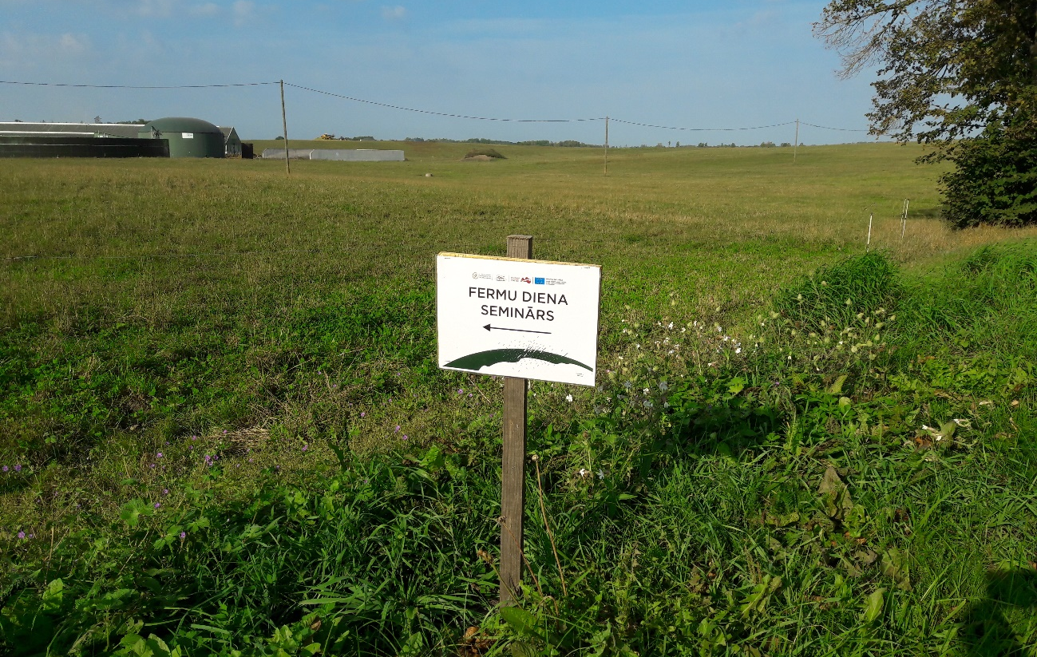
Author: Anda Adamsone-Fiskovica
The present report is based on desk research and empirical work done as part of this specific case study of the Herbivore project (see Section 9 for details). Altogether 12 in-depth interviews with managers, advisors and host farmers from different parts of Latvia involved in the project in different years have been conducted between January and September 2018. In addition, participant observations and exit surveys of attendees (131 filled-out questionnaires) have been carried out during the four Farm days held in 2018.

Governance: set up and organisation

Organiser(s) and history
The network of demonstration farms has been formed since 2012-2013 all over the country as part of a project (”Herbivore project”) initiated and coordinated by the Competence Centre in Animal Husbandry of the Latvian Rural Advisory and Training Centre (LRATC) – the leading advisory organisation in Latvia with 26 regional offices around the country. The Competence Centre is responsible for the development and implementation of demonstration programmes on dairy cattle, beef cattle, sheep-breeding, and goat-breeding, and contributes to elaboration of collaboration strategies with scientists, advisors and farmers in animal husbandry.
The project builds on the prior experience with field trials and on-farm demonstrations organised as part of different initiatives by LRATC since the late 1990s, yet these were mostly sporadic ones with periods (e.g. 2008-2012) of no developments in this domain due to the withdrawal of public funding for demonstration activities by the Ministry of Agriculture. As such the Herbivore project represents the first common large-scale framework for on-farm demonstrations in animal husbandry in Latvia after regaining its independence from the USSR in 1991. The importance of these field trials and demonstrations is boosted by the fact that, unlike crop farming, there are no research institutes in the field of animal husbandry in Latvia.
After the resumption of public funding, LRATC specialists re-approached the concept of demonstrations by building on the previous experience of publicity measures and technical solutions but reconsidering the content and organisation of field trials (also gaining inspiration from engagement in the EU-funded BalticDeal project). The network of demonstration farms within the project has been established in cooperation between farm owners, advisors, and faculty of Latvia University of Life Sciences and Technologies to develop economically grounded methodologies for setting up on-farm demonstrations.
The identification of problems to be tackled by these trials and demonstrations has been carried out by a special advisory board of the Competence Centre in Animal Husbandry (consisting of 12 members) in cooperation with researchers, advisors and other professionals. Smaller thematic groups were formed within the board to work on specific themes and attract relevant advisors. Each trial theme is then allocated one LRATC advisor and one scientific expert who both work on the given demonstration with engagement of the selected host farm. While the advisor is more involved in direct contact with, and visits to, the host farm, the scientific expert primarily provides input with insights on the trial topic and global trends from scientific literature, development of the methodology of the trial, articulation of questions and with calculations based on the data provided by the farm.
Cooperation with relevant sectoral associations (e.g., Community of producers of beef cattle, Latvian Sheep breeder association), experts from the private sector (e.g. professional evaluators of animals), the Ministry of Agriculture, as well as different input suppliers is being promoted and used in the implementation and promotion of the activities undertaking in the framework of the project.
The project took place over the course of five years, with the last field trials finalised and last Farm days held in September 2018. Altogether 29 commercial farms have been involved in the project with 58 public events (Farm days) held on these farms. There are usually two Farm days per farm where the first one is held in the first year mainly to acquaint the visitors with the host farm and the topic of the trial, while the second one is held closer to the end of the trial to present the results. Given the large number of individual farms involved in, and events organised within, the project, a process of continuous learning regarding the organisation and management of those has taken place.

Funding
The project “Measures for boosting economic efficiency of livestock production in agricultural holdings” (i.e. the Herbivore project) is funded by the Ministry of Agriculture through the activity “Implementation of sustainable pilot projects of agricultural production” managed by the National Rural network. The allocated project funding covers the costs of remuneration of the project managers, attracted advisors and scientific experts, project-related work of host farmers, costs of materials and laboratory analysis necessary for the execution of the trial, publicity measures, as well as rent of premises for the theoretical part of Farm days (see Image 2) and catering.
Image 2. Seminar part of the Farm day in Taurene on 15 August 2018
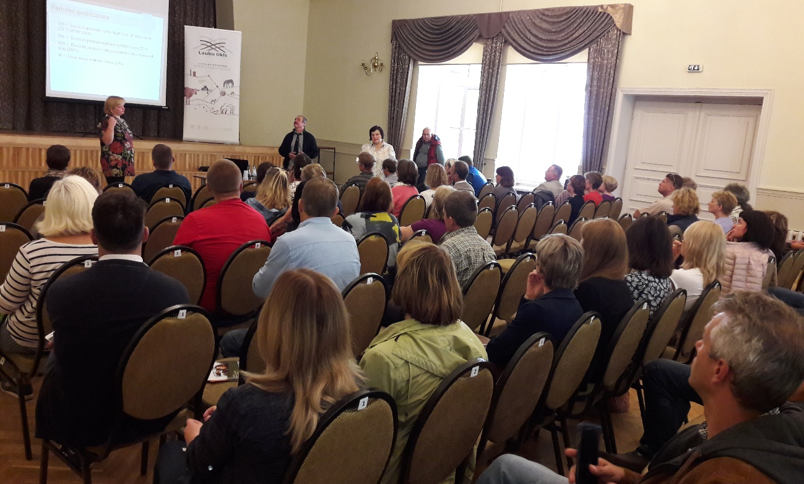
Author: Anda Adamsone-Fiskovica
Given a limited amount of project funding per trial and demonstration event, as assessed by the organisers, it is also the case that some additional individual investments are made by the host farm to ensure better catering and/or additional inputs for the execution of the trial that the host farmers see as important for themselves. One can also speak of in-kind/voluntary contribution by the involved advisors and experts, depending on their level of engagement during the trial period. Aside from that, there are no other funding sources involved in the implementation of the project – participation for Farm day visitors is free of charge and does not generate any income.

Host(s)
The recruitment of hosts for on-farm trials has been varied over the course of the project with recruiting done both by means of public announcements on calls for applications (at the outset of the project) offering participants free expert advice, and by directly approaching individual farms known personally by the organisers or suggested by other experts (e.g. practising advisors). As acknowledged by the organisers, the initial activity by self-selected farms in response to the call was lower than anticipated (11 farms applied), thus requiring additional efforts in identifying and recruiting suitable host candidates.
As noted above, 29 commercial farms (incl. one that also functions as a research and study farm of the Latvia University of Life Sciences and Technologies) have been involved as hosts in the project, representing different regions of the country (see Table 2; also Figure 5) as well as different sub-sectors in animal husbandry (see Table 3). The host farms represent a mixture of farms working under conventional and organic production systems. Most of them fall in the category of farms with the number of livestock units ranging between 50-200 and 200-600. They are involved in the process of demonstration only for a limited period (usually for two years, though with a couple of farms involved also for four or even five years) and they don’t remain an official demonstration farm after the end of the trial.

Table 2. Distribution of demonstration farms of the Herbivore project by region
 | Pieriga | Kurzeme | Zemgale | Vidzeme | Latgale
Number of farms | 7 | 6 | 8 | 5 | 3
Source: Calculations based on public information on individual trials and Farm days.

Table 3. Distribution of demonstration farms of the Herbivore project by sub-sector
 | Dairy cattle | Beef cattle | Sheep | Goats
Number of farms | 11 | 12 | 5 | 1
Source: Calculations based on public information on individual trials and Farm days.

Criteria for host farm selection
There are several criteria defined by the organisers that the host farm had to meet to qualify for participation in a trial. The most important one is related to the size of the farm (cannot be too small) and the provision of a sufficient number of animals on the farm, int. al. to ensure the possibility of establishing a control group. The size of the farm is also associated with the overall level of its activity since small farms were usually referred to as ones that “do not do much”. It was also highlighted that the host farms usually feature performance in terms of output and productivity that is above the national average. Given the focus of these demonstrations on farm animals it was also important that generally good care is being taken of them.
Another criterion was the readiness to register and share the economic and production data of the farm with the involved team of experts to allow for financial calculations (this has sometimes served as the basis for selecting demonstration farms that use the services of the LRATC accountancy thereby ensuring easier access to and use of the necessary data on costs). The accessibility and physical infrastructure of the farm also played a role to ensure that the farm can be easily reached by Farm day visitors. This is a very practical criterion as many farms are very hard to reach in autumn due to the quality of unpaved roads.
With regards to personal qualities, the open-mindedness of the host farmer(s), readiness for cooperation and self-initiative have been crucial prerequisites to qualify as a host. It indicates their willingness to learn and to share their experience, to farm in a “correct way”, to open the farm to experts as well as the ability to independently follow, and be pedantic in, all the procedures of the trial. While not necessarily holding a university degree in the field of agriculture, hosts are characterised as well-educated, determined and socially active. Earlier involvement in different projects and activities was also among the features attributed to the host farms. Recruiters of the demonstration farmers also noted their efforts in trying to avoid braggards – those who are too prone to show off without having a good reason to do so.
It has been recurrently emphasised that a key quality is also the ability of having the courage to organise a public event, allow other farmers on their farm, open their daily routines, practices and performance data for external inspection (“undressing in public”, “participating in a reality show”), which is not seen as a common feature in the farming community in Latvia. As also noted by an interviewee, “farmers abroad feel proud of themselves and are honoured to show their farm to others, while [in Latvia] we have to persuade them”. Thus, organisers in Latvia are happy if they are able to recruit farms that agree to take part in the demonstration. Communication skills are also seen as important (though acknowledged to be unpredictable, judged from initial interpersonal encounters) since the host farmers are expected to be able to talk in public with confidence during the Farm day events.
Last, but not least an implicit guiding principle for the selection of farms has been to show farms adhering to the status of a “good or very good”, “modern”, “progressive” farm that can serve as an example for other farmers to follow. Frequently the farm already has this reputation, which is known in the community. For example, one of the farms hosting a Farm day in 2018 had been selected as the best organic farm in Latvia (2017), while another had been praised as the neatest farm in the parish (2013). Not only professional but social reputation of the host farm was also sometimes mentioned, pointing to the importance of the farmer not having made many enemies in the community.
The interviewed host farmers often stated that they are generally keen on trying different new things and open for innovation. Already prior to involvement in the Herbivore project they had made active use of various learning opportunities themselves (including regular study visits abroad), attracting competent local or foreign consultants, as well as sharing knowledge with others (e.g., welcoming organised groups of agricultural students, local farmers, also foreign visitors). In many cases there was already good prior long-term cooperation with the individual advisor(s) linked to or employed by LRATC that rather naturally evolved into collaboration in the framework of the Herbivore project building on the established relationships.

Motivation for hosting a demonstration
The individual motivation for hosting the demonstrations is not a monetary one, but has been mainly related to the possibility of getting free personalised advice (also laboratory analysis and tests) from experts (advisors and scientists), devoting more time and attention to different calculations that can be made based on the available data on the farm that usually remain insufficiently used in the daily routine, as well as learning about and gaining a better understanding of the reasons for the farm’s current performance, or identifying the source of specific problems encountered on the farm. On certain occasions the public events also serve as a means of promoting the services or goods provided by the farm as part of their business, thus boosting their reputation and attracting additional clientele. While this was a recurrently mentioned effect, this was generally not seen as the primary (sometimes even treated as not legitimate) motivation by demonstration farmers as usually they already have an established position in their field.
There were also differences in the assessment by the host farmers of the degree to which participation in the trial has been beneficial for the farm and whether it was more valuable for the host farm or the visitors of the Farm days. For some more advanced farms this was more a gesture for maintaining relations with the farming community, while for others this was a major opportunity to advance their farming practices and overall performance and to allow other farmers to learn from that. Also, while some felt a high degree of personal responsibility for the use of public funding and the outcome and usefulness of the trial for a wider community (thereby also sometimes doing even more during the trial than requested by the advisor), there were also cases when the host farmer was rather reluctant to acknowledge any wider benefit of the trial for others, treating the personal benefit as a sufficient contribution of the demonstration. It was observed that sometimes a demonstration can also serve as a means for wider legitimation of the choices already made by the farm, especially if some novel practice has been introduced.

Gender
Observations on the role played by men/women in commissioning, organising and holding the demonstration did reveal certain gendered trends. The first one is closely related to the fact that most advisors involved in the project (also among all advisors employed by LRATC) as well as all the attracted scientific experts are women, with only a few male advisors taking part in the implementation of the field trials and demonstration events. It is hard to assess the implications this fact has for the way the project is managed (incl. definition of themes, selection of farms, execution and monitoring of the field trial, etc.), yet this demonstrates a noteworthy trend in the structure of the sector and the advisory landscape in the country (there is also dominance of female students at the study programmes at Latvia University of Life Sciences and Technologies).
As for the host farms, it is frequently the case that female farmers are fulfilling the function of the public face of the demonstration farm, though both spouses are involved in the practical execution of the field trial and the hosting of the public event. This does not, however, directly correlate with the division of decision-making power within the family farm, which can be equally in the hands male and female. But this illustrates the division of functions where females seem to be more inclined to get involved in public communication (soft skills). There is also a trend that women primarily deal with livestock, while men are more committed to technical equipment, machinery and land. Moreover, it was noted by some interviewees that it is very easy to say whether a farm is run by a female or a male farmer just by looking at the farm itself. This, in turn, largely resonates with the commitment that was voiced by several of the interviewed female host farmers to tidying up the farm (also washing the farm animals to be used for demonstration) for the occasion of the public event, as well as in their efforts of providing snacks and a meal for the participants by themselves as part of strengthening the good reputation of the farm. This, however, was also acknowledged by themselves as the major source of emotional stress and even some health problems resulting from the involvement in this endeavour.

Objective(s)
The officially declared primary objective of the demonstrations as defined by the organisers is to facilitate sustainable development of the sector by means of boosting the efficiency of production in the field of livestock-breeding. Quoting from the AgriSpin report: “The aim of the measure is to develop rational recommendations for livestock farms, using commercially sound good practice farming methods on a trial basis, manufacturing analysis, by promoting the transfer of knowledge in the livestock sector. The goal is (1) to promote best practice knowledge transfer and introduction of livestock farms, ensuring the exchange of experience in the livestock sector concerned: farmers, consultants and scientists, and (2) to promote cost-effective methods of farming, with a view to improving the quality and volume of production, to promote the competitiveness of livestock farming, based on economic management, taking into account animal welfare, environmental protection, and the conservation of resources” (Diebele 2016: 4).
Alongside these official objectives the interviewed representatives also noted other goals that these demonstrations are targeted at. One of those is to incentivise the livestock farming community to start thinking differently, to take up tested practices (not to “reinvent the wheel” by trial and error) by cooperating and making informed decisions and well-considered choices on investments and application of different solutions to facilitate overall economic growth. Another goal is to facilitate the transfer of scientific knowledge in a way that is of practical use for farmers. It has also been emphasised that it is important to have these demonstrations locally as knowledge coming from abroad cannot always be directly applied, given the specific local conditions that have to be taken account of.
Figure 4. Positioning of the project in the typology of demonstrations
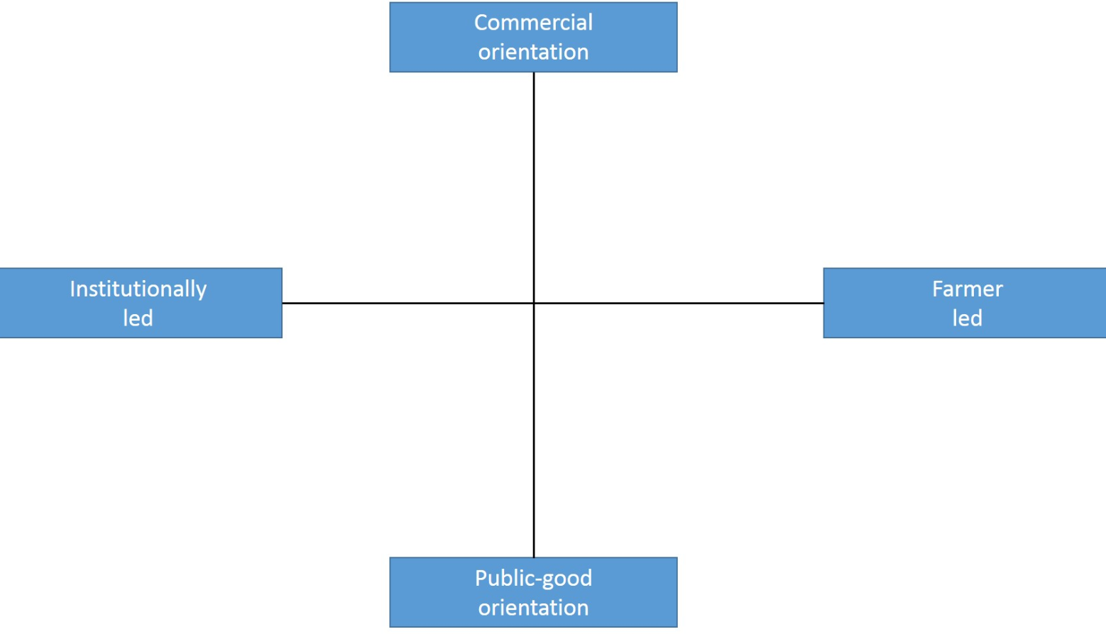
Based on the characteristics of the Herbivore project, it can be categorised as a demonstration measure that is primarily institutionally-led (initiated and managed by LRATC) yet with some elements of a farmer-led incentive given the involvement of farmers in the advisory board and the identification of relevant trial themes. In terms of orientation the project is primarily a public-good oriented one, since it does not aim to generate any direct income to the organisers through the uptake of the demonstrated practices (see Figure 4). The only signs of a commercial orientation can only be seen in the strong emphasis placed on boosting productivity of livestock farms through these demonstrations and application of the communicated knowledge on farms.

Topic(s)
Given the scale of the project, the scope of topics addressed in the field trials and demonstrations is very broad since each of the 25 trials tackled a specific issue (see Table 4). It should be noted that the trials did not necessarily deal with an innovation of some kind but rather aimed at addressing a certain problem or gaining better knowledge of the performance of a specific breed or an individual production factor.
Table 4. Topics of the Farm days held in the Herbivore project in 2018
Farm day 1  24/05/2018 | Comparison of the quality of descendants of pedigree beef cattle sires (bulls)
Farm day 2  09/08/2018 | The role of precise feeding in the dairy cattle herd; urea as the factor influencing protein
Farm day 3  15/08/2018 | Analysis of the results of fertility of pure-bred Ile-de-France female sheep, lamb retention and fattening in Latvia
Farm day 4 20/09/2018 | Analysis of milk productivity and reproduction performance of dairy cows of different origins
The identification of topics to be tackled by these field trials and demonstrations has been carried out at the outset by the board of the Competence Centre in Animal Husbandry in cooperation with researchers, advisors and other professionals. The choice of trial areas was based on an economic analysis of the sector, forecasts of the future development of the various segments of this sector, existing legal requirements, as well as feedback from participants of trials and demonstrations.
In practice, the choice of the topic for each trial has been made by following different routes, depending on the individual case. There have been cases when first a concrete farm is in mind and then a topic is selected depending on what is deemed suitable under the specific conditions of the farm but also taking account its relevance for the wider farming community. On other occasions the topic is already predefined based on the analysis of the overall landscape in animal husbandry, and a farm suitable for undertaking a given trial is sought. Under the latter scenario there can be a varying degree of the relevance of the topic for the selected farm, which can have implications for the perceived value of the trial and dedication of the farmer to this effort (see more in section 4.8.1).
While asking individual farmers for the potential topics for trials (bottom-up) is seen as a valuable source of information, advisors are nevertheless somewhat sceptical of the overall responsiveness of farmers and their ability to define relevant issues. There are farmers that “want everything, but don’t know what exactly”; the views by individual farmers can be very fragmented and lack a more overarching sectoral, long-term perspective. Experts involved in the earlier evaluation of the project have, however, drawn attention to the need of taking better care of the sufficient representation of the interests of different farmers (small, medium, big) in the advisory board (Diebele 2016).
The main identified problems or bottlenecks include the quality of animal feed, inappropriate feed rations, quality of calves, unproductive animals, mortality of young animals, quality of milk, etc. Each of the involved farms were involved in addressing a different problem in animal husbandry. Emphasis was placed on the in-house production of high-quality animal feed; longevity of herds; production and breeding of young animals, whilst also addressing various health issues (incl. fertility); introduction of new breeds, etc. Significant efforts were devoted to undertaking an economic analysis of the demonstration farms in assessing their efficiency since it was established that around 80% of farms in Latvia do not make any economic calculations of their farming activities.
While the core topic of each field trial is defined in advance and fixed in the project’s documentation, the real-life situation either on the individual farm (operating as a regular commercial farm under actual production conditions) or region during the trial period can require certain adjustments to the initial concept. Thereby additional issues and problems that become topical for the farm during the trial phase either due to observations made by the advisor (e.g. mastitis outbreak in the herd, mortality of calves, condition of animal nails) or due to some external conditions (e.g. heat stress of animals, animal behaviour and wellbeing after attack by wild animals) can be brought up and addressed as part of the demonstration, thus enriching the scope of the initially defined topics. It is also frequently the case that the Farm day programme is enriched by the host farmers with some side-topics that are either related to the core topic of the trial or to specific practices of the farm that are seen to be of potential interest for the visitors.

Access
The main target audience of the project are all farmers (as well as advisors, students, managers) working in the field of animal husbandry, with individual Farm days targeted at specific segments of the sector. The main focus has been on dairy and beef cattle breeders, which are currently more wide-spread in Latvia, but selected field trials and Farm days have been aimed at the growing segment of sheep-breeders and one at goat-breeders.
While most of the demonstration farms were medium or large ones (mostly to ensure the necessary conditions for a trial), the selection of topics and the public demonstration events have been aimed at farmers representing farms of different sizes (both small and large ones) as well as different levels of prior training and knowledge. Yet, there has been some earlier concern over the extent to which demonstrations manage to reach small and medium farms, and the less active ones (Diebele 2016). While it has been argued that most of the trial topics are relevant for all farm sizes, there are indications that demonstrations specifically aimed at and implemented on small farms, which compose a notable segment of animal farms in Latvia, are needed. And these are also farms that usually cannot afford to have a private advisor and/or go for study trips abroad.
In terms of the regional dimension, the selection of demonstration farms has been purposively done with an aim of covering all regions of Latvia (Riga, Vidzeme, Zemgale, Kurzeme, Latgale) (see Figure 5). Nevertheless, given the fact that each farm addressed a different topic, it has not been possible to cover all sub-sectors and all themes in each region. At the same time, while certain complaints have been voiced over the small number of demonstrations in Latgale, the number of visitors at the Farm days that were held there has been lower than in the other regions. This, in turn, raises questions regarding the motivation of farmers, on the one hand, and the appropriate selection of trial topics, host farms and advertising of the Farm day event, on the other.
Figure 5. Locations of demonstration farms of the Herbivore project
Source: Slightly modified, based on presentation by A. Silina (LRATC) at Farm day in Vecauce on 20 September 2018.
Note: On several farms more than one trial was carried out.
While attendance of Farm days (including the meal) is free of charge for all visitors, it has been acknowledged by the organisers that accessibility might have been restricted by the travel costs associated with coming to the demonstration farm, as these expenses are covered by the participants themselves (see Image 3). Travel costs are also closely interlinked with the duration of the trip, whereby farmers from outside the region where the Farm day is held have to devote the whole day for this activity, including the travel time to and from the demonstration site. At the same time, one of the interviewed host farmers noted that for those travelling long distances it might even be important to have a long and rich programme to justify the efforts made in coming to the event.
Image 3. Arrival of participants at the Farm day in Kuldiga on 24 May 2018.
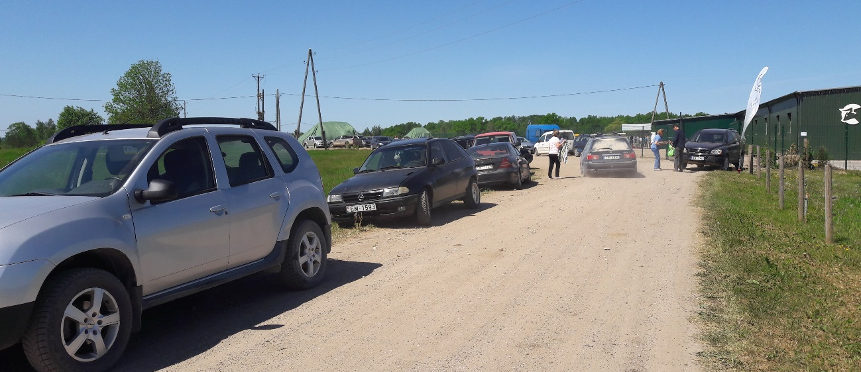
Author: Anda Adamsone-Fiskovica
Accessibility has also been addressed by means of having a timely annual schedule of the planned Farm days, which the organisers try to arrange for periods that are not at the very peak moments of the season to enable more framers to attend. Yet this has to be balanced also with the subject of the demonstration and the possibilities of the host farm, therefore the public events take place between May and October (not during winter and early spring).
Information on each Farm day along with an invitation to register for the event is published on the LRATC website and the Facebook page (at least 10 days prior to the event) (see Image 4), in several professional journals (Latvijas Lopkopis, Agrotops), also, where possible, in local newspapers, and is sent out electronically to individual farmers. LRATC advisors working in the regional offices also actively approach potential participants.
Image 4: Electronic poster of the Farm day in Kuldiga on 24 May 2018
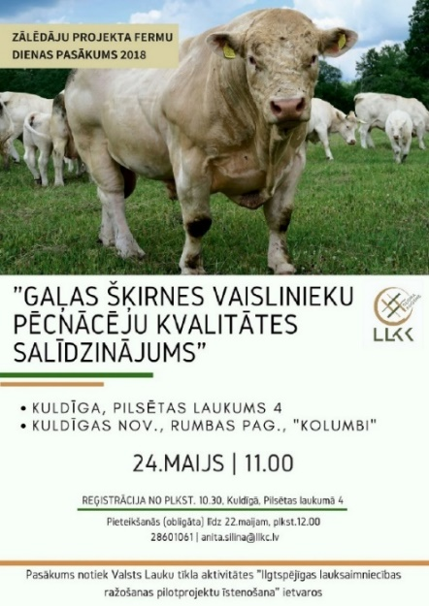
Source: Latvian Rural Advisory and Training Centre. (http://www.laukutikls.lv/sites/laukutikls.lv/files/event_posters/plakats_fermu_diena.jpg)
While rather notable advertising of the events is carried out resulting in an increasing number of visitors (not least due to the good reputation of the brand of Farm days), this is not seen as an unanimously positive feature in the light of the learning process. Though the initial intention of the organisers was to gather around 20-30 people per event to allow for more personal exchanges among the lecturers, hosts and visitors, some of the events have attracted over 100 attendees thereby making the process less manageable and creating a risk of quantity taking over the quality dimension.

Demonstration event

Visitors
The total number of visitors per all Farm days held over the course of the project has almost reached 4000 (see Table 1), with the average number of visitors per event being around 70 people, but some events have attracted up to 140 participants. The four Farm days held in 2018 that were used for in-depth analysis in the present study altogether gathered 276 people with an average of 69 participants per event (see Figure 5, Table 5). It was in line with what was expected by the organisers based on their prior experience (as noted above, the expectation at the outset of the project was about 20-30 people per event, which in practice soon grew to over 70). It was observed that there were more pre-registered people than the number of actual participants, which partially can be explained by the unpredictable nature of on-farm jobs, but also by the lack of reminders for the registered ones a day or two before the Farm day. On the day of the event all attendees are asked to register in the attendance sheet allowing to have a record of the number of profile of the actual visitors and use the contact details for any follow-up information.

Table 5. Key figures on Farm days held in 2018 and on visitors’ survey
 | Farm day 1  (24/05/2018, Kuldīga) | Farm day 2  (09/08/2018, Valdgale) | Farm day 3  (15/08/2018, Taurene) | Farm day 4 (20/09/2018, Vecauce)
Sub-sector | Beef cattle | Dairy cattle | Sheep | Dairy cattle
Number of pre-registered participants | ~90 | ~100 | ~100 | ~60
Number of registered participants | 82 | 74 | 66 | 54
Share of female participants | ~50% | ~90% | ~60% | ~75%
Number of filled out questionnaires | 37 | 29 | 37 | 28
Response rate | 45% | 40% | 56% | 52%

Most of the participants of the surveys carried out at the four Farm days had learnt of these events directly from LTARC, either through information posted on their website and Facebook profile or sent to mailing lists, as well as through a personal invitation by LRATC advisors. Others had received information on upcoming Farm days from an acquaintance, professional journal, sectoral association, local press, or lecturer. Several host farmers reported of their personal initiative in advertising the event on their personal Facebook accounts or personally approaching neighbouring farmers by phone with an invitation to attend the event.
The profile of participants is generally a rather diverse one. The occupational profile of those who participated in the surveys was also very mixed – while the majority (63%) were farmers, there was also a rather considerable share (19%) of advisors, along with selected representatives of lecturers (5%), input suppliers (4%), some scientists (2%), many of which reported to be farmers as well. There were also 20% of respondents who fell outside these predefined occupational groups and reported that they were veterinarians, students, ministry officials, engineers, accountants, zootechnicians, breeding experts, forestry specialists, etc.
The survey results show that the respondents represented a spectrum of farms ranging from one hectare to 3000 hectares, with the average farm size among the survey participants making up 226 ha (the average per event ranged from 68 to 472 hectares). It has been observed by the organisers of the Farm days that owners of large farms do not attend the demonstrations on the smaller ones, while the Farm days held on large farms are attended by farmers from all farm sizes. At the same time, it is acknowledged that farms with only 1-10 livestock units can rarely be seen among the visitors.
While visitor farmers tend to come from the region where the demonstration is held, there are also quite a few attendees from other regions of Latvia coming to the Farm days. A common trend shown by the survey results was that on average 52% of the surveyed respondents of the four Farm days came from the region of the demonstration, while the remaining 48%, if divided by regions, featured a gradually decreasing share of visitors from regions further away from the demonstration site (i.e. the further the region, the lower share of visitors from there). In the case of the four observed Farm days, the time spent by visitors for coming to the event ranged from 10 minutes to five hours, with the average of 1.5 hours. In all cases there were at least a few participants coming from outside the region where the demonstration was held, highlighting the presence of a rather strong motivation of attending this kind of event irrespective of the distance.
In terms of gender, on average the share of female and male participants among the respondents of the four events was around 70% and 30%, respectively. The observed Farm days, however, demonstrated differing patterns depending on the sectoral focus of the guiding theme. While the two Farm days dealing with dairy cattle gathered far more women than men, with the latter making up only 10-25% of participants, the gender balance was much more equal in the case of demonstrations on beef cattle and sheep-breeding where the share of male participants varied between 50-60%. These sectoral differences are rather characteristic of the different sub-sectors, where dairy farming has been a traditional and mostly female-run farm business in Latvia, while beef cattle and sheep breeding are much more recent ones, without established traditions and frequently being undertaken by younger families.
According to one of the interviewed advisors there are on average more women among the audience since they generally dominate in cognitive processes and learning as well as management of farms while men are more involved in the physical work. As argued by one host farmer, “men are hard to be brought to seminars – only if some machinery is involved”. At the same time another interviewee noted the rather notable share of male attendees arguing that they are less bound by family and household chores. While during summertime there are more families with children coming to the demonstrations, in autumn, when children are at school, women tend to stay more at home.
The sectoral differences also slightly resonate with the average age of participants where related trends can be observed. While the average age of the surveyed participants across all four Farm days was 43 years, with the overall range varying between 19 and 70 years, the observation of the whole group of attendees made the impression that in the case of dairy cattle breeding the audience was dominated by middle-aged persons (~50-60 years) with a couple of younger female participants, while beef cattle and sheep-breeding attracted comparatively younger people (~40-45 years). There were also whole families with children attending the Farm days, though more in the case of the observed event devoted to beef cattle and sheep-breeding than at the events on dairy cattle.
According to the results of the participant survey carried out at each of the four observed farm days almost two thirds (64%) have already attended a Farm day event before, while for the remaining 36% this was their first encounter with this format of a demonstration. A clear majority of the surveyed participants have been attending agricultural demonstrations once or twice a year (43%), followed by a group who report their participation in demonstration events three or four times a year (24%). Those who attend such events less than once a year (11%) or more frequently (five-six times a year – 6%; more than six times – 6%) are a minority.
It was noted by the interviewees that the profile of visitors coming to the first and the second Farm day held on the same farm at the outset and towards the end of the trial can differ. For instance, one host farmer reported having more farmers from smaller farms at the first Farm day, while more farmers from medium-sized farms showed up for the second one. Another host farmer noted that the type of questions posed by visitors by event were also different – while these were more basic for the initial Farm day, they became more advanced at the final one.
As for prior farming experience, the survey participants reported the length of it being from less than a year up to 40 years, yet the average for all the four Farm days was around 14 years (ranging from 9 to 21 years, depending on the Farm day).
The level of formal education of the visitors is rather varied. According to the survey results on average 2% had basic/lower-secondary education, 9% had secondary comprehensive education, and 29% – secondary vocational education, while those with higher education related to agriculture made up 40%, and those with higher education unrelated to agriculture – 14% (additional 6% didn’t provide an answer). The rather high variation in the level of training and education among the attending farmers was recurrently mentioned by the interviewees. It was frequently noted that the level of knowledge possessed by farmers is on average very low in Latvia, with quite a lot of basics needed to be communicated again and again during the Farm days.

Communication & Mediation
The core structure of the public event is kept in each Farm day, which generally lasts for up to five hours (10.30 a.m. – 3.30 p.m.). The programme of these Farm days usually includes a clearly separated theoretical and a practical part.
It starts with an in-doors seminar (usually not on the farm but in some nearby premises with a hall and all the necessary equipment) with an introduction by the manager of the project, information on the demonstration farm, presentation of field trial results by the supervising advisor and scientific expert, additional information and recommendations on the trial topic by other invited (local or sometimes also foreign) specialists. These are usually PowerPoint presentations, but also some short video materials are presented (for instance, about the demonstration farm or a specific practice). While the dominant format is a presentation/lecture with the lecturer standing in front of a seated audience (see Image 5), there is also a possibility to ask some questions by the participants.
There are usually also selected information materials made freely available for the participants upon registration – e.g. information leaflets (Lauku lapa) and professional journals (Latvijas Lopkopis) issued by LRATC. On certain occasions, some posters with individual trial results are also displayed. If relevant, tasting of produce can also be arranged (e.g. in one of the observed Farm days it was possible to taste and purchase different kinds of cheese produced by a company that only uses the milk delivered by the demonstration farm).
Image 5. Seminar part of the Farm day in Kuldiga on 24 May 2018
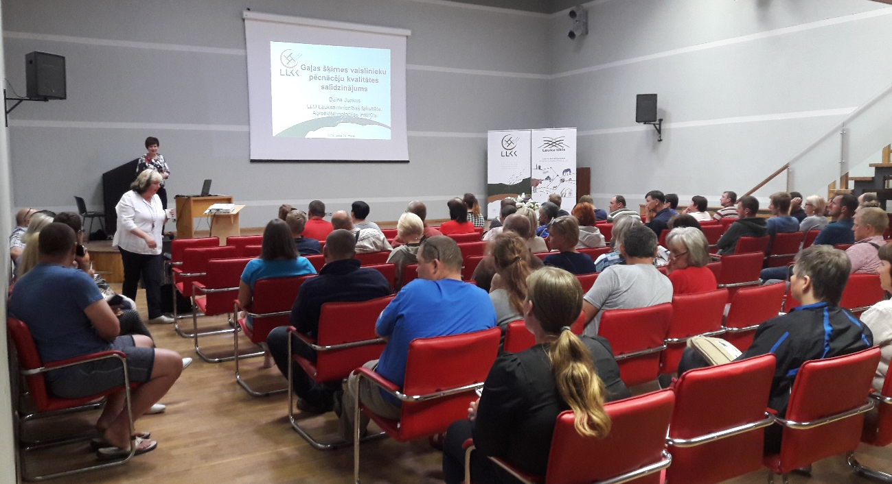
Author: Anda Adamsone-Fiskovica
After the theoretical part, participants are invited to an on-farm visit and demonstration at the trial farm where both the host farmer and advisors take the lead (see Image 6). The on-farm visit usually starts with a practical demonstration in a designated place either inside or outside a cattle-shed (depending on the level of bio-safety measures taken for the event), led either by the host farmer(s) or the advisor or carried out jointly. If the demonstration involves farm animals, a selected group of specimens is placed in an area of better visibility. Portable sound equipment with a wired microphone is usually used for better audibility.

Active participation
While the settings of a demonstration event (spatial arrangements, premises, programme, mediation techniques, etc.) provide the overall conditions for either enabling or discouraging participant engagement, the degree of engagement of visitors also depends on the personality traits of each individual person, his/her profile (e.g. farmer vs. advisor, new entrant vs. experienced farmer), as well as prior acquaintance or unfamiliarity with the other participants of the event. During the observed Farm day events one could identify a handful of more active participants that were eager to ask questions in front of the whole audience and engage into discussion, while the majority were more passive, mostly listening to the speakers and observing the demonstration.
At the same time, on an inter-personal level there were a lot of informal exchanges observed among the visitors, for instance, when having conversations in smaller groups after registration before the beginning of the seminar, over lunch or on the way from one site on the farm to the other, or when commenting immediately something of the things heard or seen during the official programme to one’s neighbour. Some visitors also took the opportunity to speak individually to the attending advisors and experts or host farmers, especially during or after the practical demonstration on the farm.
Image 6. On-farm visit at the Farm day in Valdgale on 9 August 2018
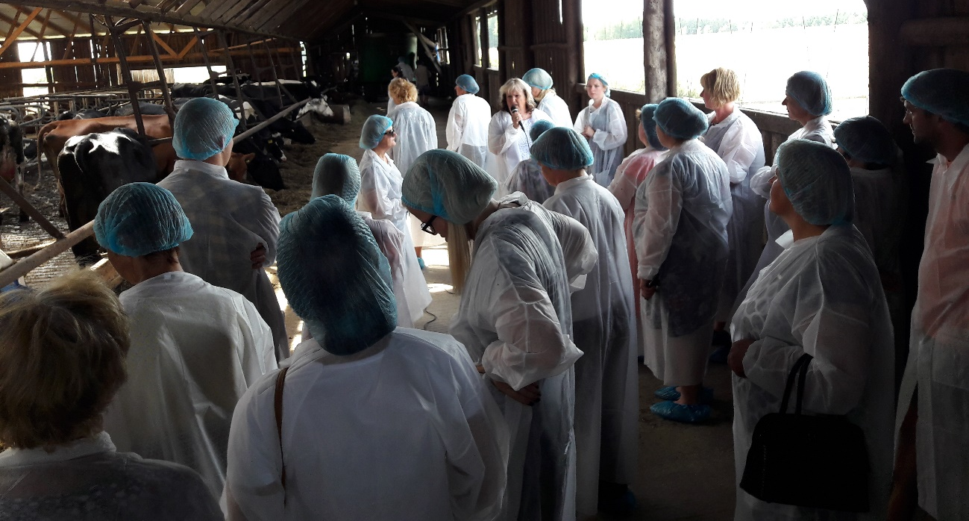
Author: Anda Adamsone-Fiskovica
The arrangement of the event does not provide much room for unguided walking around the demonstration farm, yet some visitors also manage to separate from the group to look around the site. This is, however, something that is not encouraged by the organisers either due to bio-safety concerns or the need of showing respect to the host farmers that might not want to allow unknown people to wander around their property. At the same time, one host farmer acknowledged that ideally the whole event should take place on the farm (provided the availability of suitable premises for larger groups) enabling people to more freely see for themselves the things that they find personally relevant.
It was also observed that some participants stay only for the theoretical part in-doors and do not join the others for the field visit (the reverse option of only coming for the farm visit was less common). There is always also a further gradual reduction in the number of participants during the farm visit with a comparatively small group of visitors (approximately half of all the registered visitors) staying until the very end of the event. This may be due to other commitments or duties that day, or the fact that some participants are only interested in selected aspects of the programme.

Doing business
The doing-business activities are not seen as part of the demonstration event since the specifics of the demonstrations in the Herbivore project is that these are not meant for demonstrating specific products (that could be purchased) but rather for showing applied farming practices. Yet, the Farm days do implicitly provide an opportunity also for some business arrangements by the visitors, for instance, if visiting a farm that sells breeding animals that a farmer might have an interest in obtaining in the near or more distant future.

Role of sustainability
The official aim of the Herbivore project is to “facilitate sustainable development of the sector and competence-based implementation of trials and demonstrations in animal husbandry”. Among other things, the project aims to promote animal production taking account of animal welfare, environmental protection, and the conservation of resources. While sustainability as a concept is not used much in the rhetoric of the Farm day events, this does not automatically imply that the role of sustainability is being ignored in the field trials and demonstrations carried out in the framework of the project. The main emphasis, though, is placed on the economic sustainability with an overarching focus on boosting the efficiency of production in the field of livestock-breeding in terms of productivity.
While it has been acknowledged that there has been a certain turn in the overall thinking by moving away from a mere focus on increasing the milk yield (in dairy farming) towards incorporation of concerns over environmental aspects, the role of environmental sustainability in the field trials and demonstrations is present to a much lesser extent than the economic one. For instance, though there are organic farms among the host farms, no trial has been specifically focused on organic farming.
At the same time, demonstrations on Farm days have touched upon issues of manure storage and disposal, welfare of animals as an important prerequisite for the quality of produce, as well as the potential long-term problems caused by the trend of using limited genetic material in cattle-breeding (domination of a single breed) as well as exaggerated genetic improvement of selected animal breeds and rushed commercial use, thereby integrating the environmental aspects in the overall narrative. These aspects were, however, emotionally commented on by farmers from an economic perspective (“but one wants to eat..”, “the farmer has a family to feed!”), thus demonstrating the tensions underlying the various sustainability aspects.
Social sustainability as the third dimension of sustainability, however, is largely beyond the scope of the issues addressed by the project.

Unforeseen circumstances
There were no major unforeseen circumstances observed on the four Farm days held in 2018, except for the rain that started during the farm visit on the event devoted to sheep-breeding. This factor slightly decreased the level of participation and attention by the participants, but it did not put the whole demonstration on halt since the rain was not too heavy and people didn’t seem to be much bothered by it (see Image 7). On other occasions, it was the sun that was too bright for either seeing the screen with the presentation (no blinds) or having a good view of the outdoor demonstration. During the farm visits the surrounding noise created by different machinery units (e.g. tractors, ventilation and equipment in the cattle-shed) as well as animals can also be disturbing at times.
Image 7. On-farm demonstration at the Farm day in Taurene on 15 August 2018
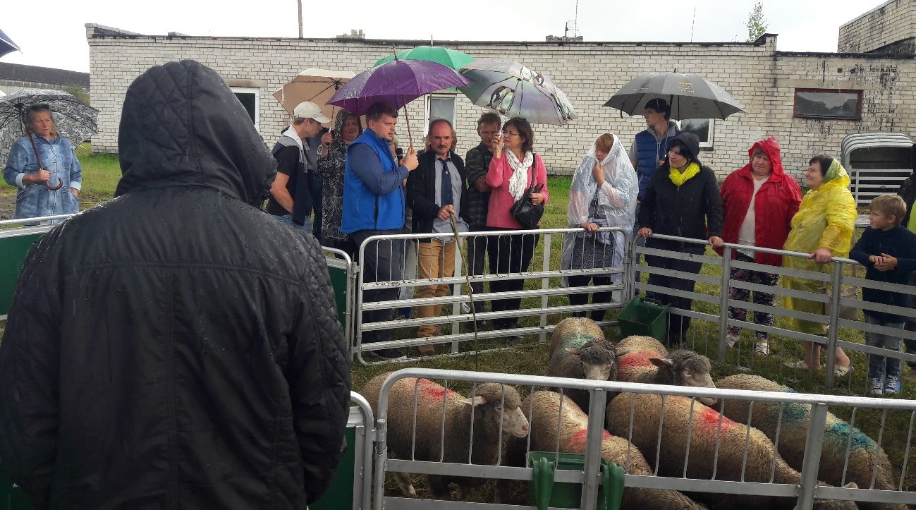
Author: Anda Adamsone-Fiskovica
Based on interviews with organisers of the field trials and demonstrations the problem with force majeure or human factors were more critical with regards to the trial phase and the demonstration farms. These had to do with a sudden illness or even death of a farm manager as a key person on the farm that makes it impossible to carry on with the trial and causes notable difficulties in terms of financial accounting and project administration. It has also been the case that at some point some of the hosts were no longer motivated to take part in the project either due to difficulties in following the procedures and ensuring the necessary conditions of the trial or due to the problems identified by the advisors regarding the efficiency or the regular farming practices on the given farm that are to be eventually revealed to the wider community. This can cause frustration and discontent both for the farmer and the advisor, at times putting at risk future relationships and collaboration prospects.
Some other instances of unforeseen circumstances include a forced change of the demonstration farm that had to be undertaken due to unanticipated problems with the production conditions (incl. change in the hired staff) on the farm in meeting the necessary requirements of the trial and ensuring reliability of results. Sometimes the aim of the planned trial can turn out to be too ambitious in the light of the practical conditions and developments on the farm. For instance, not all livestock units initially selected for the trial group turn out to be there for the whole duration of the trial due to exclusion determined by different illnesses. It might also be difficult to ensure comparability of different livestock units as heifers are born at different times on the farm, which also can introduce unplanned changes in the trial process and even undermine the possibility of drawing well-founded conclusions.
Other force majeure factors include an attack on the farm animals used in the trial by wild animals or animal death due to an outbreak of some illness, thus partially distorting the trial, or extreme weather conditions (e.g. heat, drought, floods) during the trial period affecting the trial process. At the same time, it has proven that these unforeseen circumstances can also generate valuable insights for farmers on how these can influence animal welfare and what effect these can have on productivity and other farming parameters.

Plans vs. practice
One of the major differences between the way the Farm days were planned and their actual format was the number of visitors per event, which soon exceeded the anticipated optimum. It has been recurrently noted by the different interviewees that a group of 20-30 people per event would have been the most appropriate size for this learning format. While the large number of visitors is generally a positive indication of the demand for, and farmers’ overall interest in, this kind of event and their readiness to devote their time for attending them, it requires extra solutions and practical arrangements in order to cater for the needs of attendees both in terms of infrastructure (e.g. size of premises) and learning opportunities (e.g. possibility to split into smaller guided groups). This has also been one of the reasons why the sites for the two parts of the Farm day have been arranged in separate locations since regular farms usually don’t have large empty halls with sufficient convenient seating possibilities, WC amenities, audio and video equipment, and ad hoc outdoor arrangements are usually subject to weather conditions (sun, rain, wind) that can inhibit efficient communication and uptake of information.
It has also been acknowledged by the organisers that while the primary idea of the demonstrations has been to show new approaches and practices, the overall level of farmers’ knowledge frequently requires reducing the ambition and the level of complexity of the provided information. Thus, there is a constant trade-off between the intended level of novelty and the basic knowledge needed to be communicated during the Farm days. This has to do with the fact that the generations of farmers are constantly changing with new people entering the sector, and the lack of agricultural education programmes providing comprehensive knowledge for farmers that would allow them to further build on it at these kinds of demonstrations.

Participants feedback
Participant feedback can be divided into the feedback given by the interviewed demonstration farms as participants of the field trials and hosts of the public demonstration, on the one hand, and the comments provided by the Farm day attendees as participants of the demonstration events, on the other.

Feedback by host farms
As for the host farms, they are generally satisfied with their involvement in the project with many benefits noted by the farmers, incl. the possibility to combine theory and practice, improved productivity and better animal health, strengthened capacity of supplying self-produced animal feed, evidence-based knowledge for well-informed future decision-making, personalised advice and recommendations by the involved advisors and experts, as well as widening of one’s personal horizons, enhanced reputation and publicity of the farm, and involvement in other farmers’ networks (e.g. smaller interest groups) (see also section 3.3.2 on host motivation).
Nevertheless, there were selected points of critique voiced by the interviewed host farmers that can serve as useful input for any future demonstration projects. It was generally acknowledged that involvement in the project is rather time-consuming (considerable extra work) and a source of stress for the farmers (sometimes also for farm animals) involved in the implementation of the trial and organisation of the Farm day. As the farmer must prepare and make specific arrangements for the regular visits of the advisory team to enable the measurements and other procedures required by the trial outside the usual routine of the farm, this was seen to be burdensome if the team couldn’t arrive as agreed (at the same time the organisers also noted cases where due to the lack of commitment and diligence of the host farmer there were difficulties in visiting the farm and carrying out the trial).
A more balanced distribution of work between the host farmer and the rest of the team is sometimes wished for – it was noted that the information provided to the farm at the outset not always fully corresponded to the level of actual commitment required from the farmer during the project (incl. not only the field trial but also hosting the public event and being actively engaged in the demonstration and answering visitors’ questions). Sometimes it had not been made clear from the outset what kind of data and in what form should the host farmer register, thus a lack of clear guidelines and missing data lead to potentially speculative calculations and data errors. Some host farmers also voiced concern about the very set-up and implementation of some trials, which have been tolerated by the organisers (“we did the weighting not to derange the whole endeavour, but I wouldn’t say that we were very precise in doing that”). Host farmers also reported on the lack of support for their own ideas of additional measurements needed on the farm to provide reliable data, thus undermining the validity of the results and the conclusions drawn (“a university student wouldn’t get his work accepted under similar conditions”).
This issue has largely to do with the choice of the trial topics as these are often seen to be defined top-down, sometimes based on false premises (e.g. comparisons of generally incomparable groups, selection of a wrong target group of livestock for the trial), not stemming from the actual problems faced by commercial farms and thus reducing subjective motivation by the host farmer, which has been selected for the given trial. It was emphasised that a more efficient use of public funds could be made (“not just for people to come, meet, and have free lunch”), not least by learning more of the bottom-up needs of farmers by advisors through their daily communication and on-farm observations, and by identifying the recurrent ones that could be then addressed and solved by the demonstration. This, however, again goes back to the readiness of farmers to speak of their problems and share their concerns. It is also the case that identification of a problem and finding its cause(s) is a difficult task since it may involve complex factors and may not result in a solution within the given timeframe and with the type of specific expertise held by the advisor.
The amount of funding allocated from the project’s budget for covering the catering expenses of the Farm day visitors was seen as inadequate for ensuring a decent coffee table and meal, thus leading to extra expenses by the farmer (incl. in-kind contribution, attraction of additional service staff).
The interviewees also reflected on the involvement of academics in the project that can be a challenge both for the farmers and advisors, and for the researchers themselves. The common problem is the degree to which a member of a university staff can be engaged in this kind of project given their primary job obligations and lack of institutional support for such extension activities. Some participants thought that more active engagement of the attracted scientists in the field trial and communication with the host farmers could be anticipated to facilitate direct contact and knowledge exchange between the parties. Some of the host farmers were not even aware of the attracted scientists until their appearance with their presentation on the Farm day event or until reading the overview material published on the trial results. The expertise of local scientists and advisors was also at times questioned, pointing to the lack of language skills, which precludes them from drawing on the extensive foreign experiences in the specific field and providing new knowledge to more advanced host farmers. There was some critique addressed to the organisers for attracting lecturers on the Farm day that didn’t have much to do with the trial topic, or the host farm.
Nevertheless, it has been argued that the project provides a valuable experience for the academic staff, confronting them with issues of practical relevance for the farmers and allowing them to see the real-life situations on farms. LRATC advisors, who fulfil the function of bridging science and practice and serve as an intermediary between a researcher and a farmer, in turn, benefit from the academic knowledge that is brought in by scientists.

Feedback by visitors
According to the results of the four surveys of Farm day attendees carried in 2018, the overall assessment of the events was highly positive. The average score for the level of satisfaction with the theoretical part of the four Farm days was 4.53 out of 5, while for the practical (on-farm) part – 4.63 out of 5. The things assessed for the theoretical part included the suitability of the premises, personal relevance of the presented theme(s), competence of the lecturers, and the mode of presentation in terms of comprehensibility and perceptibility. The practical part was, in turn, assessed with regards to the suitability of the farm for the event, the possibilities to see the farm, the personal usefulness of the demonstrated solutions as well as the possibilities for questions and answers on the site. While both parts were seen to be well organised and relevant, the results show that the practical part with an on-site visit of the demonstration farm received a slightly higher score and was more highly valued by the visitors (most likely due to the practice-oriented nature of the latter).
The suggestions made by the visitors regarding things that could have been improved in the organisation of the event primarily dealt with the organisation of a more extensive farm walk as part of the programme. Some additional recommendations advised of a less intense use of numbers in the presentations, provision of handouts, along with some ideas on potential extra topics that could have been addressed as part of the given demonstration or in future trials. It was also noted that there is a need for better management of the non-attentive (disturbing) audience, as well as for some seating options also for the practical part on the farm when the demonstration is carried out.
Each year a reflection seminar is organised as part of the project to review and evaluate the results. The available public accounts point to the positive feedback obtained from the project participants due to the valuable knowledge on pursuing economically efficient farming, identification of problems in farming practices and providing solutions to those, along with having the opportunity to hear of the problems faced by other cattle-breeders and the ways for tackling those. This kind of demonstration events are seen as vitally important given the limited inheritable experience from the older generation of farmers and agricultural knowledge in general (to avoid only learning by trial and error). It has been acknowledged that Farm days encourage openness of farmers and the possibility for asking uneasy questions to each other given the informal atmosphere featured by these events.
It has been emphasised that it is not only the demonstration farm that is the beneficiary of knowledge transfer via the advisory support provided during the trial period, but also the wider community of cattle-breeders via the open Farm days. Importantly, it is also the advisors that acknowledge the benefits of the project for themselves in terms of learning based on the practical experiences of the demonstration farms (real farm situations) and direct contact with farmers, and the usefulness of this knowledge in their work with other clients. Likewise, the Farm days are also attended by students and faculty of the national agricultural university with the latter using the opportunity to strengthen their knowledge in fields beyond their primary specialisation.

Motives, learning and networking

Reasons to attend demos
When reflecting on the motives and reasons for attending a demonstration event, account should be taken of general attitudes and perceptions of the visitors, different social norms at play, and various practicalities that need to be considered.

Attitudes and perceptions
The reasons for attending the Farm days are different, depending on the profile of the visitor, especially given the fact that not all attendees are farmers. For instance, some Farm days also attract representatives from public authorities (ministries, agencies) that used the opportunity to see actual farms, meet farmers in person, and learn of the issues addressed in the field trials. Students come to learn both theoretical and practical things, get inspiration for selecting a topic for their theses, and also earn their credits. Advisors, in turn, take the opportunity to meet their colleagues from other regional offices and get acquainted with other specialists and farmers, and learn new things from the field trial to widen their social networks, enhance their own knowledge base and be able to provide better advice to their own clients.
The survey results show that generally there is a mix of different motivations, equally related to the possibility of hearing/meeting specialists in animal husbandry (60%), having an interest in the specific topic of the event (55%) and taking the opportunity to see the particular farm (54%). Though not of primary importance, for many participants a motivating factor was also the possibility to meet other farmers (35%). Some people also came to the Farm day primarily as acquaintances or neighbours to provide moral support to the host farmers.
Interviews with managers, advisors and host farmers also shed some light on the perception of the motivations held by farmers for attending the Farm days. Several of them emphasised the role of such public events in providing an opportunity for farmers to meet each other and socialise. As remarked by a host farmer, in their daily work farmers are very busy and don’t feel comfortable bothering their peers with going to each other’s farm and taking up their valuable time, while this type of public event offers a chance for an informal networking outside the daily farm routine. Aside from the practical knowledge gains, Farm days also provide an opportunity for the visitors to travel around Latvia and enjoy the landscape of the different places that one might otherwise not visit. It was noted that many farmers (especially the small ones) come out of curiosity, using the opportunity to see the farm, but also intrigued to learn of the outcomes of the trial.
It is sometimes also the case that people are not “fully aware of where they have come”. But the majority are characterised as those that are owners of growth-oriented farms, which have already achieved a rather good level of performance, are aimed at further development, and have a particular interest in the topic or the trial or more generally are keen on learning of new developments in the sector. One of the host farmers divided farmers into those who want to move forward and do that irrespective of what effort it takes, on the one hand, and those who treat their business as a burden, on the other. According to him, it is the former, the inquiring ones, who mostly come to demonstrations.

Norms
There were some references during the interviews to certain differences between the owners/managers of small and large farms in terms of what farms are being attended during Farm day events. While demonstration events on smaller farms are usually not attended by the representatives of large farms, Farm days on large farms attract a full spectrum of participants. On the one hand, this trend can be treated in the light of the relevance of the farming scale on the given farm, whereby larger ones might not see it to be within the scope of issues topical for them. On the other hand, this might also be treated as a certain indication of the social norms that underlie the farmers’ preferences in terms of their attendance decisions. As noted by some interviewees, the representatives of large farms sometimes see the visiting of small farms as undermining their reputation.
As noted above, the selection of host farms also takes into account the social status (prestige) of the farm either in the local community or in a wider region. It has been acknowledged by the interviewees that a status of a good farm (informally and/or certified by specific local or national prizes) that can be treated as a model farm is essential for the demonstration. This is not only a question of the ambition and motivation of the hosts but also of the potential for it serving as a model for other farmers in taking over the demonstrated practices. As remarked by an interviewee, “why would I go to a farm where the host is a ragged fellow carrying manure in a wheelbarrow and cursing the government”. It has also been noted that the proximity of a good practice farm is important for enhancing the potential effect of the demonstration on other farms. Of course, as in any business, there are also elements of competition present that prevent some potential visitors from coming to the host farm.
Another factor influencing the motivation of attending a Farm day has to do with the model set by individual key farmers that are perceived as authorities in the farming community and can thereby attract quite a few following farmers.
The survey of Farm day attendees revealed differing attendance patterns of Farm days by individuals, but the general trend was that one third of respondents (33%) had come to the event on their own, while the rest had come together with one or several other acquaintances (35%), family/household members (19%) or farm employees (10%). Also, during participant observation at Farm days, it was noted that many visitors (women more frequently than men) came and stayed together in groups of two or three. It might be that people simply feel safer and more comfortable of going together with someone they know, but it can also be the case that this allows them to have a shared experience that they can refer to and discuss after the event.

Practicalities
Usually there is a certain number of people who register for the event in advance in response to the official announcement of the Farm day but don’t show up, as well as some individuals who attend the demonstration event without giving any prior notice to the organisers (see section 4.1). There are various personal reasons for these attendance patterns, but frequently this has to do with sudden or urgent on-farm chores for farmers (e.g. a good moment for sowing or harvesting, animal births), other unplanned activities, health condition, or simply forgetting about the upcoming event amid the daily workload.
Since participation at Farm days mostly requires the use of private means of transport to be able to reach the demonstration site and given the fact that many visitors come to the event together with some other acquaintances, relatives or colleagues, it can also be the case that unavailability or change in the plans of the driver can also hamper participation of other individuals.
As the length of the programme of a regular Farm day lasts for around five hours and getting to and from the location of the event can also be rather time-consuming (for some visitors even 3-5 hours in one direction), a full day free from any other obligations is needed, thus requiring notable planning and effort. At the same time, provided that many people cover rather long distances to come to the event, an attractive and rich programme is needed to motivate potential visitors and justify their effort.

Forms of learning
As outlined above (see section 4.2), over the course of the Farm day event a mix of different modes and settings of instruction and knowledge communication are used. These range from the classical format of an in-door lecture/presentation representing the more unidirectional mode of communication to the more interactive type of on-farm activities, thus catering to different learning styles.
The style of the in-door presentations given on Farm days is also variable since these are given by speakers of different profiles – advisors, scientists, specialists, farm managers. Usually the presentations on the results of the trial are rather densely populated with tables and figures with a few clear concluding theses that require considerable concentration and can be rather demanding for the audience (some of the comments in the survey noted the oversaturation with quantitative data). These presentations, which combine audial/verbal and static visual information, are sometimes supplemented with brief video materials that trigger other senses and represent a more easily perceivable way of the provided information, but usually these do not act as substitutes to the materials on the topic of the presentations.
At times, depending on the presenter, some engagement or feedback of the audience is stimulated, for instance, by asking to raise hands by those who find the topic relevant for their farm or asking the participants’ view on a given issue prior to giving an expert opinion on that. Nevertheless, a gradual loss of attention could usually be observed towards the end of the theoretical part with people no longer following the presentations, using their smartphones, engaging in private conversations with their neighbours, etc. (as noted by one by-passing Farm day visitor, “we are not used to such sitting”).
The average score in the assessment of the presentation during the seminar part of the Farm days in terms of comprehensibility/perceptibility done by the surveyed attendees was, however, rather high – 4.37 out of 5 (ranging from 4.25 to 4.54 in the different events). The same holds true for the assessment of the level of expertise of the involved lecturers on average being scored even at 4.71 out of 5 (ranging between 4.57 and 4.81, with 5 implying full satisfaction).
An observation made during the Farm days revealed that there are very few attendees making notes or recording the presented information in some other form. Usually it was women (frequently advisors) who made some notes on paper. Some people also took photographs of selected slides presented on the screen, as well as during the demonstration process on the farm, using their phones (see Image 8). It was observed that specific slides/moments attracted greater attention by the audience in documenting those in the various formats (e.g. a slide with the timeline for carrying out different procedures in sheep herds; a table for registering specific data used by the host farmer).
In order to engage the visitors during the seminar part of the event, questions from the audience are encouraged at certain times. Yet the experience of the observed Farm days shows that there are vary varied levels of actual engagement – while at some events there were very few questions or comments, with people being rather reluctant to participate actively, at others rather lively debates evolved, largely depending on the topic. The questions posed usually include ones that ask for a minor clarification or specification of some statement or data presented by the lecturer, as well as ones that address a new/different aspect related to what has been said by the speaker. While in some cases female participants were more active (e.g. Farm day for sheep breeders), on others male visitors took the lead (e.g. Farm day for beef cattle breeders). Usually it is noted that questions can also be asked over the lunch break as well as during the farm visit but then these are discussed tete-á-tete and not in front of the whole group. It has been noted by some of the interviewees that often people do not feel comfortable to ask questions if they haven’t understood what the main message is (e.g. the difference between the results of the trial and control groups), especially if intensive use of figures and calculations are used in the presentations. It was during the on-farm visit in one of the observed Farm days that a participant asked what, why and for what purpose was the demonstration of a practice being done.
As noted by one of the host farmers, people frequently lack the culture of listening, with many attendees repeating some questions already answered before. At the same time repetition can be conducive for learning by some of the participants if the theme is relevant for one’s own farming needs. Another host farmer acknowledged not having initially been ready for the diverse types of questions that are addressed by visitors but was more prepared for that afterwards. It has also been observed by hosts that the more advanced farmers come to look for specific information and stay for a shorter time, while new entrants are interested in the whole spectrum of issues related to farming and are keen on staying longer.
Image 7. On-farm demonstration at the Farm day in Kuldiga on 24 May 2018
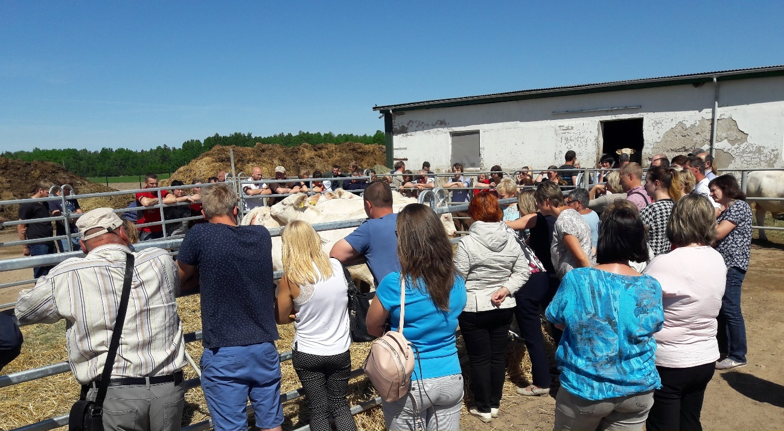
Author: Anda Adamsone-Fiskovica
Generally, the second part of the Farm day that is held on the farm is more interactive. While the dominant mode is a narrative by the demonstrator, it is accompanied by a practical demonstration or visual observation of an object that is made available for public display. In three out of the four observed Farm days the exterior of the farm animals (dairy cows, beef cows, sheep) was presented and commented on by the attracted specialists with some involvement of the host farmers (see Image 7), while in the fourth one a practical demonstration of taking a sample and measuring the level of dry matter in the animal feed with the use of a microwave was led by the host farmers (see Image 8).
While the more informal atmosphere on the farm allows for and triggers individual questions by the participants, the major part of those remain unheard by the rest of the visitors since the microphone (if used) is usually provided only for the key speaker. Also, if a farm walk is made as part of the programme after the key demonstration, the narrative of the accompanying person is heard only by the few people in direct proximity, which somewhat limits the possibilities of the other group members to follow the story and the accompanying discussions. At the same time, rather active use is made by some participants of individually approaching attending advisors, specialists or host farmers with questions of personal interest to them (incl. delicate ones – e.g. how one deals with diarrhoea in the herd), frequently not related to the core topic of the trial and the demonstration.
Image 8. On-farm demonstration at the Farm day in Valdgale on 9 August 2018
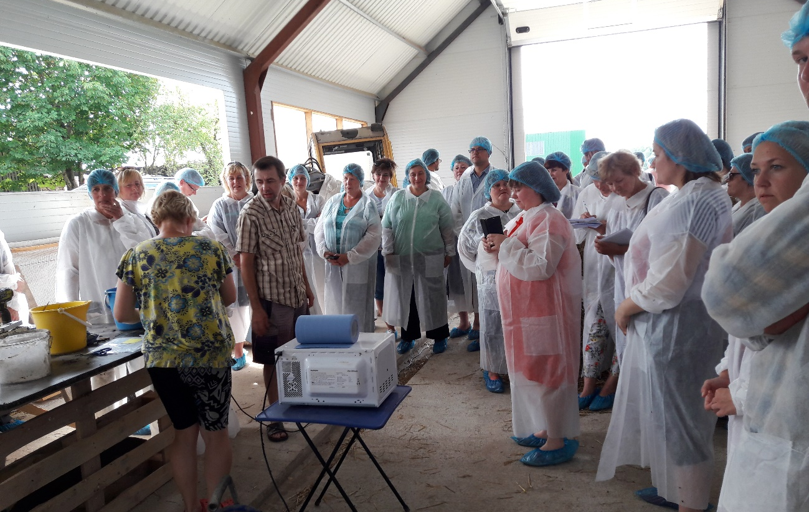
Author: Anda Adamsone-Fiskovica
The habit of speaking in a microphone is also differently perceived by the speakers as many of them (especially host farmers) are not used to it and feel this as an inhibiting factor for successful communication with the audience. Some of them felt that the use of a microphone, which is required by the size of the attending group, places an emphasis on this as an act of publicity, which, in turn, adds the need of being precise and formal in one’s statements and precludes from more personal commentaries. This is one of the many reasons why smaller groups are recurrently mentioned as a more suitable arrangement both for the hosts and the visitors, allowing to create a more relaxed atmosphere, to encourage everyone to pose his/her questions, and to discuss issues more extensively and freely. Yet, practical problems with ensuring an even distribution of individuals per group and efficient rotation of those are sometimes mentioned by organisers as factors that might need to be attended to.
There was limited room for an encouraged use of tactile senses by the visitors, though some episodes of people fingering the available animal feed for its structure or touching some piece of equipment could be observed. A host farmer of earlier demos noted that it is frequently the case that such brief episodes can usually be observed when checking on some machinery when, for instance, males test the tires of a tractor by kicking those. Though the kinaesthetic type of people (predominantly perceiving information through their senses – touch, smell, taste) would require this kind of an opportunity to enable their learning, in the case of livestock, the aspects of biosafety should be taken into account, allowing limited direct contact with animals and their surrounding environment.
Last, but not least, during one of the Farm days the organisers used the outdoor lunch at the end the on-farm demonstration to carry out a small quiz while people were queuing up for the food. The quiz served the function of both entertainment and knowledge sharing, and it included some basic questions about things important to be known by farmers working with beef cattle without a predefined set of possible answers. The visitor who was the first to give the correct answer per each question received a small prize (e.g., a pen, a notebook with the organiser's logo).
Overall, it has been emphasised that the key feature of these field trials and demonstrations lies with the fact that they are “live”, practice-based, conducted by peers under real-life conditions that are recognisable by practicing farmers, and therefore perceived as believable. Likewise, the visualisation of different farming practices enabled by demonstrations is seen as a crucial point of attraction in comparison to the conventional seminar format of instruction and learning (“not everyone is able to perceive information with ears, some also need to see”).

Content of learning
Due to the differing profiles of the presenters, the information and knowledge that is offered to the audience is rather varied not only in terms of the mode of communication used but also in terms of the scope and level of the individual topics addressed (either more general/theoretical/academic or more specific/practical). This inevitably also has implications for the content of learning by the visitors with some more applied pieces of information tending to be ready to use by other farmers (especially during the on-farm demonstration), while others require further information seeking and more extensive effort prior to applying this knowledge on one’s own farm.
It also makes a difference whether the attending person is a farmer or an advisor, student, other type of specialist, since there are different points of interest, knowledge needs and learning modes of the various types of visitors. Thus, it is most likely that each visitor takes away different things from the presentations and demonstrations, depending both on their professional background and level of prior experience in agriculture. This is largely demonstrated by the type of questions asked by different individuals as these, according to the interviewees, tend to be both basic and advanced ones pointing to the high heterogeneity of the audience. As remarked by a former host farmer attending another demonstration event – the newcomers to the field can be easily identified by the basic nature of questions (“ABC”) being asked.
On the one hand, there are the topics outlined in, and addressed as part of, the official programme. But it is inevitable that the issues touched upon during both the theoretical part, but even more so in the practical part of the Farm day, go beyond the officially defined topic of the trial since it is closely intertwined with many other aspects of farming and cannot be treated as a stand-alone topic. It is therefore quite natural that during the demonstration numerous extra topics are brought up and addressed and commented upon by the advisors and hosts (e.g. solutions used in building the cattle-shed, specific arrangements for animal stands and livestock feeding systems, type of bedding used, practicalities of the technical maintenance of milking robots, choice of the location of a new manure storage, ways of dealing with the effects of drought and heat on feed shortage, deworming of livestock, use of special covers for straw, trying out of a new maize chopper, etc.). It is especially evident after the official part of the programme when some smaller groups of well-acquainted people might stay and discuss some new things (incl. machinery) identified on the farm (see Image 9).
Image 9. Group of attendees after the official farm visit at the Farm day in Taurene on 15 August 2018
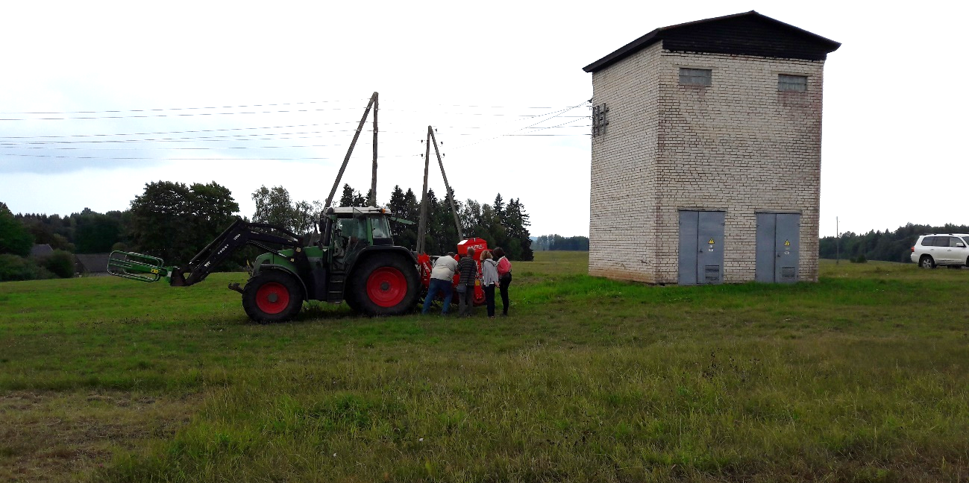
Author: Anda Adamsone-Fiskovica
An important feature both with regards to the form and content of learning recurrently emphasised by the interviewees is that it is of crucial importance for farmers involved in the demonstration to speak frankly about the problems and mistakes already faced and current concerns experienced in their own farming practice. As noted by one of the host farmers, “there is no farm that does not face a single problem” and sharing one’s negative experiences is essential for effective peer-to-peer learning. This is, however, frequently being avoided by farmers either by denying the existence of any problems on one’s own farm or by discouraging other farmers (incl. demonstration hosts) from revealing those in public and sometimes even reproaching them for doing this. Nevertheless, mutual informal exchange of individual experiences and discussions during the Farm day events is emphasised as a highly valued resource and opportunity for learning. As acknowledged by another host farmer, “[farmers] are afraid to speak about their problems but these are the single thing that it is worth talking about”, taking this as their premise for the things they want to share with others.
What is also important is that it is not only the attendees who are learning from the host farm but also the host farmer learning from other attending farmers, especially during the more informal discussions on the farm. Thus, there is an ongoing process of mutual knowledge exchange rather than one-way communication. As argued by one host farmer, it is frequently the different little nuts and bolts – things that one might not think of him/herself in daily routine (including ones that someone has modified to better adapt for particular needs, little on-farm innovations) – that one takes notice of on a farm and that can turn out to be very useful and handy on daily farming practices.

Outcomes of learning
It is hard to objectively assess the individual processing of the provided information and the outcomes of learning by the attendees of the demonstration event. Yet a certain indicator for this is the subjective assessment of the relevance of the presented topic by the visitors and of what they found useful from the things heard and seen during the Farm day.
The results of the four surveys carried out during the Farm days held in 2018 reveal that the average score for the personal relevance of the topics addressed during the theoretical part of the event was 4.35 out of 5 (1 – very unsatisfied, 5 – very satisfied), ranging from 4.19 to 4.51 for the different events. This result is an indication of good potential for a positive outcome of learning process given the necessary precondition of an interest and need for certain information to facilitate its uptake by the audience.
The respective results for the evaluation of the practical part of the Farm day, in turn, show that the average score for the personal usefulness of the demonstrated solutions was 4.39 out of 5 (1 – very unsatisfied, 5 – very satisfied), ranging from 4.32 to 4.46 for the different events. This result points to an even higher potential of applicability of the provided information than in the theoretical part (see section 6.1 on application intentions).
Several survey participants noted that the Farm day allowed them to learn many new things, especially the experience-based ones, but also to refresh some previously known but slightly forgotten things, as well as to gain more general knowledge of the situation in the sub-sector. Several of the interviewed advisors emphasised that they have also learnt quite a few things both form the field trials they were personally involved in, as well as from other ones attended on Farm days. Thus, the outcomes of learning can be varied with regards to different kinds of knowledge and their domain of application.
Several of the interviewees were of the opinion that it might also be one single sentence or minor trigger that can make a difference and stimulate a change either in the mindset of a person or eventually lead to a behaviour change. As noted by one host, there is usually at least one idea that she takes home from any visit, even if the rest of the event does not seem relevant or useful.
At the same time, with regards to farmers’ age and farm size, it has also been noted that achieving a change among farmers, especially the older people and the owners of small farms, is quite a challenge. While the older ones are generally more sceptical towards new things and changes in their established practices and routines, the small farmers are primarily guided by the motive of cost cutting and are reluctant to make long-term investments for the modernisation of their farms. Demonstration visitors from small and less advanced farms also are inclined to take the position that regular farms like theirs (“ordinary humans”) by default are not capable or in a position of doing the things done of the demonstration farms and of achieving such results (“I would also do that provided I had the means they have”). Thus, the scale and the level of advancement of the host farm can act as a notable factor in the learning outcomes by different profiles of attending farmers. If something is observed to work on a small farm, it is seen to be more likely to work on a large one than vice versa.
An important point was noted by one of the interviewed advisors on the learning outcomes for the host farm, especially if some unexpected (frequently problematic) issues are identified in the established farming practices. It was emphasised that this very much depends on the way the farmer perceives these observations – either as a major problem or a chance for making some progress. A crucial outcome of learning, both for the hosts and the visitors, is also seen to be the very awareness of something representing a problem in the first place – becoming conscious of the importance of the given aspect of farming, understanding the reasons for this and thus being better equipped in looking for solutions. For some, this awareness rising can serve as an emotional push for drawing conclusions and taking action.

Networking
As already noted before, demonstration events are attended not only for formal learning, but also for taking the opportunity to socialise and network with peers, acquaintances and colleagues, and meet new people - especially for the community of younger sectors, as is the case with beef cattle and sheep breeding in Latvia, as opposed to the dairy cattle breeders that have more established networks and more fierce internal competition and rivalry. As revealed by the answers to the survey’s open question on the main personal benefit from attending the event, the networking aspect takes a rather prominent place alongside the acquisition of new knowledge. Respondents noted the value of “seeing new faces, meeting ones that haven’t been seen for a long time”, “meeting other breeders”, “having the possibility to communicate with colleagues”, “the whole social thing”, etc. The Farm days were characterised as a valuable opportunity for a get-together, which is also used as an explanation for the constantly high level of attendance even to the consecutive Farm days on the same farm.
Image 10. Break during the Farm day in Kuldiga on 24 May 2018
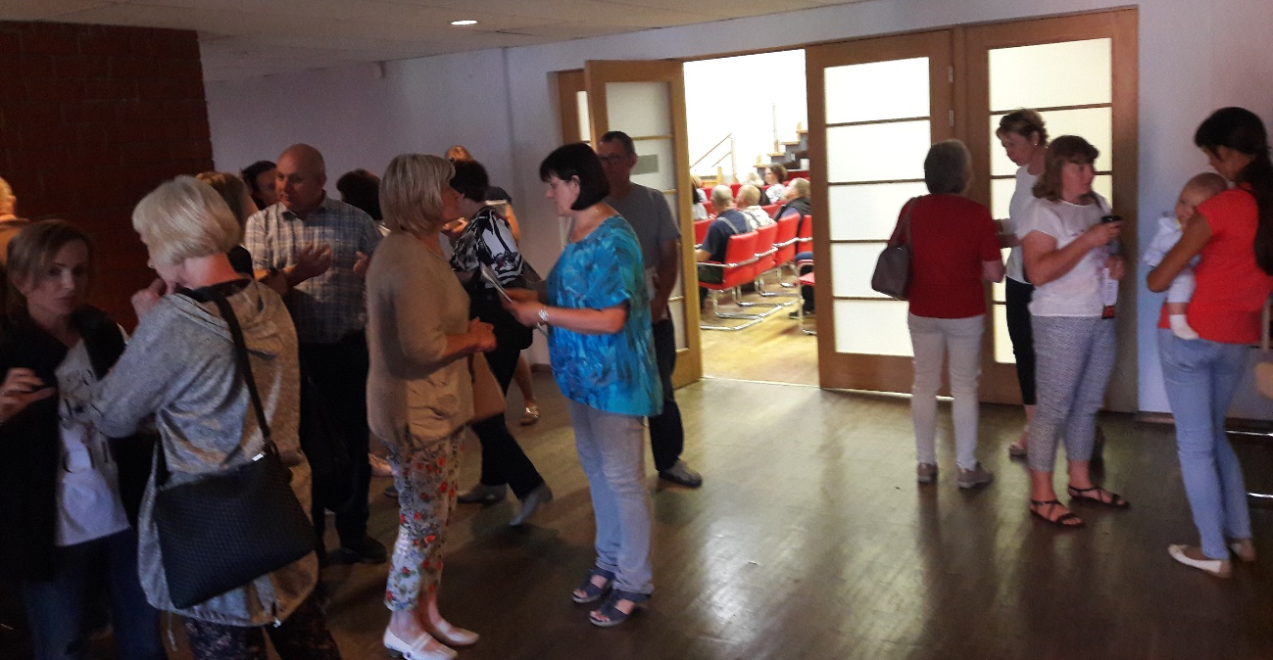
Author: Anda Adamsone-Fiskovica
As observed during the Farm days, both during in-door presentations and farm visits there were always several instances when people only periodically followed the narrative of the speakers while having their own informal talks aside. While some of those can be totally private in nature, others are more functional in that farmers take a moment to share some experiences (e.g., comparing the recent price paid for the livestock unit, telling others of the new arrangement of the drinking facility for cattle, or recent introduction of a heated water tank on the farm). Lively talks could also be observed both before the start of the seminar part at the coffee table after registration and while getting seated in the room, as well as after the end of the seminar (see Image 10), during the lunch break, upon arrival at the host farm (if in a separate location than the seminar part), and other moments along the whole day. As noted by an interviewee, demonstration events facilitate group cohesion as “people start taking to each other and make friends”.
Networking is important in that it also allows to immediately discuss the things heard and seen during the Farm day with their peers and see the others’ reactions towards the demonstrated practices. Participation at the event also allows to identify and obtain contact information of peers or different specialists that can be individually approached later when their advice or services become relevant for the person in his/her own farming or other activities (for instance, services of a livestock evaluator, agricultural advisor specialising in animal feed, veterinarian, input supplier, etc.). The latter aspect is of key importance in building the individual “know-who” knowledge resource.
Taking notice of all these benefits, it is, however, important to see those in the context of the primary objective of the demonstration event and the underlying investments, by assessing whether these effects can be achieved only by rather costly trial-based demonstrations or other forms of less financially-intensive social events.

Anchoring: Application of demonstration lessons by participants

Anchoring related to the present demo
When speaking of anchoring, i.e. if and how farmers translate their new knowledge into changes in their own practices at their farms, it is important to treat both the visitors and the host farm as the subjects of this process. Namely, there is a need to distinguish between the application of the newly encountered knowledge by participants of the Farm days, on the one hand, and the longer-term application of the new ideas and practices the by the demonstration farms, on the other.
Since numerous Farm days have been organised in the framework of the Herbivore project, and the scope of the case study has been on the project as a whole, it is difficult to link the anchoring dimension with a single demonstration and/or innovation. Yet an effort is made here to look more specifically at the four most recent observed Farm days in terms of anchoring by visitors, and the trials hosted by demonstration farms in terms of anchoring by the farmers involved in the demonstration.
As for the visitors, the anchoring dimension of the demonstration observed at the Farm day can only be assessed in terms of the extent to which participants intend to apply what has been demonstrated on their own farms. As revealed by the four surveys of Farm day attendees in 2018, the overall level of interest in applying at least some of the things heard or seen during the event in their work was quite high. On average 56% of respondents reported high likelihood of making use of the gained knowledge (“definitely yes”), while another 30% were inclined to agree that this might be the case (“rather yes than no”). Only 4% stated that they most likely won’t or definitely won’t make any use of this information (“rather no than yes”, “definitely no”), while 10% found it difficult to say or didn’t provide an answer.
When asked to specify the thing they intend to take over, the respondents mostly referred to issues related to the core topic of the Farm day. Yet the fact that none of the answers noted things that might have been inspired by off-topics or things discussed informally among peers or with specialists, possibly is more a methodological issue rather than an indication of the lack of newly learnt things beyond the official programme.
From the lessons specified by the respondents one could mention things like “reconsider the feeding”, “pay more attention to the feed composition”, “use additives in the feed (salt, yeast)”, “take better notice of the quality criteria of breeding bulls”, “buy a good breeding bull”, “make more rigid assessment of my own herd”, “make the fattening of lambs more effective”, “undertake calculation of costs, analysis of milk output parameters”, “apply the assessment of livestock exterior”, etc.
What is also very important with regards to learning and anchoring is that this is not only about opting for applying a certain new practice but also about reconsidering some choices already made or planned. Thus, for instance, one of the respondents noted that, as a result of the information and knowledge gained during the Farm day, he or she will not buy sheep for his or her farm. Thus, a valuable effect of a demonstration and knowledge sharing can also be manifested by the facilitation of well-considered and informed decisions regarding the suitability of specific solutions on one’s own farm, which can also imply a non-adoption of an initially planned innovation.
While the above-mentioned results of the survey demonstrate a rather optimistic view of the visitors on the potential effect on their behavioural change, there were rather mixed views voiced on this topic by the interviewees. Some were quite sceptical about the actual share of attending farmers who do really apply the demonstrated practices, noting a higher likelihood that the younger generation introduce concrete measures on their farms. It was emphasised that the presence of the decision-maker of the farm (incl. family farms) at the Farm day is as an important prerequisite for anchoring. Others noted that it is more likely that people will simply become more aware and better informed of the possibilities and the things that need to be attended to in one’s farming practice, thus motivating these farmers to further discuss the novelties in smaller peer groups, approach advisors for further information and gradually improve their understanding. Demonstrations can thereby serve as either the initial or an additional source of information, and as an impetus for looking for more extensive information and individual contacts with different knowledge providers. As emphasised by a host farmer, the uptake of the practice demonstrated on his farm could be possible on other farms only after meeting certain pre-conditions, including the farmer’s “technical capacity, knowledge and will”.
Nevertheless, an awareness of a problem that needs to be solved on one’s farm prior to the demonstration can be a good trigger for anchoring if the farmer learns of a solution that addresses the problem in question. Also, if the demonstrated practice is a rather straightforward one and does not require major changes to the overall farming approach used on the farm, there might be a higher likelihood of anchoring. Some of the examples mentioned by the interviewees include an increased demand for a specific breed of sheep right after a demonstration on this breed, as well as demand for the services of a company offering professional claw trimming for cows (using special boxing for animals where the leg can be fixed), which was demonstrated on a Farm day and was reported to be afterwards actively used by several demonstration visitors. Another example was a specific type of drinking machine for calves that was demonstrated during the farm visit on one of the Farm days and was said to be later purchased by some participants for use on their farms. Likewise, a particular type of electric fence for livestock used on one of the demonstration farms was said to be noticed and actively considered by some visitors. While these were not things directly related to the main topics of the demonstration, they were part of the things observed and found useful by the Farm day attendees.
As for the host farms, it should not be automatically assumed that all of them carry on with the demonstrated practice after the end of the field trial. Some might use the practice applied during the trial (e.g. making specific measurements) from time to time, by continuing to master it rather than establishing as a daily routine on the farm. It can be the case that the demonstrated thing is by no means a totally new one for the host farm, thus it is possible and has been the case that the demonstration simply provides more solid evidence for the intuition-guided decisions taken so far, strengthens the motivation for carrying on with the practice and paying more attention to it in the daily routine of the farm. As noted by a host farmer, “now we do the job in a much smarter way; [..] without [the trial] we would have done it in the usual routine way without much consideration”. It was also reported that following the trial and the demonstration the host farmer still looks for additional information in written sources and consults advisors and experts to anchor the given practice (e.g. composition of animal feed) and make it part of the farming routine since many of the things undertaken during the trial are only gradually being fully comprehended by the farmer after the official end of the project.

Stimulating anchoring
A key feature of the demonstrations organised in the framework of the Herbivore project is the fact that information on the trial results is compiled and published in a range of media – including the LRATC website (see Image 11), annual edition on all trials of that year, and professional journals (Latvijas Lopkopis, Agrotops). As noted by the interviewees, it is frequently the case that these are later read not only by the attendees of Farm days that have an interest in learning in more detail of the trial, but also people who were not among the visitors.
Image 11. Section on the Herbivore project on the LRATC website
Source: http://new.llkc.lv/lv/nozares/lopkopiba/zaledaju-projekts
It has also been noted that advisors who have attended a demonstration event later organise local seminars on these topics in their regions. Continuous repetition of things from one occasion to another and using various means of communication is seen as important to communicate the knowledge and allow it to be gradually absorbed by the attending audience.

Anchoring related to earlier demos
The available accounts reveal a trend that knowledge obtained on other visited demonstration farms might not find its practical application immediately after the event, but it may turn out to be useful after a shorter or longer time. This was the case, for instance, with a practice used as part of a practical on-farm demonstration on one of the observed Farm days (use of a microwave as part of the procedure for measuring the level of dry matter in the animal feed), which, as later revealed by the host farmers, had been first seen by themselves quite a few years ago at another farm visit. It was, however, not until recently that they had remembered of this idea, looked up their notes made at that time, tried to understand the underlying idea and apply the practice on their own farm. It was noted, however, that they still needed to consult an advisor to fully understand the idea and apply it in practice. On another occasion a practical solution observed on another farm could be taken up only after a few years since this involved making changes in many other aspects of the farm (incl. construction of a new building allowing for the introduction of the specific practice).
These cases seem to be a good illustration of the way anchoring related to earlier demos can take place and manifest itself. While a demonstration gives an idea of how things can be done, it is not until a specific moment on the attendee’s farm when the issue gains personal relevance that the observed practice is recalled, and efforts are made to reconstruct and adopt it. The first example also points to the fact that a single demonstration might not be enough for an efficient takeover of an observed practice since there are many know-how elements involved that are crucial in the actual application process, but which cannot be directly transferred and communicated in great detail to the audience during a group demonstration. Thus, a demonstration can primarily serve as a source of inspiration, an impetus for thinking in a new direction, but most likely cannot be expected to result in an immediate application on another farm without additional sources of information and extra learning by the potential adopter. As remarked by one of the interviewed host farmers, “I also couldn’t make sense of those numbers before, but one just has to start doing the measurements and then everything becomes clear”.
It has also been observed that it might take some time for farmers to take full account of the results of the conducted trials and to become willing to learn from them and find practical applications for the advice provided by the involved specialists. It is sometimes the case that a farmer realises the importance of the demonstrated practice but sees it as too complicated to be able to apply it independently.
Another interviewed host farmer noted that following a demonstration on a different farm on one of the Farm days devoted to the use of field beans in animal feed, she has started reconsidering their use also in her own herd. Yet she acknowledged that this idea was still only being considered by her since this practice was in opposition to advice provided earlier by her private foreign consultant. This case thus reveals that prior to the decision of applying a new practice by a farmer it might need to be confronted and balanced with insights from different, possibly conflicting, sources of information. On some occasions it was not unusual that certain ideas implemented during a trial were not quite in line with mainstream practices, thus somewhat challenging certain established assumptions and making it more difficult to accommodate these ideas as part of standard knowledge.
With reference to the specific topic of field beans, it was noted that later there were many calls to the advisor from the attending farmers telling of the unsuccessful application of the advised practice. What was then identified as the cause of this was the nonadherence to some basic principles that had to be met in the process of applying the given solution. Thus, anchoring is not a straightforward process, and quite some work and attention to detail is required to make the knowledge transfer successful. At the same time, the above example is a good indication of farmers willing to try new practices and looking for the reasons behind failure, rather than abandoning the whole incentive to apply this knowledge.

Scaling: Application of demonstration lessons by the wider farming community

Retrospective examples of scaling
The upscaling or diffusion dimension of the demonstrations - i.e. the adoption of the practices examined and demonstrated during the trials and Farm days in the farming community at large rather than only among those farmers who have been directly involved in or visited a demonstration – is a rather difficult task given the wide diversity of demonstration topics covered in the Herbivore project, and addressed during the demonstrations.
On the one hand, scaling can be looked at from the perspective of the wider learning and application of individual tangible practices demonstrated as part of the official programme or individually observed during the Farm days. Interviewees reported instances of people telling them that they were not present during the Farm day (not even aware of it) but have come across the online material with factual data based on the trial results while searching online for information regarding a specific issue. Access to this material not only allowed them to learn about the results but also find contact information (e.g. name of the involved advisor) that they could use to obtain further information and assistance.
It was also mentioned by the attending advisors that they bring the messages from the trials to their other clients and to other advisors with whom they are in contact. Likewise, attending farmers talk about their experiences and share information informally with their peers on other occasions, thus widening the scope of farmers who become aware of different innovations and farming approaches.
On the other hand, given the underlying emphasis of the project on undertaking comprehensive economic analysis of a farm’s performance as a tool for making individual evidence-based decisions regarding the development of the farm, the scaling dimension should also be treated more generally with regards to the spread of the practice of undertaking economic calculations based on on-farm data. While this is still something that advisors are continuously advocating for, there is a large share of small subsistence farms that are not used to or motivated to make such an effort since many of them are not commercially oriented and don’t think of their farm from the perspective of productivity and revenue.

Prospective assessment of scaling: Impact pathways
The outline of the retrospective examples of scaling is closely related with the prospective assessment of scaling and the impact pathways for boosting the potential impact of the demonstrations held in the framework of the Herbivore project.
The project has the potential to encourage a wider application of the knowledge produced during the trials and communicated on the Farm days in the farming community by means of producing new and maintaining the already published free follow-up online materials on the results of each trial on the LRATC website and other related internet platforms (incl. Rural Network), as well as including this information in the monthly editions of the professional journal for livestock breeders (Latvijas Lopkopis) published by LRATC (see Image 11).

Image 11. Monthly journal for livestock breeders issued by the LRATC
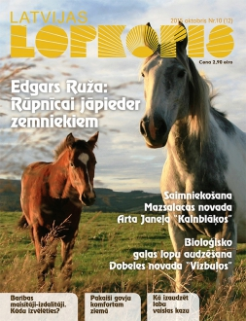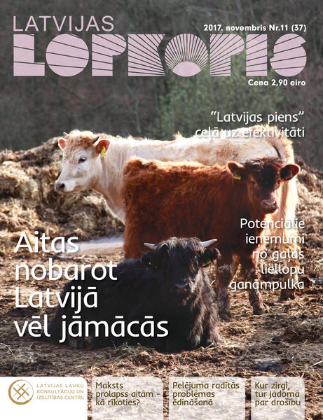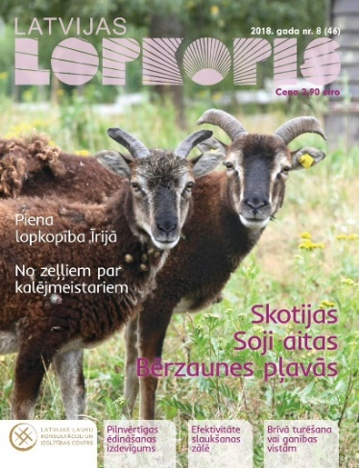
Another formal route is represented by the free printed brochures covering all LRATC demonstrations where the results of the trials carried out in animal husbandry are also summarised (see Image 12). The latter also goes in hand with the annual seminars organised by LRATC on all the trials held during the preceding year in the Herbivore project. These events provide an opportunity to recap the results of these trials and present them once again in a joint event to a mixed audience of advisors, farmers and scientists. Lessons from the implemented demonstrations, as well as information about the demonstration farms, is also distributed through video materials in regional TV stations, and publications in the local press. Considerable potential for scaling is also held by the brief online video materials on the project and its outcomes, produced and publicised by the project team (five in total: one on the project, three on demonstration farms and one on making a silage pit), which represent a tool that could be used even more intensively.
Image 12. Annual brochures on field trials in crop farming and animal husbandry published by LTARC
Source: http://new.llkc.lv/lv/nozares/augkopiba/demonstrejumi
The prevailing national agricultural knowledge and innovation system in animal husbandry in Latvia is not very beneficial to stimulating the uptake of new evidence-based practices, given the factors outlined in section 1.3, incl. the low level of farmer’s knowledge and training and the limited opportunities for vocational education in animal husbandry. Yet an important feature of all the communication formats mentioned above is that these materials are made available in Latvian, thus increasing the possibilities for local farmers to learn of, and be better equipped with information to adopt, different innovations taking place both in Latvia and abroad.

Case study reflection

Facilitating and impeding factors for successful demonstrations
The case study allows us to identify and assess a range of factors that seem to be relevant for a successful implementation of the demonstration activity and learning. Success is understood broadly, by taking into account and integrating the views of different parties – project coordinators, funders, advisors, host farmers, scientists and Farm day visitors – and identifying points of convergence and divergence. Namely, success is treated here with respect to the degree that all the involved parties with different goals and agendas, feel satisfied by the process and outcome of the demonstration activity, with the aim being to reach a balanced representation of the interests of all the involved stakeholder groups, rather than measuring the success only from the perspective of a single group.
The underlying idea for this exercise is to identify factors which have been deemed important or highlighted by the various stakeholder groups and which either have or have not been addressed during the implementation of the project, thus either facilitating or impeding the demonstration and learning process. The identified factors have been divided into three main groups dealing with (i) inputs (infrastructure, finances, human resources), (ii) access (social, economic, geographic), and (iii) demonstration process (methods, content, interaction forms).

Inputs
- Setting up, running and coordinating a demonstration activity represents a task that requires notable investments in terms of human resources, thus ideally full-time commitment of people involved in it is required. As demonstrated by the case study, the management of the whole project rests on the shoulders of a few people who have taken the responsibility to coordinate all the practical arrangements related to the demonstration, while for the rest of the involved people (advisors, host farmers, scientists) engagement in the demonstration activity is an additional task or side-activity to their main business, which has an effect on their capacity and commitment to organising the demonstration. Though many of them demonstrated great effort in fulfilling their role and undertaking the assigned tasks, the extra work placed a considerable pressure on these individuals.
- Success of a demonstration largely depends on the profile of the host farmer as he/she is the key to an efficient implementation of the demonstration and the underlying trial. The case study shows that the qualities ascribed to a good demonstration host include open-mindedness, cooperation, diligence, honesty, willingness to learn, determination, daring, attractiveness, well-considered approach to farm’s development, and status of opinion leaders in the farming community. Finding the right host is one of the major challenges faced in on-farm demonstrations, as there is a need for balancing the top-down and bottom-up identification of potential candidates both to not overburden the already tested and acknowledged hosts and to enable the identification and entry of new host farmers. A combination of personal invitations and public recruitment announcements seems to be a good solution for ensuring a democratic process of selection, yet it could be supplemented by nomination of potential candidates by peer farmers.
- For on-farm demonstrations involving field trials it is important that enough time for the trial phase is allocated to obtain reliable results and allow drawing meaningful conclusions. While the trials in the Herbivore project generally lasted for two years, it was unanimously agreed that 3-4 years per trial on a single farm would be an optimal solution to reduce the impact of annual fluctuations as well as to allow for capturing the actual daily practices on a farm. This would also allow to organise public demonstration events at longer intervals (once every two years rather than annually), when some substantial results are already available for communication to a wider audience. Implementation of long-term projects that add value to the obtained results, however, requires additional financial resources to cover for the costs over an extended period, which are frequently limited under state-funded schemes. The case also shows that host farmers might not be willing to take up such a long-term commitment, thus a balance between the available funding, the scientific ambition and the farmer’s readiness and motivation for engagement needs to be achieved.
- The set-up of a demonstration on a commercial farm needs to provide sufficient room for manoeuvre and flexibility with regard to the topic, scope and length of the trial, eligible costs and expected outputs, which can be rather challenging under state-funded measures, which usually feature rather strict terms. While there is a need for a predefined topic to be addressed in a given timeframe by the on-farm demonstration, the experience of the Herbivore project shows that the internal and/or external conditions faced by the farm during the trial period, which are frequently beyond the control of the farmer, may have a considerable impact on the possibilities for sticking to the original plan and achieving the formally anticipated outcomes.
- Adequate infrastructure represents an important element both for the implementation of the trial and for the public demonstration event. While the initial intention was to hold both the seminar and demonstration part of the event in a single location on the farm, the choice to split the two between different sites due to the growing number of visitors can be seen as a good solution. This not only removes some of the burden from the host farmers related to the provision of an adequate in-door space for seating people, ensuring all the necessary connections (incl. electricity, internet), providing additional facilities and amenities, and controlling for the unguided movement of people around the farm, but also helps to better structure the event and cater to the different needs of the various instruction modes of the two parts. There are limitations imposed by biosafety considerations that need to be taken into account when thinking about the inhibiting factors for hosting demonstrations in the field of animal husbandry.

Access
- The case study represents a good practice in terms of accessibility whereby demonstrations have been set-up in a regionally balanced way all over the country. While the study shows that for selected participants distance is not an obstacle, it, nevertheless, demonstrates that, for the most part, participants come from the region where the demonstration is held or surrounding regions (approx. within an hour’s ride). Given the fact that each trial and the subsequent demonstration is devoted to a different topic, geographic accessibility might act as a hindering factor if the topic of interest to the potential visitors is not addressed by the trials carried out in the region they reside in.
- Accessibility of the Farm days is facilitated by the fact that participation is free of charge. Yet, given the comparatively large number of attendees per event, the fact that there is no participation fee, which could act as a factor for self-selection of a smaller number of more motivated individuals, might also have a negative effect on the quality of learning opportunities. On the other hand, given the different additional benefits of the events in terms of networking etc., imposing a limitation on the number of attendees per event should not be seen as an ultimate solution as this would again potentially exclude those who could be motivated to introduce on-farm changes by this demonstration without being predisposed to that prior to the event. To boost the quality of learning opportunities, a repetition of the same event for different (smaller) sets of visitors could be an alternative option, though financial implications and human resource investments in terms of organisational arrangements need to be considered.
- The Farm day events are advertised through various media (Facebook, LRATC website, e-mail lists, professional journals, personal contacts by advisors and host farmers), allowing information to reach a rather wide audience. Some additional effort, however, might be taken in targeting and mobilising those farmers (especially small ones) who are not proactively using these established sources of information and means of communication, and who are less prone to considering and taking up innovations in their farming practices, to raise awareness of different new trends and principles of efficient farming not only among the progressive ones but also among the less active and more conservative part of the community. At the same time, a good indication is the fact that the attendees of Farm days include a mix of those who had been to earlier project events and those who attended a Farm day for the first time.
- Clear branding of a set of demonstration activities (e.g. as “Farm days”) that follow the same logic and format serves as a factor conducive to attracting both new and recurrent visitors thus facilitating the accumulation of knowledge and building of social networks among farmers as well as between farmers, advisors and different specialists working in animal husbandry or any other agricultural sector the demonstration is targeting.
- A positive feature of the set-up of the demonstration activities in terms of access is the fact that usually two Farm days are held on each demonstration farm, allowing more people to use the opportunities of on-farm visits. While usually the first Farm day is less informative in terms of the trial results due to the early stage of its implementation on the farm, this nevertheless provides a good opportunity for peer-to-peer learning and networking, and for providing initial information on the subject and triggering further interest in attendees.
- A laudable feature of the demonstration activities carried out in the framework of the project is the production of follow-up materials providing information on the event, as well as accounts with results of the trials published online and in printed materials. This facilitates access to this information not only by the attendees of the given Farm days but also those who have not been able to take part in them.

Demonstration process
- The major feature of the Farm day events is related to the combination of a diversity of information sources, represented by advisors, scientists, specialists and host farmers, and different modes of learning, as featured by the lecture/seminar format and on-farm visit and demonstration. There are inevitable differences in the way information is presented by the various individuals depending on their professional background, with some objections articulated by the attending farmers regarding the oversaturation with quantitative data. Yet, given the different profiles and knowledge level of participants, hard data also need to be presented. What might be lacking and could be strengthened, though, is communicating and highlighting a few clear and concise messages from each presentation that can be taken away by all attendees.
- A valuable feature of the established Farm day format is the coverage of the official trial topic along with additional insights into a range of side-topics, not least dealing with various observable on-farm practicalities that act as a significant source of inspiration for the visitors. While blurring the focus of the event might be considered a drawback, allocating room for a more diverse spectrum of topics under the core theme of the event allows for more diverse learning opportunities, catering to the needs of both those with a specific interest in the trial topic and ones more generally interested in learning about different farming practices and novelties.
- Given the comparatively large number of people attending Farm day events, arranging the practical demonstration on the farm in a place where good visibility and audibility can be ensured is crucial for enhancing learning opportunities. The introduction and use of a portable microphone and loudspeaker has been a way of ensuring that more people are able to follow the narrative. As for visibility, a good solution has proven to be placing the demonstration object (incl. livestock units) in a place which can be approached by visitors form several sides, thus avoiding crowding in a limited area.
- What has been lacking in the demonstrations in the framework of the project are hands-on activities by participants to allow them to personally experience some of the practical things and master specific skills. The possibilities for promoting this kind of physical engagement of visitors are, of course, limited by the topic of the demonstration and on-farm possibilities (especially, due to biosafety considerations if dealing with livestock), yet this is an aspect which could be incorporated into the demonstration process.

Impact of demonstrations
Looking at the broader direct and indirect impacts of the studied demonstrations it is rather hard to objectively assess both short-term and long-term effects of these stand-alone activities. As revealed by the study, a single demonstration event does not automatically lead to immediate anchoring of the observed practices by all attendees, and scaling is even more difficult to trace and assess. Nevertheless, what can be argued with a high degree of confidence is that while it might have initially seemed that the trials carried out in the framework of the Herbivore projects are mainly for the benefit of the individual farms involved in the relevant demonstration, the study showed that the open Farm days also provide useful resources to other farmers working in animal husbandry. Thus, the impact on the host farm, the visitors and the larger farming community should be taken into account when assessing the impact of demonstrations.
Many of the interviewed host farmers noted the effects of the evidence-based knowledge and the application of practices based on this new or refined knowledge on the efficiency of their production activities, and the welfare of their livestock, which has a direct impact on the farm’s profitability. The main thrust of these trials and demonstrations has been explicitly aimed at achieving productivity gains to make farming in animal husbandry more competitive and commercially sound, thus it is the main impact they are aiming for. While not all the trials proved to be of value in this regard due to various reasons, there are also other notable impacts that to some extent compensate for that – including the more general empowerment of farmers by facilitating their access and exposure to additional sources of information, different farming experiences, as well as building their social capital through engagement in new and established social networks. What is important is that this kind of demonstration activities are accompanied by other complementary forms of formal and informal learning and sharing – for instance, interest groups of farmers bringing together less than 10 farmers in thematic groups undertaking mutual farm visits coordinated by an advisor.

Key lessons from this case study
The case study of the Herbivore project has provided valuable insights into the organisation and implementation of agricultural demonstrations, allowing us to draw certain lessons for boosting the success and impact of future demonstrations.
Lesson 1: Involvement of farmers, advisors and scientists in jointly setting up and implementing a demonstration activity is a challenging task given the different professional domains and skills, knowledge bases, priorities, work routines, along with personal qualities and motivations. Yet, it has the potential of a mutually enriching endeavour that, ideally, allows building on and aligning the various interests and types of knowledge represented by the various actors. For this to work, there is a need for defining clear terms of reference (what is the objective of the activity; what is the outline and the rationale of the methodology, procedures and the ambition for trial-based claims) and a mutually agreed upon organisation and division of labour.
Lesson 2: On-farm demonstrations require considerable mobilisation of the host farmers in respect to providing the necessary conditions for a trial (following the instructions, interacting with advisors/researchers, investing work in generating and documenting additional data), as well as for the public event (tidying up the farm/animals, providing meals, adjusting the farm’s infrastructure, revealing other business/farming practices not directly related to the specific topic of the trial/demonstration). Therefore, it is important that the expected workload is clearly communicated to, and taken into account by, the host farmer prior to his/her involvement. The work should also be adequately compensated.
Lesson 3: There are manifold learning dimensions involved along the whole cycle of implementing the demonstration activity as different learning effects are experienced by different groups of stakeholders. Demonstration activities provide a platform for learning, not only by the farmers attending the demonstration event as the primary target group, but notably by the host farmer(s) over the course of the field trial and during and after the public demonstration. There are also learning effects for advisors and scientists (not only the ones directly involved in the given trial) and public officials, though representatives of each of these groups learn different things, depending on their professional interests. There are both cross-sectoral and inter-sectoral as well as vertical (advisor-farmer, scientist-farmer) and horizontal (peer-to-peer) learning processes taking place simultaneously. Thus, upon designing the format of a demonstration event, sufficient attention should be paid to enabling different forms and modes of learning, interaction and knowledge exchange.
Lesson 4: The value of a demonstration event goes far beyond the benefits of direct learning on the primary topic of the event, as an important self-perceived personal benefit for the visitors of demonstration events, aside from the knowledge gains, lies in the possibility to meet and exchange views with their peers/acquaintances, and establish new contacts. Demonstrations can also be treated as a way for farmers to be updated on the developments in their farming area rather than a place for learning on the subtleties of specific practices with an aim of introducing those on one’s own farm. Thus, the demonstration event provides room for a mix of differentiable knowledge gains with regards to “know-what”, “know-why”, “know-how”, and “know-who”.
Lesson 5: A large number of attendees of a demonstration event does not directly correlate with the success and efficiency of demonstrations in terms of learning effects and its broader impact, as exchanges in smaller groups tend to facilitate more active and profound engagement and learning. While funders might see the quantitative figures of attendance levels as an easily measurable indicator, these cannot be set as a primary criterion for ex-ante and/or ex-post assessment of a demonstration activity.
Acknowledgements

We would like to thank all the interviewees as well as the participants of the Farm day surveys for their time and valuable input in providing information and their views on agricultural demonstrations and experiences in the Herbivore project. Very special thanks go to the head of the project Ms. Anita Siliņa who has been very helpful and open in sharing her knowledge, welcoming and enabling the participation of the team of researchers in the Farm day events, as well as providing her valuable feed-back on the results of the case study research.

Annexes

Data sources
CSB (2017). AGRICULTURE IN LATVIA Collection of Statistics. Central Statistical Bureau of Latvia. Available at http://www.csb.gov.lv/sites/default/files/nr_24_latvijas_lauksaimnieciba_2017_17_00_lv_en_0.pdf
CSB (2018a). LLG080. Output of principal livestock products. Central Statistical Bureau of Latvia. Available at https://data1.csb.gov.lv/pxweb/en/lauks/lauks__05Lopk__ikgad/?rxid=f5d51323-6e57-4561-a398-885282c5c3b6
CSB (2018b). LLG220. Number of livestock and poultry at the end of the year (thsd heads). Central Statistical Bureau of Latvia. Available at https://data1.csb.gov.lv/pxweb/en/lauks/lauks__05Lopk__ikgad/?rxid=f5d51323-6e57-4561-a398-885282c5c3b6
CSB (2018c). LLG240. Grouping of farms of all kinds by the number of cattle and dairy cows at end of year. Central Statistical Bureau of Latvia. Available at https://data1.csb.gov.lv/pxweb/en/lauks/lauks__05Lopk__ikgad/?rxid=f5d51323-6e57-4561-a398-885282c5c3b6
CSB (2018d). LSSA13_I01. Number of agricultural holdings and land area by statistical region. Central Statistical Bureau of Latvia. Available at https://data1.csb.gov.lv/pxweb/en/lauks/lauks__05Lopk__ikgad/?rxid=f5d51323-6e57-4561-a398-885282c5c3b6
CSB (2018e). LSSA13_I07. Agricultural holdings by economic size and type of farming. Central Statistical Bureau of Latvia. Available at https://data1.csb.gov.lv/pxweb/en/lauks/lauks__05Lopk__ikgad/?rxid=f5d51323-6e57-4561-a398-885282c5c3b6
CSB (2018f). LSSA13-I11. Agricultural holdings by type of farming, age and training of manager and statistical region. Central Statistical Bureau of Latvia. Available at https://data1.csb.gov.lv/pxweb/en/lauks/lauks__05Lopk__ikgad/?rxid=f5d51323-6e57-4561-a398-885282c5c3b6
Diebele, A. (2016) Latvia Cross visit report (AgriSPin project). Latvian Rural Advisory and Training Centre. http://agrispin.eu/wp-content/uploads/2016/11/CV-Report-Lavia.pdf
Ministry of Agriculture (2017). Latvijas lauksaimniecība 2017. Available at https://www.zm.gov.lv/public/files/CMS_Static_Page_Doc/00/00/01/10/04/fs-01usersLinda.BirinaDesktopAA2017_lauksaimniecibasgadazinojums.pdf
Šteinfelde, I. (2018). Latvijā salīdzinājumā ar kaimiņvalstīm ir viszemākais pašnodrošinājums ar gaļu. Neatkarīgā Rīta avīze. Oct 29, 2018. Available at: https://nra.lv/latvija/regionos/262154-latvija-salidzinajuma-ar-kaiminvalstim-ir-viszemakais-pasnodrosinajums-ar-galu.htm

Data collection methods
The data collection for the case study included the following methods:
- Desk research
- Collection and analysis of relevant national statistical data, information on the project and the demonstration activities in online and published resources (incl. other studies as well as outputs generated by or produced on the project).
- Project events
- Attendance of the annual summary seminar of the project in January 2018.
- In-depth semi-structured interviews
- Between February and September 2018, 12 semi-structured in-depth interviews with individuals involved in the organisation and implementation of the project were conducted, including four advisors, six host farmers, and two scientists.
- Participant observation
- Participant observations by two or three researchers at four Farm days organised in May-September 2018 were carried out.
- Exit-survey
- An exit survey of participants at the four Farm day events organised between May-September 2018 was designed and carried out, using a self-administered questionnaire with both closed and open questions (16 in total; see the translated version below). The survey was conducted in four waves (each representing a separate event) resulting in 131 filled out questionnaires.

Survey results
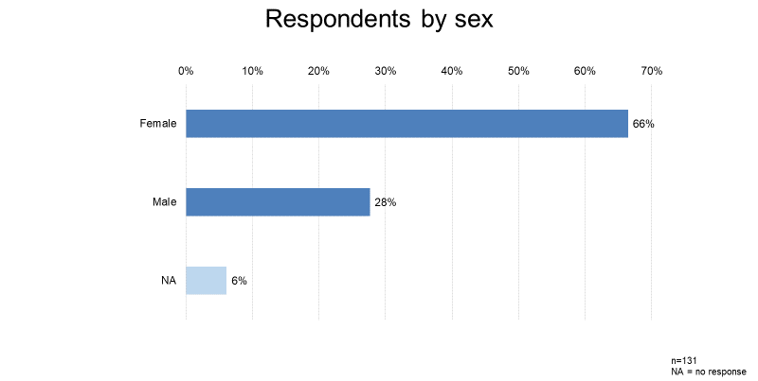

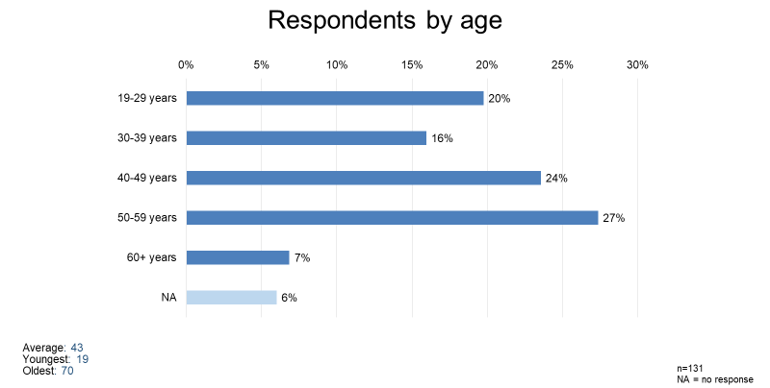
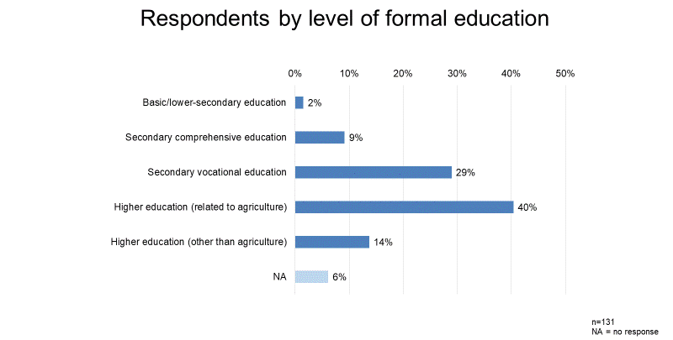

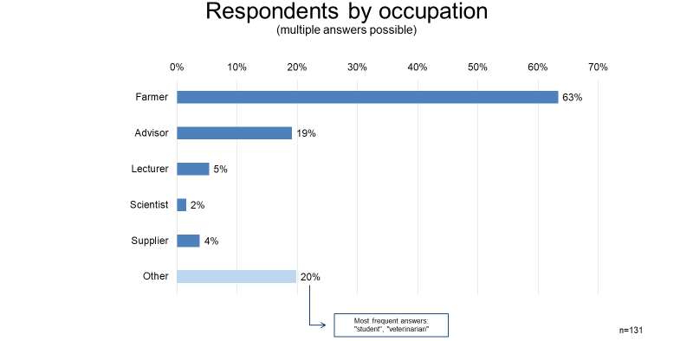

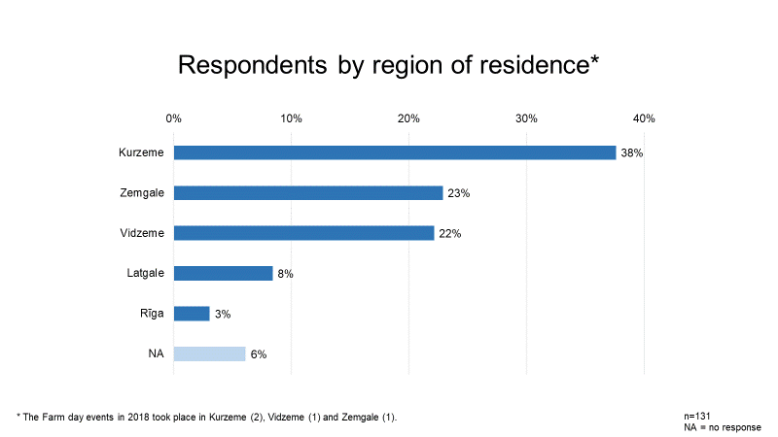

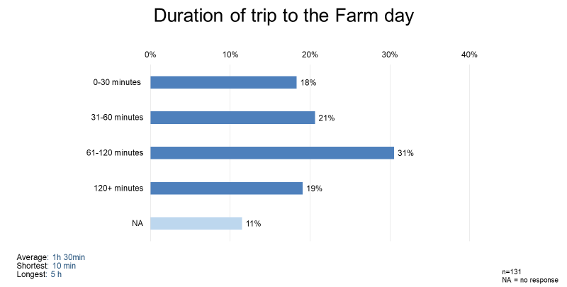
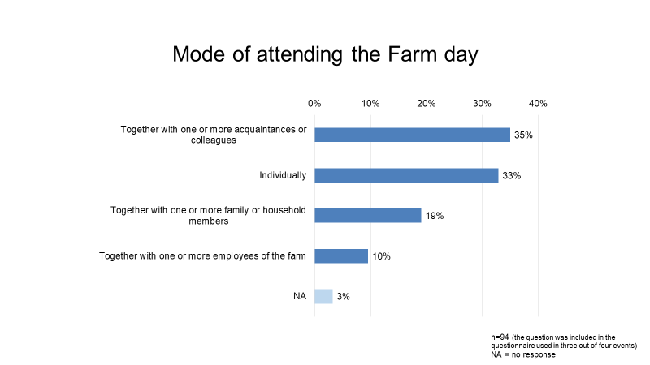
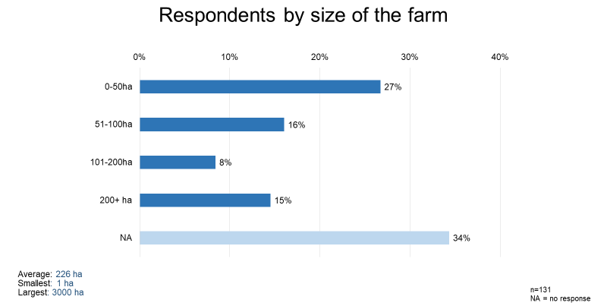

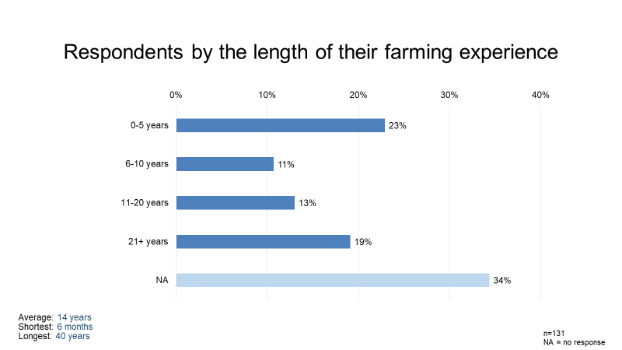
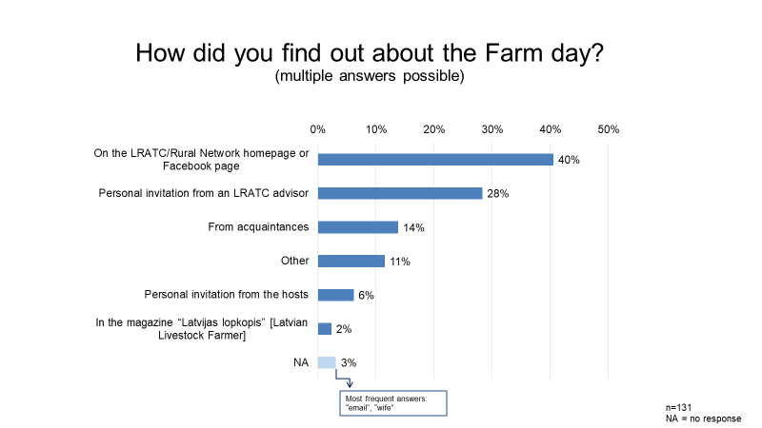

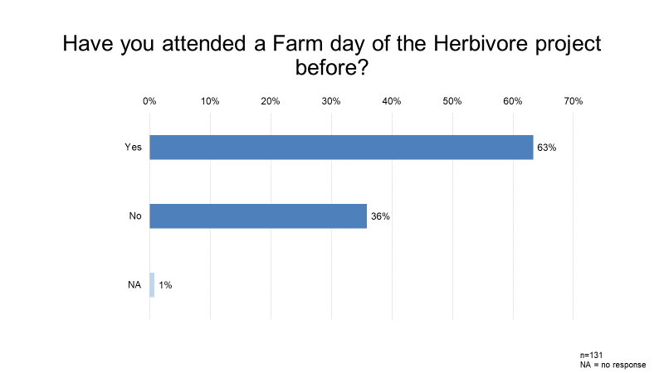
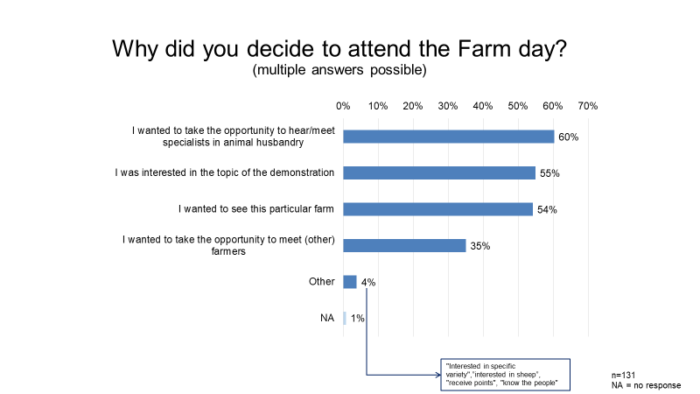
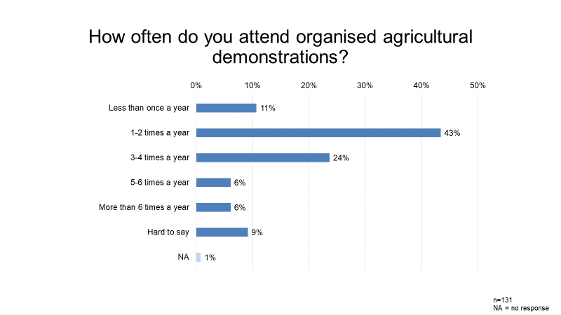
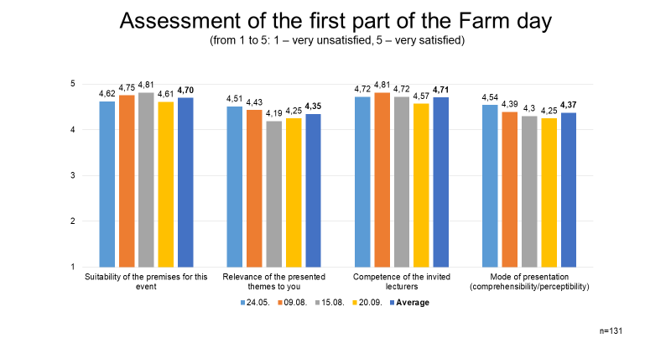

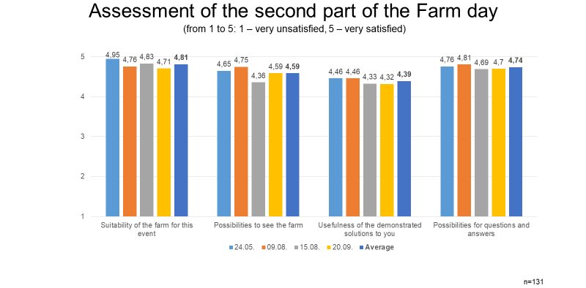

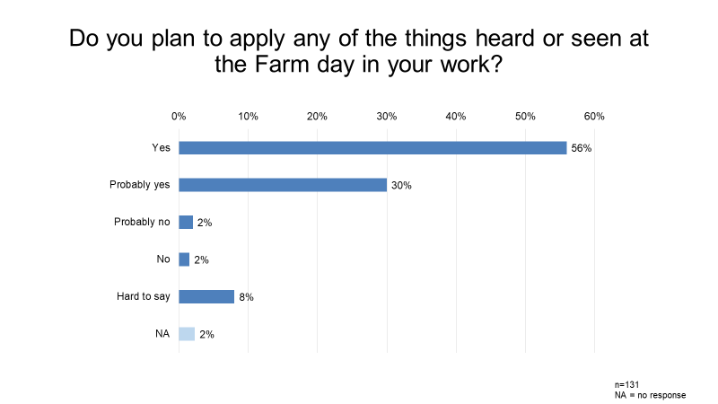

https://www.youtube.com/watch?v=JagbXxGCLxI; http://new.llkc.lv/lv/nozares/lopkopiba/zaledaju-projekts
www.llkc.lv
https://ec.europa.eu/budget/euprojects/baltic-deal_en
In 2016 the project was evaluated by experts in the framework of the AgriSpin project commending the multi-stakeholder decision-making board of the project as a valuable organisational innovation (Diebele 2016).
The overall number of initially involved farms is a slightly larger one due to selected drop-outs along the process.
In a similar vein, the AgriSpin report notes that one of the main challenges has been related to finding the right farmers for the demonstrations – those who will accept the new practices and will implement those in line with the instructions given by advisors and scientists (Diebele 2016).
Latgale features the largest share of small farms and the lowest GDP per capita in Latvia.
While pre-registration is open until two days before the event, it is launched ten days before the Farm day.
Multiple responses were possible thus one person could identify him/herself as corresponding to one or several occupational groups.
E.g. an instruction video on making a silage pit: https://youtu.be/Rzqxc2n93xQ
Lunch for all participants is either provided in the seminar premises after the theoretical part or on the farm after the field visit.
Interestingly, two different wordings of the activity under which the project has been funded has been used in different project-related documents: (1) “Implementation of sustainable pilot projects of agricultural production”, and (2) “Implementation of pilot projects of sustainable agricultural production” [both are translations from Latvian; emphasis added]. This shows the rather vague/trendy use of the notion of sustainability, rather than demonstrating a clear focus on the promotion of sustainable farming practices.
As this is a publicly-funded project no limitations on the number of attendees can be placed by the organisers of the Farm days.
It was possible to mark several options under this question.
The specific question was integrated in the questionnaire for three out of the four Farm days in 2018.
As it was a self-administered survey and no further elaboration of the survey question could be done by researchers (e.g. encouragng respondents to think of the question in a wider perspective), people might not have thought of things outside the scope of the official programme to be relevant for this question.

