Date: November 2018

Country report: Latvia

Case Study: LAT1 Informal demonstrations in integrated fruit production

WP5: Case studies of demonstration activities in commercial farms

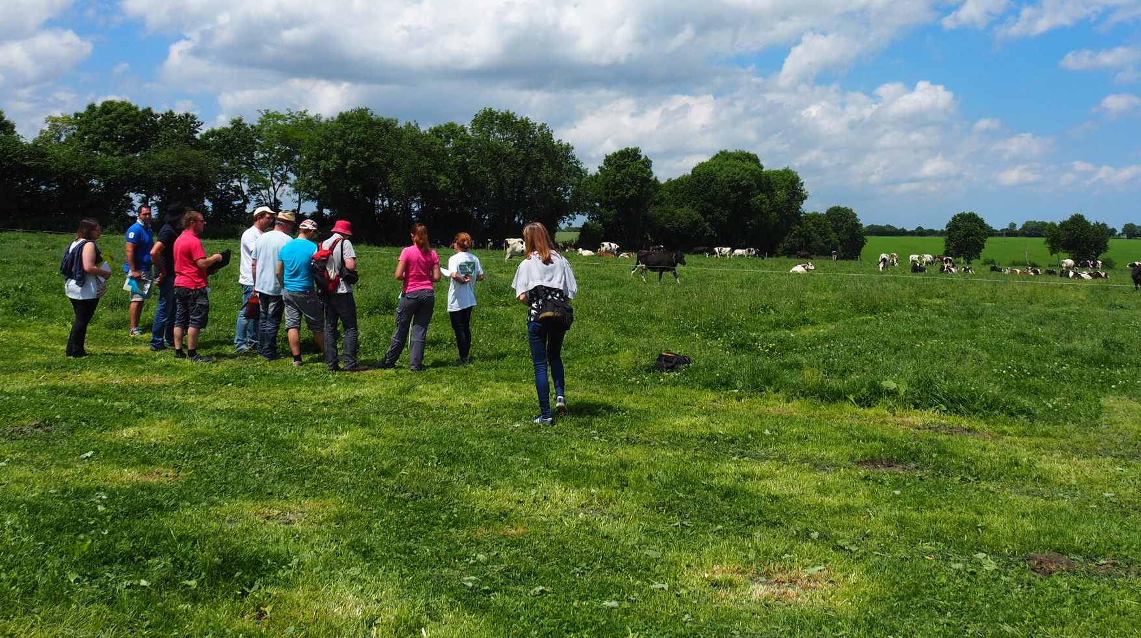
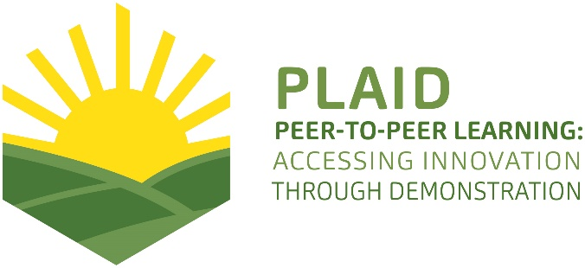
This project has received funding from the European Union’s Horizon 2020 research and innovation programme under Grant Agreement No 727388.
This project has received funding from the European Union’s Horizon 2020 research and innovation program under Grant Agreement No 727388

PLAID PARTNERS

Advisory Service Croatia ASC | ARVALIS Institut du Végétal | Association de Coordination Technique Agricole ACTA
Institute for Rural and Regional Research | Chambers of Agriculture | Delphy
European Forum for Agricultural and Rural Advisory Services EUFRAS | Innovatiesteunpunt ISP | Institut de l’Elevage – Idele
Instituto Navarro De Tecnologías E Infraestructuras Agrolimentarias | Linking Environment and Farming LEAF | National Agricultural Advisory Service
Nodibinajums Baltic Studies Centre (BSC) | Research Institute of Organic Agriculture (FIBL) | Stichting Wageningen Research
The James Hutton Institute | VINIDEA

DOCUMENT SUMMARY

__________________________________________________________________________________
Milestone Title: 24 Case Studies
__________________________________________________________________________________
Case Study Title: Informal demonstrations in integrated fruit production (Latvia)
__________________________________________________________________________________
Version: 2
__________________________________________________________________________________
Task Lead: WUR
__________________________________________________________________________________
Related Work package: WP5
__________________________________________________________________________________
Authors: Anda Adamsone-Fiskovica, Talis Tisenkopfs, Mikelis Grivins, Emils Kilis
__________________________________________________________________________________
Grant Agreement Number: 727388
__________________________________________________________________________________
Project name: PLAID
__________________________________________________________________________________
Start date of Project: January 2017
__________________________________________________________________________________
Duration: 30 Months
__________________________________________________________________________________
Project coordinator: The James Hutton Institute

ABSTRACT
(published as “Practice Abstract 5” at https://ec.europa.eu/eip/agriculture/en/find-connect/projects/peer-peer-learningaccessing-innovation-through)

ENGLISH: Role of informal agricultural demonstrations: case of fruit-growers’ cooperative in Latvia
There are many ways for organising learning through agricultural demonstrations. Quite often these events are highly formalised, but they can also be efficiently organised on an informal basis. A case study in Latvia on annual mutual farm visits of cooperative members in fruit production represents a bottom-up initiative by primary producers to share knowledge and experiences on their farming practices. It is not mandatory to have a formally structured demonstration process with a strict set of pre-arranged methods. The major advantage of the observed peer-to-peer learning activities are the real-farm management conditions and the readiness to also share farming failures. The presence of several members of the host farm encourages engagement of participants of both genders, different age groups, etc., thereby increasing the likelihood of learning on a more diverse range of topics. Farmers’ self-organisation into smaller peer groups (2-4 persons) strongly enhances learning and exchange of experiences. Peer-to-peer learning during farm visits consists of numerous small episodes of verbal and non-verbal interactions that are used to demonstrate and initially validate a new technical artefact or method. The established relationships between participants facilitate learning not only for the visiting farmers but also for the host. There is a strong complementarity of the closed activities of the group and demonstrations attended by its members as part of exhibitions, rural days, study visits. Many novelties are borrowed from pioneering farms outside the cooperative’s own network. Regular and diverse learning activities enable knowledge flows and reinforce the farmer’s decision to convert the first demonstration impulse into one’s own practice.

LATVIAN: Neformālu lauksaimniecisko demonstrējumu loma: Latvijas augļkopju kooperatīva piemērs
Ir dažādi veidi, kā veicināt zināšanu apmaiņu un mācīšanos lauksaimniecības demonstrējumos. Bieži vien tie tiek īstenoti strukturēti un plānveidīgi, bet vienlīdz nozīmīgas ir arī neformālas iniciatīvas. Latvijā pētīti augļkopju kooperatīva biedru ikgadēji saimniecību apmeklējumi ilustrē primāro ražotāju īstenotu ierosmi savstarpējā zināšanu apmaiņā. Šī pieredze rāda, ka lietderīgam demonstrējumam nav obligāti jābūt īstenotam ar iepriekš skaidri izstrādātām metodēm. Novērotās lauksaimnieku neformālas savstarpējas mācīšanās būtiska priekšrocība ir saimniecības ikdienas praktiskās darbības apstākļu vērojumi un dalībnieku gatavība dalīties pieredzē arī par saimniekošanā pieļautajām kļūdām. Vairāku saimniecības pārstāvju klātbūtne veicina abu dzimumu, dažādu vecumu u.c. dalībnieku iesaisti, vairojot mācīšanās iespējamību par plašāku jautājumu loku. Dalībnieku spontāna sadalīšanās 2-4 cilvēku grupās būtiski veicina savstarpēju zināšanu un pieredzes apmaiņu. Mācīšanās no kolēģiem apmeklējuma laikā sastāv no daudziem īsiem sarunu un bezvārdu mijiedarbības brīžiem, kuros tiek izrādītas un sākotnēji novērtētas jaunas tehnikas vienības vai saimniekošanas paņēmieni. Starp dalībniekiem jau iedibinātās attiecības veicina ne tikai apmeklētāju, bet arī saimniecības īpašnieku mācīšanās iespējas. Būtisks papildinājums grupas slēgtajām aktivitātēm ir tās locekļu dalībai arī citos demonstrējumu pasākumos izstādēs, lauku dienās, mācību braucienos. Daudzi jauninājumi tiek aizgūti no citām progresīvām saimniecībām. Regulāras un daudzveidīgas informācijas ieguves iespējas rada labu augsni zināšanu apmaiņai un palīdz lauksaimniekiem lēmumu pieņemšanā par citviet redzētā ieviešanu savā saimniecībā.
TABLE OF CONTENTS

1 Demonstration context 7
1.1 The value chain 7
1.2 Typical farm characteristics 8
1.3 Agricultural Knowledge and Innovation System 9
1.4 Sustainability challenges 10
2 Demonstration summary 11
3 Governance: set up and organisation 12
3.1 Organiser(s) and history 12
3.2 Funding 13
3.3 Host(s) 13
3.4 Gender 13
3.5 Objective(s) 13
3.6 Topic(s) 14
3.7 Access 14
4 Demonstration event 16
4.1 Visitors 16
4.2 Communication & Mediation 16
4.3 Active participation 17
4.4 Doing business 18
4.5 Role of sustainability 18
4.6 Unforeseen circumstances 18
4.7 Plans vs. practice 19
4.8 Participants feedback 19
5 Motives, learning and networking 20
5.1 Reasons to attend demos 20
5.1.1 Attitudes and perceptions 20
5.1.2 Norms 20
5.1.3 Practicalities 20
5.2 Forms of learning 21
5.3 Content of learning 23
5.4 Outcomes of learning 24
5.5 Networking 25
6 Anchoring: Application of demonstration lessons by participants 26
6.1 Anchoring related to the present demo 26
6.2 Stimulating anchoring 27
6.3 Anchoring related to earlier demos 27
7 Scaling: Application of demonstration lessons by the wider farming community 29
7.1 Retrospective examples of scaling 29
7.2 Prospective assessment of scaling: Impact pathways 30
8 Case study reflection 31
8.1 Facilitating and impeding factors for successful demonstrations 31
8.1.1 Inputs 31
8.1.2 Access 31
8.1.3 Demonstration process 32
8.2 Impact of demonstrations 32
8.3 Key lessons from this case study 33
9 Annexes 35
9.1 Data sources 35
9.2 Data collection methods 35

Demonstration context

The value chain
Fruit and berry production is a minor but fast-growing sector in Latvian agriculture (see Figure 1). Total fresh fruit and berry production in 2016 constituted 12 108 tons, and the sector contributed 0,5% of total agricultural output in Latvia (CSB 2017). While there has been an increase of production compared to 2015 by 38%, the trade balance with regards to the volume of imported and exported fresh and dried fruit is negative suggesting the possibility for expansion for local fruit and berry market.
Figure 1. Final agricultural output in 2016 (at base prices)

Source: CSB (2017).
While apples (3950 ha) take the largest part of the total area of cultivation used for fruit and berries in 2016, other main crops include red and black currants (944 ha), sea buckthorn (811 ha), strawberries (515 ha) and blueberries (299 ha) (CSB 2017).
The value chain in the fruit and berry sector in Latvia is organised in several circles and it is possible to distinguish several co-existing subsystems: domestic model, proximity model, and agro-industrial model as the principal ones (Sumane et al 2018). The domestic and proximity models are the central ones in the fruit sector in which small farms contribute approximately half of all production.
The domestic model is predominantly informal, but very important as apple and other typical fruit and berry varieties are grown on small farms and private gardens primarily for family needs. Products (fresh and home-processed fruit products) originating from domestic gardens can also be sold to local consumers in productive years.
The proximity model is delimitated by geographic boundaries of direct sales and spatial configuration of short supply chains and it often coincides with geographical boundaries of a region. Small farms, consumers, regional fruit farmer cooperatives, local markets and local retailers are the main partners in proximity chains. Farmers typically sell fruit directly to customers on farms, in farmers’ markets, or deliver them to their regular clients, or sell via cooperatives, smaller shops and retailers. Recently a new trend is developing within the proximity value chain – on-farm processing and marketing of apple, quince, sea buckthorn and other fruit, production of juices, jam, dried fruit, apple wine, apple powder, etc. These products are marketed primarily in short and local food chains.
Local fruit-growers’ cooperatives, such as Augļu nams, Zelta ābele, VTT Dārzi also operate within proximity chains but may also involve producers from other regions. Cooperatives improve farmers’ market access with the help of joint infrastructure (for instance, storage buildings), joint contracts and supplies to bigger retailers, and market information that they disseminate among members. Children are an important consumer group in proximity chains due to a positive role of the School Fruit Programme (i.e. improved nutrition, children food education, new market channel for local producers).
The agro-industrial model in the fruit sector is represented by a number of larger fruit farms and commercial orchards (e.g. Very Berry), bigger processing companies (e.g. Puratos, Spilva), supermarkets, importers and exporters and inter-regional and international fruit flows, fruit-farmer cooperatives and the general consumer. Although supermarkets buy regional apples from bigger regional producers as well as from cooperatives, in various retail chains the share of local fruit varies between 10% and 40%. The local production meets only half of the local demand, and the rest of fruit is imported primarily from Poland, Italy, the Netherlands, and Lithuania.
The recent growth in production has been determined by several policy, market and knowledge drivers that have triggered the sector’s development in recent years. Consumer demand for locally grown fruit and berries has grown, and there has been a gradual increase in fruit-tree and berry plantation areas (from 5999 ha in 2014 to 7099 ha in 2016) (CSB 2017). New berry varieties have been introduced for commercial cultivation (sea buckthorn, blueberries, quince). Implementation of public subsidy programmes has contributed to the development of fruit production. Specifically, the measures included support to farmers for planting and equipping orchards, investment support to producer groups for building storage and processing facilities, implementation of the EU School Fruit Programme. Integrated production technologies have been widely adopted, and small-scale/artisanal processing has developed. Availability of knowledge and innovation support and intensive processes of learning and networking have also made a difference, as have improvements in marketing and organisation of the fruit chain, including an increased role for cooperatives, local markets and direct sales, and improved relations with supermarkets.

Typical farm characteristics
The structure of fruit and berry production is segmented and dual – most of the statistically recorded production takes place in larger commercial orchards, while small farms account for less than half of overall production (Sumane et al. 2018). Substantial quantities of fruit and berries produced on small farms and household gardens never reach the market and are grown for self-consumption. This production is not properly accounted for in official statistics. According to the Latvian Association of Fruit Growers, there are 800 growers in Latvia. The average size of an orchard is 3 hectares. There are only 29 commercial orchards that are bigger (15-20 hectares), whereas 95% of fruit growers are small holders.

Agricultural Knowledge and Innovation System
The fruit sector, especially the commercially-oriented part of it, can be characterised as one of knowledge-intensive sectors of agriculture. In Latvia, there are various organisations that provide knowledge support to farmers, and the agricultural knowledge and innovation system (AKIS) is relatively well established. It should be noted that given the small scale of the country the AKIS in the fruit sector should be treated at the national rather than regional level.
Education in the field of fruit production is primarily supplied by the Bulduri Horticultural College and the Latvia University of Life Sciences and Technologies. Training courses in fruit production and processing are also organised by the Life-long Education Centre of the University. Yet there has been a decline of vocational education in the fruit sector due to the closure of several agricultural schools and programmes in horticulture as a result of the economic crisis and consolidation of the educational system.
In the research domain, the Institute of Horticulture (IH) (incl. Pure Horticultural Research Centre) plays a prominent and active role. The researchers of the institute carry out applied research projects, collaborate with growers and participate in producers’ groups. It is the most important AKIS actor, providing knowledge to farmers in various forms: public demonstrations, field days, seminars, individual consultations, handbooks, manuals, videos, makes information and advice available through its website and consultations. As of 2016 it issues a professional journal in horticulture. The institute also organises study visits for fruit-growers to Lithuania and Poland.
An important AKIS actor for farmers is also the Latvian Plant Protection Research Centre which is undertaking research on plant protection, incl. in the domain of integrated fruit production, and is involved in the organisation and implementation of on-farm demonstrations. The Centre also provides meteorological forecasts used to determine the precise timing for spraying, made available for farmers through the centre’s website and communicated to them via SMS. Good cooperation has been established between the Institute of Horticulture and the Centre.
Some advisory support is provided by the Latvian Rural Advisory and Training Centre (LRATC), which employs an advisor in horticulture and fruit-growing since 2012. It should be noted that there used to be at least 4-5 advisors in fruit-growing at the Centre, but presently this area of specialisation is underrepresented, and one advisor is not sufficient for meeting all the knowledge needs of fruit growers.
The Latvian Association of Fruit-Growers established in 1998 is another highly valued source of information and knowledge for farmers. It unites more than 400 of the largest producers and is engaged with dissemination of information, training and knowledge exchange about various aspects of fruit production and represents the interests of fruit-growers in agricultural policy making.
There are some professional magazines (Agrotops, Saimnieks) that publish material on various issues related to horticulture.
The State Plant Protection Authority controls the application of integrated growing methods and provides information on allowed and prohibited plant protection substances. This information is provided in the form of individual consultations, inspections and through a virtual database and the Q&A section on the organisation’s website.
The extensive study of the learning and innovation network for sustainable agriculture (LINSA) in fruit-growing in Latvia (Tisenkopfs et al. 2013) has identified three main nodes of interaction in this network around which knowledge is shared and learning takes place in close interaction:
1) Research institutes with their sub-networks of knowledge transmission to farmers and co-learning with them;
2) Smaller regionalised producers’ groups and cooperatives strong on mutual learning, access to wider knowledge networks, and oriented towards economic cooperation and up-scaling in the fruit chain;
3) Individual growers who develop limited but credible trust-based learning networks with other growers and trusted researchers.
Fruit LINSA is strong on peer-to-peer learning among farmers as well as inter-institutional learning and collaboration between researchers and practitioners. Interaction between different stakeholders is explicit and it enhances both innovation and role changes (researchers become consultants, advisors engage in commercial fruit production, farmers co-innovate with researchers, etc). As knowledge demand in this network exceeds knowledge supply, the growers and other LINSA members are looking for various forms of learning to meet this demand, including development of strong mutual learning within producer groups and cooperatives.

Sustainability challenges
The overall development of the fruit sector in Latvia is evolving in the direction of integrated fruit production as a step towards greater environmental sustainability. This approach gives preference to farming methods and practices that are safe for human health and the environment and are still profitable for growers. Such a route is being promoted both by active scientists and other opinion leaders and policy measures introduced over the last decade. Efforts are also increasingly made to boost the productivity and competitiveness of the commercial companies engaged in fruit production and processing. The sector is also seen to exhibit positive effects on social sustainability by its contribution to the rural livelihoods, development of small farms and businesses, landscape protection and management (incl. biodiversity), employment opportunities, social networking, as well as healthy diets (Tisenkopfs et al. 2013).
There are still many challenges faced by the sector with regards to all the three dimensions of sustainability (i.e. environmental, economic, and social). Further progress needs to be achieved in facilitating improvements in production and processing technologies, especially in relation to integrated growing, organic production, mild food technologies, and securing agro-ecological and genetic basis of production. The position of farmers and small food processors in the food chain need to be strengthened by making better use of improved marketing tools and strategies, cooperation, promotion of consumer education and awareness rising. Private brands, collective standards and certification could also be developed. New products need to be innovated, especially healthy and sustainably produced foods.

Demonstration summary

The present case study focuses on informal networked demonstration activities annually organised by a fruit-growers’ cooperative Augļu nams (Fruit House) on member farms since 2010. The cooperative unites 11 fruit farms and companies that grow apples and other varieties of fruit, apply integrated production methods and cooperate in production, primary processing, storage and marketing.
The case provides an interesting example of an informal (therefore less structured) arrangement of demonstration activities that represent a bottom-up initiative by primary producers. Demonstration activities take place during collective farm visits, which are organised on member farms. These visits usually take place once a year, joined with the general meeting of the cooperative. The targeted visitors are mainly members of the cooperative.
The objective of the demonstrations is primarily to share knowledge on specific new practices introduced on the farms and to share experiences regarding the specific problems faced in the given season regarding the quality of fruit, annual yield, etc. New market channels for the produce and other ad hoc issues related to boosting the quality of the produce, productivity and overall competitiveness of the cooperative are also discussed.
The approach applied for the mutual farm visits is more related to a whole farm approach looking at multiple practices linked to the overall management of the farm rather than focusing on single practices. The visits include an on-farm walk, visiting both the orchard area and storage and processing facilities (if applicable), with length of the event varying from a few hours to all-day visits.
The demonstrations are rather regarded as ‘knowledge and experience sharing activities’ by the organiser, and are part of joint learning activities and mainly concern production-related topics, such as variety selection and cultivation, management of orchards, production technologies, fruit tree pruning, pest and disease control, storage, etc.
More generally, the case of Auglu nams serves as an example of how learning and exchange of knowledge takes place in an informal arrangement between colleagues with similar goals and challenges.
The present report is based on desk research and empirical work done as part of the specific case study of the informal demonstration activities of the cooperative (see Section 9 for details). The methods used included participant observation carried out at the annual farm visit held on 25 October 2017, followed by a focus group discussion with attendants. In addition, several semi-structured phone and face-to-face interviews have been conducted both with the manager and members of the cooperative as well as several experts in the field of fruit production.

Governance: set up and organisation

Organiser(s) and history
The informal networked demonstration activities have been organised by the fruit-growers’ cooperative Augļu nams (Fruit House) on its member farms since 2010. The cooperative was formally established in 2012, but most of the current members have been cooperating under different arrangements for a longer time. Augļu nams unites 11 members (farms and companies) located in the western and southern part of Latvia (statistical regions of Zemgale, Kurzeme and Pieriga).
Cooperative members grow apples and other varieties of fruit in an area covering 110 ha, out of which 100 ha are occupied by apple trees. Most of the members are commercial farms specialised in permanent crops (apples, also cherries, pears), yet some diversification can also be observed in selected cases (e.g. grain, chicken, tourism). All members apply integrated production methods by limited use of pesticides. They cooperate in primary processing, storage and marketing (see Image 1).
Image 1: Logo and produce of the cooperative “Augļu nams”
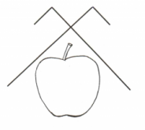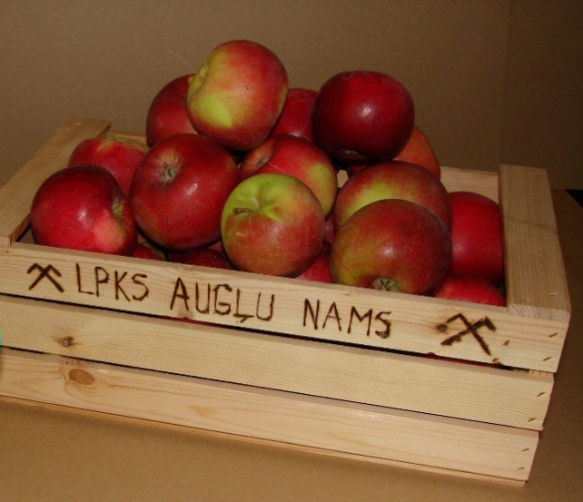
Sources: http://karotite.lv/uznemumi/auglu-nams; https://www.facebook.com/auglunams/
An important feature of the cooperative are the hybrid profiles of its individual members. All of them are practicing fruit growers, yet several of them also have an academic background and previous research experience, and a few of them have also worked, or are still working, in the capacity of agricultural advisors. Therefore, the cooperative is well-networked with most of the key national AKIS actors of the fruit sector, including the Institute of Horticulture and Pure Horticultural Research Centre, Latvia University of Life Sciences and Technologies, Latvian Rural Advisory and Training Centre, and Latvian Association of Fruit-growers. While formally there are 11 legal entities as members of the cooperative, some of them are represented by the same farmer of farmers’ family members, thus making the community even more compact.
Informal, non-structured demonstrations take place during collective farm visits, which are organised on cooperative members’ farms. These farm visits usually take place once a year either before or after harvest (mostly in autumn), preferably on a different farm. They are primarily organised by the chairman of the cooperative as part of the annual general meeting of the cooperative. These farm visits represent a bottom-up initiative stemming from an internal need of the cooperative to ensure regular contact and mutual knowledge exchange, inspired by earlier joint attendance of several thematic exhibitions and study visits abroad.

Funding
The organised farm visits to cooperative’s member farms do not involve notable financial investments for the organisation and implementation of the informal demonstrations. The only costs involved include travel expenses of the attendants and catering, which are mostly covered by the individual members themselves. There is no external public or private funding being attracted for these visits.

Host(s)
The selection of the host farm is based on the principle of rotation with an aim of visiting a different site each time. Between 2010-2018 six (out of 11) members had hosted these farm visits. It should be noted that several of the cooperative member farms have been hosting farm visits for different individuals and groups also not being part of the cooperative, thus demonstrating general openness to farmers and other interested visitors (students, general public). The host of the observed event held in October 2017 was a family farm having specialised in apple growing since 2005. The farm has gained public recognition both from the local government and the Latvian Association of Fruit-growers.

Gender
Except for the fact that the demonstration is generally organised by the chairman of the cooperative, there were no major gender differences or biases observed in the given case with regards to commissioning, organising and holding the demonstration event. It can only be noted that the observed farm walk was primarily guided by the male host farmer, while his spouse was also actively present all throughout the event.

Objective(s)
The analysed farm visits are regarded by the organiser as ‘knowledge and experience sharing activities’ rather than formal structured demonstrations. The objective of these events is primarily to share (i) knowledge on specific new practices introduced on the host farm, (ii) experiences regarding the specific problems faced that year regarding the quality of fruit, annual yield, etc.
The demonstrations address a wide variety of problems that cooperative members might encounter during any given season, but the thematic focus is generally on making the management of orchards more efficient, and the farms more competitive. Aside from production-related issues, new market channels for produce (e.g. public procurement of fruit for schools) and other ad hoc issues with the aim of boosting the quality of the produce, productivity and overall competitiveness of the cooperative and its individual members are also discussed.
Given the nature and aim of these farm visits, based on the PLAID typology of demonstrations the case can be characterised as farmer-led and commercially oriented one (see Figure 3).
Figure 3. Positioning of the case study in the typology of demonstrations
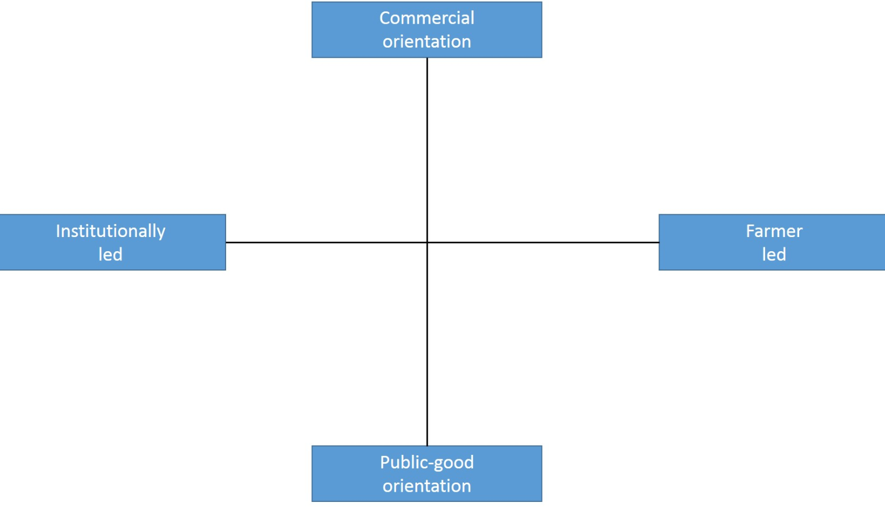

Topic(s)
The informal demonstrations are part of joint learning activities and mainly concern production-related issues that are relevant to members of the cooperative and are generally not pre-defined in advance. The demonstration allows for the possibility of having a more comprehensive view of multiple practices linked to the overall farm management (whole farm approach), rather than focusing on a specific issue. Consequently, the topics covered by the demonstrations address numerous themes related to apple production ranging from selection of varieties, spraying equipment, pest management, disease control, pruning methods and trellising systems, to storage and processing of harvested fruit.

Access
Gaining access to these demonstration events is limited by the semi-private nature of these visits as visitors are generally mutually acquainted cooperative members. Consequently, access to these demonstrations is more of an issue with regards to social accessibility given that these informal visits are meant only for a specific group and generally are not open to other participants, nor are they publicly advertised. Only on some occasions some non-member participants are invited to join the event. Yet, as noted above, cooperative’s farms are generally open for external visitors on other occasions thus not restricting access to their practices only by the limited group of the cooperative members.
While the farms of the cooperative are geographically dispersed (see Figure 2), they are still located in the same part of the country and distance does not seem to be a major obstacle for physical accessibility and to the ability of the members to take part in the visits. As these events are held only once a year, they are treated as special events of direct relevance to the cooperative. Furthermore, as all members own a car (or can share it with others), geographic distance does not significantly limit accessibility. It is more likely that the duration of the trip could be a more important factor if the demonstration is held at poorly accessible (e.g. due to the quality of gravel roads) farms.
There may be some restrictions in terms of economic accessibility for those members located further away from the host farm due to travel costs. Nonetheless, given the comparatively rare nature of these events and the fact that the largest distance between these farms is approx. 190 km, travel costs are not a major obstacle.

Demonstration event

Visitors
As the demonstrations are organised for a limited group of mutually acquainted participants, these events are seldom open to participants who are not members of the cooperative (see Figure 2). This means that the sample of participants is not representative of fruit-growers in Latvia, but this was never the intention of the organisers. Usually 8-9 members take part in these farm visits.
Figure 2: Map of Latvia with the locations of the cooperative’s members.
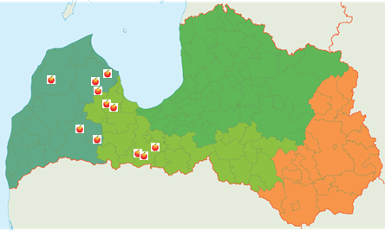
Source: https://auglunams.lv/biedri/
Aside from three observing researchers, the studied farm visit was altogether attended by 11 people, out of which five were men and six were women. An important feature was that on several occasions both spouses of the member farm were present. Some of the cooperative members had come along with their children.

Communication & Mediation
Usually there is no strictly defined structure that these on-farm events have to follow as they vary case by case, depending on the specific profile and features of the visited farm. In the observed case the farm visit was not strictly organised into a predefined programme, but it evolved rather naturally on the farm following the farm’s physical arrangement and taking account of the time planned for the visit.
The visit started with a tour from the courtyard where some heavy machinery was parked and available for display evoking a natural start for initial exchanges. It continued with a visit to the nearby storage facility, then moving further to inspect some equipment items placed outdoors a bit further away and, finally, taking a car ride along the road to the orchard area for a field walk (see Image 1). Since both the husband and the wife managing the farm were present, they both simultaneously fulfilled the roles of guides.
Image 1: Visit to the orchard area on the host farm.
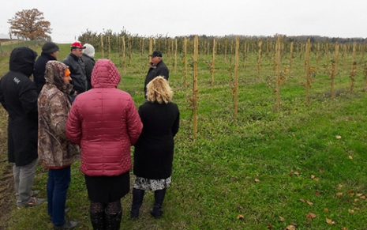
Author: Anda Adamsone-Fiskovica
Due to the informal nature of this knowledge and experience sharing activity that is held in real-farm management conditions, no major special arrangements and/or adjustments were made on the farm prior to the visit. As acknowledged by the host, “we are taking care of the farm all year round and try to maintain the farm in good condition on a daily basis”.

Active participation
Even though the hosting farm is not specifically set up to accommodate a visit by a group of peers and encourage learning, the informal nature of the event was conducive to active participation and clarifying questions. During the observed visit, each step of the demonstration lasted for a very short period, but interactions were both knowledge-intensive and engaging as the process was accompanied by humorous exchanges and the sharing of funny stories regarding different practical aspects of farming.
The comparatively small group of well-acquainted attendees lead to an informal atmosphere, thus enhancing learning among peers and allowing for a series of micro-interactions between both the hosts and the visiting farmers, and amongst the visiting farmers themselves. The fact that participants are well acquainted inevitably played an important role in facilitating interactions and the formation of shifting micro groups (see Image 2).
During the farm walk the group gradually split into male and female subgroups, though both groups participated in the discussion with hosts. The organisation of groups along gender lines could be at least partially explained by the traditional division of labour and the fact that some practices and responsibilities on the farm are gendered.
The observations made during the event suggest that each participant tries to make optimal use of the farm visit. Specifically, they became more actively engaged at moments that were deemed more relevant or interesting for them and their farming practices. Several participants posed questions after the field walk. There were many informal exchanges among the visitors in smaller groups. Some visitors also took the opportunity to speak individually to both host farmers who were present throughout the demonstration. Discussions were especially lively after the practical demonstration on the farm.
Image 2: Inspection of equipment in the yard of the host farm.
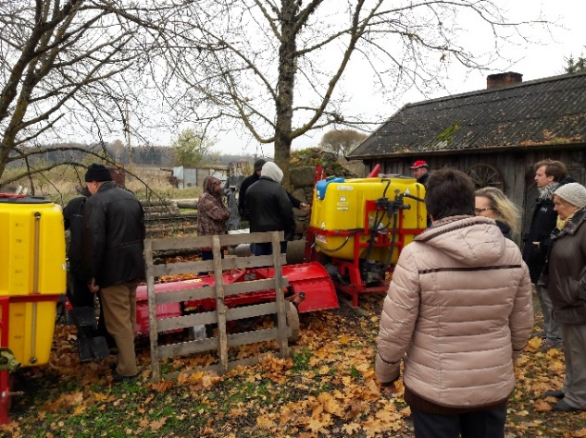
Author: Anda Adamsone-Fiskovica

Doing business
The demonstration events in question seldom involve transactions, and doing-business activities are not seen as part of the demonstration event since these are not meant to be demonstrations of specific commercial products. However, these demonstration events also serve the purpose of discussing various practical matters related to the work and functioning of the cooperative, thus taking an opportunity of combining the farm visit with a business meeting of the cooperative.

Role of sustainability
Sustainability underlies most of the cooperative’s activities since all members apply the principles of integrated fruit production on their farms. This involves the development of an economically efficient and high-quality fruit production framework, giving priority to ecologically safer methods, minimising the undesirable side effects and use of agrochemicals, and making a positive contribution to environmental quality and human health. Adopting such a stance requires a holistic system approach involving the entire orchard. There were no specific references to sustainability issues during the observed farm visit, but sustainability can be seen as an implicit, non-verbalised basis of all the activities carried out on the farm.

Unforeseen circumstances
The major factor having an influence on the course of the event was the rather nasty weather conditions as on the given day it was rather rainy, with cold wind and damp earth on the farm, which was not conducive for prolonged walks and extensive discussions outside. These conditions forced to shorten the initially planned length of the visit from 1-1.5 hours to half an hour. With this exception there were no specific unforeseen circumstances that disrupted the flow of the demonstration. The choice of the season for the farm visit is usually made taking into account the peak moments in on-farm chores, which otherwise might restrict the possibilities of allocating time by farmers.

Plans vs. practice
As there was no predefined programme for the event, except for the planned start time and indicative activities on and off the farm, there were no major deviations from the initial plan. In the case of the observed event, it took a much shorter time (30 minutes) than on other occasions both due to the planned focus group discussion and business meeting of the cooperative after the farm visit (farmers value their time and cannot afford to waste it on too many things outside their own farm) as well as due to the rather nasty weather conditions on that day. While these factors did not account for any major alterations to the intended plan, it is rather inevitable that the informal nature of the event and other practical needs may require improvisation and on-the-spot adjustments.

Participants feedback
In addition to the friendly and relaxed atmosphere, participants appreciate that these demonstrations are carried out under real-farm conditions and hosts also talk about failures and mistakes in language that is accessible to the layperson. The possibility to draw on the commonly accumulated pool of knowledge is also considered an asset, as is the opportunity to address specific issues in-depth as a collective. More generally, the opportunity for participants to express their opinions, ask questions, share user experiences thereby helping to formulate an attitude and take account of the knowledge and experiences of peers was considered very important. No specific limitations or negatives were mentioned, though a suggestion was made to organise farm visits more often.

Motives, learning and networking

Reasons to attend demos
When reflecting on the motives and reasons for attending a demonstration event, account should be taken of general attitudes and perceptions of the visitors, different social norms at play, and various practicalities that are at play.

Attitudes and perceptions
Participants provided several reasons for attending demonstrations on other members’ farms. While some were practical in nature (e.g. learning new things to improve the competitiveness of one’s own farm) and derived from the demonstration taking place in real-farm conditions (“We don’t avoid showing also the knocked-down apple trees”), others had to do with the specific learning environment provided by the cooperative. Some noted the friendly and relaxed atmosphere, the opportunity to meet other members of the cooperative (“Nice to meet colleagues”) and the benefits of an informal setting. Others stressed the absence of scientific and formal knowledge pressure (“You will never appear a fool at a farm visit”) and the possibility of drawing on the commonly accumulated pool of knowledge of cooperative members.
The mutual farm visits are, of course, not the sole source of information and knowledge for the attendants as quite a lot of learning opportunities are provided by various more formalised knowledge transfer practices offered by different AKIS actors. These formal events provide additional insights and opportunities for informal peer-to-peer learning. Comments made by the focus group participants highlighted the power dimension that may hamper learning at the larger scale public events where some farmers may feel inferior vis-a-vis scientific, formal knowledge being demonstrated, or more experienced farmers may feel annoyed by somewhat primitive questions asked by novices. It was also emphasised that gardens maintained by research institutes do not necessarily have to be profitable and can be heavily subsidised, thus lacking the real-life conditions of farming that are present at the commercial farms.
The mutual farm visits allow addressing specific issues in-depth and provide the possibility to verify with colleagues the things learnt at more formal events (e.g. Rural days), as well as experiencing peer support (“It is nice to feel the shoulder of your colleagues”). The fact that the attending farmers are part of a cooperative gives an extra motive for these visits as different common business issues can also be settled there. Unlike demonstration activities aimed at a more diverse audience, these mutual farm visits allow for a more professional and focused discussions.

Norms
These demonstrations usually take place only once a year, so there is an implicit expectation that all members will participate. Attendance is, therefore, motivated both by interest in the practices favoured by a colleague and the expectations of the group.

Practicalities
As all the member farms are located more or less in one part of the country and are motivated by the common business interest, there are no major practical obstacles for attending the event, except for some unexpected things (either work or health-related) encountered by individual participants. It is acknowledged that, while not being a decisive factor, having nice weather on the day is more beneficial as it provides for a more pleasant and stimulating setting (e.g. in spring when trees are in blossom) for an exchange of views and experiences.

Forms of learning
The investigation of the informal learning settings presented by the case study allowed to make several observations regarding the process and contents of farmers’ peer-to-peer learning. It can be argued that the semi-private nature of the demonstration contributes to a highly specific learning environment, which is characterised by the dominance of two-way peer-to-peer learning and intensive exchanges of information and knowledge. There were a large number of issues discussed and demonstration objects shown in a relatively short period of time.
The observation of the farm visit allowed to witness farmers’ self-organisation into smaller groups of peer-learning. During the farm visit, members split into several micro groups of two, three or four persons when discussing specific issues and reorganised these groups several times. The smaller peer-group format may enhance learning and direct experience exchange at demonstrations. Informal discussion among peers is an important mode of learning that has an impact on the dynamics of the whole demonstration. Thus, the time used for moving from one object to another may allow for moments of individual exchanges between visitors.
In the observed farm visit, there was a rather clear split into gendered groups during the field walk, with males mostly following the male host farmer (see Image 2) and the female group either gathering around the farmer’s wife or sticking together separately. An exception was an elder male attendant who engaged in a debate with the farmer’s wife, with the intention of giving advice to her on apple-tree pruning principles.
Image 2: Discussion between some of male attendants of the farm visit.
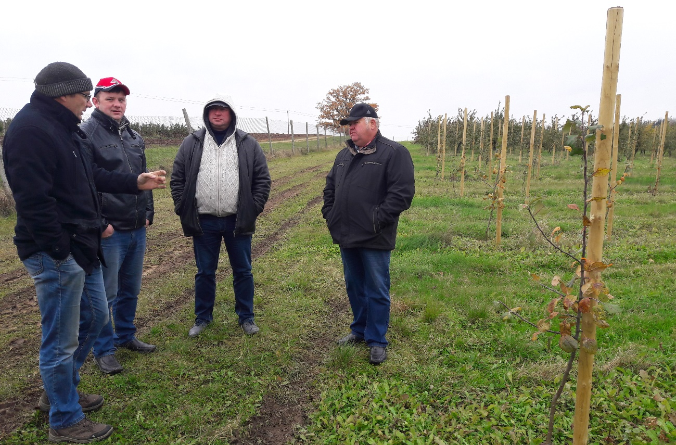
Author: Anda Adamsone-Fiskovica
It was observed that the change of the spatial arrangement (moving from the farm to the premises for group discussion) allowed for some group rearrangement with female participants approaching the host farmer with some questions that had emerged during the field walk. The gendered set up of the micro-groups could be partially explained by the traditional division of labour between spouses whereby specific farm and orchard management responsibilities and practices are gendered. This, in turn, has an effect on what are the primary objects of interest, discussion and learning for female and male participants of the demonstration event.
This observation has implications with regards to the benefits of promoting participation of both genders in demonstrations since this enhances the likelihood of learning on a more diverse range of topics that can be later used in their own farming practice, thus making the work of both spouses more productive and/or easy (“But how can we manage these poles without a man on the farm?”). As noted by one of the farmers, if time allows, several members of the farm try to attend these events as each of them may have a different opinion on the observed practices, and this allows for a possibility to share their views and discuss the novelties after the event.
Image 3. Visit to the storage and processing facilities on the host farm.
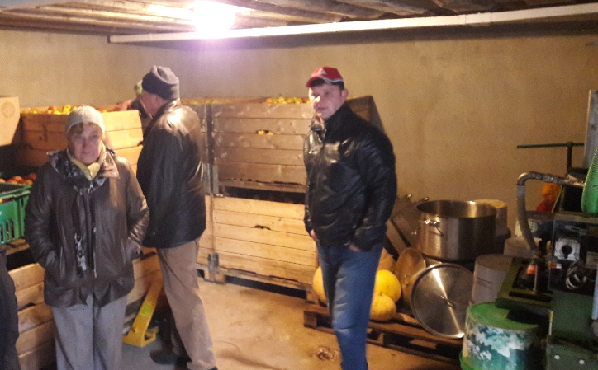
Author: Anda Adamsone-Fiskovica
It was also important that the hosts were present all along the field walk and were available for providing some initial guidance and responses to any emerging inquiries. The presence of both the farmer (taking a more active role in leading the event) and his wife seemed to encourage the active involvement of both male and female participants. Both host framers unobtrusively drew attention to different items in their respective area of responsibility for those in their proximity and engaged in individual discussions with attending farmers. Importantly, the hosts didn’t avoid bringing the group to spots in the orchard where some damage or failures could be observed (e.g. poles that didn’t manage to hold up apple trees in the recent strong wind), which serves as an important object for mutual learning.
In such personalised knowledge exchange settings farmers may feel more empowered to share their experiences. One farmer commented: “In such a small group I feel free, I don’t need to hesitate among friends, and this is different from big open day events at other demonstration farms”. There might also be a higher probability of reciprocal learning both by the visiting farmers from the observed practices on the demonstration farm and by the host farmer receiving some practical suggestions made by his/her peers on the field upon identification of some differences and/or problems.
The observed farm visit allowed to see that the demonstration activity may be extremely compressed in time and take just a few minutes to show, test and initially validate a new technical artefact, an object, shortly interact about it and share experiences of using the ‘old’ and ‘new’ thing.
The immediate contact with a demo-object is very much a sensory activity – seeing, touching, checking, sensing – acquiring a primary perceptual information and personal experience of a new thing. It could be observed that this sensory act is followed by a short verbal interaction when group members discuss the artefact in front of them and expose their personal experiences of using it, comparing it with a different/traditional/more often used technical device, a kind of machinery or technology.
Verbal interaction thus forms an important part of demonstration as it allows participants to express their opinions, ask questions, share user experiences thereby helping to formulate an attitude and take account of the knowledge and experiences of peers. Verbal interaction about demonstrated artefacts serves as a first-hand validation of new knowledge on a shared basis. It is a phase of rationalisation, which follows the phase of sensory perception in demonstration.
During the focus group discussion several references were made to observations from elsewhere, comparing the different forms of learning activities experienced by the cooperative’s members. It was acknowledged that these forms – collective and individual farm visits, Rural days organised by public organisations, study tours abroad, consultations by phone, use of online services, etc. – entail varying degrees of prior knowledge and personal involvement of farmers required for their productive participation and utmost benefit gained from the specific format, as well as the level of complexity/specificity of issues that are or can be addressed. As for the mutual farm visits, the shared knowledge of the whole group or selected individual members allowed to skip some basic/background information and directly address a more specific range of questions.

Content of learning
The demonstration events organised by the cooperative cover a wide variety of topics related to the practical needs of the members. The observed farm visit was not organised around any specific topic, but rather provided an opportunity for the visitors to briefly acquaint themselves with multiple practices linked to the daily operation of the host. While the host farmer started the visit with a comment “I don’t have much for you to see there”, the group managed to visit an apple storage, a machinery parking place and an orchard, and managed to discuss several dozens of different (albeit related) issues (see Box 1).
There was a combination of very specific and more general observations and impressions (“You have a wonderful view from here!”, “Your apple-trees look really good! When (which year) where they planted?”). The content of learning concerned not only production-related issues, including orchard management (e.g. other specific issues included the impact of hail on harvest, use of websites providing weather forecasts, orchard spraying frequency and timing, blossom thinning in spring, etc.), but also storage and processing.
Much of the discussed content is very practical and ready to use, though part of the knowledge shared by the host also include location-specific features. The informal setting is used not only for sharing farmers’ know-how but also sharing contact information and recommendations of different individuals or organisations (incl. input suppliers, other farmers) that can be useful in consulting on specific issues.
Box 1: Selected issues as discussed by farmers during the farm visit
- A juicer (“That’s new in your farm, I haven’t seen it here before.”)
- A dusting/spraying equipment (“Now I can easily spray two hectares with it.”; “You don’t have to put two filters here and there, its’s enough to put just one here.”)
- A garden mill (“This is really great acquisition, it is so easy to plant trees after milling the soil.”)
- A tractor for pulling the spraying equipment (“Even an old tractor can easily pull it.”)
- Apple varieties (farmers discussed various varieties, their productivity, exchanged opinions what to do with non-productive varieties - “You’ve got to replant them with other ones.”)
- Tree supports (various trellising systems were discussed - wooden poles, concrete poles, bamboo poles, use of metal wires, etc.)
- Drainage of the lowest places in the orchard
- Formation of rutting on the mud road caused by heavy equipment along the orchard (“I try to take a different path for the wheels each time.”)
- Specific features of the soil (clay) and its impact on farming
- Orchard cultivation techniques on hilly surfaces
- Distances between apple-tree rows (“You know, four meters is too narrow for machinery, but five meters is already too wide and inefficient. With 4,5 meters you can save space already for an additional row.”)
- Choice of root-stocks
- Pruning and crown-shaping techniques (“You have to cut it close to trunk and leave a twig on the lower end to let a new branch grow.”)
- Impact of pruning on harvest
- Use of electric shears for pruning (- “Did you also buy them?” - “Yes, last spring.”)
- Plant nursery on the farm (“We grow apple plants ourselves, it saves money, and plants from our nursery grow healthy.”)
- Wine making from apple (“Can you give me contacts of that farmer who makes wine from apple?”)
- Impact of winds on the orchard (“It is very windy on our farm; it is helpful as wind extinguishes pests, but you have to be careful when it comes to choosing the right spraying days.”)
- Disposal of old or damaged trees
- Use of online weather forecasts (- “Which one do you follow to decide for spraying?” – “Meteoblue.com – they are the most precise ones and locations are close to my farm”).
There is knowledge and experience sharing on logistics and marketing (transportation, distribution, sales), policy issues (subsidies, regulations, new government support programmes, tenders), and internal matters of the cooperative (planning of activities, accounting, paper-work, collaboration with other organisations) that are also touched upon during such cooperative meetings.

Outcomes of learning
Despite the intensity of interactions observed during the farm visit, it appears that learning does not end at the conclusion of the demonstration but extends in time. A number of stories recounted in the focus group indicate that the effect of attending a demonstration and the learning that the visit stimulated may take years to manifest itself. At first, farmers see and discuss new things or incremental innovations in routine operations that were introduced at the demonstration. Subsequently farmers continue to reflect about the novelty, seek additional information or advice, and experiment with it before making a decision whether to adopt the novelty.
Learning and anchoring are facilitated if a farmer belongs to a wider learning group or network (in this case – a cooperative) whose members share similar knowledge needs and are involved in regular learning activities. The peer group enables knowledge flows and experience-sharing and backs up the farmer’s decision to convert the first demonstration impulse into a new/modified practice on his/her own farm.

Networking
As noted above, meeting other members of the cooperative is one of the key reasons for attending the organised farm visits. Consequently, while these demonstration events organised by Augļu nams seldom provide opportunities to meet new people and service providers, they allow members to exchange experiences, share knowledge on different novelties and discuss various urgent and practical issues. This serves several purposes, as it can be regarded as either peer-to-peer learning/advice provision or a mutual support group.

Anchoring: Application of demonstration lessons by participants

Anchoring related to the present demo
While it was difficult to elicit specific immediate reflections on the attended farm visit and intentions of applying any of the observed practices in this particular farm, the focus group discussion allowed to elucidate several situations that characterise more generally how farmers learn and adopt new things as a result of seeing those applied on the farms of other cooperative members.
The first impulse experienced during a farm visit is followed by a period during which farmers reflect and consider the possibilities of introducing the new method, technique, piece of machinery, etc. on their own farm. Coming to a decision regarding the actual adoption takes time as a novelty may require financial investment as well as new skills and knowledge. It may also require changes in the farmer’s usual routine and mind-set. For instance, there were a couple of examples mentioned where a piece of advice was given by a peer from the cooperative to do things differently (e.g. a particular way of pruning apple trees) but that did not result in a change of an established practice by the other farmer, as the latter was too used to do the work in his own way.
Likewise, the focus group revealed a situation where a cooperative member had purchased some equipment (i.e. a movable ladder for pruning) along with some other cooperative members, but he admitted to having stored it somewhere and not having used it for quite some time. Therefore, in the case of equipment, the mere fact of buying an item does not automatically result in anchoring the piece of technology in daily farm practices. It can be that some additional factors need to come into play to trigger actual uptake (e.g. health and/or age as an objective factor for opting for a new practice that can make it possible to carry out certain tasks that otherwise are becoming too burdensome).
Furthermore, the focus group discussion suggested a kind of tension whereby farmers were committed to established practices, while simultaneously indicating a willingness to improve them or introduce new things. For this reason, adoption/anchoring of novelties may be psychologically challenging and sometimes difficult to farmers as it may require also lifestyle changes. One farmer admitted: “I know about electric pruning shears, have seen them demonstrated in Dobele [at the Institute of Horticulture], but I am still physically fit, I can prune my six hectares of orchard by [mechanic] hand shears in two months. But probably next year I will try electric shears.” “Yes, you should,” another farmer commented. The length of the involvement in the group has also contributed to a delayed uptake of the use of the electric shears due to more limited previous interaction and participation in previous farm visits that could have served as a tangible and reassuring demonstration of this equipment in real-farm conditions.
Generally, it is more likely that less investment-intensive and less radical novelties and incremental changes are to be introduced with less delay. From the case study it is also evident that anchoring is easier when it comes to the adoption of technical novelties. Technical innovations are also easier to trace from a methodological standpoint, by following the evolution of technical artefacts and instrumental practices. What concerns exploration of social, organisational and marketing innovations, their anchoring is more difficult to assess as these processes are less tangible and, consequently, harder to trace.

Stimulating anchoring
Regularity of demonstration events matters for successful learning and anchoring. The case in question suggests that farmers return to specific learning issues (for example, introduction and use of electric shears in orchard management) in several joint demonstrations or learning activities over a longer period before they make a decision to adopt a method/technology on their own farms. Frequency and diversity of demonstration and joint learning events help to maintain a common learning ethos among farmers; therefore, some events might be very focussed and time-compressed. On the other hand, intensive knowledge exchange activities are followed by more prolonged periods of tacit learning, reflection and trial, assessment of costs and benefits of introducing a new technology or a novel way of organising one’s work.
Mutual help and group support are also very helpful in stimulating novelty adoption. At the same time there is also the risk of a certain ‘crowd effect’ since there might be a tendency to enthusiastically follow a practice promoted by other farmers without careful consideration of personal needs, skills to master and apply the new technology, and/or readiness to alter established routines. An example would be buying one thing under the influence of other peers but gradually realising that this has not been the optimal solution for the farm.
In addition to the mutual farm visits, the cooperative also organises joint annual trips to sector-specific exhibitions abroad (e.g., Lithuania, Poland, Germany) and informs members and encourages them to participate in other demonstration events held during Rural days or study visits organised by other organisations (research institutes, advisory services) on research or commercial farms. These trips allow for learning new things of key importance for individual farms and joint cooperative activity (in particular about production technologies, garden equipment, machinery, marketing and processing solutions), learning from foreign farmers who are more advanced in production and organisation of fruit chain, as well as buying new equipment (“I first saw a garden sledge in Poland and bought it there”, “I saw pruning shears in Poland – how they were used in the garden”, “I saw a garden train in Lithuania”).
Demonstration events organised by the cooperative are part of joint learning activities, and it is important to stress that learning does not only take place during the mutual field visits, which are organised on member farms. From time to time cooperative members visit each other on an individual basis to consult on specific issues or novelties (“When I considered to diversify my activities, I visited X’s farm to see how she combines horticulture with tourism”). Members are open and responsive to each other’s knowledge needs, so a call to another cooperative member can be made outside of official working hours. Furthermore, the presence of experienced farmers and researchers/advisors in the group who are open to consulting other farmers is used as a resource. Short telephone conversations with more experienced peers may help to address and resolve some burning issues. The joint management meetings of cooperative members also entail elements of learning and can serve as a means for stimulating anchoring.

Anchoring related to earlier demos
While the examples reviewed above mainly pertain to learning within the network of cooperative’s farms, it appeared quite vividly that other demonstration events outside these group activities play a role in the process of learning of new practices and implementing those. It was rather challenging to trace the specific new practices to a definite source either within or outside the group and to disentangle the factors internal and external to the group in influencing the application of the new knowledge (“It’s hard to distinguish between things I’ve learnt from cooperative members and elsewhere”). Therefore, it proved once again, that acquaintance to and uptake of a novelty is a result of several influences coming from various sources and in various formats rather than from a single encounter (which can also be the case but is less common).
From the examples provided by cooperative members in the focus group discussion it appears that many novelties are considered and introduced after seeing them demonstrated on pioneering farms outside the cooperative’s own network (see Box 2). This suggests that establishing ties to wider learning and innovation networks for sustainable agriculture is important for diffusing novelties and boosting individual anchoring.
Box 2: Situations of initial anchoring of novelties identified during the focus group with cooperative members
- Electric pruning shears (“We saw how they were used in Poland.” “X (a cooperative member) suggested me to use electric shears.”)
- Garden sledge – a moveable ladder for pruning (“We saw them in the garden in Poland, then bought them in a shop in Poland, brought home and made several copies of those.”)
- Fruit storehouse building and equipment (“Trip to Poland was very useful as we saw how apple storehouses look there, how they are equipped and what cooling cameras are used.”)
- Wire joints tensioner for apple-tree support system (“I saw these tensioners on another farm.”)
- System of espaliers in the orchard
- Treatment of tree-beds
- Method of dusting
- Straw mulch under apple-trees (“I saw this practice in one of our member farms and decided to try it on my farm.”)
- Apple packing boxes (“These are very convenient boxes, when empty you can put them in each other and transport easily, I saw them on a cooperative member’s farm.”)
- Moveable garden train for harvesting (“I borrowed this idea from Lithuania - to put boxes on small trailers, harvest apple and then bring boxes in the storehouse.”)
- Landscape care (“I visited X’s farm (a cooperative member) to see how landscape is managed.”)

It was often the case that farmers had first seen these novelties during study tours abroad, at agricultural fairs or demonstration events of the research institutes and advisory services. Additionally, a practice observed elsewhere might not be taken over directly (especially if seen under different climate, topographic or other conditions) but used as a resource for developing other ideas or locally-adapted solutions on the farm.
On another occasion, novelties had been borrowed from other cooperative members after they had tested them in the capacity of early adopters. In the peer group the trustful relations with the other group members, the credibility of colleagues, reliance on advice and expertise of peers, and a “green light” for a novelty by formal and/or opinion leaders all play an important role in anchoring.

Scaling: Application of demonstration lessons by the wider farming community

Retrospective examples of scaling
The scaling or diffusion dimension of the demonstrations beyond the community of farmers who have been directly involved in or visited a demonstration is difficult to capture. However, the stable membership and limited number of participants allows for the possibility of identifying the uptake of specific new practices on the member farms by tracing the initial source of a specific innovation and the process of its spreading within the group and beyond.
A specific example of the dynamics of scaling of an innovation is the uptake of chargeable electric shears for pruning trees, which, when compared with their manual counterparts, double labour productivity – they deliver a more precise cut, allow for greater flexibility and require less grip strength (see Image 4). In the view of one of the interviewed experts in horticulture, these are especially handy for female farmers, which tend to dominate the sector, as this tool considerably lightens the physical work. Yet, this tool is rather costly as the price of this type of shears is around 1,5-2 thousand euros.
Image 4. Head of the cooperative demonstrating the electric pruning shears.
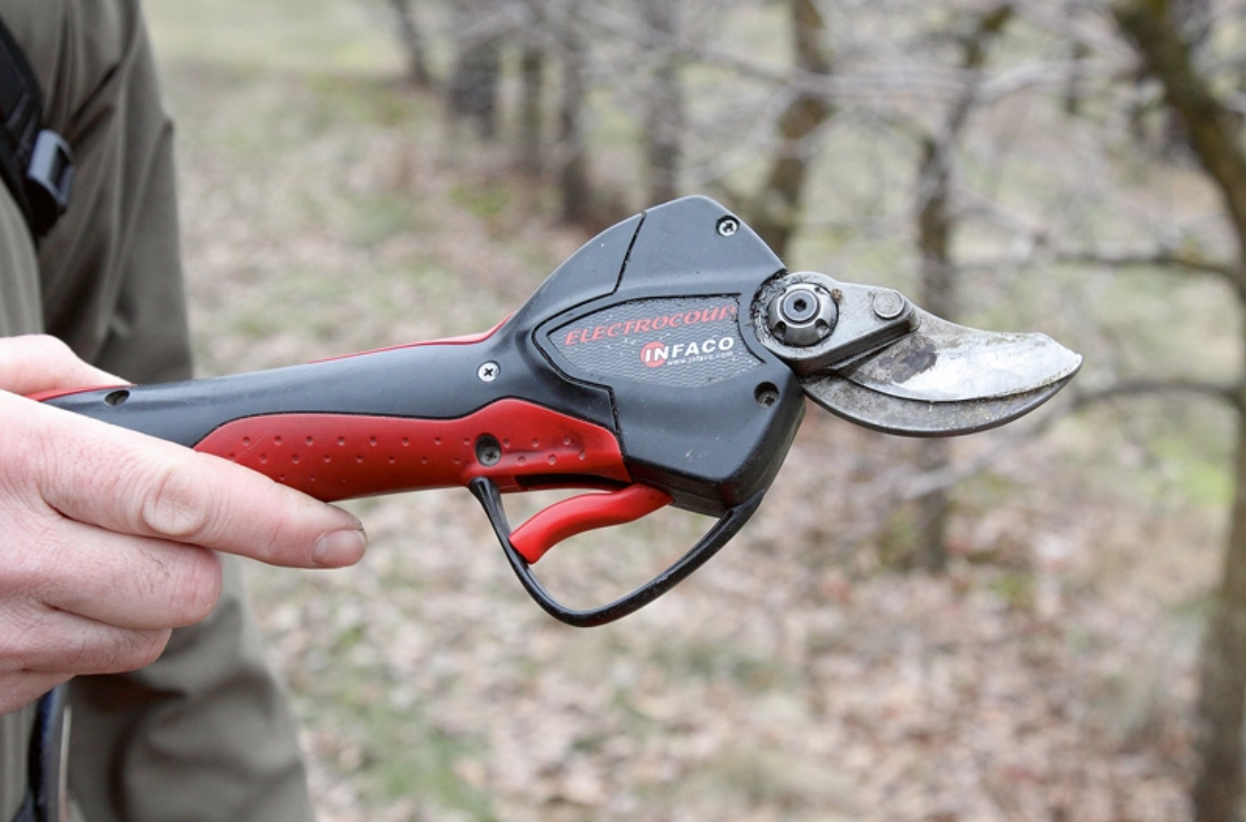
Source: http://www.la.lv/veidojam-auglu-koku-vainagus-2
According the accounts of the cooperative members, these shears were first seen by them at a fair in Warsaw, Poland, which served as the first impetus for the uptake of this novelty by the visiting farmers. Later, similar shears were demonstrated at the Institute of Horticulture in Latvia during the annual Rural days. After the cooperative leaders had tried the electric shears in practice, several other cooperative members followed this example and tested the novel tool. A project for the purchase of the shears was submitted to the Rural Support Service in Latvia. While having faced some initial resistance from the officials, the project finally received funding and support, thus enabling the application of this pruning technique and equipment on member farms.
Several distributor companies have started their activities in Latvia, paving the way for an even wider spread of this innovative tool. The use of this kind of shears has also been promoted by the head of the cooperative in press publications on apple tree pruning and other occasions. Other cooperative members also continue to demonstrate these shears to their visitors, which attract high interest by practitioners. As a result of these developments, presently this kind of shears are widely used in the farming community of commercial fruit growers, and their use has become a mainstream practice.

Prospective assessment of scaling: Impact pathways
General observations suggest that scaling is a consecutive process of several/many demonstration, learning and adoption activities and involves the interaction of various actors (farmers, advisors, researchers, peer-group, state and public authorities). It can be facilitated if multiple processes of learning and anchoring are happening simultaneously (i.e. in other words, several mutually related novelties are being adopted simultaneously). Furthermore, successful scaling requires certain institutional changes or elaboration of more favourable institutional settings and arrangements for innovation. The latter is difficult to achieve without the commitment and participation of state authorities.
The prevailing agricultural knowledge and innovation system in the fruit sector in Latvia can be treated as rather well-adapted to a wider spread of various novel practices as there are several formats for knowledge transfer and exchange presently actively in use. The study tours abroad (especially, to Lithuania, Poland, also Germany), where much is being learnt by Latvian fruit-growers from the more advanced farms and companies involved in fruit production, have become a rather regular practice, though the capacity of organising those largely depends on the availability of project funding. Locally, various practices are promoted on a regular basis by the Institute of Horticulture though the thematic Rural days, individual consultations and popular publications.
As demonstrated by the case study, there is also large potential for peer-to-peer learning in smaller formal and informal groups of fruit-growers. The recent upsurge of on-farm demonstrations run by various AKIS actors due to increased availability of targeted public funding for demonstration activities also represent an important pathway for wider application of various farming practices both in terms of facilitating increased productivity and implementation of environment-friendly methods of production. As farmers increasingly use internet as a source of information, there is also an emerging trend of short online video instructions that demonstrate various practical aspects of fruit-growing.

Case study reflection

Facilitating and impeding factors for successful demonstrations
The case study allowed us to identify several factors that seem to be relevant for a successful implementation of demonstration activities and peer-to-peer learning. Building on the preceding analysis, the identified factors have been summarised and divided into three main groups dealing with (i) inputs, (ii) access, and (iii) demonstration process.

Inputs
Most of the member farms of the cooperative were not specifically designed as demonstration farms, though demonstrations were still possible. The infrastructure at most member farms is suited to the needs of the household without any specific arrangements for potential visitors. Given the small size of the group, the storage area or a room in the living house could be sufficient. At the same time, it was clear that there was no appropriate space for the focus group on the farm, so it had to be held in a café in a nearby town. Therefore, certain restrictions could be identified on the farm, which suggests that farms that have not been designed to accommodate visitors can efficiently act as demonstration farms for group visits only to a limited extent and mostly under favourable weather conditions.
Our research did not reveal any notable financial contributions to the organisation and implementation of the demonstration, though this did not preclude the demonstration event taking place. It should be borne in mind that, aside from catering and travel expenses, financial requirements were limited. This suggests that demonstration farms can do without major financial assistance in cases where learning takes place informally, in small groups of well-acquainted peers.
Quite a lot in ensuring a successful demonstration depends on the available human resources and the quality of inter-personal relationships. These farm visits are organised on commercial farms where the hosts also act as the informal guides, with some advisory assistance by other cooperative members. The personal characteristics of the hosts of the farm and the managerial capacity of the cooperative leader(s) to bring the members together (date, time, location) and encourage their participation are crucial.

Access
In the given case of mutual farm visits the physical distance and farm location do not seem to represent a major obstacle to taking part in these events. While increased frequency could reduce the attendance in case of longer distances, especially if a visit to a fellow farm already visited before is organised, the focus on thematically unrestricted informal peer-to-peer learning and an opportunity for networking among members of this interest group might still be motivating enough. While there might be some restrictions in terms of economic accessibility for those members located farther away from the host farm due to travel costs, these do not seem to act as a major obstacle to participation for the same reasons as outlined above.
The set-up of the specific case of demonstration activities implies their limited social accessibility as these informal farm visits are meant only for the designated group of farmers. The informal nature of these farm visits inevitably places greater emphasis on direct communication with the organiser, and access to these demonstration events largely depends on established personal relations and, crucially, being a member of the cooperative. Under the given conditions this can hardly be considered a drawback of this format as this is a private initiative of a self-organised group and the restricted membership provides for the possibility to intensively interact in a smaller group of peers with a shared interest and goals. It should be borne in mind that the inclusion of outsiders may disrupt the established group dynamics and change established practices and the collective learning process.

Demonstration process
This case suggests that it is not necessary to have a formally structured demonstration process with a strict set of consciously applied methods to enable and encourage the peer-to-peer learning. However, organising the event on the farm with a field walk was a key factor as it allowed visitors to see the real-farm management conditions and the farming practices applied on the given farm. It was also important that the hosts were present throughout field walk and were available for providing some initial guidance and answering any questions. Here the fact that both the farmer and his wife were present seemed to encourage the participation of both male and female visitors.
The readiness of the host to guide participants and show both the courtyard and the backyard of the farm without eliminating the traces of any failures faced in their farming experience represents an important factor for demonstrating real-life conditions and for encouraging the process of peer-to-peer learning. This can trigger a mutual exchange of experiences in dealing with similar problems on one’s own farm. Furthermore, the informal atmosphere (incl. humour in mutual communication) also enhanced learning among peers by encouraging micro interactions between both the host and the visiting farmers and amongst the visiting farmers themselves. The earlier acquaintance of the participants plays an important role in facilitating mutual interactions.
Finally, the farm visit was not organised around any specific topic, which would allow for collectively addressing a single farming practice in depth. But the possibility to have a more comprehensive view of multiple practices linked to overall farm management seemed to be a rational way of doing the informal demonstration process on a farm which is managed as an ordinary commercial farm and visited for the first time by majority of participants. The lack of a predefined focus allows for spontaneous observations and ad hoc discussions of different practical issues as these appear and are seen as interesting, puzzling, inspiring by the visitors along the route of the farm walk. The overall format of the event (without focusing on a single demonstration object) might also account for the lack of collectively organised hands-on activities, which can also be explained by the expertise of all the involved farmers, as they possess considerable farming experience. Nevertheless, the farm walk provided room for a lot of sensory and visual information that facilitates learning.

Impact of demonstrations
The impact of a single demonstration is hard to identify and measure, yet the data collected during the case study of this informal demonstration network allow to draw some conclusions regarding the overall significance of these demonstrations for the cooperative deriving from both taking part in the demonstration itself and applying some of the novel solutions encountered during these farm visits.
The demonstration strengthens relations among farmers and acts as a space of mutual support among the group of farmers, increasing their social capital. The demonstration also allowed farmers to take time off from direct farming chores. Demonstrations, therefore, combine leisure activities with the opportunity to learn, contributing to both the empowerment and quality of life of the farmers involved.
Demonstrations also provide an opportunity to benchmark one’s own practices against those of others and obtain confirmation from other members that one’s farming practices are acceptable. This, in turn, contributes to enhanced self-reliance of participating individuals. In other cases, members can weigh the pros and cons of different approaches and identify alternative options, which can serve as an impetus for adjusting or introducing new farming practices, leading to increased productivity, improved working conditions and use of resources (human, financial) by way of improved efficiency.

Key lessons from this case study
The insights gained through the case study of the mutual farm visits by cooperative members in Latvia allows to draw certain lessons on organising a successful demonstration and achieving greater impact of this type of activities.
Lesson 1: While the investigated case does not represent a classical format of an organised and neatly structured agricultural demonstration, it provides a valuable insight into the realm of informal peer-to-peer learning through on-farm demonstration that takes place in parallel, and in addition to, the more public and visible forms of demonstrations and acts as an equally important source of knowledge for farmers. An important lesson learnt from this case is the presence of a wide spectrum of farmers’ sources of new knowledge and advice, illustrating the complementarity of the closed activities of the group and the demonstration activities attended by the group members as part of other events and learning formats.
Lesson 2: Amid the different forms of learning through demonstration, the major advantage of the mutual farm visits within a comparatively closed group of peer farmers lies in their informality and observation of real-life farming conditions. These visits are contrasted with the formal atmosphere at some more official events, which are attended by a larger number of participants of more diverse profiles, and where peer-to-peer learning is less salient. A key benefit of trust-based relations of smaller groups of peers is the possibility to speak freely of any failures or concerns in the implemented farming practices allowing for productive experience-based mutual learning by both the visitors and the hosts.
Lesson 3: The very process of demonstration does not necessarily need to be very long to allow for instant peer-to-peer learning (even a few seconds or minutes can be sufficient), which is characterised by rapid identification of a variety of demonstration objects and learning issues, and formation of shifting micro groups of visitors, frequently also gendered ones, around specific objects of observation.
Lesson 4: Adoption of new practices represents a network of closely entangled influences and sources of information that jointly contribute to anchoring as a gradual adoption and application of novelties. Regularity of being subject to various demonstration acts and continuous learning both within and outside of one’s primary social network are key for introducing changes on one’s own farm, including individual adaptation of various observed novelties tailored to the needs of the specific farm.

Acknowledgements

We would like to thank all the members of the cooperative Augļu nams who participated in the demonstration visit and the focus groups discussion for their time and valuable input in providing information and their views on agricultural demonstrations and personal experiences. Very special thanks go to the head of the cooperative Mr. Janis Lepsis who welcomed and enabled the participation of the team of researchers in the farm visit and kindly assisted with information on the activities of the cooperative.

Annexes

Data sources
Adamsone-Fiskovica, A., Grivins, M., Sumane, S., Tisenkopfs, T., Kilis, E. (2018) SWOT analysis and requirements for demonstration farms. Final report. INNOFRUIT project. Institute of Horticulture (LatHort); Baltic Studies Centre. Available at http://fruittechcentre.eu/
CSB (2017). Agriculture of Latvia. Collection of Statistics. Central Statistical Bureau of Latvia. Available at https://www.csb.gov.lv/sites/default/files/publication/2017-07/Nr%2024%20Latvijas%20lauksaimnieciba%202017%20%2817_00%29%20LV%20EN.pdf
Sumane, S., Adamsone-Fiskovica, A., Tisenkopfs, T., Grivins, M. (2017) Final study report on knowledge and innovation transfer practices. INNOFRUIT project. Institute of Horticulture (LatHort); Baltic Studies Centre. Available at http://fruittechcentre.eu/sites/default/files/files/pages/WP2_A2.2_T1T2_Synthesis_Final.pdf
Sumane, S., Adamsone-Fiskovica, A. Tisnekopfs, T., Grivins, M. (2018) Food System Regional Report: Pierīga (RR15)-Latvia. SALSA project.
Tisenkopfs, T., Kunda, I., Šūmane, S. (2013) The Latvian fruit-growing network. LINSA Case Study Report: Latvia. Baltic Studies Centre. Available at http://www.solinsa.org/fileadmin/Files/deliverables/LINSA_Reports/LATVIA_FINAL_Linsa_Fruit.pdf

Data collection methods
The data collection for the case study included the following methods:
- Desk research
- Collection and analysis of relevant national statistical data, information on the cooperative and the demonstration activities in online and published resources.
- Participant observation
- Participant observation (incl. informal conversations with attendants) by three BSC researchers at the annual farm visit organised on 25 October 2017 was carried out.
- Focus group
- A focus group discussion lasting for 1,5 hours was held with 12 representatives of the cooperative after the farm visit on 25 October 2017.
- Semi-structured interviews
- Phone and face-to-face interview with the manager of the cooperative.
- Follow-up phone interviews with several participants of the farm visit.
- Face-to-face informal exchanges with several external advisors (incl. researchers) in the field of horticulture.

For more on knowledge transfer (incl. demonstration) activities of the Institute see in the reports of the INNOFRUIT project (Sumane et al. 2017; Adamsone-Fiskovica et al. 2018).
https://www.facebook.com/auglunams/
Basic information (in Latvian) on the involved farms/companies is available at https://auglunams.lv/biedri/
See, for instance, information on the member farms: profile of the open farm “Kurzemnieki” (https://www.celotajs.lv/en/e/kurzemnieki?lang=en); Rural day for travellers in 2015 at farm “Gaidas” (https://www.delfi.lv/turismagids/latvija/lauku-diena-celotajiem.d?id=46573415&page=5); a study visit in 2010 to the farm “Osīši” (http://daugavkrasts.lv/ekavas-lauksaimnieku-pieredzes-apmaias-brauciens-uz-intensvs-augkopbas-saimniecbm-jelgavas-novad/; press article in 2012 on the history and farming practices of the farm “Lapenieki” (http://www.la.lv/aboli-no-kurzemes).
See, for instance, https://www.youtube.com/watch?v=fbdOqdBg2Zc&t=70s, https://www.youtube.com/watch?v=e76F84jAWJY, https://youtu.be/2WvNfnPRYJ8

