|  |
| --- |
| Date: October 2018  Country report: France  Case Study: FR3 - INOSYS-Réseaux d’Elevage (Network of livestock farms)  WP5: Case studies of demonstration activities in commercial farms |

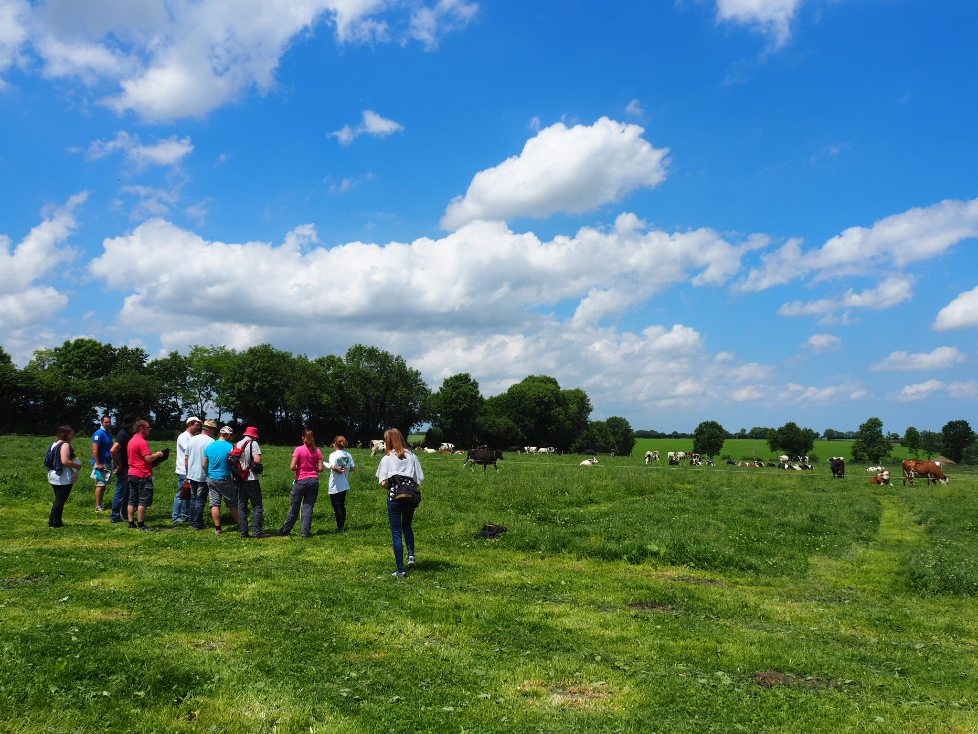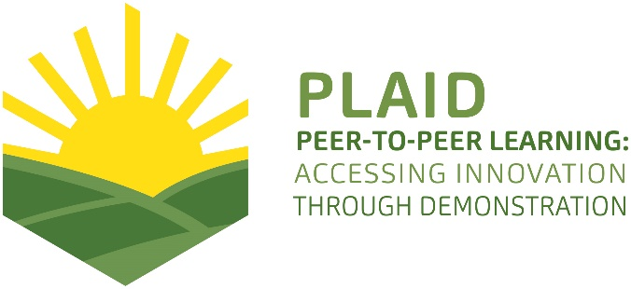

This project has received funding from the [European Union’s Horizon 2020](https://ec.europa.eu/programmes/horizon2020/) research and innovation program under Grant Agreement No 727388

PLAID PARTNERS

|  |  |  |  |
| --- | --- | --- | --- |
| [http://www.plaid-h2020.eu/sites/www.plaid-h2020.eu/files/styles/thumbnail/public/logos/LogoAdvisoryService.jpg?itok=I4li3kt3](http://www.plaid-h2020.eu/partners/advisory-service-croatia-asc)  Advisory Service Croatia ASC | [ARVALIS Institut du Vegetal image](http://www.plaid-h2020.eu/partners/arvalis-institut-du-vegetal)  ARVALIS Institut du Végétal | [Association de Coordination Technique Agricole ACTA image](http://www.plaid-h2020.eu/partners/association-de-coordination-technique-agricole-acta)  Association de Coordination Technique Agricole ACTA | |
| Institute for Rural and Regional Research | [Chambers of Agriculture image](http://www.plaid-h2020.eu/partners/chambers-agriculture-apca)  Chambers of Agriculture | [Delphy image](http://www.plaid-h2020.eu/partners/delphy)  Delphy | |
| [http://www.plaid-h2020.eu/sites/www.plaid-h2020.eu/files/styles/thumbnail/public/logos/EUFRAS_Logo_Long_7stars_bigger_europe.jpg?itok=_oilXHtY](http://www.plaid-h2020.eu/partners/european-forum-agricultural-and-rural-advisory-services-eufras)  European Forum for Agricultural and Rural Advisory Services EUFRAS | [Innovatiesteunpunt ISP](http://www.plaid-h2020.eu/partners/innovatiesteunpunt-isp)  Innovatiesteunpunt ISP | Institut de l’Elevage – Idele | |
| [Instituto Navarro De Tecnologias E Infraestructuras Agrolimentarias INTIA image](http://www.plaid-h2020.eu/partners/instituto-navarro-de-tecnologias-e-infraestructuras-agrolimentarias-intia)  Instituto Navarro De Tecnologías E Infraestructuras Agrolimentarias | [http://www.plaid-h2020.eu/sites/www.plaid-h2020.eu/files/styles/thumbnail/public/logos/LEAF_LOGO_with_text.jpg?itok=IwCrneqk](http://www.plaid-h2020.eu/partners/linking-environment-and-farming-leaf)  Linking Environment and Farming LEAF | [National Agricultural Advisory Service logo](http://www.plaid-h2020.eu/partners/national-agricultural-advisory-service-naas)  National Agricultural Advisory Service | |
| [Nodibinajums Baltic Studies Centre BSC image](http://www.plaid-h2020.eu/partners/nodibinajums-baltic-studies-centre-bsc)  Nodibinajums Baltic Studies Centre (BSC) | [Research Institute of Organic Agriculture (FIBL)](http://www.plaid-h2020.eu/partners/research-institute-organic-agriculture-fibl)  Research Institute of Organic Agriculture (FIBL) | Stichting Wageningen Research | |
| [The James Hutton Institute](http://www.plaid-h2020.eu/partners/james-hutton-institute)  The James Hutton Institute | [VINIDEA image](http://www.plaid-h2020.eu/partners/vinidea)  VINIDEA |  |

DOCUMENT SUMMARY

\_\_\_\_\_\_\_\_\_\_\_\_\_\_\_\_\_\_\_\_\_\_\_\_\_\_\_\_\_\_\_\_\_\_\_\_\_\_\_\_\_\_\_\_\_\_\_\_\_\_\_\_\_\_\_\_\_\_\_\_\_\_\_\_\_\_\_\_\_\_\_\_\_\_\_\_\_\_\_\_\_\_

**Milestone Title:** 24 Case Studies

\_\_\_\_\_\_\_\_\_\_\_\_\_\_\_\_\_\_\_\_\_\_\_\_\_\_\_\_\_\_\_\_\_\_\_\_\_\_\_\_\_\_\_\_\_\_\_\_\_\_\_\_\_\_\_\_\_\_\_\_\_\_\_\_\_\_\_\_\_\_\_\_\_\_\_\_\_\_\_\_\_\_

**Case Study Title: INOSYS-Réseaux d’Elevage (Network of livestock farms)**

\_\_\_\_\_\_\_\_\_\_\_\_\_\_\_\_\_\_\_\_\_\_\_\_\_\_\_\_\_\_\_\_\_\_\_\_\_\_\_\_\_\_\_\_\_\_\_\_\_\_\_\_\_\_\_\_\_\_\_\_\_\_\_\_\_\_\_\_\_\_\_\_\_\_\_\_\_\_\_\_\_\_

**Version:** 1

\_\_\_\_\_\_\_\_\_\_\_\_\_\_\_\_\_\_\_\_\_\_\_\_\_\_\_\_\_\_\_\_\_\_\_\_\_\_\_\_\_\_\_\_\_\_\_\_\_\_\_\_\_\_\_\_\_\_\_\_\_\_\_\_\_\_\_\_\_\_\_\_\_\_\_\_\_\_\_\_\_\_

**Task Lead:** WUR

\_\_\_\_\_\_\_\_\_\_\_\_\_\_\_\_\_\_\_\_\_\_\_\_\_\_\_\_\_\_\_\_\_\_\_\_\_\_\_\_\_\_\_\_\_\_\_\_\_\_\_\_\_\_\_\_\_\_\_\_\_\_\_\_\_\_\_\_\_\_\_\_\_\_\_\_\_\_\_\_\_\_

**Related Work package:** WP5

\_\_\_\_\_\_\_\_\_\_\_\_\_\_\_\_\_\_\_\_\_\_\_\_\_\_\_\_\_\_\_\_\_\_\_\_\_\_\_\_\_\_\_\_\_\_\_\_\_\_\_\_\_\_\_\_\_\_\_\_\_\_\_\_\_\_\_\_\_\_\_\_\_\_\_\_\_\_\_\_\_\_

**Authors:** Marina CHOLTON

\_\_\_\_\_\_\_\_\_\_\_\_\_\_\_\_\_\_\_\_\_\_\_\_\_\_\_\_\_\_\_\_\_\_\_\_\_\_\_\_\_\_\_\_\_\_\_\_\_\_\_\_\_\_\_\_\_\_\_\_\_\_\_\_\_\_\_\_\_\_\_\_\_\_\_\_\_\_\_\_\_\_

**Grant Agreement Number:** 727388

\_\_\_\_\_\_\_\_\_\_\_\_\_\_\_\_\_\_\_\_\_\_\_\_\_\_\_\_\_\_\_\_\_\_\_\_\_\_\_\_\_\_\_\_\_\_\_\_\_\_\_\_\_\_\_\_\_\_\_\_\_\_\_\_\_\_\_\_\_\_\_\_\_\_\_\_\_\_\_\_\_\_

**Project name:** PLAID

\_\_\_\_\_\_\_\_\_\_\_\_\_\_\_\_\_\_\_\_\_\_\_\_\_\_\_\_\_\_\_\_\_\_\_\_\_\_\_\_\_\_\_\_\_\_\_\_\_\_\_\_\_\_\_\_\_\_\_\_\_\_\_\_\_\_\_\_\_\_\_\_\_\_\_\_\_\_\_\_\_\_

**Start date of Project:** January 2017

\_\_\_\_\_\_\_\_\_\_\_\_\_\_\_\_\_\_\_\_\_\_\_\_\_\_\_\_\_\_\_\_\_\_\_\_\_\_\_\_\_\_\_\_\_\_\_\_\_\_\_\_\_\_\_\_\_\_\_\_\_\_\_\_\_\_\_\_\_\_\_\_\_\_\_\_\_\_\_\_\_\_

**Duration:** 30 Months

\_\_\_\_\_\_\_\_\_\_\_\_\_\_\_\_\_\_\_\_\_\_\_\_\_\_\_\_\_\_\_\_\_\_\_\_\_\_\_\_\_\_\_\_\_\_\_\_\_\_\_\_\_\_\_\_\_\_\_\_\_\_\_\_\_\_\_\_\_\_\_\_\_\_\_\_\_\_\_\_\_\_

**Project coordinator:** The James Hutton Institute

ABSTRACT

In France through the INOSYS network, which is dedicated to the development of pastoral farming, demonstration activities are jointly organized by a network composed of Farmers, the French Livestock Institute and Agricultural Chambers. Demo days are initiated through the local INOSYS program. The program is lead at regional level: each region is composed of several departments. Every year, every region organizes a demo day through the INOSYS network and the demonstration takes place in a different department. We call the "Inosys Team" the people involved in the network, they organize in the event and then ask for speakers and demonstrators. The objective of the demonstration is primarily to share ideas and knowledge on specific conditions or equipment on the farms. The farmer who opens his or her farm and presents very precise figures and information about the farm performance and organization. Practices can be connected to economic, social and environmental performance. Farmers who are here to share their lives, spend a nice moment, and discover new things in the subsector.

TABLE OF CONTENTS

[1 Demo context 6](#_Toc529979183)

[1.1 What is Inosys Réseaux d’Elevage ? 6](#_Toc529979184)

[1.2 The value chain 6](#_Toc529979185)

[1.3 Typical farm characteristics 7](#_Toc529979186)

[1.4 AKIS 7](#_Toc529979187)

[1.5 Sustainability challenges 8](#_Toc529979188)

[2 Demonstration summary 9](#_Toc529979189)

[2.1 Demo-activity in Auvergne 9](#_Toc529979190)

[2.2 Demo-activity in Bourgogne 10](#_Toc529979191)

[3 Governance: set up and organisation 10](#_Toc529979193)

[3.1 Organiser(s) and history 10](#_Toc529979194)

[3.2 Funding 11](#_Toc529979195)

[3.3 Host(s) 11](#_Toc529979196)

[3.4 Gender 12](#_Toc529979197)

[3.5 Objective(s) 12](#_Toc529979198)

[3.6 Topic(s) 13](#_Toc529979199)

[3.7 Access 14](#_Toc529979200)

[4 Demonstration event 15](#_Toc529979201)

[4.1 Visitors 15](#_Toc529979202)

[4.2 Communication & Mediation 15](#_Toc529979203)

[4.2.1 Communication 15](#_Toc529979204)

[4.2.2 Mediation 15](#_Toc529979205)

[4.3 Active participation 15](#_Toc529979206)

[4.4 Doing business 16](#_Toc529979207)

[4.5 Role of sustainability 16](#_Toc529979208)

[4.6 Unforeseen circumstances 16](#_Toc529979209)

[4.7 Plans vs. practice 16](#_Toc529979210)

[4.8 Participants feedback 16](#_Toc529979211)

[5 Motives, learning and networking 16](#_Toc529979212)

[5.1 Reasons to attend demos 16](#_Toc529979213)

[5.2 Forms of learning 17](#_Toc529979214)

[5.3 Content of learning 18](#_Toc529979215)

[5.4 Outcomes of learning 18](#_Toc529979216)

[5.5 Networking 18](#_Toc529979217)

[6 Anchoring: Application of demo lessons by participants 18](#_Toc529979218)

[6.1 Anchoring related to the present demo 18](#_Toc529979219)

[6.2 Stimulating anchoring 18](#_Toc529979220)

[6.3 Anchoring related to earlier demos 18](#_Toc529979221)

[7 Scaling: Application of demo lessons by the wider farming community 19](#_Toc529979222)

[7.1 Retrospective examples of scaling 19](#_Toc529979223)

[7.2 Prospective assessment of scaling: Impact pathways 19](#_Toc529979224)

[8 Case study reflection 19](#_Toc529979225)

[8.1 Facilitating and impeding factors for successful demonstrations 19](#_Toc529979226)

[8.2 Impact of demonstrations 20](#_Toc529979227)

[8.3 Key lessons from this case study 20](#_Toc529979228)

[9 Annexes 20](#_Toc529979229)

[9.1 Data sources 20](#_Toc529979230)

[9.2 Data collection methods 22](#_Toc529979231)

[9.2.1 Observation guide 23](#_Toc529979232)

[9.2.2 Exit Survey 25](#_Toc529979233)

[9.2.3 Farmer interview 28](#_Toc529979234)

[9.2.4 Organizer interview 29](#_Toc529979235)

[9.2.5 Farmer Focus group “Focus group” 30](#_Toc529979236)

[9.3 Les fermes de démonstrations étudiées au niveau européen 30](#_Toc529979237)

# Demo context

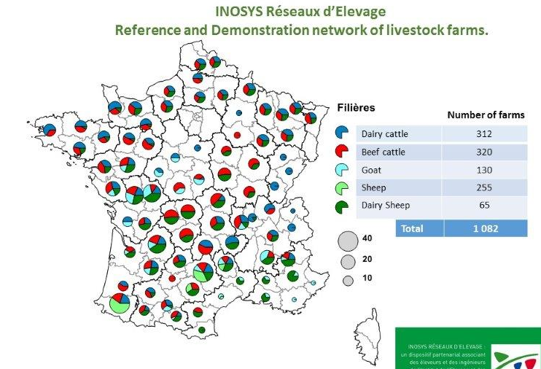The case study that has been chosen for ACTA / Idele, is a focus on demo days of the INOSYS Réseaux d’élevage. In this context, the Livestock farm networks system in France will be presented as well as the region and the sheep sectors where the demo days of the case study take place.

## What is Inosys Réseaux d’Elevage ?

In France, the Livestock Farm Networks system is dedicated to the development of pastoral farming. As they result from the historical agriculture development, these Networks can be found all over France and are organized at local level. Among them, the partnership between farmers, Chambers of Agriculture and the French Livestock Institute is really important. It uses the global approach in taking account the diversity of livestock farming regions and the study of livestock farming systems (table 1).

**Table 1 : Farms composing networks - (Source: Agreste survey structure 2007 – Metropolitan France; French Livestock Institute – Livestock Farm Networks)**

These monitoring systems took their inspiration from the experience of local development groups in which a group leader and several farmers held discussions about their practices and gave collective thought to solutions adapted to their situation.

To do this, the system is organized so as to describe farm functioning in the form of global references, expressing various possible balances and in a defined local context. The detailed and regular monitoring of farms over several years also make it possible to describe farm evolution patterns and paths of evolution which lead to new balances.

At regional level, networks are really efficient and organize jointly (farmers, French livestock institute and agricultural chambers) demonstration activities.

* **Inosys Réseaux d’Elevage as a tool for applied research**

The farm networks provide a precise knowledge of regional or national principal livestock farm systems. Based on an operational farming system classification, this panel is representative of the farming systems diversity and informs about the global evolution with which they are facing, such as enlargement of farms, adaptation to society expectations, changes in livestock management… The Farm Networks give the opportunity:

- to research and improve innovative systems with breeders,

- to carry out thematic studies on innovative practices that need to be observed or tried out in a real situation.

Finally, the technical and economic references supplied by farm networks provide a great number of information for preliminary studies to any reflection on the production trend and in particular for research necessary to define selection objectives and animal breeds schemes.

## The value chain

In the lamb sector, we can count several stakeholders, who can play different roles in a demo event:

- Farmers: organizers and / or visitors

- Advisory services of the value chain (from reproduction, health, meat production, slaughter…): roles and objectives

- Researcher: system approach, trials

- Politicians: support farm events.

- Agricultural high school: visitors, part of their studying program

- Veterinarian

- Consumers

- NGO’s

The most important actors involved in the demos are the farmers, the advisory services and the agricultural high school.

## Typical farm characteristics

Some 3,900 Auvergne farms had sheep in 2010. The regional herd had 389,000 ewes, which ranks it fifth in the country, far behind Midi-Pyrénées, but just in front of Limousin. Sheep are only present in 16% of Auvergne's farms compared with 20% in 2000. Allier is the leading sheep-producing sector in the region. In Auvergne, the sheep specialization produces a Current Income Before Taxes (RCAI) lower than the average agricultural result and the income per work unit places this Otex (technical-economic orientation) in last position. Sheep production is down, just over 9,000 tonnes. Slaughterhouse activity in the region accounts for only 17% of sheep production on farms.

In Burgundy, nearly 3000 farms raise 241100 sheep. Between 2000 and 2010, sheep production continued to decline: one-quarter of the livestock and 41% of the farms disappeared. With smaller herds than at the national level, sheep farming is often a supplemental activity for holdings with another main orientation. The cattle-sheep association, although declining, remains the most frequent. Only about sixty breeders are specialized in sheep production. The Burgundy breeding is based on the valorization of the meadows to produce mainly grass lambs.

## AKIS

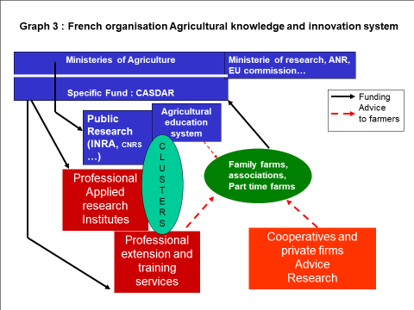The Agricultural Knowledge and Innovation System (AKIS) in France is characterized by public investments at a national scale in various research and education organizations, and by arrangements and contracting with farmers associations, non-profit organizations and private actors for advisory services and applied research (P. Labarthe, 2014)

The organization of the French AKIS can also be extended to regional scale. At regional scale (for our case study, Auvergne Rhone Alpes region), we encounter the same organization, except for the funding that can differ depending on how much the region supports networks.

Each year, farm networks realize farm demonstration activities for regional farmers, in order to demonstrate innovative, or interesting farming practices, systems and performances. For the case study we will focus on the meat sheep network in the region “Auvergne – Rhône Alpes” and “Burgondy”

**Figure 1 French AKIS**

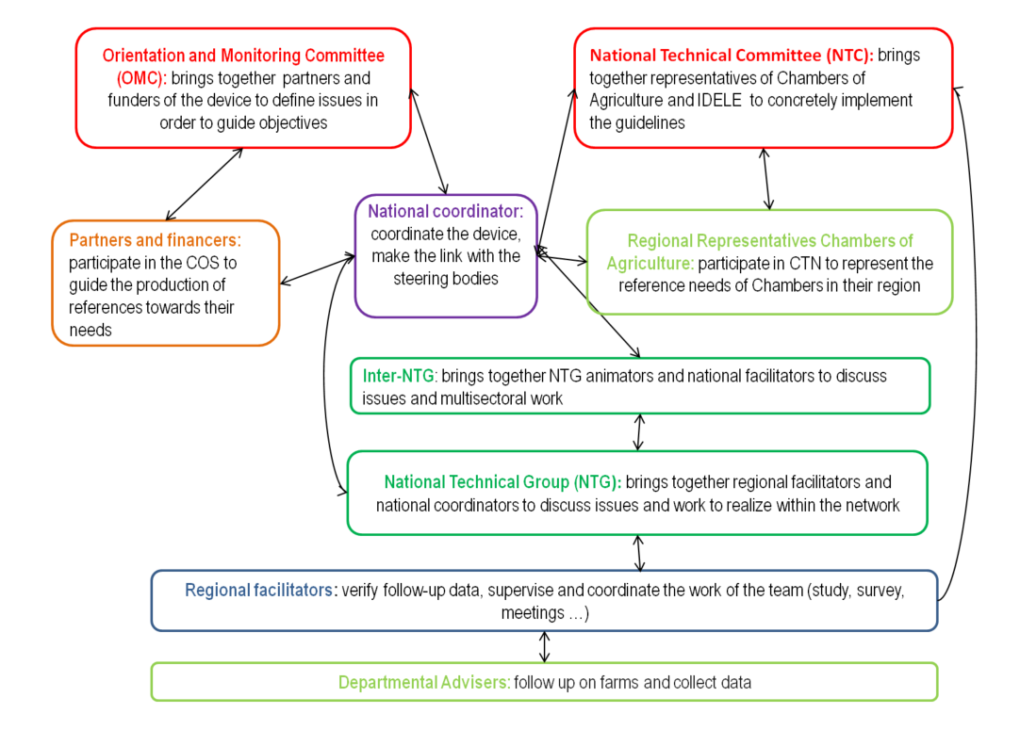The specific “INOSYS” AKIS: an organization within the network.

**Figure 2 : INOSYS Akis**

## Sustainability challenges

In France, since the 90’s, the number of sheep meat producers has declined by 50% in term of farm number and livestock. In comparison, the sheep milk production is constant even if the number of farm is decreasing.

Sheep farming plays a key social, economic and environmental role in many “less favored areas”. These decreasing trends are a worrying constraint for the sustainable development of these areas (Sheepnet project).

One of the main challenge that the sheep sector has to face, is the farmer aging. In fact, more than 63% of the meat sheep farmers and more than 39 % of the dairy sheep farmers are more than 50 years.

In that context, the sheep networks is active and trying to restore the sheep farming reputation by organizing event to promote it by showing all the benefit aspects (economical, agronomical, zootechnical, environmental ones).

# Demonstration summary

Within the INOSYS réseau d’élevage, each year some of the farms (50 to 100) open their doors to regional farmers, in order to demonstrate innovative, or interesting farming practices, systems and performances.

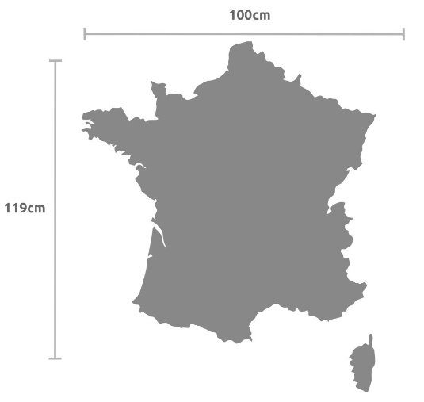The case study focuses on two demo days organized in two different locations. The cases provide two interesting examples of co-organization of Demo activities between farmers, and advisers. The farm network is rather old and well-structured but farms change on a regular bases. Each farm is very well documented with precise and up to date information regarding all the sustainability issues.

Romagnat (Auvergne)

Achun (Bourgogne)

## Demo-activity in Auvergne

This demo day has been organized in the center of France, in Thomas Farm close to Clermont-Ferrand (Romagnat). The targeted visitors are agricultural students and potential new entrants.

The main objectives is to show that sheep sector is still active and can create employment. It’s an opportunity to present all the stakeholders involved in the meat sheep sectors, and to demonstrate that this sector can innovate. The demo activity took place in March 2018, during a whole day (see agenda and organization on figure 3 below).

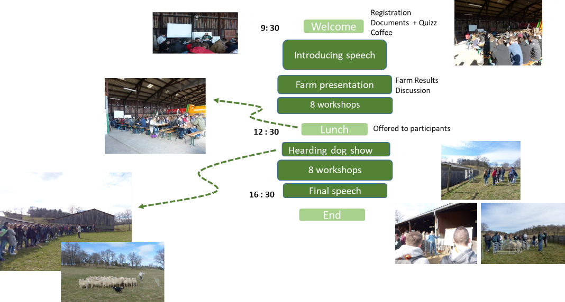**Figure 3 : Agenda and organisation**

## Demo-activity in Bourgogne

## This demo day has been organized in Bourgogne, Samuel Farm close to Nevers. The objective of the demonstration is primarily to share ideas and knowledge on specific practices or equipment introduced on the farm, and to share experiences regarding the specific problems faced on farms. The farmer who opens his farm also presents very precise figures and information about the farm performances and organization. Practices can be connected to economic, social and environmental performances. In that case, the demonstration activity is untitled “Work serenely with ewes”.

The targeted visitors are sheep farmers and advisers. The demo activity took place in September 2018 on a Thursday afternoon. The afternoon was composed of 7 workshops leaded by various actors from meat sheep sector (see agenda and organization on figure 5 below).

**Figure 4 : Agenda**

# Governance: set up and organisation

## Organiser(s) and history

Demonstration activities are jointly organized by a network composed of Farmers, the French Livestock Institute and Agricultural Chambers. It’s part of the INOSYS réseau d’Elevage. The two demo days were initiated through the local INOSYS program (Auvergne and Bourgogne). The program is lead at regional level: each region is composed of several department. Every year, each region organizes a demo day through the INOSYS network and the demonstration activity takes place in a different department. We call the “Inosys Team” the people involved all the year within the network, they organize in depth the event and then ask for speakers and demonstrators. Only one demo day will be explain in detail (the one in Bourgogne) to explain the INOSYS demo activity organization.

In the case of the demonstration in the Burgundy region, this year the demo day is in the Nièvre (58).

* Christophe Rainon : he is an advisor from “Chambre d ’agriculture” which coordinates the event in the Nièvre department:

His role? To select a farm for the event, organize all the logistical aspects during the event, organize meeting in advance the event with speakers, advisors, host farmer, demonstrator of equipment in order to create the demo topics and clarify the demo objectives

During the demo event, he presented the farm through the focus “assessment after one year of installation”.

* Lucie Legroux: she is a project manager at the regional Agricultural Chamber and she is also in charge of the INOSYS demo event for the region. She’s working a lot with Christophe to support him. She’s responsible for writing financial request, sending invitation and printing event brochure. During the event, her role is to ensure the political aspect of the event and discuss with representatives from diverse farmer association.

These two people with 9 others people (one per department) compose the INSOSYS team. Around them, other people from diverse sectors help during the event by running workshops: health insurance, meat production, equipment demonstrator …. They are involved within the department as livestock stakeholder.

Since the beginning of this INOSYS program, organizers observed on their department several farm management practice changes:

## Funding

In both demo days the funding is the same. The funding of the demo comes from several sources. The main one is the FEADER, a European funding. As the Livestock network is supported by two organizations (IDELE and APCA), they also contribute to funding activities including demo activities. The region also participates into the financial balance.

Stand holders contribute by giving their time to the event and also preparing what they will say. No contribution from visitors are expected.

The event is organized by the INOSYS network, so the host farm is supposed to belong to it. In Burgundy, the host is not into the network but really involved in the agricultural territory. No relevant influence from the funding to topic.

## Host(s)

The host in both demo event are detailed on the table:

Tableau 1: Host farmers in the two demo events

|  |  |  |
| --- | --- | --- |
|  | Yoan Thomas Farm  (AUVERG NE) | Samuel Delobbe Farm  (BOURGOGNE)  C:\Users\cholton_m\Documents\Marina\1.[PLAID]\1.1 Meetings\6. Pan European meeting\pohtoo\20181010_163554.jpg |
| Farm type | C:\Users\cholton_m\Documents\Marina\1.[PLAID]\1.0 Admin\0.2 Photos\Photo PLAID\Case_study\P1000662.JPGCommercial | Commercial |
| Farming system | Conventional | Organic + conventional |
| Farm description | On permanent grassland (106Ha), Yoan decided to dedicate all his time farming his 500 ewes organically.  Its farm is located on the heights of Clermont-Ferrand. A peri-urban situation where land pressure is felt everywhere, Yoan considers himself lucky. | In 2017, Samuel took over his father farm after working more than 10 years for a livestock salesman. His farm (70ha) is a mixed farm: 500 ewes “Ile de France” and “25 pigs; The pig production is sell through short supply chain. He also produce cereals every year (28ha). |
| Why this farm was chosen to host? | The farm has a huge potential, it’s not a common story. The farm was a former experimental farm turn into a commercial farm. The story of Thomas who was before employed by the INRA[[1]](#footnote-1) experimental farm Is interesting. The buildings and the herd management is pretty innovative. | The farm is well known in the region due to M. Delobbe senior’s reputation, Samuel father.  Samuel is turning the sheep farm into a mixed farm with organic pigs. Samuel is a new entrant.  The farm has been chosen for the strategic changes in herding practice. |
| You say good farmer? | Thomas is a young and active farmer. He’s well known in the area for his good farm results and his openness. | Samuel is a young and active farmer. The farm in itself is known in the area because of his father reputation. |
| Farmer’s involvement | Yoan Thomas is part of the Inosys livestock network. While working for INRA, he was already in touch with the network. It is therefore natural that he continued to work with the network when he took over the farm. He organizes events on his farm when asked. For him, making himself available for organized activities on his farm is essential: "I was lucky to be able to settle on this farm, I want to help". Although he does not perceive any financial advantage, it is the highlight of his work on the farm and his desire to share his job that motivates him. | Samuel Delobbe doesn’t belong to the INOSYS Réseaux d’élevage. But as soon as Christophe (department advisor) contacted him, he took the opportunity to exchange and discuss with farmers from nearest department.  As a new entrant, Samuel was really pleased to have the help of how to redesign his buildings and also how to turn his farm into organic agriculture.  Jointly with INOSYS team, they decided the appropriate demonstration topics. |

## Gender

Men and women are both involved in the demonstration as organisers (organising some work shop). In Auvergne, the main organizers at regional and departmental level are women.

Both farms were hold by a young men (around 35 years old). Their wife work outside the farm, but one of them would like to settle with her husband in the following months (Auvergne).

## Objective(s)

The objective of the demonstration is primarily to share ideas and knowledge on specific practices or equipment introduced on the farms, to share experiences regarding the specific problems faced on farms. The farmer who opens his or her farm also presents very precise figures and information about the farm performances and organisation. Practices can be connected to economic, social and environmental performances.

In Bourgogne:

The Main objectives for the event coordinator is:

* To create an event where all sheep farmers from the region can exchange, talk and meet (1 sheep event every 4 years in the area!)
* To spread technical messages.
* to use the farm as a “showcase” for the sheep production
* To present all the stakeholders involved in the sheep sector I the department in order to help them

Among the different people participating in the demo event organisation, we also notice varied objectives such as promoting the company and competences that can help farmers

The horst farmer objectives are quite the same than the organiser, for him, hosting this event is mainly to have some technical feedback on his practices, and advices on how to change his practices. He also want to share and exchange with farmers.

In Auvergne, the main objective was to show to students that the which stakeholders are involved in the sector, what can they do for them,

The case provides an interesting example of co-organisation of Demo activities between farmers, and advisers. The farm network is rather old and well-structured but farms change on a regular bases. The case study focus on two new farm on the network.

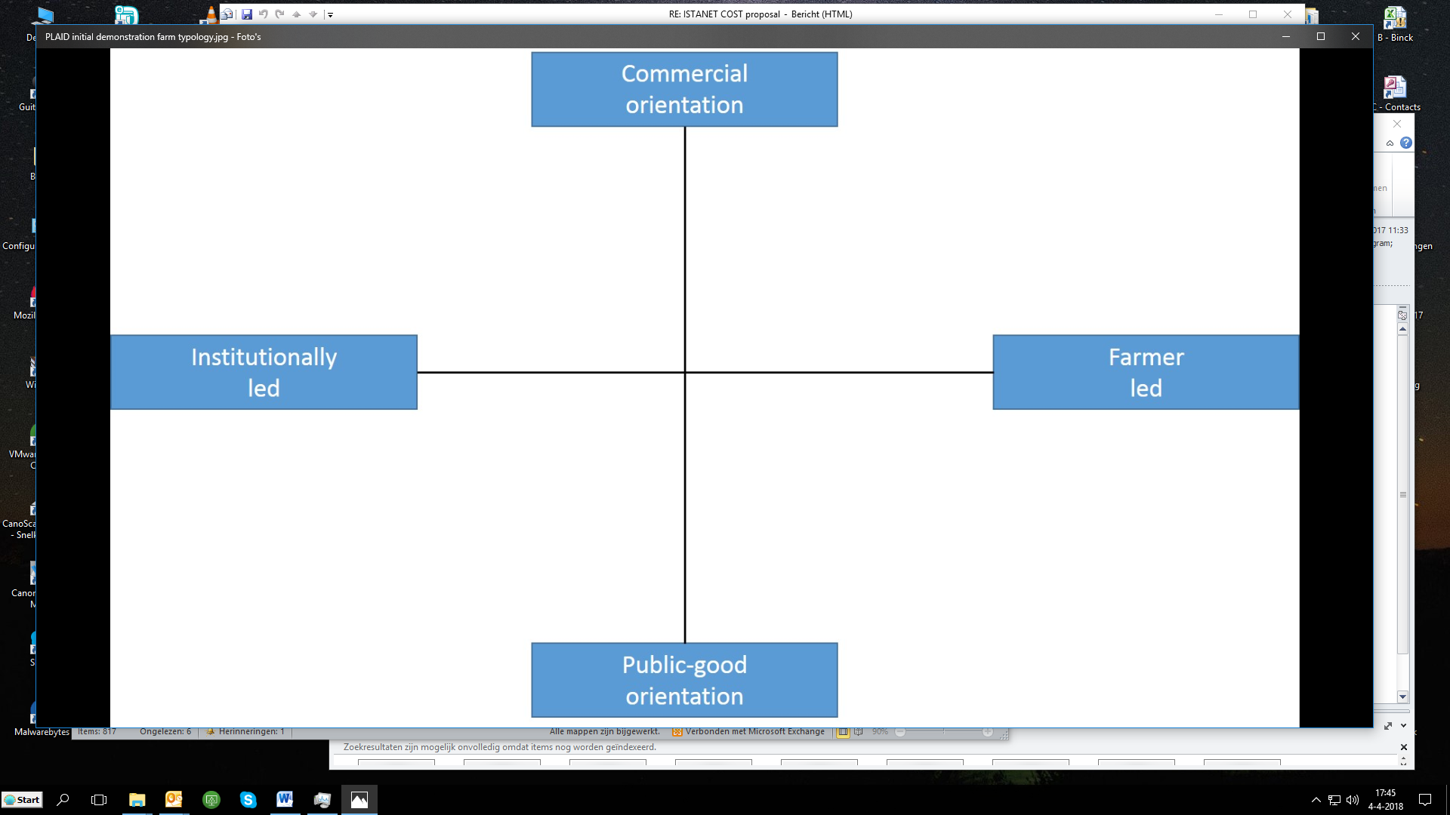

FR

## Topic(s)

According to the main objectives of the two demo days, the topics where very specific regarding the sheep production and all the different aspects. If we focus on the Bourgogne Demo Day, here are the topics who were approached through workshop on the main topic “Work serenely with ewes”:

- Preserve your health with a contention barriers

- Rebuild old buildings to work more easily

- Help the heard monitoring with OVITEL / OVICLIC

- Get replaced

- Set up a farm project

- Redesign the farm project to be self sufficient

The topic were very concreate on how to improve the farmer health conditions. These topics were chosen according to Samuel ideas and organizers competences f

For the demo event in Auvergne, the topics were selected to be as varied as they can in order to present sheep production to students.

## Access

These demo day’s targeted farmers, new entrants, students. In Bourgogne, the targeted audience is mainly farmers, but in fact they reached a lot of students as well. To increase event accessibility, INOSYS Team gave in advance the event date, and made a video presenting the event.

In Auvergne, the targeted audience is students. To increase the demo accessibility, the organization team created the event for the students, so workshops were very practical and teacher played the guided tour role.

# Demonstration event

To be more specific and to focus on one event, this part and the following ones will talk about the demo event in Bourgogne.

## Visitors

Among the visitors, two different targets have been identified:

Farmers and stakeholders from meat sheep sectors

Around 87 visitors attended, among them 59 farmers (30 % girls), 32 advisors or stakeholders (50 % girls)

Agricultural high school

4 high school came with 110 students and 7 teachers

Organizers were quite happy about the farmer number and also the student number (because for them, it’s really important to involve them in this kind of event) even if they didn’t expect that high school would bring so many pupils.

## Communication & Mediation

### Communication

Communication about the demo event has been made in advance through the INOSYS network. A flyer was presenting the event, and a video online was presenting the host farmer. It has been made in order to attract farmers, especially the new entrants. The event has been also disseminated through regional press and technical magazine (Pâtre).

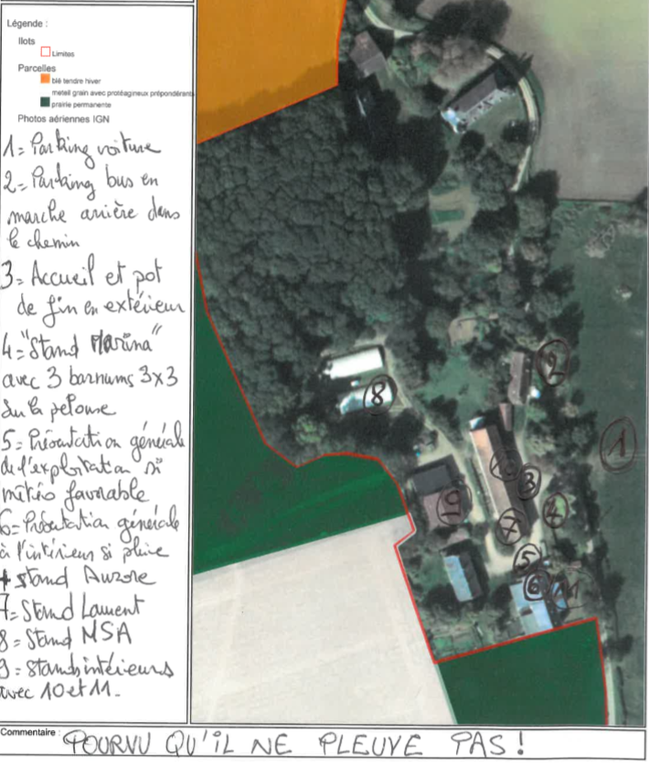On the event, posters were made with farm results. A brochure has been realized and given to visitors. This brochure was a summary of composed of all the technical references presented during the event.

Figure 5: workshop organisation on farm

### Mediation

Workshops were organised around the farm outdoor and indoor (see plan – figure 5).

Most of the workshops were running by one speaker. Lectures were carried out by advisors from advice services.

## Active participation

At the beginning, visitors were invited to listen to the global farm presentation. At the end of this presentation, they were free to choose the workshop they wanted to participate and interact with the speaker (and the farmer in one workshop). Most of the visitors played an active role during workshop by asking questions. Many farmers were discussing about what they’ve seen in small group. As some visitors were students, this visitor type was less active and had more a passive attitude.

To conclude, in most of the workshop visitors were listening and asking questions. Only in workshop more theoretical, visitors had a passive attitude.

## Doing business

At the end of the different workshops and during the “drink”, visitors can discuss with demonstrator, speaker and other visitors. They weren’t doing any business but it’s more to know the stakeholder and how they can help them (advice) in their farm activities.

## Role of sustainability

Sustainability underlies the demo activity with a “systemic view” including social, environmental and economic aspects. During the demo, visitors were actively confronted with sustainability aspect especially during the workshop “Redesign the farm project to be self-sufficient”.

## Unforeseen circumstances

Organizers were really happy about the numbers of farmers who visited the demo. But they didn’t anticipated the student number... They didn’t know that so many agricultural high schools will come with students. So that 4 high school came with 110 students and 7 teachers. This huge number of student was quite difficult to organise with workshops.

## Plans vs. practice

According to the planned set up in both demo event, they were expecting nice weather, and they had it. What didn’t work that much in Bourgogne was the participants flow through the workshop. It was such a warm weather for end of September, and the organization team didn’t anticipated this. It was a problem because there wasn’t drinkable water on site

## Participants feedback

In general terms, participants were really happy to come mainly for some workshop subjects or to exchange with sheep farmer community. The critical points were the same which are written on 4.7 and 4.6, they gave feedback on the student numbers and the water problems. They also discussed on the project to redesign the buildings and asked. Some were disappointed regarding the absence of animals: the animals were on fields.

# Motives, learning and networking

This section discusses some of the farmer motivations to attend an INOSYS demo event. It includes individual, social and rational factors. These factors are mainly related to participants’ topic interests. Some visitors will be help to describe these factors. This feedback has been made with exit questionnaires.

## Reasons to attend demos

**Attitudes and perceptions**

The mainly reason visitors attended the demo are:

* Demo Content: the interest for the topics, usually one interesting topic is enough to attend the demo in order to have ideas
* Social link: Opportunity to meet sheep farmers and sheep sector stakeholders.
* INOSYS event quality: organisation, speakers, demonstrators,
* Farm interest: non sheep farmer who want to create a new activity on farm and collect information, ideas ….
* The location

**Norms**

Knowing people attending the demo event is a very strong lever to come to the demo event. Also, the farm reputation and the fact that Samuel belongs to the organic agriculture association in the department make his farm “interesting to visit.

**Practicalities**

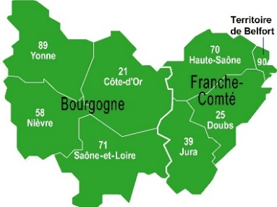As it’s explained on section 3.1, INOSYS réseau d’élevage is running at regional scale. Event on sheep production are once every 4 years at department scale: so that, the event attract many farmers.

|  |  |
| --- | --- |
| Distance | % of visitors |
| Less than one hour ride | 28 % |
| In between one hour to two hour ride | 47 % |
| More than 2 hour ride | 23 % |

Looking at the data concerning the distance, most of the visitors drove in between one hour to two hours to attend the event. Most of them shared a ride with neighbours. It proofs that the meeting is closed to the farmer needs and the format (one afternoon) was convenient for them to attend the meeting event if they were living quite far. Most of the visitors answered that they attend 3-4 event a year.

## Forms of learning

Lectures and workshops were offered at the demo. Organizer didn’t use any mediation techniques: Each speakers were presenting the topic through different formats such as poster presentation, material demonstration, explaining, and flipchart to list ideas. Visitors were actively engaged through questions related to their own practices (especially in the workshop “be replaced”) and the questions asked at the end of workshops. Participants took pictures and some come to ask questions to the speaker at the end.

Before the demo, different formats were discussed, the final decision was to let visitors chose their own workshops to attend. At the end of the workshop they were supposed to go to another one. In fact, it didn’t work well due to the time keeping that has not been made.

Demo event was also based on discussion, a dedicated time at the end of the demo around a drink allowed visitors to exchange. Informal discussions on topics and farm practices were observed a lot.

Learning style in the demo event was based on verbal and physical styles (especially when Samuel, the host farmer was explaining his organic project).

From the demo, visitors could compare their own practices to the own that were presented.

## Content of learning

The learning content depends on the workshops. The information is specific to each topics and related to the demo farm. All the workshops were discussing on how to redesign the farm: turn the farm into an organic one, adapt the old buildings, and use a contention corridor to avoid pain. Except the “set up a farm project” topic, visitors considered that all the information were ready to use and that they can applied it on their farms. The “set up a farm project” topic was considered to academic for farmers.

## Outcomes of learning

Attending a demo day where new practices on farm are demonstrate, is the best way for a farmer to start a reflexion on his own practices. And also to remember some tips to use on his own sheep herd.

## Networking

During INOSYS event, farmers have social interaction. These interactions are described by farmers as a great opportunity to exchange on farm practices at different levels. The first level is focus on peer to peer exchange between farmers which can be only social exchange or technical exchange on farm practices. The second one, is the social interaction with other stakeholders to exchange on their farming activity. .

# Anchoring: Application of demo lessons by participants

## Anchoring related to the present demo

In the case of this INOSYS event in Bourgogne, if you asked visitors “Did you see something today”, “will you apply it on your farm”, most of them would answered “yes” with different reasons. Some were interested in keeping contact with demonstrators, others had an overview of a sheep farm in order to develop their sheep activity. The key point of interest from this journey relates to explanation on how to redesign old buildings, and also how to work with contention corridors.

## Stimulating anchoring

To stimulate anchoring the organization team decided to create the brochure that has been given at the beginning of the demo event. Farmers told us that they use it usually later on, when they are looking for information related to what they’ve seen. A video and also information on the web are available for visitors and also for the ones who couldn’t attend. There is no specific follow-on activity according to this event, but as the network organise once a year a demo event, the next year another one will happen.

## Anchoring related to earlier demos

From former demo event among the INOSYS sheep production network, farmers already applied things and advices they’ve seen in another event such as

From former demo event through the network, farmers already applied things and advices they’ve seen in another event such as practices on sheep health management. One previous topic was focus on “sheep health management”, many farmers applied what they’ve seen on “how to prevent diseases” and gave now to lambs white vinegar with water. Organizers told us, that during the previous event, one farmer was measuring the space between the headlocks in a buildings instead of attending to the workshops. He applied what he measured in his own farm in the following months.

So the informal exchange, and also the informal information that visitors can collect during a demo day is also taking part of the learning and the anchoring process.

# Scaling: Application of demo lessons by the wider farming community

## Retrospective examples of scaling

In recent years, demo activities in sheep sector allowed to improve the equipment of sheep farm. Farmers used to work with old buildings where it was alsmot impossible to work without pain from animals : they used to feed animals by entering the flock, receiving head shots in the knees. This practice was not at all safe for the farmer health. Through open door, demonstration activities, within or not the network, stakeholders demonstrated to farmers the interest of headlock equipement in buildings.

Nowadays, most of the sheep farms in Bourgogne region changed their equipment and equipped their farms with headlock. The innovation in the region now, is to invest in contention corridor.

Demonstration and stakeholders involved in the sheep sector help the scaling and anchoring of innovation.

## Prospective assessment of scaling: Impact pathways

The event has been promoted through agricultural press, it was more about promoting the event on the form than in the content. At the end of this demo day, people receive pages about what they’ve seen.

# Case study reflection

## Facilitating and impeding factors for successful demonstrations

The demonstration in Bourgogne was a successful demonstration. Visitor number,

Some improvements have been identified and will be discuss in that section.

Inputs: The infrastructure was very convenient and easy to walk around. The weather help a lot with that feeling. To receive groups, the farm will have to be equipped with toilets. The demonstration received enough funds and human resources: many stakeholder were involved and they were really motivated to be there.

Access: the site was well indicated.

Regarding the demonstration process: the content was much applied, but can be more specific to the farmer targets. Some workshops were more “theoretical”. One advice can be to not mix the different target: student and farmer. Interactions within visitors and speakers could have been better with smaller groups. The end drink with food was very appreciated by visitors, it’s a dedicated time for informal discussion.

## Impact of demonstrations

To achieve maximum impact, it would be nice if organizers pay attention in the future to these following points:

* Team building within the demo day organization team is very important to create cohesion. The more the organisation team is linked, the better is the demonstration organization, and even if there’re unforeseen circumstances, participants won’t notice it.
* Involve as soon as possible the host farmer in the organisation during the demo-activity.
* Discuss with host farmer in advance to select and identify subject that can deserve the farm. Hosting a demo, is not only giving a place to organise a demonstration, but it has to be as well a sort of improvement for the farm. The host farmer is willing to have advices on how to improve his practices
* After the demonstration, organise a meeting with farmers involved in the demo to discuss with them the impact.

## Key lessons from this case study

Farmers who come to demonstration activity are here to exchange, spend a nice moment, and discover new things in the subsector. They don’t have that much possibility to meet and exchange when they are working. Especially on this sheep production, event are not that often in the department. So that, time for discussion is really precious, and if workshops are organised they should be very concrete and interactive.

**Acknowledgements**

We would like to thanks all the INOSYS team of Burgundy and Auvergne which provided us information and let us attend the organization meetings. We really appreciated the fact that they considered us as support and a help during events. We also would like to thanks the farmers, advisors, student, teacher and sheep sector stakeholders who participated at the demo days and answered questions.

A special thanks to the Lycée agricole de Moulins (du Bourbonnais) for the focus group realized with students and their teacher: Pauline PERNOLLET.

# Annexes

## Data sources

* **Report :**

L. Madeline, IDELE, The French livestock farm network, March 2010

G. Servière and al., IDELE, Livestock Farm Networks, a system at the center of French farming development, March 2014

Labarthe, P. (2014): AKIS and advisory services in France. Report for the AKIS inventory (WP3) of the PRO AKIS project. Online resource: www.proakis.eu/publicationsandevents/pubs

Agreste survey structure 2007 – Metropolitan France; French Livestock Institute – Livestock Farm Networks)

Plaquette inosys ovin 2017

2 documents de Bourgogne et

* **Website :**

Inn’ovin website, Site des partenaires de la production ovine en France, La filière ovine : <http://www.inn-ovin.fr/filieres-et-metiers/la-filiere-ovine/>

IDELE website, Ovin viande : <http://idele.fr/filieres/ovin-viande.html>

Sheepnet website, european network exchange : <http://sheepnet.network/>

* **Information briefs on the demo**

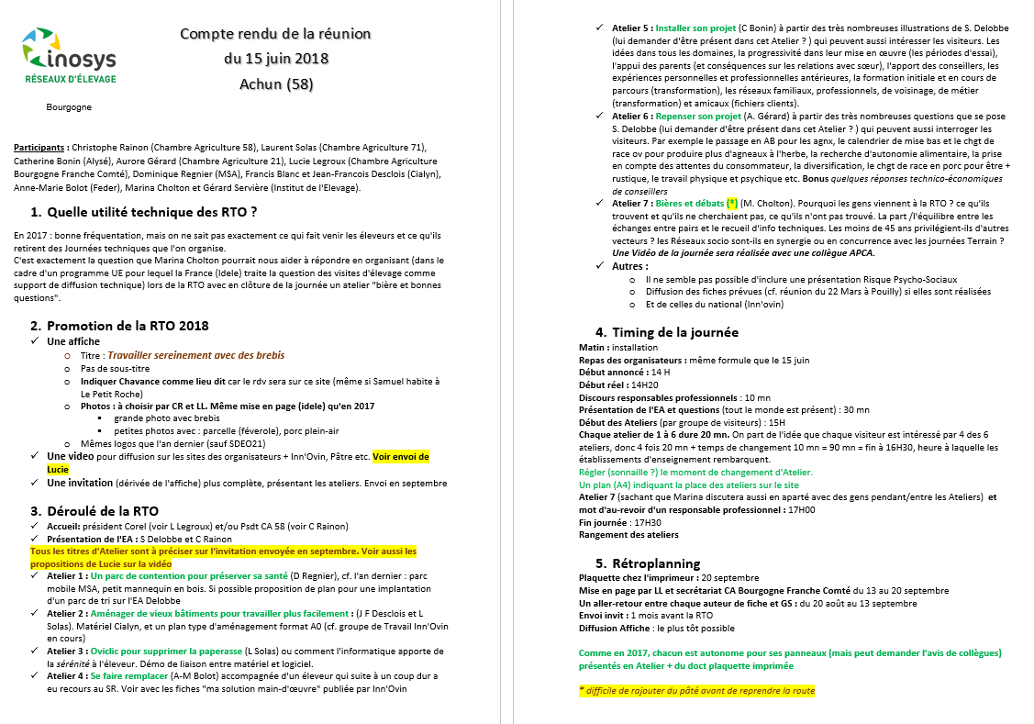

**Activities visited**

* Rencontre régionale ovine, Achun (Nièvre) on the 27th September 2018
* Journée de découverte ovine, Romagnat (Puy de dome) on the 08th March 2018

**People interviewed**

This is a not exhaustive list, on the first demo event, we interviewed 9 organizer but we keep it anonymous.

Samuel Delobbe (FARMER)

Yoan Thomas (FARMER)

Gérard Servières (Project coordinator IDELE)

Christophe Rainon (Advisor, chamber d’agriculture de la nièvre )

Lucie Legroux (project coordinator, chambre régionale Bourgogne Franche Comté)

Laurent Solas (Chambre d’griculture Soane et Loire),

Dominique Regnier (Health Advisor, MSA),

Catherine Bonin (Advisor, Alysé),

Aurore Gérard (Chambre Agriculture

Dominique Regnier (MSA),

Francis Blanc, Jean-Francois Desclois (Meat consultant, Cialyn),

Students from “Lycée agricole du Bourbonnais”

Students from “lycée agricole de Précieux)

Pauline Pernollet (Teacher, Lycée agricole du Bourbonnais)

Pascale Sabatier (Teacher, lycée agricole de Précieux)

## Data collection methods

**Before the demo event**, we collected information about the objectives and organisation of the demo through an interview. We also participated to an organization meeting where we asked questions to organizers. We also had interviews by phone call with the farmer (to better know him).

**During demo event,** we observed the demo event through an observation guide to answer the demonstration event part.

We realized exit survey and mini focus group with farmers to identify the motives, learning and networking part.

**After demo event,** we called back the organizers to give them a feedback with our external point of view and collected their own feedback

### Observation guide





### Exit Survey

**Journée régionale technique ovine : enquête de satisfaction**

1. **Comment avez-vous entendu parler de cette journée ?**
2. **Avez-vous déjà participé à une journée technique régionale ovine ?**

Oui

Non

**3.** **Pourquoi avez-vous décidé de participer à cette journée ?**

Intérêt pour la ferme à visiter

Intérêt pour la thématique de la journée

Opportunité de rencontrer les différents acteurs de la filière ovine

Lien social : rencontre d’autres éleveurs

Autres (à préciser)

1. **Combien de fois assister vous à ce type d’évènements ?**

Moins d’une fois par an

Une à deux fois par an

3-4 fois par an

5-6 fois par an

Plus de 6 fois par an

Aucune idée

1. **Enquête de satisfaction de cette journée au global (1 – pas du tout satisfait, 5 – très satisfait)**

|  |  |  |  |  |  |
| --- | --- | --- | --- | --- | --- |
| Lieu de l’évènement | 1 | 2 | 3 | 4 | 5 |
| Pertinence des thèmes abordés / contenus | 1 | 2 | 3 | 4 | 5 |
| Pertinence des intervenants | 1 | 2 | 3 | 4 | 5 |
| Mode de présentation (audible, compréhensible…) | 1 | 2 | 3 | 4 | 5 |

* Quel atelier vous a le plus plu  ?

Pourquoi ?

|  |  |  |  |
| --- | --- | --- | --- |
| Thème intéressant |  | Support adapté |  |
| Clair |  | Interactif |  |
|  |  | Autre |  |
| Intervenant pertinent |  |  |  |

* Quel atelier vous le moins plu ?

Pourquoi ?

|  |  |  |  |
| --- | --- | --- | --- |
| Thème pas intéressant |  | Support pas/mal adapté |  |
| Manque de clarté |  | Pas assez d'interaction |  |
| Trop de monde |  | Autre |  |
| Intervenant peu pertinent |  |  |  |

**6.** **Avez-vous prévu d’appliquer sur votre exploitation et/ou dans votre travail  ce que vous avez vu aujourd’hui ?**

Non

Oui, peut être

Oui

et si oui comment ?

**Qu’est-ce qui vous semble intéressant ?**

1. **Si cette journée été à refaire, quelles suggestions pour les organisateurs ?**
2. **Quel Age avez-vous ?**

\_\_\_\_\_\_\_\_\_\_\_\_\_ Ans

1. **Etes-vous ?**

Eleveur / enseignants

Conseiller / élèves / autres :

1. **Votre niveau d’étude :**
2. **. Combien de temps avez-vous mis pour venir à l’évènement ?**

\_\_\_\_\_\_\_\_ Heures\_\_\_\_\_\_\_\_\_\_ minutes

1. **De quel département venez-vous ?**

|  |  |  |  |  |
| --- | --- | --- | --- | --- |
| Allier |  |  | Saône et Loire |  |
| Nièvre |  |  | Yonne |  |
| Côte d’or |  |  | Autres |  |

**Questions pour les éleveurs :**

1. **Quel type d’exploitation ?**
2. **Depuis combien de temps faites-vous ce métier ?**

\_\_\_\_\_\_\_\_ Années

1. **Serez-vous intéressés pour être rappelé dans 2- 3 semaines pour discuter avec vous si votre projet à évoluer ?** Oui – Non

### Farmer interview



### Organizer interview



### Farmer Focus group “Focus group”

**Café-débat - Comment intéresser davantage les éleveurs aux actions collectives ?**

*Marina Cholton, Amandine Menet – institut de l’élevage*

[marina.cholton@idele.fr](mailto:marina.cholton@idele.fr) ; amandine.menet@idele.fr

*Mélanie Gracieux – APCA*

melanie.gracieux@apca.chambagri.fr

Les activités de démonstration sont des journées/moments/temps permettant aux acteurs du monde agricole d’échanger et de partager des connaissances, des innovations. Mais qu’en retiennent les éleveurs et comment les intéresser d’avantage à ce type d’évènements ? Telle est la question que nous allons vous poser au Café Débat !

## Les fermes de démonstrations étudiées au niveau européen

Dans le cadre du projet européen PLAID ((Peer to peer learning  accessing innovation through demonstration : <http://www.plaid-h2020.eu/> ), conçu pour encourager les agriculteurs et les salariés à adopter les innovations grâce à des activités de démonstration, l’institut de l’élevage en partenariat avec l’APCA se propose d’étudier et d’analyser certaines d’entre elles.

On entend par activités de démonstration toutes actions (réunion, porte ouverte, journée technique…) qui permettent un échange de connaissances entre agriculteurs sur une thématique précise, une innovation… Les activités de démonstrations sont perçues par les agriculteurs, les conseillers, les chercheurs et les membres du secteur agricole comme des opportunités précieuses pour cet échange de connaissances, cette découverte des innovations mais également pour l’entretien du lien social.

**La rencontre régionale technique ovine comme support d’étude**

Dans le cadre du réseau INOSYS, de nombreuses rencontres sont organisées, la rencontre technique ovine du 27 Septembre est utilisée comme sujet d’étude. Le but ? Identifier et comprendre les objectifs d’une telle journée du point de vue des différents organisateurs et de les mettre en parallèle avec ceux des participants/visiteurs en les questionnant sur ce qu’ils retiennent de l’évènement. Tout cela nous permettra de proposer des pistes d’amélioration pour une activité de démonstration de ce type.

**Un café débat pour échanger sur les besoins et attentes des éleveurs**

Le café débat est un lieu de discussion et d’échange en petits groupes d’éleveurs pour cerner au mieux les attentes et besoins afin d’améliorer la qualité de cette journée et mobiliser d’avantages les éleveurs.

**Exemple de questions :** Pourquoi êtes-vous venu à cette journée ? Que recherchez-vous dans ce type de journée ? En quoi cela à fait écho à votre propre pratique ? Que pensez remobiliser sur vos exploitations ? Pensez-vous parlé de cette journée autour de vous ? Si oui, à qui ?

1. National institute for agricultural research [↑](#footnote-ref-1)