Date: November 2018

Country report: Spain

Case Study: ES2 Organic cow cheese production

WP5: Case studies of demonstration activities in commercial farms

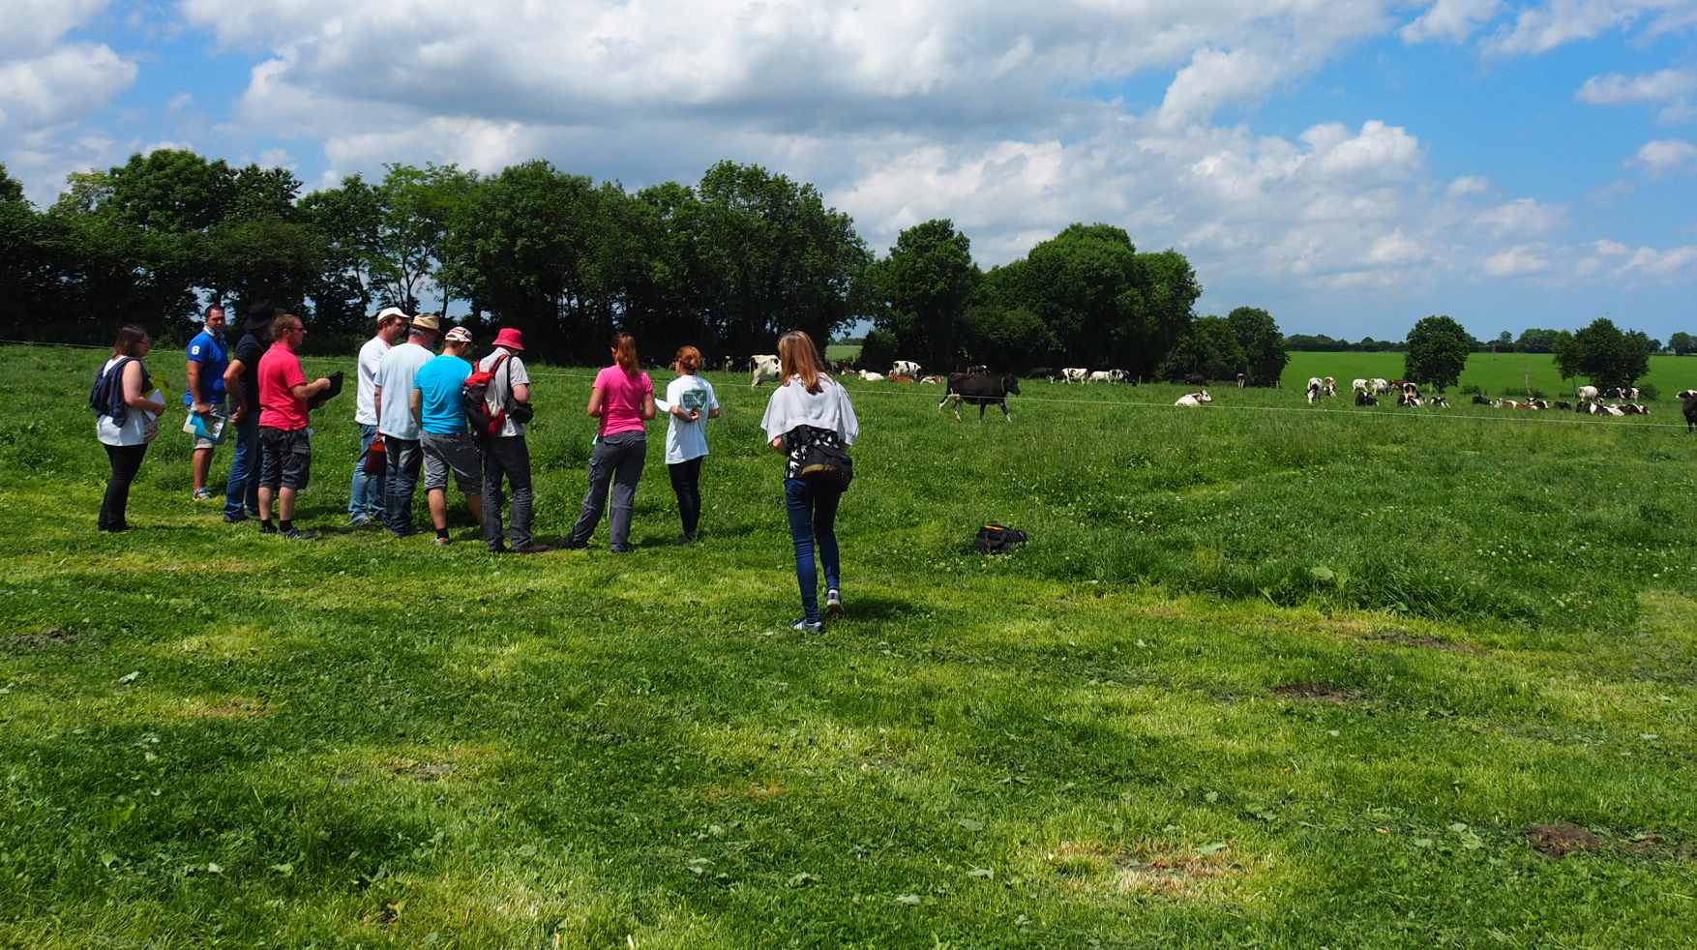
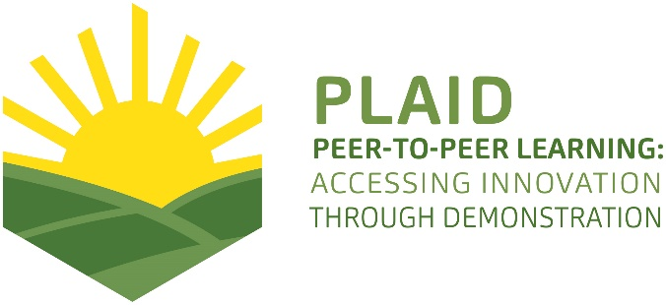
This project has received funding from the European Union’s Horizon 2020 research and innovation programme under Grant Agreement No 727388.
This project has received funding from the European Union’s Horizon 2020 research and innovation program under Grant Agreement No 727388

PLAID PARTNERS

Advisory Service Croatia ASC | 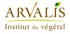  ARVALIS Institut du Végétal | Association de Coordination Technique Agricole ACTA
Institute for Rural and Regional Research | 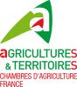  Chambers of Agriculture | Delphy
European Forum for Agricultural and Rural Advisory Services EUFRAS | Innovatiesteunpunt ISP | 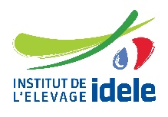  Institut de l’Elevage – Idele
Instituto Navarro de Tecnologías e Infraestructuras Agroalimentarias | 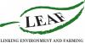  Linking Environment and Farming LEAF | 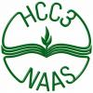  National Agricultural Advisory Service
Nodibinajums Baltic Studies Centre (BSC) | Research Institute of Organic Agriculture (FIBL) | Stichting Wageningen Research
The James Hutton Institute | VINIDEA

DOCUMENT SUMMARY

__________________________________________________________________________________
Milestone Title: 24 Case Studies
__________________________________________________________________________________
Case Study Title: Organic cow cheese production (Spain)
__________________________________________________________________________________
Version: 2
__________________________________________________________________________________
Task Lead: WUR
__________________________________________________________________________________
Related Work package: WP5
__________________________________________________________________________________
Authors: Alberto Lafarga, Isabel Gárriz (INTIA)
__________________________________________________________________________________
Grant Agreement Number: 727388
__________________________________________________________________________________
Project name: PLAID
__________________________________________________________________________________
Start date of Project: January 2017
__________________________________________________________________________________
Duration: 30 Months
__________________________________________________________________________________
Project coordinator: The James Hutton Institute

ABSTRACT

English
Title: Demonstration of organic cow cheese production in Navarra, Spain

Text: The demonstration in the farm "Jauregia" of cheese production and milk cow dairy in ecological is organized by the owners who are two brothers, who settled more than 15 years ago in the farm of his father. The purpose of the demonstration is for them to sell their products in a small store located in the cheese factory building. During the visit they show the organic production system: Controlled grazing, livestock management, milk processing and direct sale. During the visit the visitors are guided by taking a walk through the farm while the farmer explains in a very professional way. The visit is very well organized, the farmer connects very well with the attendees, there are many interactions with him and the assessment is very positive. The main recommendations for a farmer to organize a demonstration would be: Before the visit: know the group of people that will attend and define the contents of it. During the visit: Change settings, provoke interaction with the group, try the products. After the visit: Evaluate the degree of satisfaction, the possible areas for improvement.

Spanish
Título: Demostración de la producción de queso de vaca en ecológico en Navarra, España.
Texto: La demostración en la granja "Jauregia" de producción de queso y productos lácteos de vaca en ecológico está organizada por los propietarios, que son dos hermanos, que se instalaron hace más de 15 años en la granja de su padre. El propósito de la demostración es para ellos la venta de sus productos en una pequeña tienda ubicada en el edificio de la quesería. Durante la visita muestran el sistema de producción en ecológico: pastoreo controlado, manejo de ganado, elaboración de productos y venta directa. Durante la visita los visitantes son guiados por un paseo por la granja mientras el ganadero explica de una manera muy profesional. La visita está muy bien organizada, el ganadero conecta muy bien con los asistentes, hay muchas interacciones con él y la evaluación es muy positiva. Las principales recomendaciones para que un ganadero organice una demostración serían: Antes de la visita: conocer el grupo de personas que asistirán y definir el contenido de la misma. Durante la visita: Cambiar la localización, provocar interacción con el grupo, probar los productos. Después de la visita: Evaluar el grado de satisfacción, las posibles áreas de mejora.
TABLE OF CONTENTS

1 Demo context 7
1.1 The value chain 7
1.2 Typical farm characteristics 7
1.3 AKIS 9
1.4 Sustainability challenges 10
2 Demonstration summary 10
3 Governance: set up and organisation 11
3.1 Organiser(s) and history 11
3.2 Funding 11
3.3 Host(s) 12
3.4 Gender 12
3.5 Objective(s) 12
3.6 Topic(s) 13
3.7 Access 13
4 Demonstration event 13
4.1 Visitors 13
4.2 Communication & Mediation 13
4.3 Active participation 14
4.4 Doing business 15
4.5 Role of sustainability 15
4.6 Unforeseen circumstances 16
4.7 Plans vs. practice 16
4.8 Participants feedback 16
5 Motives, learning and networking 16
5.1 Reasons to attend demos 16
5.2 Forms of learning 17
5.3 Content of learning 18
5.4 Outcomes of learning 18
5.5 Networking 19
6 Anchoring: Application of demo lessons by participants 19
6.1 Anchoring related to the present demo 19
6.2 Stimulating anchoring 20
6.3 Anchoring related to earlier demos 20
7 Scaling: Application of demo lessons by the wider farming community 21
7.1 Retrospective examples of scaling 21
7.2 Prospective assessment of scaling: Impact pathways 22
8 Case study reflection 22
8.1 Demonstration-innovation narrative 22
8.2 Facilitating and impeding factors for successful demonstrations 23
8.3 Impact of demonstrations 24
8.4 Key lessons from this case study 24
9 Annexes 26
9.1 Data sources 26
9.2 Data collection methods 26

Demo context

The value chain
The agricultural profile in Spain is characterised
In Spain the total population is 47 million inhabitants, of which 4% are dedicated to agriculture around 666,000 people.
The agricultural area in Spain is 23 million ha., with about 900,000 farms, of which 58,080 are organic.
The sector of Spanish milk cattle is, within the livestock production, the second in importance in Spain behind the pig sector (36%), representing approximately 17% of the final livestock production (Mapama 2016).
38% of the production of cow's milk in Spain is made in Galicia in the north of Sapin, in Navarra 4% is produced. (Data 2015-2016).
In Navarra region there are 336,120 hectares of crops 32.3% of the total area. The 64.8% cultivated area is dryland and the remaining 35.2%, irrigated. The forest land represents more than half of the surface of Navarra, reaching 545,531 hectares. There are 92,324 hectares of meadows and pastures, representing 8.9% of the total area (2016)
The population resident in Navarra is 642,797 inhabitants. In the primary sector there are 11,936 workers. Of the 15,604 farms registered in 2017, 26.0% are owned by women, 65.1% by men, and 8.9% by legal entities. Of the 2,632 PTA registered in 2017, 16.5% are in the name of women and 83.5% are men. (2017)

During the last few years, Navarre has seen a severe reduction in the census of dairy cattle ranches and the farms that work in conventional production have a very high level of development with respect to the average of the rest of the state, which places them in a good reference level. However, it is possible that a part of the total of conventional production farms, especially those with production systems characterized by not very high livestock densities and medium or low production levels per cow, want to know the general vision of organic production for see in detail what your situation would be in this very different context. For this, it is necessary to offer the sector certain and rigorous information such as the one that is intended to be given in this course.

Typical farm characteristics
Spain there are more than 25 million head of pigs, 16 million sheep and 5 million heads of cattle according to the document prepared by the MAGRAMA "180 data of MAGRAMA". The dairy cattle census in Spain is of 851,363 milking cows, in Navarra the effective ones are around 4%. (2017)
The stock of cattle of Porcino are the most numerous 780,535 heads, followed by the cash sheep 493,055 heads and in third place the cattle 123,636 effective.
The total number of agricultural holdings in Navarra is 15,064, with dairy cattle only 153 farms, of which only 2 holdings are produced on an ecological basis (2017).

Trends of the dairy sector in Navarra
Crisis in the Dairy sector. In Spain, milk consumption fell by almost 20% between 2000 and 2015, according to the last monographic report of Alimarket, of December 2015. The decrease coincides with a greater purchase of vegetable drinks and without lactose. Between 2014 and 2015, the consumption of this type of drinks grew by 16%.
The end of the quota period meant a change for European cattle farmers: the arrival of a liberalized market. The production limit with quotas ceased to be a problem. Spain reached 6.8 million tons in 2015, 2.1% more than the previous year. But in 2016, the decline in milk prices intensified. The increase in the production of cow's milk in the European Union, together with the decrease in the consumption of dairy products, was the main cause of the crisis of prices paid to the farmer.
In both Spain and Europe, the size of dairy farms has grown steadily. On the contrary, the number of farms has decreased significantly and constantly. In Navarre, in 2015 there were 223 farms with a milk quota, while in 1995 there were 1,462 farms. Despite this, milk production in Navarra has grown. The territorial base of the holdings (SAU) has grown in the same way as the cash of farm cows.
According to the INTIA Dairy Advisory Service, which includes, since its inception (in the eighties), technical-economic information on dairy farms in Navarra that voluntarily participate in this service. Thanks to this work, there is a database in which all the information collected during these years is collected without interruption. Some trends are observed such as: Increase in the size of farms in livestock, labor and territorial base.
- Increase in production per cow, per UTA and per farm.
- Increase in the price of the concentrate since 2008.
- Since the year 2009, volatility and decrease in the price of milk.
- Increase of the liters to produce to obtain the reference income on the part of the farmer.
- In the last 7 years, decrease in economic margins (ton, cow, family UTA).
It is important that the farms manage a territorial base according to the number of cows they have, in order to reduce production costs. The stocking density has oscillated between 2 and 3 cows / ha in the historical series analyzed. The objective of the management of the territorial base is to provide the cattle with quantity and quality of forage with the idea of ​​reducing the feeding costs. (2017)
Subsector: Organic dairy
Main technologies and practices used: Organic production will have as an essential basis the production of organic fodder for livestock feeding, mainly of own production. Targeted grazing, although not the only one, is the technique par excellence (220-240 days/year), the production of cow's milk in organic, the production and transformation of milk into cheese and dairy products and marketing and short marketing circuits.

AKIS
Key actors of Agricultural Knowledge and Innovation Systems (AKIS) in the region of Navarra, Spain in connection with agrarian sector are and specifically from the dairy sector:
- Instituto Navarro de Tecnologías e Infraestructuras Agroalimentarias (INTIA). The public Institute financed by the Government of Navarre since its inception in the 80s has had a team of technical advisers to the dairy farms. The advice has consisted in such important topics as animal health, livestock feeding, investments in ships, management of pastures, milking techniques, accounts of technical and economic results, environmental problems of livestock waste ...
- Association of the Friesian of Navarre (AFNA). Association of farmers created in the 80s whose mission has been the dairy control of farms, genetic improvement and morphological classification of animals
- Universities of Navarra (public, private and distance). Universities have a role in the scientific field and this knowledge is transmitted to the agricultural sector through the technicians who advise the sector.
- Cooperative association: Cooperativa del ovino y vacuno de Navarra (COOVA): It is a cooperative of farmers that was created more than 30 years ago for the commercialization of livestock. They collect the animals from the farm and insure a sale price by contract. Realizes a fundamental work in the marketing of livestock.
- Farmer’s associations (2). In Navarra there are two trade union associations. They have an important weight in the directives that the Government raises on the agrarian sector.

- Council of Ecological Agrarian Production of Navarra (CPAEN). Exercises the functions of the only Control Authority in the territory of the Autonomous Community of Navarre for the Registration, Control, Certification and Promotion created by the Government of Navarre almost 20 years ago.

- Others, such as commercial feed, veterinary ... also advise farmers and has some influence on the decisions of farmers.
The milk production sector in Navarra is a very professional sector, with high knowledge and training. The main current problem faced is low farm profitability. The dairies mark the prices and do not cover the production costs in many cases. A tendency of the farms has been to produce many liters of milk to ensure profitability, others as in our case of study has decided the processing of milk and organic production as a differentiating stamp.

Sustainability challenges
The tendency of the last years of increase of the size of the dairy farms in Navarra to look for the profitability via dimension has caused a problem of high cattle pressure on the pasture surface. This causes the necessary storage of slurry with strict environmental regulations regarding its use as fertilizer.

The economic, environmental and social sustainability challenges faced by the dairy farming in particular are:

- The economic sustainability challenges are to obtain margins of exploitation that allow live from livestock. Among these production costs are those derived from investments for the storage of mandatory slurry.
- The main social sustainability challenge is the continuity of the farms: The aging of the population and the lack of generational change in livestock farms. And the maintenance of the rural population in rural areas
- And the main environmental challenge is the impact of slurry produced on the farm. The increase in the number of cattle on the prairie surface has led to the challenge of storage of slurry during times of year when the environmental regulations do not allow them to be used as fertilizers.
In general, sustainability is an issue that proffesional farmers take very much into account and know very well, to be very well informed about these aspects through the AKIS network discussed in point 1.3 AKIS.

Demonstration summary

This dairy cattle has been since its inception partner of INTIA and has received advice and ongoing training on aspects such as: livestock management, food, investments, environmental aspects, economic results, and transformation of products. The relationship between farm (Jauregia) and INTIA is very close, and receive advice on all aspects related to organic production. The farmers are very active and very well prepared young people, and collaborate on many occasions with INTIA in research projects. INTIA's role in this demonstration has been to contact them, explain the project and make them participate as a case study.

The demonstration of organic cow cheese production is organized by a small dairy farmers family "Jauregia Esnekiak", located in Aniz, a town in the Valley of Baztán, north of Navarra (Spain), which has traditionally been dedicated to dairy produce.

The farm is owned for 15 years by two brothers and their wives. The brothers take care of the cows and their women in the preparation of the cheese. It also has a rural house next to the cheese factory for 14 people. The cow farm was previously owned by his father who only had milk cows. The milk was sold directly without processing.

Since 2004 they began to process the milk they produced into cheese and yogurt and sell them by direct market. In 2008 they installed in the first milk vending machine in Spain. Right now it has about 56 animals among calves, heifers and cows, of which 29 cows are milked daily by themselves. In 2010 and after a period of adaptation they started producing all the products in organic.

The demonstrations take place on the farm itself throughout the year (around 50 visits in 2017). The minimum number to organize the visit are 15 people, normally it varies between 25-30 the average number of visitors per demonstration. The visits are part of the tourism offer of the region for the general public, and for professional breeders who want to know the production in ecological, and for the young farmers. The cost is 3 euros per person.

The demonstration was held on April 24, 2018, for a group of 12 young farmers who settled in the agricultural sector. The objective of the visit was to train young farmers about the possibilities offered by ecological production in milk cow, to know the transformation and the direct sale of the products on the farm. During the 200 hours of training they receive before settling in the agricultural sector, 2-3 days are devoted to training visits in professional farms. After a short break with a tasting of the farm's products, the dynamics of the Focus Group are launched to evaluate the experience. After the demonstration, the attendees had to complete an on-line survey evaluation of the visit.

During the demonstration was a tour of the cattle farm visiting the meadows where the forages are produced, the livestock shed, the cheese factory, and direct point of sale. They also offer accommodation in two rural houses that they manage with their women.

The demonstrations cover a wide range of topics related to dairy cattle farming in organic production, topics such as fodder autonomy, managed grazing, ecological management of pastures, extensive management and regenerative agriculture. They are the ones who vary the content of the topics that they explain in the demonstration based on the profile of the visitors.

The demonstrations are part of the commercial activity of the dairy, which aims to inform on how to make healthier foods, recover and enhance genuine aromas and tastes, respecting animal welfare and promoting sustainable rural development. In this context, the process does not start in milk or even in cows, it starts in the pastures, the feeding of the cows is key to obtain an excellent milk, which gives a quality cheese or yogurt. In the pastures calves are also raised that when they reach adulthood will start to produce milk. This supposes a smaller number of animals per hectare, a strict control in the feeding, and a greater number of days of the cows in the pasture per year, etc.

Image 1: Arrival to the visit in Jauregia in Navarra on April 24, 2018
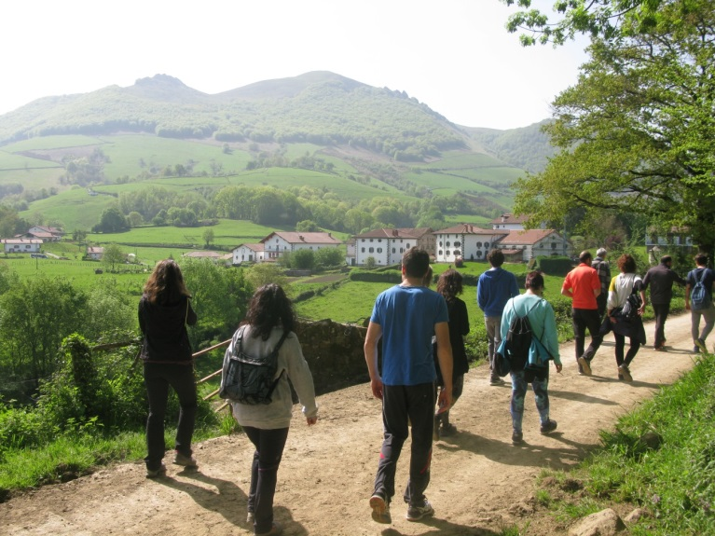
Author: Isabel Gárriz

This report is based on desk research obtained and empirical work. In addition to the information obtained from the individual interviews conducted with the owners of the farm and the INTIA advisory technician, carried out from January to October 2018. In addition to the interviews carried out with the 12 young participants and the observations made during the demonstration, and the observation of the Focus Group.

Governance: set up and organisation

Organiser(s) and history
Jauregia Esnekiak is the first dairy cattle and organic cheese farm in Navarra.
Since the installation of two brothers in the father’s farm in 2000 and 2004 have taken many innovative decisions in all areas: products, processes, marketing, organization and customer relations. In 2004 they started with the transformation of milk into cheese, and in 2007, they began to organize the first visits in theirs farm, in order to promote the direct sale in their own cheese factory of processed products, including yoghurts and cheeses.

The demonstrations take place on the farm itself throughout the year (around 50 visits in 2017). The minimum number to organize the visit are 15 people, normally it varies between 25-30 the average number of visitors per demonstration. The visits are part of the tourism offer of the region for the general public, the cost is 3 euros per person. During the demonstration there is a tour of the cattle farm visiting the meadows where the forages are produced, the livestock shed, the cheese factory, and direct point of sale. They also offer accommodation in two rural houses that they manage with their women.

INTIA has not had any role in the organization of the demonstrations, it has been an initiative promoted by the farmers themselves.

Funding
The demonstrations are part of the commercial activity of the dairy, and visitors pay 3 euros for the visit. It does not influence the topics of the demonstration, they change them according to the profile of the attendees. The ultimate goal is to end up in the store where they sell the products they make.
The costs of the demonstration are borne by the farmer himself.
The costs of bus travel, for the twelve young people and INTIA advisors, are paid by INTIA.

Host(s)
This farm was chosen for INTIA to participate in this case studies the demonstration because they are two brothers who have been organizing visits for several years, and are very used to receiving people.
They are also young farmers, very well prepared, one of the farmers studied business and business management with stays in Ireland, as well as a master's degree in agroecology. And the other is agricultural technician.
They are partners of INTIA and very close to collaborate. Also innovative and open to new ideas: They are the first to put a machine to sell milk in Spain and the only dairy farmers in organic in Navarra. They are also very active has website, facebook, are partners of several networks of local producers ...

The two brothers participate in demonstrations of farmers of the Cantabrian coast of Spain and they take turns explaining their farm and to in other events they attend. The demonstration is in a commercial farm with organic system. It is an example of how to move from one a conventional system of cow milk production to the wholesale market, towards an ecological model with direct sale of processed dairy products.

Image 2: Jauregia family farm
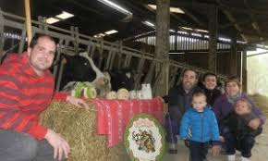
Author: Jauregia Esnekiak

Gender
It is the brothers who organize and carry out the visits. The demonstration is carried out by men because they are those who have studies and technical knowledge to explain this production system in ecological (livestock management, food ...Their women are engaged in the production of dairy products on the farm. This employment of female family labor contributes to the increase in profitability of farms in two directions: Increase in income and increase in female employment. Traditionally, the transformation of products into livestock farms is carried out by women in Navarra.

Objective(s)
The objective of the demonstration is to disseminate the technical knowledge and experiences on the production of organic cow cheese to young farmers to young farmers who settle in the agricultural sector with livestock. The objective of the demonstration was chosen by INTIA as an important part of the training that young farmers receive. The objective of the demonstration was chosen by INTIA as an important part of the training that young farmers receive, with the recommendations made by the INTIA advisor. From the perspective of the farmer in this visit the objectives are to convey all the knowledge about this type of production and about a way of life in the rural world linked to livestock and life in the village.

Figure 1. Positioning of the project in the typology demonstrations
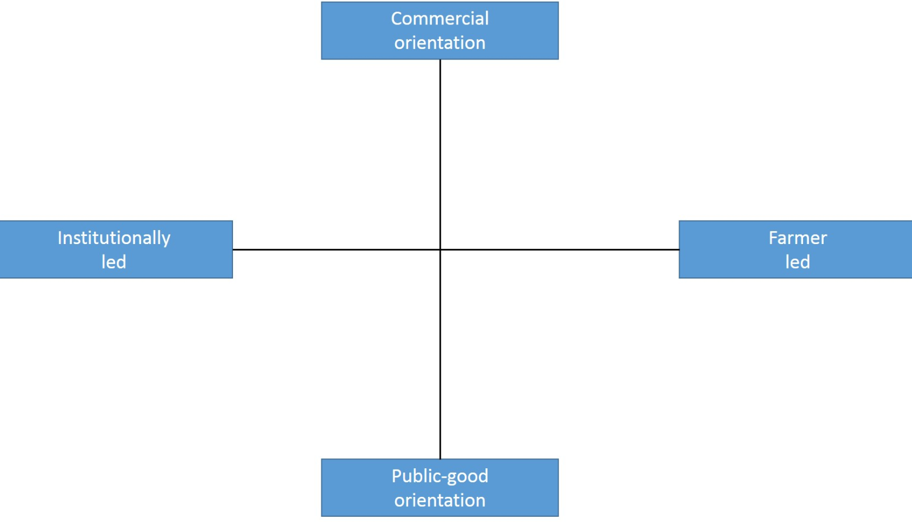
ES2

Topic(s)
The identification of the topics was made by the advisor of INTIA and validated by the technician in charge of the training course for young farmers and by the farmer.
Four different and well-defined topics were chosen so that attendees could better understand 4 different innovations that may be applicable to all or only some of them: 1) the production of organic forages for livestock feeding, 2) the production of cow's milk in organic, 3) the production and transformation of milk into cheese and 4) dairy products and short marketing circuits..
This topics were chosen because the visitors was the young farmers that will be future farmers and need to know precise techniques on the different parts of the production system of a livestock. The objective of the demonstration is to disseminate the technical knowledge and experiences on the production of organic cow cheese to young farmers who settle in the agricultural sector with livestock

Access
The attendees will be the young farmers who settle this year 2018 in the agricultural sector.
The course of incorporation to the agrarian company is directed by INTIA. Its objective is the transfer and training of young farmers to promote the incorporation of young people into the primary and rural areas, offering them the possibility of training and becoming professional.
This course "incorporation into the exploitation agrarian ", blended with a duration of 200 hours, is necessary to justify the training and adequate professional competence to benefit from the aid for the "installation of young farmers" measure.
In this course, technical, business and personal competences are worked (associated with the profile of an entrepreneur).
At the end of the 200-hour course in which they receive technical training, several visits are made to professional farmers to learn first hand how to manage a livestock farm.
To be able to access the demonstration it is necessary to pay 3 euros / person, in groups of no more than 15 people. There are demos for closed groups (as in this case) and not for open public events.

Figure 2. Location of demo Jauregia farm in Spain.
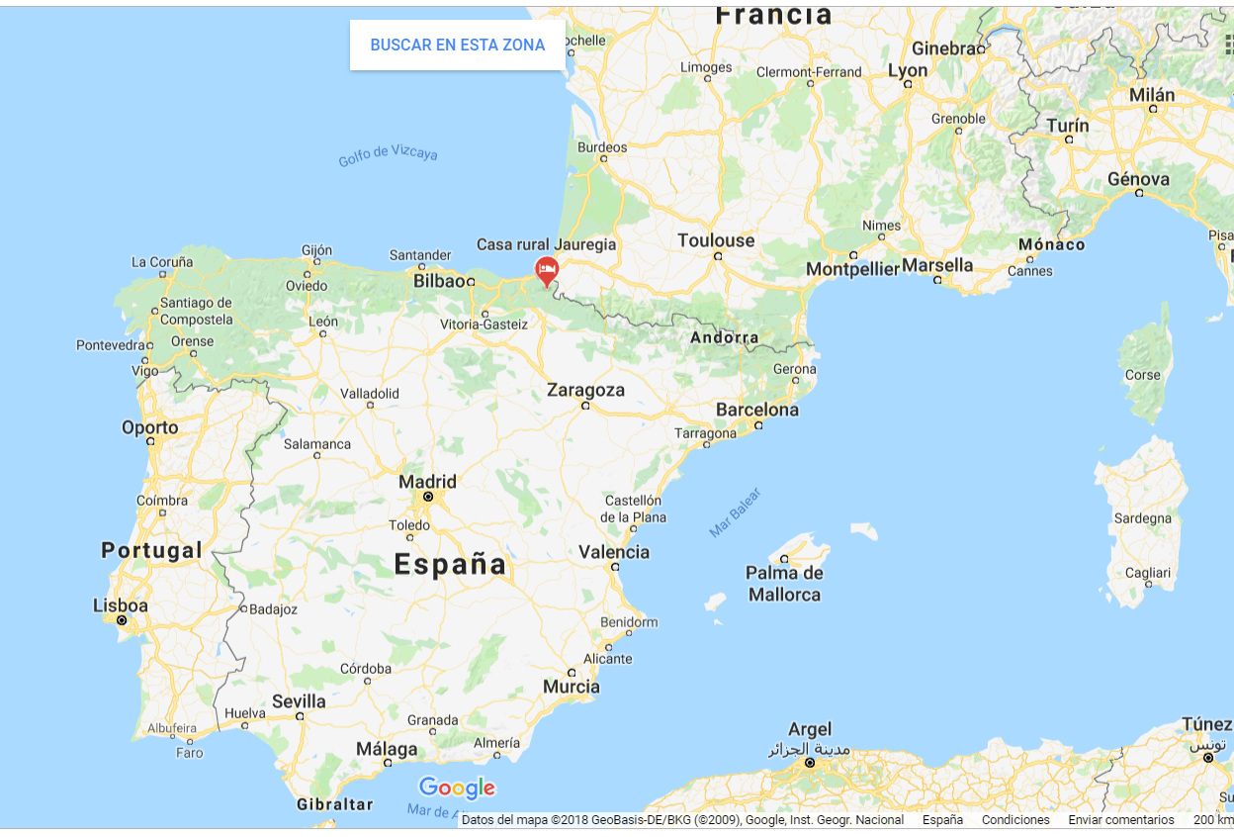
Source: Google maps.
.
Who can access this demonstration are: General public (tourists who visit the Baztan Valley), agricultural schools, other dairy cattle herders from other communities, and countries, young farmers who settle in the agricultural sector...
The availability of information about these demo are:
Facebook: https://www.facebook.com/jauregiaesnekiak/
Video facebook: https://www.facebook.com/626721067430205/videos/1010583582377283/
Youtube: https://www.youtube.com/watch?v=L7rBTpipEns (Leche ecológica de Baztan. Yogures y quesos. La leche de Primavera)
https://www.youtube.com/watch?v=PlD-mCab4v4 (1ª máquina expendedora de leche fresca.mov)
Webpage Turism of Navarra:
http://www.turismo.navarra.es/esp/organice-viaje/recurso/Compras/4253/Queseria-Jauregia.htm
http://www.turismo.navarra.es/esp/organice-viaje/recurso/Alojamiento/424/Jauregia-II.htm
https://farmdemo.eu/app/farm.php?id=2157

Demonstration event

Visitors
The visitors were 12 young farmers, we expected 15, but 3 of them could not go.
The 12 visitors were 6 women and six men, with ages between 18-38 years old. There were not differences in the behaviours of visitors during the demonstration event.
The usual visitors in this farm are tourists, and agricultural schools. Only a few years receive the young farmers of the course.
They are young farmers who settle this year 2018 in the agricultural sector. At the end of the 200-hour course in which they receive technical training, several visits are made to professional farmers to learn first hand how to manage a livestock farm. Visits to farms of professional farmers are compulsory and they include hours of assistance in the 200 hours they have to complete to obtain the certificate of professional qualification to exercise the agrarian activity and receive the aid of incorporation to the agrarian company.
Image 3. Beginning of the demo in Jauregia on April 24, 2018
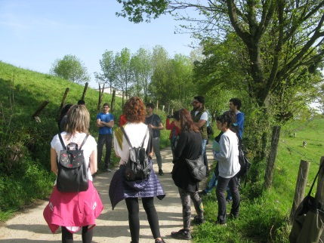
Source: Isabel Gárriz

Communication & Mediation
During the demonstration there is a tour guide by the farmer of the cattle farm visiting the meadows where the forages are produced, the livestock shed, the cheese factory, and direct point of sale. After a short break with a tasting of the farm's products, the dynamics of the Focus Group are launched to evaluate the experience.
The programme of the visit was:
9h00 Departure by bus from INTIA
10h00 Arrival at Jauregia
- Introduction: model change approach. Determinants of the environment, production in ecological, and market.
- Strategy for the food plan.
- Livestock production plan: reproductive, rearing, health, milk quality.
- Valorization of the milk through the transformation.
- Commercialization.
12h00 Focus Group
13h00 Return by bus to INTIA
14h00 Arrival at INTIA
The visit was structured in 4 parts, each with a different scenario, which allowed to identify them clearly for evaluation.

The visit started in the field, located the group in a space from where you can clearly see the meadow where a group of cows grazes the visit. It is in this framework where the owner is presenting his exploitation, with some data of its history, paying special attention to the evolution from a conventional system of cow milk production to the wholesale market, towards an ecological model with direct sale of processed dairy products.

Then the farmer focused on the explanations corresponding to the first topic of interest, the production of forages and grazing. The rotational grazing model acquires a special relevance given that we are seeing how the cows are grazing in an area delimited by an electric shepherd, while other areas of the plot have already been grazed or are prepared to be grazed.
On the other hand, the information is complemented with the production of forages in other plots and even the purchase of external forages when necessary. The importance of the quality of forages is clearly evident for a good management of livestock feed.

The visit continued in the cattle shed, where curiously there are no cattle. It explains how it should be in an organic livestock, the catlle is in the pastures. This space is the appropriate to talk about the management of livestock on the farm. The milking system, the management of slurry, animal health, productivity, ... are the aspects that are addressed both in the presentation of the farmer and through the questions that his intervention is generating attendees.

Subsequently, the group moved to the processing facilities where the third theme of the planned training is addressed, the processing of milk into cheese, yogurt, etc.

Image 4. Visit to Jauregia Cheese factory on 24 April, 2018
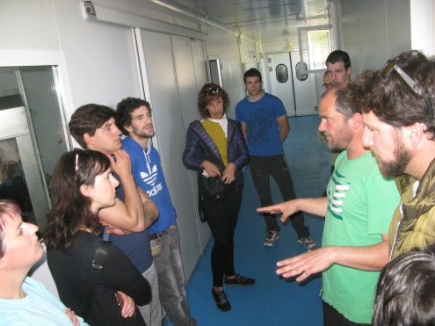
Source: Isabel Gárriz

Finally and next to the processing facilities, the store is located and visited, having the opportunity to talk about the direct sale marketing and being able to buy the products that have been presented.

Active participation
The visit was structured in 4 parts, each with a different scenario, which allowed to identify them clearly for evaluation.

In the first scenario in the field, the group remainded very attentive and very active, with a large number of questions and comments around on the topic that were discussed. No doubt his explanations generate interest.
With the course of the morning there are some small distractions, very punctual, with loss of attention, in some cases due to telephone calls and in others to collateral conversations. The general trend continues to be intense attention and good use of the information that is being offered to the group.

The visit continued in the cattle shed: The change of scenery, with a short walk between the pastures and the ship, helps to relax and rest the group that again focused very well on the explanations and was very active in the discussion. Although there may be some people more proactive, in general almost the entire group intervened.

Then, the group moved to the processing facilities processed, this part generated a lot of interest in the group for its novelty and the expectation that some of the visitors have to market their products in this way.

Finally the attendees visited the point of sale, having the opportunity to talk about the direct sale marketing and being able to buy the products that have been presented.
These parts of the visit were shorter. In general, the group followed with interest both the processing and the marketing data offered. The attitude of all was exemplary in terms of the level of interaction with the farmer.

The importance of very practical questions can be highlighted when dealing with young farmers with certain experience and expectations of innovations in their farms.

Doing business
All the attendees could do business, in fact all of them could bought demonstrated products in the point of sale to the farm.

Image 5: On farm visit point of sale Jauregia, April 24, 2018
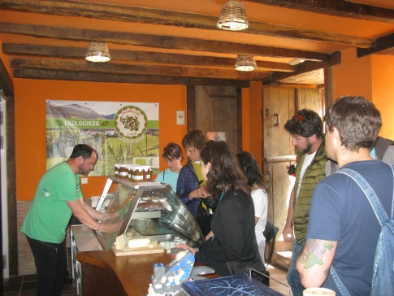
Author: Isabel Gárriz

Role of sustainability
The visitors were at all times in front of the environmental aspects. Organic production is based on a feed with quality fodder, which means less milk production per cow based on grazing, good milk quality and transformation. At all times, the farmer explained the advantages of this production that respects the environment and the animals themselves. The cattle shed during the visit was somewhat rare, because the cows are in the pasture grazing.
Image 6: On Jauregia visit cows in the pasture grazing, April 24, 2018
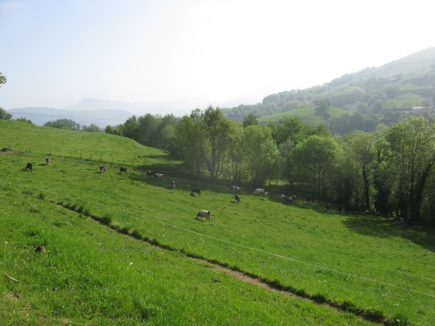
Author: Isabel Gárriz
Regarding the economic aspects, the owner explained his exploitation, with some data of its history, paying special attention to the evolution from a conventional system of cow milk production to the wholesale market, towards an ecological model with direct sale of processed dairy products. It is a type of farm in which they are in the entire value chain of the farm: milk production, processing and sale of products.
The social sustainability issues faced in is a system that requires a lot of work, but with the satisfaction of living in rural surroundings. The farmer explains that where once lived a family (his father), now live 2 families (those of the two brothers and their wives). It also explains the satisfaction of doing what they like.

Unforeseen circumstances
The demonstration was perfect and the weather wonderful.

Image 7: On Jauregia visit, April 24, 2018
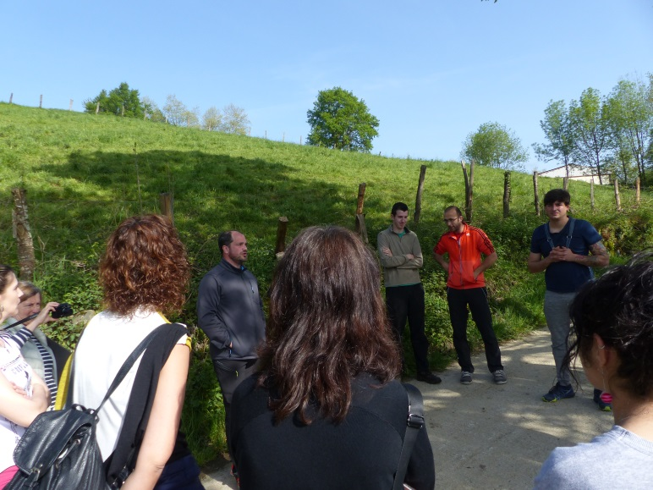
Author: Isabel Gárriz

Plans vs. practice
The number of visitors were 12 young farmers, we expected 15, but 3 of them could not go. But we continue with the planned plan.
The demonstration was according to the planned set-up. The farmer explained very well all aspects of the farm system and the attendees were very attentive to the explanations. They asked a lot of questions. The visit was also made at the scheduled time. There was good atmosphere in the visit. It can be said that it was even better than expected.

Participants feedback
General feeling very favorable to the experience lived. It can be said that the visit has pleased them, they have enjoyed it, they value it positively. On the other hand, everyone has some prior knowledge of the exploitation or the systems that have been presented, which does not mean that it has been novel in many aspects.

According to the results of the subsequent survey carried out on-line to the assistants the answers were that: They are very well organized, it is noted that it is not the first one and that they are sure to learn and improve. In general, the answers are that he is very organized, that he has explained everything to them very well, and that they attended to them very well.

Motives, learning and networking

Reasons to attend demos
Attitudes and perceptions
In this case of study the attendees are the young farmers who come as part of the training they receive to be able to settle in the agricultural sector.
They are young people who settle in livestock farms and in this demonstration they receive training from an experienced farmer, learn techniques and visit a real farm. There were not differences to gender in the answers.

The results of the survey make the students that the main reasons to attend to the demonstration are “to learn”, to take ideas and to know the production system in ecological.

The other options that exist to learn about the themes of the demonstration are the INTIA advisers, INTIA training courses, agricultural unions, the public administration, specialized magazines ... To interact with other farmers there are INTIA training days, workshops of the agrarian unions, associations of producers ...

One of the aspects that could be differentiated from the demonstration, compared to the other learning options is the opportunity to meet interesting people in the demonstrations. We asked a question in the survey related to this question asking if they had met someone interesting in the hearing and answered that they had liked to know the owner of the farm, that it was a project that had been carried out with great effort.

Norms
Farmers participate in this case because it is part of their training.
The farm where the demonstration is held is considered good and innovative farm, due to several aspects: 1) They were the first in Navarra to produce dairy certified in organic. 2) They were the first in Spain to install a vending machine for fresh milk.
The attendance of all the young farmers of the course is obligatory. Visits to farms of professional farmers are compulsory and they include hours of assistance in the 200 hours they have to complete to obtain the certificate of professional qualification to exercise the agrarian activity and receive the aid of incorporation to the agrarian company.
In Navarra there is currently only another dairy cow farmer in organic.
Practicalities
Attendance at the event was planned from January and a bus was set up to facilitate the attendance of all the participants. The date did not coincide with other events. The assistance to the demonstration opens doors to other production systems different from the conventional one.

Forms of learning
The demonstration consisted of a guided tour of the farm in which the farmer used his verbal expression, accompanying the exact location so that attendees could see for themselves what he was explaining. They are not presentations, and not leaflets.

Image 8: On Jauregia visit, April 24, 2018

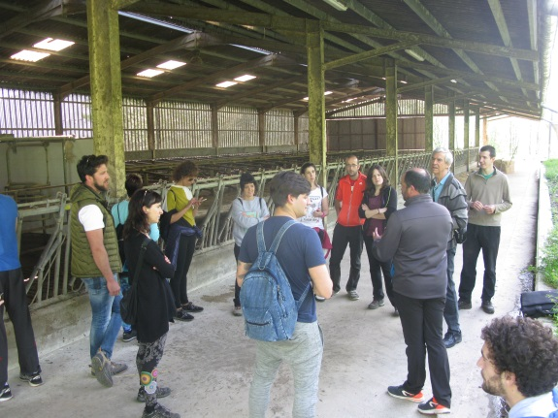
Author: Isabel Gárriz

At the end of the visit the farmer offers a tasting of his cheese and yogurt to the attendees.

Image 9: On Jauregia visit tasting products, April 24, 2018

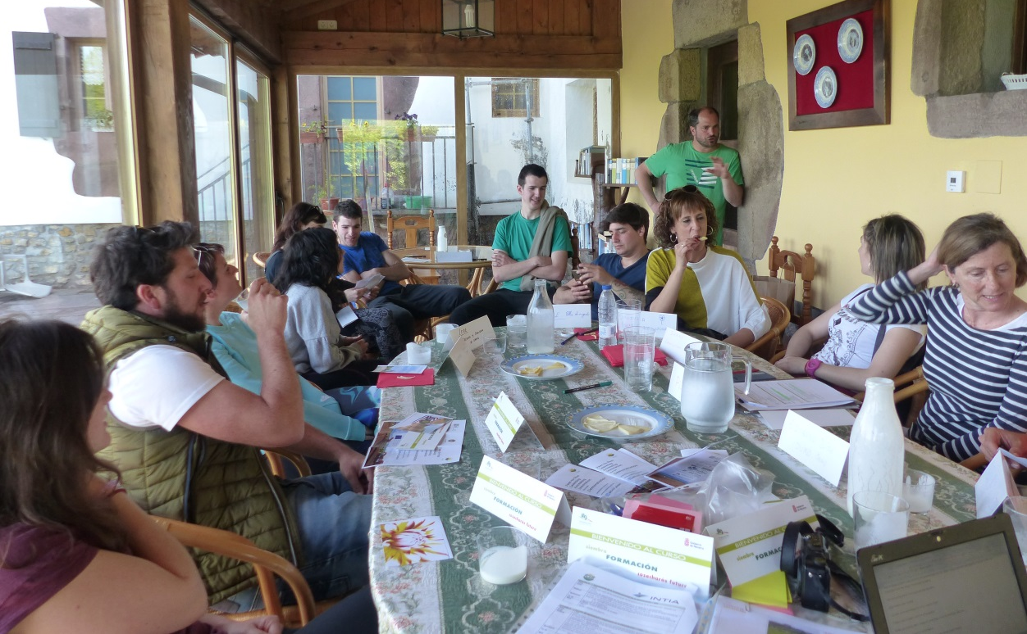
Author: Isabel Gárriz

Content of learning
The farmer structures the visit in 4 parts, each with a different scenario: Management of pastures for cattle feed, cattle management, cheese production and the point of sale of the farm. The explanations are very detailed and can be put into practice at the moment.
Attendees commented in the survey that the part where they had learned the most and the most surprised them was the feeding part, how they had to educate the cows in rotational grazing Attendees commented in the survey that the part where they had learned the most and the most surprised them was the feeding part, how they had to educate the cows in rotational grazing. Some also the handling of the cattle and one of them commented that the processing of dairy.

Outcomes of learning
The attendees asked the farmer many questions, which shows that they were thinking at the same time if they could apply it to their farm.
After a short break with a tasting of the farm's products, the dynamics of the Focus Group are launched to evaluate the experience.

In the exercise carried out in the Focus group the assistants show that rotational grazing and the importance of forage quality have had the greatest impact. Some also talk about livestock management and transformation. No one has highlighted the issue of marketing.

After the demonstration, the attendees had to complete an on-line survey evaluation of the visit. In this survey we asked about what have toy learned more and what is the most interesting thing learned for his own farm. The results the answers were the following: “Pasture feeding for 3 people was the best interesting, and other 3 people answered that for their farm there are nothing interesting.

Networking
In the general survey they answered that the most interesting people they had met were the family of farmers, whom they considered to be doing a great job.

Being a group that already know each other because they have been several months in the training course between them there were no people who knew each other in the demonstration.

Anchoring: Application of demo lessons by participants

Anchoring related to the present demo
The visitors have no plans to apply what they have learned in general. The responses collected are rather pessimistic and focused on the barriers that exist: The territorial base limits me a lot. The production of organic meat is unfeasible. They begin to discuss whether the model of the mountain is different from that of the flatter zone. Who will consume sheep in organic, ... Little lamb is consumed in Navarra. Relay, the competition. There is no government support, bureaucratic barriers, paperwork that needs to be done. Farmers are going to quantity and not quality. All this does not help me. I could get more fodder if I had more land. "

Perhaps we can explain this refusal to apply the learned ones taking into account these factors:
The production of cheese and dairy products in organic with food linked to the rotation of fodder requires a lot of technical knowledge and a great effort to educate the animals in this feeding system.
In addition, the management of livestock in ecological also means changing the mentality of the traditional farmer to produce many liters of milk to seek profitability, to produce less liters of milk.
It must also be added that the regulation of the use of medicines and the management of livestock is more complicated
Although there is an increasing demand for organic products, processing and direct sales also require an effort on the part of farmers. In Navarra there is the production of cow cheese in conventional but also requires family labor in the farm.

It should also be noted that although the farm system requires a lot of effort, the profitability and added value of the transformed products and the sale price are put by the producers. In this way they are economically compensated.

The direct sale is easier to implement in fact dairy sheep farmers do it on a regular basis, although the novelty of this case study is that through the demonstrations they organize get a greater number of customers on their own farm.

Stimulating anchoring
The group of young farmers continue with a period of tutoring with an INTIA advisor who guides them in the process of installation in the agricultural sector. They also have access to all the training courses organized by INTIA.

INTIA has created a specific Service of Integral Support to Young people who want to settle in the agricultural sector, who coordinates legal and administrative advice with advice technical-professional to the future professionals.

This Support Service is part of a Strategic Plan with which you want to deal with one of the main current problems of the agricultural sector, which is aging of the active population and the lack of generational change.
In Navarra there is a clear concern and sensitivity for this problem, both on the part of the institutions as of the sector itself and society, which moves to local rural development programs.

The PDR of Navarra 2014-2020 proposes installation aids of young farmers, investments in agrarian farms, creation of companies for non-agrarian activities
in rural areas and to the transformation and marketing.

Design of specific workshops, demonstration activities, technical trips and exchange programs.

Anchoring related to earlier demos
It seems to be according to the experience we have at INTIA that it is very difficult to apply this knowledge. For more than 15 years we have had an experimental sheep farm of organic production in Navarra and rotational grazing does not seem to be a technique that farmers do not easily implant.

In the case of dairy cattle in a conference organized by INTIA, was discussed about grazing systems, since the grazing that we can call modern is one of the most transcendental techniques. Organic production will have as an essential basis the production of organic forages, mainly of own production. Wherever the structure and the environment allow it to be emphasized, grazing, although not the only one, is the technique par excellence.this year this
https://www.intiasa.es/es/component/content/article/27-comunicacion/1044-intia-organizo-un-curso-sobre-ganaderia-ecologica-de-vacuno-de-leche.html

Scaling: Application of demo lessons by the wider farming community

Retrospective examples of scaling
INTIA recently published an article on the diagnosis of the ecological sector in Navarre, framed the project 'SME Organics', a European project, co-financed by Interreg Europe, which aims to promote entrepreneurship and support existing SMEs to improve their competitiveness, sustainability and are capable of growing the sector of organic food and agriculture in regional markets, National and international. The project, led by INTIA, with participation of the Department of Rural Development, Environment and Local Administration of the Government of Navarre, and other 7 associated European regions: Aargau (Switzerland), New Aquitaine (France), Lodzkie (Poland), Southern Ostrobothnia (Finland), Transylvania from the north (Romania), Lombardy (Italy) and Puglia (Italy)
also has in its partnership with key partners in the sector of organic production, such as IFOAM EU, FiBL and CIHEAM MAIB.
The food industry in Navarra is frequently supplied with primary production from outside Navarre: wineries, trujales for olive oil, canneries, bakery and confectionery, juices, coffee, infusions, sausages, meats, preserves of fish, honey, beer, prepared products and others food products. There are 131 companies and they are in continuous growth, which is an indicator of the upward trend in
the production and consumption of organic products.
As regards the points of sale, there has been an increase in last years of the number of partners in consumer associations /of organic products, specialized stores and of the space dedicated to these products in supermarkets.
The percentage of ecological area is 14% in Navarra.

Prospective assessment of scaling: Impact pathways
The main impact pathways identified which lessons from a demo become widely shared and may influence the farming community at large are:

- Via advisors: INTIA has a team of organic farming advisers who attend other demonstrations and events on organic farming and inform farmers.
- Via European projects: INTIA participates as a leader in several European SMEorganics projects, organizes meetings and visits to other European regions.
- Via Gobierno de Navarra: Currently the Government of Navarra has increased the subsidies for organic farming and has a service to promote and advise.
- Via CPAEN: Public organism for the control of organic agricultural production in Navarra.
- Via p2p contacts: Peer learning plays a key role in scaling up innovation in the region. Innovative farmers, together with their technicians, initiate the change and are then followed by the rest of the farmers in the region
- Agricultural press: Magazine specialized as Navarra Agraria that discloses the demonstrations that are made in INTIA
- Internet: The supply of information through online media is increasing, not only through the classic dissemination instruments of INTIA and companies, but also through the role played by social networks in the dissemination of good practices and the good results of innovation from one farm to another.
- Agrarian organizations: unions, networks…

In our case study we are talking about 4 different areas of innovation that occur in the same demonstration, and in which there are different ways of impact:
- Directed grazing and organic forage production. In this case the main ways of impact are: Advisors and contacts, contacts with other farmers.
- Ecological livestock management. The ways of impact are: advisory technicians.
- Product transformation: Training courses.
- Direct sales and marketing strategies: Networks ...

Case study reflection

Demonstration-innovation narrative
Short history about – Direct sales in short marketing circuits.

Jauregia Esnekiak is the first dairy cattle and organic cheese farm in Navarra.
Since the installation of two brothers in the father’s farm in 2000 and 2004 have taken many innovative decisions in all areas: products, processes, marketing, organization and customer relations.
The initial idea begins in 2004 with the transformation of milk into cheese with a clear economic objective and environmental aspects.
In 2007, they began to organize the first visits in theirs farm, in order to promote the direct sale in their own cheese factory of processed products, including yoghurts and cheeses.
It is in 2008 when they installed the first authomatic pasteurized milk vending machine in Elizondo.
In the year 2009, they began with the conversion into ecological products and, for the first time, they commercialized certified organic products in 2010.
In 2011, they created the exploitation's website to promote visits and marketing sales.
In 2013, local producers that sell their products directly are associated in a BIZILUR consumer group.
In the year 2017 the Sabores de Baztan Association was created - promoted by the Valley Town Council, with producers from the valley.

In our days the sale in short circuits of commercialization is supported by the Government of Navarre through INTIA, through its dynamic team of Short Channels created to support the farms that want to bet on this type of marketing.

Facilitating and impeding factors for successful demonstrations
The case study allows us to identify and evaluate the factors that contribute to a successful demonstration.
The main indicators to determine if a demonstration is successful are:

- During and after de demonstration the attendees ask questions
- Interaction, feedback, discussion between the attendees and the speaker.
- The assistants are satisfied with what they have learned.
- Sales – learning
- Confidence to change
- Connect - involve
- Followers-adoption-implement
- The theme of the demonstration is attractive to farmers.

And there are others like obviously are important too:
- Time is good and allows you to do it.
- The place where it is done is the right one.
- The day that is done does not coincide with important tasks for farmers.
- All possible assistants have received information beforehand.
- The broadcast messages of the show are attractive.
- The organization of the demonstration is impeccable in form and time.
- The duration and the planned program are met.
- The demonstration atmosphere is serious and friendly.
- The speaker is a good speaker and well considered.
- Participation of attendees is planned before, trying to assist the interest groups to which the demonstration is directed.

Factors that have impeded successful organization and implementation of the demonstration activity. These are the following three groups of factors, as proposed by the PLAID conceptual framework:
• inputs (infrastructure, finance, human resources)
- One of the farmers handles visits to the farm. The brothers take turns depending on the jobs they have on the farm.
- The place is not the right one and the date is not right either.
- The organizer is not expert or well considered.

• access (geographic, social, economic) (including gender, age, income, stakeholder groups)
- The interested parties have not been notified the objective in advance.
- The targets groups are not in the demonstration.
• Demonstration process (methods, content, interaction form)
- Interaction with attendees is not planned. In our case study it was not necessary because they were very active, but questions should be organized or foreseen for the attendees
- The contents of the demonstration were selected and studied prior to the demonstration in relation to the attendees.
- The farmer is a good communicator and connects well with the attendees
- The time to the speaker is to long different techniques are not used.

Impact of demonstrations
The impact of this demonstration is very important because they are the only producers of organic dairy cattle in Navarra. This type of production requires a high level of knowledge on the part of farmers in various production techniques, such as forage, livestock management, dairy production, all under the organic production regulations. It requires a greater effort in all aspects and is an example of the use of family labor on the farm (Two brothers and their women are the ones who run the farm)

Productivity and profitability. In this production system the important thing is not the productivity of the cows, it goes to high quality average productions. The profitability comes from the transformation into dairy products and direct sales in short circuits.

Resilience. The little dependence on livestock feed of foreign products, makes them adapt better to changes. The family workforce of the farm also allows them to be stronger in the face of changes.

Sustainability of the environment. It is this case of study the production system in ecological, in which the use in this context, the process does not start in milk or even in cows, it starts in the pastures, the feeding of the cows is key to obtain an excellent milk , which gives a quality cheese or yogurt. In the pastures they are also raised that when they reach adulthood they will start to produce milk. This supposes a smaller number of animals per hectare, a strict control in the feeding, and a greater number of days of the cows in the pasture per year, etc.

Quality of life. One of the greatest satisfactions of the owners of the farm is that the farm is in the town where they reside. The property of the farm is two brothers and their wives. The brothers carry the part of the production of the cows and their women the elaboration of dairy products. They also have in a building next to the dairy a rural house to accommodate 14 people. They are also very happy to be able to do what they like most. The quality of life is very high.

Empowerment. The importance of the brothers themselves transmitting the knowledge is in this case very clear. They are farmers who are well known in our region and throughout the Cantabrian coast.

Key lessons from this case study
- The demonstration has to offer something new that attendees can see beneficial to their interests: New techniques, be up to date, meet with other professionals ...

- The demonstration has to be organized by someone considered well prepared, expert, closed, and reconigsed.

- The planning of the demonstration is very important and you have to dedicate time. You also have to be prepared for the unexpected. A good demonstration is many hours of work of a large team of people. It is necessary to learn to handle this type of events and dedicate more time.

- The methodology proposed by PLAID project for the realization of the demonstrations is a great help to realize its full potential in the area of ​​sustainable innovation.

- We need to find instruments that facilitate communication so that all farmers can express themselves.

- Empower the farmer like an important figure in the transfer of innovation to the agricultural sector, against the easier speech of the technical specialists.

- It is surprising that although the visitors have considered what they have learned very interesting, they find it very difficult to apply what they have learned. The change is not immediate, it takes time to digest the information

Acknowledgements

We want to thank Aitor and Mikel Azkárate the hosts of the demonstration, who always lend themselves to collaborating with INTIA, in all the novelties that we propose. To our colleagues of INTIA Pilar Larumbe and Jose Luis Sáez, who made us visit with his students and your technical advice for this report, and for Anda Adamsone-Fiskovica for recommendations and suggestions to deepen the report.

Annexes

Data sources
Evolución de resultados técnico-económicos de vacuno de leche. Revista Navarra Agraria nº 219. Noviembre-Diciembre 2016.
https://www.navarraagraria.com/categories/item/1249-explotaciones-de-vacuno-de-leche-evolucion-de-resultados-tecnico-economicos

Circuitos cortos de comercialización. Revista Navarra Agraria nº 221. Marzo-Abril 2017.
https://www.navarraagraria.com/categories/item/1278-circuitos-cortos

Diagnóstico del sector ecológico en Navarra. Revista Navarra Agraria nº 222. Mayo-Junio 2017
https://www.navarraagraria.com/categories/item/1295-sme

Plan estratégico de apoyo a los jóvenes agricultores. Revista Navarra Agraria nº 223. Julio-Agosto 2017
https://www.navarraagraria.com/categories/item/1320-apoyo-a-la-instalacion-de-jovenes-en-sector-agrario

SME organics project. Revista Navarra Agraria nº 225. Julio-Agosto 2017
https://www.navarraagraria.com/categories/item/1350-sme-organics-proyecto-sector-ecologico

Report Goverment of Navarra: Principales cifras del sector agrario- Desarrollo Rural, Medio Ambiente y Administración Local (Marzo 2018)
https://www.navarra.es/home_es/Temas/Ambito+rural/Vida+rural/Observatorio+agrario/Otras+estadisticas/Programas+Anuales+de+Estadistica/2018/

Portal web Valle del Baztan
https://www.valledebaztan.com/tours/queseria-jauregia-esnekiak/

Portal web turismo en Navarra
http://www.turismo.navarra.es/esp/organice-viaje/recurso/Compras/4253/Queseria-Jauregia.htm

Portal web INTIA
https://www.intiasa.es/es/component/content/article/27-comunicacion/1044-intia-organizo-un-curso-sobre-ganaderia-ecologica-de-vacuno-de-leche.html

Data collection methods
The data collection for the case study included the following methods:

- Desk research
Collection and analysis of relevant regional statistical data, information about evolution organic and dairy sector in Navarra.

- In depth semi-structured interviews
Between January and October 2018, 2-3 semi-structured interviews with with those responsible for the course and the first installation and with the INTIA advisor in dairy cattle were carried out. People interviewed:
Aitor y Mikel Jauregia (Jauregia Esnekiak), Pilar Larumbe (INTIA), José Luis Sáez (INTIA)

- Demo event
Attendance to the demonstration on 24 April, 2018

- Participant observation
Comments from 2 INTIA technicians during the demonstration: notes were taken of what was happening, photos.

- Focus Group
Once the demonstration is finished, a Focus Group is carried out to teach about learning, anchoring and scaling.

- On-line interview to attendees
The following day an online survey was sent to the attendees with 12 questions

- Snowball’ technique: To obtain additional info on anchoring and scaling, we did an interview with the INTIA expert on organic cattle feed, which we asked the following:
o Innovations in the past few years in the area of interest.
o Knowledge they have on demonstrations in the past years in this area.
o An assessment of the potential role of demos in the uptake of this innovation and other reasons that it was adopted.

